Subject: ACT: Execute Recertification of Firewall Rules

Body Text:
ASK – Our IT coworkers to review & recertify all firewall rules so that we have a full understanding of our attack surface area. Please access the sharepoint list linked in this email to recertify your rules. The list has a simple drop-down option in the Recertification Field:

- Recertify – Use this option for actively used rules that are required for your application.
- Recertify – Disaster Recovery (DR) – Use this option for rules that are necessary for disaster recovery, but may not be used frequently.
- Cleanup/Remove – Use this option if the rule is no longer necessary and can be removed
- Need Assistance – If you are unsure which option to select, please attend office hours. A list of office hours times and links are at the bottom of this message.
Please respond to this request and update your assigned rules within one week. You may receive multiple emails for different groups of rules due to limitations of sharepoint lists. All rules must be recertified by 9/18.
Background

Here are a brief points that signal the drivers for this effort:

- Heightened geopolitical strain and regional volatility are increasing the likelihood of opportunistic and state-aligned cyber activity, prompting a prudent reassessment of perimeter and inter-node controls.
- An evolving “Mythos” threat narrative—where automation, AI-assisted actors, and asymmetric techniques compress attack timelines—requires sharper situational awareness across all exposed attack surfaces.
- Growth in connectivity and exception-based access over time necessitates periodic rationalization to ensure firewall rules remain intentionally aligned to today’s risk posture, not yesterday’s needs.
- Proactive governance and operational readiness ahead of the upcoming Board of Directors session demonstrates disciplined control hygiene and reinforces that we are ahead of emerging risk vectors, not reacting to them.
- Compliance with PG&E and industry standards.

How to Recertify your Applications:
- Open the sharepoint list linked above
- Click the Edit in grid view button at the top of the page. 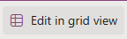
- Filter the list to show only your applications.
  - You can filter by selecting a column heading and choosing “Filter by”. You can apply this to multiple headings.
    - If you know your Application ID(s), that column will be the most effective.
    - Alternatively, Filter by your IT Director, then filter in the IT SME, IT SME Backup, or Client Owner fields for your name. Filtering by IT Director first will reduce the number of options for the other fields.
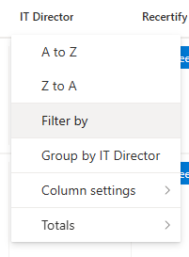
  - The Filter icon will open a list of all possible filters. The most useful will be Application Name (App-ID), or selecting your name in the IT SME, IT SME Backup, Client Owner, or IT Director fields. Close the filter options list by clicking the X in the upper right corner.
- Review the rule and select the appropriate disposition in the Recertification Column. Note that you will need to double-click in the cell in the Recertification Column to bring up the pick list.
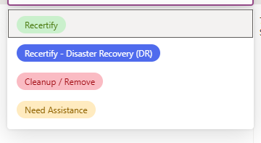
  - Recertify -> This rule will be kept and recertified.
  - Recertify – Disaster Recovery (DR) -> This rule will be kept, recertified, and tagged as necessary for Disaster Recovery activities. This will prevent removal if it is unused for longer than 365 days.
  - Cleanup / Remove -> This rule will be disabled and deleted later via CRQs.
  - Need Assistance -> Network Protection Services (NPS) will reach out to you and provide assistance. Alternatively, you can join Office Hours for support.
NOTE: The “Last Hit” column is a useful tool for determining if a rule is needed or not. This date indicates the last time the rule was used. If it is blank, the rule has never been used. If the rule has never been hit, or was last used more than 365 days ago, please either consider this rule for deletion or mark it as Disaster Recovery, if needed.
Frequently Asked Questions
- I can’t access the recertification pick list or I can’t access the list at all.
  - Make sure you click on the “Edit in Grid View” button at the top left.
- How do I get help if I don’t know if a rule is needed or not?
  - Please come to office hours or mark the line as “Need Assistance / Unsure” and NPS will reach out to you.
- I don’t think this rule should belong to me. How do I get assistance?
  - Please come to office hours or mark the line as “Need Assistance / Unsure” and NPS will reach out to you.
- Can I update multiple rows at once?
  - Yes! Please update the first row with the option you wish to use. Next, select that cell and hit CTRL-C to copy. Then, highlight the next couple of cells you wish to update and hit CTRL-V to paste. Please note you can only paste into ~10-15 rows at a time easily.
The online FAQ will be updated as additional questions arise:  Firewall Recertification How-To and FAQ.docx

