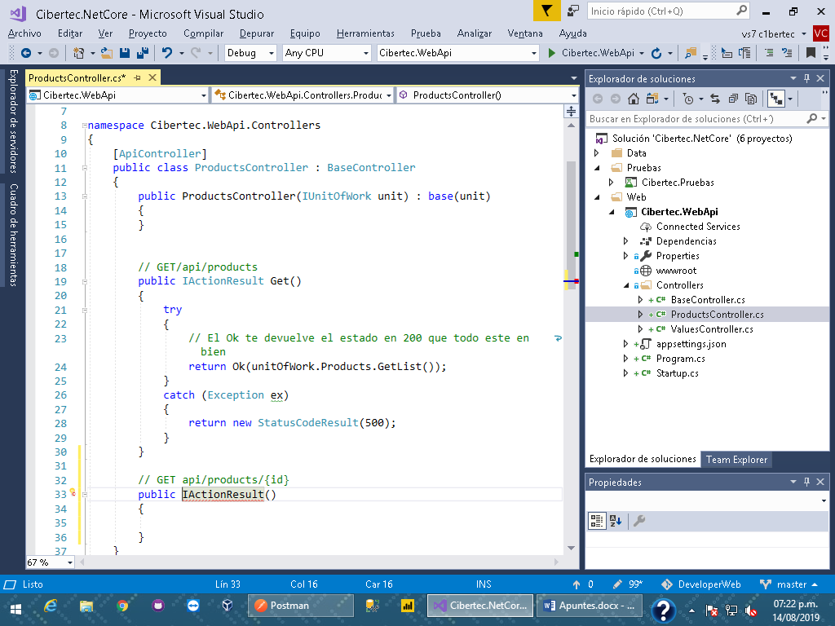

GET api/products/100

POST api/products

* Headers: {“content-type”: “application/json” }
* Body: {“prodName”: “….” }

{

“productNames”: “Postman”,

“supplierId”: 1

}

Shopity

git creating an issues