## Text Compression

Here at Hitachi Data Systems, we like to store things efficiently.  But look at our name!

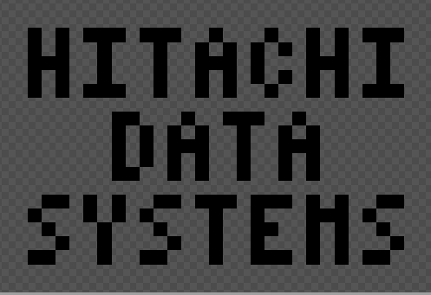

That's 18 letters, each 3 * 5 pixels in size, only 157 dark pixels, and yet we are using a 32 * 21 = 651 pixel canvas!  Clearly that is too much wasted space.  We should rearrange the letters to use less space.

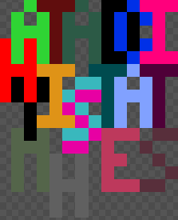

That's *much* better.  By moving the letters around a little, we can fit them all into canvas that's only 14 * 17 = 238 pixels.  
  
Can you compress our name *even more*?  Without rotating, reflecting, or breaking apart letters, rearrange the pixel-art "Hitachi Data Systems" so it fits on as small a canvas as you can.  It doesn't have to be the globally optimal size -- just try to make it smaller than this.  Bonus points if you write a program to calculate your answer.