Intro2SE - Requirements Analysis - GroupID

Project Name

The student team is required to complete the Software Requirements Specification (SRS) document for the assigned course project, following the attached template.


Software Engineering Department
Faculty of Information and Technology
VNU-HCMUS
Table of Contents
Objectives 1
1 Member Contribution Assessment 2
2 Problem Statement 3
3 Requirements Overview 4
4 Requirements Analysis 6
5 AI Usage Declaration 8
6 Presentation 9
7 Reflective Report 10

Software Requirements Specification

Objectives
This document focus on the following topics:
- Completing the Software Requirements Specification (SRS) document with the following contents:
  - Elaborate on the Problem Statement
  - Overview of Requirements (Functional and Non-Functional), Stakeholders
  - Use Case Model
  - Use Case Specifications
  - Create Prototype and Mockup Diagrams of the System Interface
- Understanding the Project Requirement Analysis document.
- This document will be used as input for AI tools to verify the quality of subsequent project artifacts.

All project artifacts must remain consistent and synchronized.
For example, if the project proposal is modified during this phase, a new version of the proposal must be documented.
By the conclusion of the project, all versions of every artifact must be submitted to demonstrate the evolution of your work.

Member Contribution Assessment

StudentID 1 - Fullname 1 - Contribution (%)
- Task Evidence: Provide a comprehensive list of tasks managed via Jira / Git (or a similar project management tool). For each entry, include: Task Details: Task name and a descriptive summary of the work performed. Visual Evidence: Clear screenshots that explicitly show the Task Name, Assignee, Status, Assigned Date, and Completion Date.
StudentID 2 - Fullname 2 - Contribution (%)
- Task Evidence

Each task must be assigned to and completed by only one student.
The sum of all student contributions is less than or equal to 100%.
The project tasks includes report writing, self-training, and implementation tasks.

Problem Statement
Please include the ID and full name of the student who authored, reviewed, or updated this section.
Written by: 24127382 - Trần Nhật Hoàng
Edited by:
Reviewed by:

Context & The Problem
In the modern corporate landscape, companies fundamentally rely on high-performing teams. To meet hiring demands, HR departments must process thousands of resumes annually. In traditional setups, this initial screening is predominantly manual, creating a slow, administrative bottleneck. This manual workflow leads to severe consequences across three main dimensions:
- Financial Loss: According to SHRM, the average "Time-to-Hire" spans 36–42 days. Recruiters waste hours scanning irrelevant resumes (direct labor costs), while critical roles remain vacant, delaying product launches and bleeding potential revenue (opportunity costs).
- The "First Come, First Served" Dilemma: Due to cognitive fatigue, recruiters process CVs linearly. Top talent applying late may sit at the bottom of a massive stack and never be opened, making candidate selection luck-based rather than merit-based.
- HR & Technical Misalignment: Manual screening is subjective and prone to human bias. Furthermore, generalist recruiters often judge CVs based on superficial buzzwords. This domain-knowledge gap leads to mismatched candidates, wasted interview rounds, and high turnover rates.

The Proposed Solution
To resolve these bottlenecks, we propose an AI-powered Applicant Tracking System (ATS). Instead of rigid keyword matching, the system leverages Large Language Models (LLMs) and Semantic Search to comprehend and rank resumes based on contextual capability.
The core innovation is the integration of autonomous AI Agents via the Model Context Protocol (MCP). This architecture allows specialized agents (e.g., HR Agent and Technical Agent) to securely fetch data and collaborate on resume summaries in real-time. This eliminates human bias, slashes Time-to-Hire, and bridges the gap between HR evaluation and technical reality.

Operating Environment
The AI-powered ATS is deployed as a cloud-native, client-server web application operating in the following environment:
- Client-Side: Responsive web interface accessible via modern browsers supporting HTML5, CSS3, and ES6+ (Google Chrome, Mozilla Firefox, Microsoft Edge, Safari). Fully optimized for Desktop and Tablet viewports.
- Server-Side: Local (cái này cũng cần chỉnh)
- AI Engine: Secure API connectivity to LLM providers (e.g., Hugging face) integrated with an embedded MCP Host layer to orchestrate live agent-to-data communication.

Design & Implementation Constraints

Tech Stack Constraints
- Backend: Python 3.11+ with FastAPI for high-performance API routing and native integration with LLM and MCP SDKs.
- Frontend: React.js (TypeScript) and Tailwind CSS for a dynamic, component-driven user interface.
- Database: PostgreSQL with the pgvector extension to handle both structured relational data and vector embeddings for semantic search.
- AI Integration: LangChain (or LlamaIndex) for agent orchestration, and the official MCP SDK for secure protocol connectors.

Design Constraints
- Architectural Pattern: Strict Client-Server Separation via RESTful APIs. The AI execution layer must be decoupled from the core business logic to prevent interface lag during heavy AI inference.
- Data Privacy & Security: All uploaded CVs must be encrypted at rest using AES-256. User authentication and endpoint protection must strictly comply with OAuth 2.0 and JWT standards to protect sensitive personal data (PII). (ai chuyên thì tìm hiểu cái này dùm)
- User Interface (UI) Design: Built upon Material Design guidelines, prioritizing high-contrast typography for resume scanning and data-dense dashboards for recruitment metrics.

Documentation Standards
- System Modeling: Architecture must be documented using UML 2.0 diagrams, including Use Case, Class (database schema), and Sequence diagrams detailing the recruiter-to-agent workflow.
- Code Documentation: Source code must follow the Google Python Style Guide (PEP 8), enforcing strict Type Hinting and clear docstrings for all public APIs and AI tools.

Requirements Overview

Stakeholders
Written by: 24127252 - Nguyễn Khánh Toàn
Edited by:
Reviewed by:
3.1.1 System Context Diagram
The diagram below positions SmartATS as the central system under design, bounded by a single dashed-line boundary that separates internal components from external actors and third-party systems. Two human actor roles sit on the left of the boundary: the HR Manager, who drives the core ingestion and review workflow, and the Tech Lead, who consumes analytical output under an ABAC-restricted, PII-masked view.
On the right, the diagram maps every external system the platform integrates with: Azure Blob Storage and Azure Service Bus form the asynchronous ingestion backbone; GitHub and LinkedIn are scraped by the Portfolio-Enrich module to augment candidate profiles; Google Calendar API is queried for interviewer availability; and Slack Webhooks deliver automated notifications back to the hiring team. The bidirectional WebSocket channel (wss://api.smartats.io/ws/v1/analysis/{candidate_uuid}) is shown explicitly, since it is the primary real-time data path between the AI Core and the Split-Screen Workspace UI. This diagram establishes the system's outer boundary and integration surface, serving as the baseline reference for all subsequent Use Case and Sequence diagrams in this document.
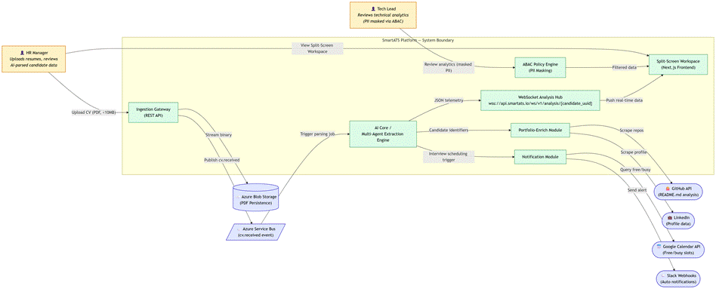
3.1.2 Stakeholders Matrix
STT | Stakeholder | Type | Description
1 | Project Sponsor | Internal / Business | Funds and oversees the SmartATS initiative; approves scope, budget, and final delivery acceptance.
2 | HR Manager | Primary Human Actor | Uploads candidate resumes, monitors ingestion status, and reviews AI-parsed analytical output via the Split-Screen Workspace. Holds full visibility into candidate PII.
3 | Tech Lead | Secondary Human Actor | Reviews technical-skill analytics (Radar Chart, career timeline) for hiring decisions; operates under ABAC policy with PII fields masked/redacted.
4 | Candidate (Data Subject) | Indirect Stakeholder | Submits CV data indirectly through the recruitment process; does not interact with the system directly but is the subject of all processed data, governed by data-privacy obligations.
5 | Autonomous AI Analytics Engine (AI Core) | Internal System Component | Multi-agent backend service that parses ingested PDFs, extracts structured candidate metadata, and streams results to the frontend via WebSocket.
6 | Azure Blob Storage | External System | Cloud persistence layer storing raw candidate PDF binaries under a private container, referenced by a deterministic UUID-mapped URL.
7 | Azure Service Bus | External System | Asynchronous message broker decoupling the ingestion API from the downstream AI parsing pipeline via the cv.received event.
8 | GitHub | External Third-Party System | Source queried by the Portfolio-Enrich module to analyze public repositories and README.md content for technical-skill corroboration.
9 | LinkedIn | External Third-Party System | Source queried by the Portfolio-Enrich module to enrich candidate profiles with professional history data.
10 | Google Calendar API | External Third-Party System | Queried by the Notification module to identify interviewer free/busy slots for scheduling.
11 | Slack Webhooks | External Third-Party System | Outbound channel used by the Notification module to push automated hiring-pipeline alerts to internal HR/recruiting channels.
12 | System Administrator | Internal Operational Actor | Manages ABAC policy configuration, system uptime, and infrastructure scaling (Azure resources, message queue throughput).

Requirements
    - Functional Requirements Specification
a/Ingestion Infrastructure & Verification Layout
Written by: 24127254 - Hồ Đình Trí
Edited by: 24127337 - Nguyễn Tiến Cường
Reviewed by: 24127382 - Trần Nhật Hoàng
-Multipart File Ingestion Gateway:
+Description: The system must provide a secure RESTful API endpoint accepting form-data payloads to allow authorized HR Managers to upload raw candidate resume documents.
+System Action: Intercept the payload at the API gateway, validate that the MIME type strictly matches application/pdf, and enforce a hard boundary limits check where files exceeding 10MB are immediately blocked
-Deterministic Storage and Cloud Persistence:
+Description: Validated assets must be safely structured and stored in isolated cloud environments to eliminate data fragmentation risks.
+System Action: Stream the raw binary PDF data stream directly to Microsoft Azure Blob Storage under a secure private container registry, generating a deterministic, non-guessable storage URL mapped to a fresh candidate Universally Unique Identifier (UUID).
-Asynchronous Event Broker Broadcast:
+Description: The system must decouple the heavy processing pipeline from the client thread using an event-driven mechanism to guarantee performance stability.
+System Action: Initialize an integration transaction and publish a structured cv.received event payload—containing the candidate UUID, storage URL reference, and timestamps—to the Azure Service Bus message queue backbone, then instantly flush an HTTP 202 Accepted status back to the frontend application client.
-Split-Screen Layout Initialization:
+Description: The responsive web interface must render a multi-panel workspace layout optimized for comparative verification.
+System Action: Initialize a Split-Screen Workspace flexbox container grid. The left-hand panel must pull the candidate asset from the storage URL via a client-side streaming wrapper, rendering the native PDF document layout page-by-page dynamically.
-Real-Time WebSocket Synchronization Hub:
+Description: The UI must establish bidirectional pipes to push backend analytical intelligence to the dashboard view without full-page reloads.
+System Action: Upon workspace layout mounting, open a secure persistent WebSocket sub-channel (wss://api.smartats.io/ws/v1/analysis/{candidate_uuid}). The frontend client must transition into a listening state, awaiting data frames from the downstream multi-agent extraction loop nodes.
-Interactive Visual Analytics Projection:
+Description: The system must map complex semantic metrics into clear, scannable visual components once background processing finishes.
+System Action: Consume incoming WebSocket JSON metadata payloads containing structured candidate details. Render an interactive, high-dimensional Canvas Radar Chart on the right-hand layout panel to visualize technical skill distributions, and project an expandable SVG career timeline summarizing verified employment history alongside the original document.
b/ Cross-Channel Profile Enrichment Engine
External Profile Identifier Extraction:
- Description: Upon completion of the CV ingestion phase, the system must automatically locate and extract all recognizable external profile identifiers embedded within the candidate's parsed document record.
- System Action: Scan the structured candidate JSON payload produced by the upstream parsing worker to detect and capture any GitHub profile URL and LinkedIn profile URL fields. Store the extracted identifiers as indexed attributes on the candidate record within the PostgreSQL database before dispatching enrichment tasks.
Asynchronous Enrichment Pipeline Dispatch:
- Description: The enrichment pipeline must be initiated as a fully non-blocking background operation that does not interrupt the active split-screen workspace session or the primary CV parsing flow.
- System Action: Publish a dedicated profile.enrich event payload — containing the candidate UUID and the extracted external profile identifiers — to the Azure Service Bus message queue backbone. The enrichment worker pool independently consumes this event without blocking the API Gateway thread.
GitHub Repository Intelligence Extraction:
- Description: The system must crawl the candidate's public GitHub presence to derive objective, evidence-based signals of real-world technical capability beyond what is self-reported in the CV.
- System Action: Invoke the authenticated GitHub REST API to retrieve the candidate's public repository index. For each repository, extract the full README.md content for NLP-based project summarization, compute the programming language distribution ratio from repository metadata, and derive a contribution activity timeline from the commit history records.
LinkedIn Professional History Harvesting:
- Description: The system must retrieve structured professional history data from the candidate's LinkedIn profile to supplement and cross-validate the experience and education claims declared in the raw CV.
- System Action: Dispatch a secure outbound request to the integrated third-party LinkedIn data provider (Proxycurl API or equivalent rotating-proxy service) to harvest the candidate's structured employment experience timeline, educational background, active skill endorsements, and professional certification records.
Unified Candidate Profile Consolidation:
- Description: All enriched external metadata harvested from GitHub and LinkedIn must be normalized and merged into the candidate's existing database record under a consistent, canonical data schema.
- System Action: Apply an idempotent merge operation on the candidate's CandidateProfile JSON structure within the PostgreSQL database, integrating the enriched skill attributes, project summaries, and professional history fields without duplicating pre-existing entries from the original CV parsing output.
Semantic Re-Indexing & Smatch Score Recalculation:
- Description: The AI Analytics Engine must incorporate the newly enriched profile data to produce a recalibrated semantic match score that accurately reflects the candidate's full cross-platform capability set.
- System Action: Signal the AI Analytics Engine to re-execute vector transformation procedures on the updated candidate profile via the pgvector extension, then recalculate the Smatch score against the active Job Description embedding. Persist the revised score and updated justification log to the database.
Real-Time Enrichment Result Projection:
- Description: The HR Manager's workspace must reflect enriched analytics automatically upon pipeline completion without requiring a manual page refresh.
- System Action: Transmit the finalized enriched analytics payload through the active WebSocket channel mapped to the candidate UUID. The frontend must refresh the right-side panel to render the updated Canvas Radar Chart, revised SVG career timeline, and recalculated programming language distribution chart in-place.
Manual Sync Trigger Control:
- Description: HR Managers must retain explicit on-demand control to re-initiate the enrichment pipeline at any stage of the candidate review lifecycle.
- System Action: Expose a "Run Sync" action button on the candidate profile view. Upon activation, the system re-publishes a profile.enrich event to the message queue, resetting the enrichment status to QUEUED and restarting the full external data harvesting sequence for the targeted candidate record.
Enrichment Status Transparency:
- Description: The HR Manager must have continuous visibility into the real-time processing state of the enrichment pipeline for each candidate.
- System Action: Maintain a persisted enrichment_status field on each candidate database record, cycling through discrete states: QUEUED → IN_PROGRESS → ENRICHED / ENRICHMENT_FAILED / NO_PROFILES_FOUND. Push status transition events to the frontend via the active WebSocket channel to update the visible status indicator on the candidate dashboard in real time.
Missing Identifier Graceful Degradation:
- Description: The system must handle candidates whose CVs contain no detectable external profile links without crashing the pipeline or corrupting the existing baseline analytics record.
- System Action: If no GitHub URL or LinkedIn URL is extractable from the candidate's parsed JSON record, update the candidate enrichment status to NO_PROFILES_FOUND, emit a warning notification frame through the WebSocket channel, and surface a descriptive banner alert on the workspace UI. All existing baseline CV analytics must remain intact and unchanged.

[Describe the functional requirements of the system using natural language. The combination of forms and regulations is acceptable. Number and group the requirements accordingly]
    - Non-Functional Requirements Specification
a/Ingestion Infrastructure & Verification Layout
Written by: 24127254 - Hồ Đình Trí
Edited by: 24127337 - Nguyễn Tiến Cường
Reviewed by: 24127382 - Trần Nhật Hoàng
-Low-Latency File Rendering (Performance)
+Constraint: The system must guarantee that the first page of the candidate's native PDF document is rendered and completely interactive inside the left viewport layout within 800 milliseconds after the cloud storage confirmation is received.
-High-Velocity WebSocket Throughput (Performance)
+Constraint: Once the background multi-agent loop finishes parsing the structured candidate profile, the WebSocket channel must broadcast and transfer the complete JSON metadata payload to the right-hand panel viewport container within a maximum threshold of 200 milliseconds.
-Responsive Grid Adaptability (Usability/Design)
+Constraint: The split-screen dual-panel workspace layout grid must adapt fluidly across varied desktop monitoring resolutions (minimum width of 1280px up to 4K displays) utilizing responsive Flexbox/Grid structures, maintaining stable view proportions without horizontal text-overflow clipping.
-Concurrent Ingestion Load Capacity (Scalability)
+Constraint: The message queue architecture (Azure Service Bus) coupled with the stateless API gateway must support an ingestion load capacity handling up to 100 simultaneous multi-part file uploads per minute without dropped connections or message duplication.
-Input Scrubbing & Perimeter Guardrails (Security)
+Constraint: The Multipart File Ingestion Gateway must conduct strict byte-level header checks on all uploaded assets to prevent extension spoofing attacks, immediately terminating transactions that contain hidden malicious executable macros disguised within the PDF stream.
-Cross-Browser Engine Compatibility (Portability)
+Constraint: The client-side PDF canvas streaming engine and persistent WebSocket communication modules must operate seamlessly and maintain uniform styling matrices across major web browsers compliant with the ECMAScript 2024 execution standard, including Google Chrome, Mozilla Firefox, and Apple Safari.
b/ Cross-Channel Profile Enrichment Engine
- Non-Blocking Async Compliance (Performance)
- Constraint: The enrichment pipeline dispatch must publish the profile.enrich event to the Azure Service Bus queue within 500 milliseconds of the upstream CV parsing completion signal. Throughout the entire background enrichment execution, the primary HR workspace UI must maintain a client-side interaction response time below 200 milliseconds to preserve workspace usability.
- End-to-End Enrichment Throughput (Performance)
- Constraint: The complete enrichment cycle — spanning external API crawling, LinkedIn harvesting, profile consolidation, vector re-indexing, and Smatch recalculation — must deliver the finalized updated analytics payload to the client WebSocket channel within 45 seconds under standard network conditions and nominal third-party API response latencies.
- Fault Tolerance & Retry Resilience (Reliability)
- Constraint: The enrichment integration layer must enforce an Exponential Backoff retry policy across all outbound external API calls, executing a minimum of 3 retry attempts with progressively increasing backoff intervals before declaring a hard failure. Upon exhausting all retry attempts, the system must transition the candidate enrichment status to ENRICHMENT_FAILED, emit a fallback alert via the active WebSocket channel, and guarantee zero corruption of the existing baseline candidate analytics record.
- Third-Party Rate Limit Compliance (Reliability)
- Constraint: The enrichment engine must enforce internal request throttling logic to strictly comply with external provider rate-limit policies, including the GitHub REST API authenticated ceiling of 5,000 requests per hour. The throttling layer must prevent API token revocations, temporary IP bans, or service suspensions from any integrated third-party data provider.
- Enrichment Worker Scalability (Scalability)
- Constraint: The enrichment worker pool must support horizontal scaling via the Azure Service Bus message queue backbone. Under peak load conditions — defined as 50 or more simultaneous enrichment events queued concurrently — all tasks must be processed to completion without degrading API Gateway response times for active HR Manager sessions.
- Credential Isolation & Secret Hygiene (Security)
- Constraint: All outbound authentication credentials used for third-party API integrations — including GitHub API tokens and LinkedIn provider API keys — must be stored exclusively within server-side environment-scoped secret vaults. No authentication tokens may be exposed to the client application layer, embedded in frontend bundles, or recorded in plaintext within the system's centralized audit log.
- Idempotent Data Merge Integrity (Data Integrity)
- Constraint: The profile consolidation operation must be fully idempotent. Re-executing the enrichment pipeline against the same candidate UUID any number of times must consistently produce an identical final database state, with no duplication of skill entries, employment records, or repository data within the PostgreSQL candidate profile schema.
- Enrichment Auditability (Maintainability)
- Constraint: Every enrichment pipeline execution must emit a structured audit log entry — persisted to the system's centralized audit trail — recording the trigger timestamp, external API response status codes, retry attempt counts, and final pipeline outcome, all traceable by candidate_uuid for retrospective debugging and compliance verification.
- Module-Level Deployment Independence (Maintainability)
- Constraint: The Portfolio-Enrich Engine must be implemented and deployable as an independently isolated module within the Modular Monolith architecture, decoupled from both the CV Parser and AI Analytics Engine exclusively through the message queue boundary. Upgrades or full replacements of any external data provider integration must require zero modifications to the API Gateway layer or the AI Analytics Engine codebase.

[Describe the non-functional requirements of the system using natural language]

Requirements Analysis

Use Case model
Please include the ID and full name of the student who authored, reviewed, or updated this section.
Written by:
Edited by:
Reviewed by:
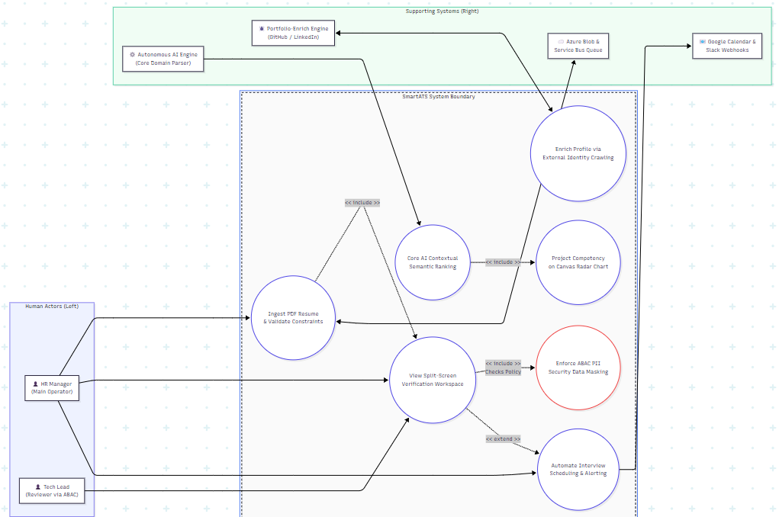
System Boundary and Actor Interaction Overview: The Use Case Diagram above establishes the operational boundary of the SmartATS platform, illustrating the behavioral relationships between external actors and internal system components. The architecture is designed to decouple user-facing interactions from automated background processes to ensure system stability and high performance.
- Primary Human Actors: The HR Manager serves as the primary system operator, holding explicit privileges to initiate the core file ingestion pipeline, view the synchronized split-screen verification workspace, and manage interview schedules. Conversely, the Tech Lead acts as a secondary reviewer, strictly bounded by Attribute-Based Access Control (ABAC) policies that dynamically redact and mask Candidate Personally Identifiable Information (PII) to ensure data privacy.
- Core System Use Cases & Internal Relationships: Ingestion Layer: When a resume is uploaded, the system validates file constraints (MIME types and size boundaries under 10MB), which automatically triggers (<<include>>) the mounting of the Split-Screen Verification Workspace.
AI Analytics Layer: Initiated by the Autonomous AI Engine, the system extracts contextual metadata and calculates semantic proximity scores, which are immediately projected onto an interactive Canvas Radar Chart (<<include>>) via a live WebSocket stream.
Profile Enrichment: Operating asynchronously, the system invokes the Portfolio-Enrich Engine to crawl external GitHub and LinkedIn profiles, augmenting the candidate record without interrupting the client thread.
Security & Automation: The verification layout strictly incorporates (<<include>>) ABAC security protocols to mask data fields before rendering analytics to non-authorized roles. Furthermore, the workspace dynamically extends (<<extend>>) its capabilities to allow direct interview scheduling and automated alerting via third-party channels (Google Calendar and Slack Webhooks) once a candidate passes initial verification hurdles.

Use Case Specification
    - Profile Ingestion & Split-Screen Verification Layout
Written by: 24127254 - Hồ Đình Trí
Edited by: 24127337 - Nguyễn Tiến Cường
Reviewed by: 24127382 - Trần Nhật Hoàng

Use case ID | U001
Use Case | Profile Ingestion & Split-Screen Verification Layout
Brief Description | Allows an authenticated HR Manager to upload raw candidate resume documents and instantly inspect AI-parsed visual analytical telemetry side-by-side with the original file layout
Actor | HR Manager, Autonomous AI Analytics Engine
Pre-Condition | - The HR Manager must be securely logged into the SmartATS portal with appropriate access roles.  - The client browser environment must support persistent WebSocket channels and canvas streaming.
Result | - The raw PDF binary document is securely archived in cloud blob persistence storage.  - An ingestion tracking message token is published to the queue cluster.  - The active split-screen view updates with real-time parsed data metrics.
Main Scenario | - The HR Manager accesses the central talent acquisition pipeline workspace.  - The HR Manager drags and drops a candidate's resume file (PDF layout) onto the file ingestion interface panel.  - The system activates input filters to validate file format policies and size constraint parameters (under 10MB).  - The system streams the verified binary asset to Microsoft Azure Blob Storage and captures a unique secure storage URL.  - The system generates a candidate record token mapped to a new candidate UUID.  - The system fires an asynchronous cv.received notification payload to the Azure Service Bus queue broker and pushes an HTTP 202 Accepted status token to the frontend client.  - The interface dynamically triggers a Split-Screen Workspace UI container layout.  - The system streams and displays the original candidate PDF on the left-hand viewport canvas panel.  - The frontend application establishes a dedicated, listening WebSocket sub-channel handshake mapped to the candidate's UUID.  - The Autonomous AI Analytics Engine completes parsing and transmits structured JSON telemetry back via the active WebSocket pipeline.  - The system catches the payload frame and instantly visualizes the candidate profile metadata, interactive Radar Charts, and SVG career timelines on the right-hand layout panel.
Alternatice Scenarios | Alternatice 1 - Invalid File Format/Size Execution: At Step 3: If the file data fails policy validation checks (violates PDF MIME constraints or size boundary limits exceed 10MB):  - The system blocks further upload operations and cancels storage stream transactions.  - The system generates an HTTP 400 Bad Request client boundary code error.  - The workspace interface catches the exception code and shows a validation failure banner alerting the user.  - The layout returns safely to an idle ingestion holding state.  Alternatice 2 - Asynchronous Engine Failure Timeout:  At Step 10: If the background AI parsing worker nodes face deep server execution crashes or token timeout limits are reached:  - The orchestration loop fails to update the processing state to completion.  - The active WebSocket channel pushes an execution failure state token to the client interface.  - The left-hand canvas retains the native PDF view, while the right-hand analytics block shifts into a fallback state UI.  - The interface presents a manual data curation wizard option to the HR Manager to handle the exception gracefully.
Non-Functional Constraints | - Rendering Deadline: The native client canvas must display page one of the file stream inside the left pane within 800ms of API confirmation.  - Layout Integrity: The dual view pane must respond gracefully to panel resizing without triggering horizontal text layout overflow clipping.
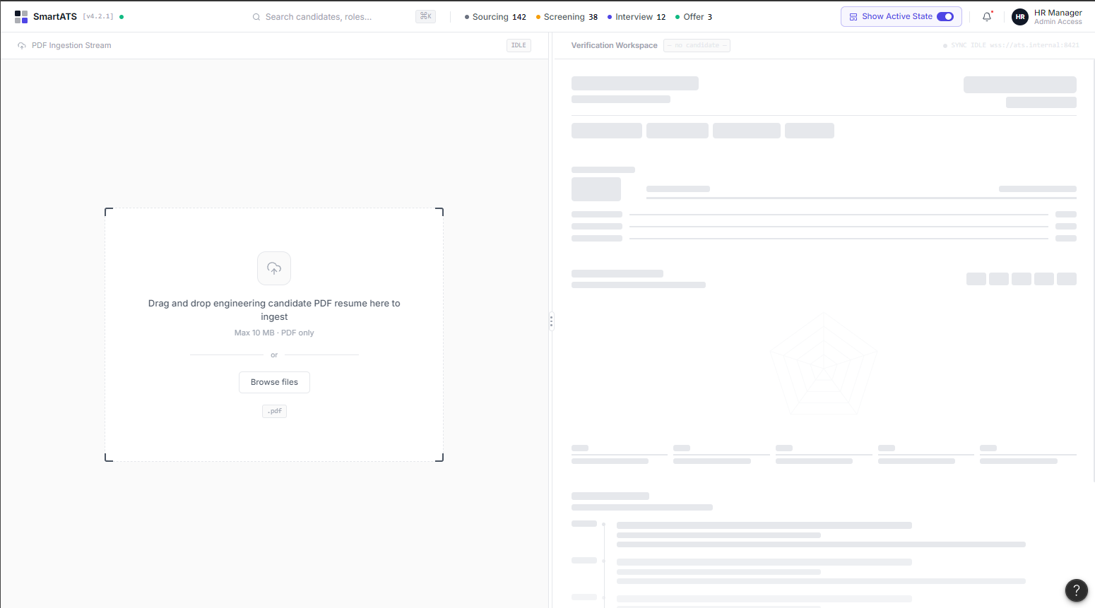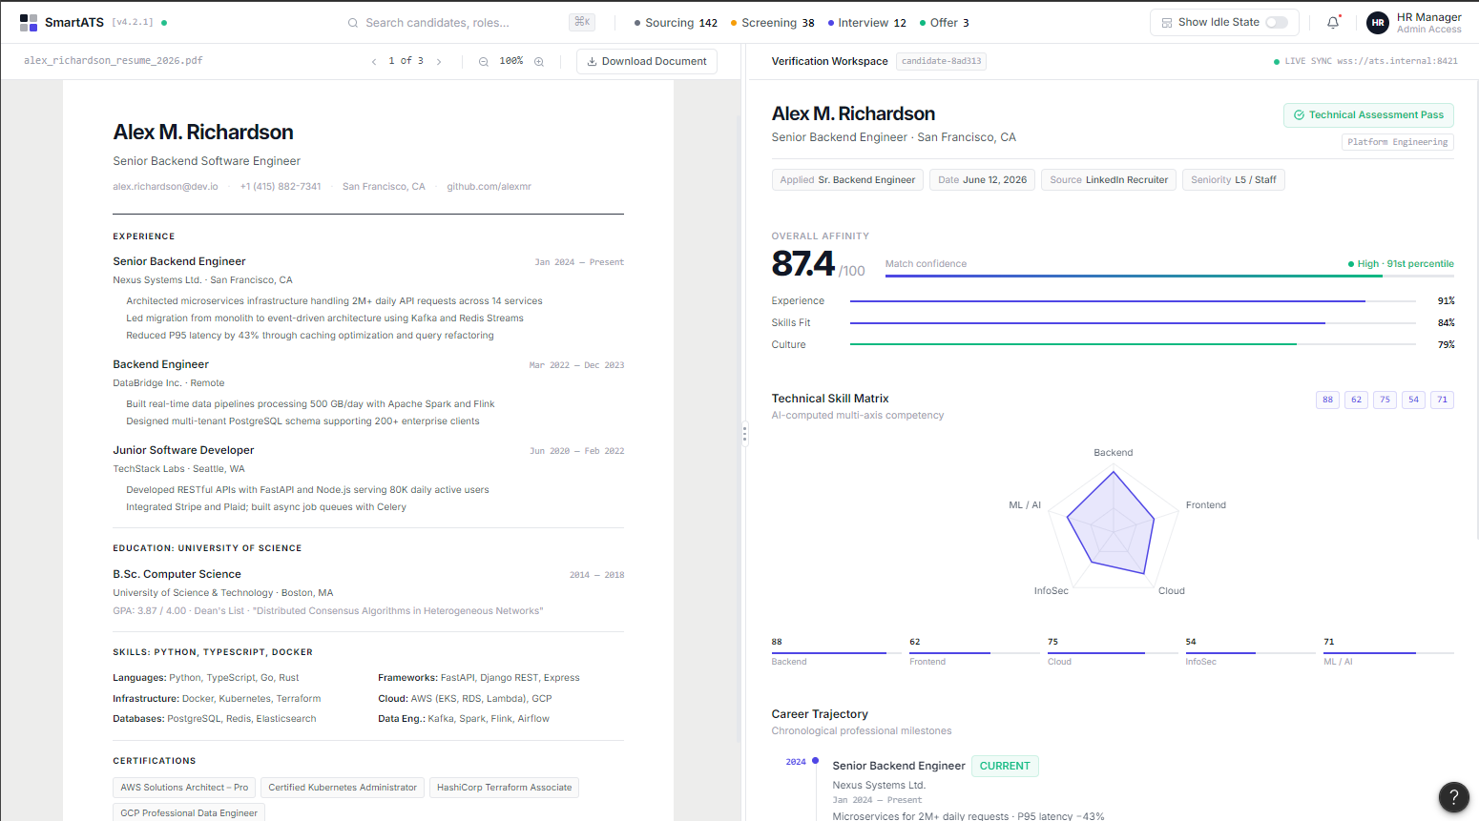
    - Cross-Channel Profile Enrichment & Manual Sync Trigger
Use case ID | U002
Use Case | Cross-Channel Profile Enrichment & Manual Sync Trigger
Brief Description | Allows an authorized HR Manager to manually trigger data harvesting from external third-party APIs (GitHub, LinkedIn) based on the candidate's extracted profile details and seamlessly integrate enriched technical telemetry into the analytics dashboard.
Actor | HR Manager, Portfolio-Enrich Engine (External Third-Party System), Autonomous AI Analytics Engine.
Pre-Condition | 1. The HR Manager must be authenticated and actively viewing the candidate's initial parsed profile page.  2. The candidate's raw resume data must already be processed by the Ingestion Gateway, with a valid candidate_uuid generated.  3. External third-party identity APIs (GitHub API, LinkedIn API) must be operational with authenticated credential handshakes configured.
Result | Verified external portfolio metrics and professional history are safely integrated into the relational vector database without blocking the client UI thread, updating the centralized visual dashboards dynamically.
Main Scenario | 1. The HR Manager accesses the specific candidate profile view displaying raw PDF analytics.  2. The HR Manager clicks the "Run Sync" action button on the top navigation bar to initialize external verification.  3. The system captures the request and securely extracts professional social identifiers (e.g., GitHub username, LinkedIn profile URL) from the candidate's indexed database record.  4. The platform launches an asynchronous background worker task, dispatching secure payload queries to the GitHub API and LinkedIn API.  5. The Portfolio-Enrich module crawls and analyzes public code repositories (parsing README.md files) from GitHub and structured employment history timelines from LinkedIn.  6. The background pipeline normalizes the fetched unstructured metadata into a unified technical capability schema.  7. The database synchronization layer executes vector transformations, updating and enriching candidate skill attributes within the pgvector/PostgreSQL cluster.  8. The system signals the Autonomous AI Analytics Engine to recalculate overall match matrices and instantly pushes updated telemetry frames across the active WebSocket tunnel.  9. The UI refreshes the Left Viewport to present the scrollable external integration metrics and projects enhanced Canvas Radar Charts and SVG timelines on the Right Panel.
Alternatice Scenarios | Alternative 1 - Missing External Profile Identifiers:  At Step 3: If the candidate's raw resume does not contain any recognizable GitHub link or LinkedIn profile pointers:  - The system immediately flags the synchronization transaction status as "No External Profiles Identified".  - The workspace interface intercepts the status token and displays a warning banner to the user.  - The workflow terminates safely, keeping the baseline CV analytics unchanged.  Alternative 2 - Third-Party API Interruption or Rate Limit Breaches:  At Step 4: If the third-party integrations experience server-side crashes or return HTTP 429 (Too Many Requests) / Timeout errors:  - The platform registers the execution exception inside the logging queue backbone.  - The background task engine initiates an automated background retry routine utilizing an Exponential Backoff strategy.  - If errors persist beyond the hardcoded maximum threshold, the sync state flags "Enrichment Failed" via WebSocket, maintaining the original raw CV baseline while providing a manual retry control option.
Non-Functional Constraints | - Asynchronous Compliance: The external data harvesting pipeline must execute strictly as a non-blocking background thread, preserving interactive interface responsiveness below a 200ms threshold.  - Rate Limiting Guardrails: The integration layer must enforce internal throttling matrices to comply with third-party endpoint rate-limiting policies, preventing API token revocations or temporary IP blocking.
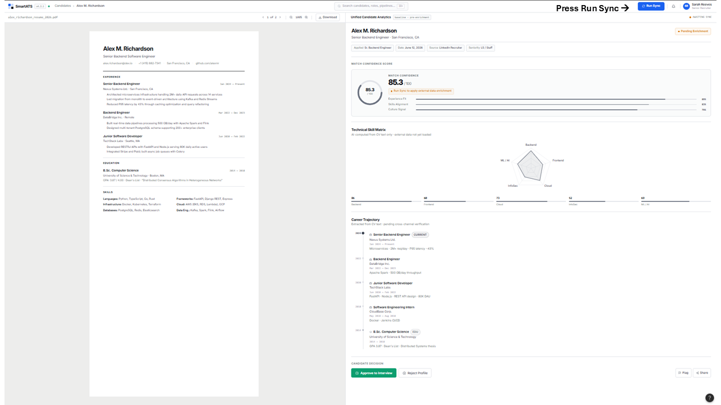
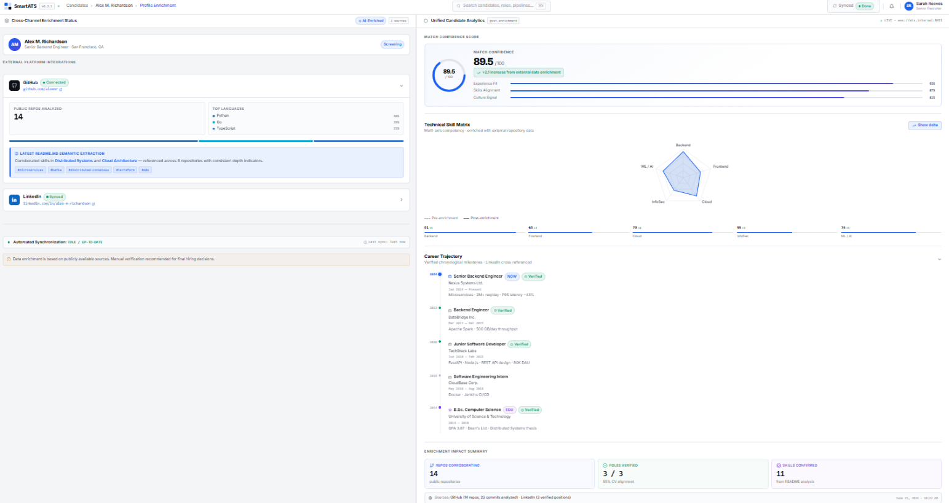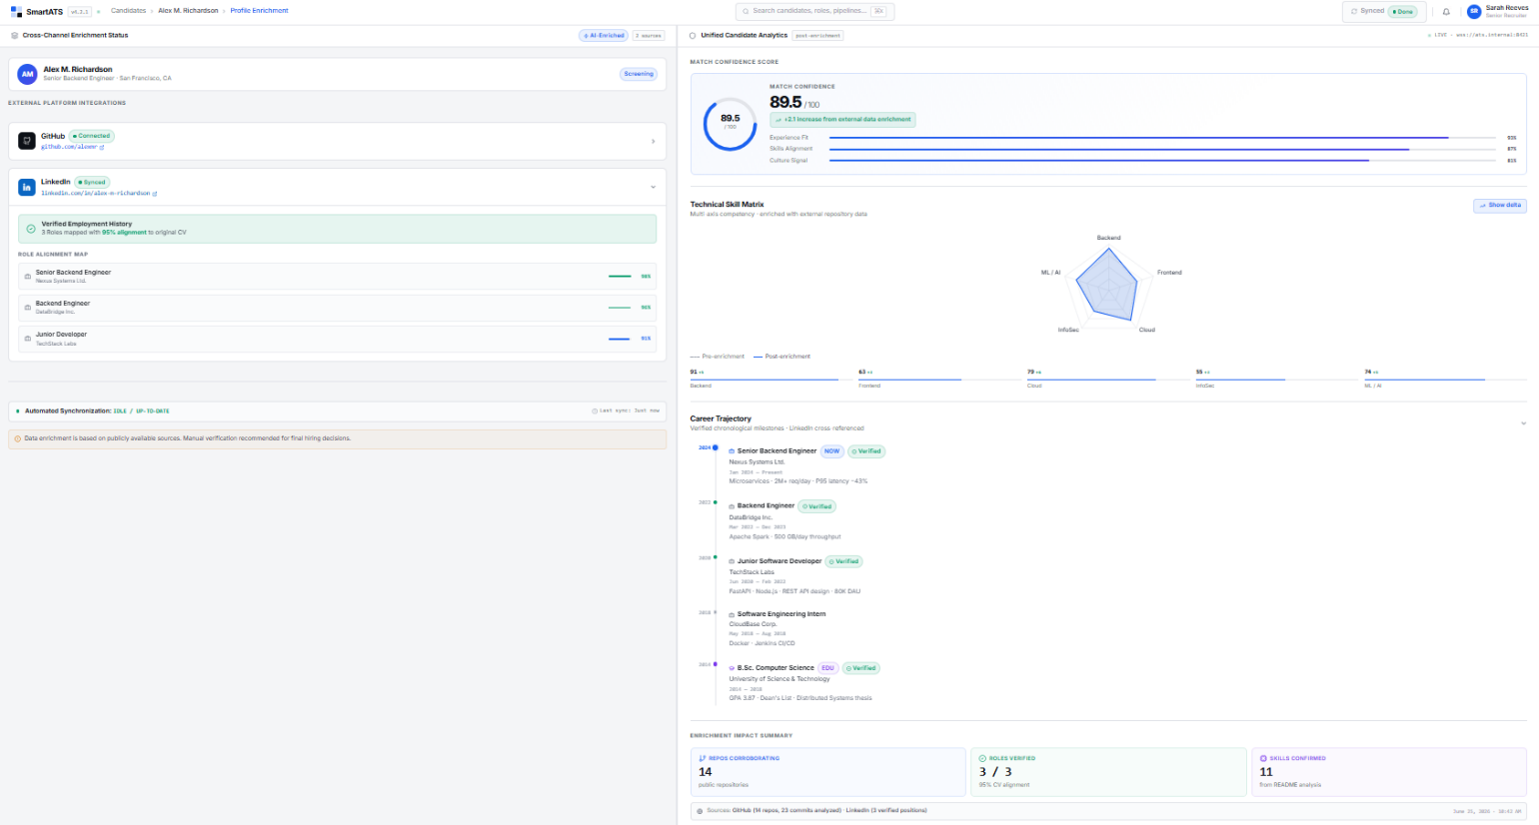
Click this link for a clearer view of the Figma prototype.

AI Usage Declaration
Based on the provided AI Usage Guideline document, teams must submit their AI usage declaration here. Students are encouraged to leverage AI tools creatively and effectively in this project.

Presentation
Teams are required to record presentation videos of their work using the provided template.
Every team member must participate in the presentation, specifically covering the sections their contributed to the project.
Videos must not exceed 30 minutes.
Please upload your videos to Youtube (set to either Unlisted or Public).
Provide the Youtube links the the field below.

Reflective Report
Which sections of this template are most helpful for implementation, and which are unnecessary? Provide specific examples to support your reasoning.

