# Milestones
Since I wrote the tasklisk I have decided to not host grok.

1. Self host llm - **19/11/2025**
2. Implement API user authenication and session - **21/11/2025**
3. Database for table above - **22/11/2025**
4. Implement API routes for file storage and retrieval. - **22/11/2025**
5. Database for table above - **22/11/2025**
6. Implement API routes to generate flash card questions to anki packages. - **22/11/2025**
7. Develop frontend to implement the user session from task 2. - **23/11/2025**
8. Develop frontend to complete the actions from tasks 4 and 6. - **23/11/2025**
9. Develop threejs game loop to live render multiple players. - **28/11/2025**
10. Compose or acquire player model. - **29/11/2025**
11. Develop basic player actions, move, jump, ect. - **30/11/2025**
12. Generate assets ad hoc to create first game. - **30/11/2025**
13. Script and program game loop so the game is playable. - **12/1/2026**
14. Implement API routes to generate game sessions. - **7/12/2025**
15. Develop frontend to create and join game sessions. - **7/12/2025**
16. Develop and integrate frontend to serve the game client embedded in the frontend. - **15/1/2026**
17. Integrate backend API to spawn game servers - **1/2/2026**
- kubernetes(helm)
- docker(dind)
18. Figure out production deployment and proxy. - **1/3/2026**

# Timeline
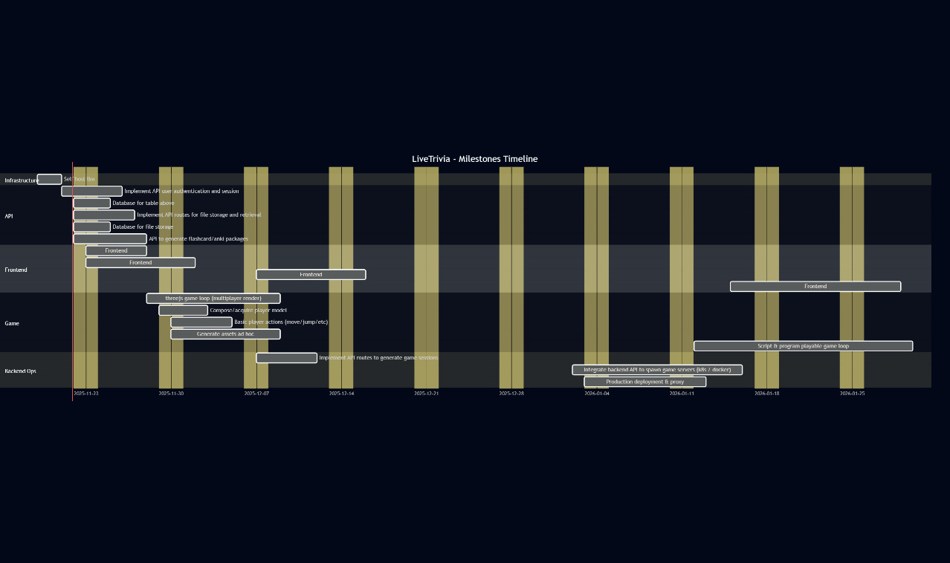
# Effort Matrix
