User Stories
1. As a student, I want to be able to review and study in the form of a game to effectively cover materials in a small group.
2. As a student, I want to be able to automatically generate flashcards via LLM in order to rapidly review material.
3. As a teacher, I want a game to review materials to engage with students during classroom review sessions.
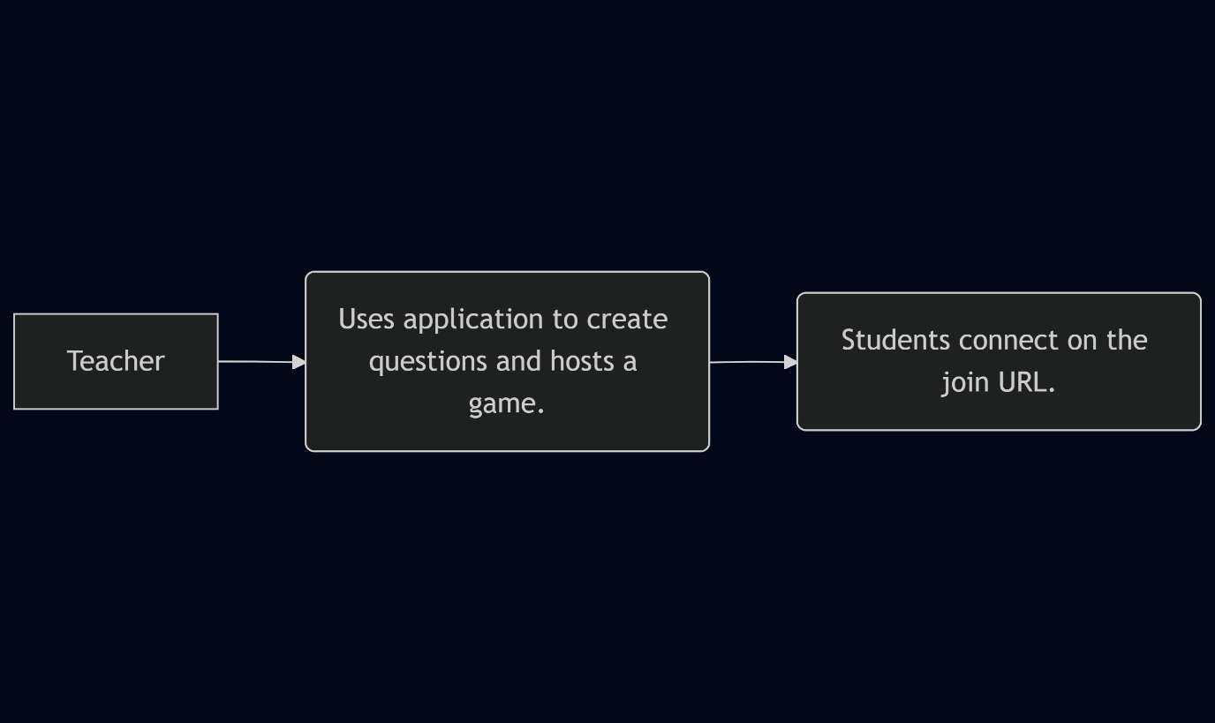
Boxes indicate steps for usage as an outside user. The arrows indicate the order of the steps the user would take to play this game.

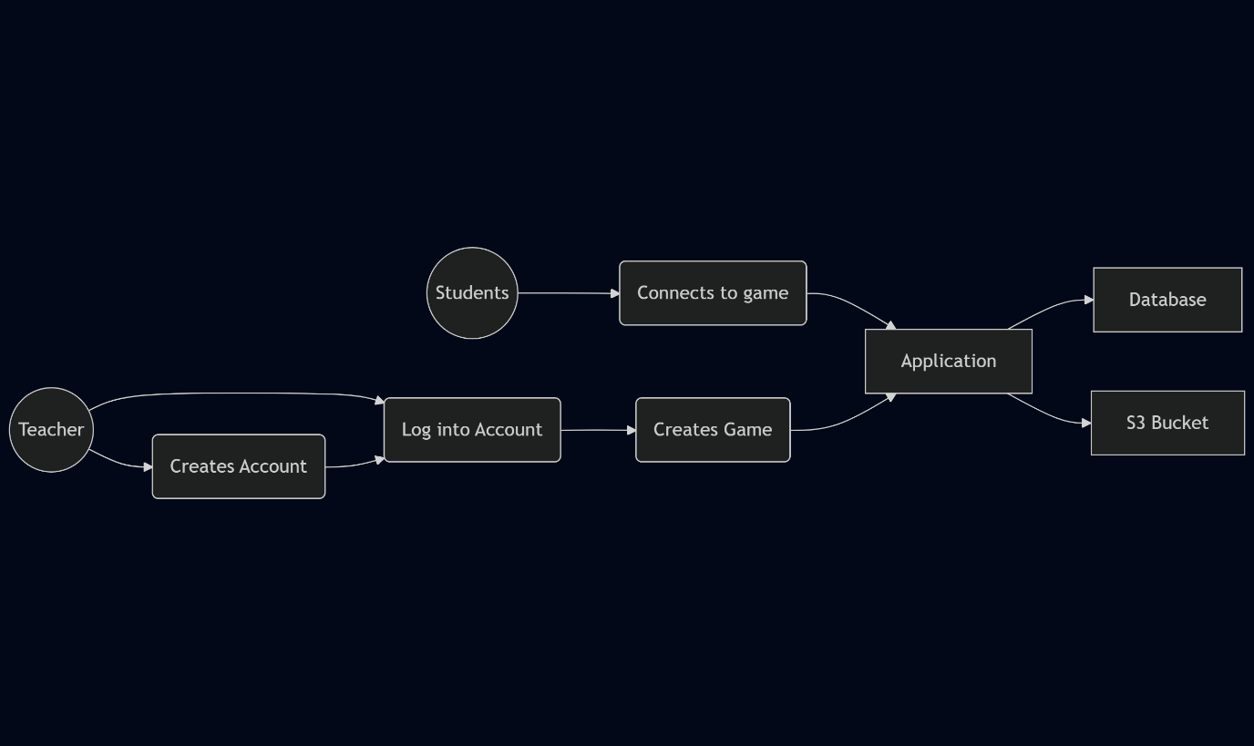
Soft-edge boxes are actions. Circles are clients. Hard rectangles are applications. This is still in the perspective of the outside user.

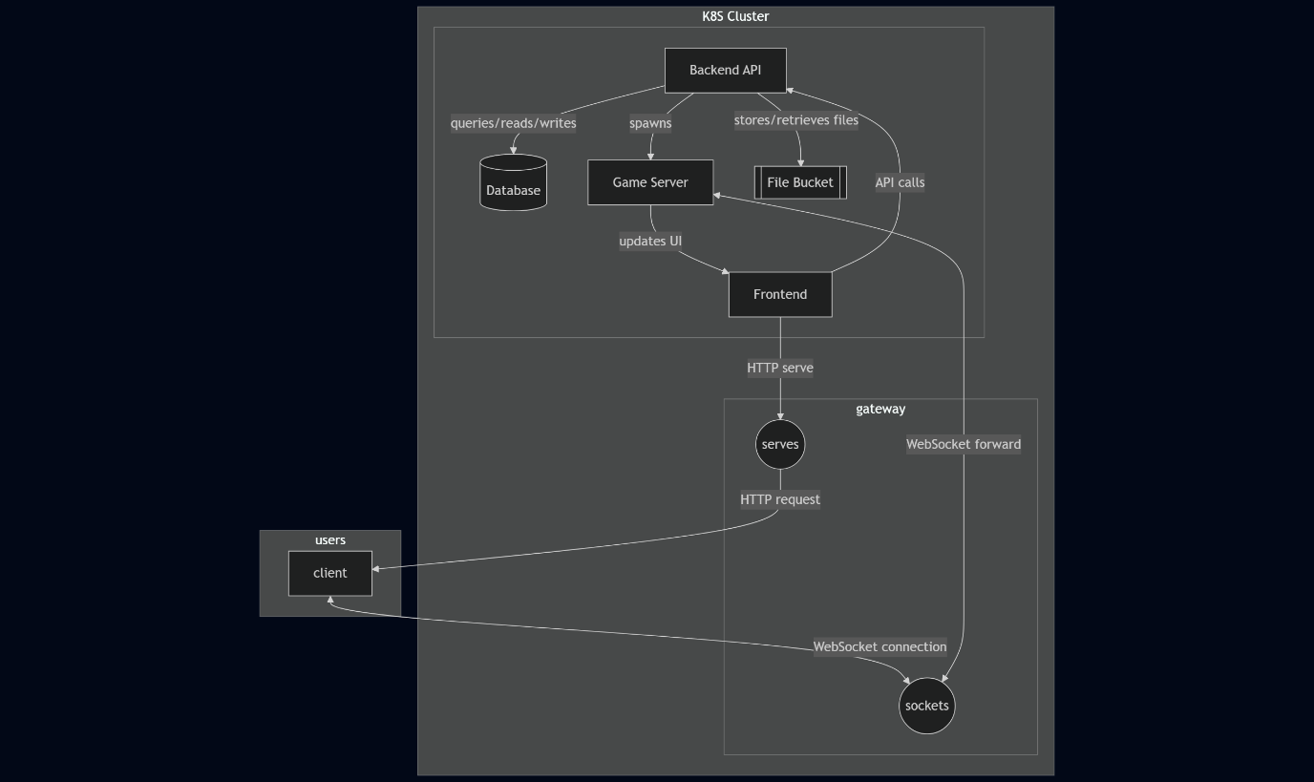
Arrows are labelled indicating the action being taken. Circles represent the different application layer protocols that will be used to serve the game and sync the game with the server. Hard rectangles are machines that are involved in starting or participating in the game loop. The cylinder and double rectangle represent the database and file store respectively. Note that the entire section listed under the k8s (kubernetes) cluster and gateway are expected to scale and load balance in a production deployment.

