|  |  |  |
| --- | --- | --- |
| ID | Last Name | First Name |
|  |  |  |

Variant E

**1.05.3** In what situations Zero Flag will be set to 1?

**2.12.18** There are two numbers in decimal binary system: X1 = 9973(10), X2 = 17837(10).

Find X3 = –X1, X4 = X1 + X2. Translate decimal numbers X1, X2, X3 and X4 to binary system (X1(10) -> B1(2), X2(10) -> B2(2), X3(10) -> B3(2), X4(10) -> B4(2)), using 16-bits signed binary format. Calculate numbers B5 = B2 + B4 and B6 = B2 + B3. Set 6 arithmetic flags (SF, ZF, PF, AF, CF, OF) for B5 and B6. All calculations in binary format should be done using two’s complement.

**3.25.5** There are n=5 numbers (1,2,3,4,5). Find the 80th permutation(for example, 31425 is 10th permutation). Explain/write full decision, not result only.

**4.32.6** Translate number 42.66(10) to binary NS (7 digits after point) and to 8-NS (2 digits after point).

**5.45.3** The following Python code is given:

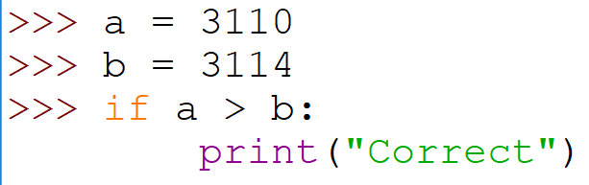

What will be displayed? If you think that nothing, then write the word "Nothing".

**6.55.4** How many kibibytes are in 2 TB?

**7.65.4** Translate the number ${101010101}_{(Z)}$ in Zeckendorf to the decimal system. Provide the solution.

**8.75.4** In which numeral system 341 + 30 = 401? Explain the answer.

**9.85.4** Translate the number 2021 from nega-decimal to decimal numeral system.

**10.95.3** A binary number is represented in a 10-bit signed format. Specify the range of valid values.

**11.102.5** Is it useful to use the Shannon measure for systems whose states are equally probable (have the same probability)? Explain the answer.

**12.115.3** Which number contains more bits: 128 kilobytes or 125 kibibytes?

* 128 kilobytes
* 125 kibibytes
* The numbers are equal
* There is no right answer

**13.121.2** Decipher (= decode, decrypt, provide full phrase) the abbreviations WYSIWYG and WYSIWYM. Example: HDU = Hangzhou Dianzi University.

**14.132.6** Describe how the function VLOOKUP works in MS Excel/Libre Office Calc and what is it for.

**15.141.3** System has 9120 equiprobable (with the same probabilities) states. Calculate in dits the Hartley measure for this system. The answer should be rounded up to the integer.

**16.151.5** What is the base of the numeral system if 10000 + 1000 = 100000? Please explain.

**17.161.5** System has 52 equiprobable (with the same probabilities) states. Calculate in nits the Hartley measure for this system. The answer should be rounded to the nearest integer.

**18.171.3** There is a binary number in “two’s complement” representation placed in 7 digits. Please specify the range of valid values.

**19.181.3** How can one sentence be styled as *cursive* (italic) in TeX? There should be more than one answer.

**20.191.3** Please round a number 20,7 to the nearest integer if you should use a banking way of rounding.

**21.201.3** Please provide some examples of Bag Tracking Systems (at least two ones).

**22.212.4** Translate number 1210122001 presented in numeral system with the base 3 to numeral system with the base 81 using short translation method. Explain/write your solution.