|  |  |  |
| --- | --- | --- |
|  | Last Name | First Name |
|  |  |  |

Variant F

**1.06.3** In what situations Sign Flag will be set to 1?

**2.13.18** There are two numbers in decimal binary system: X1 = 3804(10), X2 = 24486(10).

Find X3 = –X1, X4 = X1 + X2. Translate decimal numbers X1, X2, X3 and X4 to binary system (X1(10) -> B1(2), X2(10) -> B2(2), X3(10) -> B3(2), X4(10) -> B4(2)), using 16-bits signed binary format. Calculate numbers B5 = B2 + B4 and B6 = B2 + B3. Set 6 arithmetic flags (SF, ZF, PF, AF, CF, OF) for B5 and B6. All calculations in binary format should be done using two’s complement.

**3.26.5** There are n=5 numbers (1,2,3,4,5). Find the 67th permutation(for example, 31425 is 10th permutation). Explain/write full decision, not result only.

**4.33.6** Translate the number to 4-NS (4 digits after point) and to 16-NS (2 digits after point).

**5.42.3** There is a code fragment on Python language.

Why “self.a” definition is not a member of the class “Student”?

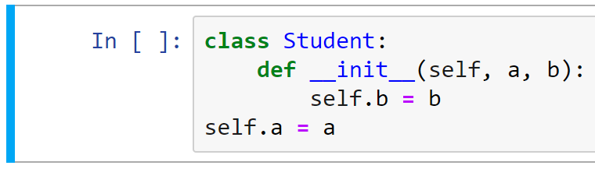

**6.56.3** An equation of the form has a solution:

* x = 2
* x = 20
* x = 200
* There is no correct answer

**7.66.4** Translate the number in Zeckendorf to the decimal system. Provide the solution.

**8.76.4** Calculate the value of the expression and present the result in the decimal system:

35311 – 3538

**9.86.4** Translate the number to decimal numeral system.

**10.96.3** A binary number is represented in a 6-bit unsigned format. Specify the range of valid values.

**11.104.3** The system can be in one of three unknown states. The probabilities of these states are 0.3333, 0.3333 and 0.3333, respectively. How much information in trits does this system contain according to Hartley's measure?

**12.116.5** There is the formula for writing a number (for example 2019,1018) in the positional numeral system. Explain what are xi, n, m and q in this formula.



**13.122.2** What command is used in TeX to generate text-"template"? Text-“template” is a text without any meaning (like ‘cat likes milk’) to fill the paper and check fonts.

**14.133.6** Explain the difference between the cell designations $E$5, $E5, and E$5 in the table processor.

**15.142.3** System has 977 equiprobable (with the same probabilities) states. Calculate in dits the Hartley measure for this system. The answer should be rounded up to the integer.

**16.152.5** In the optimal numeral system (pay attention to the plot) please specify the x-value for the maximum of the function, explain the axis: the measure of “x” and the measure of “y”.

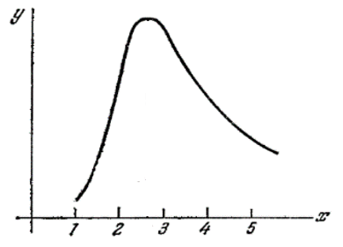

**17.161.5** System has 52 equiprobable (with the same probabilities) states. Calculate in nits the Hartley measure for this system. The answer should be rounded to the integer.

**18.171.3** There is a binary number in “inverse” (one’s complement) representation placed in 7 digits. Please specify the range of valid values.

**19.182.3** How can one sentence be styled as “**bold**” in TeX? There should be more than one answer.

**20.192.3** Please specify the reason why every professional programmer should definitely use a version control system.

**21.202.3** Please list below some programs one can use for running a webinar (at least two).

**22.213.4** Translate number 3310201 presented in numeral system with the base 4 to numeral system with the base 64 using short translation method. Explain/write your solution.