

《Digital Image Processing》

Assessment

Coursework 1：
Basic MATLAB operation for Digital Image Processing

Student Name： 孙恺泽
Student ID： 22270318
Major： 网络工程

Hangzhou Dianzi University
School of Cyberspace
- Assignment Requirements

1). Master the MATLAB functions used for digital image reading and writing.

A = imread(filename)；
A = imread(filename,fmt)；
A = imread(___,idx)；
A = imread(___,Name,Value)；
[A,map] = imread(___)；
[A,map,transparency] = imread(___)；

imwrite(A,filename)；
imwrite(A,map,filename)；
imwrite(___,fmt)；
imwrite(___,Name,Value)；

2). Master the basic MATLAB functions used for digital image processing. Try to convert RGB color image values to YUV and YCbCr color space, and display YUV/YCbCr components separately.

MATLAB Function: imshow, figure, plot, subplot, size, ind2rgb

- Assignment Content and Steps
1). Read and write different types of images by MATLAB.
Find different types of digital test images, including different file format (bmp, jpg, png gif) and different image coding methods (grey image, color image, indexed image, transparent background image, dynamic graph).
Read and write these images by MATLAB.
Compare the MATLAB image data (output of “imread” function or input of “imwrite” function) for different types of image from the following aspects:
- The Size of Image Data/Variable (m*n)
- Support Bit Depths (1 bit, 8 bit or 24 bit etc.)
- Input/Output Class (logical, uint8, uint16 etc.)
- The Size of Image Data/Variable v.s. The Storage Size of Saved Image File
For example:
color image size: 256*256 with 24 bits per pixel
the input/output variable is a 256*256*3 matrix, and the variable class is uint8.
Storage Size: 123KB for bmp file; 57KB for jpg file…
2). Convert RGB color image values to YUV and YCbCr color space.
Reference Code:
2.1) Read original image:
rgb=imread('lenacolor.bmp');
2.2) Get the R, G, B components and display them separately:
rgb_r=rgb(:,:,1);
rgb_g=rgb(:,:,2);
rgb_b=rgb(:,:,3);
[n, m] = size(rgb);
zero=zeros(n,m/3);
R=cat(3,rgb_r,zero,zero);
G=cat(3,zero,rgb_g,zero);
B=cat(3,zero,zero,rgb_b);
figure;
subplot(2,2,1),imshow(R),title('R Component');
subplot(2,2,2),imshow(G),title(' G Component ');
subplot(2,2,3),imshow(B),title(' B Component ');
subplot(2,2,4),imshow(rgb),title('RGB color image');

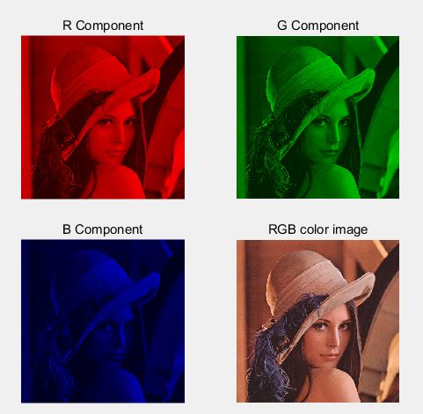
2.3) Get the YUV components and display them separately:
Y = …
U = …
V = …
YUV=cat(3, Y, U, V);
Note: the variable type exchange between ‘uint8’ and ‘double’.
2.4) Get the YCbCr components and display them separately:
Y = …
Cb = …
Cr = …
YCbCr=cat(3, Y, Cb, Cr);
Note: the variable type exchange between ‘uint8’ and ‘double’.
2.5) Compare the image value in RGB and YCbCr color space. Tell the difference between them.

- MATLAB Source Code
实验源码如下：
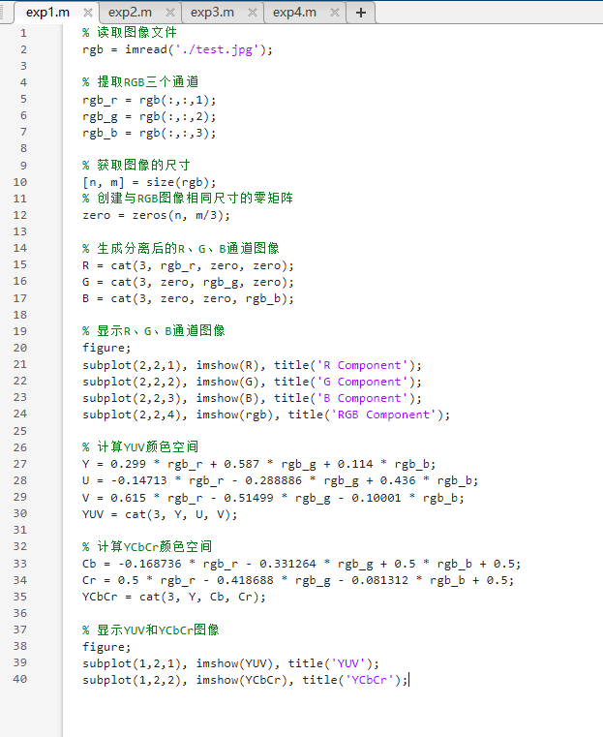

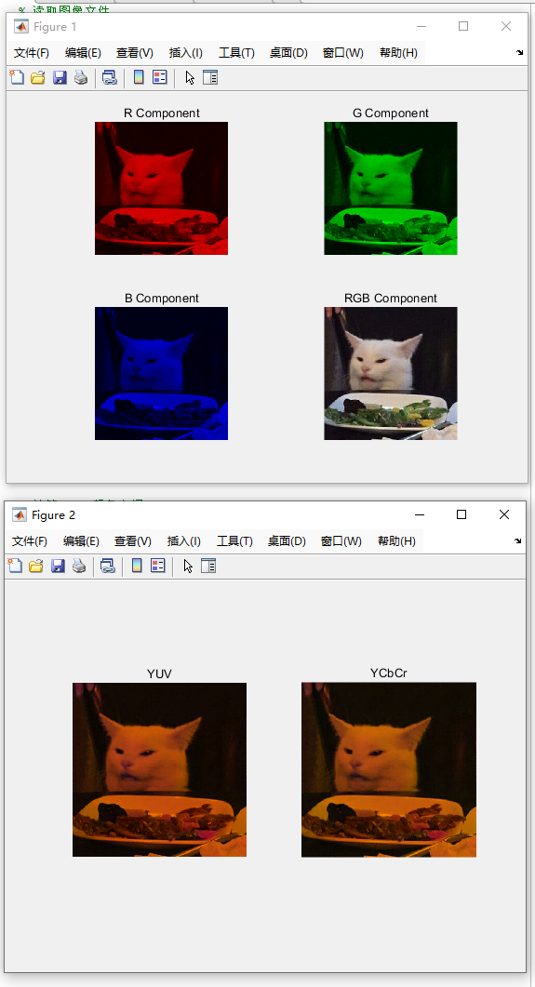

- Results Analysis and Conclusion
RGB是一种颜色表示方式，包括红色、绿色和蓝色三种成分，每种颜色的取值范围在0到255之间。数值越接近0，颜色越偏黑；数值越接近255，颜色越偏白。不同数值区间的组合呈现出各种不同的颜色。

YUV是另一种颜色表示方式，其中“Y”代表亮度，即灰阶值；“U”和“V”代表色度，描述颜色和饱和度。YUV利用了人眼对亮度敏感、对色度不敏感的特性，从而降低色彩传输的带宽要求。

