

《Digital Image Processing》

Assessment

Coursework 4：
Image Segmentation and Edge Detection

Student Name： 孙恺泽
Student ID： 22270318
Major： 网络工程

Hangzhou Dianzi University
School of Cyberspace
- Assignment Requirements
1). Demonstrate various aspects of filtering, including spatial and frequency domains, and then analyse the frequency response of various filters and their interpretation.

%Simple low pass filters
fmean3 = ones(3,3);
fmean5 = ones(5,5);
fmean11 = ones(11,11);
%Better ones
fgaussian5_1 = fspecial('gaussian',5,1);
fgaussian7_05 = fspecial('gaussian',7,0.5);
fgaussian7_3 = fspecial('gaussian',7,3);
%Simple edge detectors
fsobelx = fspecial('sobel');
fprewittx = fspecial('prewitt');
%More advanced ones
flog = fspecial('log',5,1);

2). Write the code for Edge detection using different edge detectors (canny method, prewitt method, zero cross method, roberts method etc.). Compare different edge detectors with adding different image noises (Gaussian noise, poisson noise, salt and pepper noise etc.).

% For example: adding gaussian noise
Img2 = imnoise(Img1,'gaussian',0,0.02);
Img3 = edge(Img2,'Canny');

3). Segment a sample 2D image into a binary image using a fixed or adaptive threshold. Write the code for image segmentation.

- Assignment Content and Steps
1.1). Create different filters and apply them to the original image. Compare the filters using correlation and convolution.
For example:

imfilter(A,h); % Filter using correlation, the default.
imfilter(A,h,'conv'); % Filter using convolution

1.2). Analyse the frequency response of various filters and their interpretation.

freqz2(h);

2.1). Read original image.
2.2). Add different kinds of image noises.
% For example
Img2 = imnoise(Img1,'gaussian',0,0.02);

2.3). Apply edge detection using different edge detectors (canny method, prewitt method, zero cross method, roberts method etc.).
% For example
Img3 = edge(Img2,'Canny');

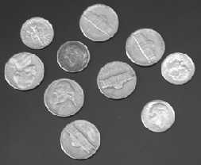
3.1). Read in a standard MATLAB demo image of coins

img=imread('coins.png');

3.2). Get its histogram and display it.
imhist(img);

3.3). According to the histogram, define the value of the threshold.
3.4) Segment the image into a binary image using the threshold.
3.5) Show the binary image.

- MATLAB Source Code
- 设置不同滤波并且绘制二维滤波器的频率响应
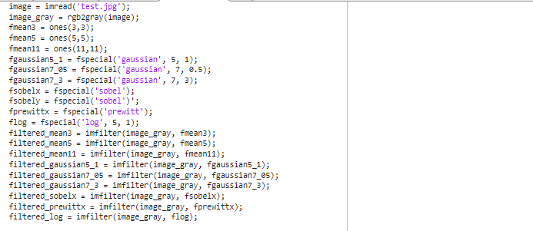
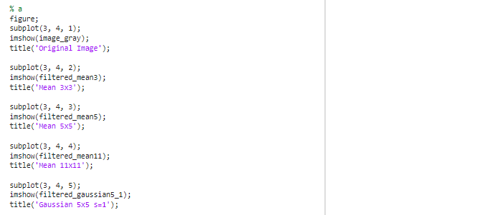
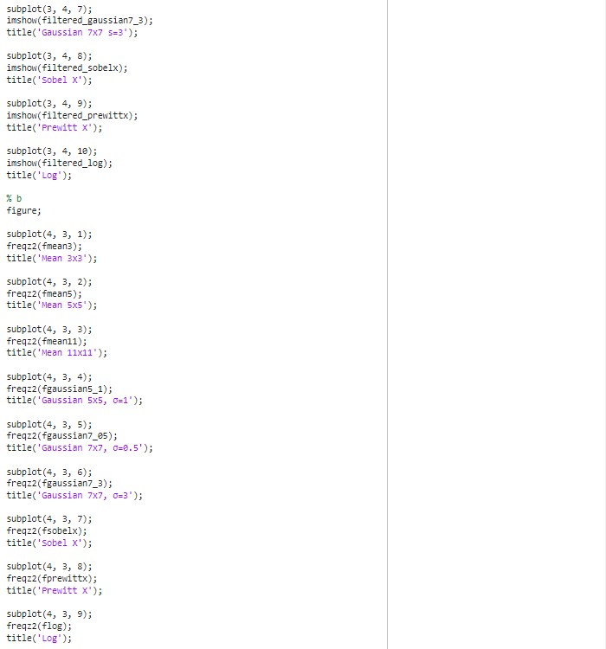
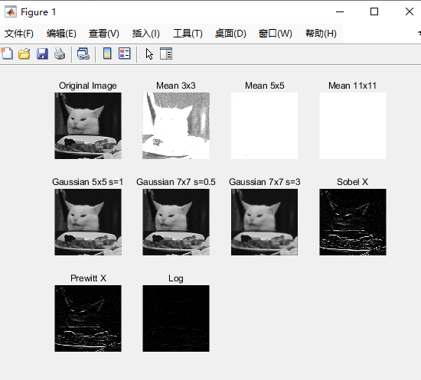

- 添加不同噪声并且使用不同边缘检测函数
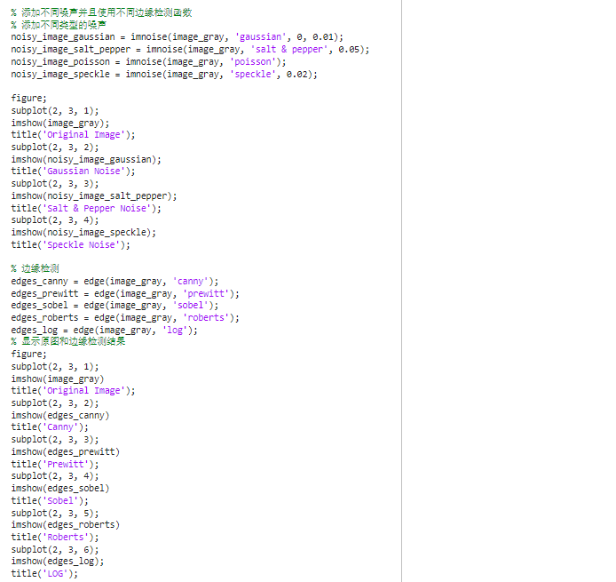
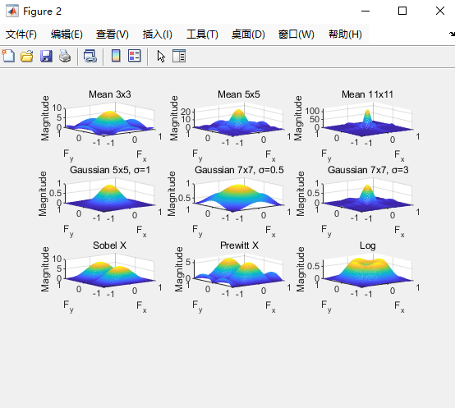

- 显示直方图后设定阈值二值化，调整 threshold 的值来看看不同阈值对二值化结果的影响
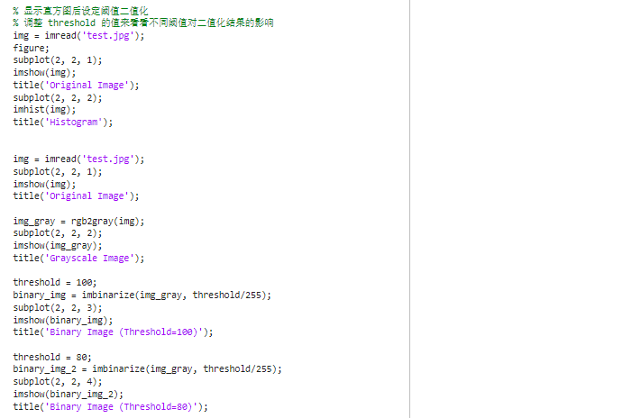

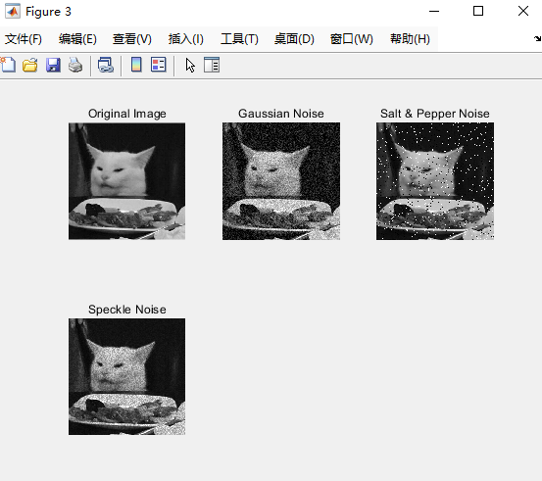
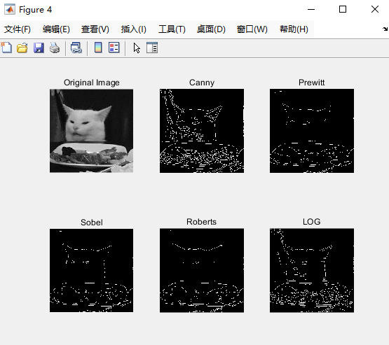
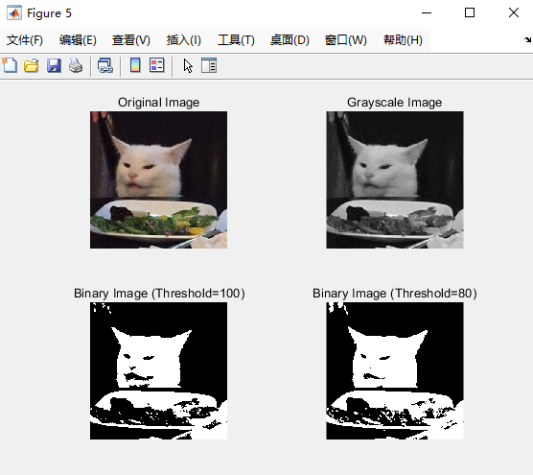
- Results Analysis and Conclusion
- 均值滤波器在频率域中呈现出平坦的频率响应，因为它平滑地混合了图像中的所有频率成分，没有明显的高频或低频响应。
- 高斯滤波器的频率响应呈钟形曲线状，这是因为在频率域中进行卷积时，高斯函数的傅里叶变换也是高斯函数，导致频率响应呈现高斯分布。
- 边缘检测器（如Sobel和Prewitt）在频率域中显示出明显的高频成分，因为它们旨在突出图像中的边缘，边缘是高频特征。
- LoG（高斯拉普拉斯）滤波器在频率域中呈现环状结构，结合了高斯和拉普拉斯滤波的特性。
调整阈值有助于分离图像中的目标和背景，增强目标与背景之间的对比度，便于后续处理和分析。二值化处理也有助于识别和分析图像中的噪声，适当的阈值选择可以减少噪声影响。观察二值化后的图像可更容易识别对象形状和结构，对物体检测和识别等应用有帮助。

