

《Digital Image Processing》

Assessment

Coursework 2：
Image Transformation: DFT and DCT

Student Name：
Student ID：
Major：

Hangzhou Dianzi University
School of Cyberspace
- Assignment Requirements
1). Master the MATLAB functions used for digital image transforms.

B = fft2(A,m,n)；
A = ifft2(B)；
B = dct2(A,m,n)；
A = idct2(B)；

2). Master the image transformation properties.
Show some special shape images and apply 2D Fourier Transform and 2D-DCT transform to them to show the transform domain.

- Assignment Content and Steps
1). Create different shapes of images (at least 5 types of shapes, such as square, rectangle, parallel lines etc.), and transform them into 2D Fourier Transform domain.
For example:


img=zeros(100);img(46:55,46:55)=255;
X=uint8(img);figure,imshow(X);

Y=fft2(img);
% Shift zero-frequency component to center of spectrum
Z=abs(fftshift(Y));
% Display image with scaled colors
imagesc(Z);

2). Rotate and translate shapes, and apply 2D Fourier Transform to them again. Compare the difference between the original image and rotated or translated shapes.

img2=imrotate(img1,angle,method);

3). Read an image into workspace, and convert the image to grayscale. Then apply 2D DCT to the grayscale image, and display the transformed image using a logarithmic scale.
For example:

RGB = imread('autumn.tif');
I = im2gray(RGB);
J = dct2(I);
imshow(log(abs(J)),[])
colormap parula
colorbar
s
imagesc(Z);
4). Quantize the DCT coefficients, or Set values less than magnitude 10 in the DCT matrix to zero. Reconstruct the image using the inverse DCT function ‘idct2’.

Display the original grayscale image and the processed image, and compare their differences.

5). Display the transformed images for different original image contents, such as a smooth background image or the one with different textural features. Explain the different DCT features for different image contents.

- MATLAB Source Code
- 图形展示
- 正方形展示
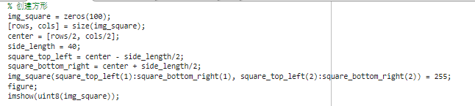
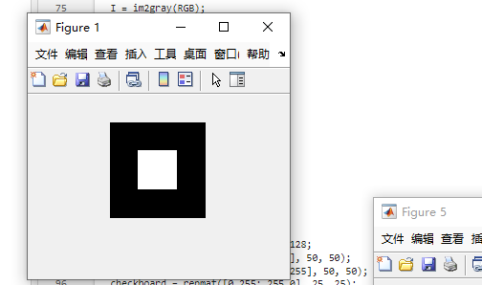

- 条纹线展示
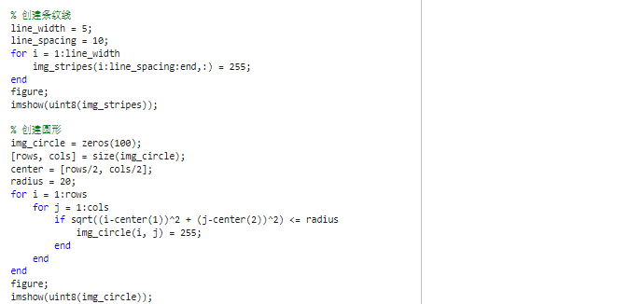
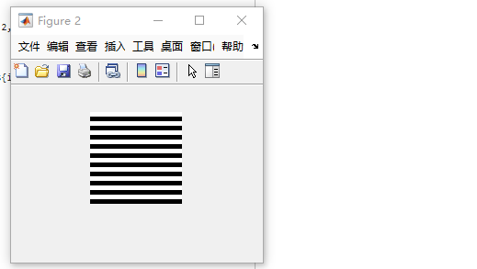

- 圆形展示
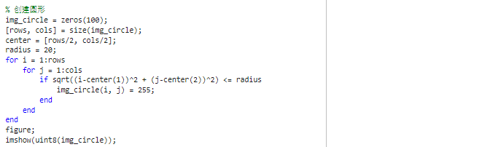
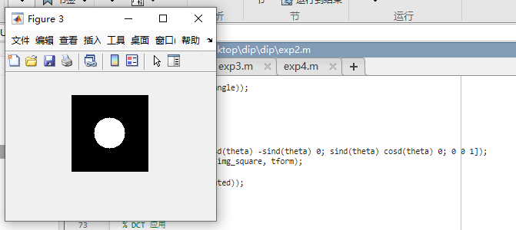

- 矩形展示
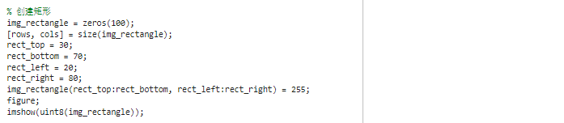
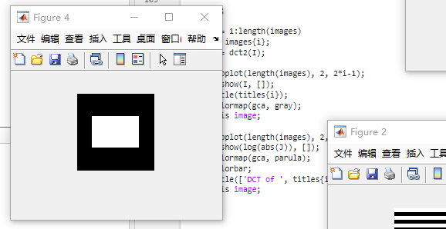

- 三角形展示
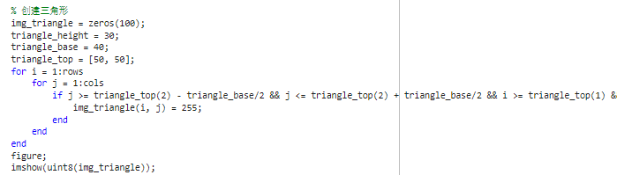
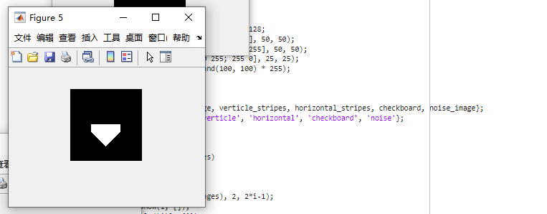

- 旋转展示
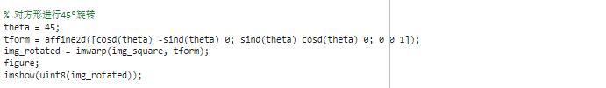
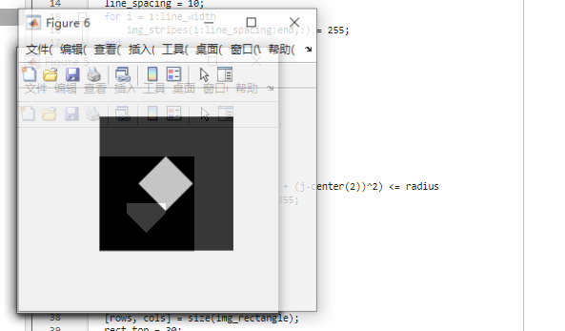

- DCT 应用
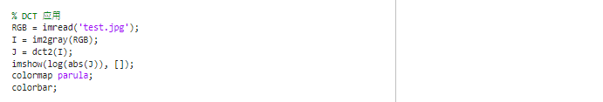
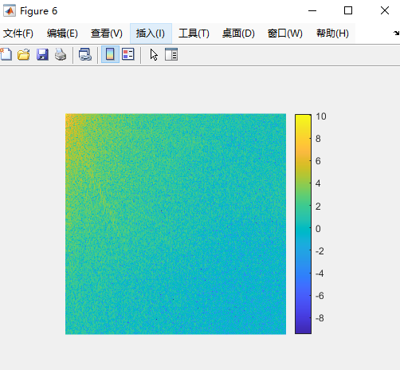

- IDCT 逆变换
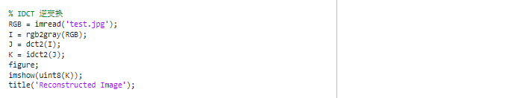
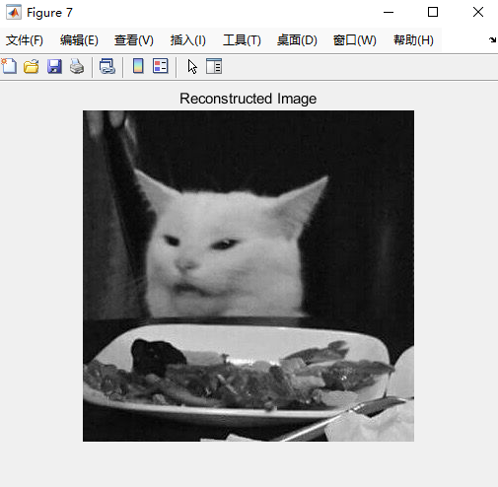

- 不同图像的 DCT 对比
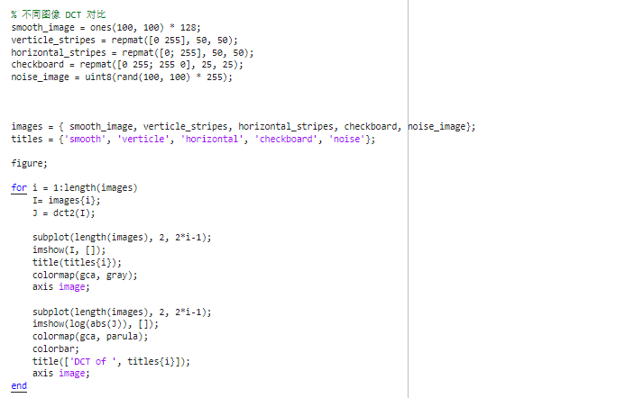

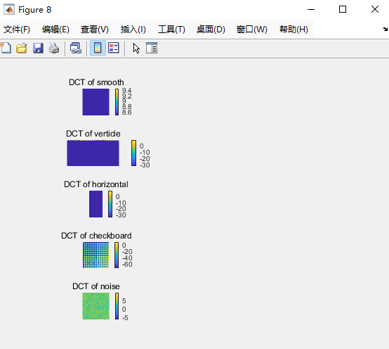

- Results Analysis and Conclusion
不同类型的图像在频域中呈现出独特的特征：
- 平滑图像主要包含低频成分，因此DCT系数能量主要集中在低频区域。
- 垂直条纹图像在水平方向具有显著的高频成分，而水平条纹图像在垂直方向具有显著的高频成分。
- 棋盘格图像在两个方向上都有显著的高频成分。
- 随机噪声图像的DCT系数在整个频域内分布均匀。

这些频域特征可用于不同应用：
- 图像压缩中，保留低频成分可减少数据量而不明显影响图像质量。
- 图像分析中，通过DCT分析可识别图像的纹理特征，有助于分类和识别。
- 图像处理中，利用DCT分离高频噪声和低频内容可有效去除噪声。

