

《Digital Image Processing》

Assessment

Coursework 3：
Digital Image Histogram Processing

Student Name：
Student ID：
Major：

Hangzhou Dianzi University
School of Cyberspace
- Assignment Requirements

1). Master the basic MATLAB functions used for digital image processing.

MATLAB Function: imshow, figure, plot, subplot, size, ind2rgb,imhist

2). Write a program that conduct histogram equalization on a given image. Firstly, calculate the histogram for different digital images and display their histogram. Then, enhance the contrast of an image using histogram equalization.
MATLAB Function: imhist, histeq

- Assignment Content and Steps
1). Read an image into a variable and display the image.

2). Convert the image to grayscale if it is a color image.

3). Calculate the histogram for different digital images and display their histogram.
MATLAB Function: imhist()

4). Enhance the contrast of an intensity image using histogram equalization.
- Use linear stretch function to stretch the grey-scaled value.
- Calculate the probability of occurrence of image value
- Calculate the cumulative distribution function (CDF) of image value
- Use the general histogram equalization formula to get the final processed image.
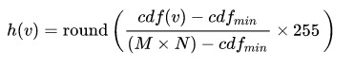
5). Display the original image and enhanced image. Tell the difference between the two images and explain why.

- MATLAB Source Code
- 展示图象


- 转换为灰度图
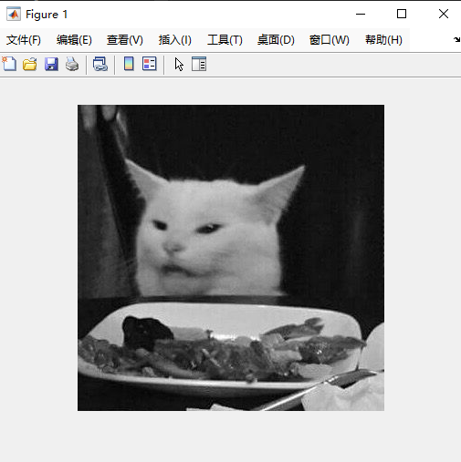

- 显示直方图
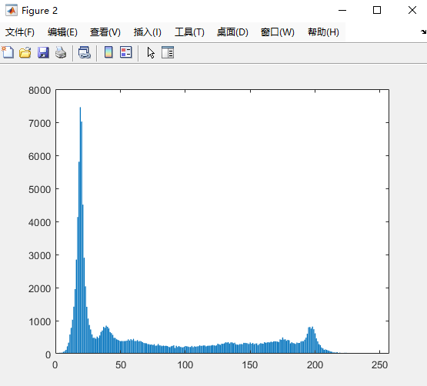

- 对图像进行加强处理
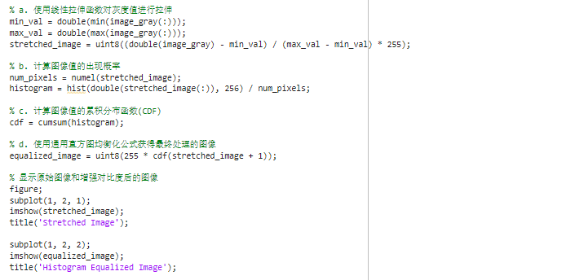
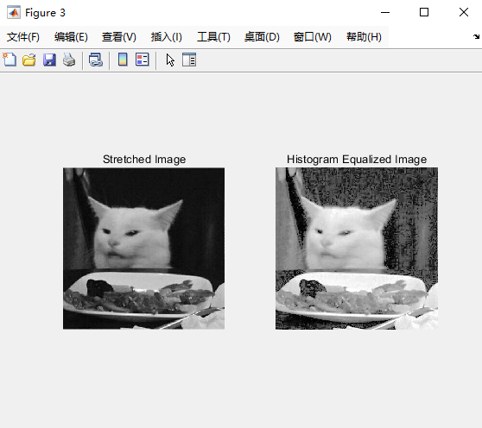

- Results Analysis and Conclusion
对比度增强是通过直方图均衡化实现的，它重新分配了图像的灰度级别，使得灰度级别在整个范围内均匀分布。这样做可以突出图像中的细节并增强对比度。在原始图像中，一些灰度级别可能占据了大部分像素，导致动态范围受限。直方图均衡化通过重新分配这些灰度级别，使得每个灰度级别的像素数量更均衡，从而增强了图像的对比度。

