**INDIAN INSTITUTE OF INFORMATION TECHNOLOGY ALLAHABAD**

(A Centre of Excellence in Information Technology) Deoghat, Jhalwa, Allahabad – 211 012 (U.P.), India Ph. 0532‐2922008, 2922216, Fax: 0532‐2430006,

Web: www.iiita.ac.in, E‐mail: dr.e@iiita.ac.in



|  |
| --- |
| **Semester VII – End Semester Project Report**  **Project Title**  **DETECTION OF HEDONIC RESPONSE USING**  **BALLISTOCARDIOGRAPHY (BCG)** |

Under the Guidance of:

**Prof. U.S. Tiwari**

**Submission By:**

Praneel Rathore (IIT2013034)

Aayush Garg (IIT2013061)

Nipun Manocha (IIT2013124)

**CERTIFICATION**

This is to certify that the group of below mentioned students has successfully completed the project work title **“DETECTION OF HEDONIC RESPONSE USING BALLISTOCARDIOGRAPHY(BCG)”** as the VII semester project prescribed by the Indian Institute of Information Technology, Allahabad.

This project is the record of authentic work carried out during the academic year (August-December) 2016.

Praneel Rathore (IIT2013034)

Aayush Garg (IIT2013061)

Nipun Manocha (IIT2013124)

**ACKNOWLEDGEMENT**

We have taken efforts in this project. However, it would not have been possible without the kind support and help of many individuals and organizations. We would like to extend our sincere thanks to all of them.

We are highly indebted to **Prof. U.S. Tiwari** for his guidance and constant supervision as well as for providing necessary information regarding the project and also for his support in completing the project.

We would also like to express our special gratitude towards **Mr. Sudhakar Mishra** for his kind co-operation which helped us in completion of this project.

Our thanks and appreciations also go to our colleagues in developing the project and people who have willingly helped us out with their abilities.

**Table of Content**

|  |  |
| --- | --- |
| **S. No.** | **Content** |
| **1** | Abstract |
| **2** | Project Title |
| **3** | Introduction |
| **3.1** | Problem |
| **3.2** | Solution |
| **4** | Project Objectives |
| **5** | Scope Of Project Work |
| **6** | Literature Survey |
| **6.1** | Heart Rate Variability |
| **6.2** | Pulse Rate |
| **6.3** | Background and technique |
| **6.4** | Relation between heart rate variability and emotions |
| **7** | Technologies Used |
| **7.1** | OpenCV |
| **7.2** | Python |
| **7.3** | Lucas-Kanade Point Tracker Algorithm |
| **7.4** | Haar-Cascade Detection |
| **7.5** | Principle Component Analysis |
| **7.6** | Cubic Spline Interpolation |
| **7.7** | Butterworth Filter |
| **8** | Other Related Work |
| **9** | Methodology |
| **9.1** | Face Detection |
| **9.2** | Region Selection |
| **9.3** | Feature Extraction |
| **9.4** | Tracking |
| **9.5** | Cubic Spline Interpolation |
| **9.6** | Filtering |
| **9.7** | PCA Decomposition |
| **9.8** | Signal Selection |
| **9.9** | Peak Detection |
| **9.10** | Heart Rate Variability |
| **9.11** | Emotion Analysis using Hedonic response |
| **10** | Experiment |
| **11** | Results |
| **12** | Applications Of This Model |
| **13** | Future Directions |
| **14** | References |
| **15** | Comments |

**1. ABSTRACT**

We extract heart rate and beat lengths from videos by measuring subtle head motion caused by the Newtonian reaction to the influx of blood at each beat. We used Ballistocardiography technique which describes ballistic force applied by heart on blood. Ballistocardiography depicts repetitive motion in human body against blood flow because of the ballistic force.

Our method tracks features using Canny Edge Detector [6] and ORB [5] feature detection of OpenCV. We then track movement between these features frame-by-frame using Lucas - Kanade[4] point tracker and resultant trajectories is processed with high-pass filter to filter out noise (Unwanted signal) on the head and then perform principal component analysis (PCA) to decompose their trajectories into a set of component motions. It then chooses the component that best corresponds to heartbeats based on its temporal frequency spectrum. Finally, we analyze the motion projected to this component and identify peaks of the trajectories, which correspond to heartbeats.

We then use the resultant filtered out heart rate to come up with the final hedonic response which showcases the change in emotions of the subjects face. We are currently analyzing for two broad categories of emotions - positive and negative.

**2. Project Title**

**DETECTION OF HEDONIC RESPONSE USING BALLISTOCARDIOGRAPHY (BCG)**

**3. Introduction**

**3.1 The Problem**

There is a need to develop a new technique which is simple, comfortable, unobtrusive, non - invasive, and ubiquitous to measure parameters associated with heartbeat and in turn depicting change in emotions using hedonic response.

**3.2 The Solution**

The proposed solution includes modules for detecting face in video frame, tracking feature points on face in every frame, trajectory filtering and component analysis to represent frames on dimension corresponding to pulse. We developed a model that is simple, comfortable, unobtrusive, non – invasive and ubiquitous in nature, to accomplish the required task. We start the model with face detection in successive frames of a video, followed by region selection to find preferred ROI, and then performed feature tracking between successive frames of a video. We also used cubic spline interpolation as well as Butterworth filtering to improve our results of heart beat detection. Finally after doing component analysis, we obtained a heartbeat measure through peak detection using a window algorithm. Then we calculated the HRV (Heart Rate Variability) by successive distances between the peaks in the heartbeat pulse, and associated it to the positive or negative emotions using an analytical and statistical based analysis from a reputed and trusted test data.

**4. Project Objectives**

By doing this project, the followings are meant to achieve:

* The goal of this project is to develop contact-less, cable less, non-invasive and simple technique to measure important heart related parameters, Pulse Rate and Heart Rate Variability.
* The technique should record pulse rate and Heart Rate Variability using head vibrations in video.
* Technique should be simple to use and require no expert.
* Technique should be able to capture variation in pulse rate for different user states.
* Technique should be comfortable enough to be used for long term monitoring.
* Technique should work even when face is not visible so that it can be used in cases when subject is wearing mask/severely burnt.
* With the help of this technique, we should be able to classify the mood/emotion of a subject as positive or negative, where positive mood is considered to be happy, fun, excited etc. and negative mood as sad, hate, depressed, angry etc.

**5. Scope of Project Work**

The scope of work will include the followings:

* If head displacement is proportional to the force of blood being pumped by the heart, it may serve as a useful metric to estimate blood stroke volume and cardiac output. Additionally, the direction of the movement could reveal asymmetries in blood flow into or out of the head. This might be useful for the diagnosis of a stenosis, or blockage, of the carotid arteries.
* Using the hedonic response from this technique, it is possible to keep a track on change in emotions as a result of movements induced in the head.
* These change in emotions can further be used in detecting and analyzing conversations between humans in a video. Though to accomplish this, more sophisticated filtering and decomposition methods will be needed to isolate pulse.

**6. Literature Survey**

**6.1 Heart Rate Variability**

Heart rate variability is a useful parameter. By definition it is a measure of variation in beat to beat interval. It can give fruitful results if it is measured for long time. Heart rate variability (HRV) leads to predict many cardiac events and gives information about "Sympathetic and parasympathetic autonomic nervous system”. “Sympathetic and parasympathetic autonomic nervous system" are directly connected to "Heart" and "Lungs" through fibers. It controls "Heart rate" as well as "Respiration rate".

**6.2 Pulse Rate**

Pulse is generated due to blood vessels' wall resistance against blood flow. Each cardiac cycle push blood to these arteries, consequently pulse is generated. Pulse rate is "number of pulses per unit time". Pulse rate is very important parameter. Pulse rate is usually considered equivalent to heart rate by medical practitioners for cases where subject is not exposed to bad heart condition which is restricting blood flow. Pulse rate differs from heart rate when heart is not pushing blood properly (Its muscles got weak) but it is "Depolarizing and Re-polarizing" i.e. beating.

**6.3. Background and Technique**

In this project we use an old technique called Ballistocardiography which was first acknowledged by Gordon in 1877, later described in more detail by Starr in 1939. With the advanced tools of the 21st century in the field of signal processing, human sensor's simulation techniques, hardware technology and increasing demand of e-home systems and unobtrusive computing give reason to again develop this technique.

Task force of some U.K. based researchers presented a concept that pulsation causes vibration in head, which can be captured by camera. Principal behind this vibration is "Newton's third law" which states that every action has an equal and opposite reaction. Heart applies ballistic force to blood when it contracts and generates blood flow against arterial wall. A force is applied to arterial wall by blood flow, consequently wall of these arteries expands from its normal size. After passing blood arteries wall restores its original size. Since face has enough arteries which collectively gives movement to head. Due to pulse arrival head moves in downward direction as shown in figure 1(a). Movement in head due to pulsation is corrupted by cervical discs in head-neck joint. These Discs are arranged in stack form and each disc has analogy with spring fixed at both the ends. This stack organization is supported by facet joints which provide stability and movement as shown in figure 1 (b) and (c). Vibration in head is created due to concept called Dynamic equilibrium which says "Net force on mechanical system is zero".

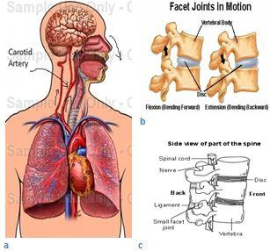

Fig. 1 a) Ventricular Contraction Blood flow and eventually head motion

b) Facet joint in motion c) Discs Stack Organization

Two equal and opposite forces called displacement force and restoring force applies on discs and creates vibration in head. Net acceleration due to which head moves calculated by D.D.He. [1] is 0.98 mG (≈0.098 m/s2).

Using the following equation:

Displacement = ½*a*t2

Calculated displacement of head is = $\frac{1}{2}*0.098* {(\frac{1}{3})}^{2}$ ≈ 5 mm.

Where $\frac{1}{3}$ second is ventricular ejection time. This displacement is very small to track.

We recorded a video of human face using camera. Although this movement is very small so precautions has to be taken while recording this video. Light source should be constant, subject should sit idle while recording is going on. With these constraints we will record video of a human face. Face detector is applied to detect face in frame. There is vibration in face so I need to have some feature points. These feature points are tracked using point tracker which is working on the concept of optical flow. Along with information related to pulse, resultant trajectory of these feature points also has other movements which is noise and need to be filtered. A high pass Butterworth filter is applied to pass frequencies require to recover pulse information from noisy signal. Component analyzer is used to extract a component corresponds to pulse. Finally beat locations are localized to get information about time of beat and Heart rate variability is calculated. In the end, this will be used to predict the emotions of the subject.

**6.4. Relation between heart rate variability and emotions [10]**

Although the nature of emotions has been the subject of much debate, most theorists consider emotions to be multifaceted processes involving coordinated changes in peripheral and central physiology, behavior or behavioral tendencies, and cognitive processing. , heart rate variability (HRV) is a measure of the continuous interplay between sympathetic and parasympathetic influences on heart rate that yields information about autonomic flexibility and thereby represents the capacity for regulated emotional responding. HRV is emerging as an objective measure of individual differences in regulated emotional responding, particularly as it relates to social processes and mental health. HRV can be derived through a number of statistical, geometrical, and frequency-based analyses that provide information about sympathetic, parasympathetic, and/or overall autonomic regulation of the heart. Theories suggest that the ability of the nervous system to track changes in the environment and respond with physiological arousal that is both proportionate to the context in which it occurs and well integrated with behavior and cognition is critical to emotional expression and regulation.

**7. Technologies Used**

**7.1 OPENCV [2]:-**

OpenCV (Open Source Computer Vision) is a library of programming functions mainly aimed at real-time computer vision, originally developed by Intel's research center in Nizhny Novgorod (Russia), later supported by Willow Garage and now maintained by Itseez. The library is cross-platform and free for use under the open-source BSD license. OpenCV is written in C++ and its primary interface is in C++. There are bindings in Python, Java and MATLAB/OCTAVE. Wrappers in other languages such as C#, Perl, and Ruby have also been developed. All of the new developments and algorithms in OpenCV are now developed in the C++ interface

**7.2 PYTHON [3]:-**

Python is a widely used high-level, general-purpose, interpreted, dynamic programming language. Its design philosophy emphasizes code readability, and its syntax allows programmers to express concepts in fewer lines of code than would be possible in languages such as C++ or Java. The language provides constructs intended to enable clear programs on both a small and large scale.

Python supports multiple programming paradigms, including object-oriented, imperative and functional programming or procedural styles. It features a dynamic type system and automatic memory management and has a large and comprehensive standard library.

**7.3 LUCAS-KANADE POINT TRACKER ALGORITHM [4]**

The Lucas–Kanade algorithm was used to track features between successive frames of the video that was processed. The algorithm comes along with the opencv python bindings.

This algorithm rests on three principal assumptions:

1. *Brightness Constancy:* A pixel from the image of an object in the scene does not change in appearance as it (possibly) moves from frame to frame.

Equation for same concept is: I(**x**, t + 1) = I(**x** + **d**, t)   
 Where:

**x =** coordinates in image

**d =** Motion Vector (Real values i.e. Sub-pixel Accuracy)

2. *Temporal Persistence or Small Movements:*The image motion of a surface patch changes slowly in time. In practice, this means the temporal increments are fast enough relative to the scale of motion in the image that the object does not move much from frame to frame.

3. *Spatial Coherence:*Neighboring points in a scene belong to the same surface, have similar motion, and project to nearby points on the image plane.

## 7.4 Haar-cascade Detection [7]

Object Detection using Haar feature-based cascade classifiers is an effective object detection method proposed by Paul Viola and Michael Jones in their paper, "Rapid Object Detection using a Boosted Cascade of Simple Features" in 2001. It is a machine learning based approach where a cascade function is trained from a lot of positive and negative images. It is then used to detect objects in other images. OpenCV provides us with the python bindings for these haar-cascades in xml format, which we will directly use in our implementation by integrating these xml files according to our requirements.

**7.5 Principal Component Analysis (PCA) [8]**

The official definition of PCA from Wikipedia is “***Principal component analysis (PCA)*** is a statistical procedure that uses orthogonal transformation to convert a set of observations of possibly correlated variables into a set of values of linearly uncorrelated variables called principal components.”

From an engineering point of view, PCA is defined as a dimensionality reduction algorithm. Two straightforward examples of where the dimension might need to be reduced are data visualization and data compression. For example in data visualization, spreadsheets with a lot of columns are difficult to visualize. By reducing the data to 3 or 2 dimensions, you can chart/graph it. An example of data compression is an image compression. Processing large images is computationally expensive. By reducing a large image and still preserving the critical data in the image that is required for processing, you can speed up the processing and use less resources.

The PCA eigenvector decomposition algorithm:

* Mean normalize the data (feature scale if needed)
* Calculate the covariance matrix
* Find the eigenvectors in the covariance matrix.
* Sort the eigenvectors from largest to smallest
* Use the largest ones as the principal components

Multiply the data by the largest components to transform the data to the desired component.

**7.6 Cubic Spline Interpolation [5]**

It is a form of interpolation where the interpolant is a special type of piecewise polynomial called a spline. Spline interpolation is often preferred over polynomial interpolation because the interpolation error can be made small even when using low degree polynomials for the spline. Spline interpolation avoids the problem of Runge's phenomenon, in which oscillation can occur between points when interpolating using high degree polynomials

**7.7 Butterworth Filter [6]**

The **Butterworth filter** is a type of signal processing filter designed to have as flat a frequency response as possible in the pass band. It is also referred to as a **maximally flat magnitude filter.** We used a fifth order band-pass butterworth filter with band of [0.75Hz – 2.0Hz].

**8. Other Related Work**

**Detecting Pulse from head motions in video [9]**

Their method tracks features on the head and performs principal component analysis (PCA) to decompose their trajectories into a set of component motions. It then chooses the component that best corresponds to heartbeats based on its temporal frequency spectrum. Finally, they analyze the motion projected to this component and identify peaks of the trajectories, which correspond to heartbeats. When evaluated on 18 subjects, their approach reported heart rates nearly identical to an electrocardiogram device. Additionally they were able to capture clinically relevant information about heart rate variability.

**9. Methodology**

**9.1) Face Detection:-**

First and foremost task is to detect the face in any video. The face will be of the subject which is to be analyzed further. For face detection, we will simply use Haar-Cascade classifiers **[7]** that are available in OpenCV python bindings. Haar-Cascade classifiers are based on Viola-Jones face detection algorithm, which is fast (real time processing), good detection rate (99-100%) and with very low false negative rate.

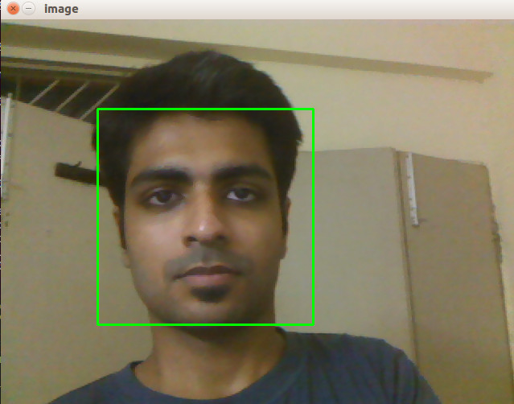

Fig. 2: Face Detection

**9.2) Region Selection:-**

In the above detected face, we only need a specific area of the face. We don’t need the eye region, as it’s blinking will cause extra overhead as noise in our further steps. Also, the blinking of eye is in no way related to pumping of the heart. Thus, removal of the eyes from the area of interest will be done as second step. We have followed the below shown (Fig 3(a), Fig 3(b)) facial dimension rules to geometrically filter out the ROI(Region of Interest) for the required region **[15]**.

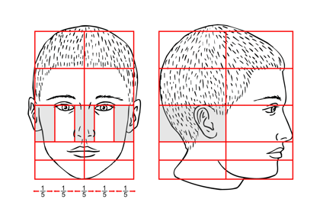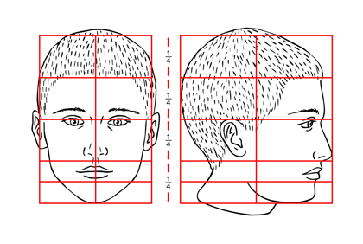

Fig. 3(a) Fig. 3(b)

The general dimensions of human face accepted globally **[21]**.

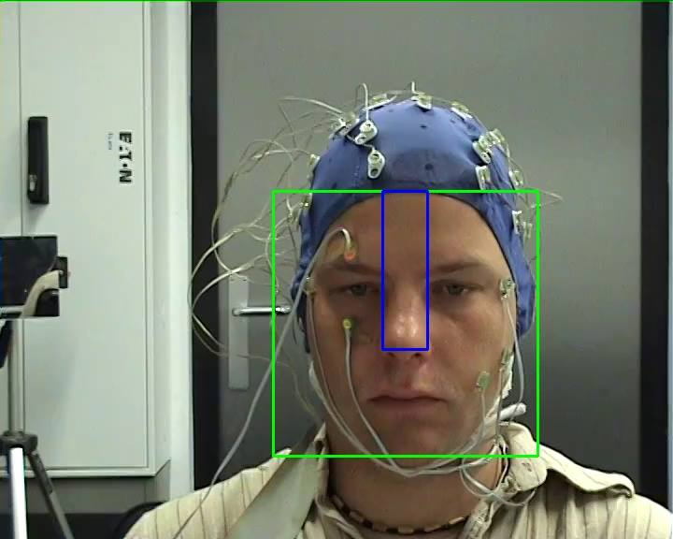

Fig. 4

Screenshot of a test video with marked ROI for further processing.

Fig 4 shows the detected face and the ROI of one of the subjects from the test data **[11]**. After this step, we worked only on the blue (inner) rectangle marked region in Fig 4.

**9.3) Feature Extraction:-**

Features are distinctive attributes which provide useful information. Handful of unique features can represent whole scenario. Good feature selection is very important to acquire useful information. Feature are selected from first frame and in subsequent frames these features are tracked using optical-flow point tracker. We used Shi-Tomasi Corner **[16]** Detector available with OpenCV python bindings.

The image processed was converted to a grayscale image. Then we specified the number of corners we wanted to find. Then we specified the quality level, which is a value between 0-1, which denotes the minimum quality of corner below which every other corner will be rejected. Then we provided the minimum Euclidean distance between corners detected.

We provided these parameters initially and kept them constant for every video on which we tested our model.

**9.4) Tracking:-**

This process will be done through an implementation of Lucas-Kanade’s algorithm in python. We apply the tracker between frame 1 and each frame t = 2 ··· T to obtain the location time-series (xn(t), yn (t)) for each point n. Literature survey done brings us to conclusion that due to blood flow, the head moves in upward-downward direction, thus helping us in limiting our monitoring for trajectories of feature points only in vertical direction.

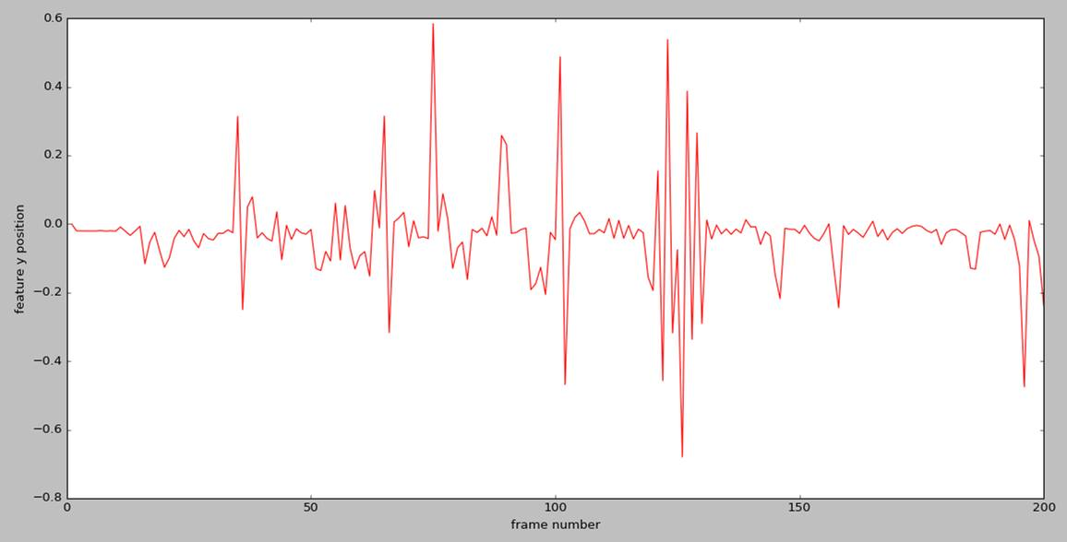

Fig. 5

Screenshot of the trajectory of y coordinate chosen as a feature point along with subsequent frames in one of the test videos.

**9.5) Cubic Spline Interpolation:-**

Our test videos are capturing 50 frames per second i.e. 50 samples per second. According to Nyquist criteria we can recover maximum of 25Hz component, which is not enough to get sharp peaks. That's why we are up sampling the signals by 5 samples using Cubic Spline interpolation to capture sharp peaks. Normally ECG records signals at 250Hz to recover sudden electric impulse due to ventricular depolarization. This impulse is so quick, but movement in head due to pulse arrival is not this much quick. So we are increasing sampling frequency of signal from 50Hz to 250Hz using cubic Spline interpolation. **[5]**

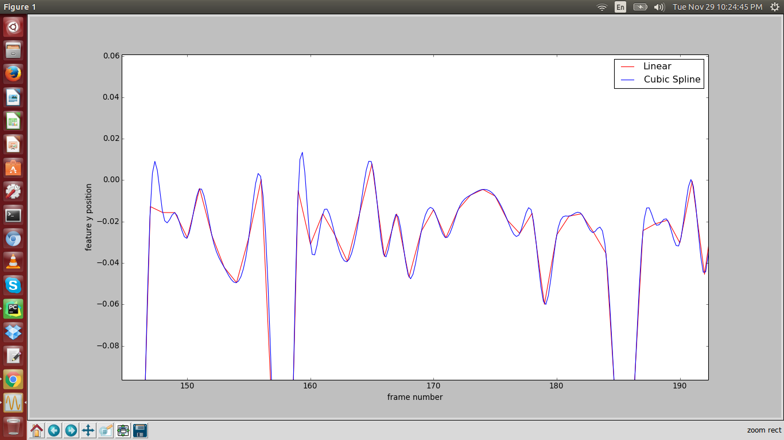

Fig. 6

Screenshot of the trajectory of y coordinate of a feature point after applying cubic spline along with subsequent frames in one of the test videos.

**9.6) Filtering:-**

Trajectories which we will get will not only have variations due to arteries pulsation only, but also movement due to respiration causing baseline drift present throughout the trajectory. Other than respiration, head vibrations interfere signal randomly. Head vibrates due to structure of head neck joint. Thus filtering would be required for noise reduction. In our case, we found that not all frequencies of the trajectories are required or useful for pulse detection. A normal adult’s resting pulse rate falls within [0.75, 2] Hz, or [45, 120] beats/min. We found that frequencies lower than 0.75 Hz negatively affect our system’s performance. This is because low-frequency movements like respiration and changes in posture have high amplitude and dominate the trajectories of the feature points. However, harmonics and other frequencies higher than 2 Hz provide useful precision needed for peak detection. Taking these elements into consideration, we filter each yn(t) to a pass band of [0.75, 5] Hz. We use a 5th order Butterworth filter for its maximally flat pass band. **[6]**

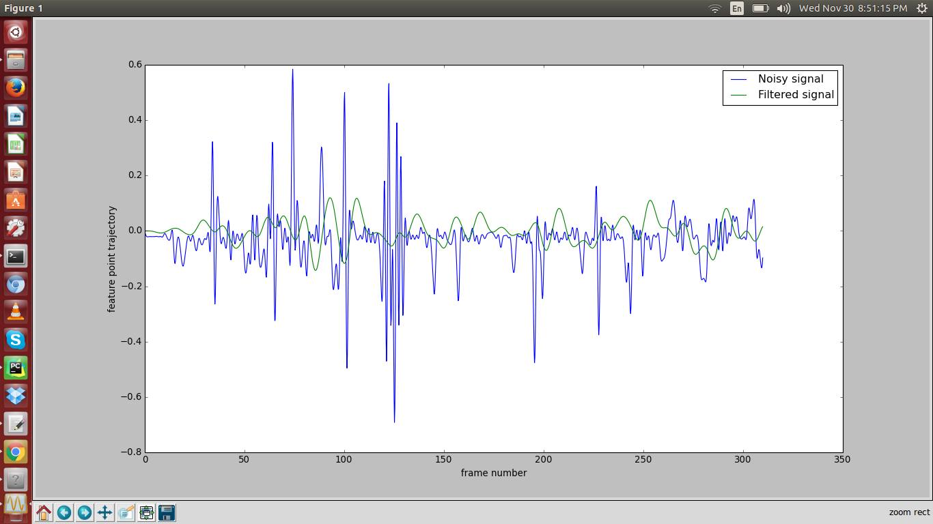

Fig. 7

Screenshot of the trajectory of y coordinate of a feature point after applying Butterworth filtering along with subsequent frames in one of the test videos.

**9.7) PCA Decomposition:-**

After several experiments, we observed that even after above processing like filtering, point elimination, we are still left with corrupted signals. This signal is corrupted due to three reasons –

1. Random variation in signal due to head vibration subjected to head neck connection by stack of cervical disks
2. Second reason is variation due to involuntarily muscle movements
3. Third reason is variation in local surface texture, consequently variation in optical flow pattern.

Position of feature points are varying not only because of blood flow but because of respiration and above three movements also. Respiration frequencies are filtered out by the Butterworth filter that we applied in the previous step. Here we are Using PCA (Principle Component Analysis) for getting the signal which is maximally varying due to pulse component. Since signal has various elementary movements along with pulse movement and these elementary motions are components of original signal, using "Principal Component Analysis" we are getting principle components of variations.

Formally, given N feature points, we represent the N-dimensional position of the head at a frame t as mt = [y1(t), y2(t), ···, yN (t)]. The mean and the covariance matrix of the positions are:

$\overline{m} = \frac{1}{|T|}\sum_{i=1}^{T}{m_{i}}$ (1)

$\sum_{m}{=} \frac{1}{T}\sum_{i=1}^{T}{ (m_{t}}- \overline{m}){(m_{t}- \overline{m})}^{T}$ (2)

PCA finds the principal axes of variation of the position as the eigenvectors of the covariance matrix:

ΣmΦm = ΦmΛm (3)

Where Λm denotes a diagonal matrix of the eigenvalues λ1, λ2, ··· , λN corresponding to the eigenvectors in the columns of Φm, φ1, φ2, ··· , φN. We obtain the 1-D position signal si(t) by projecting the position time-series onto φi:

si(t) = $\left({\begin{matrix}m1 \\ m2 \\ .\end{matrix} \atop mT}\right)$. φi  (4)

**9.8) Signal Selection:-**

We were still left with the dilemma of choosing the appropriate eigenvector to use for pulse signal extraction. The eigenvectors are ordered such that φ1 explains the most variance in the data, φ1 explains the second most, and so on. Although φ1 explains most of the variance, s1 may not be the clearest pulse signal for analysis. We instead chose the si that was most periodic. We quantified a signal’s periodicity as the percentage of total spectral power accounted for by the frequency with maximal power and its first harmonic. We found that it was not necessary to consider any signals beyond the first five, i.e. s1, s2, s3, s4, s5 for any of our subjects. We labeled the maximal frequency of the chosen signal fpulse and approximate the pulse rate as (60 / fpulse) beats per minute. **[9]**

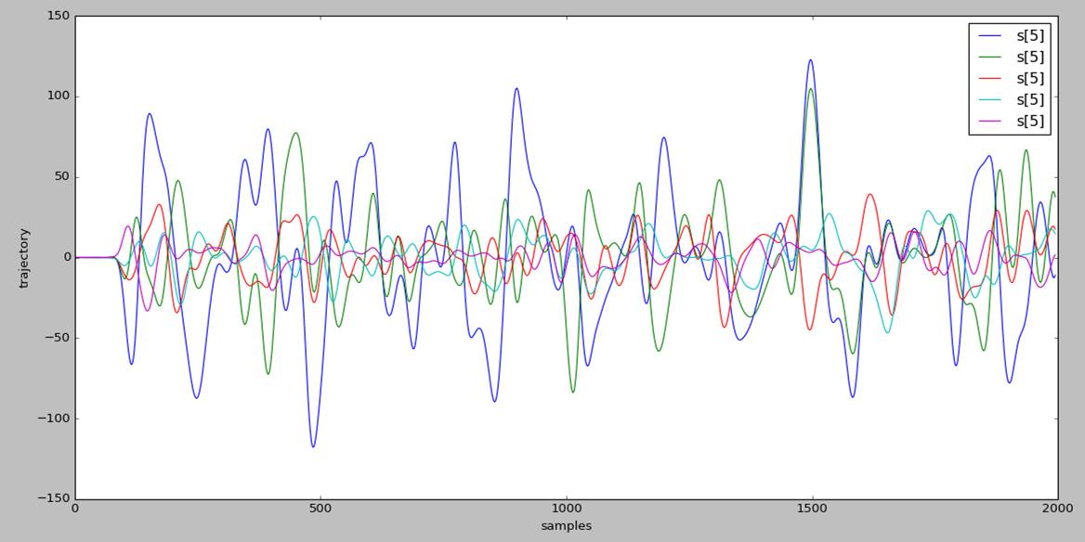

Fig. 8

Screenshot of trajectory of y coordinates obtained after pca and considering first five signals on one of the test videos

**9.9) Peak Detection:-**

We generated the pulse by using the results that were obtained by following the previous steps of our methodology. The maximum movement caused by the blood on the head will lead to an impulse in the pulse generation, thus giving us a heartbeat like trajectory. The peaks were close to (1 / fpulse) seconds apart with some variability due to the natural variability of heartbeats, variations of the head motion, and noise. We label each sample in the signal as a peak if it is the largest value in a window centered at the sample. To detect the heartbeat of the subject, we applied a window algorithm on the signal with the window size:-

Size of Window = Sampling Frequency / Pulse Frequency (5)

Here, the sampling frequency was taken to be 250Hz. **[9]**

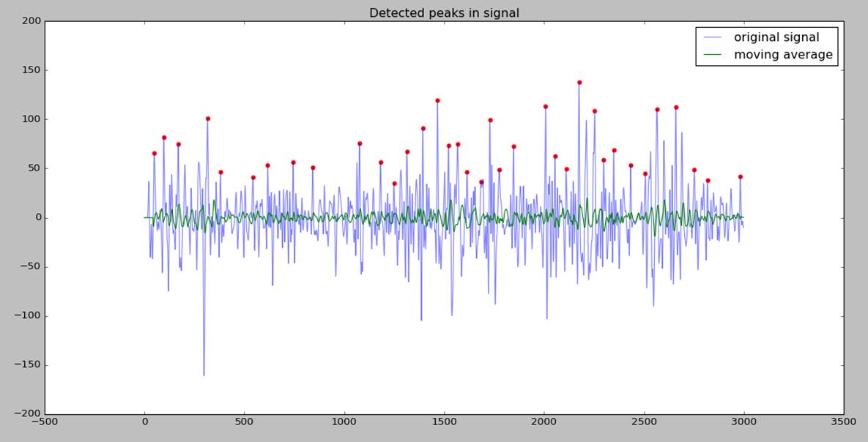

Fig. 9

Screenshot of the pulse detection in a signal using our window algorithm for one of our subject of study.

**9.10) Heart Rate Variability**

It is the physiological phenomenon of variation in the time interval between heartbeats. It is measured by the variation in the beat-to-beat interval. In the field of psychophysiology, there is interest in HRV. For example, HRV is related to emotional arousal. High-frequency (HF) activity has been found to decrease under conditions of acute time pressure and emotional strain and elevated state anxiety, presumably related to focused attention and motor inhibition. HRV has been shown to be reduced in individuals reporting a greater frequency and duration of daily worry. In individuals with post-traumatic stress disorder (PTSD), HRV and its HF component (see below) is reduced compared to controls whilst the low-frequency (LF) component is elevated

**9.11) Emotion Analysis using Hedonic Response:-**

Once we have the beats, we can analyze them for detecting emotions. We will just be monitoring two types of emotions, which are, positive (happy) and negative (anger, anxiety). A positive emotion will show a relatively peaceful pulse and beats while a negative emotion will result in peaks in the generated pulse. As no such work was done before, we worked only on the statistics that were computed by us on our model and tried to figure the mood/emotion of the subject through the video. We did a rigorous analysis based on analytical aspects and measures of central tendency to compile the appropriate results. **[10]**

**10. Experiment:-**

We needed a reference to test our obtained heart beat for the subjects. During our literature survey we stumbled upon a dataset DEAP **[11]**, which is a dataset for emotion analysis using EEG, physiological and video signals. It was a multimodal dataset for the analysis of human affective states. The electroencephalogram (EEG) and peripheral physiological signals of 32 participants were recorded as each watched 40 one-minute long excerpts of music videos. Participants rated each video in terms of the levels of arousal, valence, like/dislike, dominance and familiarity. For 22 of the 32 participants, frontal face video was also recorded. We tested our model on these 22 participant’s videos that were publically made available by them. The dataset was first presented in the paper **[12]**.

The data also came with the photoplethysmogram (PPG) **[13]** data for all the 22 subjects whose videos were made available. We used this PPG data to measure approximately the heartbeat of the subjects that we tested through our model. Though the PPG model required some alteration like Butterworth filtering, but they gave us a rough idea about the heart beats of the subjects.

To further test our model, we locally collected frontal face videos of our colleagues and simultaneously, while recording their videos, calculated their heart beats using sophisticated market devices such as MI Band, which is a fitness band that can be used to detect the heart beats of a person through the wrist PPG data of the person **[14]**. We accumulated the results of both, the PPG data of the subjects of our dataset and our colleagues’ data, and then moved forward with the calculation of heart rate variability and emotional analysis.

For heart rate variability, we calculated it using the formula:-

HRV = Sampling Frequency / d (6)

Where d is the distance between consecutive peaks in the heart beat signal.

Once we had the HRV data, we

**11. Results:-**

The results were acceptable with our local experiment that was, with ourselves and our colleagues’ video wearing a MI Band. We got a maximum error of +1 or -1 in most of the cases. Thus we used the same videos to test the mood of the person. We could not arrive on a specific strategy to stimulate an emotion on the subjects of study deliberately. Hence, we conducted the experiments and provide a rigorous statistical report on our findings.

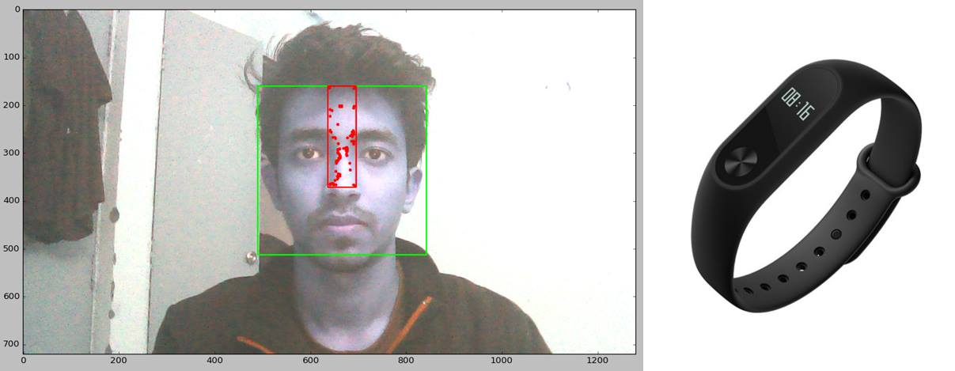

Fig. 10

Locally conducted experiment with a fitness band to verify the obtained heart beats from our model.

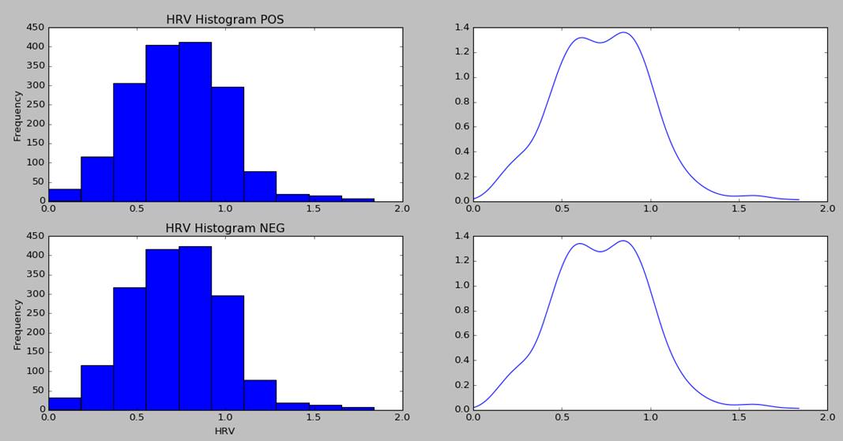

Fig. 11

Cumulative Histograms of all the subjects of study. HRV Histogram POS is for the Positive mood and HRV Histogram NEG is for the negative moods of the subject.

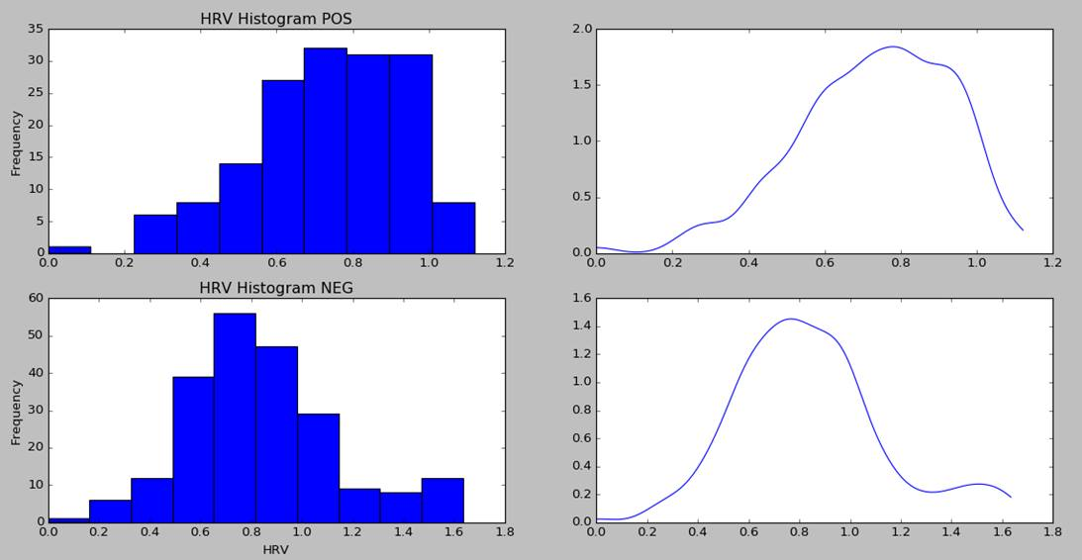

Fig. 12

Histograms of one subject with positive and negative mood. HRV Histogram POS shows the positive mood of the subject and HRV Histogram NEG shows the negative mood of the subject.

We provide a table of our observations for all the subjects as shown below:-

|  |  |  |  |  |  |  |  |  |  |  |  |
| --- | --- | --- | --- | --- | --- | --- | --- | --- | --- | --- | --- |
| **Sub. No.** | **Statistical Measure** | **Positive** | | | | | **Negative** | | | | |
| 01 | **Area under the curve** | 36.16 | | | | | 42.03 | | | | |
| **Standard Deviation** | 0.26 | | | | | 0.255 | | | | |
| **Skewness** | -0.314 | | | | | -0.208 | | | | |
| **Val Scale (Skewness)** | 5.76 | | | | | 0.91 | | | | |
| **Area for intervals (0.3)** | 0.14 | 0 | 5.4 | 9 | 9 | 0 | 0.98 | 6.25 | 9 | 9 |
| 02 | **Area under the curve** | 25.50 | | | | | 32.009 | | | | |
| **Standard Deviation** | 0.282 | | | | | 0.287 | | | | |
| **Skewness** | 0.012 | | | | | -0.027 | | | | |
| **Val Scale (Skewness)** | 5.33 | | | | | 3.58 | | | | |
| **Area for intervals (0.3)** | 0 | 0.62 | 5.44 | 9 | 9 | 0 | 0.86 | 4.84 | 9 | 9 |
| 03 | **Area under the curve** | 31.888 | | | | | 53.369 | | | | |
| **Standard Deviation** | 0.231 | | | | | 0.345 | | | | |
| **Skewness** | 0.0756 | | | | | 0.697 | | | | |
| **Val Scale (Skewness)** | 4.79 | | | | | 3.76 | | | | |
| **Area for intervals (0.3)** | 0 | 2.95 | 6.65 | 9 | 9 | 0 | 2.41 | 6.08 | 8.11 | 9 |
| 04 | **Area under the curve** | 47.587 | | | | | 56.433 | | | | |
| **Standard Deviation** | 0.316 | | | | | 0.300 | | | | |
| **Skewness** | 0.738 | | | | | 0.889 | | | | |
| **Val Scale (Skewness)** | 3.59 | | | | | 0.0 | | | | |
| **Area for intervals (0.3)** | 3.55 | 0 | 7.34 | 8.41 | 9 | 2.96 | 0 | 7.70 | 8.53 | 9 |
| 05 | **Area under the curve** | 22.725 | | | | | 27.435 | | | | |
| **Standard Deviation** | 0.363 | | | | | 0.343 | | | | |
| **Skewness** | 1.046 | | | | | 1.081 | | | | |
| **Val Scale (Skewness)** | 5.4 | | | | | 6.65 | | | | |
| **Area for intervals (0.3)** | 0.24 | 0 | 8.27 | 9 | 8.51 | 0 | 0.55 | 8.44 | 9 | 8.63 |
| 06 | **Area under the curve** | 34.546 | | | | | 55.367 | | | | |
| **Standard Deviation** | 0.202 | | | | | 0.299 | | | | |
| **Skewness** | -0.595 | | | | | 0.561 | | | | |
| **Val Scale (Skewness)** | 5.28 | | | | | 1.63 | | | | |
| **Area for intervals (0.3)** | 3.07 | 0 | 8.04 | 9 | 9 | 3.29 | 0 | 6.38 | 7.83 | 9 |
| 07 | **Area under the curve** | 27.867 | | | | | 39.268 | | | | |
| **Standard Deviation** | 0.213 | | | | | 0.215 | | | | |
| **Skewness** | -0.125 | | | | | -0.037 | | | | |
| **Val Scale (Skewness)** | 8.0 | | | | | 2.45 | | | | |
| **Area for intervals (0.3)** | 1.83 | 0 | 6.86 | 9 | 9 | 1.42 | 0 | 5.92 | 9 | 9 |
| 08 | **Area under the curve** | 48.669 | | | | | 61.109 | | | | |
| **Standard Deviation** | 0.231 | | | | | 0.232 | | | | |
| **Skewness** | -0.074 | | | | | -0.052 | | | | |
| **Val Scale (Skewness)** | 6.16 | | | | | 1.83 | | | | |
| **Area for intervals (0.3)** | 1.32 | 0 | 5.21 | 9 | 9 | 1.21 | 0 | 4.32 | 9 | 9 |
| 09 | **Area under the curve** | 41.600 | | | | | 48.960 | | | | |
| **Standard Deviation** | 0.203 | | | | | 0.202 | | | | |
| **Skewness** | -0.210 | | | | | -0.160 | | | | |
| **Val Scale (Skewness)** | 6.15 | | | | | 5.92 | | | | |
| **Area for intervals (0.3)** | 0.41 | 0 | 7.22 | 9 | 9 | 0.17 | 0 | 7.39 | 9 | 9 |
| 10 | **Area under the curve** | 10.327 | | | | | 12.775 | | | | |
| **Standard Deviation** | 0.253 | | | | | 0.247 | | | | |
| **Skewness** | 0.327 | | | | | 0.329 | | | | |
| **Val Scale (Skewness)** | 5.51 | | | | | 5.1 | | | | |
| **Area for intervals (0.3)** | 0 | 3.6 | 9 | 9 | 9 | 0 | 3.77 | 9 | 9 | 9 |
| 11 | **Area under the curve** | 39.917 | | | | | 46.876 | | | | |
| **Standard Deviation** | 0.317 | | | | | 0.299 | | | | |
| **Skewness** | 0.133 | | | | | 0.292 | | | | |
| **Val Scale (Skewness)** | 4.52 | | | | | 0.17 | | | | |
| **Area for intervals (0.3)** | 0 | 1.39 | 3.25 | 7.60 | 9 | 0 | 2.4 | 4.9 | 8.01 | 9 |

We tried to come to a conclusion from the data that we presented above. The area of the curve under the negative emotions is continuously higher than the one at positive curve for the same subject. But due to inefficient test data and due to the non-reliability of stimulating a particular emotion on a subject, we do not see very large differences between the calculations we have obtained for positive and negative emotions. Though we can surely say that with more sophisticated dataset and methods, one could obtain a criteria to separate between positive and negative moods using ballistocardiography.

**12. Applications of this model:-**

* It has various applications in medical sector for cardiac related diseases. For example, by detecting an asymmetrical vibration it could suggest that an obstruction in the blood flow is located on one side. Similarly it might be possible to work out the volume of blood pumped and other diagnostic measures.
* With a certain level of accuracy it can provide results exactly same has ECG which would be really helpful for detecting heart related problems through a video itself.
* Detecting change in emotions through hedonic response will also be helpful in analyzing a video of two people conversing. Analysis might include detecting the importance of topic of discussion and mood of conversation among others.

**13. Future Directions:-**

* An important future direction is to develop approaches for moving subjects. This is complicated because, as our results show, even other involuntary head movements are quite large in relation to pulse motion. Clearly with larger motions such as talking, more sophisticated filtering and decomposition methods will be needed to isolate pulse.
* In this work we considered the frequency and variability of the pulse signal. However, head movement can offer other information about the cardiac cycle. If head displacement is proportional to the force of blood being pumped by the heart, it may serve as a useful metric to estimate blood stroke volume and cardiac output. Additionally, the direction of the movement could reveal asymmetries in blood flow into or out of the head. This might be useful for the diagnosis of a stenosis, or blockage, of the carotid arteries.

**14. References**

**[1]** D. D. He, “A wearable heart monitor at the ear using ballistocardiogram (BCG) and electrocardiogram (ECG) with a nano-watt ECG heartbeat detection circuit,” Thesis, Massachusetts Institute of Technology, 2013.

**[2]** http://opencv.org/documentation.html

**[3]** https://docs.python.org/3/

**[4]** http://docs.opencv.org/trunk/d7/d8b/tutorial_py_lucas_kanade.html

**[5]** https://docs.scipy.org/doc/scipy/reference/tutorial/interpolate.html

**[6]**https://docs.scipy.org/doc/scipy-0.14.0/reference/generated/scipy.signal.butter.html

**[7]** <http://docs.opencv.org/3.1.0/d7/d8b/tutorial_py_face_detection.html#gsc.tab=0>

**[8]** <http://blog.translucentcomputing.com/2014/03/principal-component-analysis-for.html>

**[9]** http://people.csail.mit.edu/balakg/cvpr2013_pulsepaper.pdf

**[10]**http://tir-training.de/wp-content/uploads/2015/08/Bradley-Appelhans-Luecken-HRV_emotional-regulation.pdf

**[11]** http://www.eecs.qmul.ac.uk/mmv/datasets/deap/

**[12]** http://www.eecs.qmul.ac.uk/mmv/datasets/deap/doc/tac_special_issue_2011.pdf

**[13]** https://en.wikipedia.org/wiki/Photoplethysmogram

**[14]** http://www.mi.com/en/miband/

**[15]** http://www.artyfactory.com/portraits/pencil-portraits/proportions-of-a-head.html

**[16]**http://docs.opencv.org/2.4/doc/tutorials/features2d/trackingmotion/good_features_to_track/good_features_to_track.html

**15. Comments**