Table of Contents
I.Boot processes for x86 machines 3
I.1.Bios (Basic Input Output System) 3
I.1.1.Power On Reset[1] 4
I.1.2.BIOS (Basic Input Output System)[1] 5
I.1.3.MBR anatomy[3] 7
I.1.4.Boot Loader (GRUB)[4] 8
I.1.4.a.Main image files and installation 9
I.1.4.b.Execution steps 11
I.1.4.c.Module loading 13
I.1.4.d.Grub.cfg file 15
I.1.4.e.Kernel and initramfs[6][7] 18
I.2.Uefi (Unified Extensible Firmware Interface)[8] 19
I.2.1.Advantages over BIOS systems 20
I.2.2.Processor compatibility 20
I.2.3.GPT (GUID Partition Table) 20
I.2.4.ESP (EFI System Partition) 23
I.2.5.Features 23
I.2.6.Boot methods 25
II.Ramfs, Rootfs and Initramfs 27
II.1.Introduction[6] 27
II.2.Ramdisk, Ramfs, Tmpfs and Rootfs[9] 29
II.3.Initramfs[12][13] 30
III.Windowing system[9] 33
IV.Raspberry bringup 37
IV.1.Headless wifi connection on home network 37
IV.2.Configuring No-IP to access devices outside home network 38
V.Virtualization[15][16] 40
V.1.Introduction to virtualization 40
V.2.Operating system virtualization 40
V.3.Full virtualization 42
V.3.1.Software Assisted – Full Virtualization (BT – Binary Translation ) 42
V.3.2.Hardware-Assisted – Full Virtualization (VT) 43
V.4.Paravirtualization 45
V.5.Libvirt 47
V.5.1.Using Virsh 48
V.5.2. Win10 Guest Installation 49
V.6.Setting up KVM/Qemu environment[17] 50
V.6.1.Virtio drivers 51

Linux System References

Boot processes for x86 machines
There are essentially two ways of booting: Bios and Uefi.

Bios (Basic Input Output System)
The boot sequence consists of these steps[1]:
- Initiating the boot sequence. Power on Reset or Other
- Basic Input Output System (BIOS) Power On Self Test (POST). The POST tests and initializes the hardware.
- BIOS Boot. The BIOS Boot routine selects a boot device and boots it. If booting the hard disk, it reads the MBR into memory.
- Master Boot Record (MBR): contains the first stage of boot loading, its role is to laod the real boot loader.
- Boot Loader. The boot loader corresponds in reality to the second stage of boot loading. It reads the kernel and selected drivers into memory. The details depend on the OS being loaded.
- Kernel Initialization. The kernel initializes internal state and other data structures to begin normal operation.
- System Process Initialization. Once the kernel is initialized it begins dispatching processes. The initial process continues the system initialization.
- Login. Part of system initialization is to start the mechanism to allow users to log in.
- User Process Startup. Once a user logs on, additional processing occurs to initialize the user’s desired configuration.
The process is illustrated below and follows the enumareted steps in order[2]:

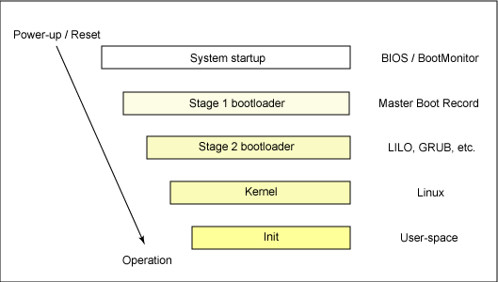Illustration 1: Generic boot sequence

Power On Reset[1]
When the power is removed from most electronic memory devices, they loose their contents. That's one of the main reasons for doing a system boot--to reload the operating system from disk after a power on. In addition to main memory, there are small storage areas inside the CPU (Central Processing Unit) called registers. Some of these registers are visible to the software, while others are only used internally by the processor to keep track of its state. These registers also lose their contents when power is removed. Two important examples of registers (for the x86 family of processors, which are the processors used by Windows PCs) are the CS (Code Segment) register and the IP (Instruction Pointer) register. The combination of these two registers defines where the next instruction is to be found in memory.
When power is restored to these electronic devices (including both main memory and CPU registers) the contents are random and therefore useless.
The power on reset is triggered when a signal is received by the CPU from the power supply called "power stable". The power on reset initializes all CPU registers to a specified state. Many registers are set to zero (for example the IP register). A few registers require special non-zero values to put the CPU into a reasonable state. Once the power on reset sequence is finished, the CPU begins executing instructions in its normal fashion. The combination of the initial CS and IP values causes execution to begin in the BIOS.

BIOS (Basic Input Output System)[1]
BIOS stands for Basic Input Output System. It is the only piece of software that is stored in non-volitile memory (EEPROM – Electrically Erasable Programmable ROM). That means that the contents of memory are not lost even when the power has been turned off and then on. Thus it is available for execution as soon as the CPU has finished its power-on reset. The BIOS is divided into four components:
- Drivers: These are special-purpose pieces of software, each designed to control a specific I/O device. There is a keyboard driver, display driver, disk driver, etc.
- Power On Self Test (POST) This is the component that initially gains control during a boot sequence. It is a piece of software which runs after power on and its purpose is to test and initialize various hardware components. It both tests and initializes various hardware components. The specific order varies depending on the creator of the BIOS but generally follows this sequence:
  - The CPU
  - The Video Screen. This is the first time you'll see any evidence of the system starting.
  - Memory. This step is time-consuming so it is often optional.
  - Floppy disks.
  - Peripheral Components. Each controller card plugged into the system bus (usually the PCI bus) can have its own piece of BIOS code. The BIOS looks for a special signature in memory for these add-ons and if found calls them.
The system cannot communicate on the video screen until after step 2 above is finished. Therefore if there are problems found before that, the POST beeps the system loudspeaker and halts. Of course, if the CPU isn't functioning properly, it's unlikely the POST will get far enough to beep or do anything else useful. When the POST finishes, the BIOS looks to see if a special key was pressed and if so the Setup routine is called.
- Setup: System setup is designed to allow the user to configure very low-level hardware information. This is the only part of the BIOS that interacts with the user. To enter Setup, the user presses some specified key during the POST. Which key depends on who wrote the BIOS; common keys are DEL or F2.
- Boot. If the user didn't press the special key to invoke Setup, then when the POST is finished it will transfer control the the Boot routine. The boot function with the BIOS has two steps:
  - To determine the device from which to boot. Depending on who wrote the BIOS, this is done in one of several ways:
    - By configuration options within the BIOS setup function. The user specifies which device to boot via a setup parameter.
    - By configuration options from a boot menu. This is conceptually identical to the preceding method. The user selects which device to boot. The difference is the method used for getting to the menu of boot devices: In the previous method, the boot device is simply one of many options available in the setup function; in the current method, there is a separate boot-device menu that is shown if the user selects an alternate "special" key, that is a key other than the one that invokes the setup function.
    - By testing each potential boot device in some specified order until a device is found that is ready for and capable of being booted. The order depends on the specific BIOS implementation; a common order might be:
      - Floppy disk
      - CD-ROM (or DVD-ROM)
      - Hard Disk
      - Network (PXE Boot)
The first device that is found ready to boot is booted and the remaining devices are not checked.
    - A combination of the above, where the user uses setup to select the order in which the devices are to be checked.
  - To boot the device selected by the previous step. This generally means reading the first block from the device into memory and then transferring to the first byte of that block which is assumed to contain executable instructions. (The network boot is more complicated and will not be covered here.)
When the hard disk is booted, the first block of the device is called the Master Boot Record (MBR).

MBR anatomy[3]
The master boot record is the first physical block on the disk. (Note: The terms "block", "record", and "sector" are often used interchangebly to describe the smallest addressable unit of a disk drive.) Since the MBR is only one record, or sector, long it is severely limited in what it can contain. Typcially a sector holds 512 bytes.

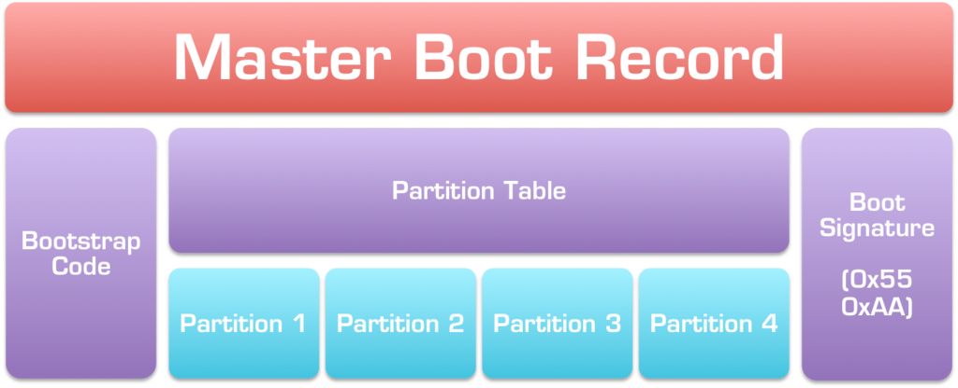Illustration 2: Master Boot Record layout
The MBR contains three types of information:
- Executable code: This code searches the Partition Table (described below) to find the first partition that is marked as an "active" or boot partition. The first block of that partition is read into memory and control is transferred to the first byte of that block in memory which is assumed to contain executable code. This disk block is called the Partition Boot Sector.
- The Partition Table. The partition table specifies how the disk is divided into partitions. There are several reasons to divide a disk drive into partitions:
  - Some file systems have a maximum size limit, and so, on disks that would otherwise be too large, the disk can be divideded into partitions with each parition being set to the file-system's size limit or smaller.
  - Each partition can be used for a different purpose. For example, they can contain different kinds of file systems.
  - Each partition can contain a different operating system. By changing the active partition one can change which operating system boots.
Normally each partition contains a file system. Every different operating system supports a different set of types of file systems. It is also possible for a partition to contain other types of data (i.e. not contain a file system). For example Linux swap space is normally in a separate partition; there is no file system in such a partition. Some database management systems (such as Oracle) can also place their data directly into a partition without that partition containing a file system. (A partition that is accessed directly without a file system is often referred to as a "raw partition".)
The partition table records the location of each partition on the drive. The partition table can be thought of as containing rows and columns. Each row describes one partition. There is room for four rows and thus there can be a maximum of four partitions on the disk. (Actually there can be more partitions by having a secondary partition table, but that functionality is implemented by operating systems and is not part of the boot process. The partitions listed in the MBR are often referred to as "primary partitions"). Each column in the partition table contains one piece of data about the partition:
  - The disk address of the beginning of the partition.
  - The disk address of the end of the partition.
  - A flag specifying the active partition. The active partition is the partition to be booted.
  - A numeric code indicating the use of the partition. (Typically this specifies the type of file system within the partition.)
- The signature. The signature is only two bytes and has a consant value (0x55 0xaa). This value can be used by the BIOS boot routine to determine whether there is a valid MBR present.

Boot Loader (GRUB)[4]

A boot loader is the first software program that runs when a computer starts. It is responsible for loading and transferring control to an operating system kernel software (such as Linux or GNU Mach). The kernel, in turn, initializes the rest of the operating system (e.g. a GNU system). The most popular boot loader for Linux is Grub 2.X “Grand Unified Boot Loader”. GRUB. When we talk about Grub, we generally refer to stage 2 of bootloader (i.e. when core.img is executed). Grub comes with two distinct boot methods:
- The multiboot option is the native one and allows to load an operating system directly.
- Chainloading another boot loader which then will load other bootloaders or other operating systems directly.
Generally speaking, a) is more desirable, because you don’t need to install or maintain other boot loaders and GRUB is flexible enough to load an operating system from an arbitrary disk/partition. However, the latter is sometimes required, since GRUB doesn’t support all the existing operating systems natively. The chainload normally can point to the Partition Boot Record (first sector of a partition in the disk) or in a more complex way can be programmed to point to a new disk. The PBR of a Linux partition, in case the chainloading is not adopted, doesn’t containg bootstrap code (even after creating a file system on it) thus a Linux partition cannot bootstrap itself, even if it contains a kernel and a valid root file system. A boot sector with a valid start code contains the same magic number as the MBR in its last two bytes (AA55).

Main image files and installation
The partition table traditionally used on PC BIOS platforms allows up to four primary partitions and additional logical partitions. With this partition table format, there are two ways to install GRUB: it can be embedded in the area between the MBR and the first partition (called by various names, such as the "boot track", "MBR gap", or "embedding area", and which is usually at least 31 KiB), or the core image can be installed in a file system and a list of the blocks that make it up can be stored in the first sector of that partition. Each of these has different problems. There is no way to reserve space in the embedding area with complete safety, and some proprietary software is known to use it to make it difficult for users to work around licensing restrictions; and systems are sometimes partitioned without leaving enough space before the first partition. On the other hand, installing to a filesystem means that GRUB is vulnerable to its blocks being moved around by filesystem features such as tail packing, or even by aggressive fsck implementations, so this approach is quite fragile; and this approach can only be used if the /boot filesystem is on the same disk that the BIOS boots from, so that GRUB does not have to rely on guessing BIOS driver numbers.

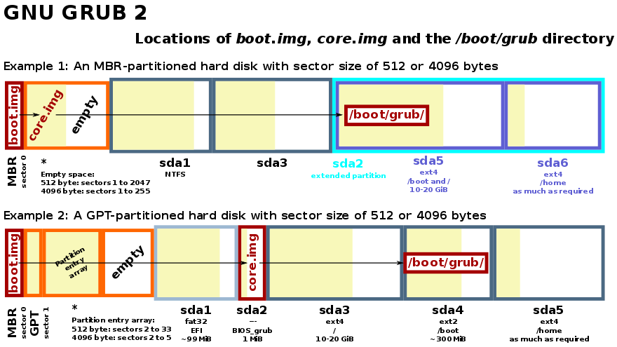Illustration 3: core.img position in partitioned hd
Regardless the solution chosen, the two most important files which must be placed in on the disk are:
- boot.img: On PC BIOS systems, this image is the first part of GRUB to start. This image is used for stage 1 of bootloading It is written to a master boot record (MBR) or to the boot sector of a partition. Because a PC boot sector is 512 bytes, the size of this image is exactly 512 bytes. The sole function of boot.img is to read the first sector of the core image from a local disk and jump to it. Because of the size restriction, boot.img cannot understand any file system structure, so grub-install hardcodes the location of the first sector of the core image into boot.img when installing GRUB.
- core.img This is used for stage 2 of bootloading. It is built dynamically from the kernel image and an arbitrary list of modules by the grub-mkimage program. Usually, it contains a minimal sets of modules (*.mod) to access /boot/grub folder, and loads everything else (including menu handling, the ability to load target operating systems, and so on) from the file system at run-time. The modular design allows the core image to be kept small, since the areas of disk where it must be installed are often as small as 32KB. The kernel.img is embedded in the core.img together with other optional modules. This image contains GRUB’s basic run-time facilities: frameworks for device and file handling, environment variables, the rescue mode command-line parser, and so on. It is rarely used directly, but is built into all core images. Everything else in GRUB resides in dynamically loadable modules.

Execution steps
The steps of GRUB bootloading can be summarised as follows[5]:
- Grub’s MBR code loads a single sector whose address is hard-wired into the MBR block. It then loops over the (address,len) pairs in that sector loading all that data from the disk into memory (ie loads the contents of file /boot/grub/core.img, or its “embedded” copy). The MBR code then jumps to the loaded code, ie “executes” the program in core.img. This trick of embedding the raw disk block addresses makes it possible to store core.img in space that is not in a partition, and that has never been formatted as a filesystem at all (“embedding”). And in this case, if core.img is modified, as long as the new version is “embedded” at the same location, the MBR code does not need to be updated. Alternatively, it is possible for the core.img to be inside a real filesystem, and for Grub to read the core.img file contents without having a driver for that filesystem. However in this case, if core.img is modified then the first block of the file may well be given a new address on disk; if this happens then the MBR must be updated to point to this new location. Nevertheless, as core.img is usually updated by running grub-install, this is not usually a problem. Note that theoretically, if core.img is on a different device than the MBR, and new hardware is added then the Grub-generated MBR record might not be able to correctly load the core.img file; the device-id on which the first sector of core.img is to be found is hard-wired into the MBR, not searched for. However there is no solution for this; there is no way to embed the equivalent of the Grub “search” command into the 512-byte MBR. This problem is not likely though; normally the core.img is embedded on the same device as the MBR. And once core.img has been loaded it can use search.mod to find all further /boot/grub files, and is therefore immune to hardware rearrangements.
- The executed core.img code now initialises all the modules that are built into it (linked into core.img); one of these modules will be a filesystem driver capable of reading the filesystem on which directory /boot/grub lives. It also registers a set of built-in commands: set, unset, ls, insmod. If a “config file” has been linked into core.img, this is then passed to a very simple build-in script parser for processing. Scripting commands in the config file can only invoke built-in or linked-in commands. Simple scenarios (eg booting a typical desktop computer from a local drive) need no config file; this facility is used for things like booting via pxe, remote nfs or when /boot/grub is on an LVM device.
- Core.img now loads file “/boot/grub/normal.mod” dynamically from disk, and jumps to its entry function. Note that this step requires the appropriate filesystem driver to be set up (ie built-in).
- The normal.mod module:
    - Registers command “menuentry” for use by scripts .
    - Loads a script parser (aka an “interpreter”) named “parser.grub”. The handler.lst file is used to determine the name of the *.mod file to actually load (normally “sh.mod”).
    - Loads file /boot/grub/grub.cfg and passes the contents to the script parser for execution.
    - Puts up a menu on the screen showing an entry for each time the script parser had encountered a menuentry{...} block in the script (if no menuentry blocks exist in the script, then it just displays an interactive commandline).
    - Lets the user select an option.
    - Passes the contents of the {...} block for that menu-entry to the script parser again.
    - Invokes the “boot” command from the boot.mod module.
The standard script parser implementation is named “parser.grub” and can be found in file /boot/grub/sh.mod. This implementation provides features very similar to a standard posix shell. Therefore grub.cfg’s syntax is very similar to a standard Unix shell script:
  - Environment variables are accessed via $name or ${name}.
  - Any of the commands provided by the *.mod files can be invoked like a shell script would invoke an external app or built-in command (eg “ps” or “ls”). If a command is issued which is not provided by a currently-loaded module, then file “command.lst” is used to determine which *.mod file provides that command, and that module is then loaded. See the following section for more details.
  - If/then/else/fi is supported as in normal shell scripts.
  - Script functions can be defined and invoked as in normal shell scripts.
  - Variables can be defined as in normal shell scripts.
  - Additional modules can be explicitly loaded via “insmod” commands, eg “insmod sleep.mod”. This is not necessary to access “commands”, as they are automatically loaded (see above). However insmod is needed to load modules providing filesystem drivers, parsers, crypto implementations, etc.
Module normal.mod also provides an interactive command-line with gnu readline support. Each line read from the keyboard is passed to the current script-parser for processing. The result is that Grub can provide an environment very similar to a standard unix interactive shell, where the commands that can be invoked are anything provided in the available modules. This is useful for diagnosing and fixing boot problems.

Module loading
Grub modules have some similarity to linux kernel modules, and in fact the commands to load and unload them into Grub are “insmod” and “rmmod” just as for linux modules. However in many respects they are more like “plugins” for an IDE or editor.
When a module is loaded (from a *.mod file), or a linked-in module is initialised, the module can register commands, variables, parsers, filesystem drivers and cryptographic algorithm implementations. A command is simply a mapping from a name to a function; Grub scripts can then invoke that function by name (eg “ls”, “boot”, “linux”). Often the command name has the same name as the .mod file (eg “search.mod” registers command “search”). However this is not always the case; for example module “loadenv.mod” registers both load_env and save_env commands. If a script uses a command that is not yet registered, then file commands.lst is used to determine which module to load. A variable is a mapping from a name to a variable defined in the module; scripts can then access the variable as $name. Optionally, a module can ensure it gets a callback when a script assigns to that variable. A module can register a “parser” to support additional non-standard script syntaxes (eg lua). If any script (eg grub.cfg or something loaded from grub.cfg) starts with “#!parserid” then the specified parser function will be used to process that script. If there is no parser function registered with that id, then normal.mod looks in handler.lst for a line mapping key “parser.someparserid” to the name of a .mod file to load, ie autoloading works for parsers as well as commands. A module can register filesystem drivers (eg ext2, reiserfs, befs, ntfs). Note that at least one filesystem driver module is embedded in core.img so the files in directory /boot/grub can be read. Filesystem drivers cannot be auto-loaded; the “insmod” command must be used to explicitly load the necessary modules. The filesystem driver modules for Grub support reading only; Grub does not need to write data back to the filesystem during boot, and skipping write support makes the modules a lot smaller and easier to implement. A module can also register cryptographic algorithms. As for filesystem drivers, they must be explicitly loaded via insmod before being available.
Module (.mod) files are actually ELF format files; core.img contains the necessary code to parse the ELF headers, load the code and do dynamic-linking (ie resolve calls to functions and variables exported by the core.img for use by modules). The core.img exports lots of things to modules including functions for manipulating strings, iterating over disks, registering themselves, etc.
File “/boot/grub/moddep.lst” contains a list of inter-module dependencies; when a module is loaded, its dependencies are also automatically loaded. Note that module “normal.mod” has dependencies, as declared in moddep.lst. Therefore when core.img loads normal.mod during startup those declared dependencies are also automatically loaded. One of the more significant ones is “boot.mod”, which provides the “boot” command that is automatically executed after a menuentry{...} block has been selected by the user, or ctrl-x has been pressed after editing a menuentry.
A module can be:
- built-in to core.img (see grub-mkimage, called from grub-install),
- dynamically loaded using “insmod” from a script,
- loaded because a module that depends on it was loaded (as declared in moddep.lst)
Module “normal.mod” is a special exception and is automatically dynamically loaded by core.img. Module “sh.mod” is also a special exception, and is automatically dynamically loaded by “normal.mod” (via the mapping for parser-id “parser.grub” in file handler.lst).

Grub.cfg file
Normally, during boot Grub will load a file /boot/grub/grub.cfg which is a shell-script-like file that then configures the standard Grub boot menus. This file can be written by hand if desired; the syntax is fairly easy for anyone familiar with shell scripts. However Grub also comes with a convenient shell script called “grub-mkconfig” which uses a set of helper scripts and templates to create a suitable grub.cfg file automatically. As most Linux distributions automatically invoke grub-mkconfig after updating kernel versions etc, causing any hand-written config file to be overwritten, it is generally better to customise the “templates” rather than modify grub.cfg directly. On some Linux distros (eg Ubuntu) the name “update-grub” is used as an alias for grub-mkconfig. Note that grub-mkconfig simply regenerates the /boot/grub/grub.cfg shell script that Grub interprets on boot. It does nothing else, as the MBR + core.img + modules are enough to get the interpreter up and running scripts out of normal filesystem files. Script “grub-mkconfig” reads all files in /etc/grub.d, executing each in order. Each should be a shell script whose output ends up in the grub.cfg file. To add a custom entry just modify file /etc/grub.d/40_custom which is explicitly designed as a template for custom entries. And if you want your custom entries to appear before the standard boot entries in the list, then rename file 40_custom to 08_custom or similar. You may not even need to customize anything; Grub’s default scripts automatically create menu entries for each vmlinuz-* file that exists in /boot. All of the functionality of grub-mkconfig (aka update-grub) is implemented in shell script, so the best reference for this topic is the script files themselves.
When we need to reference drive partitions from grub.cfg, we need to consider that Grub understands only ‘(hdx,y)’ type expressions natively, where x is the physical disk device (0..n), and y is the partition. In Grub 1.98 is just a number in range (1..n); in later versions of Grub, it also specifies the partition type, eg ‘(hd0,msdos1)’. And in complicated configurations, it can even look like ‘(hd0,msdos2,sunpc2)’, which specifies a particular solaris ‘slice’ embedded in msdos partition #2 on drive #0. As this article is specifically about Grub 1.98, the rest of this article will use the ‘(hd0,1)’ format in examples.
Files can be referenced via paths like “(hd0,1)/boot/mykernel”. If no device-id is present on the front, then “magic” shell variable $root is used by default.The ‘search’ module can be used to search all partitions for a filesystem that matches a certain criteria, and setting a shell variable to the matching ‘hdx,y’ value. That variable can then be used later to reference the matched filesystem. Using the search command is not necessary if you are happy to reference filesystems by their raw ‘(hdx,y)’ descriptions. By default, the “search” command stores its result in environment variable $root, ie it is intended for searching for the device on which /boot/grub/*.mod files live. It can be used to search for devices for other purposes, but in these cases an alternative environment variable should always be specified, eg:
> search.label mylabel MYDEV
The “search” command can invoke any of the more specific search.* commands, so this command is equivalent to the one above:
> search –set=MYDEV –label mylabel
The returned value is of form ‘hdx,y’. Note that there are no parentheses; if you wish to later use this value as part of a file-path, then you need to add the parentheses, eg:
> somecommand ($MYDEV)…
Note that if you set $root to point to something other than the device on which Grub’s *.mod files live, then Grub will no longer be able to load any modules. Note also that $root has absolutely nothing to do with the “root=” value passed to a Linux kernel. However the kernel’s image file (first parameter to the “linux” command) will be looked for on the $root device by default, ie:
linux /mykernel root=xyz
means
linux ($root)/mykernel root=xyz
which means something like
linux (hd0,1)/mykernel root=xyz
The most important modules used during the boot phase is the linux.mod. It loads a kernel into memory and sets up Grub data-structures so that a later call to the “boot” command will jump to the loaded kernel. The module registers two commands that can be called from scripts:
- linux: Expects its first argument to be the path to the kernel image itself. Simply passes all other arguments through to the invoked kernel. The specified kernel is loaded into memory by this command by the bootloader. The ‘root=’ command points the driver from where we are booting which is passed to the linux kernel
- initrd: is a scheme to populate a temporary root file system in memory, which may be used as part of the Linux startup process. initrd and initramfs refer to two different methods of achieving this. It is optional if the kernel image to boot does has been compiled with the necessary modules for bootup. In case it is present, the bootloader will load the image to a known memory address.

Kernel and initramfs[6][7]
The kernel in Linux handles all operating system processes, such as memory management, task scheduling, I/O, interprocess communication, and overall system control. This is loaded in two stages:
- Loading stage: the kernel is typically loaded as an image file, compressed into either zImage or bzImage formats. A routine at the head of it does a minimal amount of hardware setup, decompresses the image fully into high memory, and takes note of any initramfs if configured. It then executes kernel startup via ./arch/i386/boot/head and the startup_32 () (for x86 based processors) process.
- Startup stage: The startup function for the kernel (also called the swapper or process 0) establishes memory management (paging tables and memory paging), detects the type of CPU and any additional functionality such as floating point capabilities, and then switches to non-architecture specific Linux kernel functionality via a call to start_kernel(). This last function executes a wide range of initialization functions. It sets up interrupt handling (IRQs), further configures memory, starts the init process (the first user-space process), and then starts the idle task via cpu_idle(). The important point is to find where the init() process is located and run it before the cpu goes in idle mode. When each kernel boots (from version 2.6), it mounts "rootfs" as its first filesystem. This is a special instance of tmpfs which can't be moved or unmounted. Most kernels just leave it empty and mount another root filesystem on top of it, but rootfs is always there (check /proc/mounts to see) and it's a fully capable ram based filesystem. Shortly after mounting rootfs during bootup, the kernel extracts a gzipped cpio archive into it. Each kernel image has one of these archives built into it, but by default it's empty, so extracting it adds no files to rootfs. Then the kernel tries to run "/init" out of rootfs, and if that works the kernel is done booting, and the newly spawned init program takes over. Only if the kernel can't run "/init" will it fall back to the legacy behavior of parsing the "root=" kernel command line to find another filesystem to mount on top of rootfs, so it can try to run an init program out of the new filesystem. Using initramfs just means supplying the kernel with an /init program for rootfs, either by replacing the cpio.gz archive built into the kernel or by supplying a cpio.gz archive externally the way initrd used to do it.
Once the kernel hands the control to the init process, we move to the so called early user space. The init() process has PID=1 and should run forever, if it crashes for some reason, a kernel panic event occurs. Its role is to startup the bring up the system to a ready state for the final user. A common use of initramfs is to find and mount another root filesystem. Since rootfs can't be unmounted, the way to switch to a different root filesystem is with switch_root command. What switch_root does is deleting all the files out of rootfs (to free up the memory) and then chroot into a new filesystem and exec a new init process out of the new filesystem. The new init process will inherit the PID of its creator (ie. PID=1) and will never terminate as well. There are different version of init() program, the most famous are: SysV, systemd and Upstart.

Uefi (Unified Extensible Firmware Interface)[8]
The original motivation for EFI came during early development of the first Intel–HP Itanium systems in the mid-1990s. BIOS limitations (such as 16-bit processor mode, 1 MB addressable space and PC AT hardware) had become too restrictive for the larger server platforms Itanium was targeting. The effort to address these concerns began in 1998 and was initially called Intel Boot Initiative.It was later renamed to Extensible Firmware Interface (EFI). In July 2005, Intel ceased its development of the EFI specification at version 1.10, and contributed it to the Unified EFI Forum, which has developed the specification as the Unified Extensible Firmware Interface (UEFI). The original EFI specification remains owned by Intel, which exclusively provides licenses for EFI-based products, but the UEFI specification is owned by the Forum. Version 2.1 of the UEFI specification was released on 7 January 2007. It added cryptography, network authentication and the User Interface Architecture (Human Interface Infrastructure in UEFI).

Advantages over BIOS systems
The interface defined by the EFI specification includes data tables that contain platform information, and boot and runtime services that are available to the OS loader and OS. In particular:
- Ability to use large disks (over 2 TB) with a GUID Partition Table (GPT)
- CPU-independent architecture
- CPU-independent drivers
- Flexible pre-OS environment, including network capability
- Modular design
- Backward and forward compatibility
- It stores a backup header and partition table at the end of the disk so it can be recovered if the primary tables are corrupted.
- CRC32 checksums to detect errors and corruption of the header and partition table.

Processor compatibility
64-bit UEFI firmware implementations support long mode, which allows applications in the preboot execution environment to use 64-bit addressing to get direct access to all of the machine's memory. UEFI requires the firmware and operating system loader (or kernel) to be size-matched; for example, a 64-bit UEFI firmware implementation can load only a 64-bit operating system (OS) boot loader or kernel. After the system transitions from "Boot Services" to "Runtime Services", the operating system kernel takes over. At this point, the kernel can change processor modes if it desires, but this bars usage of the runtime services (unless the kernel switches back again). As of version 3.15, the Linux kernel supports 64-bit kernels to be booted on 32-bit UEFI firmware implementations running on x86-64 CPUs, with UEFI handover support from a UEFI boot loader as the requirement

GPT (GUID Partition Table)
Uefi is able to work as well with GPT tables which can be enabled activating the option during kernel configuration CONFIG_EFI_PARTITION. This option allows Linux to recognize and use GPT disks after the system firmware passes control over the system to Linux. Like modern MBRs, GPTs use logical block addressing (LBA) in place of the historical cylinder-head-sector (CHS) addressing. The protective MBR is contained in LBA 0, the GPT header is in LBA 1, and the GPT header has a pointer to the partition table, or Partition Entry Array, typically LBA 2. The UEFI specification stipulates that a minimum of 16,384 bytes, regardless of sector size, be allocated for the Partition Entry Array. On a disk having 512-byte sectors, a partition entry array size of 16,384 bytes and the minimum size of 128 bytes for each partition entry, LBA 34 is the first usable sector on the disk. Hard-disk manufacturers are transitioning to 4,096-byte sectors. Below a short analysis of the GPT:

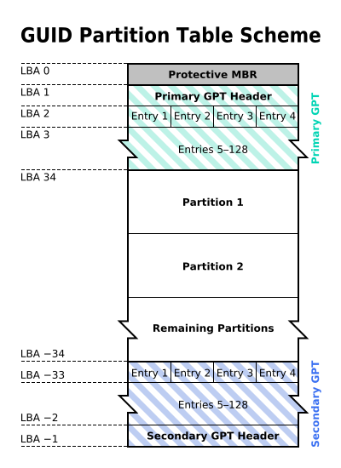Illustration 4: GPT table
- LBA 0: For limited backward compatibility, the space of the legacy MBR is still reserved in the GPT specification, but it is now used in a way that prevents MBR-based disk utilities from misrecognizing and possibly overwriting GPT disks. This is referred to as a protective MBR. A single partition type of Eeh (defined in the MBR), encompassing the entire GPT drive (where "entire" actually means as much of the drive as can be represented in an MBR), is indicated and identifies it as GPT. Operating systems and tools which cannot read GPT disks will generally recognize the disk as containing one partition of unknown type and no empty space, and will typically refuse to modify the disk unless the user explicitly requests and confirms the deletion of this partition. This minimizes accidental erasures. Furthermore, GPT-aware OSes may check the protective MBR and if the enclosed partition type is not of type EEh or if there are multiple partitions defined on the target device, the OS may refuse to manipulate the partition table.
In operating systems that support GPT-based boot through BIOS services rather than EFI, the first sector is also still used to store the first stage of the bootloader code, but modified to recognize GPT partitions. The bootloader in the MBR must not assume a sector size of 512 bytes.
- LBA 1: it contains the partition table header. It defines the usable blocks on the disk and the number and size of the partition entries that make up the partition table
- LBA 2-33: After the header, the Partition Entry Array describes partitions, using a minimum size of 128 bytes for each entry block.[8] The starting location of the array on disk, and the size of each entry, are given in the GPT header. The first 16 bytes of each entry designate the partition type's globally unique identifier (GUID). For example, the GUID for an EFI system partition is C12A7328-F81F-11D2-BA4B-00A0C93EC93B. The second 16 bytes are a GUID unique to the partition. Then follow the starting and ending 64 bit LBAs, partition attributes, and the 36 character (max.) Unicode partition name. As is the nature and purpose of GUIDs, no central registry is needed to ensure the uniqueness of the GUID partition type designators

ESP (EFI System Partition)
An EFI System partition, often abbreviated to ESP, is a data storage device partition that is used in computers adhering to the UEFI specification. Accessed by the UEFI firmware when a computer is powered up, it stores UEFI applications and the files these applications need to run, including operating system kernels. For use on ESPs, UEFI defines a specific version of the FAT file system, which is maintained as part of the UEFI specification and independently from the original FAT specification, encompassing a variant of the FAT32 file system on ESPs, and FAT16 and FAT12 file systems on removable media. The ESP also provides space for a boot sector as part of the backward BIOS compatibility. The mount point for the EFI system partition is usually /boot/efi, where its content is accessible after Linux is booted.

Features
The supported features in UEFI system are the following:
- Services two types of services are defined: boot services are available onlywhile the firmware owns the platform and they include text and graphical consoles on various devices, and bus, block and file services. Runtime services are still accessible while the operating system is running; they include services such as date, time and NVRAM access.
- Applications they reside as files on the EFI System Partition (ESP). They can be executed from the UEFI command shell, by the firmware's boot manager, or by other UEFI applications. UEFI applications can be developed and installed independently of the system manufacturer. Among the applications we need to mention the boot loaders (Grub, Windows boot manager and so on) which load an OS file into memory and executes it. Also, an OS loader can provide a user interface to allow the selection of another UEFI application to run. Utilities like the UEFI shell are also UEFI applications.
- Protocols EFI defines protocols as a set of software interfaces used for communication between two binary modules. All EFI drivers must provide services to others via protocols.
- Device drivers in addition to standard processor architecture-specific device drivers, EFI provides for a processor-independent device driver stored in memory as EFI byte code or EBC. System firmware has an interpreter for EBC images. Some architecture-specific (non-EFI Byte Code) EFI drivers for some device types can have interfaces for use by the OS. This allows the OS to rely on EFI for drivers to perform basic graphics and network functions before, and if, operating-system-specific drivers are loaded.
- Graphic The EFI specification defined a UGA (Universal Graphic Adapter) protocol as a way to support device-independent graphics. UEFI did not include UGA and replaced it with GOP (Graphics Output Protocol), with the explicit goal of removing VGA hardware dependencies. The two are similar. UEFI 2.1 defined a "Human Interface Infrastructure" (HII) to manage user input, localized strings, fonts, and forms (in the HTML sense). These enable original equipment manufacturers (OEMs) or independent BIOS vendors (IBVs) to design graphical interfaces for pre-boot configuration; UEFI itself does not define a user interface. Most early UEFI firmware implementations were console-based, but as early as 2007 some implementations featured a graphical user interface

Boot methods
In UEFI there are different boot process which can be used:
- UEFI-GPT Unlike BIOS, UEFI does not rely on a boot sector, defining instead a boot manager as part of the UEFI specification. When a computer is powered on, the boot manager checks the boot configuration and based on its settings, loads into memory and then executes the specified OS loader or operating system kernel. The boot configuration is defined by variables stored in NVRAM, including variables that indicate the file system paths to OS loaders and OS kernels. OS loaders can be automatically detected by UEFI, which enables easy booting from removable devices such as USB flash drives. This automated detection relies on standardized file paths to the OS loader, with the path varying depending on the computer architecture. The format of the file path is defined as <EFI_SYSTEM_PARTITION>/EFI/BOOT/BOOT<MACHINE_TYPE_SHORT_NAME>.EFI; for example, the file path to the OS loader on an x86-64 system is /efi/BOOT/BOOTX64.EFI, and efi\boot\bootaa64.efi on ARM64 architecture. GRUB2 and elilo serve as conventional, full-fledged standalone UEFI boot managers for Linux. Once loaded by a UEFI firmware, they both can access and boot kernel images from all devices, partitions and file systems they support, without being limited to the EFI system partition.
EFI Boot Stub makes possible to boot a Linux kernel image without the use of a conventional UEFI boot loader. By masquerading itself as a PE/COFF image and appearing to the firmware as a UEFI application, an x86 kernel image with EFI Boot Stub enabled can be directly loaded and executed by a UEFI firmware. Such kernel images can still be loaded and run by BIOS-based boot loaders; thus, EFI Boot Stub allows a single kernel image to work in any boot environment. Linux kernel's support for the EFI Boot Stub is enabled by turning on option CONFIG_EFI_STUB (EFI stub support) during the kernel configuration.
Despite the fact that the UEFI specification requires MBR partition tables to be fully supported, some UEFI firmware implementations immediately switch to the BIOS-based CSM booting depending on the type of boot disk's partition table, effectively preventing UEFI booting to be performed from EFI System partitions on MBR-partitioned disks.
- CSM (Compatibility Support Module) is a component of the UEFI firmware that provides legacy BIOS compatibility by emulating a BIOS environment, allowing legacy operating systems and some option ROMs that do not support UEFI to still be used. There are two way to start the system in backward compatibility mode:
  - BIOS-MBR which occurs on disks which are MBR-partitioned (the BIOS-MBR name is used regardless of it being performed on UEFI or legacy BIOS-based systems). Booting is performed in the same way as on legacy BIOS-based systems, by ignoring the partition table and relying on the content of a boot sector.
  - BIOS-GPT Linux can use GPT disks in BIOS-based systems for both data storage and booting, as both GRUB 2 and Linux are GPT-aware. As GPT incorporates the protective MBR, a BIOS-based computer can boot from a GPT disk using a GPT-aware boot loader stored in the protective MBR's bootstrap code area. In the case of GRUB, such a configuration requires a BIOS boot partition for GRUB to embed its second-stage code due to absence of the post-MBR gap in GPT partitioned disks (which is taken over by the GPT's Primary Header and Primary Partition Table). Commonly 1 MB in size, this partition's Globally Unique Identifier (GUID) in GPT scheme is 21686148-6449-6E6F-744E-656564454649 and is used by GRUB only in BIOS-GPT setups. From GRUB's perspective, no such partition type exists in case of MBR partitioning.
- Network booting The UEFI specification includes support for booting over network via the Preboot eXecution Environment (PXE). PXE booting use network protocols include Internet Protocol (IPv4 and IPv6), User Datagram Protocol (UDP), Dynamic Host Configuration Protocol (DHCP) and Trivial File Transfer Protocol (TFTP). OS images can be remotely stored on storage area networks (SANs), with Internet Small Computer System Interface (iSCSI) and Fibre Channel over Ethernet (FCoE) as supported protocols for accessing the SANs. Version 2.5 of the UEFI specification adds support for accessing boot images over the HTTP protocol.
- Secure boot The UEFI 2.3.1 Errata C specification (or higher) defines a protocol known as secure boot, which can secure the boot process by preventing the loading of drivers or OS loaders that are not signed with an acceptable digital signature. The mechanical details of how precisely these drivers are to be signed are not specified. When secure boot is enabled, it is initially placed in "setup" mode, which allows a public key known as the "Platform key" (PK) to be written to the firmware. Once the key is written, secure boot enters "User" mode, where only drivers and loaders signed with the platform key can be loaded by the firmware. Additional "Key Exchange Keys" (KEK) can be added to a database stored in memory to allow other certificates to be used, but they must still have a connection to the private portion of the Platform key. Secure boot can also be placed in "Custom" mode, where additional public keys can be added to the system that do not match the private key.

Ramfs, Rootfs and Initramfs

Introduction[6]
When the Linux kernel boots the system, it must find and run the first user program, generally called "init". User programs live in filesystems, so the Linux kernel must find and mount the first (or "root") filesystem in order to boot successfully. Ordinarily, available filesystems are listed in the file /etc/fstab so the mount program can find them. But /etc/fstab is itself a file, stored in a filesystem. Finding the very first filesystem is a chicken and egg problem, and to solve it the kernel developers created the kernel command line option "root=", to specify which device the root filesystem lives on. Long time ago, "root=" was easy to interpret. It was either a floppy drive or a partition on a hard drive. These days the root filesystem could be on dozens of different types of hardware (SCSI, SATA, flash MTD), or even spread across several of them in a RAID. Its location could move around from boot to boot, such as hot pluggable USB devices on a system with multiple USB ports -- when there are several USB devices, which one is correct? The root filesystem might be compressed (how?), encrypted (with what keys?), or loopback mounted (where?). It could even live out on a network server, requiring the kernel to acquire a DHCP address, perform a DNS lookup, and log in to a remote server (with username and password), all before the kernel can find and run the first userspace program. These days, "root=" just isn't enough information. Even hard-wiring tons of special case behavior into the kernel doesn't help with device enumeration, encryption keys, or network logins that vary from system to system. Worse, programming the kernel to perform these kind of complicated multipart tasks is like writing web software in assembly language: it can be done, but it's considerably easier to simply use the proper tools for the job. The kernel is designed to follow orders, not give them. With no end to this ever-increasing complexity in sight, the kernel developers decided to back up and find a better way to deal with the whole problem. The proposed solutions changed over time and in the next paragraphs we will dwell on their characteristics.

Ramdisk, Ramfs, Tmpfs and Rootfs[9]
- Ramdisk it was an old mechanism for creating a synthetic block device out of an area of RAM and used it as backing store for a filesystem. This block device was of fixed size, so the filesystem mounted on it was of fixed size. Using a ram disk also required unnecessarily copying memory from the fake block device into the page cache (and copying changes back out), as well as creating and destroying dentries. It needed a filesystem driver (such as ext2) to format and interpret this data.
- Ramfs it is newer than ramdise and it is a very simple filesystem that exports Linux's disk caching mechanisms (the page cache for data and dentry cache for directory) as a dynamically resizable RAM-based filesystem. Normally all files are cached in memory by Linux. Pages of data read from backing store (usually the block device the filesystem is mounted on) are kept around in case it's needed again, but marked as clean (freeable) in case the Virtual Memory (VM) system needs the memory for something else. Similarly, data written to files is marked clean as soon as it has been written to backing store, but kept around for caching purposes until the VM reallocates the memory. A similar mechanism (the dentry cache) greatly speeds up access to directories. With ramfs, there is no backing store. Files written into ramfs allocate dentries and page cache as usual, but there's nowhere to write them to. This means the pages are never marked clean, so they can't be freed by the VM when it's looking to recycle memory. Ramfs file systems cannot be limited in size like a disk base file system which is limited by it’s capacity, it will continue using memory storage until the system runs out of RAM and likely crashes or becomes unresponsive[10]. The amount of code required to implement ramfs is tiny, because all the work is done by the existing Linux caching infrastructure. Basically, you're mounting the disk cache as a filesystem. Because of this, ramfs is not an optional component removable via menuconfig, since there would be negligible space savings.
- Tmpfs[11] is newer than ramfs and respect to it offers the following differences: it can be specified a limit for growing beyond which it will return “disk full error”. It uses swap space: if a system runs out of physical RAM, files in tmpfs partitions may be written to disk based SWAP partitions and will have to be read from disk when the file is next accessed. In some environments this can be seen as a benefit as you are less likely to get out of memory exceptions as you could with ramfs because more ‘memory’ is available to use, on the other side the swap access will decrease the data access.
- Rootfs is a special instance of ramfs (or tmpfs, if that's enabled), which is always present in 2.6.X systems. This is a special instance of tmpfs which can't be moved or unmounted, it's used as a placeholder inside the Linux kernel, as the place to start and stop searching the doubly-linked list of mount points. Most 2.6 systems just leave it empty and mount another root filesystem on top of it, but rootfs is always there (check /proc/mounts to see) and it's a fully capable ram based filesystem. If CONFIG_TMPFS is enabled, rootfs will use tmpfs instead of ramfs by default.

Initramfs[12][13]
All 2.6 Linux kernels contain a gzipped "cpio" format archive, the archive is unpacked by the kernel into a special instance of a tmpfs that becomes the initial rootfs. After extracting, the kernel checks to see if rootfs contains a file "init", and if so it executes it as PID 1. If found, this init process is responsible for bringing the system the rest of the way up, including locating and mounting the real root device (if any). If rootfs does not contain an init program after the embedded cpio archive is extracted into it, the kernel will fall through to the older code to locate and mount a root partition, then exec some variant of /sbin/init out of that. All this differs from the old initrd in several ways:
- The old initrd was always a separate file, while the initramfs archive can be as well linked into the linux kernel image. (The directory linux-*/usr is devoted to generating this archive during the build.)
- The old initrd file was a gzipped filesystem image (in some file format, such as ext2, that needed a driver built into the kernel), while the new initramfs archive is a gzipped cpio archive (like tar only simpler). The kernel's cpio extraction code is not only extremely small, it's also __init text and data that can be discarded during the boot process.
- The program run by the old initrd (which was called /initrd, not /init) did some setup and then returned to the kernel, while the init program from initramfs is not expected to return to the kernel. If /init needs to hand off control it can overmount / with a new root device and exec another init program.
- When switching another root device, initrd would pivot_root and then umount the ramdisk. But initramfs is rootfs: you can neither pivot_root rootfs, nor unmount it. Instead delete everything out of rootfs to free up the space (find -xdev / -exec rm '{}' ';'), overmount rootfs with the new root (cd /newmount; mount --move . /; chroot .), attach stdin/stdout/stderr to the new /dev/console, and exec the new init. Since this is a remarkably difficult process (and involves deleting commands before you can run them), the klibc package introduced a helper program (utils/run_init.c) to do all this for you. Most other packages (such as busybox) have named this command "switch_root".
If the kernel has initrd support enabled, an external cpio.gz archive can also be passed into a 2.6 kernel in place of an initrd. In this case, the kernel will autodetect the type (initramfs, not initrd) and extract the external cpio archive into rootfs before trying to run /init. This has the memory efficiency advantages of initramfs (no ramdisk block device) but the separate packaging of initrd (which is nice if you have non-GPL code you'd like to run from initramfs, without conflating it with the GPL licensed Linux kernel binary). It can also be used to supplement the kernel's built-in initramfs image. The files in the external archive will overwrite any conflicting files in the built-in initramfs archive. Some distributors also prefer to customize a single kernel image with task-specific initramfs images, without recompiling. It is not explicitly said but it is assumed that the kernel image has always a built-in version of initramfs which can even minimal or a dummy one.
[14]For most distributions, kernel modules are the biggest reason to have an initramfs: in a general distribution, there are many unknowns such as file system types and disk layouts which need the appropriate scripts and tools to mount the particular file systems. There are only four primary reasons to have an initramfs: loading the rootfs from a network, loading it from an LVM logical volume, having an encrypted rootfs where a password is required, or for the convenience of specifying the rootfs as a LABEL or UUID.

Windowing system[9]

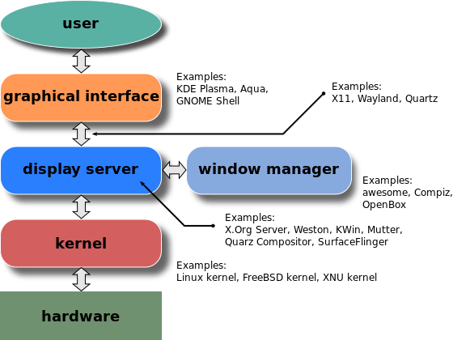Illustration 5: Windowing stack

- Display server: it is a program whose primary task is to coordinate the input and output of its clients to and from the rest of the operating system, the hardware, and each other. The display server communicates with its clients over the display server protocol, a communications protocol, which can be network-transparent or simply network-capable.
One example of a display server is the X.Org Server, which runs on top of the kernel (usually a Unix-based kernel, such as Linux or BSD). It receives data from evdev and passes it to one of its clients. The display server also receives data from its clients; it processes the data, it does the compositing and passes the data to one of three kernel components – DRM, gem or KMS driver. The component writes the data into the framebuffer and content of the framebuffer is transmitted to the connected screen and displayed. X relies on GLX.
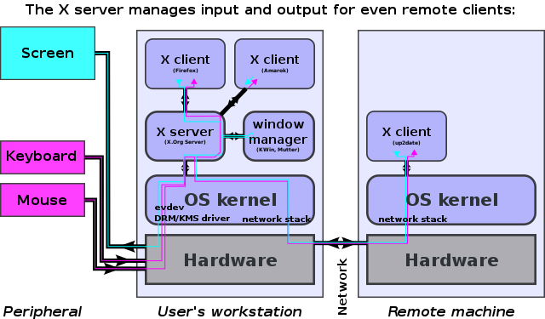Illustration 6: Display server
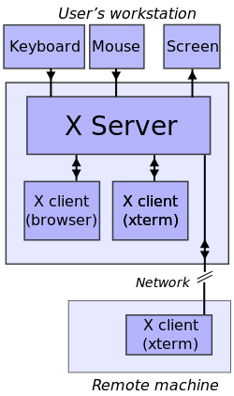Illustration 7: X-server-clients interaction
It is important to remark that in this model the server is located where the monitor and other hw devices are connected. The clients are normally local or remote running programs.
- Windows Manager: it runs on top of the X Window System and it can be considered its client. When a window manager is running, some kinds of interaction between the X server and its clients are redirected through the window manager. In particular, whenever an attempt to show a new window is made, this request is redirected to the window manager, which decides the initial position of the window. Additionally, most modern window managers are reparenting, which usually leads to a banner being placed at the top of the window and a decorative frame being drawn around the window. These two elements are controlled by the window manager rather than the program. Therefore, when the user clicks or drags these elements, it is the window manager that takes the appropriate actions (such as moving or resizing the window). Window managers are also responsible for icons. Indeed, icons do not exist at the X Window System core protocol level. When the user requests a window to be iconified, the window manager unmaps it (makes it non-visible) and takes the appropriate actions to show an icon in its place. Most modern window managers do not literally show icons to represent iconified windows anymore. Often, an auxiliary toolbar program will allow access to iconified windows.. When a window manWhen a window manager is running, some kinds of interaction between the X server and its clients are redirected through the window manager. In particular, whenever an attempt to show a new window is made, this request is redirected to the window manager, which decides the initial position of the window. Additionally, most modern window managers are reparenting, which usually leads to a banner being placed at the top of the window and a decorative frame being drawn around the window. These two elements are controlled by the window manager rather than the program. Therefore, when the user clicks or drags these elements, it is the window manager that takes the appropriate actions (such as moving or resizing the window). Window managers are also responsible for icons. Indeed, icons do not exist at the X Window System core protocol level. When the user requests a window to be iconified, the window manager unmaps it (makes it non-visible) and takes the appropriate actions to show an icon in its place. Most modern window managers do not literally show icons to represent iconified windows anymore. Often, an auxiliary toolbar program will allow access to iconified windows.rame being drawn around the window. These two elements are controlled by the window manager rather than the program. Therefore, when the user clicks or drags these elements, it is the window manager that takes the appropriate actions (such as moving or resizing the window). Window managers are also responsible for icons. Indeed, icons do not exist at the X Window System core protocol level. When the user requests a window to be iconified, the window manager unmaps it (makes it non-visible) and takes the appropriate actions to show an icon in its place. Most modern window managers do not literally show icons to represent iconified windows anymore. Often, an auxiliary toolbar program will allow access to iconified windows.
- Graphical interface: it is also known as Desktop environment (DE) and it is logically located on top of windows manager. It bundles together a variety of components to provide common graphical user interface elements such as icons, toolbars, wallpapers, and desktop widgets. Additionally, most desktop environments include a set of integrated applications and utilities. Most importantly, desktop environments provide their own window manager, which can however usually be replaced with another compatible one.

RaspberryPi 3 Model B HowTo

Raspberry bringup

Headless wifi connection on home network

The steps are substantially the following and must be execute on the microSD before plugging it in to card slot:
- Enabling ssh creating a file called ssh in /boot
- Edit /etc/wpa_supplicant/wpa_supplicant.conf as following:
country=GB
ctrl_interface=DIR=/var/run/wpa_supplicant GROUP=netdev
update_config=1
network={
ssid="SSID"
psk="PASSWORD"
}
- ssh into the machine using ssh protocol with X11 support running an optimised command otherwise the browser will work too slow:
ssh -Y -C simone@eleuterion.ddns.net -p 5001

It is important to remark that the computer with the monitor and mouse+keyboard will need to have ssh server installed and running in order to satisfy the the connection request coming from the ssh client.
The ssh client in order to grant X forwarding doesn't need the X server, but just an authentication protocol. The most secure one is xauth which uses the .Xauthority file to autenticate the users.

NOTE: The option -Y it is necessary to grant “trusted X11 forwarding” to the root. It is also important to specify in the actual user .<shell_name>rc file the export variable XAUTHORITY to the local .Xauthority file otherwise still we won't be able to allow the use of the gui system.

Configuring No-IP to access devices outside home network

Below the steps necessary to allow to access your device outside the home network:
- Creating an account on NoIp.
- From router configuration page:
  - Assign static ip to the device from: this prevents the dhcp protocol from changing
  - Configuring the NoIP section according to the domain name created, it the router doesn't have this option is important to install the NoIp application which will sync the router ip when it will change to keep the NoIp table updated.
  - Open port forwarding for the specific port we need to use to communicate with the main device
- From device terminal/GUI:
  - Allow the firewall, if present, to communicate via the selected port.
  - Allow all users to access connection at statup: this is important if the OS uses network manager app, if this option is not selected it will be possible to access into the machine only if a user is already logged in. To enable the option is enough to get into the network manager configuration for the specific connection and grant the permission to all users as option.

If more than one device has to be connected to the network it can be used the port mapping option: the outside port has a user defined value which is linked to the static address assigned to device n, this tuple <ext_port, ip_addr> is than connected to the real value on incoming port in_port which is the one which will allow the particular service. For example:
Service Type | External Port | Internal IP | Internal Port | Protocol
ssh | 5000 | 192.168.1.100 | 22 | TCP
ssh | 5001 | 192.168.1.101 | 22 | TCP

Virtualization[15][16][17][18]

Introduction to x86 virtualization

Virtualization is nothing but abstracting operating system, application, storage or network away from the true underlying hardware or software. It creates the illusion of physical hardware to achieve the goal of operating system isolation
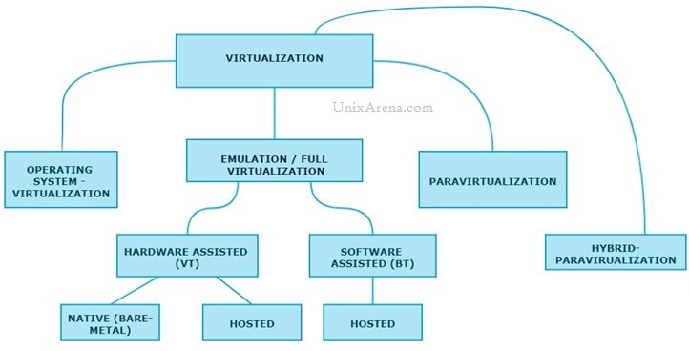Illustration 8: Map of virtualization types
To better understand the techniques employed for x86 virtualization, a brief background on the component parts is useful. The virtualization layer is the software responsible for hosting and m anaging all virtual machines on virtual machine monitors (VMMs). The virtualization layer is a hypervisor running directly on the hardware. The functionality of the hypervisor varies greatly based on architecture and implementation. Each VMM running on the hypervisor implements the virtual machine hardware abstraction and is responsible for running a guest OS. Each VMM has to partition and share the CPU, memory and I/O devices to successfully virtualize the system.
Hypervisor
VMM
VMM
VMM
Base functionality (e.g. scheduling)
Enhanced
functionality
OS
HW
App
OS
HW
App
OS
HW
App
OS
HW
App
OS
HW
App
OS
HW
App
Illustration 9: Hypervisor model

Operating system virtualization

Operating system virtualization helps to create virtualized layer of software on the top of host operating system that resides above the hardware layer. Unlike other virtualization, they create an OS interfaces for applications to run, giving the feeling of a complete OS for the applications. Each virtualized environment has its own:
- file system
- system libraries
- process tables
- network configuration.
Since they create a self-contained environment, they are also known as “container”. Therefore, creating the software emulation of an entire OS in a physical server is the essence of OS virtualization. Each container gets its own isolated user space to allow multiple containers to run on a single host machine. We can see that all the operating system level architecture is being shared across containers. The one big difference between containers and VMs is that containers “share” the host system’s kernel with other containers. The only parts that are created from scratch are the bins and libs. This is what makes containers so lightweight.
- Disadvantages: They support only one operating system as base and guest OS in a single server. You have to choose a single OS such as either Windows and Linux. All the OS in the container should be same version and should have same patch level of the base OS. If the base OS crash, all the virtual container become unavailable. Basically Windows dockers can’t be run on Linux and vice versa.
- Advantages: Since OS virtualization provide least overhead among all types of virtualization solution, they offer highest performance and highest density of virtual environment.
- Applications: They are great for isolating applications, web hosting and training. Popular OS virtualized products are OpenVZ, Virtuozzo, Docker and so on.
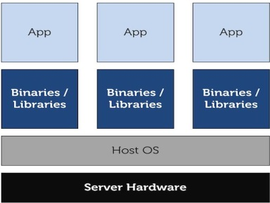Illustration 10: Operating system virtualization

Full virtualization
Virtual machine simulates hardware to allow an unmodified guest OS to be run in isolation. There is two type of Full virtualizations in the enterprise market. On both full virtualization types, guest operating system’s source information will not be modified.

Software Assisted – Full Virtualization (BT – Binary Translation )
It completely relies on binary translation to trap and virtualize the execution of sensitive, non-virtualizable instructions sets. It emulates the hardware using the software instruction sets. Due to binary translation, it often criticized for performance issue. Here is the list of software which will fall under software assisted (BT).

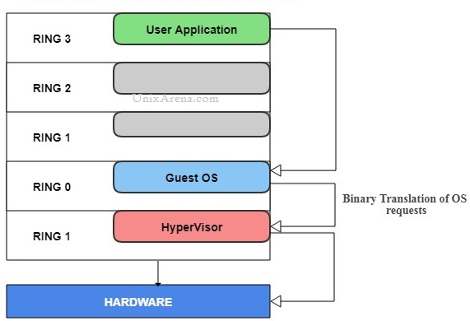Illustration 11: Binary translation - full virtualization
- Products: Vmware workstation (32 bit guests), Virtual PC, VirtualBox (32 bit guests), Vmware Server

Hardware-Assisted – Full Virtualization (VT)
Hardware-assisted full virtualization eliminates the binary translation and it directly interrupts with hardware using the virtualization technology which has been integrated on X86 processors since 2005 (Intel VT-x and AMD-V). Guest OS’s instructions might allow a virtual context execute privileged instructions directly on the processor, even though it is virtualized.

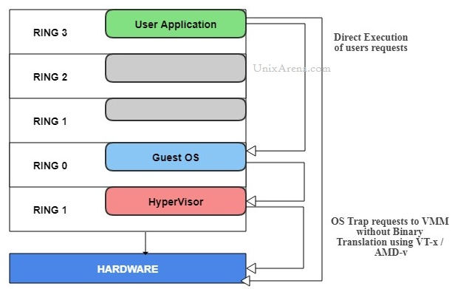Illustration 12: Hardware assisted - Full virtualization

There are two types of virtualization:
- Hypervisor type 1 or Bare Metal
Example of this type are: Vmware ESXI/ESX, KVM, Hyper-V, Xen
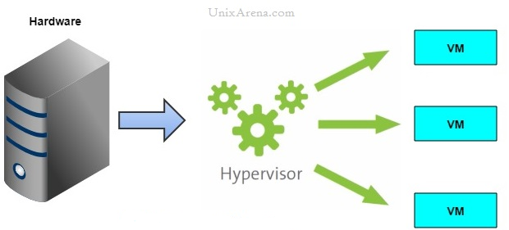Illustration 13: Hypervisor type 1 - Bare Metal
- Hypervisor type 2 or Hosted
Example of this type are: Vmware Workstation (64 bit guest only), VirtualBox (64 bit guest only)

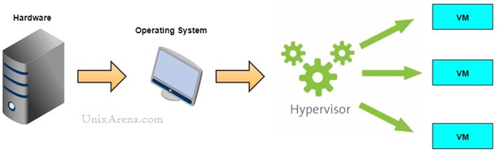Illustration 14: Hypervisor type 2 - Hosted

Paravirtualization
Unlike hardware emulation, paravirtualization does not emulate hardware environment in software, instead it coordinates or multiplexes access to hardware resources in favor of virtual machine. In this scenario guest systems are aware of virtualization. This means that the collaboration guest/host leads to better results compared to full virtualization.
In paravirtualized environment, a guest OS( called DomainU) is directly installed on the hypervisor (bare-metal architecture) that does not contain any device drivers for network and storage. Instead a privileged guest OS-also known as DomainO-has direct access to hardware. All guest OSes access hardware resources via DomainO. When a guest OS (virtual machine) needs to access hardware resources it sends a message to DomianO that access the hardware on behalf of guest OS. When data returns to the hardware, DomainO reads the information and passes it back to the guest operating system that has request it. DomainO is a standard OS such as Linux that has been modified to communicate with hypervisor to control access to hardware.
Unlike hardware emulation, which has device drivers installed in the hypervisor, paravirtualization uses device drivers of the DomainO. All the guest operating systems have stub drivers that communicate with the stub drivers in the privileged guest. Instead of making direct contact with the hardware, each stub driver in the guest OS communicate with its counterpart in the DomainO.
- Advantages: The main benefit of having stub driver is that the hypervisor does not have to have its own device drivers. Therefore, the users of the virtual machine never have to depend on the hypervisor software provider for driver software. Faster run time translation for system calls is the second benefit of this approach of device driver.
- Disadvantages the requirement of modifying guest operating system to execute and communicate with the hypervisor. You must modify the kernel of the guest OS before installation. Since, it is not possible to modify the kernel of proprietary OS like Windows, paravirtualization software users ( such as Xen users) have to use open source OS like Linux or OpenSolaris.
- Examples: Xen.

Libvirt
Libvirt is collection of software that provides a convenient way to manage virtual machines and other virtualization functionality, such as storage and network interface management. These software pieces include a long term stable C API, a daemon (libvirtd), and a command line utility (virsh). A primary goal of libvirt is to provide a single way to manage multiple different virtualization providers/hypervisors, such as the KVM/QEMU, Xen, LXC, OpenVZ or VirtualBox hypervisors (among others). Some of the major libvirt features are:
- VM management: Various domain lifecycle operations such as start, stop, pause, save, restore, and migrate. Hotplug operations for many device types including disk and network interfaces, memory, and CPUs.
- Remote machine support: All libvirt functionality is accessible on any machine running the libvirt daemon, including remote machines. A variety of network transports are supported for connecting remotely, with the simplest being SSH, which requires no extra explicit configuration.
- Storage management: Any host running the libvirt daemon can be used to manage various types of storage: create file images of various formats (qcow2, vmdk, raw, ...), mount NFS shares, enumerate existing LVM volume groups, create new LVM volume groups and logical volumes, partition raw disk devices, mount iSCSI shares, and much more.
- Network interface management: Any host running the libvirt daemon can be used to manage physical and logical network interfaces. Enumerate existing interfaces, as well as configure (and create) interfaces, bridges, vlans, and bond devices.
- Virtual NAT and Route based networking: Any host running the libvirt daemon can manage and create virtual networks. Libvirt virtual networks use firewall rules to act as a router, providing VMs transparent access to the host machines network.
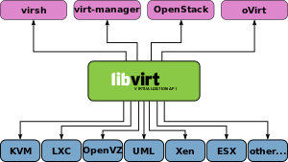Illustration 15: Libvirt stack

Libvirt is composed of two parts:
- Server which is responsible to serve communication between clients and hypervisor
- Client is the user interface that will be used to manage and access the virtual machine (virsh, virt-manager, so on…) reading and/or writing a socket to communicate with it.
For system-level administration (i.e. global settings and image-volume location), libvirt minimally requires setting up authorization (for the socket between daemon and hypervisor which will setup ro or rw permission), and starting the daemon (libvirtd).

Using Virsh
The virsh program is for managing guest domains (virtual machines) and works well for scripting, virtualization administration. Though most virsh commands require root privileges to run due to the communication channels used to talk to the hypervisor, typical management, creation, and running of domains (like that done with VirtualBox) can be done as a regular user. Some important terminology is:
- Storage pool location where “volumes”(or said also virtual disks) are kept. It can be a directory, a network filesystem or partition. Pools can be toggled active or inactive and allocated for space. To create one this is an example:
pool-define-as VirtualZeus --type dir --target /home/simone/VirtualMachines

Win10 Guest Installation
First thing to do is to use virt-install library to install it:
virt-install --connect qemu:///system \
--virt-type=kvm \
-n Win10 \
-ram 4096 \
-cpu=host \
-c /home/simone/Downloads/Windows10.iso \
--os-type=windows \
--disk=pool=VirtualMachines,size=25,format=raw \
--c /home/simone/Downloads/virtio-win-0.1.141.iso
-w network=default

As far as concerns the Windows10 license, it is possible to bind it to the email using hotmail, this means that windows can be ported on any virtual machine. The only caveat to follow is the windows version, bitness and language, they need to match with the original copy. In my case is Windows10 Pro, 64bit, italian language, Microsoft distributes a single iso which supports all kind of windows 10 types (Home, Pro and so on).
The audio is a problem. I partially solved it installing the AC97 Realtek audio drivers rebooting windows from Settings->Update&Recovery->Recovery->Advanced Startup→Restart Now. At reboot time I clicked Troubleshoot→Advanced Options→Startup Settings→Restart and than I selected option “Disable Driver Signature Enforcement”. I installed than on Windows the drivers ffrom System resources allowing the installation even if not trusted by the system. The audio might not work correctly when we reboot the system, however if this happens another reboot fixes it.

Setting up KVM/Qemu environment[19]
Kernel-based Virtual Machine (KVM) is a virtualization infrastructure for the Linux kernel that turns it into a hypervisor. It was merged into the Linux kernel mainline in kernel version 2.6.20, which was released on February 5, 2007. KVM requires a processor with hardware virtualization extensions. KVM has also been ported to FreeBSD and illumos in the form of loadable kernel modules. KVM originally supported x86 processors and has been ported to S/390, PowerPC, and IA-64. An ARM port was merged during the 3.9 kernel merge window. A wide variety of guest operating systems work with KVM, including many flavours and versions of Linux, BSD, Solaris, Windows, Haiku, ReactOS, Plan 9, AROS Research Operating System and OS X. In addition, Android 2.2, GNU/Hurd (Debian K16), Minix 3.1.2a, Solaris 10 U3 and Darwin 8.0.1, together with other operating systems and some newer versions of these listed, are known to work with certain limitations. Paravirtualization support for certain devices is available for Linux, OpenBSD, FreeBSD, NetBSD, Plan 9 and Windows guests using the VirtIO API. This supports a paravirtual Ethernet card, a paravirtual disk I/O controller, a balloon device for adjusting guest memory usage, and a VGA graphics interface using SPICE or VMware drivers.
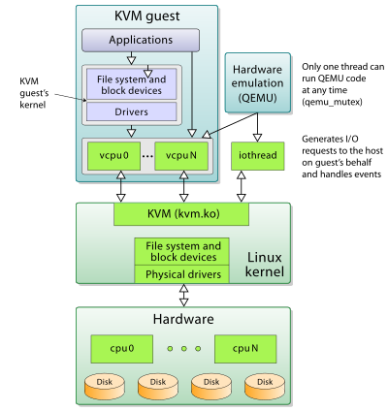Illustration 16: Qemu/KVM stack
By itself, KVM does not perform any emulation. Instead, it exposes the /dev/kvm interface, which a userspace host can then use to:
- Set up the guest VM's address space. The host must also supply a firmware image (usually a custom BIOS when emulating PCs) that the guest can use to bootstrap into its main OS.
- Feed the guest simulated I/O.
- Map the guest's video display back onto the system host.
On Linux, QEMU versions 0.10.1 and later is one such userspace host. QEMU uses KVM when available to virtualize guests at near-native speeds, but otherwise falls back to software-only emulation.

Virtio drivers
Bibliography
1: Glenn, PC Boot Sequence, 2010, http://glennastory.net/boot/
2: M.Jones, Inside the Linux boot process, 2006, https://www.ibm.com/developerworks/library/l-linuxboot/
3: NeoSmart Knowledgebase, The BIOS/MBR Boot Process, 2015, https://neosmart.net/wiki/mbr-boot-process/#fn6-2994
4: None, GNU GRUB Manual 2.02, None, https://www.gnu.org/software/grub/manual/grub/grub.html#SEC_Contents
5: The Mine of Information, Booting Linux on x86 using Grub2, 2010, http://moi.vonos.net/linux/Booting_Linux_on_x86_with_Grub2/#booting-the-computer
6: R.Landley, Initramfs, NoInfo, http://landley.net/writing/
7: Wikipedia, Linux startup process, NoInfo, https://en.wikipedia.org/wiki/Linux_startup_process#Kernel_loading_stage
8: Wikipedia, Unified Extensible Firmware Interface, , https://en.wikipedia.org/wiki/Unified_Extensible_Firmware_Interface
9: Wikipedia, Windowing System, 2014, https://en.wikipedia.org/wiki/Windowing_system
10: James Coyle, The Difference Between a tmpfs and ramfs RAM Disk, 2013, https://www.jamescoyle.net/knowledge/951-the-difference-between-a-tmpfs-and-ramfs-ram-disk
11: James Coyle, What is tmpfs?, 2015, https://www.jamescoyle.net/knowledge/1659-what-is-tmpfs
12: R.Landley, ramfs, rootfs and initramfs, 2005, https://www.kernel.org/doc/Documentation/filesystems/ramfs-rootfs-initramfs.txt
13: Wikipedia, initial ramdisk, NoInfo, https://en.wikipedia.org/wiki/Initial_ramdisk
14: Beyond Linux® From Scratch , File Systems and Disk Management , 2017, http://www.linuxfromscratch.org/blfs/view/cvs/postlfs/initramfs.html
15: wing, Types of Virtualization Technology-Advantages vs. Disadvantages, 2014, https://securitywing.com/types-virtualization-technology/
16: UnixArena, Para virtualization vs Full virtualization vs Hardware assisted Virtualization, None, https://www.unixarena.com/2017/12/para-virtualization-full-virtualization-hardware-assisted-virtualization.html
17: Ravello Community, Nested Virtualization With Binary Translation: Back to the Future, 2013, https://blogs.oracle.com/ravello/nested-virtualization-with-binary-translation
18: VMWare, Understanding Full Virtualization, Paravirtualization, and Hardware Assist, 2008,
19: Wikipedia, Kernel-based Virtual Machine, 2018, https://en.wikipedia.org/wiki/Kernel-based_Virtual_Machine

Illustration Index
Illustration 1: Generic boot sequence 4
Illustration 2: Master Boot Record layout 7
Illustration 3: core.img position in partitioned hd 10
Illustration 4: GPT table 21
Illustration 5: Windowing stack 33
Illustration 6: Display server 34
Illustration 7: X-server-clients interaction 34
Illustration 8: Map of virtualization types 40
Illustration 9: Operating system virtualization 42
Illustration 10: Binary translation - full virtualization 43
Illustration 11: Hardware assisted - Full virtualization 44
Illustration 12: Hypervisor type 1 - Bare Metal 45
Illustration 13: Hypervisor type 2 - Hosted 45
Illustration 14: Libvirt stack 48
Illustration 15: Qemu/KVM stack 51

