**PROJECT DESCRIPTION**

Eco-Go-Green is a source code developed in python which provides tools for individuals to access and improve their energy consumption. This user-friendly program enables users to make smart energy consumption choices by providing the user with feedback performance indicators based on user inputs.

This source code uses recently published yearly global temperature increase and per capita CO2 emissions data to guide users to choose personal appliances that minimize their net carbon footprint. Some of the data used to develop this program has been obtained through web-scraping of reliable sources.

**CONTACT**

If you have any questions, please do not hesitate to contact us at the following addresses.

Sandra Fomete | Sandra.f@ecoinsights.com

Haonan Di | Haonan.d@ecoinsights.com

A.J. Ferrara | aj.f@ecoinsights.com

**System Requirements**

1. Download anaconda 3 (comes with latest version of python)

<https://www.anaconda.com/download/>

Refer to [Anaconda Documentation](https://docs.anaconda.com/anaconda/install/windows/) for more on how to install and run Anaconda for

Windows and Mac.

1. If you’re new to Anaconda, follow the directions at [Getting started with Anaconda](https://docs.anaconda.com/anaconda/user-guide/getting-started/) to learn how to write and run your first Python project using Anaconda.
2. Open an Integrated Development Environment (IDE) such Spyder available through Anaconda

**Getting Started**

1. Download the zip-file (EcoInsight_DFP_Group12) containing the Eco-Go-Green source code, excel sheet containing clean data used by this program, and supporting documents made available via the CMU Canvas site.
2. Open the source code using the Spyder IDE installed on your computer.
3. Make sure the excel data file (*Project_Prototype_DFP_group12.xlsx*) and the source code (*suggestion.py, webscrape.py*) are in the same working directory.
4. Specify the location path for the excel data file, *Project_Prototype_DFP_group12.xlsx* in *suggestion.py line117*.
5. Please note that the Selenium Python package requires an extension to be loaded for Chrome. Here is the download link: <https://chromedriver.chromium.org/downloads>
6. Run the source code. You will be prompted with the following information.

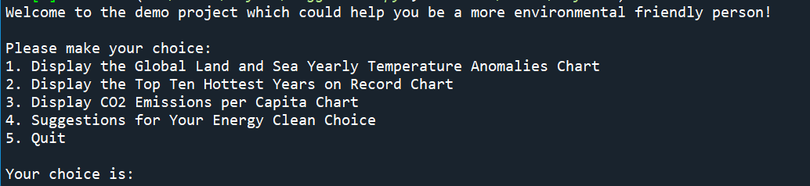

**Figure 1**: Main Selection menu

1. Selecting options 1-3 shown in Figure 1 will output data showing relevant trends pertinent to global warming and increase in per capita CO2 emissions.
2. By selecting option 4, you will be guided through a series of questions from which to choose your typical household appliances used. Energy consumption, energy cost, and carbon footprint for the chosen appliances will be displayed. Feedback will equally be provided for ways to improve energy consumption and minimize carbon footprint.
3. You can **selection option 5** at anytime to exit the program.

**FAQ**

1. How can I save my user feedback data to make sure to implement energy cost saving tips?

*For the moment, this program does not allow you to save the feedback given into a text file. However, you can take a screenshot of the provided tips on your PC for future use.*

1. How can I interact with the data on the temperature and CO2 emissions plots to see data relevant for a specific year?

Spyder offers great tools to zoom-in, zoom-out, and lookup relevant data for specified point on the graph window. You also have the option to save the output graph.

**Troubleshooting**

* Incase your Console runs extremely slow, try re-starting Spyder and running the code.
* Incase you run into a “No such file or Directory” error, make sure to doublecheck that your source code and data files are stored in the same directory on your computer.