SQD from Scratch: UIQC Qiskit Fall Fest 2026 Final Report
Oct 21, 2026

1. Project plan and team details
We completed all three notebooks of the SQD challenge series and extended notebook 03 with a noise-and-iteration study on water.
Item | Details
Team name | Nameless Quantum
Members | Mustapha Awwal; Adedeji Oluwole Precious
Project title | Sample-Based Quantum Diagonalization from Scratch: From Spin Chains to Molecules
Challenge | SQD challenge series, notebooks 01 to 03 (UIQC Qiskit Fall Fest 2026)
Repository (fork) | github.com/MustaphaAwwal/qff26xUIQC
Plan submitted | 13 October 2026
Project plan (as submitted). We will complete the three-part SQD challenge series. Sample-based quantum diagonalization uses a quantum circuit to sample the most important basis states (bitstrings) of a system. A classical computer then diagonalizes the Hamiltonian only within that small subspace, which avoids the exponential cost of full diagonalization.
- Notebook 01, Sample, Then Diagonalize: build the SQD method on an 8-spin transverse-field Ising chain. Implement subspace (cropped) diagonalization, show that sampled bitstrings give far better energies than random ones, and show that a rough, unoptimized circuit's samples give a much more accurate energy than the circuit's own expectation value.
- Notebook 02, Molecules as Bitstrings: represent the electron configurations of H₂ as bitstrings and use solve_fermion from qiskit-addon-sqd to diagonalize in small determinant subspaces. Along a bond-breaking curve, compare with Hartree-Fock and the exact (FCI) solution.
- Notebook 03, The Full SQD Pipeline: run the complete workflow on stretched N₂ (16 qubits): molecular integrals from PySCF, a CCSD-informed UCJ ansatz built with ffsim, sampling on a simulator, and configuration recovery with projected diagonalization. Study how sampling noise and the number of recovery iterations affect accuracy, then apply the pipeline to a new molecule, water (H₂O).
Delivered against the plan: every item above was completed. All sampling ran on a local simulator (Qiskit Aer); no real quantum hardware was used.

2. Introduction
Sample-based quantum diagonalization (SQD) finds a molecule's lowest energy by solving only a small, well-chosen piece of an otherwise impossibly large problem.
The lowest energy (ground-state energy) of a molecule decides its bond lengths, reaction energies and stability. Finding it means diagonalizing the Hamiltonian, the table of energies between every pair of electron configurations. That table grows exponentially. H₂ in our basis has 16 valid configurations, water in our active space 225, and a molecule with 50 orbitals and 50 electrons about 10^28. No classical computer can store the last one.
SQD works because ground states are concentrated: a short list of configurations carries almost all of the weight. The method has three steps:
- Sample: run a quantum circuit and measure it many times. Each measurement is a bitstring, and each bitstring labels one configuration.
- Crop: keep only the rows and columns of the Hamiltonian for the sampled configurations.
- Diagonalize: solve that small block on a classical computer.
The result is variational: adding configurations can only lower the energy toward the exact answer, never overshoot it. Our target throughout is chemical accuracy, an error below 1.6 milli-Hartree (mHa), the level at which predictions about chemistry can be trusted.

3. Methodology
We built SQD in three stages, each adding one real-world complication: first a spin model, then molecules, then a quantum circuit with noise.
Notebook 01: SQD on a spin chain. The test system is an 8-spin transverse-field Ising chain, whose full Hamiltonian is a 256 × 256 matrix (exact ground energy −7.405591). We wrote subspace_energy, which crops the matrix to a chosen set of bitstrings and diagonalizes the block. We compared bitstrings sampled from the ground state against uniformly random ones at budgets of 10 to 800 shots. We then sampled a rough, unoptimized circuit and compared its own energy expectation value with the energy from diagonalizing its samples.
Notebook 02: molecules as bitstrings. For H₂ in the 6-31G basis set, PySCF gives 4 molecular orbitals, so each configuration is 8 bits: 4 for the spin-up (alpha) electron and 4 for the spin-down (beta) electron. PySCF also supplies the Hamiltonian's ingredients: one-electron integrals (hcore), two-electron repulsion integrals (eri) and the nuclear repulsion constant (e_core). solve_fermion from qiskit-addon-sqd splits the supplied rows into unique alpha and beta strings and diagonalizes in their full product (M alpha × N beta determinants). We compared one row (the Hartree-Fock configuration) with two rows (adding the double excitation into orbital 1) at 11 bond lengths from 0.5 to 2.5 Å.
Notebook 03: the full pipeline. The target is N₂ stretched from 1.09 Å to 1.5 Å (STO-3G basis, 2 frozen core orbitals, 8 active orbitals, 5 + 5 electrons, 16 qubits):
- Integrals: PySCF computes Hartree-Fock, CCSD and the exact FCI reference.
- Circuit: ffsim builds a UCJ ansatz whose parameters come from the CCSD amplitudes, with no optimization loop (depth 156, 604 two-qubit gates after compilation).
- Sampling: 20,000 shots on the Qiskit Aer simulator.
- Toy noise: each bit is flipped with probability 2% after sampling. About 73% of rows keep the correct electron counts.
- Configuration recovery and diagonalization: rows with wrong electron counts are repaired using average orbital occupancies from the previous pass, then diagonalized in batches (3 batches of 500 samples, fixed seed).
A controlled experiment varied only two factors: clean vs noisy samples, and 1 vs 6 recovery passes (conditions A to D). We repeated the noisy run at 5% flips. Finally we applied the pipeline to water (STO-3G, oxygen 1s frozen, 6 active orbitals, 4 + 4 electrons, 12 qubits). As our own extension, we ran the full noise × iterations grid on water: 0%, 2% and 5% noise, each with 1 and 6 passes.

4. Results
SQD reached chemical accuracy for N₂ and water once noisy samples were repaired over several passes, and two configurations kept H₂'s bond-breaking error flat where Hartree-Fock failed.

4.1 Spin chain (notebook 01)
- Sampled beats random. At every budget from 10 to 800 shots, the sampled subspace's error was more than 10× below the median random list of the same size. At 800 shots, 27 distinct sampled bitstrings (out of 256) gave an error of 0.037, against about 2.4 for random lists.
- Samples beat the circuit's own energy. The rough circuit's expectation value was −6.177 (error 1.23). Diagonalizing its samples gave −7.368 (error 0.037), 33× more accurate. Across six circuit angles, SQD beat the expectation value at every nonzero angle, reaching an error of 0.0036 at θ = 1.0.

4.2 H₂ bond breaking (notebook 02)
At the natural bond length (0.74 Å), Hartree-Fock is 24.92 mHa above exact. Adding one row, the double excitation into orbital 1, builds a 2 × 2 = 4 determinant space and lowers the error to 19.28 mHa. All 16 determinants reproduce FCI exactly.
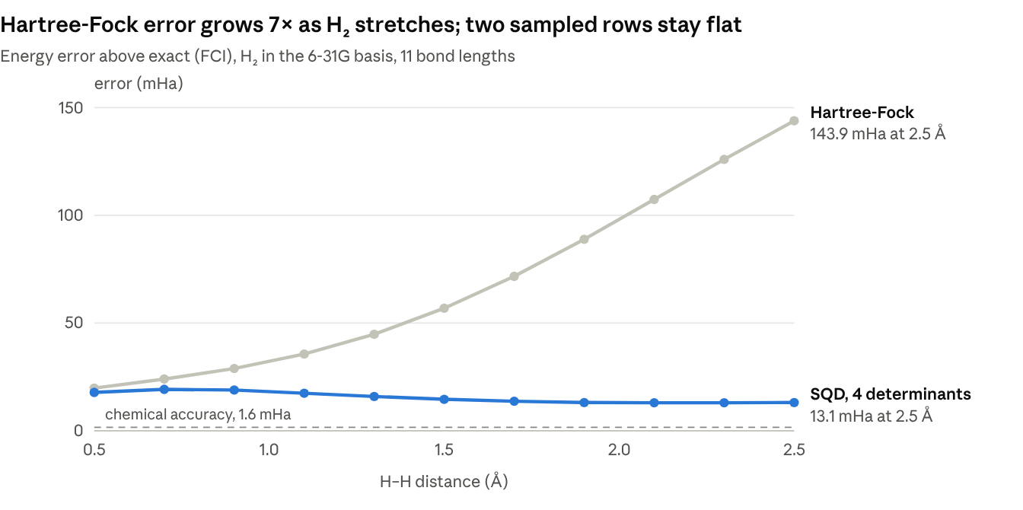
Computed with PySCF 2.14.0 and qiskit-addon-sqd 0.12.1 · H₂, 6-31G, 0.5 to 2.5 Å · same setup as notebook 02, Your turn 2
The exact ground state explains the gap: the double-excitation configuration carries 0.6% of the weight at 0.74 Å but 34.8% at 2.5 Å, so a single configuration can no longer describe the molecule. Neither curve reaches chemical accuracy; that needs determinants outside the two supplied rows.

4.3 N₂ and water (notebook 03)
Hartree-Fock misses stretched N₂ by 309.0 mHa and CCSD by 13.77 mHa. For water, Hartree-Fock misses by 49.48 mHa and CCSD by 0.12 mHa. The table gives SQD's error (lower is better; chemical accuracy is 1.6 mHa).
Molecule (qubits) | Sample noise | 1 pass (mHa) | 6 passes (mHa) | Determinants after 6 passes | Share of all valid determinants
N₂ (16) | none | 15.49 | 15.49 | 380 | 12%
N₂ (16) | 2% | 3.53 | 0.42 | 2,208 | 70%
N₂ (16) | 5% | 1.36 | 0.07 | 2,756 | 88%
H₂O (12) | none | 12.46 | 12.46 | 36 | 16%
H₂O (12) | 2% | 0.11 | 0.04 | 168 | 75%
H₂O (12) | 5% | 0.11 | 0.003 | 210 | 93%
N₂ has 3,136 valid determinants in this active space (56 × 56) and water 225 (15 × 15). Clean N₂ samples held only 99 distinct rows, against 850 with 2% noise. All values come from one seeded run; notebook 03 varies slightly between runs because circuit compilation is randomized (a second run gave 0.63 mHa for N₂ at 2% noise and 6 passes).

5. Discussion and conclusion
SQD's accuracy is set by which configurations the samples cover, not by how many samples are taken. This one idea explains every result above.
Coverage limits accuracy. Clean N₂ samples held only 99 distinct rows, so every recovery pass rebuilt the same 380-determinant space and the error stayed at 15.49 mHa. Water behaved the same way (36 determinants, 12.46 mHa). In notebook 02, 50 perfect shots from the exact H₂ state all landed on the Hartree-Fock configuration, because it carries 98.6% of the weight: repeated heavy samples add nothing new.
Why Hartree-Fock fails when a bond breaks. Hartree-Fock places both H₂ electrons in one orbital spread over both atoms, so half of its description puts both electrons on the same atom. That is a poor picture once the atoms are far apart, which is why its error grew to 143.9 mHa. Mixing in the double-excitation configuration cancels this wrong part, which is why two rows kept the error near 13 mHa.
Why recovery helped noisy samples. Bit flips left only 73% (2% noise) or 48% (5% noise) of rows with correct electron counts. Recovery repaired the rest into valid configurations that the clean circuit never produced, growing the N₂ subspace from 380 to 2,208 determinants over six passes. Each pass also refined the orbital occupancies used for the next repair, so the error kept falling (3.53 to 0.42 mHa).
Limits of these results.
- The noise was a simulated, independent bit flip added after sampling, not the correlated noise of real quantum hardware.
- "Noisy beat clean" here is not evidence that noise helps in general. Noise plus recovery happened to diversify the samples; a better circuit or more distinct samples should achieve this more reliably.
- Our molecules are small: the best subspaces covered 70% to 93% of all valid determinants, so near-exact energies partly reflect system size. Water near equilibrium is also easy for CCSD (0.12 mHa). SQD matters where the full space is far too large for exact diagonalization.
- Notebook 03 results vary slightly between runs because circuit compilation is randomized.
Conclusion. We built SQD from a cropped matrix on a spin chain up to a full molecular pipeline with circuit sampling, noise and configuration recovery, and completed every item in our plan. Both N₂ and water reached chemical accuracy after six recovery passes on noisy samples. Natural next steps are running the sampler on real IBM quantum hardware, stretching water's O–H bonds where Hartree-Fock fails, and moving to systems too large for an exact reference.

6. Declaration of assistance and resources
We used one AI assistant, the challenge materials, open-source software and their documentation. All results come from code we ran, and we can explain every method and result in this report.
AI tools: Claude (Anthropic) October 2026
Use | How it contributed
Concept learning | Built a structured self-study course on SQD foundations (qubits, Hamiltonians, ground-state concentration, subspace cropping), which we used to prepare for the challenge
Concept clarification | Explained concepts as we worked through the notebooks: electron configurations as bitstrings, alpha and beta spin, basis sets (6-31G, STO-3G), molecular integrals (hcore, eri, e_core) and determinant basis states
Environment setup | Diagnosed a missing-package error (ModuleNotFoundError: pyscf) and installed the required chemistry libraries (PySCF, qiskit-addon-sqd, ffsim)
Exercise support | Provided guidance and reference code for the four exercise cells in notebooks 02 and 03, consistent with the solutions included in the notebooks, and ran test copies to verify the software setup. We ran all three notebooks ourselves
Analysis extension | Proposed the water noise × recovery-iterations study and drafted its code; computed the H₂ bond-dissociation values plotted in Section 4
Report preparation | Helped structure and draft this report from our notebook results; we reviewed and edited the final text

Challenge materials and references
- UIQC Qiskit Fall Fest 2026 SQD challenge notebooks 01 to 03, in the challenge repository
- J. Robledo-Moreno et al., Science Advances, arXiv:2405.05068: the SQD method, cited by notebook 03
Software and documentation
- Qiskit 2.5.2 and Qiskit Aer (simulator)
- qiskit-addon-sqd 0.12.1: solve_fermion and configuration recovery
- PySCF 2.14.0: integrals, Hartree-Fock, CCSD and FCI references
- ffsim: the UCJ ansatz circuit
- NumPy and Matplotlib

