SmokyProbe Manual

Electrical characteristics
Voltage*: min 8V - max 30V
Voltage*: stabilized 5V
* Selectable by jumper J1 and J2 configuration
Minimum required input power: 5 W + output consumption
Maximum output current: 10A/channel (protected by resettable fuses)
Maximum total output current: 30A (unprotected)

BEFORE POWER ON THE BOARD
- Check JP1 and JP2 configuration
- Check JP4 and STM32 power jumper (JP2)

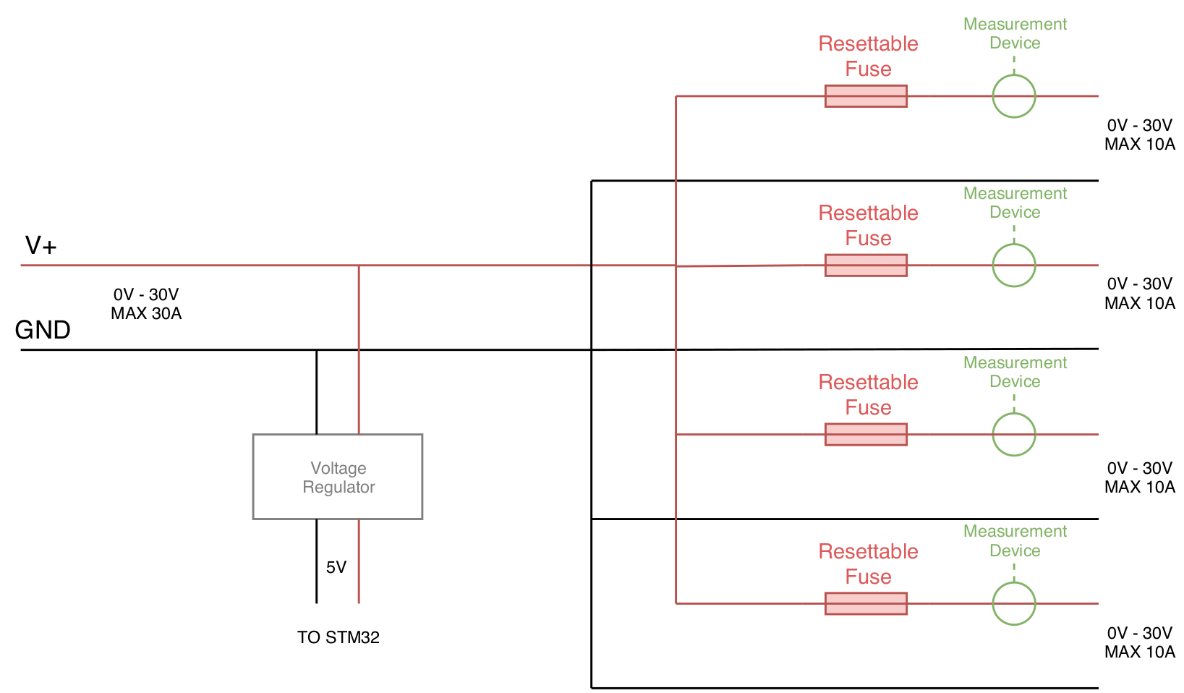
Logic Scheme

Jumpers configuration

WARNING! PAY ATTENTION TO THE JUMPERS CONFIGURATION! THE BOARD OR THE STM32 COULD BE IRREMEDIABLY DAMAGED IF JUMPERS ARE NOT CORRECTLY SET

JP1 & JP2
Jumpers 1 and jumpers 2 configure the on-board voltage regulator. JP1 and JP2 could be left unconnected if the power to measurement ICs is provided by STM32. If connected, they must be configured with the same configuration or no power is provided to the board. Selecting the wrong voltage may damage the board.

If V+ >= 8V:
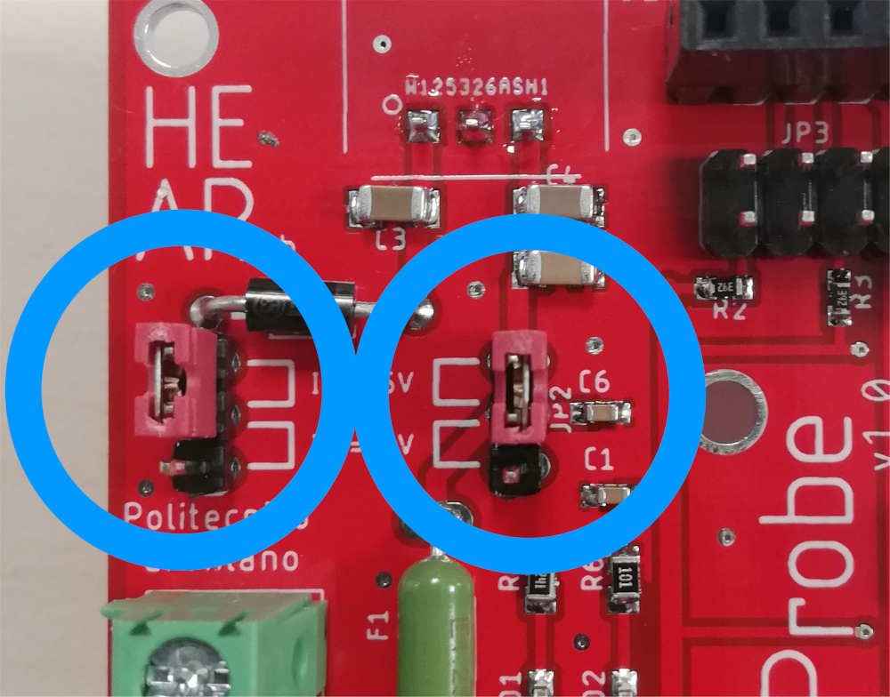

If V+ = 5V:

DO NOT USE THIS J1 AND J2 CONFIGURATION IF V+ > 5V!
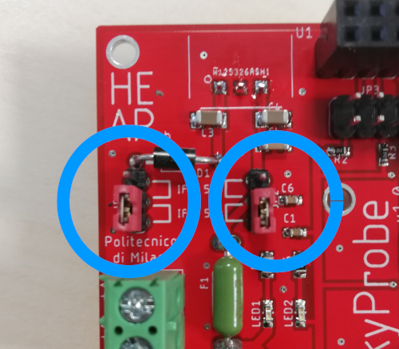

JP4
The jumper JP4 configure the power connection between the STM32 and the SmokyProbe board. The 5V line provides power from SmokyProbe to the STM32. Instead, the 3V3 line provides power from STM32 to SmokyProbe.

Common configurations:
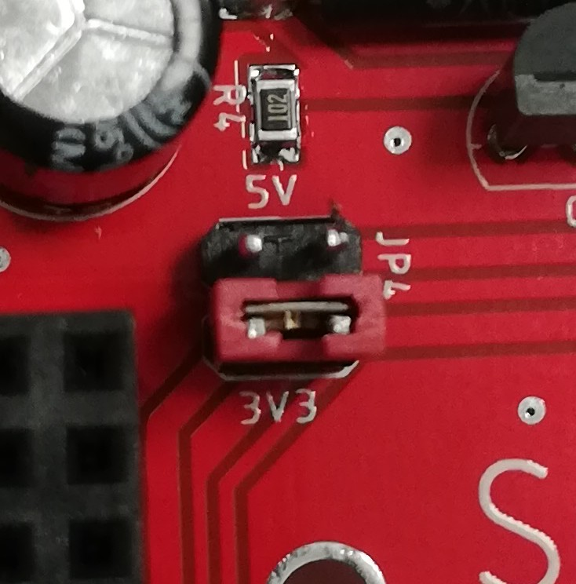

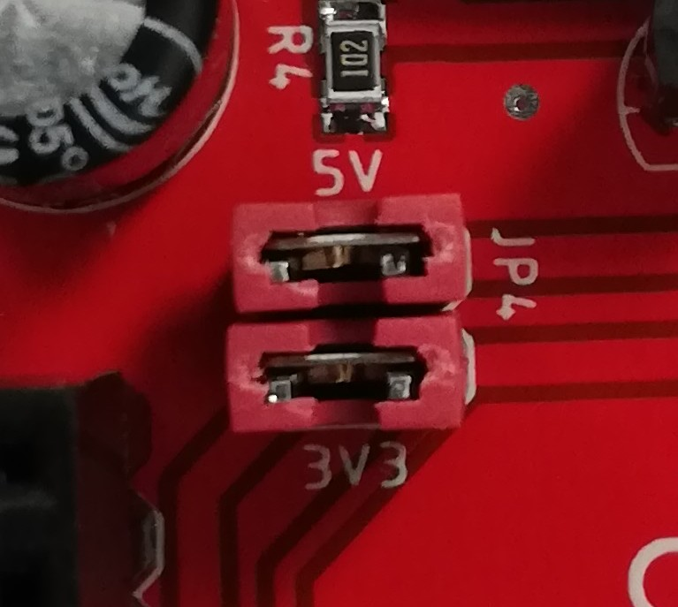
STM32 Self-powered
NOTE:
Configure the STM32 jumper according to the power source

STM32 Powered by the SmokyProbe voltage regulator
NOTE:
Configure the STM32 jumper to be E5V

JP3
This jumper selects the STM32 I2C line used by SmokyProbe. Only two possible configuration can be used. Other jumper configurations are not allowed.

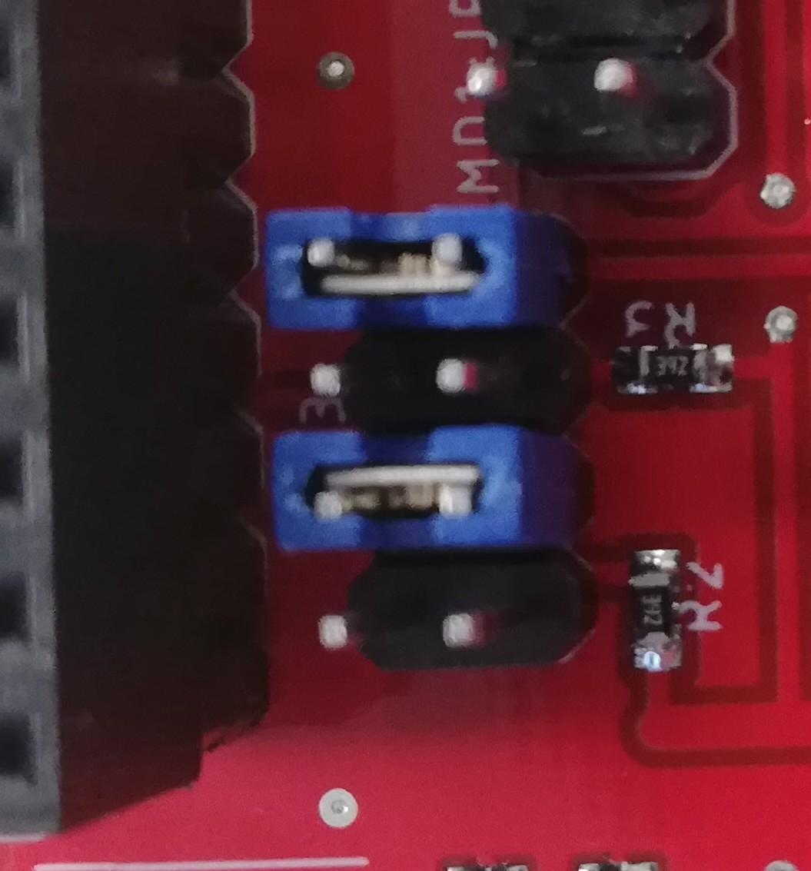

Primary STM32 I2C1 line

STM32 pins: PB8/PB9

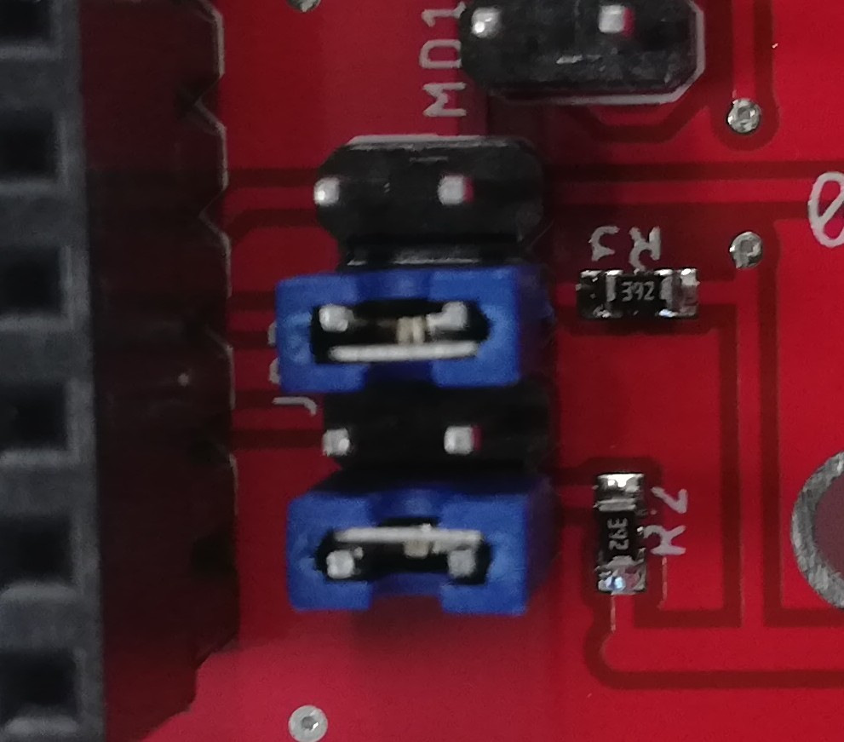

Secondary STM32 I2C2 line
STM32 pins: PB10/PB11

MDX:JP3
These jumpers set the addresses of the four I2C measurement ICs. Please refer to the INA233 datasheet to convert the following A0/A1 to the actual I2C address value.

A0 connection:
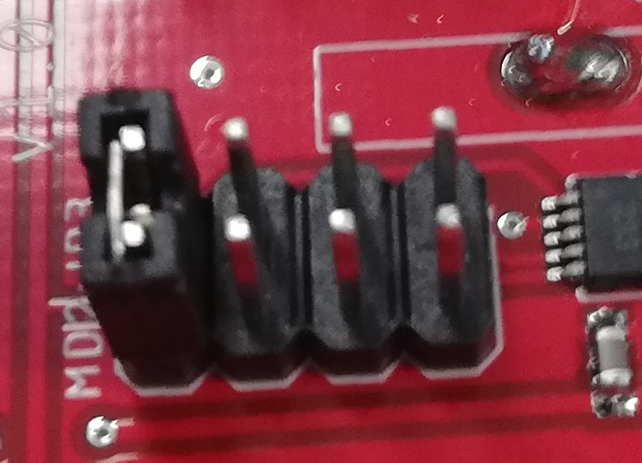  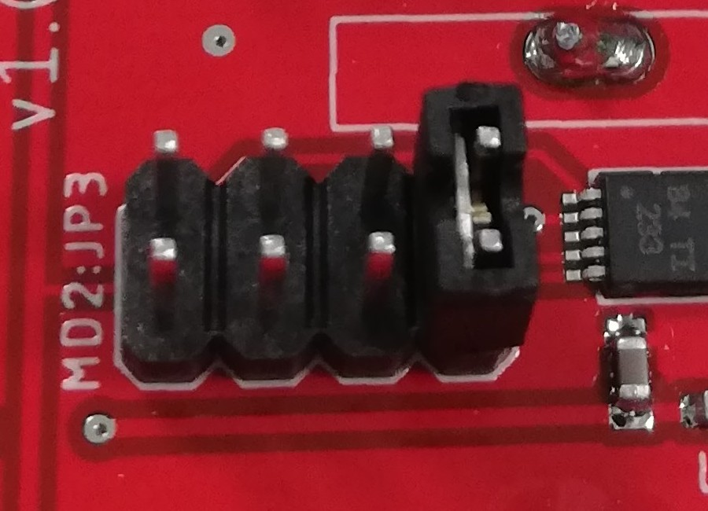 | 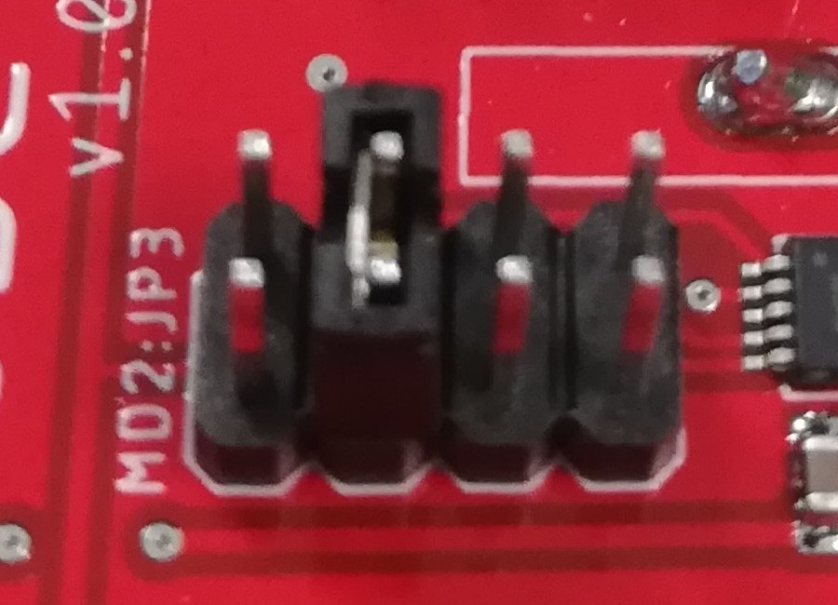 | 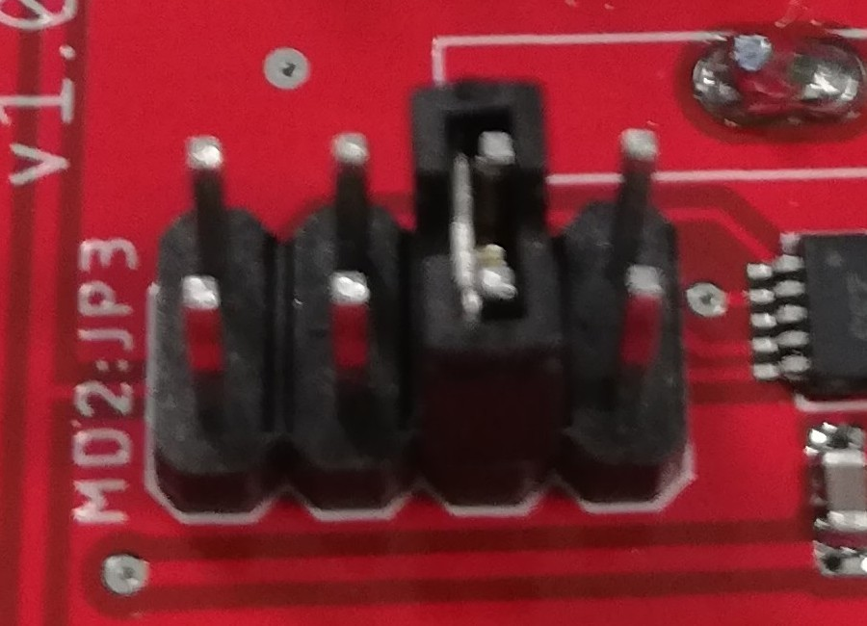
VS | SDA | SCL | GND

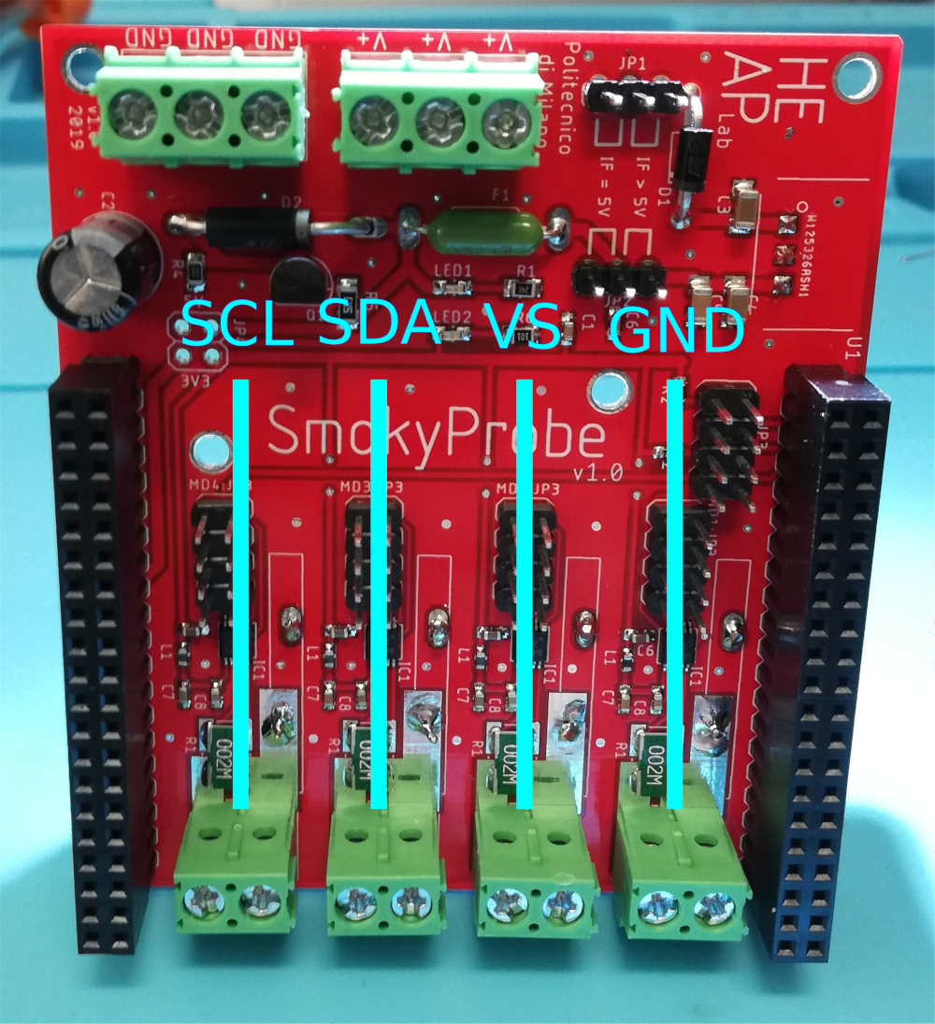
A1 connection:

(A1 values are fixed and cannot be changed)

Shielding
The female connector has one extra row compared to the male connector of the STM32. The two unconnected female pin (and the two on the other side) that must remain unconnected are the ones near the HEAP Lab logo.
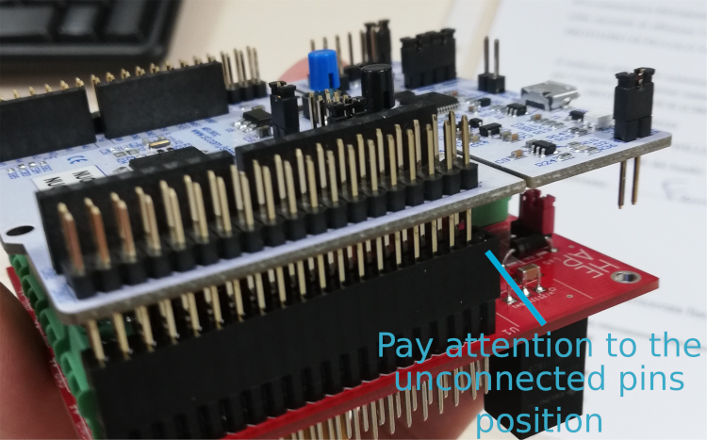
WRONG CONNECTIONS MAY DAMAGE SMOKYPROBE OR THE STM32

