Analysis of the initial system Amber ARM-compatible core.
So, I decided to port the ARM-compatible processor with opencores.org our Marsohod2 fee .
To download the sources from the site opencores first need to register on it. After that actually becomes available downloads.
Go to the project page: http://opencores.org/project, amber
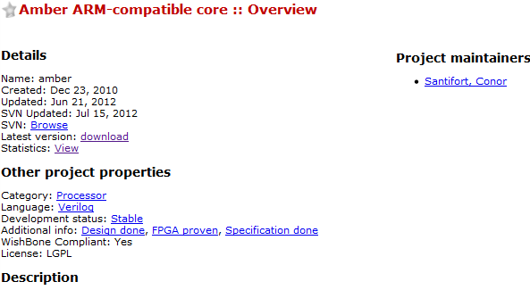
The Amber processor core is an ARM-compatible 32-bit RISC processor. The Amber core is fully compatible with the ARM ® v2a instruction set architecture (ISA) and is therefore supported by the GNU toolset. This older version of the ARM instruction set is supported because it is still fully supported by the GNU tool chain and is not covered by patents so can be implemented without a license from ARM. The Amber project provides a complete embedded system incorporating the Amber core and a number of peripherals, including UARTs, timers and an Ethernet MAC.

The first impression is very good. Written in Verilog, which I am studying. Project seems stable, proven in FPGA.They say there's specification. License LGPL. Last update of the project - a little more than a month ago, so he lives and improved. According to statistics, downloads can be seen that the project is very popular. Let's see what's next.
Download it by direct link (but you can take and through SVN).
Got amber_latest.tar.gz file size 3,601,132 bytes. Yeah, the file type as it suggests that the underlying operating system project developer (author Santifort Connor) was Linux.
Okay, unpack the archive and will see what's inside. Thus, we can understand more precisely what we have in hand. After a rather superficial examination can say the following:
- Project Amber - it's not clean processor is a system-on-chip. Top module project - this Verilog file amber / trunk / hw / vlog / system / system.v
- If I am not mistaken, the system contains the actual processor Amber, timer, interrupt controller, memory controller, DDR, serial port, Ethernet. All components are combined on a bus Wishbone BUS. How many things I did not expect ..
- The system is built for some cards based on chip FPGA company Xilinx. We have to work hard to run it on Altera.
- A bit odd that the processor itself has no input asynchronous reset. It seemed to me that in large systems it would be better to have it.
- It turned out that Amber - this is not one, but two similar processor and Amber23 Amber25. Amber23processor has a 3-stage pipeline. Amber25 - 5-phasic. Amber23 involves two 32-bit bus Wishbone, andAmber25 - 128-minute bit. Apparently Amber25 faster and requires more logic in FPGA.
- Amber realizes the system commands ARM v2a. This is a pretty old system the ARM processors.Implemented it solely because the company is not covered by patents ARM, therefore does not require a patent license fees. On the other hand - say that the GCC compiler supports this system commands, then we will be able to write programs in C.
- Detects that the processor has a built-in cache memory. In addition, the system has BOOTROM - memory that stores the very first program started after the start kotoroya processor.
After a cursory inspection of the source programs can already try to make a rough plan of action. And he probably will not be small. We need:
- Create a project for Altera Quartus II. Included in the draft all the necessary files from the source project Amber. Surely something will not compile. Trying pofiksit.
- Dwell on Amber23, as more simple processor. I am sure that it will last us.
- In the first phase of the project vykusit all superfluous, what is not useful either never or not useful at the initial stage. For example, our board has no Marsohod2 DDR memory, but has SDRAM. So removing DDR.You can temporarily remove the Ethernet, then we'll see. It is desirable to retain only the most necessary, possibly only the CPU and BOOTROM for ease of initial experiments. Well, maybe even leave the serial port? Let's see .. apply for conditional compilation "off" is not relevant modules.
- Certainly have to make their generation module clock frequencies. They are typically made in the on-chip FPGA components PLL. Naturally, they have Xilinx and Altera are different. Because of this, and do not foresee compatibility projects.
- Similarly, paragraph 4 foresee a problem with static memory. It is used for cache memory and BOOTROM.Components for static memory in FPGA Xilinx and Altera for the course will be different. Need to see what is required.
- Here's another problem. In BOOTROM need to put the initial program, which starts with the processor. First, you need somewhere to take compiler for ARM. Learn how to use it. Then what you need to generate it somehow placed in BOOTROM, ie SRAM FPGA. Altera to initialize memory uses a special type of file MIF - Memory Initialization File. It would not have had to convert files from one format to another.
- Make an appointment inputs and outputs for the project under the scheme fees Marsohod2. Since initially want to throw out all the excess and leave only the most necessary, then I think we will have so far only a few inputs and outputs: clock frequency clk, reset asynchronous reset, the two signals are serial port Rx and Tx.Perhaps even led?
- So yes, what to do with discharge? On the processor is no such entry! It may add to the project sources Amber? Or I do not understand something. I would like to have a reset input to the board Marsohod2 button.I push the button on the board - the processor is reset and starts from the beginning.
And of course, who believe that it's all here so soon starts up and running on the board Marsohod2? Could do without the simulation project? I think it's unlikely. Certainly there are a million nuances that no simulation is difficult to understand. Undecided than simulate: may Icarus Verilog, maybe ModelSim. In any case, the simulation of course we will need. We're sure to want to look inside the processor, how does this work? So we write testbenchi.
As you can see a lot of work. But, we are not accustomed to retreat! Will work!

Transfer Project Amber Wednesday Altera Quartus II card Marsohod2
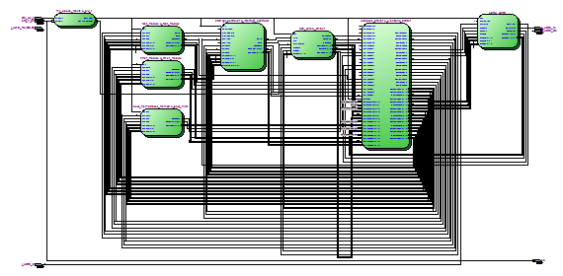
According to our plan , we begin to adapt the project to the board Marsohod2 Amber. Now we do not need to go into the finer details, you just need to try to compile the project formally on the capability with minimum modification.
1) Carefully examine the file structure of the project Amber. There are three main folders: doc, hw and fw.Apparently «hw» denotes hardware, and «fw» - this firmware. Inside that folder create a new folder hw marsohod2- there will be all otnosyasheesya to our new project for Altera Quartus II and Marsohod2 board.
2) In general, the top module project Amber - it hw / vlog / system / system.v
I decided not to modify it, because maybe there will be many changes. So I just copy it to your folder under a new name hw/marsohod2/msystem.v. Now my top module will review this file.
3) Create a new project with Altera Quartus II mARM name in this folder hw/marsohod2. Detail to paint this step will not, I hope our website http://marsohod.org can find this information. Most importantly for the project to appoint:
- type of FPGA chip on the board in Marsohod2 - EP3C10E144C8;
- in the project settings Device and Pin Options desirable to set an option in the state Unused pins As Input tri-stated.
- need to make an appointment under the scheme pin board. But there is not so easy, because we do not know really what the inputs and outputs have to be in the project. It must not forget to do so later.
4) added to the project until a single file and make it msystem.v module Top Level menu Project => Set As-Top Level Entity.
5) From the top of the module msystem.v delete everything related to DDR. On our board it is still there. Where there is a question of Ethernet turn it off until - suddenly come in handy later? Turn very simple, write Verilog design for conditional compilation, like this:

`Ifdef ETHERNET
eth_top u_eth_top (
. Wb_clk_i (sys_clk),
. Wb_rst_i
.....
`Endif

At the same ETHERNET nowhere defined using `define, then part of the code will be excluded at compile time. I hope we can once it is still included in the future?
6) Create your clock generation module instead of the original hw/marsohod2/my_clocks_resets.v hw / vlog / system / clocks_resets.v. Then I just apply conditional compilation:

`Ifdef MARSOHOD2
my_clocks_resets u_clk_r (
. I_brd_rst (brd_rst), / / from board button
. I_brd_clk (brd_clk_p), / / from board crystal
. O_sys_rst (sys_rst), / / main project reset made ​​out of board button reset
. O_sys_clk (sys_clk), / / main system clock
. O_system_ready (system_rdy)
);
`Else
clocks_resets u_clocks_resets (
. I_brd_rst (brd_rst),
. I_brd_clk_n (brd_clk_n),
. I_brd_clk_p (brd_clk_p),
. I_ddr_calib_done (phy_init_done),
. O_sys_rst (sys_rst),
. O_sys_clk (sys_clk),
. O_clk_200 (clk_200)
);
`Endif

Only now I'm in front, I want to define a macro MARSOHOD2, if it is defined, is chosen my part of the source code, if not specified, the original code. MARSOHOD2 can define a macro in the project settings Altera Quartus II menuAssignments => Settings and then in the dialog box Analysis & Synthesis Settings / Verilog HDL Input.
Generally module my_clocks_resets.v need to one of the input clock signal and a reset signal to make all of the system clock frequency and system reset. Theoretically, the system may have multiple clock frequencies for different needs. We still will not, but at least it must be provided. Again, I still can not say at what frequency will work our processor. Need the ability to somehow change the system clock frequency.
For this I using the menu Tools => MegaWizard Plug-in Manager to create a component PLL and insert it into my generation module clock. PLL components can be adjusted to set the coefficients of multiplication and division of the clock frequency. About PLL can read more here .
I do not know. Clock on board has Marsohod2 frequency 100Mhz. One can simply divide the frequency by two, albeit the system frequency is 50Mhz?
6) Start to compile a project using Altera Quartus II. When the compiler says that some file is missing, then look for Verilog file on disk in a subfolder of hw / vlog / file found and add to our project. So in the end we find out what is really needed files.
7) Here's another problem. In top module detects this code here:

`Ifndef XILINX_FPGA
/ / ======================================
/ / Instantiate non-synthesizable main memory model
/ / ======================================
main_mem # (
. WB_DWIDTH (WB_DWIDTH),
. WB_SWIDTH (WB_SWIDTH)
....

We do all that is connected with DDR removed, macro XILINX_FPGA not identified. Now trying to compile in Quartus project module main_mem, which actually is not a model sintiziruemoy main system memory on the chip.This module will have to shut down as well.
6) Gradually add new files to the project. Strangeness - file a23_decode.v declared register named type - the type of the decoded instructions of the processor. For Altera is a reserved name. Quartus II generates an error at this point. I had to rename type in itype throughout the text.
7) When you compile the Quartus II project hangs naturally and now understood why. One can not compile modulegeneric_sram_line_en, it looks like a model of static memory. There's a Verilog file hw/vlog/amber23/a23_cache.vhave code:

generate
for (i = 0; i <WAYS; i = i +1) begin: rams
/ / Tag RAMs
`Ifdef XILINX_SPARTAN6_FPGA
xs6_sram_256x21_line_en
`Endif
`Ifdef XILINX_VIRTEX6_FPGA
xv6_sram_256x21_line_en
`Endif
`Ifndef XILINX_FPGA
generic_sram_line_en
`Endif

Seen the project could be used with chips Xilinx Spartan and Virtex. If the corresponding macros are not defined, the code includes generic_sram_line_en.
Actually, there are built-in FPGA memory blocks. For them, there are special components, the alter it, for example,altsyncram. On its basis, setting its parameters can be made of different modules and the bit volume.
There had to tinker.
Create the basis altsyncram (using Altera Quartus II MegaWizard Plug-in Manager) and its componentsmy_sram_256_21_line_en my_sram_256_128_byte_en module cache and a23_cache.v and another formy_sram_2048_32_byte_en boot_mem32.v - there happened this same story - not compiled and Quartus hung.
But after all these, and other, smaller changes can be compiled.
A miracle happened - I was able to compile the project formally!
Netlist Viewer shows which modules we exist / remain in the project (see above graphic to the article):
- my_clocks_reset;
- timer_module;
- test_module;
- boot_mem32;
- interrupt_controller;
- a23_core;
- wishbone_arbiter;
- uart.
Course load in the FPGA project is still impossible.
First, the location is not assigned to the input and output signals. Secondly, boot_mem32 contains no proper initial program, which should be executed when the processor.
These issues have to be addressed.
Naturally, while the project is to download I can not lay still his poroblvat impossible. But you can see the changes in our project System-on-Chip (SOC) in github repository: https://github.com/marsohod4you/Amber-Marsohod2
The next thing to do - to write and compile for ARM processor running a program and put it in the code BOOTROM our system. That's when we try it.

Installing ARM cross-compiler
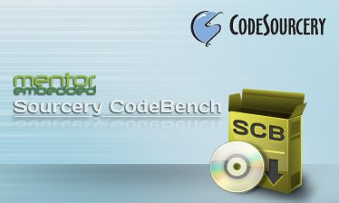
Continue to build a system-on-chip Amber for Marsohod2 board .
For any processor need a program. Theoretically possible to write a program in assembler or C / C + +. Amber to run the project in our board Marsohod2 course we have to write and compile programs. How to do it?
As you can see in the folder sw / Amber project are all sorts of different programs. Usually novice programmers write programs like "hello world". Well and here we see a folder sw / hello-world with multiple files: hello-world.c, start.S, Makefile, sections.lds.
Hellow-world.c essentially contains a very simple program in C:

# Include "stdio.h"
main ()
{
printf ("Hello, World! \ n");
/ * Flush out UART FIFO * /
printf ("");
_testpass ();
}

Printf function prints a formatted text string to the console, and the console with us - it seems the serial port.
Are like other project folders Amber - nothing like the compiler can not see. But in the doc folder there is a description of the project in English amber-spec.pdf.
That's where, in Chapter 10.2 Installing compiler all we need is written.
Try to execute instruction contained therein.
1) go to the first link in the documentation specified http://www.codesourcery.com/sgpp/lite/arm and get to the site mentor.com!
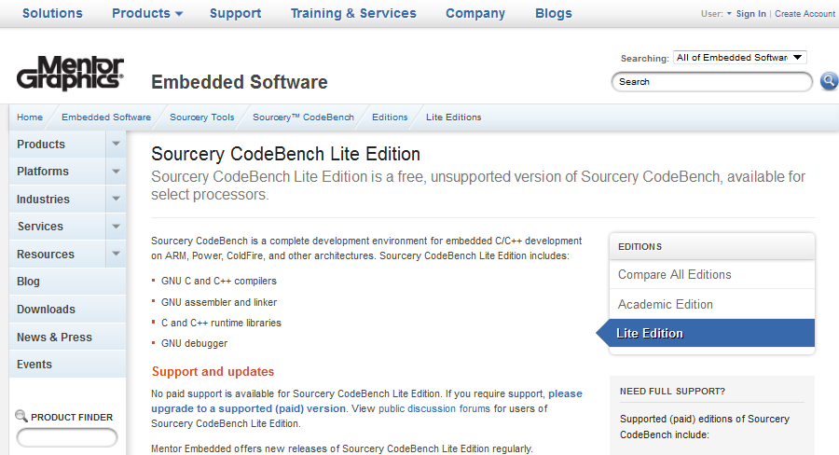
2) The documentation is a screenshot of the target page, but what I see is very different from the documentation.However, read carefully, perhaps here there is still necessary to us the link to download? And perhaps this is my user guide once obsolete when mentor.com again will change your site's pages ..
3) Below see that you can deflate free (free) compiler Sourcery Codebench Lite Edition for multiple platforms. Of course, choose the ARM, the link "Download GNU / Linux Release” http://www.mentor.com/embedded-software/sourcery-tools/sourcery-codebench/editions/lite-edition/arm-gnu-linux
4) Appears that's such a page - will have to fill the form with your name and surname email, before we will download the file. Zaponyayu form and press the button Get It.
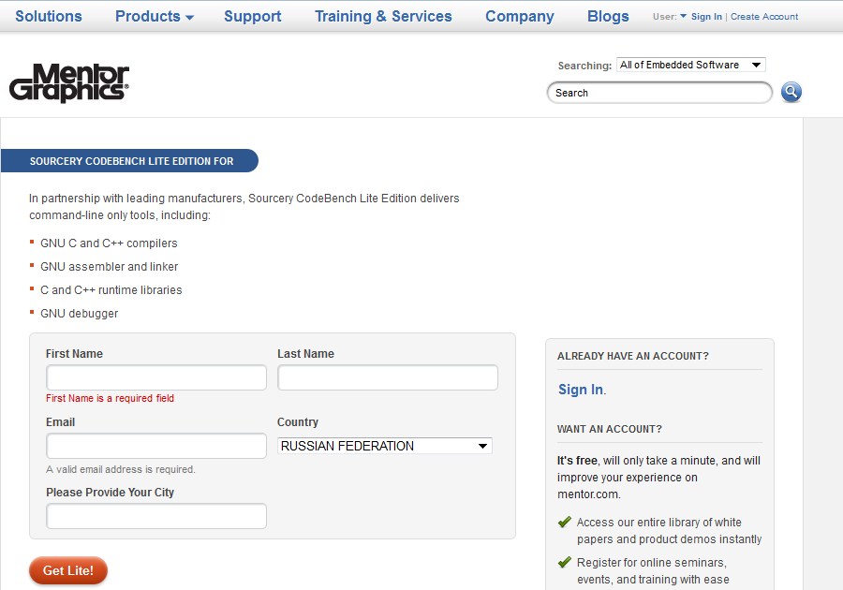
On the next page, I was told that the mail was sent a link to download Sourcery Codebench.
5) It is. I got a letter from them. I pass by reference.
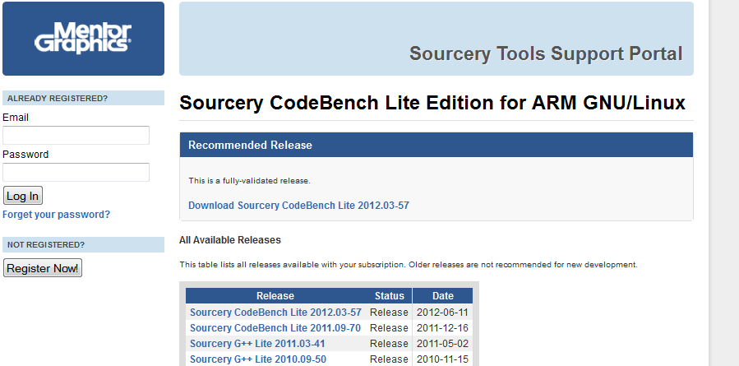
Last page, where you can download! By the way it seems you can select the compiler running under Linux or running Windows. I still choose to Linux.
In fact, I tried to extort compiler for Windows. Such a beautiful instalyashki him. We pose no problems, only use for our purposes just does not work. There are two problems:
- Sources for Amber have Makefile, which describe how and what to build. To use the Makefile need to have installed the program make - it's such a special utility. In principle, there seems to make for Windows, but to be honest it was too lazy to look. In my Linux program seems to make the default was to begin with.
- Some project folder Amber, eg, sw / tools are executable scripts *. Sh. Probably they also could be run in Windows, but did not mess with that.
I have a virtual machine with Ubuntu - and used it, put everything there.
I received a file from a site Mentor arm-2012.03-57-arm-none-linux-gnueabi.bin
It must be set as executable commands Linux:
chmod a + x arm-2012.03-57-arm-none-linux-gnueabi.bin
then run
./arm-2012.03-57-arm-none-linux-gnueabi.bin
and respond to all questions by pressing Enter. After that, the home folder appears CodeSourcery folder and everything in it and installed.
Thus, the compiler gets installed.
To compile the source code for our Amber need to set an environment variable
export AMBER_CROSSTOOL = arm-none-linux-gnueabi
and add to the PATH variable path to the compiler
export PATH = $ PATH :/ home / nick / CodeSourcery / Sourcery_CodeBench_Lite_for_ARM_GNU_Linux / bin
I wrote the following initialization file sw / init that sets these variables. Now when you run the terminal in Linux, you can simply type in the project root
source sw / init
and all - development environment is almost ready.
What else?
Yes, that's still in the scripts folder sw / tools are run. To fix this, they need to ask the right execution permissions
chmod a + x sw / tools / *. sh
Now if you go, for example, a folder sw / hello-world and dial
make
then there is a compilation of programs and there are different object and text files - the actual result of the compilation.

Compiling hello-world for Amber ARM SoC
So, for our system on a chip need a program that would be launched from the bootrom. Naturally, you need to start with something very simple. In our project folder Amber has such a program sw / hello-world. I understand when the processor it should be displayed in the console to the serial port that's the message "Hello, World!".
Try it!
I did not make any changes to this program. Instead, I created a copy of this folder sw / hello-world-my already here and will make changes.
Actually, you can track all changes in GitHub https://github.com/marsohod4you/Amber-Marsohod2 , where I work on the project.
Compile the program is very easy. Compiler Sourcery CodeBench we already installed . After starting the terminal in Linux you need to dial once in the console

source sw / init

to install the necessary environment variables. Then for compilation:

make

After compiling, if no errors appear many new object and text files *. O, *. Elf, *. Map, *. Mem and others. In fact, I'm interested in the file hello-world.mem it as described in the text contents of the memory bootrom.
This file looks something like this:

/ / Section name. Text
/ / Type SHT_PROGBITS, Size 0xddc, Start address 0x00000000, File offset 0x8000, boffset 0
/ / Section name. Text.startup
/ / Type SHT_PROGBITS, Size 0x24, Start address 0x00000ddc, File offset 0x8ddc, boffset 0
/ / Section name. Rodata.str1.4
/ / Type SHT_PROGBITS, Size 0x24, Start address 0x00000e00, File offset 0x8e00, boffset 0
/ / Section name. Rodata.str1.1
/ / Type SHT_PROGBITS, Size 0x7, Start address 0x00000e24, File offset 0x8e24, boffset 0
/ / Section name. Bss
/ / Type SHT_NOBITS, Size 0x4, Start address 0x00000e2b, File offset 0x8e2b, boffset 3
/ /. Bss Dump Zeros
/ / Section name. ARM.attributes
/ / Type???, Size 0x2b, Start address 0x00000000, File offset 0x8e2b, boffset 3
/ / Section name. Shstrtab
/ / Type SHT_STRTAB, Size 0x62, Start address 0x00000000, File offset 0x8e56, boffset 2
/ / Section name. Symtab
/ / Type SHT_SYMTAB, Size 0x3a0, Start address 0x00000000, File offset 0x9048, boffset 0
/ / Section name. Strtab
/ / Type SHT_STRTAB, Size 0x167, Start address 0x00000000, File offset 0x93e8, boffset 0
@ 00000000 e3a00000
@ 00000004 e13ff000
@ 00000008 e3e00000
@ 0000000c ee030f10
@ 00000010 e3a00001
@ 00000014 ee020f10
@ 00000018 e59fd004
@ 0000001c eb00036e
@ 00000020 ea000110

Here there is a problem - the file can not be used in projects Altera Quartus II. In an environment in Quartus II FPGA can create static memory blocks and set the initial memory contents by using the so-called Memory Initialization File, MIF.
So I wrote a small utility to convert the file into MEM MIF file. It is located in the project folder sw/tools/mem2mif. Its the same need to first compile: open sw / tools and type make. Now, being in your hello-world can convert the resulting file to the mem mif file with the command in the console

../tools/mem2mif hello-world.mem> hello-world.mif

Now tell me about the changes made:
First. Somehow, it is unclear why the file sections.lds start address of the program was established in 0x8000

ENTRY (main)
SECTIONS {
. = 0x008000;
. Text: {start * (. Text); * (. Text); }
. Data: {* (. Data); }

It is very strange, as the comments above written in the same section.lds:
/ / Description / /
/ / Sections linker file for the hello-world application. / /
/ / Note that the address map starts at 0x0 because this is / /
/ / A stand-alone application, not using the boot-loader. / /
/ / As such, it would need to be put into the FPGA during / /
/ / Synthesis.
I honestly do not know what this file section.lds, but drew attention here because when you compile the file mem starting from scratch to address 0x8000 contain zeros. Well, this can not be. The fact that the memory of the FPGA is quite limited resource. I can not think that it was used as wasteful. In general, set the base address of zero. Pure common sense.
The second change, which I did - in the file start.S suffered address of the stack pointer. They have been in the system memory DDR, and we do not have external memory. I put the stack at the top of memory bootrom - 0h1FF0 until there seems to have some space.
And the third change, which I did - corrected the message "Hello, World!" To "" Marsohod2: Hello, World! "Well it is - a cosmetic fix.
Now compile and convert to MIF file:

make
../tools/mem2mif hello-world.mem> hello-world.mif

Is a file hello-world.mif that we need to somehow connect to bootrom project. How to do it?
If the Altera Quartus II menu command Processing => Start => Analisis & Elaboration, then after that in Project Navigator can see the hierarchy of the project. There bootmem component and components of which can be seen it prostroen.
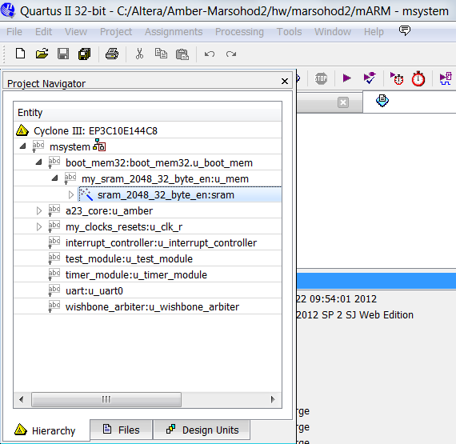
The lowest in the hierarchy - sram_2048_32_byte_en: sram, he is depicted with a magic wand. Click on it - opens Wizard (which I created this component and in the beginning).
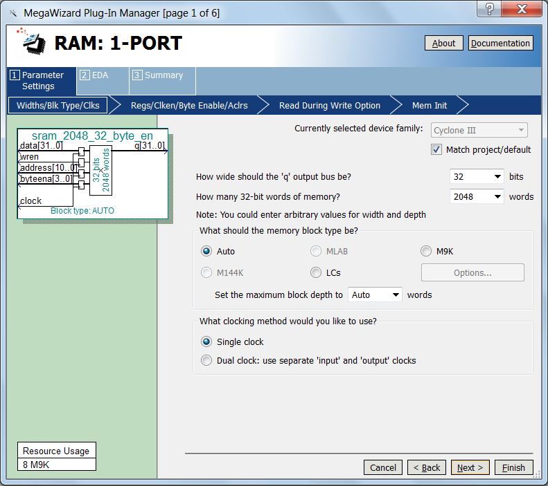
On page 4, you can specify wizarda initial memory contents after the FPGA. There I ask hello-world.mif.
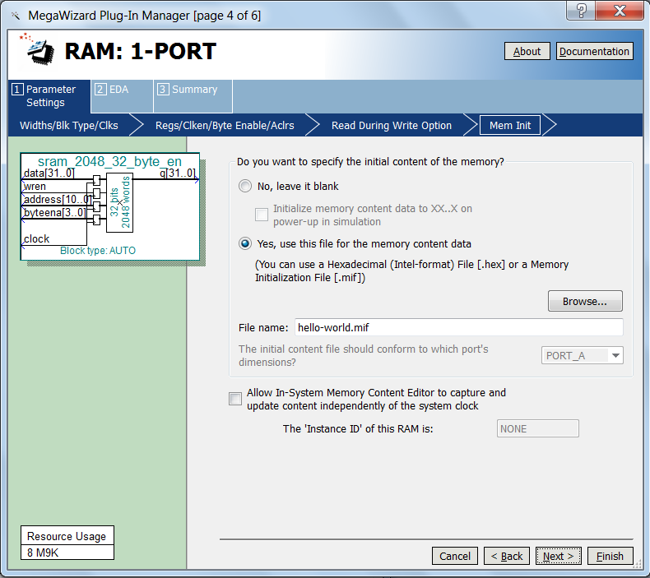
Well, in general, seems to be all set.
Compile the project. Run the programmer still run a terminal program PUTTY and it open my COM9, expecting to get the console message Marsohod2: Hello, World!
Uploading project of FPGA programming, and that (there Ta-ra-ram!!) - Nothing happens ...
Well, as it so happens. Something else is not taken into account. Obtained as in the best detective novels, while only tie plot
In fact, there are still some obscure points. For example, I do not know at what speed data transfers Amber COM-port. Although the options are not so much - trying to open port at different speeds reception I am increasingly convinced that the project does not work.
I will fix it.

Amber simulation project with Icarus Verilog.
After the first unsuccessful attempt to start a project in Amber board Marsohod2 need to think about what to do next. There are several options:
- Trying to explore the processes occurring inside the FPGA using Altera SignalTap .
- Try to simulate in ModelSim .
- Try to simulate with Icarus Verilog .
The first point - use SignalTap, allow "live" to see some signals within the processor Amber, but the problem is that I do not know exactly where to look, what to look for signals. All at once of course we can see, the selection signals for subsequent research requires recompilation, which takes time (about 12 minutes on my laptop). So have to spend a lot of time researching on the iteration of one or another group of signals.
The second point is probably the most correct, as it will allow all prosimulirovat, including Altera native components like PLL or memory blocks ALTSYNCRAM.
Honestly, ModelSim I do not like - and the main reason is there are no general - quite normal tool. Perhaps I simply do not fully mastered.
I'll try to simulate using Icarus Verilog, simple console simulator. Of course, now my simulation is not complete, it will have limitations associated just with PLL and memory blocks.
So I define the variable ICARUS for conditional compilation. Now in file hw/marsohod2/my_clocks_reset.v installs an instance where PLL is conditional compilation:

`Ifdef ICARUS
assign pll_clk = i_brd_clk;
assign pll_locked = 1'b1;
`Else
/ / Insert altera's PLL
my_pll my_pll_inst (
. Inclk0 (i_brd_clk),
. Areset (1'b0 / * i_brd_rst * /),
. C0 (pll_clk),
. Locked (pll_locked)
);
`Endif

In contrast to the Quartus II project for the simulation with Icarus Verilog I would not define a variable conditional compilation MARSOHOD2. Then, for example, in a file hw/vlog/system/boot_mem32.v for program memory will be used instead of a component generic_sram_byte_en my_sram_2048_32_byte_en (which I created using Altera Quartus II wizard)

`Ifndef XILINX_FPGA
`Ifdef MARSOHOD2
my_sram_2048_32_byte_en
`Else
generic_sram_byte_en
`Endif
# (
. DATA_WIDTH (WB_DWIDTH),
. ADDRESS_WIDTH (MADDR_WIDTH)
)
`Endif
u_mem (
. I_clk (i_wb_clk),
. I_write_enable (start_write),
. I_byte_enable (byte_enable),
. I_address (address), / / 2048 words, 32 bits
. O_read_data (read_data),
. I_write_data (write_data)
);

Another subtlety - like Icarus Verilog does not support log2 (..), so I had to fix hw/vlog/amber23/a23_cache.v like this:

`Ifdef ICARUS
parameter CACHE_ADDR_WIDTH = 8 / / = 8
parameter WORD_SEL_WIDTH = 2, / / = 2
`Else
parameter CACHE_ADDR_WIDTH = log2 (CACHE_LINES), / / = 8
parameter WORD_SEL_WIDTH = log2 (CACHE_WORDS_PER_LINE), / / = 2
`Endif

In the project I added my folder hw/marsohod2/my_tb and there are now several new files:
- hello-world.mem - text file that describes the contents of the bootrom. Created when you compile hello-world.c compiler Sourcery CodeBench
- srclist - a list of all files in the project Verilog
- c.bat - batch file compiles the project using Icarus Verilog. In fact there is only one long command:iverilog-o qqq-g2005-DICARUS = 1-DAMBER_A23_CORE = 1-DNOMEMORY = 1-csrclist -I../../vlog/system / -I../../vlog / amber23 / -I../../vlog/tb /
- tb.v - my testbench. Based on the original project testbencha of Amber, which is in the folder hw / vlog / tb
The entire project is on GitHub https://github.com/marsohod4you/Amber-Marsohod2
Testbench itself you can watch right now here .
In testbenche have a copy of the module and the module instance msystem tb_uart - it will simulate a terminal program running on a computer - to accept and print characters. Testbench reads the file hello-world.mem and initializes bootrom before startup.
Actually log simulation in cmd console looks like this:

c: \ Altera \ Amber-Marsohod2 \ hw \ marsohod2 \ my_tb> c.bat
c: \ Altera \ Amber-Marsohod2 \ hw \ marsohod2 \ my_tb> iverilog-o qqq-g2005-DICARUS = 1 -
-I../../vlog/system / -I../../vlog/amber23 / -I../../vlog/tb /
c: \ Altera \ Amber-Marsohod2 \ hw \ marsohod2 \ my_tb> vvp qqq
VCD info: dumpfile out.vcd opened for output.
reseting ..
Load boot memory from hello-world.mem
Read in 951 lines
log file tests.log, timeout 0, test name my ARM simulation
go ..
Marsohod2: Hello, World!
* 0 *
* 1 *
* 2 *
* 3 *
* 4 *
** VVP Stop (0) **
** Flushing output streams.
** Current simulation time is 960856250 ticks.
> Finish
** Continue **
c: \ Altera \ Amber-Marsohod2 \ hw \ marsohod2 \ my_tb>

As you can see - the processor something works! In the console simulator an inscription "Marsohod2: Hello, World!" - This is the message that we derive printf function in our program in C.
By the way, as a result of the simulation we got out.vcd file and can be opened using the program and GtkWave poissledovat signals in the processor:
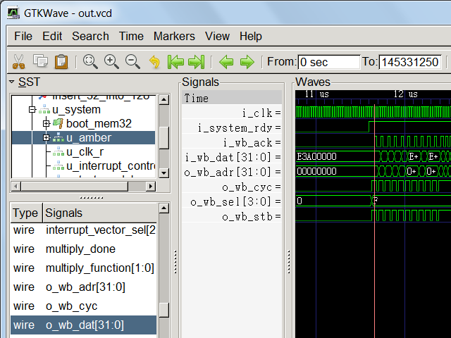
At least now we can look inside and see how it should be, that would work. Now it is possible to run SignalTap compare real signals in the FPGA to those that must be what they can be seen in the simulator.
Yes, it is still unclear why the project does not work in Marsohod2 board, but I'm sure that'll figure it out.

Amber ARM first runs on the board Marsohod2!
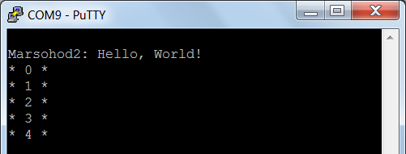
Now it works - after a few corrections in the project code Amber. Now the program hello-world, napisannnaya in C and compiled to run in ARM board Marsohod2. The program prints the message function printf (..), which sends it to us through the serial port at a speed of 921,600 bits / s. And it was so.
After simulation project in Icarus Verilog I was convinced that the project worker Amber (generally it would be strange if it were inoperative). But the problem remained - in my project Quartus II FPGA Altera apparently something was not right.
I used a program Altera Quartus II SignalTap, to look inside the FPGA. Now I had the opportunity to compare the signals in the simulation with the signals that I can capture the logic analyzer SignalTap .
My project is done in such a way that the entrance to the buttons (the one nearest to the connector USB) board isMarsohod2 brd_n_rst reset signal for the project. Truth at the processor reset Amber does not, but there is a signal i_system_rdy, which I linked with discharge. Thus, the processor must be started after the reset signal is removed. This gives the possibility to use a logic analyzer at the start of the processor.
In the SignalTap I ask studied signals such as external signals to the CPU bus Wishbone bus. I want to see how the processor reads the program code of the bootrom. Initial moment of capture logic analyzer (trigger) - it is a signal Processor i_system_rdy. Analysis of internal signals at the start of the processor as follows:
- compile the project included a logic analyzer and signal selected for analysis.
- run SignalTap.
- on-board push button reset for the project Amber.
- SignalTap load of the FPGA design - whereby the project does not start, as I hold the reset button.
- to run SignalTap logic analyzer, which "hangs" waiting for a trigger signal processor i_system_rdy.
- let go of the button to reset the board - SignalTap immediately gives me the picture look like my signals inside the FPGA Cyclone III.
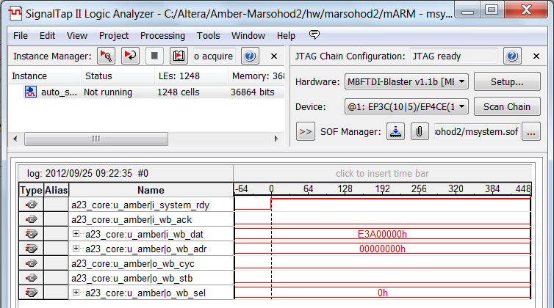
Using this method I was able to ensure that the processor at the start of more dead than alive. Wishbone bus on the bus, nothing happens, although the address given on the bootrom correct - is zero and bootrom comes first command processor ARM 0xE3A00000 (this mov r0, # 0x00000000). Other bus signals o_wb_cyc, o_wb_stb, i_wb_ack not move.
Had quite a long tricky considering where these signals come from and what they depend on. Each iteration takes a lot of time, because if I change the list of the signals in SignalTap I need to recompile the project.
Eventually I got to a very strange oddities - Module hw/vlog/amber23/a23_cache.v have so-called "state machine»(StateMachine) and it seems that its state at startup initially not true.
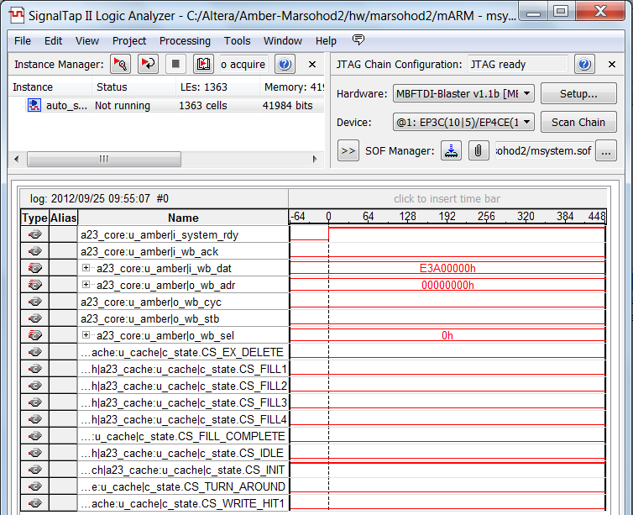
See that the initial state of the state machine to the cache controller c_state.CS_INIT = 1, but that should not be so!The code is written Verilog a23_cache.v fact quite different:
reg [3:0] c_state = CS_IDLE;
Moreover, if you enter the Quartus II menu Tools => Netlist Viewers => State Machine Viewer you can see that the Quartus II compiler does not detect the behavior described in the language Verilog state machine.
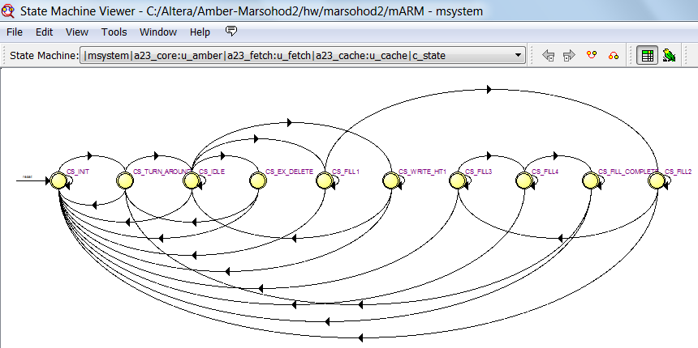
Quartus II believes that the initial state of the machine is CS_INIT, but should be CS_IDLE.
In fact, I find it hard to argue that this is a bug compiler Quartus II, maybe there is some subtlety or uncertainty in the language standard Verilog. I am not a connoisseur doskonolnym specification Verilog. All what I am saying - not written correspondence compiled and synthesized in the FPGA.
Very strange that even explicit initial value for register c_state not change the situation, I wrote this:
reg [3:0] c_state = CS_IDLE;
initial
c_state = CS_IDLE;
But it did not help. All because apparently Register c_state interpreted Quartus II compiler in a particular way because describes the state machine. Very strange bug (or feature?) In Quartus II.
In principle, Quartus II has a variety of settings related to the peculiarities of compilation. They can see through the menu Assignments => Settings and then in the Customize dialog Analysis & Synthesis Settings button and thenMore Settings.
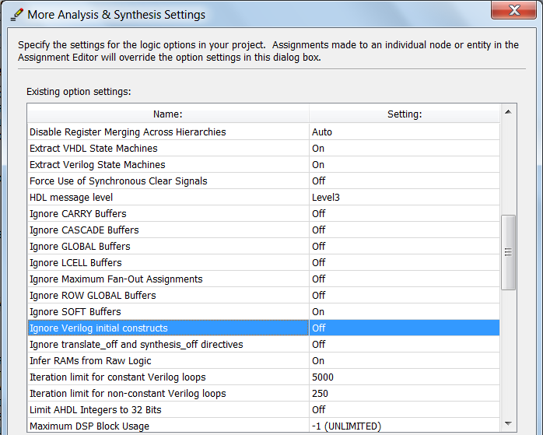
Here is listed Ignore Verilog initial constructs and I, as the position, standing here Off. Ie I want to initial constructsworked to plan at the start of registers have been defined in the project value.
In general, to torment a little, I found here in settings other useful option - Extract Verilog State Machines - stood here On. This is precisely the option that causes the compiler to interpret the Quartus Register c_state not as an ordinary case, but as a state machine specific register. As written in the prompt Quartus this option allows you to:
Allows the Compiler to extract state machines from Verilog Design Files. The Compiler optimizes state machines using special techniques to reduce area and / or improve performance. If set to Off, the Compiler extracts and optimizes state machines in Verilog Design Files as regular logic.
Yeah, as the same, dooptimizirovali area and performance, that the project does not work correctly. In general, I turned off this option in the settings. Now Extract Verilog State Machines => Off.
You know, it was better, but not much. Wishbone bus signals to become somehow changed, but still the processor does not work:
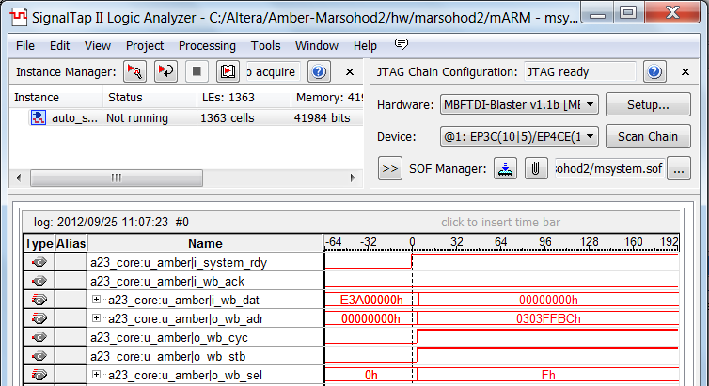
After that, I found another place in the draft Amber incorrectly interpreted by the compiler Quartus II - this filea23_decode.v
In this file, the output signals of the module are declared simultaneously given their initial value, like so:

module a23_decode
(
input i_clk,
input [31:0] i_read_data,
...................
output reg [31:0] o_read_data = 1'd0,
output reg [4:0] o_read_data_alignment = 1'd0, / / 2 LSBs of read address used for calculating shift in LDRB ops
output reg [31:0] o_imm32 = 'd0,
output reg [4:0] o_imm_shift_amount = 'd0,
output reg o_shift_imm_zero = 'd0,
output reg [3:0] o_condition = 4'he, / / 4'he = al
output reg o_exclusive_exec = 'd0, / / exclusive access request (swap instruction)
output reg o_data_access_exec = 'd0, / / high means the memory access is a read
/ / Read or write, low for instruction
output reg [1:0] o_status_bits_mode = 2'b11, / / SVC
output reg o_status_bits_irq_mask = 1'd1,
output reg o_status_bits_firq_mask = 1'd1,
.................

So it turns out that all of these initial values ​​for output reg ignored if the compiler. I could not find the option in Quartus II, which would be forced to use these assigned values.
Had in the text below the module to set them explicitly using the design initial.
That's only after all these manipulations with the project settings and code changes a23_decode.v project and earned the console serial port I saw a cherished phrase "Marsohod2: Hello, World!"
Now in SignalTap I see the active process of reading the code processor bootrom:
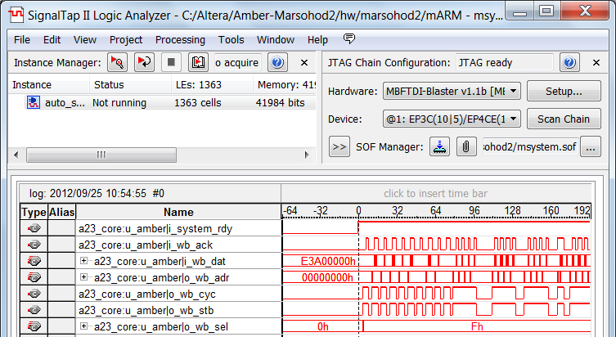
And the message to the console serial port - a clear proof of performance of the project.
Now it could be further developed.
In general, it appears that the project uses some Amber design language Verilog, which are interpreted by the compiler Quartus II several specific way. Nevertheless, we were able to get around this project settings correcting Altera Quartus II and slightly modified the original text processor Amber.
All recent changes in the project is on GitHub in our section https://github.com/marsohod4you/Amber-Marsohod2 .

Connecting the SDRAM system-on-chip Amber
Actually, the original project Amber had already embedded controller DDR. I threw it as unnecessary, because ourboard Marsohod2 not worth DDR memory and SDRAM. Memory SDRAM, certainly easier than DDR. It does not require a separate power supply and allocation of special banks conclusions with FPGA. However, now we have a problem - how to connect to SDRAM system?
We will not reinvent the wheel, and take some ready controller opencores.org. I choose this one :
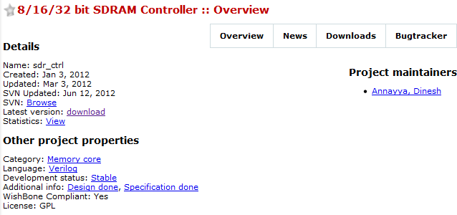
Looks like this is what you need:

Description
Feature:
• 8/16/32 Configurable SDRAM data width
• Wish Bone compatible
• Application clock and SDRAM clock can be async
• Programmable column address
• Support for industry-standard SDRAM devices and modules
• Supports all standard SDRAM functions
• Fully Synchronous; All signals registered on positive edge of system clock
• One chip-select signals
• Support SDRAM with four bank
• Programmable CAS latency
• Data mask signals for partial write operations
• Bank management architecture, which minimizes latency
• Automatic controlled refresh
• Static synchronous design
• Fully synthesizable
Pumped source site OpenCores ( I said that there are many useful can be found ) and put them in a folder of our project Amber hw / vlog / sdram.
What's next? Added to my project of Amber for Quartus II file msystem.qsf added links to files:
set_global_assignment-name VERILOG_FILE .. / vlog / sdram / ​​sdr_ctrl / trunk / rtl / lib / sync_fifo.v
set_global_assignment-name VERILOG_FILE .. / vlog / sdram / ​​sdr_ctrl / trunk / rtl / lib / async_fifo.v
set_global_assignment-name VERILOG_FILE .. / vlog/sdram/sdr_ctrl/trunk/rtl/wb2sdrc/wb2sdrc.v
set_global_assignment-name VERILOG_FILE .. / vlog / sdram / ​​sdr_ctrl / trunk / rtl / top / sdrc_top.v
Expanded the search path to a compiler Quartus II:
set_global_assignment-name SEARCH_PATH .. / vlog / sdram / ​​sdr_ctrl / trunk / rtl / core
Added new macros for Verilog:
set_global_assignment-name VERILOG_MACRO "SDRAM = 1"
In addition, changed Verilog top-level module msystem.v:
- Added inputs and outputs SDRAM.
- Wishbone bus connected to the memory controller module sdrc_top.
- Appointed controller parameters SDRAM.
Here is the inclusion of SDRAM controller module

`Ifdef SDRAM
/ / System with SDRAM
assign s_wb_err [2] = 0;
wire sdr_init_done;
assign phy_init_done = sdr_init_done;
assign sdr_clk = mem_clk;
sdrc_top # (. SDR_DW (16),. SDR_BW (2)) u_sdram (
. Cfg_sdr_width (2'b01), / / 16 BIT SDRAM
. Cfg_colbits (2'b00), / / 8 Bit Column Address
/ * WISHBONE * /
. Wb_rst_i (sys_rst),
. Wb_clk_i (sys_clk),
. Wb_stb_i (s_wb_stb [2]),
. Wb_ack_o (s_wb_ack [2]),
. Wb_addr_i (s_wb_adr [2] >> 2)
. Wb_we_i (s_wb_we [2]),
. Wb_dat_i (s_wb_dat_w [2]),
. Wb_sel_i (s_wb_sel [2]),
. Wb_dat_o (s_wb_dat_r [2]),
. Wb_cyc_i (s_wb_cyc [2]),
. Wb_cti_i (0)
/ * Interface to SDRAMs * /
. Sdram_clk (sdr_clk),
. Sdram_resetn (~ sys_rst),
. Sdr_cs_n (/ * sdr_cs_n * /),
. Sdr_cke (/ * sdr_cke * /),
. Sdr_ras_n (sdr_ras_n),
. Sdr_cas_n (sdr_cas_n),
. Sdr_we_n (sdr_we_n),
. Sdr_dqm (sdr_dqm),
. Sdr_ba (sdr_ba),
. Sdr_addr (sdr_addr),
. Sdr_dq (sdr_dq),
/ * Parameters * /
. Sdr_init_done (sdr_init_done),
. Cfg_req_depth (2'h3), / / how many req. buffer should hold
. Cfg_sdr_en (sdr_ena),
. Cfg_sdr_mode_reg (12'h023),
. Cfg_sdr_tras_d (4'h4), / / 44-120000ns
. Cfg_sdr_trp_d (4'h2), / / min 20ns
. Cfg_sdr_trcd_d (4'h2), / / min 20ns
. Cfg_sdr_cas (3'h3), / / cas latency in clocks, depends on mode reg
. Cfg_sdr_trcar_d (4'h7), / / min 66ns
. Cfg_sdr_twr_d (4'h1), / / write recovery time, 1ck +7,5 / 15ns
. Cfg_sdr_rfsh (12'h100), / / 16 or 64 ms?
. Cfg_sdr_rfmax (3'h6)
);
`Else
/ / Assume memory always ready if no SDRAM
assign phy_init_done = 1'd1;
`Endif

Another module changed my_clocks_reset.v. It is now synthesized in two PLL clock frequency: 40MHz to 80MHz and the system memory SDRAM.
In the process of debugging the project using SignalTap and read documentation on the controller SDRAM (it is in the folder hw / vlog / sdram / ​​sdr_ctrl / trunk / doc) revealed that successful memory initialization is necessary to submit to her clock, and wait about 100mcs. Only after this, the controller can provide some first memory chip initialization commands. I did not realize it. Cfg_sdr_en signal on the controller module to do just that. Now my module my_clocks_reset himself waits kako time and provides the memory controller enable signal sdrc_top cfg_sdr_en. Controller programs mikroskheamu memory at some preset mode and then outputs a signalsdr_init_done. Here only then starts processing.
Another problem that I met - in the controller settings for some reason there are duplicates of each other settings.Thus, the input is fed cfg_sdr_mode_reg 12'h023 constant and the second nibble "2" denotes the CAS Latency - delay in data availability. Nevertheless, there is another signal configuring cfg_sdr_cas which means the same.But strange things to work properly you need to cfg_sdr_cas was one greater than the specified number in the MODE register is determined by the signal cfg_sdr_mode_reg. It's pretty weird. Quite a lot of time lost here until figured out how to do. MODE register in SDRAM memory chip determines the operation mode and must be initialized at system startup.
In the processor in the boot-rom I now place the file is not a program hello-World , as before, and a special program boot-loader. I wrote it myself, and took from my original sw / boot-loader. I created a folder boot-loader-8Mand copied all the original files back. Actually change in this project only one. You need to put a stack of programs under the peak of our memory 8MB.
As in the case of the program hello-world I compile a boot-loader and converts MEM file Altera MIF teams
make
../tools/mem2mif boot-loader.mem >> boot-loader.mif
In Altera Quartus II project in a wizard for sram_2048_32_byte_en now indicate that bootrom should initialized at start new boot-loader.mif
In principle, it is generally all.
For further experiments, we need a terminal program for the serial port TeraTerm . I used to use Putty, but now recommend this program TeraTerm. A little later I will explain why.
Now describe how it works. After compiling the project in Quartus II open in TeraTerm serial COM9 at speeds of 921,600, 1 stop bit, no parity. Run the Quartus II programmer and load the project in FPGA board Marsohod2.
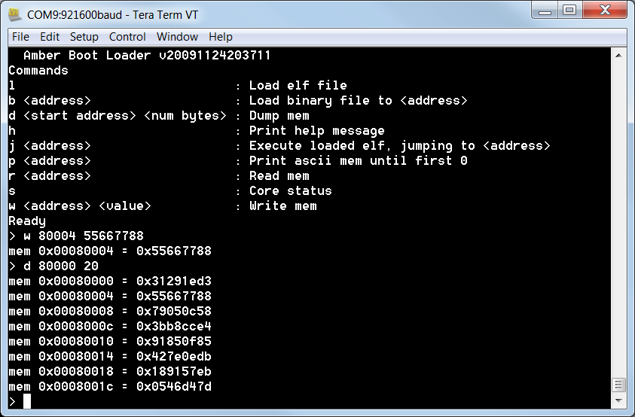
In the console serial port appears here is the "menu". This is in contrast to the program hello-world, is an interactive application. Typing a command «w» can be written to memory, and team «d» read and display a block of memory. The picture shows that I recorded at number 0x55667788 0x80004 and then looked up the area from the address 0x80000.
But that's not all! Now you can through the serial port to download the program to your device. That's what a terminal TeraTerm. It allows you to transfer files via XMODEM w/1k on our device. In the boot-loader is just implemented this protocol.
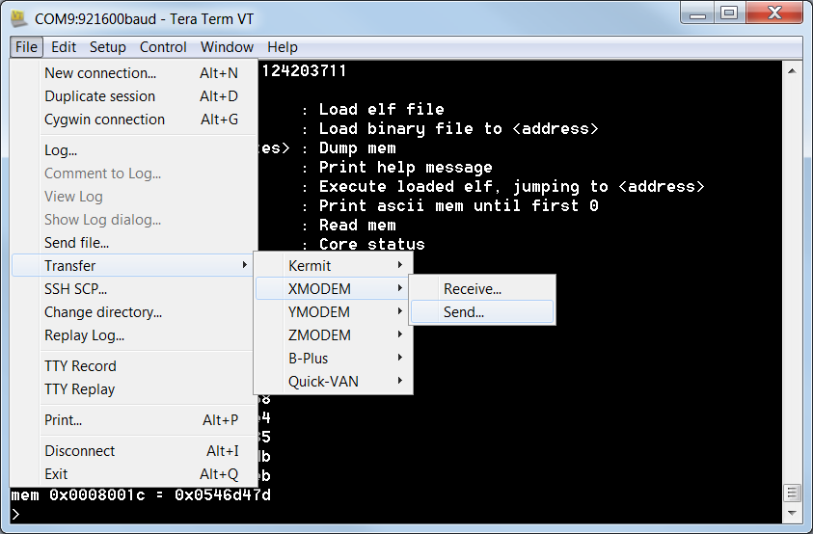
Type in console command «l» and boot-loader file begins to expect from a COM port. In the menu items TeraTerm choose File => Transfer => XMODEM => Send
Next, select the file you wish to transfer and do not forget to select “1K” as the protocol.
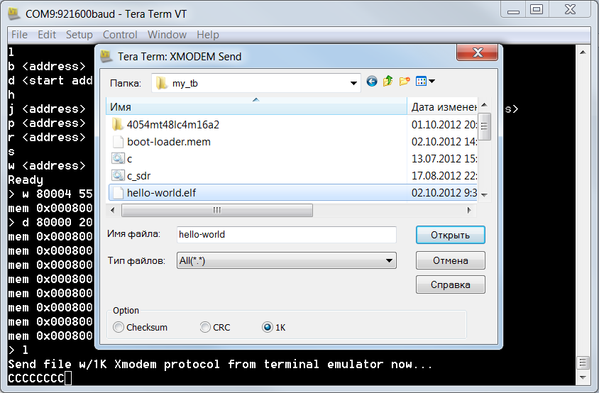
I choose a program compiled before - hello-world.elf - ELF is a type of executable files in Linux. That's just such subtlety. Remember, for the first run in the hello-world board Marsohod2 I had to change the base address 0x8000 in program 0x0000? I then wondered why the author makes this so strange address, because there is no boot-rom? So now it is clear - address 0x8000 just need to program hello-world download using boot-loader into memory via the serial port protocol XMODEM! In general, the program hello-world need to recompile the program by setting the base address back to 0x8000 in the file sections.lds.
Selecting a file do not forget to use the option in the dialog box terminal TeraTerm - "1K" - is apparently some kind of protocol.
All - the program is loaded:
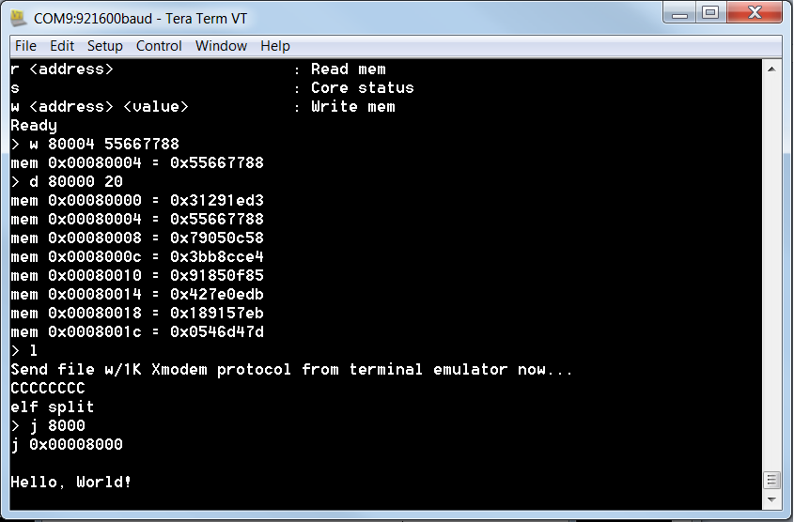
Its easy to run on the device by typing "j 8000"
So, I connected to the system memory SDRAM. Can not yet say with certainty that everything works perfectly - you need to look at the timing diagrams. However, it is already clear that the system becomes more functional.

Study of ARM processor instruction set
System on Chip Amber implements ARM processor. To better understand how it works you need to understand his system commands. Frankly, I understand the assembly code is generally not very easy. Even harder to understand the code for the ARM processor - a lot of strange suffixes the teams, there are different icons near incomprehensible operands in teams. Not very easy to understand, but it's worth once understand, then to easily navigate someone else's code.
I hope this article will help in the development of family processors ARM.
Despite the fact that the system is implemented Amber youngest series processor ARM v2a much remains true for older models of processors.
To do this you need to - to understand the assembler? For now, all write programs in high-level languages ​​like C + +, C #, Java or Python? All right, but not all. If you develop a real-time system and write an interrupt handler, or even just write a device driver that runs in kernel mode - you might need some knowledge of assembler.
Thus, the assembly code - is a text file in which one line of text, usually describes a single command processor.Assembler compiler converts the text to a binary file in which teams encode special way. The processor will read these commands from the system memory and perform on stage. Sometimes it can go to the command execution at a different address, performing conditional or unconditional jump. Within the processor has a set of registers, relatively speaking - it is a temporary program variables. The processor may manipulate the values ​​in these registers via the arithmetic, logical, shift instructions or commands. It can also be loaded into registers or memory values ​​in memory upload. It's all pretty basic facts that relate to the assembler for any CPU. Let's move specifically to ARM.
Example programs and compiler.
As we study the system-on-chip Amber, then probably we already have its source code (you can take on our website GitHub https://github.com/marsohod4you/Amber-Marsohod2 ), and hence the source of some of its programs in the folder sw /. So, we have already installed the CodeSourcery , which is actually a C compiler and assembler and compiler.
For the experiments with the assembler can take any simple project like sw / hello-world. Inside this folder is a filehello-world.c containing the function main (..) in C and start.S file which is the file in assembly language. Actually the program starts with the procedure _start file start.S
Just compile the program. Type in console «make» and he will do all that is necessary. As a result, we get a few files, including the actual executable file hello-world.elf in a special format for Linux and listing file hello-world.dis.As can be seen from the listing file which addresses what is now the compiled code:

hello-world.elf: file format elf32-littlearm
Disassembly of section. Text:
00000000 <_start>:
0: e3a00000 mov r0, # 0
4: e13ff000 teq pc, r0
8: e3e00000 mvn r0, # 0
c: ee030f10 mcr 15, 0, r0, cr3, cr0, {0}
10: e3a00001 mov r0, # 1
14: ee020f10 mcr 15, 0, r0, cr2, cr0, {0}
18: e59fd004 ldr sp, [pc, # 4]; 24 <AdrStack>
1c: eb00036e bl ddc <main>
20: ea000110 b 468 <_testpass>
00000024 <AdrStack>:
24: 00001ff0. Word 0x00001ff0
......

It is seen that at 0 is code 0xE3A00000, which indicates a command processor ARM mov r0, # 0 at the address 0x20 code 0xEA000110 - a team of transition to address 0x468
In essence, our compiler - it is a good tool for learning assembler. You can write code, compile, and watch its binary representation.
Command system ARM processor
ARM is a RISC processor - it Reduced Instruction Set Computer _{(wiki)} . There are other types of processors, such as the x86 family - CISC ( Complex Instruction Set Computer _{(wiki)} ).
CISC processors perform the same team is pretty complex operations, including arithmetic and logical operations on the contents of the memory cells. Teams CISC processor can have different lengths.
In contrast, RISC has a relatively simple system of commands with a clear division of the type of operation:
- memory operation (read from memory to registers or write registers in memory)
- data processing registers (arithmetic, logic, data shifts left / right or rotation bit in register)
- Team conditional or unconditional jump to other addresses.
Usually (but not always, and only when entering the program code in memory cache controller) command is executed in one single clock cycle. Length of the command processor ARM fixed - 4 bytes (one computer word).Actually modern ARM processor can move to other modes, such as mode THUMB, when the length of the command becomes 2 bytes. This allows you to make your code more compact. However, in this article we do not consider this mode, since the processor Amber ARM v2a it is not supported. For the same reason we will not consider such regimes as Jazelle (optimized to run Java code), and the team will not consider NEON - command operations on multiple data. Still, we are exploring a clean system commands ARM.
CPU registers ARM.
The ARM processor has a number of sets of registers of which at any given time only available programmer 16. There are several modes of operation of the processor, depending on the mode selected the appropriate bank of registers. These modes of operation:
- Application Mode (USR, user mode),
- supervisor mode or mode of operating system (SVC, supervisor mode),
- mode interrupt (IRQ, interrupt mode) and
- processing mode "urgent interrupt» (FIRQ, fast interrupt mode).
That is, for example, when an interrupt occurs, the processor jumps to the address itself interrupt the program itself automatically "switch" banks of registers.
ARM processors are older versions than those listed above modes have additional modes:
- Abort (used for exception handling memory access)
- Undefined (used to implement coprocessor programmatically) and
- mode privileged operating system tasks System.
The processor Amber ARM v2a these three additional modes not.
For Amber ARM v2a register set can be represented as follows:
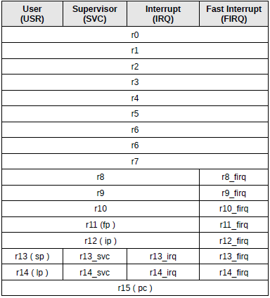
Registers r0-r7 are the same for all modes.
Registers r8-r12 common mode only USR, SVC, IRQ.
Register r13 - is the stack pointer. He in all modes of his own.
Register r14 - Register return from the subroutine as well in all modes of his own.
Register r15 is a pointer to the executable instructions. It is common for all modes.
It is evident that the regime FIRQ most isolated, it is more likely their own registers. This is done to a very critical interrupt could not handle keeping registers on the stack, without wasting time on it.
Particular attention should be paid to the register r15, aka pc (Program Counter) - pointer to the executable instructions. Over its contents can perform various arithmetic and logical operations, thereby program execution will jump to other addresses. However, it is for the processor ARM v2a, Amber realized in the system there are some subtleties in the interpretation of the bits in this register.
The fact that in this processor, the register r15 (pc) except the actual pointer to the executable command contains the following information:
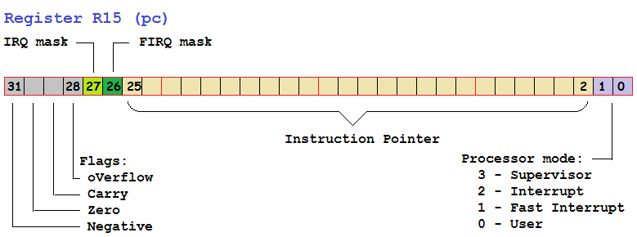
Bits 31:28 - flags the result of an arithmetic or logic operation {Negative, Zero, Carry, oVerflow}
Bits 27 - mask IRQ interrupts, interrupts are disabled when this bit is set.
Bits 26 - FIRQ mask interrupts fast interrupts are disabled when this bit is set.
Bits 25:2 - actually a pointer to the program command takes only 26 bits.
Bits 1:0 - the current mode of the processor.
3 - Supervisor
2 - Interrupt
1 - Fast Interrupt
0 - User
In older ARM processors all the flags and control bits are located in separate registers Current Program Status Register (cpsr) and Saved Program Status Register (spsr), for which there is access to some special teams. This is done in order to expand the available address space for programs.
One of the difficulties of development assembler ARM - alternate names of some registers. Thus, as mentioned above, r15 - is the same pc. Still have r13 - it's the same sp (Stack Pointer), r14 - it lr (Link Register) - Register the return address of the procedure. Besides, r12 - it is the same ip (Intra-Procedure-call scratch register), C compilers used a special way to access the parameters on the stack. Such an alternative naming sometimes confusing when you look at someone else's code program - and there are those out there and these designations registers.
Features of the code execution.
In many types of protsessororov (eg x86) by the condition can be satisfied only change to another program address. In ARM is not. Each team ARM processor can be performed or not performed by the condition. This minimizes the number of clicks on the program and therefore more efficient use pipeline (pipeline) processor.
Because what is a pipeline? One command processor now selected from the program code, the previous one is decoded and the previous one is pre-executed. This is in case 3 stage pipeline processor Amber A23, which we use in our project for board Marsohod2 . Modification Amber A25 processor has a 5-stage pipeline, it is even more effective. But there is one big BUT. Transition team are forced to clean the processor pipeline and fill it again.Thus, the new team is selected but still nothing to decode and especially nothing to execute immediately.Efficiency of code execution with frequent transitions falls. In modern processors have any prediction mechanism that somehow optimize filling the pipeline, but in our processor does not. In any case, ARM was wise, making possible the performance of each team contingent.
The processor ARM, in any type of team four bits of command execution conditions are coded in high four bits of the instruction code:
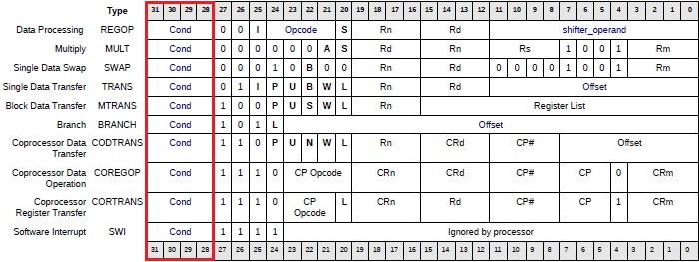
Just 4 processor flag conditions:
• Negative - result of the operation has turned negative,
• Zero - the result is zero,
• Carry - when performing unsigned chisoami a carry,
• oVerflow - when performing operations with signed numbers overflow occurs, the result is placed in register}
These four flag form many possible combinations of conditions:
Code | Suffix | Value | Flags
4'h0 | eq | Equal | Z set
4'h1 | ne | Not equal | Z clear
4'h2 | cs / hs | Carry set / unsigned higher or same | C set
4'h3 | cc / lo | Carry clear / unsigned lower | C clear
4'h4 | mi | Minus / negative | N set
4'h5 | pl | Plus / positive or zero | N clear
4'h6 | vs | Overflow | V set
4'h7 | vc | No overflow | V clear
4'h8 | hi | Unsigned higher | C set and Z clear
4'h9 | ls | Unsigned lower or same | C clear or Z set
4'ha | ge | Signed greater than or equal | N == V
4'hb | lt | Signed less than | N! = V
4'hc | gt | Signed greater than | Z == 0, N == V
4'hd | le | Signed less than or equal | Z == 1 or N! = V
4'he | al | Always (unconditional)
4'hf | - | Invalid condition
Now this should be another complication study teams processor ARM - set of suffixes that can be added to the code team. For example, adding the condition that the Z flag is set - as a team addeq add + suffix eq. Daylight subroutine if the flag N = 0 - as it blpl bl + suffix pl.
Flags {Negative, Zero, Carry, oVerflow} set is not always the same in arithmetic or logic operations, as is the case for example in the x86 processor, but only when he wants programmer. To do this, there is another suffix to the mnemonic commands: «s» (in the instruction code encoded bit 20). Thus, the command does not change the addition add flags, and command changes adds flags. And can also be conditional add instruction, but that changes the flags. For example: addgts. It is clear that the number of possible combinations of team names with different suffixes conditional execution and installation of flags makes assembly code ARM processor very peculiar and difficult to read. However, with time to get used to it and begin to understand the text.
Arithmetic and logic operations (Data Processing).
The ARM processor can execute various arithmetic and logical operations.
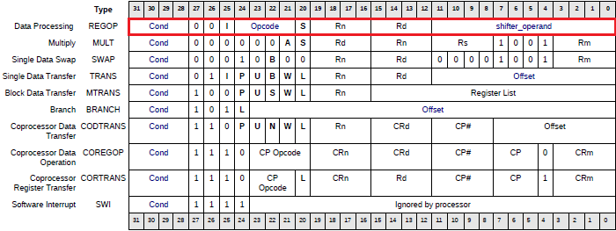
Actually four-bit opcode {Opcode} is contained in bits [24:21] command processor.
Any operation performed on the contents of the register [Rn] and the so-called shifter_operand. Result of the operation is placed in the register [Rd]. A four Rn and Rd - this index registers in the active bank processor.
Depending on the bit I ₂₅ shifter_operand interpreted as either a numeric constant or as an index of the second operand register, and even shift operation over the value of the second operand.
Simple examples of assembler commands will look something like this:

add r0, r1, r2 @ place the sum into the register values ​​of registers r0 and r1 r2
sub r5, r4, # 7 @ put into register r5 difference (r4-7)

Hereinafter everywhere after "@" symbol in the assembler text is a comment.
Operations performed are coded as follows:
4'h0 and Logical AND Rd: = Rn AND shifter_operand
4'h1 eor Logicheskaoe XOR Rd: = Rn XOR shifter_operand
4'h2 sub Arithmetic subtraction Rd: = Rn - shifter_operand
4'h3 rsb Arithmetic reverse subtraction Rd: = shifter_operand - Rn
4'h4 add addition arithmetic Rd: = Rn + shifter_operand
4'h5 adc Arithmetic Addition plus the carry flag Rd: = Rn + shifter_operand + Carry Flag
4'h6 sbc Arithmetic subtraction with carry Rd: = Rn - shifter_operand - NOT (Carry Flag)
4'h7 rsc reverse arithmetic subtraction with carry Rd: = shifter_operand - Rn - NOT (Carry Flag)
4'h8 tst Boolean AND, but without memorizing result only change flags Rn AND shifter_operand S bit always set
4'h9 teq logical XOR, but without storing the result, only change flags Rn EOR shifter_operand
S bit always set
4'ha cmp comparison rather arithmetic subtraction without saving results change only flags Rn - shifter_operand S bit always set
4'hb cmn comparison inverse rather arithmetic addition without saving results change only flags Rn + shifter_operand S bit always set
4'hc orr Logical OR Rd: = Rn OR shifter_operand
4'hd mov values ​​Copy Rd: = shifter_operand (no first operand)
4'he bic Reset bits Rd: = Rn AND NOT (shifter_operand)
4'hf mvn Copying inversnogoznacheniya Rd: = NOT shifter_operand (no first operand)
Next, let's see what is shifter_operand?
Barrel shifter.
In the ARM processor has a special scheme "barrel shifter" which allows one of the operands to move or deploy a predetermined number of bits before any arithmetic or logic operation. It's quite an interesting feature of the processor which allows you to create a very efficient code.
For example:

Multiplication @ 9 - is a multiplication of the number 8
@ Shift to the left by 3 bits plus a number
add r0, r1, r1, lsl # 3 @ r0 = r1 + (r1 << 3) = r1 * 9
@ Multiplication by 15 - 16 is multiplication by minus
rsb r0, r1, r1, lsl # 4 @ r0 = (r1 << 4)-r1 = r1 * 15
@ Access table 4 byte words, wherein
@ R1 - is the base address of the table
@ R2 - the index of the item in the table
ldr r0, [r1, r2, lsl # 2]

Besides the logical left shift lsl there is a logical shift right lsr and arithmetic right shift asr (shift preserving the sign, MSB propagated simultaneously with a shift to the left).
There is still a bit rotation ror - nominated bits to the right and those that vydvinnuty - are pushed to the left.
There is a shift by one bit through flag C - a team rrx. The register value is shifted right by one bit. Left in the MSB register is loaded flag C
Shift can not be implemented by a fixed constant, and by the value of the third register operand. For example:

add r0, r1, r1, lsr r3 @ is r0 = r1 + (r1 >> r3);
add r0, r0, r1, lsr r3 @ is r0 = r0 + (r1 >> r3);

Thus, shifter_operand is what we describe in assembler commands such as «r1, lsr r3» or «r2, lsl # 5".
Most interestingly, the use of changes in operations costs nothing. To these changes (usually) do not waste additional cycles and is very good for performance.
Using numeric operands.
Arithmetic or logical operations can be used as the second operand is not only the contents of the register, but also a numeric constant.
Unfortunately, there is one important limitation. Since all teams have a fixed length of 4 bytes (32 bits), then encode it in "any" number will not work. In the operation code and 4 bits so busy condition code execution {Cond}, 4 bits for opcode itself {Opcode}, then 4 bits - Receive Register Rd, and 4 bits - the first operand register Rn, plus ₂₅different flags I (just denotes a numeric constant in the opcode) and S ₂₀ (flags after surgery). Overall, the potential remains constant only 12 bits, so-called shifter_operand - we have seen above. Since the 12th bits can encode numbers only in a narrow range of ARM processor developers have decided to make coding constants as follows.Twelve bits shifter_operand divided into two parts: the four-bit index and the actual rotation encode_imm octet numeric value imm_8.
In the ARM processor eight-bit integer constant is defined within a 32-bit number, deployed right into an even number of bits. That is:
imm_32 = imm_8 ROR (encode_imm * 2)
It turned out pretty surprising. It turns out that not every number is a constant can be used in the assembly instructions.
You can write

add r0, r2, # 255 @ constant in decimal form
add r0, r3, # 0xFF @ constant in hexadecimal form

255 as in the range of 8 bits. These commands are compiled like this:

0: e28200ff add r0, r2, # 255; 0xff
4: e28300ff add r0, r3, # 255; 0xff

And you can even write

add r0, r4, # 512
add r0, r5, 0x650000

Compiled code will be here like this:

0: e2840c02 add r0, r4, # 512; 0x200
4: e2850865 add r0, r5, # 6,619,136; 0x650000

In this case, the sheer number of 512, of course, does not fit into bytes. But we imagine it as a hexadecimal 32'h00000200 and see that it is deployed to the right 2 24-bit (1 ror 24). Factor rotation twice less than 24, that is 12. It turns shifter_operand = {4'hc, 8'h02} - this twelve least significant bits of the team. Likewise, the number of 0x650000. For him shifter_operand = {4'h8, 8'h65}.
It is clear that you can not write

add r0, r1, # 1234567

or you can not write

mov r0, # 511

since here the number is impossible to imagine a imm_8 and encode_imm - factor rotation. Assembler compiler will generate an error.
What do you do when a constant can not be directly encoded in shifter_operand? Have to do all sorts of tricks.
For example, you can download a free first register number 512, and then subtract one:

mov r0, # 511
sub r0, r0, # 1

The second way to get a specific number in the register - treat it specially reserved variable in-memory:

ldr r7, my_var
.....
my_var:. word 0x123456

His most easiest way to write this:

ldr r2, = 511

In this case (note the sign "=") if the constant can be represented as imm_8 and encode_imm, if it can be written into the 12-bit shifter_operand, the compiler will automatically compile assembler ldr team mov. But if the number can not be so represented, then the compiler will reserve program memory for this constant, and he will ask the name of that memory and compile command in the ldr.
So I wrote this:

ldr r7, my_var
ldr r8, = 511
ldr r8, = 1024
ldr r9, = 0x3456
........
My_var:. Word 0x123456

After compiling got this:

18: e59f7030 ldr r7, [pc, # 48]; 50 <my_var>
1c: e59f8030 ldr r8, [pc, # 48]; 54 <my_var+0x4>
20: e3a08b01 mov r8, # 1024; 0x400
24: e59f902c ldr r9, [pc, # 44]; 58 <my_var+0x8>
.............
00000050 <my_var>:
50: 00123456. Word 0x00123456
54: 000001ff. Word 0x000001ff
58: 00003456. Word 0x00003456

Note that the compiler uses relative addressing memory register pc (aka r15).
Reading and writing memory register in memory.
As I already wrote above, the ARM processor can perform arithmetic or logic operations only on the contents of the registers. These operations should be read from the memory and write operations result in memory again. There are special commands: ldr (probably from a combination of «LoaD Register») for reading and str (probably«STore Regi ster») for recording.
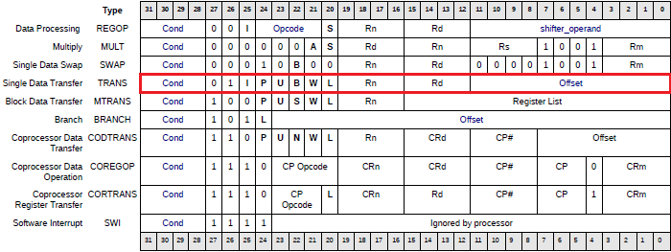
It would seem - just two teams, but in fact they have a lot of variations. Just look at ways of coding teams ldr / strprocessor Amber ARM, to see how many auxiliary bits-flags L _{20,} W _{21,} B _{22,} U _{23,} P _{24,} I ₂₅ - and they define the specific behavior of the team:
Here:
- L Bit ₂₀ determines read or write. 1 - ldr, reading 0 - str, record.
- Bit ₂₂ B defines read / write 32-bit word or 8-bit bytes. 1 - means the operation with a byte. When reading byte register senior register bits are cleared.
- I bit ₂₅ specifies the use of field Offset. If I ₂₅ == 0, Offset is interpreted as a numeric offset, which should either be added to the base address of the register [Rn] or take away. But add or subtract depends on the bit U _{23.}
{Cond} - condition for the operation. Interpreted as well as for logic / arithmetic instructions - reading or writing can be conditional.
Thus, we can write assembly code here is:

ldr r1, [r0] @ in the register r1 read the word at the register r0
ldrb r1, [r0] @ in the register r1 read byte at the register r0
ldreq r2, [r1] @ conditional word reading
ldrgtb r2, [r1] @ conditional reading bytes
ldr r3, [r4, # 8] @ reading words at 8 of the address of the register r4
ldr r4, [r5, # -16] @ word reading at -16 relative to the address of the register r5

Compile this text, you can see the actual code for these commands:

0: e5901000 ldr r1, [r0]
4: e5d01000 ldrb r1, [r0]
8: 05912000 ldreq r2, [r1]
c: c5d12000 ldrbgt r2, [r1]
10: e5943008 ldr r3, [r4, # 8]
14: e5154010 ldr r4, [r5, # -16]

In the above example I only use ldr, but str is used about the same.
The most interesting thing starts on, because special bits and P ₂₄ W ₂₁ code Read / Write describe a lot of different modes.
There are modes of pre-and post-index index memory access writeback. In these modes, the pointer memory access updated before or after executing the command. If you are familiar with the programming language C, then you know the design of the signs like access (* psource + +;) or (a = * + + psource;). In this mode the ARM processor access to memory just realized. When the read command is updated once two registers - Register receiver gets read from the memory and meaning of the value in the register pointer to a memory location is moved forward or backward.
A record of these teams, in my opinion, somewhat illogical. Takes a long time to get used to.

ldr r3, [r0, # 4]! @ Psrc + +; r3 = * psrc;
ldr r3, [r0], # 4 @ r3 = * psrc; psrc + +;

First team ldr first increases pointer, then reads. The second command reads the first, then increase the index.Psrc pointer value in register r0.
All the above examples were for the case when the bit I ₂₅ in the instruction code has been reset. But he can still be installed! Then the value of the field in the Offset is not a numerical constant, and the third register, participate in the operation. Moreover, the third register has a value can be pre-shifted!
Here are some examples of possible variations of the code:

0: e7921003 ldr r1, [r2, r3] @ read address - the sum of the values ​​of the registers r2 and r3
4: e7b21003 ldr r1, [r2, r3]! @ Is the same, but after reading r2 is incremented by the value of r3
8: e6932004 ldr r2, [r3], r4 @ will first reading at r3, and then increase by r3 r4
c: e7943185 ldr r3, [r4, r5, lsl # 3] @ address read r4 + r5 * 8
10: e7b43285 ldr r3, [r4, r5, lsl # 5]! @ Read address r4 + r5 * 32, after reading r4 is set to this address
14: e69431a5 ldr r3, [r4], r5, lsr # 3 @ address read r4, after the execution of commands on r4 is set to r4 + r5 / 8

These are variations of read / write processor ARM v2a.
In older models of ARM processors is more variety of commands.
This is because the processor can, for example, not only the read word (32-bit number) and the byte, but halfword (16-bit, two bytes). Then commands ldr / str suffix «h», the word half-word. Teams will look like or ldrh strh. As there is a load instruction bytes or halfwords ldrsh ldrsb interpreted as signed numbers. In these cases, the highest bit or byte loaded poloslova replicates in the upper bits of the whole word in the register of the receiver. For example, downloading a team ldrsh halfword 0xff25 register receiver turns 0xffffff25.
Multiple read and write.
Teams ldr / str not only for the memory access. In the ARM processor are still commands allow you to perform block transfer - You can download the contents of several consecutive words from memory several registers. You can record sequentially in memory Multiple Registers.
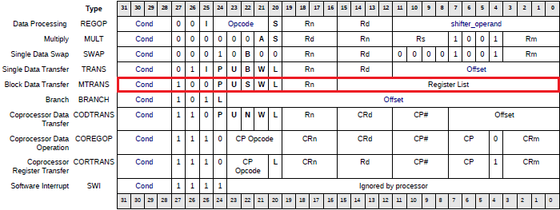
Mnemonics block transfer begins with the root ldm (LoaD Multiple) or stm (Store Multiple). But then, as usual in the ARM, the story begins with the suffixes.
In general, the command looks like this:
op {cond} {mode} Rd {!}, {Register list}
Suffix {Cond} - it is clear that this condition of the command. Suffix {mode} - transfer mode, chet about it later. Rd - register determines the base address in memory to read or write. Exclamation mark after the register Rd is that after read / write operations it will be changed. List of registers to be loaded or unloaded from memory to memory - it {Register list}.
List of registers specified in the braces, separated by commas, or a range. For example:

stm r0, {r3, r1, r5-r8}

Storing prozvedena is not in the order listed. List simply indicates which registers will be written to memory and all.The code team has reserved for 16-bit Register List, just the number of registers in the processor bank. Each bit in this field indicates which register will participate in operation.
Now read / write mode. Here is where to get confused. The fact that the same action can be different profile name.
If we make a small digression, then you need to talk about ... the stack. Stack - a way to access the data type LIFO - Last In First Out _{(wiki)} - last in, first out. Stack widely used in programming when calling procedures and maintaining the status registers on function entry and restore them on exit, as well as when passing parameters to the calling procedure.
Stack memory is, who would have thought, four types.
The first type - Full Descending. This is when the stack pointer points to the stack busy and the stack grows downward addresses. When you need to put a word on the stack, the stack pointer is first reduced (Decrement Before), then the address of the stack pointer is written word. When you need to remove the computer word from the stack, then the current value of the stack pointer is read the word, then the pointer moves up (Increment After).
The second type - Full Ascending. The stack grows downwards and not upwards, towards higher addresses.Pointer also indicates a busy element. When you need to put a word on the stack, the stack pointer is increased first, then made ​​entry word pointer (Increment Before). When it is necessary to remove from the stack, the first read on the stack pointer, because it indicates a busy element, then decreases the stack pointer (Decrement Afte r).
The third type - Empty Descending. The stack grows downwards as in the case of Full Descending, but the difference is that the stack pointer is not already occupied by ukazyvavet cell. So, when you need to put a word on the stack, once the entry is made, then the stack pointer decreases (Decrement After). When removing from the stack pointer first increase, then read (Increment Before).
The fourth type - Empty Ascending. I hope everything is clear - the stack grows up. The stack pointer points to an empty element. Put on the stack - is written word at the stack pointer and increase the stack pointer (Increment After). Remove from the stack - to reduce the stack pointer and read the word (Decrement Before).
Thus, in operations with the stack pointer need to increase or decrease - (Increment / Decrement) before or after(Before / After) read / write memory, depending on the type of the stack. In processors Intel, for example, there are special commands for working with the stack type PUSH (put the word on the stack) or POP (remove the word from the stack). In the ARM processor-specific commands not, but used ldm and stm team.
If you implement a stack using the command processor ARM, it turns out that's such a picture:
Type stack | Put on the stack,  PUSH | Remove from the stack,  POP
Full descending | STMFD (STMDB) | LDMFD (LDMIA)
Full ascending | STMFA (STMIB) | LDMFA (LDMDA)
Empty descending | STMED (STMDA) | LDMED (LDMIB)
Empty ascending | STMEA (STMIA) | LDMEA (LDMDB)
Why the same team had to give different names? Do not understand ... Here, of course, it should be noted that the standard stack for ARM - yet Full Descending.
Stack pointer processor ARM - this sp or register r13. This is generally such an agreement. Of course, writing or reading stm ldm can be made ​​with other base registers. However, we must remember what the register sp differs from other registers - he is in different modes of operation of the processor (USR, SVC, IRQ, FIRQ) may be his own, because there the banks of registers.
Also remark. Write in ARM assembly code string like push {r0-r3}, of course you can. Only here in fact it is the same team stmfd sp!, {R0-r3}.
Lastly, here is an example of assembly code and compile it disassembled text. We have:

@ These three directions the same and make the same
stmfd sp!, {r0-r3}
stmdb sp!, {r0-r3}
push {r0-r3}
@ These three directions the same and make the same
pop {r0-r3}
ldmia sp!, {r0-r3}
ldmfd r13!, {r0-r3}
stmfd r4, {r0-r3, r5, r8}
stmea r4!, {r0-r3, r7, r9, lr, pc}
ldm r5, {r0, pc}

Get after compilation:

0: e92d000f push {r0, r1, r2, r3}
4: e92d000f push {r0, r1, r2, r3}
8: e92d000f push {r0, r1, r2, r3}
c: e8bd000f pop {r0, r1, r2, r3}
10: e8bd000f pop {r0, r1, r2, r3}
14: e8bd000f pop {r0, r1, r2, r3}
18: e904012f stmdb r4, {r0, r1, r2, r3, r5, r8}
1c: e8a4c28f stmia r4!, {R0, r1, r2, r3, r7, r9, lr, pc}
20: e8958001 ldm r5, {r0, pc}

Transitions programs.
Programming is not possible without transitions. In any program meets and cyclic execution of code and call procedures, functions, and have conditional execution of code segments.
The processor Amber ARM v2a has only two commands: b (from the word Branch - branch, jump) and bl (Branch with Link - transition to the conservation of the return address).
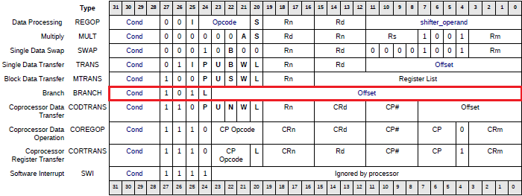
The command syntax is very simple:
b {cond} label
bl {cond} label
It is understood that any transitions can be conditional, that is, the program can meet here are derived from the roots of «b» and «bl» conditions and suffixes {Cond}, strange words:
beq, bne, bcs, bhs, bcc, blo, bmi, bpl, bvs, bvc, bhi, bls, bge, bgt, ble, bal, b
and
bleq, blne, blcs, blhs, blcc, bllo, blmi, blpl, blvs, blvc, blhi, blls, blge, blgt, blle, blal, bl
Variety striking, is not it?
In the transition team provides 24-bit offset Offset. Branch address is calculated as the sum of the current value of the pointer pc and shifted 2 bits to the left of the number Offset, interpreted as a signed number:
New pc = pc + Offset * 4
Thus, the range of transitions is 32MB forward or backward.
We consider that such a transition while preserving the return address bl. This command is used to call subroutines. An interesting feature of this command is that the return address of the procedure when the procedure is not saved in the stack, such as Intel processors, and in the normal register r14. Then return from the procedure do not need a special team ret, as at the same Intel processors, but you can just copy the value back tor14 pc. Now I understand why register r14 is an alternate name lr (Link Register).
Consider procedure outbyte of hello-world project for a system-on-chip Amber.

000004a0 <_outbyte>:
4a0: e59f1454 ldr r1, [pc, # 1108]; 8fc <address data register UART>
4a4: e59f3454 ldr r3, [pc, # 1108]; 900 <address status register UART>
4a8: e5932000 ldr r2, [r3]; read the current status of
4ac: e2022020 and r2, r2, # 32
4b0: e3520000 cmp r2, # 0; check that the UART is not busy
4b4: 05c10000 strbeq r0, [r1]; Writes a character to UART only if he is not busy
4b8: 01b0f00e movseq pc, lr; conditional return from the procedure if UART was not busy
4bc: 1afffff9 bne 4a8 <_outbyte+0x8>; cycle to check the status of the UART

I think from the comments of this fragment clear how this procedure works.
Another important note on transitions. Register r15 (pc) can be used in ordinary arithmetic or logic operations as the receiver register. So what kind of team add pc, pc, # 8 is quite a statement to jump to another address.
About transitions need to make one more remark. In older ARM processors there are additional commands transitions bx, blx and blj. This command to go to the code snippets with other system commands. Bx / blx allows you to transition to 16-bit code THUMB processor ARM. Blj - this procedure call system commands Jazelle (Java support in ARM processors). In our Amber ARM v2a these teams do not.
Other instructions processor ARM.
In this article, I described a lot, but not all.
I have not talked about the data transmission between the memory and coprocessor on the commands transfer data between processor registers and registers coprocessor Command data in the coprocessor and software interrupts. I also overlooked the multiply:
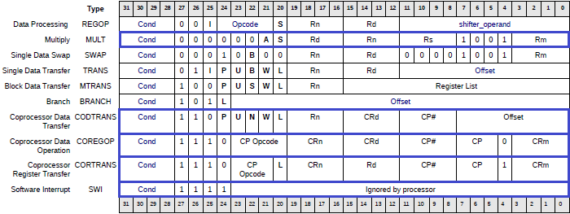
Maybe someday I fill this gap.
Hopefully the information presented was useful.
Bibliography:
- Documentation System-on-Chip Amber
- Whirlwind Tour of ARM Assembly
- arm.com

The first (unsuccessful) run Linux in SoC Amber

Continuing series of articles about the system-on-chip in the card Marsohod2 that we create based on opensource Amber ARM.
Of course, I would like to receive from the system the maximum possible. "The idea-fix" - is, of course, to run Linux in the board. Unfortunately, I am not so much of an expert in Linux, but treat it as a "god", considering it one of the greatest achievements of mankind .
Well, at least what some version of, if not the latest, would run!
In principle, it seems it should not be a big problem. After all, the author AMBER SoC successfully launched kernel version 2.4.27. In the source code of the project is a folder AMBER sw / vmlinux, it contains the following files:
- README.txt - description of the method in the kernel boot and user self-compile the kernel.
- vmlinux - compiled Linux kernel, file type elf, ready to be loaded into the system.
- v mlinux.dis.bz2 - archive dizassembirovannogo Linux kernel.
- vmlinux.mem.bz2 - archive text file describing the contents of the vmlinux as "e-word." This file may be needed for the simulation of Linux in Verilog simulator.
- initrd-200k-hello-world - the simplest way Initial Ram Disk, the disk can be installed after booting the kernel and then this CD program should start hello-world.
- initrd-200k-dhry - another way of Initial Ram Disk
- patch-2.4.27-vrs1.bz2 - Linux kernel patch from the company ARM. Needed for self-assembly of the nucleus.
- patch-2.4.27-amber2.bz2 - patch AMBER SoC, also needed in the case of self-assembly of the nucleus.
So, read the instructions in README.txt and try to execute it.
We have a project for FPGA Cyclone III board Marsohod2 that implements SoC. You can take, such as GitHub, this one TAG: https://github.com/marsohod4you/Amber-Marsohod2/archive/sdram-attached.zip
Here fully design environment Altera Quartus II for our board Marsohod2.
After starting the system of internal BOOTROM first run monitor that allows you to write in memory SDRAM, memory read, upload images into the system memory via the serial port protocol XMODEM-1K. I have this monitor is described in detail here .
Now, using this monitor, we need to first download the command «b» binary initrd image into memory and then load the team «l» Linux kernel image - vmlinux.
Team «l» elf file downloads at 0x80000. There, at 0x80000 need to make the transition to run the image. Monitored for this team has «j». That is, I will recruit a team «j 80000."
But with the initrd image is not so simple.
The original design made for AMBER FPGA Xilinx and board containing 32MB of memory. I'm just trying to port this project for Altera Cyclone III and for our board Marsohod2. I have only 8MB of memory. In this case, the instruction says that the initrd image you want to download from the 8th megabytes (which I no longer have).
What to do?
I looked like run Linux. The idea is that the monitor (its source code is in the project folder sw / boot-loader) creates a structure ATAG, describing various startup parameters: the size of the memory address of the initrd and stuff.The structure will be copied is located at a fixed address 0x7c00. Apparently the Linux kernel knows where to get this table.
I decided that I modify it fit me well, and way it should work.
I do my boot, its source folder sw/boot-loader-8M ( on GitHub ).
It assembler file in this table here start.S ATAG:

ATAGBase:. Word ATAG_CORE_SIZE
. Word ATAG_CORE
. Word FLAG_READONLY @ flags
. Word 4096 @ page size
. Word 0x0 @ rootdev
. Word ATAG_MEM_SIZE
. Word ATAG_MEM
/ *. Word 32 * 1024 * 1024 @ size - 32MB * /
. Word 8 * 1024 * 1024 @ size - 8MB
. Word 0x0 @ start
. Word ATAG_RAMDISK_SIZE
. Word ATAG_RAMDISK
. Word 1 @ flags: bit 0 = load, bit 1 = prompt
. Word 0x000000d0 @ size in 1k blocks
/ *. Word 0x00800000 @ physical address of start of ramdisk * /
. Word 0x00700000 @ physical address of start of ramdisk
. Word ATAG_INITRD_SIZE
. Word ATAG_INITRD
/ *. Word 0x02800000 @ virtual address of start of initrd image * /
. Word 0x02700000 @ virtual address of start of initrd image
. Word 0x00032000 @ size = 200k
. Word ATAG_NONE
. Word 0x0
EndATAG:. Word 0x0

I declare that I have only 8MB and that initrd is the 7th megabytes. Boot loader is already compiled and stored in the FPGA SRAM.
Here try. I use serial port terminal TeraTerm, he can be sent via com port files via XMODEM:
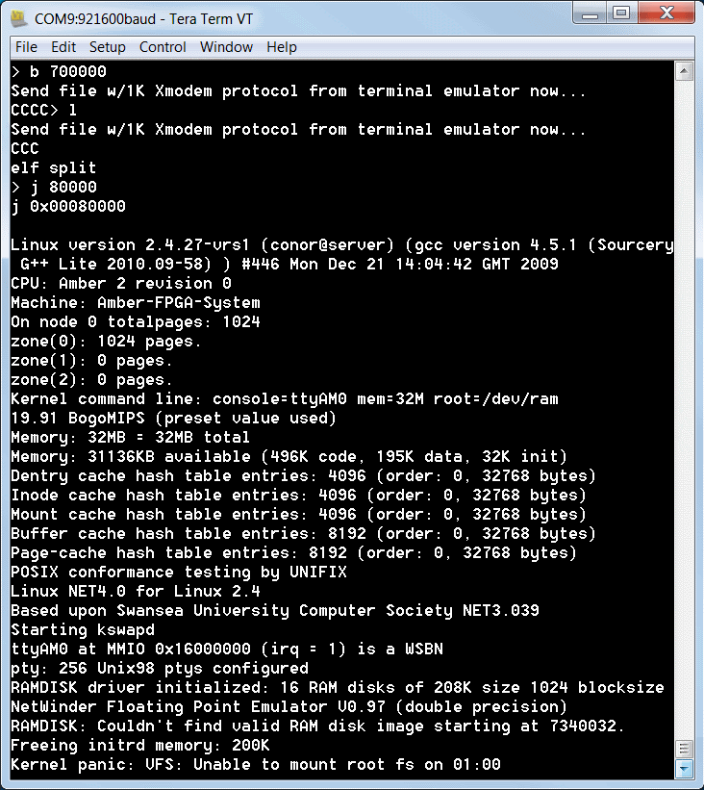
Does not work. In principle, once started, but eventually hangs.
First, it is clear that the kernel has not taken my option from the table ATAG about the total size of memory 8Mb. And continues to write - 32MB in the system. This is wrong and it's bad.
Secondly, not mounted initrd. It gets worse.
It turns out that it is necessary to compile the Linux kernel itself and to understand why all this is happening.
On the other hand - maybe it's not a bad thing? Get new experience and maybe understand something new for themselves from the device Linux.

Compile Linux for SoC AMBER

So, I need to compile the Linux for System-on-chip based on ARM project Amber . To do this I will need red eyes like this penguin.
At first glance, the compilation should not be a problem, because there is the original owner's how to do it. And instruction must say quite simple. It is in the file sw / vmlinux / README.txt:

# Download the kernel source
wget http://www.kernel.org/pub/linux/kernel/v2.4/linux-2.4.27.tar.gz
tar zxf linux-2.4.27.tar.gz
ln-s linux-2.4.27 linux
cd $ {LINUX_WORK_DIR} / linux
# Apply 2 patch files
cp $ {AMBER_BASE} / sw/vmlinux/patch-2.4.27-vrs1.bz2.
cp $ {AMBER_BASE} / sw/vmlinux/patch-2.4.27-amber2.bz2.
bzip2-d patch-2.4.27-vrs1.bz2
bzip2-d patch-2.4.27-amber2.bz2
patch-p1 <patch-2.4.27-vrs1
patch-p1 <patch-2.4.27-amber2
# Build the kernel
make dep
make vmlinux

Linux itself can be extorted from kernel.org . Patches have in the project. I thought it was working so for thirty minutes. But there it was. Honestly - for me it was not easy.
So what's the problem?
Actually the kernel download really not hard - command wget.
Unzip as simple:
tar zxf linux-2.4.27.tar.gz
The first patch patch-2.4.27-vrs1 from ARM easily superimposed. But the second patch-2.4.27-amber2, proper patch for Project Amber - I did not go smoothly ...
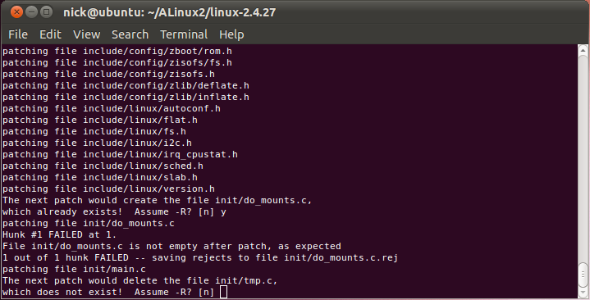
Patch stumbled, had to answer "yes" and now I'm not sure that everything will be just ... And so it happened.
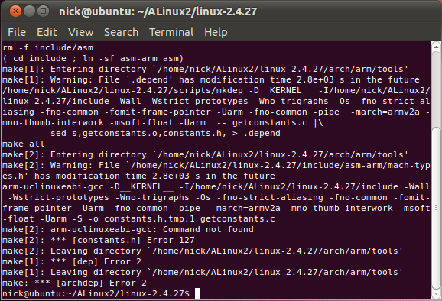
The following command from the instruction make dep failed. Found command arm-uclinuxeabi-gcc. Well, this is understandable. It does not involve "isporennym" patch. Just used the compiler is not called so. I have now installed a fairly new company CodeSourcery CodeBench from Mentor. Its compiler is called arm-none-linux-gnueabi-gcc. Okay, not a big problem. Found in the Makefile where the compiler name is given explicitly. Changed it. Try again:
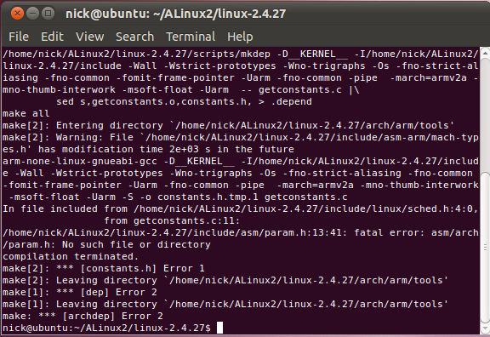
Here already, I strongly reflected. It is evident that the problem is serious. For half an hour it will not work and will have a very long time to understand. I honestly do not know how the author of the project turned out Amber write such an instruction. And he used it? Remains to think that perhaps it was more the other version of Linux on the desktop machine and, of course, he had a different compiler (some arm-uclinuxeabi-gcc). Once all this is probably affected. I do not know.
I understood very long. Actually there were a few initial data:
- I need a minimum kernel configuration with a minimum number of installed drivers as little memory, and indeed the system is very simple.
- I need to make the kernel aware that my processor - is an early ARM v2a and that he is not 32 bits of address space, but only 26.
- I need to tell the kernel that I only have 8 MB of memory.
- I need to get in the system was equipped with a special serial port driver, the hardware is compatible with SoC Amber.
Have long to "google" and "Yandex". So I realized that in the long run it is good to first select the desired system configuration.
In the folder arch / arm / def-configs Linux kernel is the set of files that describe the already predefined configurations for different systems. In any file no word «amber». Configuration file named «amber» just not. I thought I may want to choose from the available konfiruratsy one that most close to my system. I had to just browse through the eyes of all these configuration files from start to finish studying the possible configuration options. After hours of browsing through all of these configurations, when the eyes have dazzled, I thought that probably the most appropriate configuration will a5k. I found there's these lines:
# CONFIG_CPU_32 is not set
CONFIG_CPU_26 = y
Here is what you need. At least it sets the correct CPU type - because in our early ARM proetsessore just address space is limited to 26 address lines.
So try to choose this configuration:
make a5k_config
This team seems to worked. In response, I got a bit «*** Default configuration for a5k installed». After this, even the team «make dep» worked without errors. Happiness was so close ...
Begin to actually compile Linux:
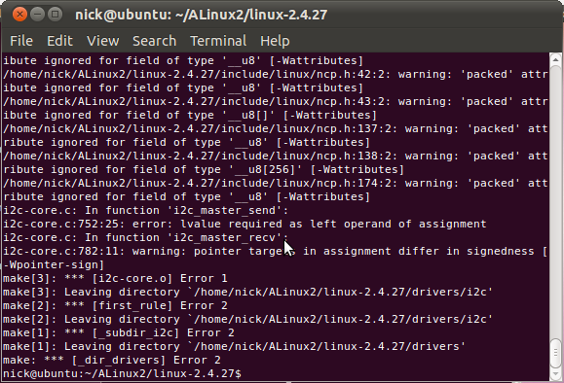
Hmm .. some mistakes in the drivers i2c ...
I do not know what the problem is. How is that even be? Did the broken patch? Unused but it I can not, because it seems a lot and makes necessary changes in the code and configuration. Then I thought to make povyklyuchat almost all unused drivers - this will reduce the number of possible problems to a minimum. Run the command
make menuconfig
It provides just such a wonderful the menus, where you can ask all all kernel configuration.
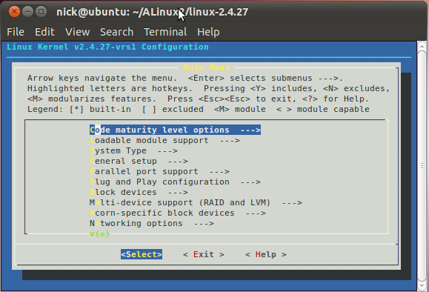
Fair to say that all the settings might be in the right configuration file arch/arm/def-configs/a5k me or some other.While I think it is more convenient to find all the desired options using «make menuconfig», and only later do a simple configuration file.
That began my quest for all sorts of useful and not so useful settings kernel Linux. What draver leave? What drivers include? File systems and network settings? Too many degrees of freedom. Povyklyuchal floppy, ATA, framebuffer, i2c and a lot more then. Found a command line option, which runs Linux:
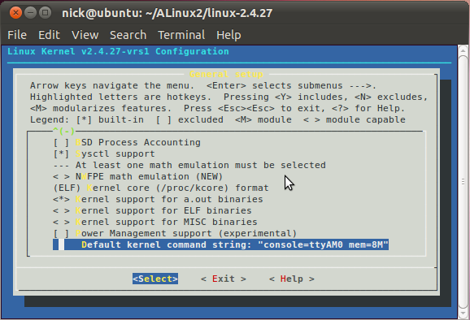
Added to the command line «mem = 8M». I hope now Linux understand how much my system memory actually.Then save the settings and repeat all over again: «make dep» and «make vmlinux».
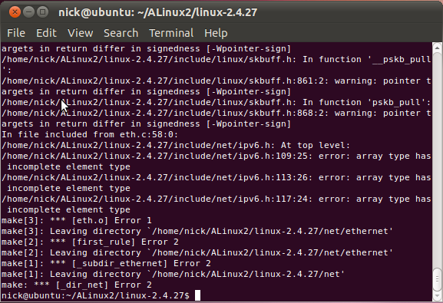
And again wrong. Now in header files somehow related to the network. It's some kind of horror and nightmare. I think I'm going somewhere is not there, it is in the wrong direction. But what to do? No other way or I do not see him. Network - it's not something that can be easily turned off in the kernel configuration. More precisely it is possible to turn off, but the support network - this is one of the most important properties of the kernel Linux. I can not give it up. Can I ever connected to the system ethernet ..
Correcting two files in the kernel source include / net / icmp.h and include/net/ipv6.h, add them to a string
# Include <net/snmp.h>
After this fix compile «make vmlinux» and now another attack:
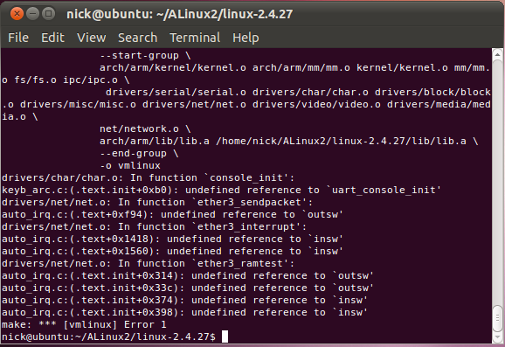
Somehow, some functions are indeterminate low-level read / write: outsw, insw. Looked at more closely. It turns out that's what. In the folder arch / arm / lib there are several assembler files for different types of processors ARM.They describe the function access to the ports of the equipment: read or write halfwords, words, bytes. These files like io-readsl-armv3.S or io-writesw-armv4.S. These and similar files are selected depending on the installed options in the kernel configuration or CONFIG_CPU_32v3 CONFIG_CPU_32v4 or other. In my case, these options are not set, so no assembler files are not connected to the project. Had to create your file io-sw.S by analogy withCPU_32v3 processor and add it to the kernel by correcting the corresponding Makefile in the folder arch / arn / lib.
Another serious problem - I need to work in the system probably is not very standard serial port SoCs Amber.
In the folder of the Linux kernel drivers / serial I found amba.c file which has the line:
# Define AMBER_UART0_BASE 0x16000000
# Define AMBER_UART1_BASE 0x17000000
Here the keyword "AMBER" and more importantly, that 0x16000000 - this is the actual physical address of the serial port in the system.
Apparently amba.c is teskt original serial driver. But here's the problem: it is impossible to include serial port support AMBA program menu «make menuconfig». This option of AMBA serial just is not available on the menu.
After much searching realized that option AMBA serial depends on the option CONFIG_ARCH_INTEGRATOR. And I chose it because the basic platform completely different - A5K.
Fixed file driver / serial / Config.in, now there is my string:
dep_tristate 'ARM AMBA serial port support' CONFIG_SERIAL_AMBA $ CONFIG_ARCH_ARCA5K
Now, if you run make menuconfig, then the option AMBA serial becomes quite affordable:
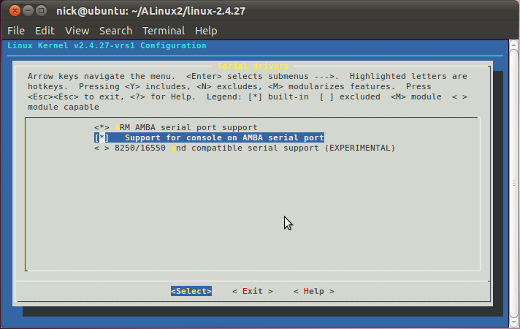
It was after this, after all this, I was able to compile the voodoo kernel and an executable image vmlinux.
Now we need to test it in Marsohod2 board. Score or not?
Card is connected to my laptop Marsohod2 USB cable. Protection of Altera Quartus II programmer load image SoC AMBER in FPGA Cyclone III. TeraTerm program opens the serial port, leading to the board and using XMODEM upload my own image yadla Linux. Run his team «j 80000" and here:
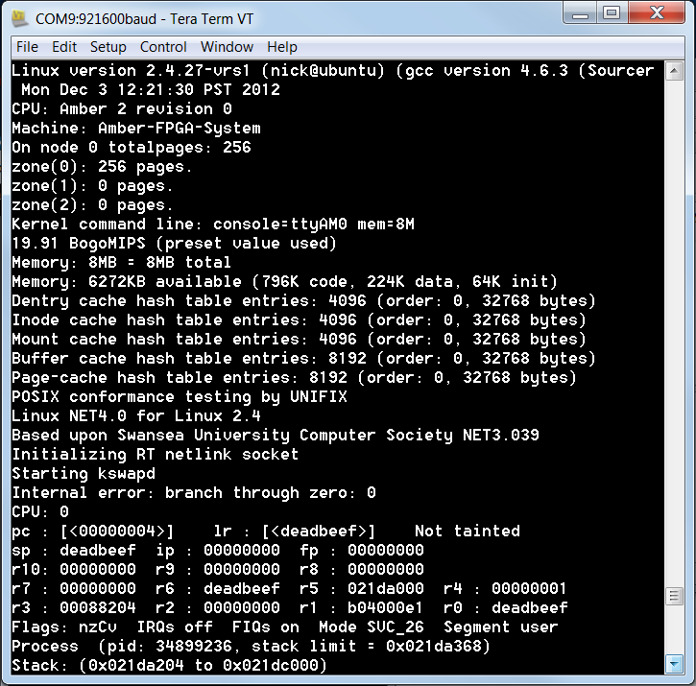
Can not say that does not work at all. First, in the console I see the startup process - it is good, it means the serial driver in Linux is installed and working properly. In the console, I see that this is my build on the first line «Linux version 2.4.27-vrs1 (nick @ ubuntu)» and created my kernel image. The second good novostv that image now Linux knows how many I have in the system memory and writes correctly 8M total. If you remember, I asked the size of the memory in the kernel command line in a line «mem = 8M».
But the bad thing is that immediately after Starting kswapd kernel hangs corny. This has to be a separate deal.
This means that a continuation of the history of our Santa Barbara will be soon.
PS: while Linux does not start normally I would not do Komita important to our project on github SoC Amber . A little later, will and full instructions and assembly method.

Debugging Linux in Amber SoC

In a previous article I wrote that I was able to compile the Linux kernel , but when I run in the board Marsohod2 he strangely hangs.
It's time to deal with it. The problem seems to be serious. Not even clear which side to approach. After the cause of suspension could be anywhere:
- May be a hardware problem? Whether the processor or in some cases fails? Does the right memory controller SDRAM?
- Can be a problem in the compiler? Indeed, it seems that I use one of the latest versions of the compiler , not this, what was the original author of the project at Amber.
- I still can not correctly configure the kernel ? Or there is an error in some drivers?
What in general there are ways to deal with all this?
Unfortunately we have no way for in-stepping CPU Amber. Many modern microprocessors allow you to debug programs in a real device for example, via the JTAG. This hardware feature in our project is not implemented.
Probably the easiest way to "debug" - is inserted into the program control messages. Linux kernel because the same kind of program. And the message from the kernel can be easily displayed on the console function printk (...). This feature - full analogue usual language C printf (...). If the program will print a lot of different messages in the course of execution and then suddenly hangs, then we can at last hangs before post to understand about where the problem area code. Then this problem area code to add new posts. And so on until the cause of the failure of the program is not found.
It is with this method of troubleshooting I started my research. The method is quite simple, but not fast. I had to do a lot of iterations, "added printk in driver code Linux» => «compiled Linux» => «uploaded image in charge" and if the problem is not clear, then start again from the beginning. I eventually slumped to a rather strange situation.Here, look. I changed the file kernel source Linux arch / arm / kernel / process.c function arch_kernel_thread:

pid_t arch_kernel_thread (int (* fn) (void *), void * arg, unsigned long flags)
{
pid_t __ ret;
printk ("arch_kernel_thread \ n");
__asm__ __ volatile__ (
"Orr r0,% 1,% 2 @ kernel_thread sys_clone \ n \
mov r1, # 0 \ n \
"__syscall (Clone)" \ n \
movs% 0, r0 @ if we are the child \ n \
bne 1f \ n \
mov fp, # 0 @ ensure that fp is zero \ n \
mov r0,% 4 \ n \
mov lr, pc \ ​​n \
mov pc,% 3 \ n \
b sys_exit \ n \
1: "
: "= & R" (__ret)
: "Ir" (flags), "I" (CLONE_VM), "r" (fn), "r" (arg)
: "R0", "r1", "lr");
printk ("arch_kernel_thread exit \ n");
return __ ret;
}

I added here when the function printk and output of function printk. So the message from the need to go in pairs "entered-released." Function itself makes a system call, and finally falls into the function of the core file do_forkLinux kernel / fork.c

int do_fork (unsigned long clone_flags, unsigned long stack_start,
struct pt_regs * regs, unsigned long stack_size)
{
int retval;
struct task_struct * p;
struct completion vfork;
if ((clone_flags & (CLONE_NEWNS | CLONE_FS)) == (CLONE_NEWNS | CLONE_FS))
return-EINVAL;
retval =-EPERM;
printk ("do_fork enter \ n");
..................
/ / More code here
..................
printk ("do_fork exit \ n");
}

Function do_fork I just corrected adding printk FUNCTIONS inlet and outlet of it.
Compiled kernel. Feel it in Marsohod2 board. What do I see? Do_fork function is called multiple times, and several times successfully. I see that printk messages are as expected in pairs:
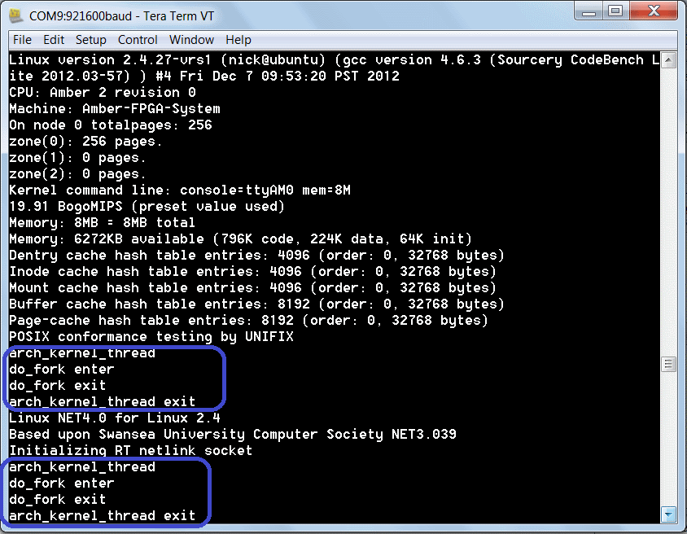
However, the last time before the Linux kernel povicnut this pairing calls violated. And it turns out that the functiondo_fork processor comes out, but back to the calling arch_kernel_thread not be returned:
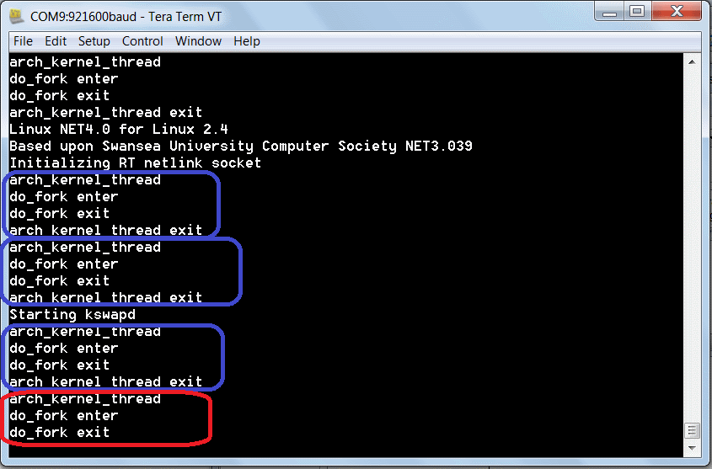
And here is how such a thing be?
After a rather long attempts to understand the problem I really had quite despaired, but then, on reflection, decided to hold a complete simulation start Linux processor using Icarus Verilog . Let's see if there is a problem in this simulator.
The idea of ​​the simulation may seem fantastic - I'm going to spend a long Verilog simulation of a very complex system with a processor executing many thousands of instructions from memory SDRAM.
In fact, nothing of space here. I've already pretended to run the program hello-world processor Amber . In the case of running Linux and simulation will be about the same, but slightly more complicated testbench.
- Now I need to make a complete model of the system: CPU, boot-rom, memory, serial port. Model system - this is the testbench. Testbencha from hello-world difference is - to be inserted into the system model has a model of the chip itself SDRAM. Where do I get? The simplest - is to try to use some of the models that are "bundled" with the component SDRAM, which I took on OpenCores . But I did not do, but I went to the website of Micron (we in fact on board Marsohod2 worth mikronovskaya memory chip) and began to look there.Choose a memory chip on the page of Micron and there on each chip manufacturer provides Verilog model.That is the right approach. I downloaded the model mt48lc4m16a2.v. Now there is this file in my project on GitHub .
Note that the model can keep a log of memory accesses. For this code can correct string model verilog
wire Debug = 1'b0;
on
wire Debug = 1'b1;
- Testbench at startup must do two important things - read from the disk image boot-loader.mem and place it in a static memory module boot_mem32 and then read from the disk image vmlinux.mem Linux and put it in the model memory SDRAM. In memory model has mt48lc4m16a2 imitation arrays of memory cells:
reg [data_bits - 1: 0] Bank0 [0: mem_sizes];
reg [data_bits - 1: 0] Bank1 [0: mem_sizes];
reg [data_bits - 1: 0] Bank2 [0: mem_sizes];
reg [data_bits - 1: 0] Bank3 [0: mem_sizes];
Here in these banks to the right address and you need to place an executable image Linux for simulation.
- Normal boot-loader folder sw/boot-loader-8M for our purpose simulation Linux is not suitable. After all, if it starts, it then waits for the command from the console:

Amber Boot Loader v20091124203711
Commands
l: Load elf file
b <address>: Load binary file to <address>
d <start address> <num bytes>: Dump mem
h: Print help message
j <address>: Execute loaded elf, jumping to <address>
p <address>: Print ascii mem until first 0
r <address>: Read mem
s: Core status
w <address> <value>: Write mem
Ready
>

Therefore, slightly modifying the code (file sw/boot-loader-8M/start.S) - immediately after the start he will jump to code execution at 0x80000, and there is already a way of SDRAM is Linux, downloaded testbenchem.

. Extern main
@ Bl main
mov r0, # 0x80000
@ Jump to program at r0
. Globl _jump_to_program
_jump_to_program:
@ ----------------------------------------------
@ Copy ATAG structure to AdrBootParams
@ ----------------------------------------------
ldr r1, AdrBootParams
ldr r2, AdrATAGBase
ldr r3, AdeEndATAG
1: cmp r2, r3
beq 2f
ldr r4, [r2], # 4
str r4, [r1], # 4
b 1b

Commenting on the transition line and main procedure in the register r0 load address 0x8000 linux image that will be executed immediately.
- How to get vmlinux.mem? This is a text file of the form "@ address: value" means to simulate verilog. In the project folder sw / tools have special utility amber-elfsplitter. But with the help of this utility converts the image to a file type vmlinux mem. From the command line shell call:
$ AMBER_BASE / sw / tools / amber-elfsplitter vmlinux> vmlinux.mem
Here is a file like this:

/ / Section name. Init
/ / Type SHT_PROGBITS, Size 0x10000, Start address 0x00080000, File offset 0x8000, boffset 0
@ 00080000 e35f0402
@ 00080004 b59ff034
@ 00080008 e3300000
@ 0008000c 1b000013
@ 00080010 e28f0028
@ 00080014 e990203c
@ 00080018 e3a00000
@ 0008001c e1520003
@ 00080020 34820004
@ 00080024 3afffffc
....

- We also need to be disassembled image Linux, to some orientation in the course of execution of the processor. Get it like this (as well from the command line):
arm-none-linux-gnueabi-objdump-C-S-EL vmlinux> vmlinux.dis
Here is a file like this:

vmlinux-org: file format elf32-littlearm
Disassembly of section. Init:
02080000 <__init_begin>:
2080000: e35f0402 cmp pc, # 33554432; 0x2000000
2080004: b59ff034 ldrlt pc, [pc, # 52]; 2080040 <LC0>
2080008: e3300000 teq r0, # 0
208000c: 1b000013 blne 2,080,060 <oldparams>
2080010: e28f0028 add r0, pc, # 40; 0x28
2080014: e990203c ldmib r0, {r2, r3, r4, r5, sp}
2080018: e3a00000 mov r0, # 0
208001c: e1520003 cmp r2, r3
2080020: 34820004 strcc r0, [r2], # 4
...........

- I want testbench written in the log file sequence of execution of all instructions and status registers of the processor after each command. It will do this here snippet testbencha on Verilog:

integer ena_rec = 0;
integer prev_a = 0;
always @ (posedge u_system.u_amber.i_clk)
begin
if (u_system.u_amber.u_execute.i_pc_wen &&
u_system.u_amber.i_system_rdy &&
! U_system.u_amber.fetch_stall &&
u_system.u_amber.u_decode.instruction_address! = prev_a
)
begin
prev_a = u_system.u_amber.u_decode.instruction_address; if(u_system.u_amber.u_decode.instruction_address==32'h209c9f4)
begin
ena_rec = ena_rec +1;
$ Display ("do_fork% d", ena_rec);
$ Fdisplay (log_file, "do_fork");
end
if (ena_rec == 5)
begin
$ Dumpon;
end
if (ena_rec! = 0)
begin
$ Fdisplay (log_file, "#% 08X:% 08X",
u_system.u_amber.u_decode.instruction_address,
u_system.u_amber.u_decode.instruction
);
$ Fdisplay (log_file, "% 08X% 08X% 08X% 08X% 08X% 08X% 08X% 08X",
u_system.u_amber.u_execute.u_register_bank.r0,
u_system.u_amber.u_execute.u_register_bank.r1,
u_system.u_amber.u_execute.u_register_bank.r2,
u_system.u_amber.u_execute.u_register_bank.r3,
u_system.u_amber.u_execute.u_register_bank.r4,
u_system.u_amber.u_execute.u_register_bank.r5,
u_system.u_amber.u_execute.u_register_bank.r6,
u_system.u_amber.u_execute.u_register_bank.r7
);
$ Fdisplay (log_file, "% 08X% 08X% 08X% 08X% 08X% 08X% 08X% 08X",
u_system.u_amber.u_execute.u_register_bank.r8,
u_system.u_amber.u_execute.u_register_bank.r9,
u_system.u_amber.u_execute.u_register_bank.r10,
u_system.u_amber.u_execute.u_register_bank.r11,
u_system.u_amber.u_execute.u_register_bank.r12,
u_system.u_amber.u_execute.u_register_bank.r13_svc, u_system.u_amber.u_execute.u_register_bank.r14_svc,
u_system.u_amber.u_execute.u_register_bank.r15
);
end
end
end

Log file will look similar to this:

# 021426e0: e8a013f8
021d8340 021f0360 00000008 00000000 00000000 00000000 00000000 00000000
00000000 00000000 00000008 021f1f1c 021f0338 021f1ef8 2209ca73 008509b9
# 021426e4: e2522020
021d8360 021f0360 00000008 00000000 00000000 00000000 00000000 00000000
00000000 00000000 00000008 00000000 021f1f1c 021f1ef8 2209ca73 008509ba
# 021426e8: aafffffb
021d8360 021f0360 00000008 00000000 00000000 00000000 00000000 00000000
00000000 00000000 00000008 00000000 021f1f1c 021f1ef8 2209ca73 008509bb
# 021426ec: e3720010
021d8360 021f0360 ffffffe8 00000000 00000000 00000000 00000000 00000000
00000000 00000000 00000008 00000000 021f1f1c 021f1ef8 2209ca73 008509bc
# 021426f0: a8b10078
021d8360 021f0360 ffffffe8 00000000 00000000 00000000 00000000 00000000
00000000 00000000 00000008 00000000 021f1f1c 021f1ef8 2209ca73 008509bd
# 021426fc: e2922014
021d8360 021f0360 ffffffe8 00000000 00000000 00000000 00000000 00000000
00000000 00000000 00000008 00000000 021f1f1c 021f1ef8 2209ca73 008509c0

Here you can see the current address and execute commands as well as the current state of the CPU registers.
Since the volume of logs may be just a giant, I decided to artificially limit them. Entry in the log file starts only after the processor gets to address 32'h209c9f4 - I spied it in the disassembled file vmlinux.dis. This procedure address do_fork.
Recording to VCD file status of all signals in the system generally starts only from the 5th call do_fork.
Even in this case the volume VCD file I composes more 200Mbayt. A log file is more than 50 MB. Incidentally simulation itself takes about an hour on my laptop.
So, starting Icarus Verilog simulator with my testbenchem for Amber Linux, I saw that the system just hangs, like in a real board!
Look:
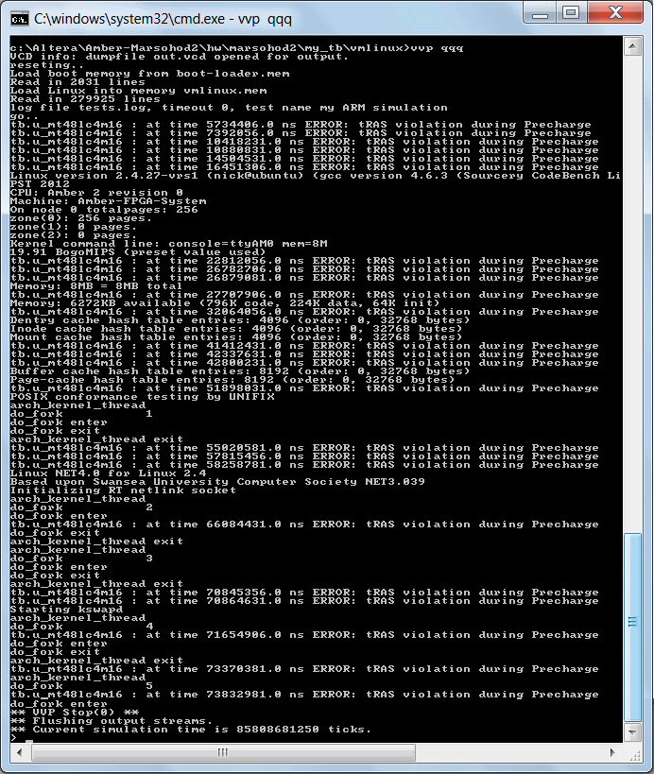
The first thing that catches your eye - mikronovskaya memory model error messages refer to memory tRAS violation during precharge. It is not very good - or very bad. Apparently used the SDRAM controller contains an error? It is not clear whether it somehow affects the system is working. Maybe that does not affect - because in principle the system is running the Linux kernel and, in general, it is loaded, just to the same place, until the 5th function calls do_fork.
Now I have a chance to explore what is happening. I can see the log file with a sequence of instructions executed. I can consider the VCD file GTKWave. It's not very simple, but if you ask for, it may help.
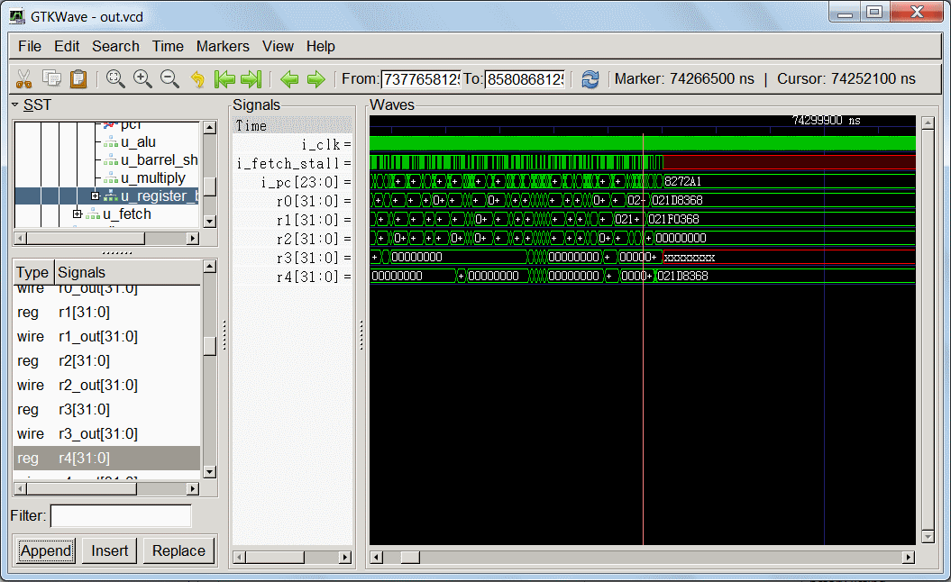
By viewing waveforms in GTKWave I noticed that starting sometime after the 74th microsecond Amber ARM processor goes into a limbo. The register r3 value appears xxx and i_fetch_stall signal becomes uncertain - see red area in the image c GTKWave? However, this is not the only signals whose meaning is more simulator can not compute. Just at this point there are any unforeseen things.
It took me quite some time to understand what is happening. And in the end I found the problem. Look at this code:

209ca48: ebffe357 bl 20957ac <alloc_task_struct>
209ca4c: e2504000 subs r4, r0, # 0
209ca50: 03e0700b mvneq r7, # 11
209ca54: 0a0001e7 beq 209d1f8 <do_fork+0x804>
209ca58: ebfffe5f bl 209c3dc <get_current>
209ca5c: e1a05000 mov r5, r0
209ca60: e1a00004 mov r0, r4
209ca64: e1a01005 mov r1, r5
209ca68: e3a02fda mov r2, # 872; 0x368
209ca6c: eb02970b bl 21426a0 <memcpy>
209ca70: e1a04000 mov r4, r0
209ca74: e59031e0 ldr r3, [r0, # 480]; 0x1e0
209ca78: e593c004 ldr ip, [r3, # 4]
209ca7c: e5902214 ldr r2, [r0, # 532]; 0x214
209ca80: e15c0002 cmp ip, r2

This piece of disassembled code of the Linux kernel function corresponds snippet do_fork:

p = alloc_task_struct ();
if (! p)
goto fork_out;
* P = * current;
retval =-EAGAIN;
/ *
* Check if we are over our maximum process limit, but be sure to
* Exclude root. This is needed to make it possible for login and
* Friends to set the per-user process limit to something lower
* Than the amount of processes root is running. - Rik
* /
if (atomic_read (& p-> user-> processes)> = p-> rlim [RLIMIT_NPROC]. rlim_cur
&& P-> user! = & Root_user
&&! Capable (CAP_SYS_ADMIN) &&! Capable (CAP_SYS_RESOURCE))
goto bad_fork_free;

Actually register r3 "spoiled" when the command at 0x9ca74 on the team «ldr r3, [r0, # 480]." Even more wrong. R3register value does not deteriorate, and it is loaded pointer "to nowhere." Further it is used as a pointer, but only by the memory address there is nothing definite, previously there was nothing recorded. Once the processor reads from this memory some random value on the program's behavior becomes unpredictable course.
And all because ... function memcpy, which copies a block of memory, in some cases spoils register r0! And whether the right of the called function to spoil the value of registers or not? This of course depends on the compiler, on how they form and passed to the function parameters.
Now another question - what other features? They also will I spoil the registers? It is not clear ..
At least I picked up and corrected in the Linux kernel file arch / arm / lib / memcpy.S. Now I save a memcpy function on the stack still registers r0-r3 and restore them from the stack when the function exits.
Removed all my support debug function calls pkintk of do_fork and others. Recompiled the kernel. Trying to boardMarsohod2 and - a miracle happened:
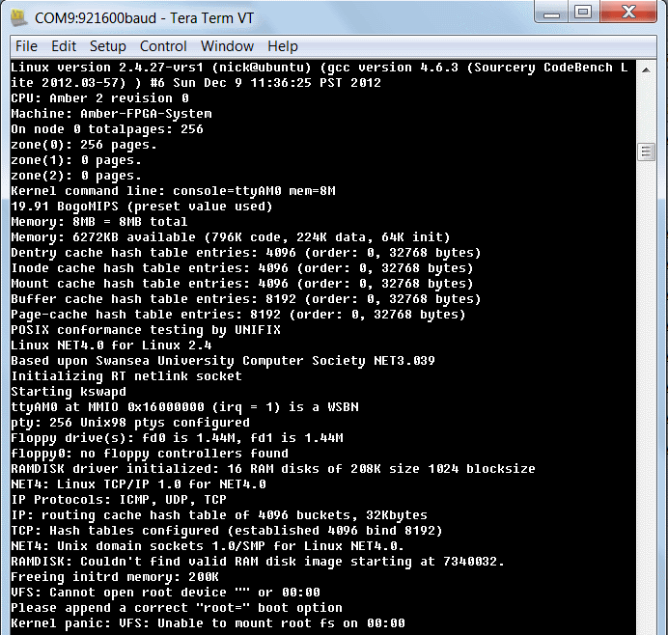
Linux almost off! Now he no longer hangs after "Starting kswapd" as before!
Well, not really start - yet there is a problem with the initrd.
But that's another story.
I hope and fix it!

Linux on board Marsohod2 successfully starts and mounts RAM Disk

So Linux on board Marsohod2 successfully starts and mounts RAM Disk and runs the user program sbin / initfrom the RAM disk.
Frankly I do not think it would be so difficult. Spent all of New Year holidays. The most important thing is not very clear why this is so. Original instructions Amber project site OpenCores either not entirely correct, or somehow outdated. If you follow them, it is impossible to compile the kernel, there is a lot of problems when compiling and configuring the kernel. Tested a lot to debug . The last problem that I met - not properly mmap executable user file.In the end, it seems it works.
Now everything behind.
I slelali commits on our GitHub page dedicated to Amber and Linux on board Marsohod2. Now, I hope you'll have no problem to compile the kernel yourself and run it.
Now RAM disk successfully installed and run with it already "user program» init. In our case, it is nothing particularly sensible does not, simply write "Hello, World! Hello, Marsohod! "
That's actually the output from the console terminal (I use a program TeraTerm):

Linux version 2.4.27-vrs1 (nick @ ubuntu) (gcc version 4.5.2 (Sourcery G+ + Lite 2011.03-46)) # 1 Tue Jan 22 23:48:37 PST 2013
CPU: Amber 2 revision 0
Machine: Amber-FPGA-System
On node 0 totalpages: 256
zone (0): 256 pages.
zone (1): 0 pages.
zone (2): 0 pages.
Kernel command line: console = ttyAM0 mem = 8M root = / dev / ram
19.91 BogoMIPS (preset value used)
Memory: 8MB = 8MB total
Memory: 6304KB available (783K code, 222K data, 64K init)
Dentry cache hash table entries: 4096 (order: 0, 32768 bytes)
Inode cache hash table entries: 4096 (order: 0, 32768 bytes)
Mount cache hash table entries: 4096 (order: 0, 32768 bytes)
Buffer cache hash table entries: 8192 (order: 0, 32768 bytes)
Page-cache hash table entries: 8192 (order: 0, 32768 bytes)
POSIX conformance testing by UNIFIX
Linux NET4.0 for Linux 2.4
Based upon Swansea University Computer Society NET3.039
Initializing RT netlink socket
Starting kswapd
ttyAM0 at MMIO 0x16000000 (irq = 1) is a WSBN
pty: 256 Unix98 ptys configured
Serial driver version 5.05c (2001-07-08) with no serial options enabled
ttyS00 at 0x03f8 (irq = 10) is a 16450
ttyS01 at 0x02f8 (irq = 10) is a 16450
RAMDISK driver initialized: 16 RAM disks of 208K size 1024 blocksize
NET4: Linux TCP / IP 1.0 for NET4.0
IP Protocols: ICMP, UDP, TCP
IP: routing cache hash table of 4096 buckets, 32Kbytes
TCP: Hash tables configured (established 4096 bind 8192)
NET4: Unix domain sockets 1.0/SMP for Linux NET4.0.
RAMDISK: ext2 filesystem found at block 0
RAMDISK: Loading 200 blocks [1 disk] into ram disk ... done.
Freeing initrd memory: 208K
VFS: Mounted root (ext2 filesystem) readonly.
Freeing init memory: 64K
BINFMT_FLAT: Loading file: / sbin / init
Mapping is 2b0000, Entry point is 8068, data_start is 8e4c
Load / sbin / init: TEXT = 2b0040-2b8e4c DATA = 2b8e50-2b8e83 BSS = 2b8e83-2b8e88
start_thread (regs = 0x21f9fa4, entry = 0x2b8068, start_stack = 0x2affb4)
Hello, World!
Hello, Marsohod!

So, there is now a GitHub tag: linux-ramdisk-mounts-with-hello-World
It is today the latest version of the system-on-chip in the card Amber Marsohod2.
In the new folder sw / vmlinux-my now my files and my instructions.
I use OS Ubuntu, as a workplace for the kernel.
To build the Linux kernel for Amber ARM need:
- Set environment variable referencing our working folder Amber-Marsohod2, for example:
export AMBER_BASE = / home/nick/Amber-Marsohod2 /
- Create a folder for the kernel work and go there, for example
mkdir / home / nick / my-linux
export LINUX_WORK_DIR = / home / nick / my-linux
cd $ {LINUX_WORK_DIR}
- Take the Linux kernel archive link:
w get http://www.kernel.org/pub/linux/kernel/v2.4/linux-2.4.27.tar.gz
- Unzip it and create a symbolic link for the convenience of
tar zxf linux-2.4.27.tar.gz
ln-s linux-2.4.27 linux
- Repins here in $ {LINUX_WORK_DIR}, patches
cp $ {AMBER_BASE} / sw/vmlinux-my/patch-2.4.27-vrs1.bz2.
cp $ {AMBER_BASE} / sw/vmlinux-my/patch-2.4.27-myamber2.tar-gz.
- Unzip patches
bzip2-d patch-2.4.27-vrs1.bz2
tar-zxf patch-2.4.27-myamber2.tar.gz
The first patch from the company ARM, the second patch patch-2.4.27-myamber2.tar.gz created by me, based on the results of my research. It includes all changes from the original project Amber, but it has my fix.
- Enter the folder and put Linux patches
cd $ {LINUX_WORK_DIR} / linux
patch-p1 <.. / patch-2.4.27-vrs1
patch-p1 <.. / patch-2.4.27-myamber2
- Select konfiruratsiyu kernel
make a5k_config
- Apply configuration - it's pretty strange move, but I did not come up with smarter
make menuconfig
Dialog appears for editing the configuration, but do not do anything, just go out and save.
- Depending on scan
make dep
- Compile the kernel
make vmlinux
All done! Appears want us to file vmlinux.
Image creation initrd, initial ram disk.
For this procedure, I made ​​a script that simply run: create_initrd.
There is a true fly in the ointment.
Executable file / sbin / init should be format FLT - a special simple executable file format, which is usually not used to Linux, and uClinux.
Everything would be okay, but I have used the compiler arm-none-linux-gnueabi-gcc can not create these types of files. In principle can not. Only knows how to create ELF files, and I have everything they have not yet started.
Had all the same site to download Mentor other compiler for OS uClinux.
This Sourcery_G + + _Lite. The compiler is arm-uclinuxeabi-gcc.
Here they compiler now and doing things.
They need to first compile sw / hello-world - get the executable hello-world-flt.
Then create initrd already running my script sw / vmlinux-my / create_initrd
After running the script appears folder disk, and it initrd.
Like trying to board Marsohod2 (I already do on another machine in Windows 7).
- TeraTerm run the terminal and open the serial port that leads to the board Marsohod2. Once again, I note that the board uses a dual-channel chip FTDI. Theoretically, there can be seen two serial ports. However, the first channel is busy under the JTAG programmer MBFTDI. The second port is connected to a Cyclone III FPGA chip on the board and actually used as a console project SoCs Amber. Need to open a second port at a speed of 921,600 bits / s.
- Loading in charge of the FPGA hardware image via JTAG programming of Altera Quartus II. In the console serial port appears "interactive monitor." You can read or write to a memory cell, download files via the serial port protocol XMODEM/1K - just TeraTerm terminal can do that.
- Loading initrd image into system memory in megabytes 7th:
> B 700000
The program TeraTerm use menu File => Transfer => XMODEM => Send choose my initrd file to send to the board
- Uploading image Linux (only a small letter L, load)
> L
The principle is the same, only using a different command "monitor» "l", which not only puts the image into memory, but also makes parsing ELF core file. The program TeraTerm use menu File => Transfer => XMODEM => Send my file vmlinux choose to send in a fee.
- Run the system - a transition at 0x80000. Use the monitor command:
> J 80000
That's probably all. Linux starts.
In principle, of course, there is a certain satisfaction with the work done - the kernel starts, ram disk is installed, the user program / ​​sbin / init is started.
But there is a little upset.
First, while still only FLT file can run on the system. ELF does not start.
Secondly, it is clear now that my custom init program is rather limited in scope. In fact it turns out that all the core features that she can not use. To use the kernel need a library libc, or its equivalent.
I have the opportunity to go to rassmitrivayu use uClinux - there now seems fresher and the kernel, and built the libc or uclibc available. Experience now has. In general, there where to go and how to develop the system.

