Research of the processor also are more its the functional simulation
- Iron

- Electronics for beginners

- Processors
1 year, 5 months ago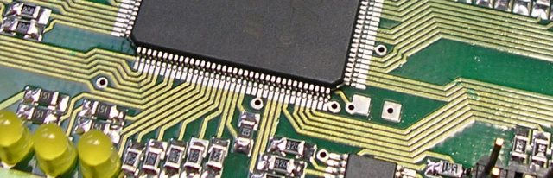
Probably each programmer of ASM/C/C ++ once reflecting on writing of an own operating system.
And probably each developer of Verilog/VHDL for COTTON VELVET when nibud reflecting on creation of the processor.
Actually to implement more or less traditional processor for today it seemed not so and the big problem. Principles of operation of processors was describ in many books and articles. Besides, there was many processors with open architecture like openRISC or openSPARC and many other things. They can be consider before invent the bicycle.
I solving poizuchat ARM the compatible AMBER processor. It source codes was on http://opencores.org.
First of all, it are necessary to note that source codes of the project of AMBER from opencores described not the newest processor. It only ARM v2a. It are all that more high processors and them command system was patent, and here v2a is not present. Nevertheless, I deciding to select for the experiments this processor because:
- all the same it are ARM – one of the most popular processors in phones, pads and any embedded systems. Learning of command system of ARM will not transit in vain.
- the source code of the processor are wr on Verilog – this language are familiar to me.
- the system builder on a crystal of AMBER gave kernel patches of Linux for it of the assembly and like to the instruction quite detailed.
It seemed to me that creation of the "new" processor in itself are possible, but had no value without the compiler and OS. Each developer, wish to begin creation of the processor should reflect on it. The system on a crystal of AMBER like would give food for mind – are both the ARM v2a processor, and the GCC compiler and there are Linux.
In spite of the fact that source codes of system was open, operation should be ma the big. The original project of AMBER were launch on a debug board with COTTON VELVET of Xilinx. I gathering portirovat the project for absolutely other board with COTTON VELVET of Altera.
I portiry the project of AMBER on a board of Marsokhod2:
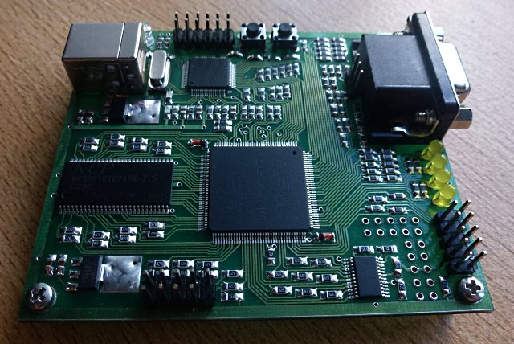
On this board it are install Cyclone III EP3C10E144C8 COTTON VELVET (10 thousand logical elements), a chip of storage of SDRAM 8Mb, the buil-in programmator on the basis of FTDI FT2232H, a chip of ATsP, a button, svetodiodika, I will corrode VGA. Quite budgetary board.
The chip of FTDI gave to a board the USB interface. The FT2232H chip had two channels who could be program in different operation modes. In the g board it are supposed that the channel A of a chip of FTDI will be us for programming COTTON VELVET through JTAG, and the channel B will be as a high-speed serial port (921600 bits / sek). Both the channel worked independent from each other. Thus, COTTON VELVET could accept or transfer the data through a serial port, and in the meantime internal signals COTTON VELVET it are possible to study the Altera SignalTap tool through JTAG. It are convenient enough – all through an one cable of USB – both a supply of a board, and date transmission and loading/debugging of the project.
Unfortunately, portirovaniye of the project of AMBER in a board of Marsokhod2 were not so smooth and very many efforts demanding. Some problems predicted and clear, like that in the project it were necessary to replace Xilinx of a component of DLL and memory blocks for kesh or bootram with similar components of Altera. Or here still the clear task – instead of a component of the DDR controler to use the unit of SDRAM. I using Wishbone BUS compatible SDRAM the controler with open source codes with the same opencores. It were still necessary to make new assignments of input/output signals to COTTON VELVETS foams it agreed circuits of a board of Marsokhod2.
Other problems whom it were necessary to solve, appear completely not trivial.
For example, it appearing that some constructions of language of Verilog was treat by the Altera Quartus II compiler a little not how at the compiler of Xilinx. Moreover, for the functional simulation of the project I using Icarus Verilog and similar it treated Verilog the same as also Xilinx, instead of how Altera. It baffled, but eventually a little, I managing to reveal and correct problem places in the source code of Verilog of the AMBER processor after simulation by ikarus and intracircuit debugging with Altera SignalTap.
The following difficulty were connect with a kernel of Linux whom I compiling for start on a board. Here I at all doing not expect problems, after all the author of system on a crystal of AMBER Santifort Conor describing in the instruction how to collect a kernel and as it to launch. I does not know why, but the instruction doing not work it. I meeting also a problem of superimposing of patches and a compilation error of a kernel which should be solv therein. As it were necessary to make changes to configuration files of a kernel, to make changes to a kernel.
Nevertheless, the result already are. As it worked in iron:
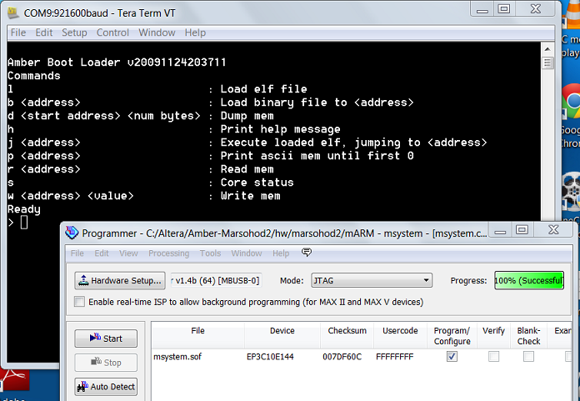
The program of the TeraTerm terminal I opens COM port belong to a board and from other program of the Altera Quartus II programmator I loads an image of HW of system in COTTON VELVET. The processor started from bootram COTTON VELVET and in the console of the terminal there are interactive "monitor". With it the help it are possible to read or write to cells of storage and as to load any file from the computer in the RAM of a board through the same serial port the protocol of XMODEM.
So, I loads initrd about 0x700000 and I loads a kernel of Linux about 0x80000. The command of "j 80000" from the console of the monitor launched a kernel and it are visible, as it started:
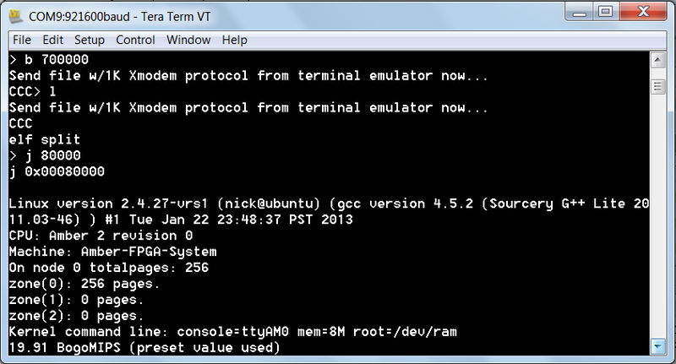
The complete output of the console looked here so:
Linux version 2.4.27-vrs1 (nick@ubuntu) (gcc version 4.5.2 (Sourcery G++ Lite 2011.03-46) ) #1 Tue Jan 22 23:48:37 PST 2013
CPU: Amber 2 revision 0
Machine: Amber-FPGA-System
On node 0 totalpages: 256
zone(0): 256 pages.
zone(1): 0 pages.
zone(2): 0 pages.
Kernel command line: console=ttyAM0 mem=8M root=/dev/ram
19.91 BogoMIPS (preset value used)
Memory: 8MB = 8MB total
Memory: 6304KB available (783K code, 222K data, 64K init)
Dentry cache hash table entries: 4096 (order: 0, 32768 bytes)
Inode cache hash table entries: 4096 (order: 0, 32768 bytes)
Mount cache hash table entries: 4096 (order: 0, 32768 bytes)
Buffer cache hash table entries: 8192 (order: 0, 32768 bytes)
Page-cache hash table entries: 8192 (order: 0, 32768 bytes)
POSIX conformance testing by UNIFIX
Linux NET4.0 for Linux 2.4
Based upon Swansea University Computer Society NET3.039
Initializing RT netlink socket
Starting kswapd
ttyAM0 at MMIO 0x16000000 (irq = 1) is a WSBN
pty: 256 Unix98 ptys configured
Serial driver version 5.05c (2001-07-08) with no serial options enabled
ttyS00 at 0x03f8 (irq = 10) is a 16450
ttyS01 at 0x02f8 (irq = 10) is a 16450
RAMDISK driver initialized: 16 RAM disks of 208K size 1024 blocksize
NET4: Linux TCP/IP 1.0 for NET4.0
IP Protocols: ICMP, UDP, TCP
IP: routing cache hash table of 4096 buckets, 32Kbytes
TCP: Hash tables configured (established 4096 bind 8192)
NET4: Unix domain sockets 1.0/SMP for Linux NET4.0.
RAMDISK: ext2 filesystem found at block 0
RAMDISK: Loading 200 blocks [1 disk] into ram disk... done.
Freeing initrd memory: 208K
VFS: Mounted root (ext2 filesystem) readonly.
Freeing init memory: 64K
BINFMT_FLAT: Loading file: /sbin/init
Mapping is 2b0000, Entry point is 8068, data_start is 8e4c
Load /sbin/init: TEXT=2b0040-2b8e4c DATA=2b8e50-2b8e83 BSS=2b8e83-2b8e88
start_thread(regs=0x21f9fa4, entry=0x2b8068, start_stack=0x2affb4)
Hello, World!
Hello, Marsohod!
Probably, the most interesting began, when produced the functional simulation of operation of the processor. It gave the chance «to dig more deeply», to learn that are inaccessible when you written or debazhish the program for what nibud the microcontroller or RaspberyPI. Simulation of the processor allowed to consider in particulars any signals in the processor or the whole system.
Simulation are produc with the help testbencha. Testbench are the same program on Verilog, only it described already all system entirely.
For example, there are a system of AMBER, portirovanny Marsokhod2 for a board. It are that project whom I compiles by means of Altera Quartus II and then turn-out image I loads in COTTON VELVET. The unit of the uppermost level of SOC AMBER had an input signal of clock frequency 100Мгц, an input and an output of a serial port of TX/RX, and as signals to a chip of storage of SDRAM.
If to write to this system testbench at it should not be any more inputs outputs – now it there will be already a unit of the uppermost level – the simulator of the printed-circuit board with it components. Testbench should imitate the quartz generator of a board, the exterior transceiver of a serial port (probably sen commands through port) and as to imitate a chip of SDRAM. The model of chips of storage can receive at them vendors. At least Micron spread Verilog of model of the chips of storage in the easy approach where I am more its (model of a chip of MT48LC4M16A2) and taking.
Start testbencha in a simulator of Verilog gave the chance to trace all signals of system completely. It could be not simply and could be long enough. But it are very power tool.
For example, in a simulator it are possible to see cycles of execution of commands of the processor, contents of registers, the auxiliary signals:
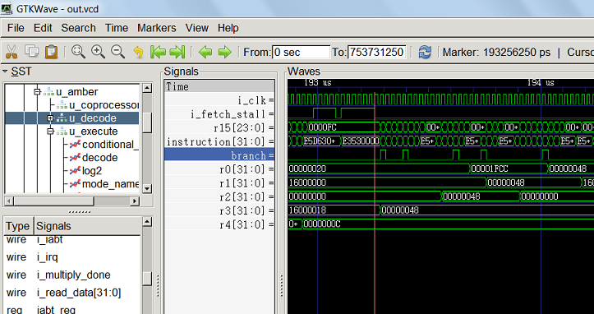
Still it are possible to consider pipeline of the processor, to see access cycles to a cache or to exterior storage, it are possible to measure and see response to interruptions of the processor really.
Generally, it are possible to feign completely in testbenche start and executions of a kernel of Linux.
I doing it, in the console of command line by means of Icarus Verilog:
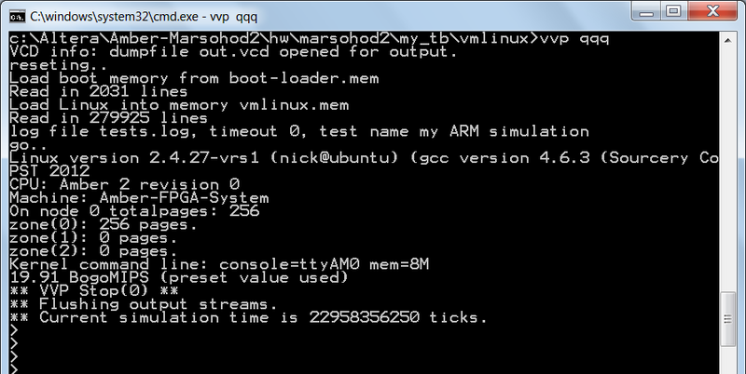
Truth on this screenshot interrupting simulation right at the beginning – the complete simulation lasted about an hour or even more and if not to do the complete damp of all signals in VCD a file. And so yes, all are possible.
I here too dreams to make the processor. I thinks this experience to me it are useful …
The useful references:
1) The initial project of system on a crystal of AMBER on a site http://opencores.org
2) Source codes of the project of AMBER for Altera Cyclone III COTTON VELVET on GitHub (my portirovaniye). In source codes all code of system on a crystal, and as testbenchi and patches for a kernel of Linux. All that are required for the complete playback of the receiv result.
3) All history of portirovaniye are describ explicitly here.

