# **agenda_programadores**

# Created on July 23 2017

# **Table of Contents**

1.0. agenda

2.0. agenda/todos

3.0. agenda/lenguaje/:id

# **1.0. agenda**

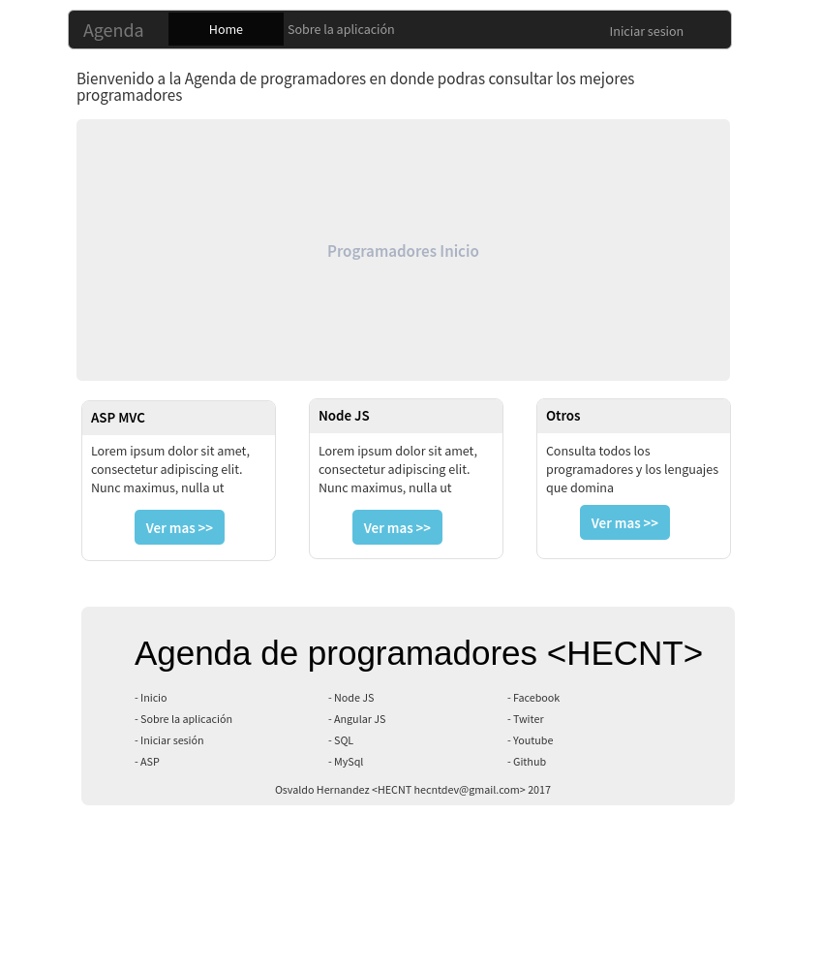

# **2.0. agenda/todos**

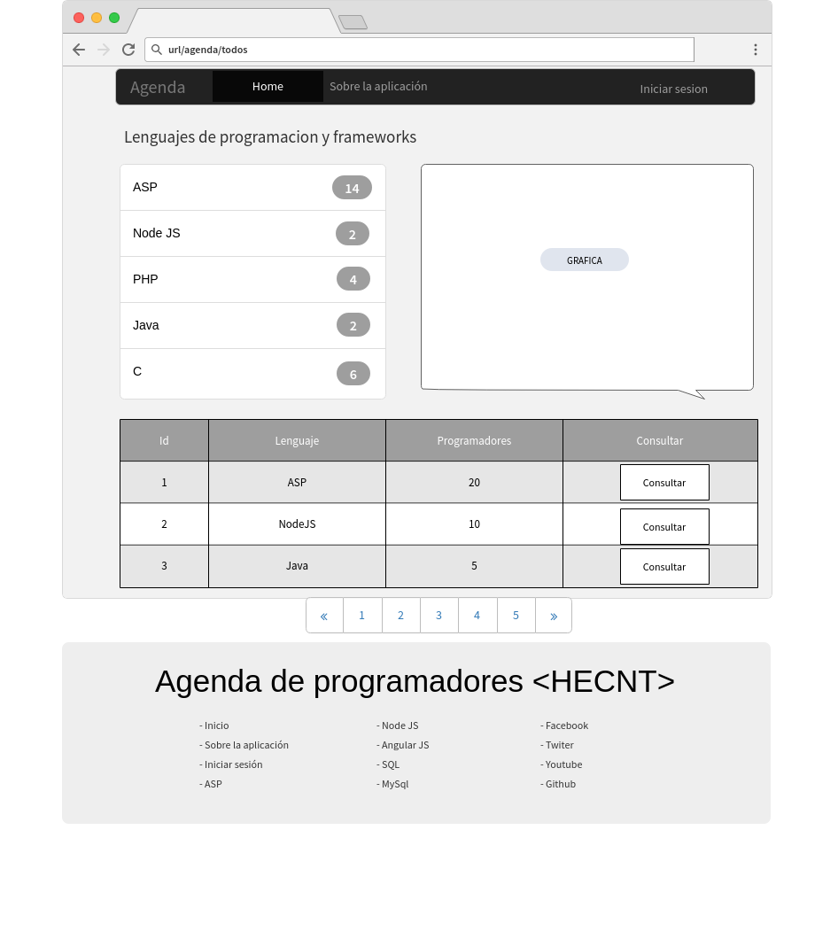

# **3.0. agenda/lenguaje/:id**

