A
Mini Project Report
On
Skin Cancer Detection Using Convolutional Neural Networks
Submitted for partial fulfillment of the requirements for the award of the degree of
BACHELOR OF TECHNOLOGY
in
CSE-DATA SCIENCE
By
T. Heema Sree (21N81A6770)
P. Navya Sri (21N81A6782)
K. Vamshidhar (21N81A67B3)
Under the guidance of
Mr. Raghavendra M I
M.Tech
Assistant Professor


DEPARTMENT OF COMPUTER SCIENCE & ENGINEERING-DATA SCIENCE
SPHOORTHY ENGINEERING COLLEGE
Affiliated to JNTUH & Recognized by AICTE
Nadergul, Hyderabad-501510
Academic Year-2024-25



CERTIFICATE

This is to certify that this Mini Project entitled “Skin Cancer Detection Using Convolutional Neural Networks” is a bonafied work carried out by T.HeemaSree (21N81A6770), P. NavyaSri (21N81A6782) ,K. Vamshidhar (21N81A67B3)in partial fulfilment of the Requirements for the award of degree of Bachelor of Technology in Computer Science Engineering-DATA SCIENCE from Sphoorthy Engineering College, affiliated to Jawaharlal Nehru Technological University Hyderabad, Hyderabad, during the Academic Year 2024-25 under our guidance and supervision.
The results embodied in this report have not been submitted to any other University or institute for the award of any degree or diploma.

Internal Guide Head of the Department
Raghavendra Ichangi Dr.K. Ramesh Rao
Assistant Professor Head, Dept.of CSE-DS
Dept.of CSE-DS

Principal

DECLARATION

We, the undersigned, declare that the Seminar entitled “Skin Cancer Detection Using Convolutional Neural Networks” carried out at SPHOORTHY ENGINEERING COLLEGE is original and is being submitted to the Department of COMPUTER SCIENCE ENGINEERING-DATA SCIENCE, Sphoorthy Engineering College, Hyderabad towards partial fulfilment for the award of Bachelor of Technology.

We, declare that the result embodied in the Real Time Research Project work has not been submitted to any other University or Institute for the award of any Degree or Diploma.

Date:
Place: Hyderabad

T.HeemaSree(21N81A6770)
P. Navya Sri (21N81A6782)
K. Vamshidhar (21N81A67B3)

ACKNOWLEDGEMENT

We, deem it a great privilege to express our profound gratitude and sincere thanks to Sri. S. Chalama Reddy, Chairman, Sri. S. Jagan Mohan Reddy, Secretary, Prof. M.V.S. Ramprasad, Director, Prof. Giridhar Akula, Principal, Sphoorthy Engineering College, for their moral support, necessary arrangements and kind help in the completion of our project work.
We, express my deep sense of gratitude to my Project Guide Mr.Raghavendra, Assistant professor, Department of CSE-DS, Sphoorthy Engineering College, Jawaharlal Nehru Technological Univeristy Hyderabad(JNTUH), Hyderabad for his/her inspiring guidance, consistent encouragement, constructive criticism and helpful suggestions during the entire course of my research and seminar work.
We, express my sincere thanks to Dr. K .Ramesh Rao, Professor & Head of CSE-Data Science department, Sphoorthy Engineering College, for his/her encouragement which helped me to complete my seminar work.
We, express my heartfelt thanks to my department faculty members, non-teaching staff for providing the necessary information pertaining to my seminar work.
We,always greatful to my parents, family members, well-wishers and friends for their remarkable support during our seminar work.

Abstract
Skin cancer, particularly melanoma, has a high mortality rate when detected at advanced stages, making early and accurate diagnosis essential. This study presents a deep learning-based system for automated skin cancer detection using dermascopic images. A convolutional neural network (CNN) was developed to classify skin lesions into benign and malignant categories, utilizing a large, publicly available dataset. Key preprocessing steps, including lesion segmentation, image enhancement, and data augmentation, were applied to improve the model’s accuracy and robustness. Transfer learning was incorporated to address the challenge of limited annotated data, allowing the model to leverage pre-trained weights from large-scale image classification tasks. The proposed model achieved superior performance in terms of accuracy, sensitivity, and specificity when compared to traditional diagnostic methods and existing machine learning approaches. This automated system significantly reduces the time required for diagnosis, assisting dermatologists in early detection and minimizing the risk of human error. Moreover, it offers a scalable solution for regions with limited access to dermatological expertise, enabling remote and cost-effective skin cancer screening.
The system is evaluated using metrics such as accuracy, precision, recall, and F1-score, demonstrating promising results that rival or exceed human-level diagnostic accuracy. The findings suggest that CNN-based approaches can provide reliable and efficient tools for skin cancer detection, potentially assisting dermatologists in clinical settings and improving accessibility in resource-limited regions. The study demonstrates the potential of AI-driven technologies to revolutionize skin cancer detection, ultimately contributing to improved patient outcomes through timely interventions.
Keywords: Skin cancer detection, Melanoma diagnosis, Deep learning, Convolutional neural network (CNN).

INDEX

Content |  |  | Page. No
Abstract |  |  | Ii
List of Figures |  |  | Iii
List of Tables |  |  | Iiii
1. | Introduction
 | 1.1 | Skin cancer | 1
 | 1.2 | Types of Skin Cancer | 02
 | 1.3 | Stages of Skin Cancer | 03
2. | Literature Survey
 | 2.1 | Skin Cancer Detection utilizing Deep Learning | 06
 | 2.2 | Skin Cancer Images Classification using Transfer Learning Techniques | 08
 | 2.3 | Skin Cancer | 11
3. | System Design
 | 3.1 | System’s Architecture | 13
 | 3.2 | Work Flow Design | 14
4. | Methodology
 | 4.1 | Normalization | 18
 | 4.2 | Data Augmentation | 19
 | 4.3 | Class Balancing | 24
 | 4.4 | CNN Model Design | 29
 | 4.5 | Optimizer | 32
5. | Implementation |  | 35
6. | Future Enhancement |  | 40
7. | Conclusion |  | 44
 | References |  | 45

LIST OF FIGURES

Figure No. | Figure Name | Page No.
1.1 | Types of Skin Cancer | 02
1.2 | Stages of Non-Melanoma | 03
1.3 | Stages of Melanoma | 04
2.1 | Vision Transformer by Dosovitskiy et al. | 06
2.3 | Skin Cancer detection using Transfer Learning | 09
2.4 | ResNet 50 | 10
2.5 | Warning signs for melanoma | 11
3.1 | CNN Architecture | 14
3.2 | Image Preprocessing | 14
3.3 | Solution Desgin | 16
4.1 | Data Augumentation | 20
4.2 | Class Balancing | 25
4.3 | Detection using Deep Learning Technique | 29
4.4 | Model Selection | 29
4.5 | Binary cross-entropy | 31
4.6 | Categorical cross-entropy | 32
5.2 | Classes based on model’s output | 36
6.1 | Future Enhancement for Skin Cancer Detection | 41
6.2 | Mobile App for Future Enhancement | 43

LIST OF TABLES

Table No. | Table Name | Page No.
1.4 | Estimation of Cancer Cases And their causes | 05
2.5 | Warning Signs of Melanoma | 11
2.6 | Reasons and Sources | 12
3.4 | Evaluation of other Methodology | 16
5.1 | Visual representation of skin cancer cases in a pie chart | 35
5.3 | Prediction of Testing and Training values | 36

INTRODUCTION
Skin cancer is the abnormal growth of skin cells, typically resulting from damage caused by ultraviolet (UV) radiation from the sun or artificial sources like tanning beds. It is one of the most common types of cancer and can affect people of all skin types. While skin cancer is generally treatable when detected early, certain types can become life-threatening if they spread to other parts of the body.
Types of Skin Cancer
The three main types of skin cancer are:
- Basal Cell Carcinoma (BCC):
  - The most common and least aggressive form of skin cancer.
  - Develops in the basal cells, located in the lower part of the epidermis.
  - Typically appears as a pearly or waxy bump on sun-exposed areas like the face or neck.
- Squamous Cell Carcinoma (SCC):
  - The second most common type, more aggressive than BCC but still highly treatable.
  - Arises from squamous cells, which make up the outer layer of the skin.
  - Often appears as a scaly, red patch, a sore, or a raised growth with a central depression.
- Melanoma:
  - The most dangerous type of skin cancer, responsible for the majority of skin cancer deaths.
  - Develops in melanocytes, the cells that produce pigment (melanin).
  - Can appear as an irregular mole or dark spot with asymmetry, uneven borders, or color variation.
Skin cancer is one of the most common types of cancer all over the world. The most common cause is excessive exposure of the skin to UV rays from the sun. Fair-skinned, sun-sensitive people have a higher rate of UV exposure than dark-skinned people who are less sensitive to the sun. There are various types of skin cancer. Among them, melanoma skin cancer is the most common and dangerous type of cancer. It involves an abnormal proliferation of pigment cells in the skin. It is a common life-threatening disease in humans. It brightens the skin and can quickly spread to other areas body. Therefore, early detection of melanoma is essential. Invasive melanoma accounts for approximately 1% of all skin cancer cases but contributes to most skin cancer deaths. The incidence of melanoma skin cancer has increased rapidly over the past 30 years. In 2021, it was estimated that 100,350 new cases of melanoma were diagnosed in the United States, ultimately resulting in about 6,850 deaths.
Skin cancer is a significant public health issue, and early detection is paramount for successful treatment. Traditional diagnosis often relies on visual examination by dermatologists, which can be subjective and time-consuming. This project investigates the application of Convolutional Neural Networks (CNNs) to automate the process of skin cancer detection. By leveraging the power of deep learning, we aim to develop a model that can accurately classify skin lesions as benign or malignant based on [Image type - e.g., dermoscopic images, clinical photographs]. Our CNN architecture will learn intricate patterns and features within the images, enabling more objective and potentially more accurate diagnoses. This project has the potential to assist dermatologists in their clinical practice, improve diagnostic efficiency, and enhance patient outcomes.

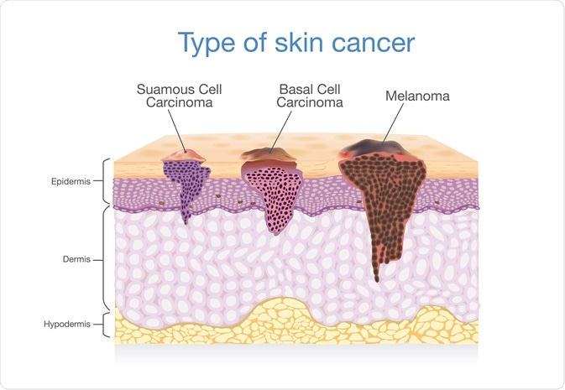
Fig.1.1Types of Skin Cancer

Stages of Skin Cancer
Skin cancer staging helps determine the extent of cancer spread and guides treatment decisions. The stages vary slightly depending on the type of skin cancer (e.g., melanoma or non-melanoma), but they generally follow the TNM system, which considers Tumour size (T), Node involvement (N), and Metastasis (M). Here’s a detailed explanation:
Non-Melanoma Skin Cancer Stages
Non-melanoma skin cancers, such as Basal Cell Carcinoma (BCC) and Squamous Cell Carcinoma (SCC), are typically less aggressive. Their stages are as follows:
- Stage 0 (Carcinoma in situ):
  - Cancer cells are confined to the top layer of the skin (epidermis).
  - No spread to deeper tissues or other areas.
- Stage I:
  - Tumor is small (≤2 cm in diameter).
  - Has not spread to nearby lymph nodes or other parts of the body.
- Stage II:
  - Tumor is larger than 2 cm or has high-risk features (e.g., thicker, faster-growing).
  - Still localized without lymph node involvement.
- Stage III:
  - Cancer has spread to nearby lymph nodes or structures like the bones or cartilage.
  - Has not metastasized to distant organs.
- Stage IV:
  - Cancer has metastasized to distant parts of the body, such as the lungs or liver.
  - Advanced and requires systemic treatment.
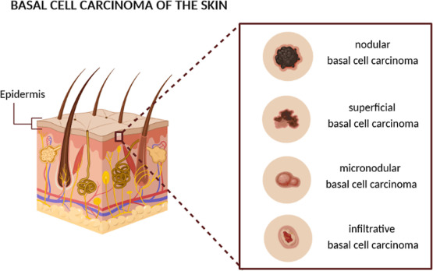
Fig1.2 Stages of Non-Melanoma

Melanoma Skin Cancer Stages
Melanoma is staged based on tumor thickness, ulceration, lymph node involvement, and distant metastasis. The stages include:
- Stage 0 (In situ melanoma):
  - Melanoma cells are confined to the epidermis.
  - No invasion into deeper layers of skin.
- Stage I:
  - Tumor is thin (≤2 mm thickness), with or without ulceration.
  - No spread to lymph nodes or distant sites.
- Stage II:
  - Tumor is thicker (>2 mm) or has ulceration.
  - Still localized without lymph node involvement or distant metastasis.
- Stage III:
  - Cancer has spread to nearby lymph nodes or surrounding skin.
  - No evidence of distant metastasis.
- Stage IV:
  - Cancer has metastasized to distant organs (e.g., lungs, liver, brain) or distant lymph nodes.
  - Often requires aggressive treatment, including immunotherapy or targeted therapy.
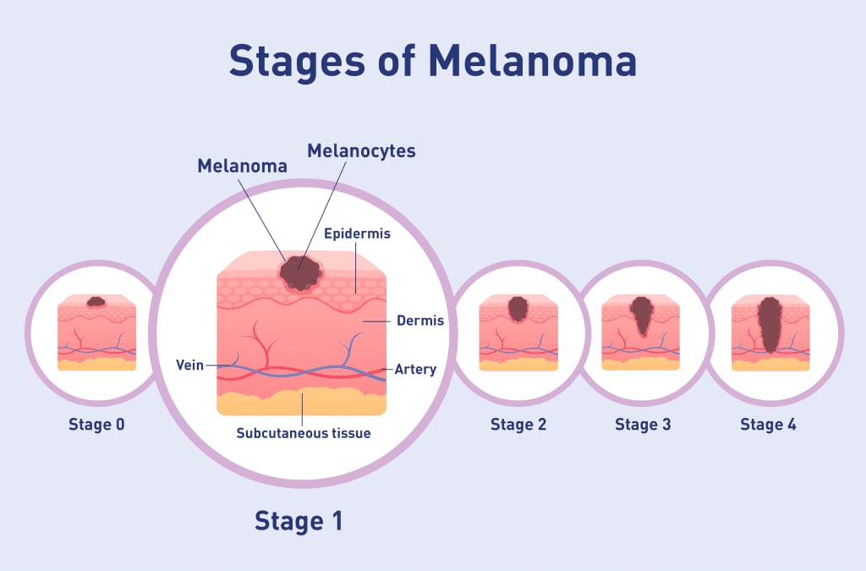
Fig1.3Stages of Melanoma
The critical factor in skin cancer treatment is early diagnosis [6]. Doctors ordinarily use the biopsy method for skin cancer detection. This procedure removes a sample from a suspected skin lesion for medical examination to determine whether it is cancerous or not. This process is painful, slow, and time-consuming. Computer-based technology provides a comfortable, less expensive, and speedy diagnosis of skin cancer symptoms. In order to examine the skin cancer symptoms, whether they represent melanoma or nonmelanoma, multiple techniques, non-invasive in nature, are proposed.
Skin cancer is a disease caused by changes in the properties of normal skin cells to become malignant, in which cells will continue to divide into abnormal shapes that are uncontrolled due to DNA damage. Based on histopathology view, skin cancer has an irregular structure with cell differentiation in various levels of chromatin, nucleus, and cytoplasm. Skin cancer is a malignancy disease that is often found in Indonesia in addition to cervical cancer and breast cancer. Skin cancer found 5.9 to 7.8% for all types of skin cancer per year. The most common skin cancers in Indonesia are basal cell carcinoma (65.5%), followed by squamous cell carcinoma (23%), malignant melanoma (7.9%), and other skin cancers .Even though the number of Malignant Melanoma incidents is smaller than Basal Cell Carcinoma and Squamous Cell Carcinoma, the death rate tends to be greater, which causes 75% of deaths from skin cancer .The most invasive skin cancer is melanoma, which has a high mortality rate, especially if it is not early detected. Non-melanoma skin cancers, such as basal cell carcinoma and squamous cell carcinoma are more common but less metastatic, and only partially leads to disability or death. Accurate diagnosis and early detection of skin cancer can help the healing process, proper medical treatment, and avoid the worst effects of skin cancer. Therefore, an early detection system is needed that can facilitate and increase public awareness in identifying types of skin cancer or other skin disorders such as a benign tumor on the skin that look very similar to skin cancer.

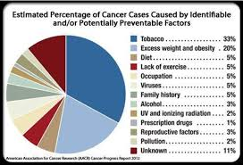
Table.1.4 Estimation of Cancer Cases And their causes

Literature Survey
The literature survey provides an overview of existing research, methods, and advancements in skin cancer detection, highlighting the evolution of techniques and the role of technology in improving diagnostic accuracy.
1.Skin Cancer Detection utilizing Deep Learning: Classification of Skin Lesion Images using a Vision Transformer.Publisher by: Carolin Flosdorf, Justin Engelker, Igor Keller, Nicolas Mohr. Published Date: 2024.
There are a variety of machine learning approaches in research that aim to classify images with diseases caused by skin lesions in general. Several publications use clinical images for a CNN approach (Brinker et al. 2018; Hanet al. 2018). The successful performance of CNN-based models is also confirmed by their superior performance in skin cancer classification compared against 58 international dermatologists (Haenssleetal. 2018). For the classification of images from the Skin Cancer MNIST: HAM10000 dataset in particular, there are similarly neural network-driven approaches (Codella et al. 2019; Tschandl, Rosendahl, and Kittler 2018). As of December 2023, the Kaggle page of the dataset contains over 475 codes (Mader 2020). In research, this dataset is also used frequently in combination with a CNN approach to classify the skin cancer images (Shete et al. 2021; Nugroho, Slamet, and Sugiyanto 2019; Huo 2021). Garg, Maheshwari, and Shukla (2021) achieve a highly successful result with their CNN based approach in combination with augmentation strategies to increase the number of images and also use transfer learning methods such as Residual Neural Network (ResNet).
In addition, the newer approach from 2020 for image classification called ViT is becoming increasingly relevant in the field. Empirical evidence shows that this approach leads to better results in classification tasks compared to common methods such as CNN (Dosovitskiyetal. 2020). Korgialas (2021) uses in his work the configurations ViT B16 and ViT B32 as well as an augmentation approach to assign the images from the Skin Cancer MNIST: HAM10000 dataset to one of the seven skin cancer types. Overall, primarily existing research mainly uses the established CNN approach for classification or the smaller pre trained ViT configurations. Furthermore, the existing work does not explicitly assess the performance of the respective model for the relatively most lethal skin cancer type of the dataset, melanoma.
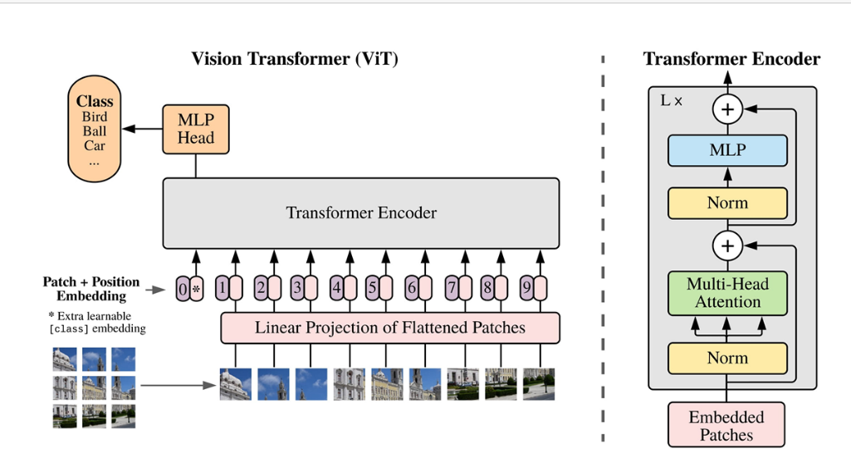
Fig 2.1 Vision Transformer by Dosovitskiy et al.
The respective ViT model is followed by a flatten layer, which lowers the input from a 3Dtensor to a 1Dtensor. The flatten layer is followed by abatch normalization layer to normalize and stabilize the activations of the network. It is further extended by a dense layer (fully connected) with 28 neurons. The scientifically established non-linear rectified linear unit (ReLU) is applied as the activation function (James et al. 2013). Its definition is as follows:
ReLU(z) = max(0,z)
Again, a batch normalization layer is added, followed by a dropout layer and the final dense layer that has 7 (skin cancer types) neurons and the activation function softmax to facilitate the interpretation of the output values as class probabilities, as this is a crucial aspect in multi-class clas sification tasks (Goodfellow, Bengio, and Courville 2016). The softmax function for this problem is designed accord ing to the following equation:
σ(zi) = ezi 7 j=1 ezj for i = 1,2,...,7
This study shows that Vision Transformers (ViT) can be more effective than traditional methods like CNNs in classifying skin cancer. The main findings indicate that our ViT models, specifically ViT L32 and ViT L16, outperform baseline models (DTC and KNN) and previous studies that use smaller ViT configurations or CNNs. ViT L16 achieves an accuracy of 92.79% and a melanoma recall of 56.10%, demonstrating its potential for accurate skin cancer detection. These findings highlight the effectiveness of ViT models in capturing intricate patterns in dermascopic images, owing to their advanced attention mechanisms. Nevertheless, this study has limitations. The models are trained on a dataset with uneven representation of skin cancer types, which may have affected their performance on di verse real-world datasets. Furthermore, while the recall for the most lethal skin cancer type in our models is better than most reference models, the metric is slightly below 60% in both models, meaning that over 40% with melanoma are classified as something else. Additionally, ViTs, like many deep learning models, can be considered “black-boxes”. It is crucial to understand how these models make decisions, par ticularly in healthcare applications. The lack of interpretability could be a significant limitation in clinical settings where comprehending the reasoning behind a diagnosis is as important as the diagnosis itself. Moreover, ViT models, particularly larger configurations such as ViT L16 and ViT L32, necessitate significant computational resources for training and inference. The deployment of these technologies in resource-constrained environments, such as rural clinics or developing countries, may be limited. Lastly, the use of data augmentation techniques to address class imbalance may result in overfitting, particularly if the augmented data does not accurately represent real-world variations.
The future research could benefit from exploring ways to optimize ViT models for more balanced datasets or using techniques to mitigate class imbalance. In addition, future research could broaden its scope to identify and classify other skin diseases, not just cancer, using ViT models or conduct a long-term study to evaluate the performance and reliability of ViT models over time, and their adaptability to evolving clinical guidelines and practices. Investigating the integration of ViT models into clinical workflows could pave the way for their practical application in the early detection of skin cancer, potentially reducing the burden on health care systems and improving patient outcomes.

2.Skin Cancer Images Classification using Transfer Learning Techniques
Publisher by : MdSirajul Islam & Sanjeev Panta. Published Date: 18 Jun 2024
Many new methods have emerged in recent years given the rise in the importance of the detection and classification of skin cancer from dermatoscopy skin lesions images. Computer-assisted diagnosis systems become fast and inexpensive alternatives for detecting various types of diseases. Recently, deep learning techniques have made a huge impact on various problems including medical image processing.It is challenging to perform research on medical data due to the unavailability of large and accurate datasets. Medical institutions do not like to share privacy sensitive patient data. Despite of having such challenges many prior research is able to assist healthcare practitioners at a large scale. In the past few years, several works aimed at skin cancer detection and classification using CNNs have been published. Although the goals of all these tasks are very similar, each task focuses on a specific type of problem. For example, is proposing a two-class (malignant and benign) classifier. Other works in consider more complex 7-class classification (melanoma, melanocytic nevus, basal cell carcinoma, actinic keratosis, benign keratosis, dermatofibroma, and vascular lesion). In the next few paragraphs, we will discuss about prior research those focuses on the classification of skin cancer images using deep learning techniques. Milton et al. proposed an approach to classify Melanoma and other skin lesion cancer images. The author conducted experiments by using the ISIC 2018 dataset on various deep learning models such as PNASNet-5-large, InceptionResNetV2, SENet154, and InceptionV4. They trained their models on different settings by changing parameters and learning rates, and optimizers. The experimental results displayed a class number for each type of skin lesion. Their experimental results provided the highest validation score of 76% for the PNASNet-5-large model. This work showed good classification results for a variety of skin lesions but did not consider the transfer learning process. One of the effective techniques to reduce bias and oversampling in datasets is data augmentation. It is more efficient when the dataset size is small. It helps to augment the data by rotating, flipping, and 2 cropping the images. Another way of achieving higher accuracy in the case of smaller datasets is transfer learning. Sometimes a small amount of data is not enough to train a deep learning model. It is therefore advantageous to use pre-trained models to overcome this problem. Nugroho et al. constructed a skin cancer detection system by using a customized CNN model. They used the HAM10000 skin cancer dataset. They achieved an accuracy of 78%. Bassi et al. introduced a transfer learning-based deep learning strategy on the HAM10000 dataset. They fine-tuned the VGG-16 model as well as resized HAM10000 dataset photos into 224×224. They attained 82.8% accuracy from their model. Chaturvedi et al. presented the detection of seven different types of skin lesions using MobileNet. They were able to achieve an accuracy of 83%. Canziani et al. applied two types of machine learning algorithms such as K-Means and Support Vector Machine. Their proposed approach provided an accuracy of 90%. Moldovan et al. exploit a transfer learning-based technique.
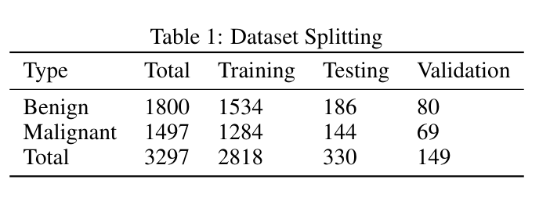
Table 2.2 Data Set Splitting
Transfer Learning:
Transfer learning is a machine learning technique in which a model developed from one domain is reused in another domain. It is mainly useful in the case when we do not have enough training data. However, the required amount of data can be increased by applying data augmentation. One of the main reasons for using transfer learning due to the high similarity between the malignant and benign images. It will take a longer time to detect and classify images without transfer learning. Moreover, it becomes our first choice because of the effective detection of similar images. Generally, transfer learning models are trained on larger datasets. We use these pre-trained models and finetune a few layers to fit our dataset. In this work, we used five different transfer learning models. They are ResNet-50, MobileNet, InceptionV3, DenseNet-169, and InceptionResNetV2. We re-trained these models using our dataset. We analyze their predictions by applying these transfer learning techniques to the skin lesion dataset.

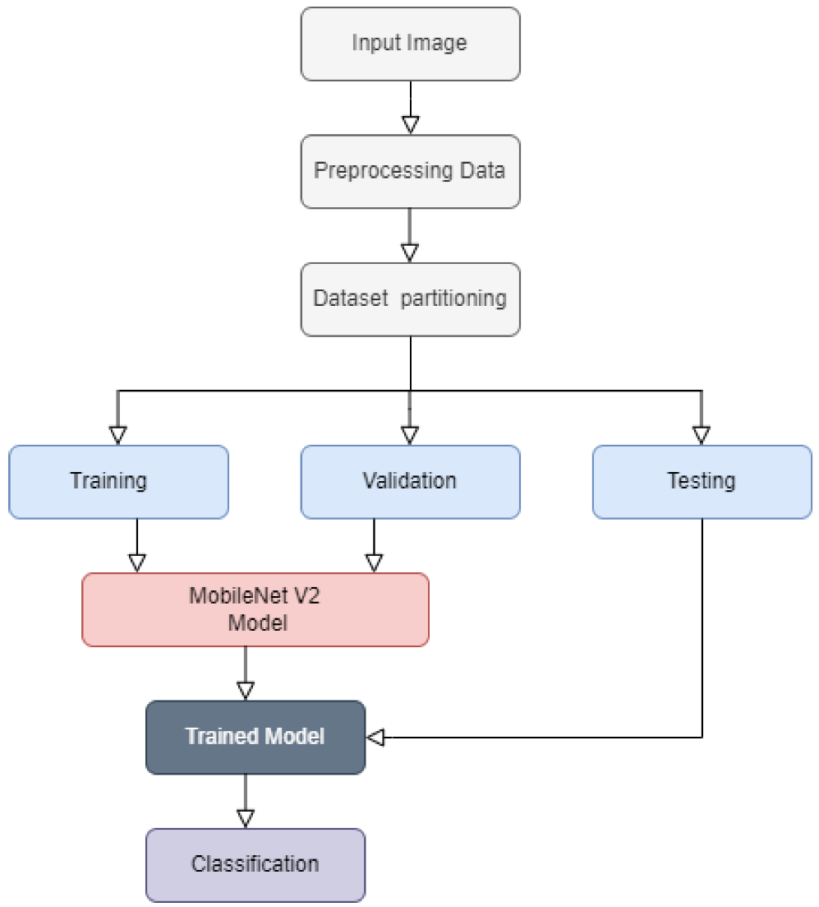
Fig 2.3Skin Cancer detection using Transfer Learning

ResNet-50:
ResNet is the shorter form of residual network. It could provide powerful performance that trains very large convolutional neural networks with many layers [22]. Parameter selection is dependent on the number of layers in the network. It performs batch normalization after each convolutional layer. It can reduce the issue of covariate shift and vanishing gradient descent problems. Were-trained the ResNet50 model on our dataset. We fine-tuned across all layers and replace the top layers with one average pooling and one fully connected layer to fit our dataset. Finally, we added a soft-max activation function that classifies images into two categories. To fit with this model, we resized all input images into (224 × 224 × 3) pixels. We used the Adam optimizer and the learning rate was 0.0001

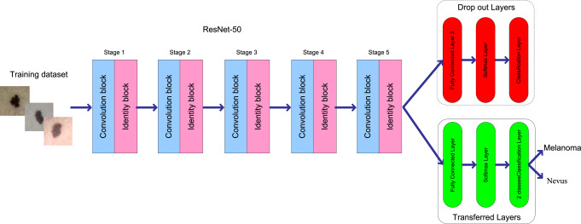
Fig 2.4 ResNet50 Work Flow

3.SKIN CANCER
Publisher by : Apple Bodemer, Publisher Date: 2014, updated 2020.
Skin cancer can be divided into two groups—melanoma and nonmelanoma. Most nonmelanoma skin cancers are either basal cell or squamous cell cancers. Basal cell and squamous cell cancers are the most common forms of skin cancer. They typically occur on areas of the body exposed to ultraviolet (UV) radiation (from the sun or from tanning beds) or other forms of radiation. The damaging effects of UV radiation build over time, so greater lifetime exposure increases the risk of developing these types of cancers. Nonmelanoma skin cancers typically show up as red, scaly plaques or shiny pink to red papules that can be tender, bleed spontaneously and won’t heal. These cancers grow very slowly and are generally easy to treat with surgery. However, if they are not treated, they can grow very large and, in rare circumstances, can spread to other parts of the body. Depending on the size and part of the body affected, treatment can include topical chemotherapeutic creams, surgery, and/or radiation. Melanoma is a serious type of skin cancer and can occur anywhere on the body including areas that are never exposed to UV radiation. If caught late or left untreated, it can spread to other parts of the body. It is more common in fair-skinned people and can run in families. UV exposure is a common cause of melanoma, and intermittent high-intensity exposure is the most dangerous pattern of UV exposure for increasing the risk of developing melanoma. Melanoma typically shows up as a dark brown or black mole on the skin. Signs that a mole might be abnormal or might be a melanoma include the A, B, C, D, Es: Asymmetry, jagged or uneven Borders, multiple Colors, large Diameter (larger than the eraser on a pencil), and/or a mole that is Evolving or changing color or shape.
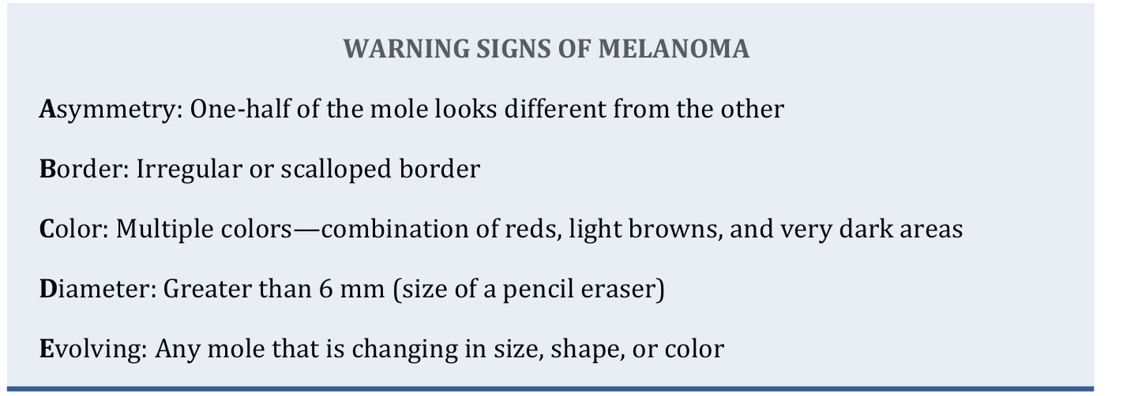
Fig 2.5Warning Signs of Melanoma
If a spot is suspicious, a biopsy is needed to make the diagnosis. This involves surgically removing the affected area of skin. If a spot is found to be melanoma, the type of treatment depends on how deep the melanoma cells go into the skin. For very thin melanomas, simply removing extra skin around the spot may be all that is needed. For thicker VA Office of Patient Centered Care and Cultural Transformation Page 1 of 8 Skin Cancer melanomas, the lymph nodes may need to be looked at to find out if any cancerous cells have spread into the blood stream. Chemotherapy and/or radiation may be options. These treatments can be very toxic, so it is important to work with a doctor or team of doctors to come up with the most appropriate treatment plan.
PREVENTION SUMMARY:
- Practice UV protection: o Avoid midday sun exposure (10 a.m. to 2-4 p.m.).
- Wear protective clothing and wide-brimmed hats. o Use sunscreen with SPF 30 or above and reapply often—at least every 2 hours or after the skin has been wet.
- Avoid tanning bed use.
- Practice monthly skin self-examination with appropriate health care provider screening.
- Eat a low-fat diet with lots of vegetables, fruits and spices, including garlic, onion, turmeric, and foods that contain a lot of beta-carotene, carotenoids, and vitamin C.
- Consider increasing fish intake or taking an omega-3 supplement.
- Drink green tea.
- Consider vitamin D supplementation.
- Consider increasing turmeric/curcumin in diet or taking as a supplement.

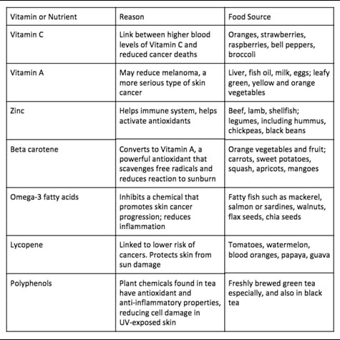
Table 2.6 Reasons and Sources

System Design
To ensure smooth execution, the following hardware and software configurations are recommended:
Hardware
- Processor: Intel i5/i7 or AMD Ryzen 5/7 (or better)
- RAM: At least 8 GB (16 GB recommended for large datasets)
- GPU: NVIDIA GPU with CUDA support (e.g., GTX 1050 or better) for faster training (Optional but recommended)
- Storage: 20 GB or more free space to store datasets and models
Software
- Operating System: Windows, macOS, or Linux
- Python: Version 3.8 or higher.
Required Libraries
The following Python libraries are necessary for this project:
- TensorFlow
- NumPy
- Matplotlib
- scikit-learn
- Pandas
System Architecture
Provide a high-level diagram and explanation of the system’s architecture. Key components include:
- Input Layer: Accepts raw dermoscopic images.
- Preprocessing Module: Performs image resizing, normalization, and augmentation.
- Feature Extraction Module: Utilizes the CNN layers to extract meaningful features from the input images.
- Classification Module: Applies fully connected layers or a softmax function to classify images as benign or malignant.
- Output Layer: Generates the final prediction along with confidence scores.

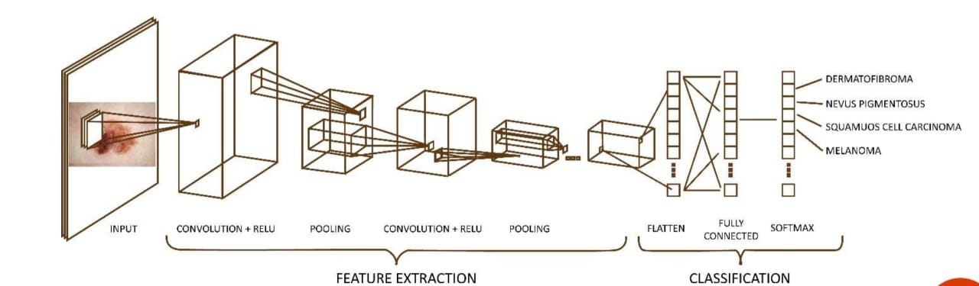
Fig 3.1 CNN Architecture
Workflow Design
Detail the end-to-end process in sequential steps:
- Data Acquisition: Describe the datasets used, including their source, size, and class distribution.
- Preprocessing:
  - Resizing images to a uniform size for model input.
  - Normalizing pixel values to a specific range (e.g., 0 to 1).
  - Augmenting data to increase diversity (e.g., flipping, rotation, zoom, color jitter).
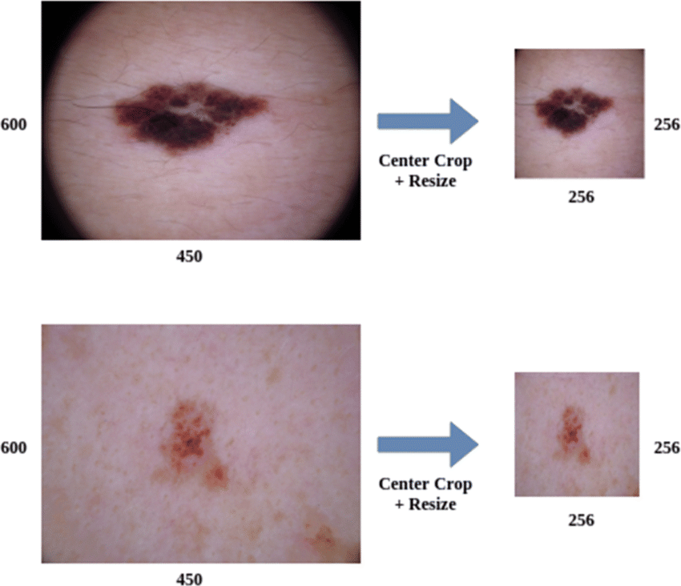
Fig 3.2 Image Preprocessing
- CNN Model Architecture:
1.Input Layer:
In a CNN-based skin cancer detection system, the input layer is the initial stage that processes raw images of skin lesions to extract relevant features for classification. The input layer accepts images in a structured format, typically in RGB color space, with dimensions standardized to a fixed size (e.g., 224x224 or 256x256 pixels). This resizing ensures uniformity across the dataset, making it easier for the neural network to learn patterns without being influenced by variations in image sizes.

The input layer serves as the interface between the raw image data and the deeper layers of the CNN. It converts pixel values into numerical arrays, normalizing them to a range between 0 and 1 or -1 to 1 to improve the efficiency of the learning process. This normalization helps the model converge faster by ensuring that input values are within a consistent range.
In skin cancer detection, the input layer is crucial for preserving the fine details of skin lesions, such as color variations, textures, and irregular borders, which are essential for differentiating between benign and malignant cases. The input layer also handles data augmentation techniques like rotation, flipping, and zooming to increase the diversity of training images, improving the model's generalization capabilities. Overall, the input layer plays a vital role in preparing and presenting the data to the CNN, ensuring that subsequent layers receive meaningful and well-processed input for accurate skin cancer detection.
2.Preprocessing
The preprocessing module in a skin cancer detection system is a crucial component that prepares raw input images for efficient processing by the convolutional neural network (CNN). Skin lesion images often contain noise, variations in lighting, and unwanted artifacts that can negatively impact the accuracy of the model. Therefore, the preprocessing module ensures that the input data is clean, consistent, and standardized before feeding it into the CNN.
3.Feature Extraction:
The feature extraction module is a core component of a skin cancer detection system that identifies critical patterns and characteristics from skin lesion images. This module automatically extracts important features, such as color, texture, shape, and edges, which are essential for distinguishing between benign and malignant skin lesions. In a CNN-based system, this process is handled by the convolutional layers, which are designed to detect hierarchical features at different levels of abstraction.
4.Classificatiion:
The classification module in a skin cancer detection system is responsible for analysing the features extracted by the convolutional layers and making the final decision regarding whether a skin lesion is benign or malignant. This module takes the high-level features identified during feature extraction and uses them to assign a class label to the input image based on patterns learned from labelled training data.
5.Output Layer:
The output layer in a skin cancer detection system serves as the final stage of the model, where the classification decision is made based on the features extracted and processed by the convolutional neural network (CNN). This layer is responsible for producing the model's prediction, whether it's a binary decision (benign vs. malignant) or a multi-class classification (different types of skin lesions or cancers). The design and function of the output layer depend on the specific classification task and the structure of the model

- Training and Validation:
  - Split the data into training, validation, and testing sets.
  - Use techniques like early stopping and learning rate adjustment to prevent overfitting.
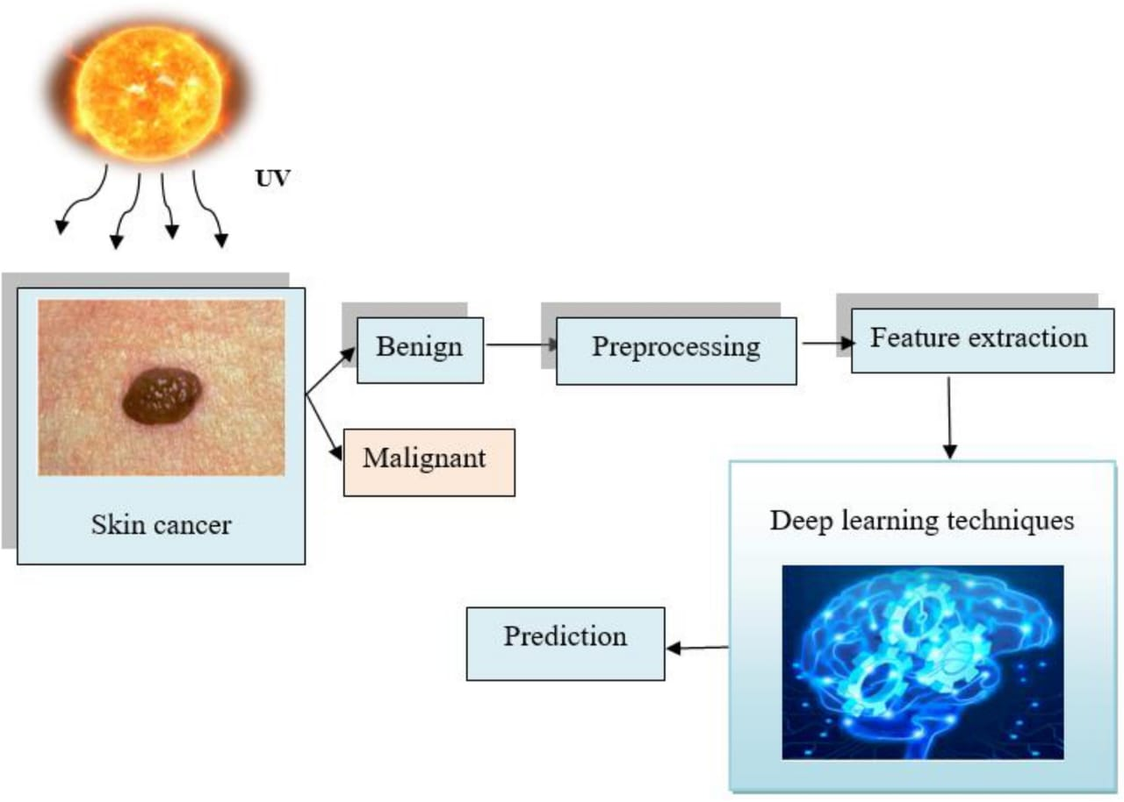
Fig 3.3 Solution Desgin
- Evaluation:
  - Describe the metrics used for performance evaluation (e.g., accuracy, precision, recall, F1-score).
  - Include confusion matrix analysis for detailed insight.
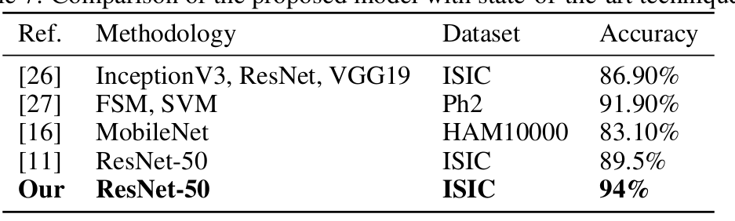
Table 3.4 Evaluation of other Methodology
This architecture is modular, scalable, and flexible, supporting real-world clinical applications while facilitating improvements through user feedback and additional data integration. It automates early diagnosis, enhancing accuracy and efficiency in skin cancer detection.

METHODOLOGY
The methodologies for skin cancer detection using Convolutional Neural Networks (CNNs) encompass several stages, from data preparation to model evaluation. Below is a detailed explanation of the key steps involved:
1. Data Acquisition
Obtaining high-quality labeled datasets is the foundation of any CNN-based skin cancer detection system.
- Datasets:
  - ISIC (International Skin Imaging Collaboration): A large repository of annotated dermoscopic images.
  - HAM10000: A dataset with diverse skin lesions, widely used for training CNNs.
  - PH2: A smaller dataset for melanoma detection.
- Data Collection Sources: Images are typically collected from dermoscopy devices, smartphones, or clinical databases.
2. Preprocessing Techniques
Preprocessing prepares raw data for training, ensuring consistency and improving model performance.
2.1.Image Resizing: Standardizing input image dimensions (e.g., 224x224 or 256x256) to fit the CNN architecture.
- Image resizing is a crucial preprocessing step in skin cancer detection using CNNs. It involves transforming input images to a uniform size to ensure compatibility with the CNN architecture. Most pre-trained models and custom CNNs require images of a specific dimension (e.g., 224x224, 256x256) as input. Resizing standardizes the dataset, enabling consistent feature extraction and reducing computational overhead.
- The process typically uses interpolation techniques like bilinear or bicubic interpolation to scale the image dimensions without distorting the features. For dermoscopic images, preserving lesion details during resizing is vital to ensure diagnostic accuracy. Careful resizing helps retain critical features like texture, shape, and color of skin lesions, which are essential for distinguishing between benign and malignant conditions.
- However, resizing can lead to information loss if the aspect ratio or resolution is significantly altered. To address this, padding or cropping may be used to maintain the image's integrity while fitting it into the desired dimensions.
- By ensuring uniformity, image resizing facilitates efficient training and inference, making it a fundamental step in preprocessing for skin cancer detection. When combined with other preprocessing techniques, resizing contributes to creating a robust and reliable input pipeline for CNN-based models.

2.2 Normalization: Scaling pixel values to a range (e.g., 0 to 1) for better gradient flow during training. Normalization is a critical preprocessing step in image-based deep learning tasks, including skin cancer detection using CNNs. It ensures that input image data is scaled to a uniform range, improving model performance and training stability.
In raw image data, pixel intensity values typically range between 0 and 255. These wide variations can lead to inefficiencies in gradient calculations during training, causing slower convergence and potentially suboptimal results. Normalization addresses this by scaling pixel values to a smaller, consistent range, such as 0 to 1 or -1 to 1.
Normalization is a crucial preprocessing step in skin cancer detection, particularly when using deep learning models. Its primary purpose is to ensure that the input data has a consistent scale, making it easier for the model to learn effectively. Here's how normalization applies in the context of skin cancer detection:
1. Image Normalization
When dealing with images of skin lesions or skin cancer datasets, normalization ensures that pixel intensity values are scaled to a uniform range.
- Typical Methods:
  - Min-Max Scaling: Scales pixel values to a range, often [0, 1] or [-1, 1].
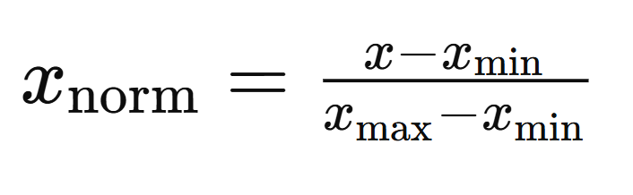
  - Mean-Variance Normalization: Adjusts pixel values to have zero mean and unit variance.
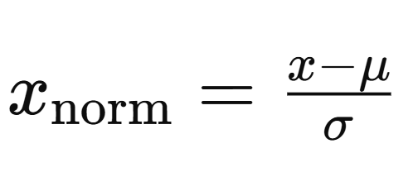
- Purpose:
  - Reduces the impact of varying lighting conditions.
  - Ensures consistent contrast across different images.
  - Helps deep learning models converge faster during training.
2. Dataset Normalization
Skin cancer datasets often contain images collected under various conditions, leading to discrepancies in resolution, color distribution, and background noise. Normalization addresses these inconsistencies.
- Histogram Equalization: Balances the distribution of pixel intensities for better contrast.
- Color Normalization: Adjusts color channels (RGB) to maintain consistent appearance across samples.

3. Feature Normalization
If additional features (e.g., age, lesion size, or texture metrics) are used alongside image data:
- Normalize numerical features to have zero mean and unit variance or scale them to [0, 1].
- Ensures that features with larger numerical ranges do not dominate the learning process.
4. Importance in Deep Learning
Normalization is especially critical in convolutional neural networks (CNNs) used for skin cancer detection because:
- It prevents vanishing or exploding gradients.
- It improves generalization by reducing model sensitivity to input variability.
- It accelerates model training by enabling the optimizer to take more consistent steps.
5. Techniques and Tools
- Libraries like TensorFlow, PyTorch, or OpenCV provide functions for image normalization.
- Batch Normalization within the network architecture further stabilizes intermediate outputs.

Benefits of Normalization:
- Improved Gradient Descent: It accelerates optimization by ensuring consistent gradient magnitudes across input features.
- Reduces Bias Toward Larger Values: Features with larger ranges no longer dominate the learning process, allowing the model to learn equally from all input features.
- Compatibility with Pre-Trained Models: Pre-trained CNNs often expect normalized inputs, as they were trained with scaled data (e.g., ImageNet models).
2.3. Data augmentation
Data augmentation is a powerful and indispensable technique used in machine learning, particularly in the domain of image-based tasks such as skin cancer detection. It involves artificially increasing the size and variability of a dataset by applying transformations to existing data samples. In skin cancer detection, obtaining large annotated datasets is often a significant challenge due to the sensitive and specialized nature of medical data. Data augmentation addresses this limitation by simulating real-world variations, improving model performance, and reducing overfitting.
Importance of Data Augmentation
1. Mitigating Limited Dataset Size
Skin cancer datasets are often limited in size because collecting and annotating medical images requires expert knowledge and is time-consuming. Augmentation generates additional training examples from existing data, creating a more diverse dataset without the need for manual labeling.
2. Improving Model Generalization
Deep learning models, particularly convolutional neural networks (CNNs), excel when exposed to diverse data during training. Augmentation introduces variations that mimic real-world scenarios, enabling models to generalize better to unseen data.
3. Reducing Overfitting
With limited training data, models tend to memorize rather than learn patterns, leading to overfitting. Data augmentation introduces variability that prevents overfitting by encouraging the model to focus on essential features rather than noise or specific details of individual samples.
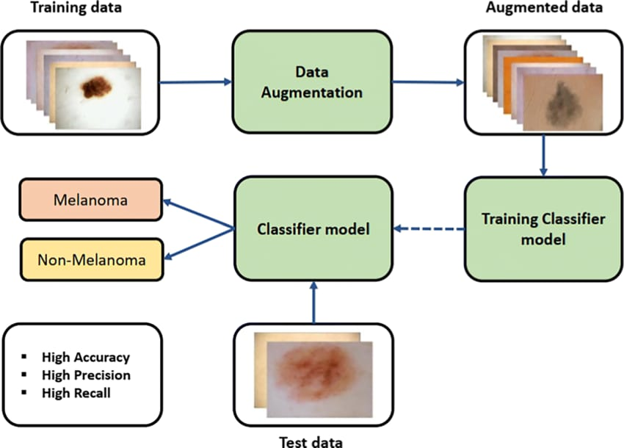
Fig4.1 Data Augumentation

Common Data Augmentation Techniques
1. Geometric Transformations
Geometric transformations alter the spatial properties of an image, simulating variations in camera angle, orientation, or positioning. These transformations include:
- Rotation: Rotating images by a random degree (e.g., ±5, ±15, or ±30 degrees) mimics variations in how skin lesions are photographed.
- Flipping: Horizontal or vertical flipping changes the orientation, ensuring the model is not biased towards specific directions.
- Scaling: Adjusting the size of lesions or images helps the model learn to detect lesions regardless of their scale.
- Cropping: Randomly cropping parts of the image focuses the model on learning from localized features.
- Translation: Shifting the image along the x or y axis simulates variations in lesion placement within the frame.
2. Color Transformations
Skin lesions are often photographed under varying lighting conditions or on different skin tones. Color transformations mimic these variations by modifying the image's color properties:
- Brightness Adjustment: Varying brightness levels simulates different lighting conditions.
- Contrast Adjustment: Enhancing or reducing contrast improves the model's ability to detect lesions under varying conditions.
- Saturation and Hue Adjustment: Altering color saturation and hue introduces diversity in skin tone representation.
3. Noise Addition
Adding noise to images makes the model robust to real-world imperfections such as poor image quality or environmental artifacts. Common noise types include:
- Gaussian Noise: Adds small random values to pixels, simulating graininess.
- Salt-and-Pepper Noise: Introduces random white and black pixels, mimicking visual artifacts in medical imaging.
4. Random Zoom and Distortion
Zooming in on specific regions or distorting the shape of a lesion increases variability. These techniques help the model learn from:
- Lesions of different sizes.
- Irregular or atypical lesion shapes, which are common in malignant cases.
5. Elastic Deformations
Elastic transformations warp the image, mimicking changes in skin texture or the camera's perspective. This technique is particularly useful for simulating variations in dermatoscopic imaging.
Purpose of Data Augmentation
1. Increasing Dataset Variability
Augmentation helps create a more diverse dataset, ensuring that the model is exposed to a wide range of conditions. This diversity is crucial for skin cancer detection, where lesions vary in size, shape, color, and texture.
2. Addressing Overfitting
Overfitting occurs when the model performs well on training data but poorly on unseen data. Augmentation reduces this risk by generating variations that encourage the model to generalize better.
3. Simulating Real-World Scenarios
Augmentation mimics challenges encountered in real-world applications, such as variations in lighting, orientation, or image quality. This prepares the model for deployment in clinical settings.
Specific Augmentation Techniques in Skin Cancer Detection
Rotation
- Implementation: Randomly rotate images by a specified degree range (e.g., -30 to +30 degrees).
- Impact: Helps the model recognize lesions regardless of their orientation.
Flipping
- Implementation: Apply horizontal or vertical flips to images.
- Impact: Ensures the model is not biased towards specific lesion orientations.
Cropping and Resizing
- Implementation: Randomly crop a portion of the image and resize it to the original dimensions.
- Impact: Focuses the model on localized lesion features.
Brightness and Contrast Adjustments
- Implementation: Randomly adjust brightness and contrast within a defined range.
- Impact: Simulates variations in lighting conditions.
Gaussian Blur and Noise
- Implementation: Apply Gaussian blur or add noise to images.
- Impact: Enhances robustness against image quality variations.
Random Zoom
- Implementation: Zoom into random parts of the image.
- Impact: Helps the model learn to detect small or localized lesions.
Advanced Augmentation Techniques
1. Generative Adversarial Networks (GANs)
GANs can synthesize new images that resemble real skin lesion images. These synthetic images expand the dataset and introduce additional variability.
2. Mixup Augmentation
Mixup combines two images and their labels, creating a weighted average of both. This forces the model to generalize across blended features.
3. Cutout Augmentation
Randomly masks out sections of an image, encouraging the model to focus on the unmasked regions.
4. Test-Time Augmentation (TTA)
TTA applies augmentation to test images during inference. The model's predictions are averaged across augmented versions of the same image, improving robustness.
Implementation in Practice
1. Tools and Libraries
Popular libraries for implementing data augmentation include:
- TensorFlow/Keras: Offers ImageDataGenerator and tf.image modules for image transformations.
- PyTorch: Provides the torchvision.transforms module for various augmentation techniques.
- Albumentations: A fast and flexible library designed specifically for image augmentation.
- OpenCV: General-purpose library for image processing and augmentation.
2. Workflow
- Step 1: Load the skin cancer dataset.
- Step 2: Define augmentation techniques relevant to the dataset's characteristics.
- Step 3: Apply augmentations during training using a pipeline or generator.
- Step 4: Validate the model's performance on unaugmented test data to ensure generalization.

Challenges and Considerations
1. Over-Aggressive Augmentation
Excessive transformations can distort the original lesion features, leading to incorrect labels or reduced model accuracy.
2. Maintaining Label Integrity
Augmentation must preserve the original label's meaning. For example, flipping a lesion should not alter its classification.
3. Balancing Variability and Realism
While diversity is essential, augmented images should remain realistic to ensure that the model learns meaningful patterns.
4. Computational Overhead
Real-time augmentation during training can increase computational requirements. Preprocessing and storing augmented images can mitigate this issue.
2.4 Class balancing
Class balancing is an essential preprocessing step in training convolutional neural network (CNN) models for tasks like skin cancer detection. In medical imaging datasets, the issue of class imbalance is prevalent, where one class, such as benign lesions, may vastly outnumber another, such as malignant lesions. This imbalance can lead to a biased model that performs well for the majority class but poorly for the minority class, which is often the critical focus in medical diagnostics. Addressing class imbalance is vital to ensure that the model performs equitably across all classes and achieves high accuracy in detecting malignant lesions.
The Challenge of Class Imbalance
1. Impact on Model Training
- Bias Toward the Majority Class: During training, a model exposed to an imbalanced dataset tends to favor the majority class, leading to predictions skewed towards this class.
- Reduced Sensitivity: The model may fail to detect critical cases from the minority class, resulting in low sensitivity (recall) for malignant lesions.
- Poor Generalization: An imbalanced dataset hampers the model’s ability to generalize well to unseen data, particularly for minority class examples.
2. Evaluation Metrics Affected
- Accuracy Paradox: Accuracy may appear high because the model predicts the majority class correctly, masking poor performance on the minority class.
- Misleading Metrics: Metrics like precision, recall, and F1-score for the minority class become more critical than overall accuracy in evaluating model performance.
Techniques for Class Balancing
To mitigate the effects of class imbalance, several techniques can be employed. These methods ensure that the model is exposed to balanced training data, improving its ability to detect both majority and minority class instances effectively.
1. Oversampling
Oversampling involves increasing the representation of the minority class by duplicating its samples or generating new synthetic examples. This approach ensures that both classes are equally represented during training.
- Random Oversampling:
  - Simple duplication of existing minority class samples.
  - Risk: May lead to overfitting, as the model sees repeated examples of the same data.
- Synthetic Minority Oversampling Technique (SMOTE):
  - Generates synthetic samples by interpolating between existing minority class samples.
  - Advantages:
    - Increases diversity within the minority class.
    - Reduces the risk of overfitting compared to random oversampling.
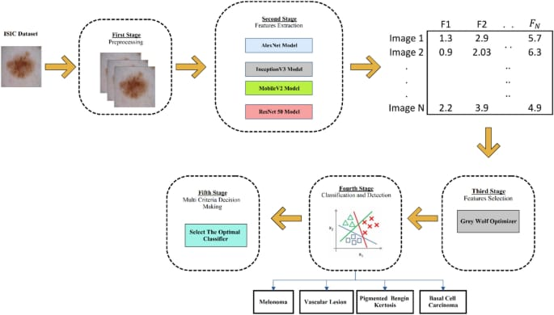
Fig 4.2 Class Balancing

2. Undersampling
Undersampling reduces the number of majority class samples to balance the dataset. While this method is straightforward, it comes with trade-offs.
- Random Undersampling:
  - Randomly removes majority class samples.
  - Risk: Valuable information from the majority class may be discarded, potentially reducing model performance.
- Cluster-Based Undersampling:
  - Groups similar majority class samples and selects representative ones for training.
  - Advantage: Retains more information while reducing redundancy.
3. Data Augmentation for the Minority Class
Data augmentation increases the diversity of the minority class by applying transformations to existing samples. This approach generates new examples while maintaining the original label.
- Common Transformations:
  - Geometric: Rotation, flipping, scaling, cropping, and translation.
  - Color: Brightness, contrast, saturation, and hue adjustments.
  - Noise Addition: Introduces distortions to improve model robustness.
- Advantages:
  - Enhances model generalization.
  - Avoids the risks of overfitting or data loss associated with oversampling or undersampling.
4. Synthetic Data Generation
Advanced techniques like generative adversarial networks (GANs) can generate high-quality synthetic images that resemble real-world examples of the minority class.
- GANs:
  - Trains two models (generator and discriminator) in tandem to create realistic synthetic images.
  - Advantage: Provides highly varied and realistic samples, enhancing minority class representation.
- Applications:
  - Used for rare lesion types where annotated images are scarce.

5. Class Weights
Class weights assign higher importance to the minority class during model training. This method modifies the loss function so that errors in the minority class contribute more to the overall loss.
- Implementation:
  - Assign weights inversely proportional to class frequencies.
  - Example: In a dataset with a 9:1 class ratio, the minority class may receive a weight of 0.9, and the majority class a weight of 0.1.
- Advantages:
  - Does not alter the dataset structure.
  - Encourages the model to focus on the minority class without discarding majority class samples.
Combining Techniques
Often, a combination of methods yields the best results in balancing classes. For example:
- SMOTE + Undersampling: Generates synthetic samples for the minority class while reducing redundancy in the majority class.
- Augmentation + Class Weights: Enhances diversity within the minority class while ensuring the model emphasizes its importance during training.
Implementation in Practice
1. Oversampling and SMOTE
- Libraries:
  - imbalanced-learn (Python): Provides SMOTE and other resampling techniques.
- Steps:
  - Analyze class distribution.
  - Apply SMOTE to generate synthetic minority class samples.
  - Train the model on the balanced dataset.
2. Undersampling
- Steps:
  - Analyze class distribution.
  - Randomly or strategically remove majority class samples.
  - Train the model on the reduced dataset.
3. Data Augmentation
- Tools:
  - TensorFlow/Keras: ImageDataGenerator or tf.image.
  - PyTorch: torchvision.transforms.
- Steps:
  - Define augmentation transformations.
  - Apply transformations to minority class samples during training.

4. Class Weights
- Frameworks:
  - TensorFlow/Keras: Use the class_weight parameter.
  - PyTorch: Modify the loss function to include weights.
- Steps:
  - Calculate class weights based on frequency.
  - Incorporate weights into the model’s loss function.
Advantages of Class Balancing
1. Improved Minority Class Metrics
- Enhances recall and F1-score for the minority class, ensuring critical cases like malignant lesions are detected.
2. Better Generalization
- Models trained on balanced datasets are more robust and perform well on unseen data.
3. Real-World Applicability
- Balanced models are better suited for deployment in clinical settings, where detecting rare but critical conditions is essential.
Challenges and Considerations
1. Risk of Overfitting
- Oversampling and data augmentation may lead to overfitting if synthetic or augmented samples dominate the training process.
2. Computational Complexity
- Synthetic data generation (e.g., SMOTE or GANs) and augmentation techniques can increase computational requirements.
3. Trade-Offs in Undersampling
- While undersampling reduces imbalance, it risks discarding valuable majority class information.
4. Validation Strategy
- Ensure that the test set remains representative of the original data distribution to evaluate the model’s true performance.
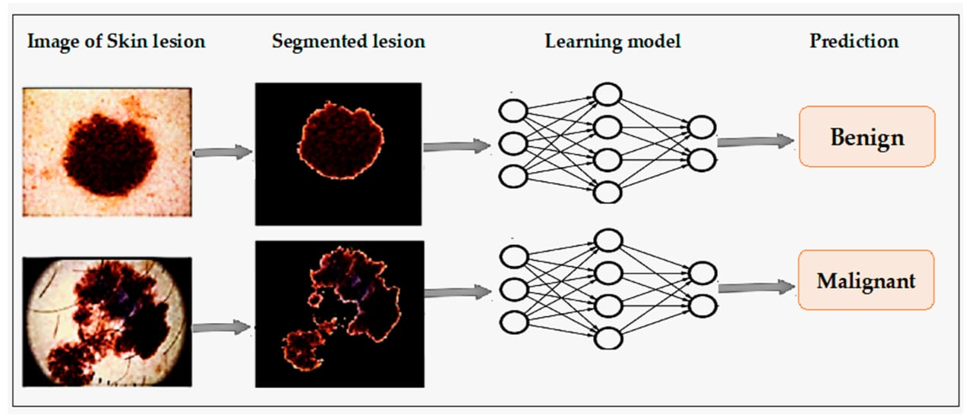
Fig 4.3 Detection using Deep Learning Technique

3. CNN Model Design and Selection
CNNs are the core of the methodology, designed for automatic feature extraction and classification.
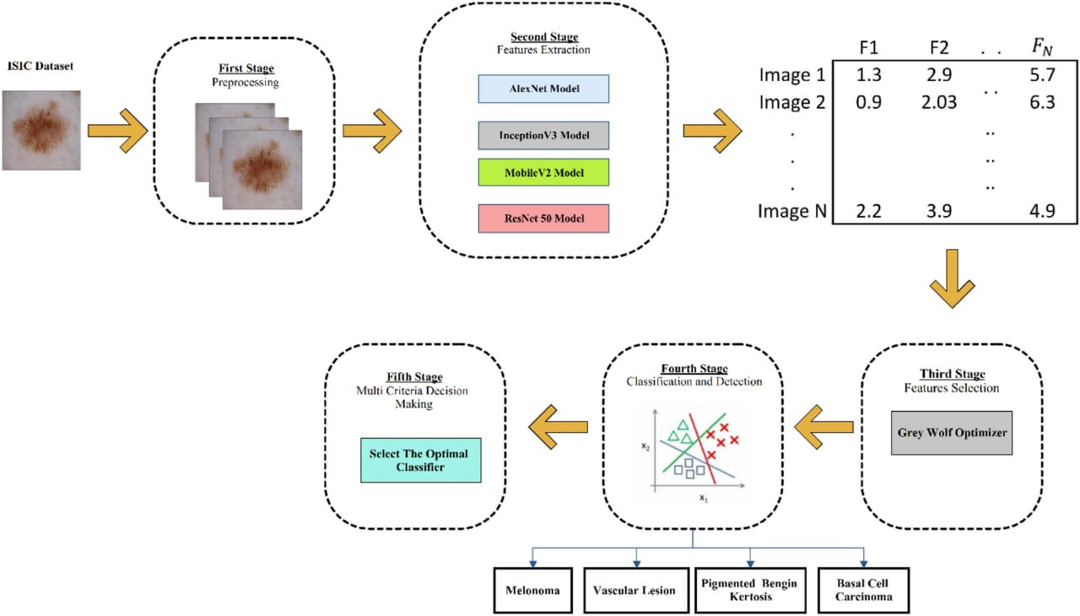
Fig4.4 Model Selection
- Custom CNN Models:
The development of a custom convolutional neural network (CNN) for skin cancer detection involves a structured process to ensure accurate and reliable classification of skin lesions.
The first step is problem definition, which focuses on identifying the objective of the model—detecting whether a given skin lesion is malignant or benign. Understanding the types of skin cancer to be detected, such as melanoma or basal cell carcinoma, is crucial for tailoring the model to specific medical needs.
Next, dataset preparation is a critical stage. Skin cancer datasets can be sourced from publicly available repositories such as the International Skin Imaging Collaboration (ISIC). The dataset must be pre-processed by resizing images to a uniform dimension (e.g., 224x224 pixels), normalizing pixel values, and splitting the data into training, validation, and testing sets. Data augmentation techniques like flipping, rotation, and zooming can be applied to increase dataset diversity and improve the model’s generalizability.
The design of a custom CNN architecture follows, consisting of multiple convolutional layers to extract features from images, followed by pooling layers to reduce dimensionality. A typical architecture includes an input layer, a series of convolutional layers with ReLU activation functions, max-pooling layers, a flattening layer, and dense layers. The final layer uses a sigmoid activation function for binary classification (malignant or benign). For multi-class classification, a softmax activation function is used.
Model compilation involves selecting the appropriate optimizer, loss function, and performance metrics. The Adam optimizer is commonly used due to its adaptive learning rate capabilities. For binary classification, the binary cross-entropy loss function is suitable, whereas categorical cross-entropy is used for multi-class classification. Performance metrics such as accuracy, precision, recall, and the area under the receiver operating characteristic (AUC-ROC) curve are essential for evaluating the model’s performance.
- Pre-trained CNN Architectures:
  - Leveraging transfer learning by fine-tuning models like ResNet, VGG, Inception, or EfficientNet.
  - These architectures, trained on large-scale datasets like ImageNet, extract general features and are fine-tuned on the skin cancer dataset for domain-specific tasks.

4. Training Methodology
Training involves optimizing the model to minimize errors and improve prediction accuracy.
  - Loss Function:
  - Binary Cross-Entropy:
Binary cross-entropy is a commonly used loss function in CNN models for binary classification problems, where the task is to distinguish between two categories. In skin cancer detection, this loss function is appropriate when the model is designed to classify skin lesions as either malignant (cancerous) or benign (non-cancerous). Binary cross-entropy measures the difference between the predicted probability of the lesion being malignant and the actual label. The output layer of the CNN for this task typically consists of a single neuron with a sigmoid activation function, which outputs a probability between 0 and 1.
The binary cross-entropy loss function works by calculating the negative log probability of the correct class for each prediction. If the model predicts a high probability (close to 1) for the malignant class when the lesion is indeed malignant, the loss will be low. Conversely, if the model predicts a low probability for the malignant class when the lesion is actually malignant, the loss will be high. The model adjusts its weights during training to minimize this loss, improving its ability to correctly classify lesions. This loss function is ideal for binary skin cancer detection tasks, where the goal is to identify whether a lesion is cancerous or not with high accuracy. Used for binary classification tasks (e.g., benign vs. malignant).
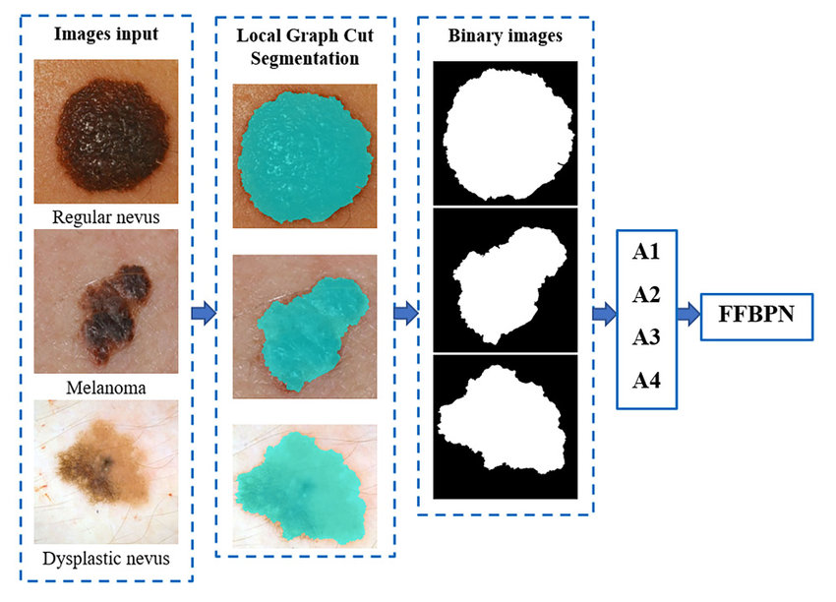
Fig 4.5 Binary Cross Entropy
  - Categorical Cross-Entropy:
Categorical cross-entropy is used in multi-class classification problems, where the model needs to distinguish between multiple categories. In skin cancer detection, this loss function is suitable when the task is to classify skin lesions into different types of cancer, such as melanoma, basal cell carcinoma, squamous cell carcinoma, or benign lesions. The output layer of the CNN for this task typically has multiple neurons, each representing a different class, and uses a softmax activation function to produce a probability distribution across all classes.
Categorical cross-entropy calculates the difference between the predicted probability distribution and the actual one-hot encoded labels. For each input image, the model assigns probabilities to all possible classes, and the loss function encourages the model to assign a high probability to the correct class while minimizing probabilities for the incorrect classes. For example, if a lesion is melanoma, the model should predict a high probability for melanoma and low probabilities for other classes. Applied in multi-class classification (e.g., identifying melanoma, BCC, SCC).
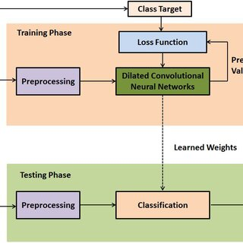
Fig 4.6 Categorical Cross-Entropy

  - Optimizer:
An optimizer plays a crucial role in training a CNN model for skin cancer detection by adjusting the model's weights to minimize the loss function. In a CNN, the optimizer determines how the model updates its parameters (such as filter weights) to improve predictions over time. The goal of using an optimizer is to ensure the model converges to an optimal solution where it can accurately distinguish between different types of skin lesions. Common optimizers used in skin cancer detection models include Adam, SGD (Stochastic Gradient Descent), and RMSprop.
Popular optimizers like Adam, SGD, or RMSProp are used to minimize the loss function.
  - Learning Rate Scheduling:
Dynamically adjusting the learning rate during training to avoid overfitting or slow convergence. Learning rate scheduling is an essential technique in training a CNN model for skin cancer detection, as it helps optimize the learning process by adjusting the learning rate dynamically during training. The learning rate controls how much the model's weights are updated with each step of the optimizer. Setting an appropriate learning rate is critical because a high learning rate can cause the model to overshoot the optimal solution, while a low learning rate can slow down convergence. Learning rate scheduling helps balance this by starting with a higher learning rate and reducing it as the model progresses through training.
In skin cancer detection, where the model needs to learn complex patterns from medical images, learning rate scheduling ensures that the model makes large updates in the initial phases of training to learn general features. As training continues, reducing the learning rate allows the model to make more precise adjustments, which helps in fine-tuning the learned features for better classification accuracy. This approach is particularly useful in preventing the model from getting stuck in local minima and helps achieve better generalization on unseen data.
  - Batch Size and Epochs:
Training in batches (e.g., 32, 64) over multiple epochs ensures optimal learning. Batch Size and Epochs are key parameters in training machine learning models, including CNNs.
- Batch Size refers to the number of training samples processed before the model updates its parameters. Instead of using the entire dataset at once, which can be computationally expensive, the data is divided into smaller subsets called batches. For example, if the dataset contains 1,000 images and the batch size is 32, the model will process the data in 32-sample increments until all 1,000 samples are covered. Smaller batch sizes may lead to noisy updates but better generalization, while larger batch sizes result in smoother updates but require more memory.
- Epochs represent one complete pass through the entire training dataset. During each epoch, the model processes all batches sequentially. For instance, if you train for 10 epochs, the model sees the entire dataset 10 times. More epochs allow the model to learn better patterns, but excessive epochs may lead to overfitting, where the model performs well on training data but poorly on unseen data.

5. Model Evaluation and Validation
Assessing the model’s performance is crucial for determining its reliability and applicability.
- Data Split: Dividing data into training, validation, and testing sets (e.g., 70%-15%-15%).
- Evaluation Metrics:
- Evaluation metrics assess the performance of a CNN model and determine its reliability for skin cancer detection. These metrics provide insights into how well the model classifies benign and malignant lesions or other skin conditions.
- Accuracy: Measures the percentage of correct predictions among all cases. While useful for balanced datasets, it can be misleading in imbalanced datasets where one class dominates.
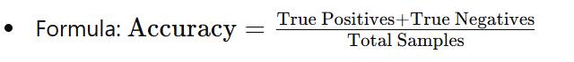​
- Precision: Indicates the proportion of true positives among all predicted positives, highlighting the model's ability to avoid false positives.
.
- F1-Score: A harmonic mean of precision and recall, providing a balanced evaluation in imbalanced datasets.
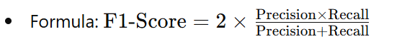
- Recall (Sensitivity): Reflects the model’s ability to detect true positives, critical in identifying malignant cases.
- ROC-AUC (Receiver Operating Characteristic – Area Under Curve): Evaluates the trade-off between sensitivity and specificity, indicating the model's discriminatory power.
- These metrics collectively ensure a comprehensive evaluation of the CNN model, addressing both overall performance and specific diagnostic needs.
- Confusion Matrix: Provides detailed insights into classification errors.

6. Explainable AI Techniques
Making CNNs interpretable is essential in medical diagnostics.
- Grad-CAM (Gradient-weighted Class Activation Mapping): Highlights the regions of the image that influenced the model’s decision.
- LIME (Local Interpretable Model-agnostic Explanations): Provides explanations for individual predictions.

7. Deployment and Real-World Applications
Developing a system ready for clinical or consumer use involves additional considerations:
- Real-Time Processing: Optimizing the model for fast predictions using frameworks like TensorFlow Lite or ONNX.
- User Interfaces:
  - Web or mobile applications allowing users to upload images for analysis.
  - API integration for clinical systems.
- Edge Deployment: Deploying models on portable devices like smartphones or edge GPUs for remote diagnostics.

Implementation
The implementation of the skin cancer detection system using CNN involves several sequential steps to ensure accurate and efficient diagnosis. The process begins with data acquisition, where publicly available datasets like ISIC, HAM10000, or PH2 are used to obtain high-quality dermoscopic images of various skin lesions. These images undergo preprocessing to prepare them for training, including resizing to a uniform dimension (e.g., 224x224 pixels), normalization of pixel values, and data augmentation techniques like rotation, flipping, and brightness adjustments to enhance variability and prevent overfitting.
The core of the implementation is the CNN model, which serves as the feature extractor and classifier. A custom CNN architecture is designed for this task, consisting of convolutional layers for feature extraction, pooling layers for dimensionality reduction, dropout layers for regularization, and fully connected layers for classification. Alternatively, pre-trained CNN architectures like ResNet or VGG can be fine-tuned using transfer learning to leverage pre-learned features. The model is trained using optimizers like Adam and loss functions like Binary Cross-Entropy or Categorical Cross-Entropy, depending on the classification task. The training process involves dividing the data into training, validation, and testing sets, iterating through multiple epochs with an appropriate batch size.
Evaluation metrics, such as accuracy, precision, recall, F1-score, and ROC-AUC, are used to assess model performance. Explainable AI techniques like Grad-CAM are incorporated to highlight the regions influencing the model's predictions, ensuring transparency and trust in medical applications. Finally, the system is prepared for deployment, with options like web-based interfaces or mobile applications to enable users to upload images for real-time diagnosis, making it accessible for both clinical use and remote diagnostics.
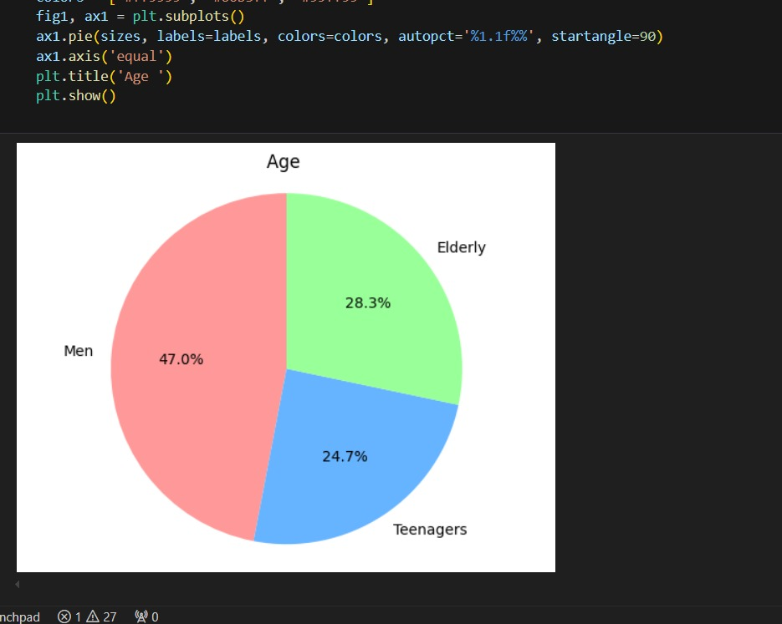
Table 5.1 Visual representation of skin cancer cases in a pie chart

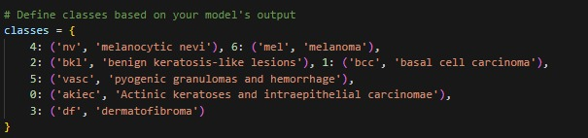
Fig 5.2 Classes based on model’s output

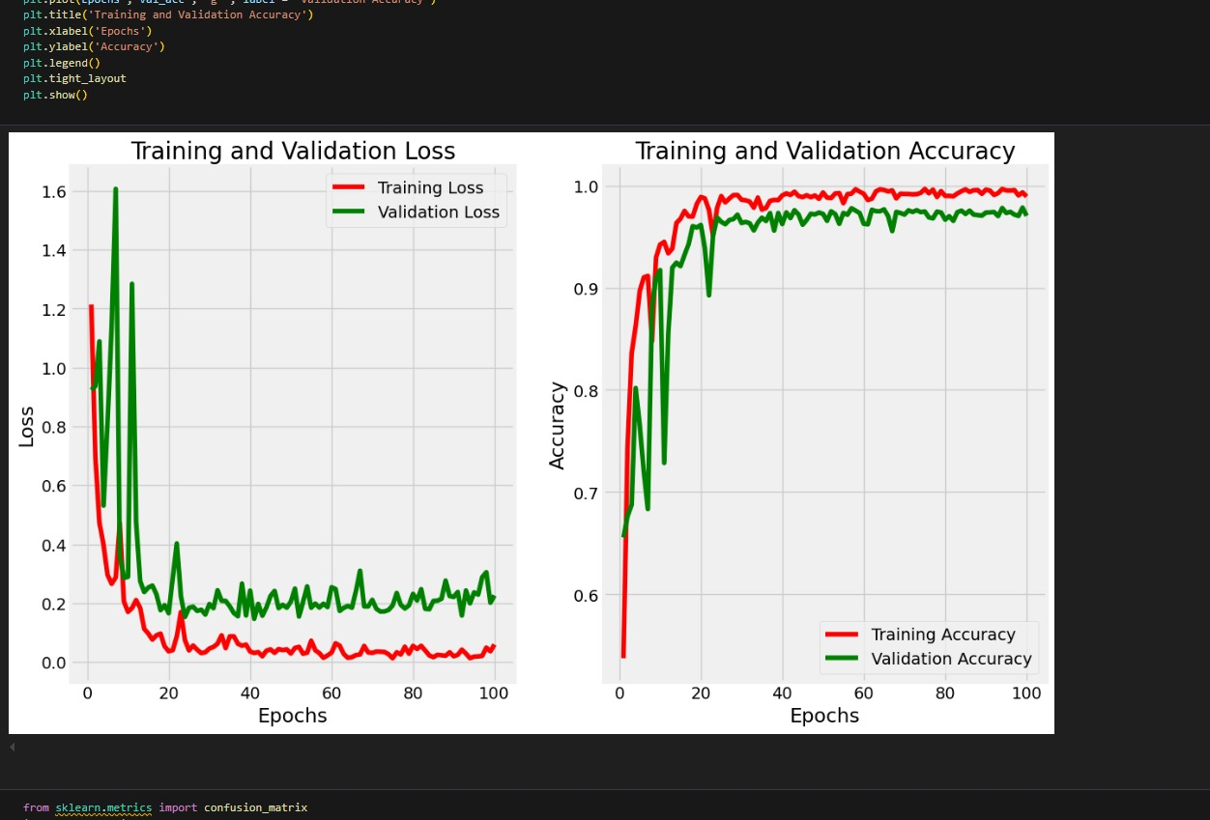
Table 5.3 Prediction of Testing and Training values

Some of the prediction:
1.
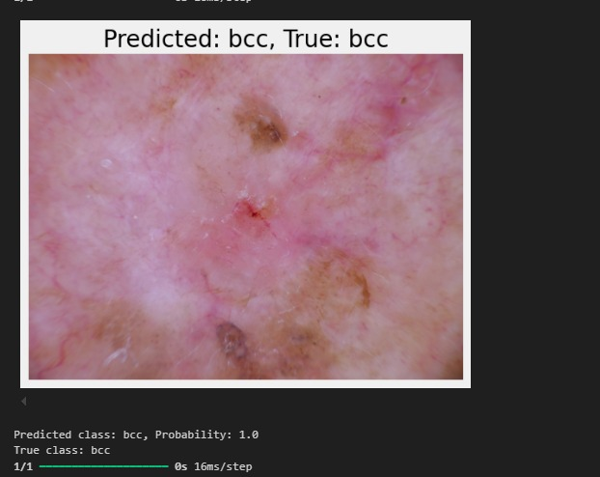
Fig 5.4 Output-01
2.

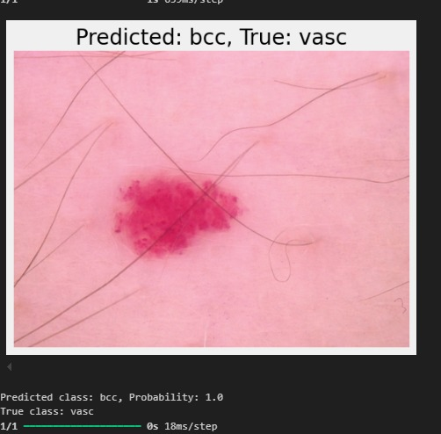
Fig 5.5 Ouput-02
3.

Fig 5.6 Ouput-03
4.
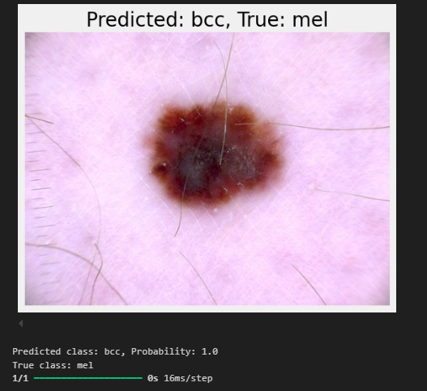
Fig 5.7Ouput-04
5.
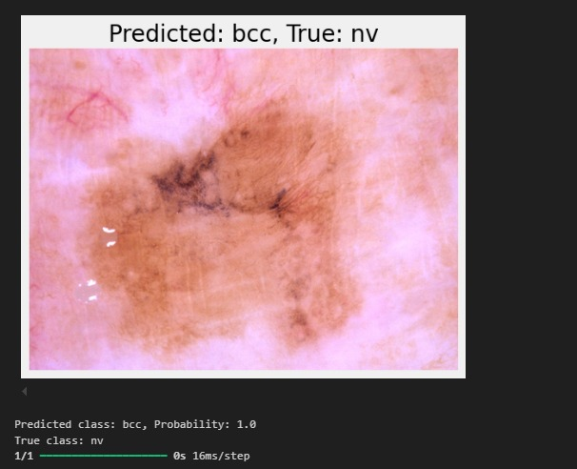
Fig 5.8 Ouput-05

Future Enhancement
The detection of skin cancer using Convolutional Neural Networks (CNNs) has already shown remarkable promise in the field of medical diagnostics. However, there are several potential enhancements that can be made to improve accuracy, reliability, and scalability of these systems. One future enhancement involves the integration of more diverse and larger datasets. Current CNN models often suffer from biases due to limited data diversity, which can be addressed by incorporating images from different skin tones, age groups, and cancer types to make the model more inclusive and robust.
Another significant improvement could be achieved through the use of multi-modal learning. By combining dermoscopic images with patient metadata such as age, gender, medical history, and genetic predisposition, CNNs can achieve more accurate predictions. This approach can help models differentiate between benign and malignant lesions more effectively, reducing false positives and improving early detection rates.
Advancements in explainable AI (XAI) are also crucial for the future of CNN-based skin cancer detection. These enhancements will enable models to provide clear, interpretable explanations for their predictions, helping doctors understand the reasoning behind a diagnosis. This is essential for building trust in AI systems and ensuring their adoption in clinical practice.
Additionally, future CNN models can benefit from real-time mobile applications, making skin cancer detection more accessible. By utilizing edge computing and lightweight CNN architectures, patients can perform preliminary skin checks using their smartphones. These applications can act as early warning systems, prompting users to seek medical advice if any suspicious lesions are detected.
Below, we explore potential future enhancements in the domain of CNN-based skin cancer detection systems that could be incorporated to advance the field further.
Improved Data Collection and Augmentation
One of the major challenges in developing effective CNN models for skin cancer detection is the availability of diverse and high-quality datasets. Future efforts should focus on creating larger, more diverse datasets that include images from varied populations, skin types, and demographics. This will ensure that the models are trained to identify skin cancer across different ethnicities and conditions. Additionally, advanced data augmentation techniques such as generative adversarial networks (GANs) could be employed to synthetically enhance datasets by generating realistic skin lesion images that increase model robustness and generalizability.
Multimodal Integration
Integrating multimodal data, such as dermoscopic images, clinical photographs, patient medical history, and genetic information, could significantly enhance the accuracy of CNN-based systems. Future models could leverage these additional data sources to provide a more comprehensive analysis, thereby reducing the risk of false positives and false negatives. By combining image analysis with non-visual data, CNN models can better understand the context of a diagnosis, improving predictive accuracy.

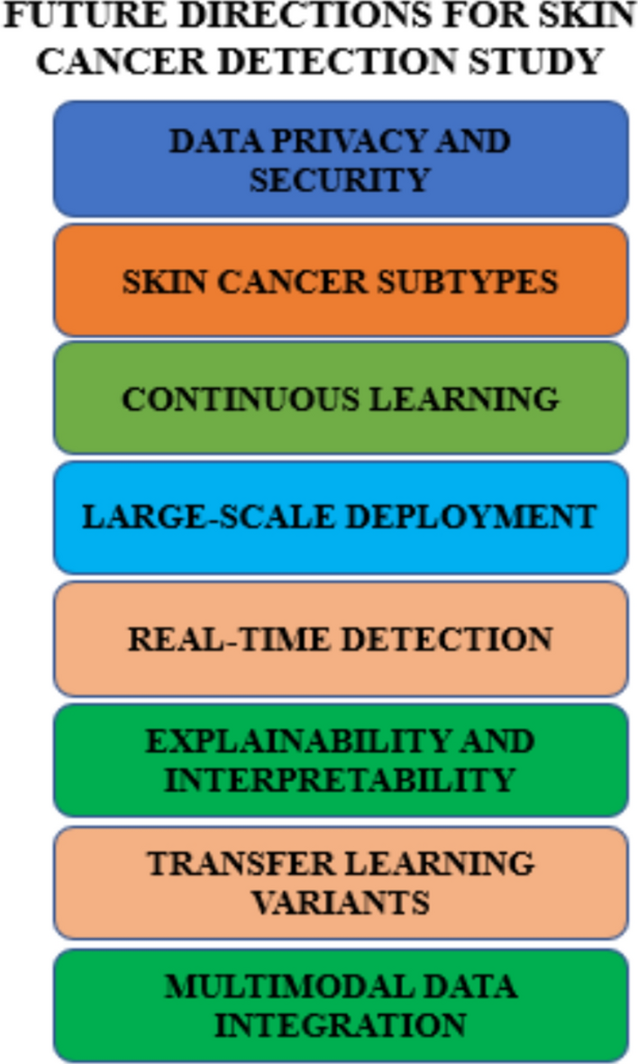
Fig 6.1 Future Enhancement for Skin Cancer Detection

Real-Time Detection and Mobile Deployment
Developing lightweight and efficient CNN models that can be deployed on mobile devices or edge computing platforms is a promising avenue. These portable solutions could facilitate real-time skin cancer detection, especially in remote or resource-limited areas where access to dermatologists is scarce. Advances in model compression techniques, such as quantization and pruning, can help in creating compact models without compromising accuracy, enabling deployment on devices with limited computational power.
Enhanced Explainability and Interpretability
One of the significant barriers to the adoption of CNN-based systems in clinical settings is the "black-box" nature of these models. Future research should focus on developing explainable AI (XAI) techniques that provide clear and interpretable insights into the model's decision-making process. Techniques such as saliency maps, Grad-CAM, and SHAP (SHapley Additive exPlanations) can help highlight the regions of interest in an image, allowing clinicians to verify and trust the model's predictions.
Incorporation of Transfer Learning and Pretrained Models
Transfer learning, which involves leveraging pretrained CNN models from other domains, has already shown great potential in skin cancer detection. Future work could involve refining these pretrained models specifically for dermatology applications. Training on a broader range of medical imaging datasets and fine-tuning for specific skin cancer types could improve detection accuracy while reducing training time and resource requirements.
Leveraging Advanced Architectures
Exploring and adopting advanced CNN architectures, such as EfficientNet, Vision Transformers (ViT), and Swin Transformers, could lead to better performance in skin cancer detection. These newer architectures often achieve state-of-the-art results on various image classification tasks while being computationally efficient. Incorporating these innovations could enhance the diagnostic capabilities of CNNs in detecting skin cancer.
Addressing Imbalanced Data
Skin cancer datasets often suffer from class imbalance, where benign lesions vastly outnumber malignant ones. Future enhancements could involve using techniques such as oversampling, undersampling, and synthetic data generation to balance the dataset. Additionally, cost-sensitive learning and focal loss functions could be employed to ensure the model focuses adequately on minority classes, improving its sensitivity to malignant lesions.
Integration with Telemedicine Platforms
CNN-based skin cancer detection systems could be integrated into telemedicine platforms, allowing users to upload images of skin lesions for remote evaluation. This integration could facilitate early diagnosis and triage, enabling patients to seek timely medical intervention. Future systems could also incorporate chatbots or virtual assistants powered by natural language processing (NLP) to guide users through the image submission process and provide preliminary recommendations.
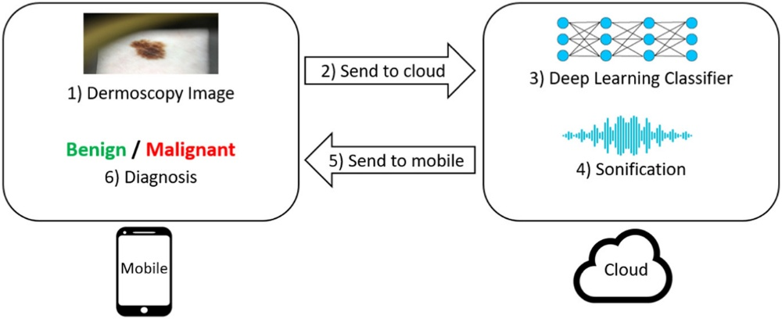
Fig 6.2 Mobile App for Future Enhancement

Continuous Learning and Adaptability
To remain effective in real-world applications, CNN models need to adapt to new data and evolving diagnostic criteria. Future systems could incorporate continuous learning mechanisms that allow models to be updated with new data without requiring complete retraining. Techniques like online learning and incremental learning could help maintain model relevance and performance over time.
Robustness to Variations in Imaging Conditions
Skin lesion images can vary significantly due to differences in lighting, camera quality, and angles of capture. Future enhancements should focus on improving the robustness of CNN models to these variations. This could involve training models on augmented datasets that simulate different imaging conditions or using domain adaptation techniques to ensure consistent performance across diverse environments.
Collaboration with Dermatologists and Experts
Collaborating closely with dermatologists and other medical professionals can help refine CNN-based systems for practical use. Future enhancements could include the development of hybrid models that combine CNN-based predictions with expert annotations, ensuring that the final diagnosis benefits from both machine intelligence and human expertise. This collaborative approach could also help in identifying edge cases and improving model reliability.

Conclusion
Skin cancer detection using Convolutional Neural Networks (CNNs) has emerged as a powerful tool in the field of medical diagnostics. CNN models can accurately classify skin lesions and differentiate between benign and malignant cases with minimal human intervention. By automating the detection process, these models have the potential to significantly reduce the burden on dermatologists and improve early diagnosis, leading to timely treatment and better patient outcomes.
The implementation journey began with the careful preprocessing of dermoscopic images to ensure uniformity and consistency. Techniques like data augmentation and normalization were employed to tackle the challenges of limited and imbalanced datasets. The core CNN model, designed to extract and classify intricate features from dermoscopic images, exemplified the strength of automated feature extraction in overcoming the limitations of traditional machine learning methods. Furthermore, the use of pre-trained architectures such as ResNet and VGG enhanced the model’s performance by utilizing knowledge from large-scale image datasets, reducing training time, and improving generalization.
Evaluation metrics, including accuracy, precision, recall, and F1-score, validated the reliability of the proposed model. The inclusion of explainable AI techniques like Grad-CAM brought transparency to the system, highlighting areas of the images influencing predictions and instilling confidence among healthcare professionals and patients alike. This capability not only enhances model trust but also facilitates collaboration between AI and medical practitioners.
The project underscores the potential of CNN-based systems to augment dermatological expertise, especially in regions with limited access to healthcare facilities or trained dermatologists. With the integration of mobile and web-based platforms, this system can be deployed for real-time diagnostics, enabling users to assess their skin lesions conveniently and accurately. The model’s adaptability to edge devices also highlights its potential for use in low-resource settings, bridging the gap between advanced diagnostics and underserved populations.
However, challenges remain. Variability in skin tones, lesion appearances, and imaging conditions can affect the model’s robustness. Addressing these issues requires access to diverse, high-quality datasets that capture the full spectrum of real-world scenarios. Additionally, the inherent black-box nature of deep learning models, while partially mitigated by explainable AI, still demands further research to improve interpretability and explainability.
This project lays the groundwork for future advancements in skin cancer detection using AI. Emerging trends such as multi-modal learning, which combines image data with patient metadata, and self-supervised learning, which reduces dependency on labeled datasets, promise to further enhance the accuracy and applicability of such systems. Additionally, the use of synthetic data generated by GANs can help overcome data scarcity, while federated learning could enable privacy-preserving model training on distributed datasets.

Reference
[1] S.Baheti, P. 2021. Train test validation split: How to & best practices. Retrieved: 28.01.2024.
[2] Brinker, T. J.; Hekler, A.; Utikal, J. S.; Grabe, N.; Schaden dorf, D.; Klode, J.; Berking, C.; Steeb, T.; Enk, A. H.; and Von Kalle, C. 2018. Skin cancer classification using con volutional neural networks: systematic review. Journal of medical Internet research 20(10):e11936.
[3] Chollet, F., et al. 2015. Keras. Retrieved: 10.12.2023.
[4] Codella, N.; Rotemberg, V.; Tschandl, P.; Celebi, M. E.; Dusza, S.; Gutman, D.; Helba, B.; Kalloo, A.; Liopyris, K.; Marchetti, M.; et al. 2019. Skin lesion analysis toward melanoma detection 2018: A challenge hosted by the international skin imaging collaboration (isic). arXiv preprint arXiv:1902.03368.
[5] Dosovitskiy, A.; Beyer, L.; Kolesnikov, A.; Weissenborn, D.; Zhai, X.; Unterthiner, T.; Dehghani, M.; Minderer, M.; Heigold, G.; Gelly, S.; et al. 2020. An image is worth 16x16 words: Transformers for image recognition at scale. arXiv preprint arXiv:2010.11929.
[6] Dermatology AAo. Detect skin cancer: How to perform a skin self-exam. 2014;
[7] Black HS, Thornby JI, Wolf JE, Jr., et al. Evidence that a low-fat diet reduces the occurrence of non-melanoma skin cancer. Int J Cancer. 1995;62(2):165-169.
[8] Black HS, Herd JA, Goldberg LH, et al. Effect of a low-fat diet on the incidence of actinic keratosis. N Engl J Med. 1994;330(18):1272-1275.
[9] Black HS. Influence of dietary factors on actinically-induced skin cancer. Mutat Res. 1998;422(1):185-190.
[10]Gamba CS, Stefanick ML, Shikany JM, et al. Low-fat diet and skin cancer risk: the women's health initiative randomized controlled dietary modification trial. Cancer Epidemiol Biomarkers Prev. 2013;22(9):1509-1519.
[11] Fortes C, Mastroeni S, Melchi F, et al. A protective effect of the Mediterranean diet for cutaneous melanoma. Int J Epidemiol. 2008;37(5):1018-1029.
[12] Pal HC, Hunt KM, Diamond A, Elmets CA, Afaq F. Phytochemicals for the management of melanoma. Mini Rev Med Chem. 2016;16(12):953-979.
[13] Kricker A., Armstrong B.K., English D.R. Sun exposure and non-melanocytic skin cancer. Cancer Causes Control. 1994; 5 :367–392. doi: 10.1007/BF01804988.
[14] Armstrong B.K., Kricker A. The epidemiology of UV-induced skin cancer.J. Photochem. Photobiol. B. 2001;63:8–18. doi: 10.1016/S1011-1344(01)00198-1.
[15]Christo Ananth and M Julie Therese. A survey on melanoma: Skin cancer through computerized diagnosis. Available at SSRN 3551811, 2020.
[16]American Cancer Society Cancer Facts and Figures. 2020. [(accessed on 4 April 2024)]. Available online.

