Create EC2 INSTANCE

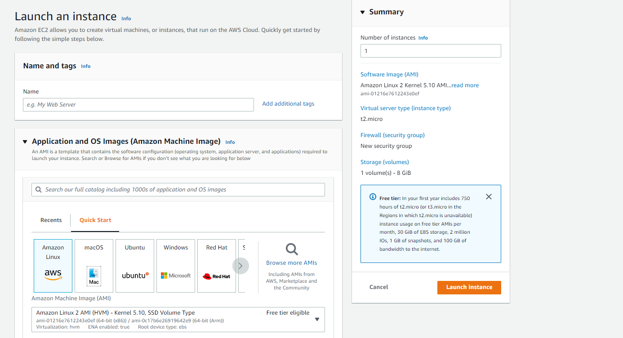

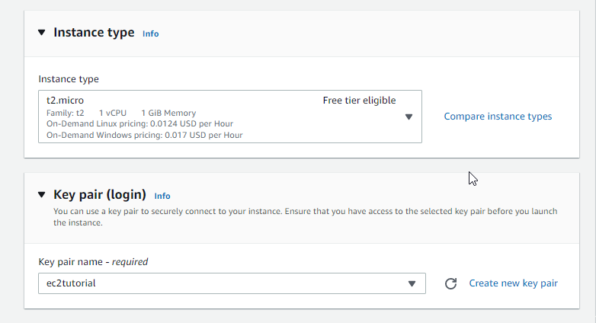

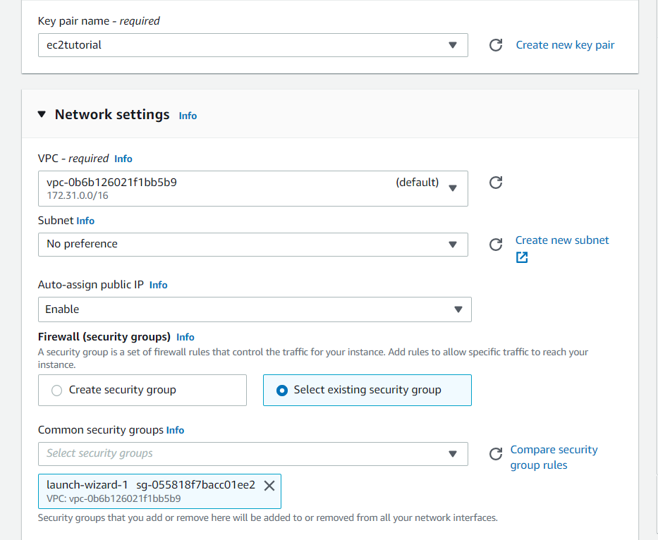

Go to advanced detail addd this code on user detail

#!/bin/bash

# Use this for your user data (script from top to bottom)

# install httpd (Linux 2 version)

yum update -y

yum install -y httpd

systemctl start httpd

systemctl enable httpd

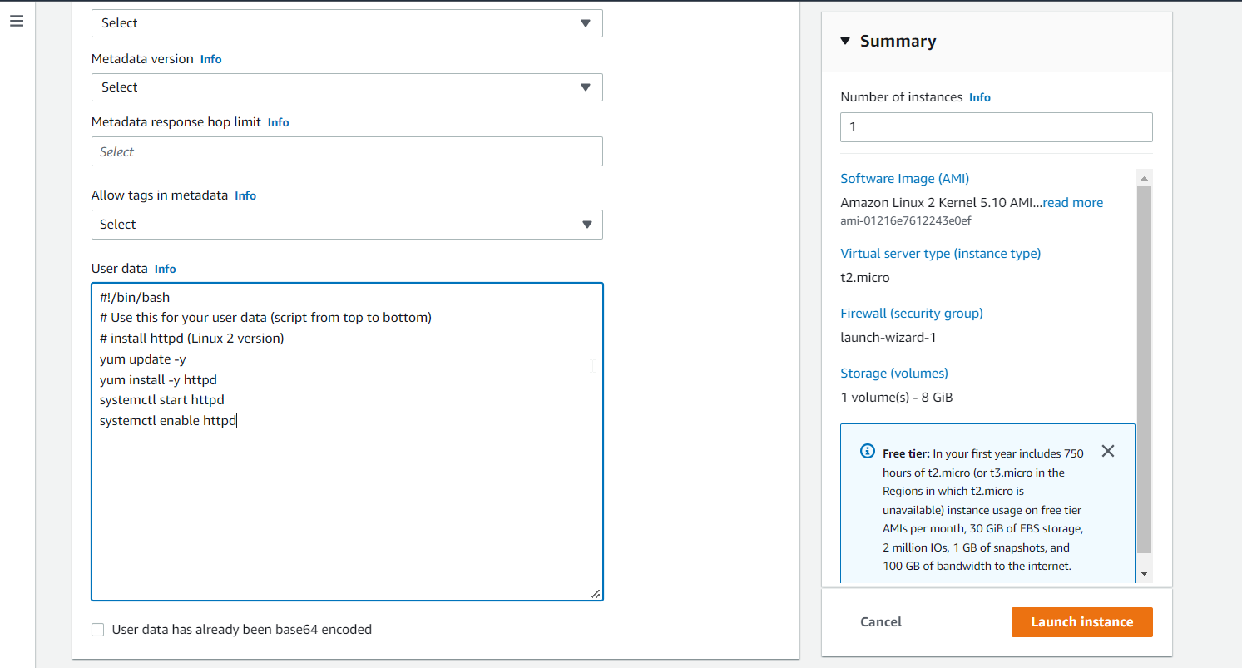

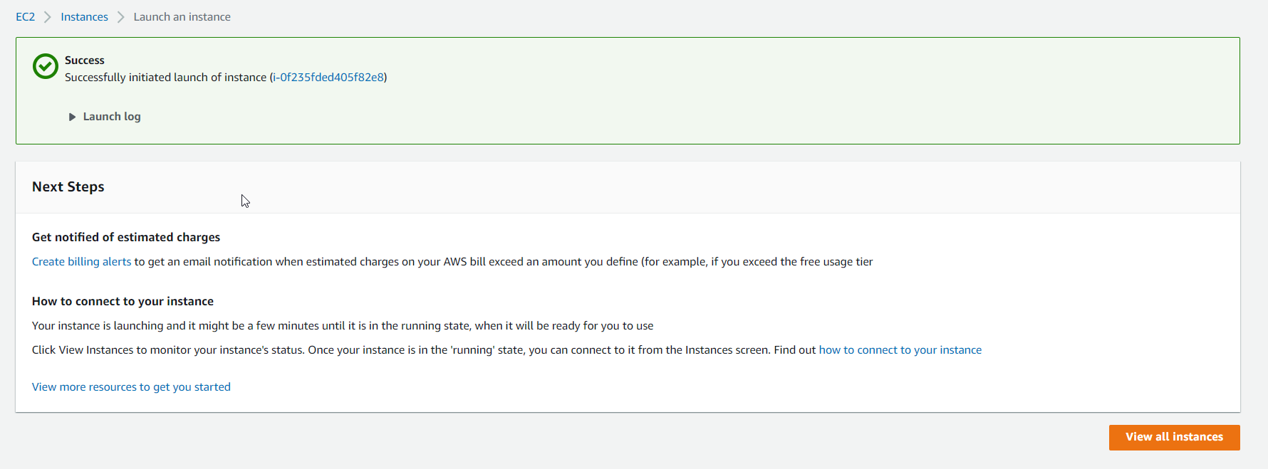

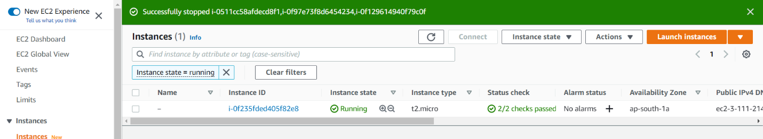

Paste public address ( wait 2-3 minutes to run page)

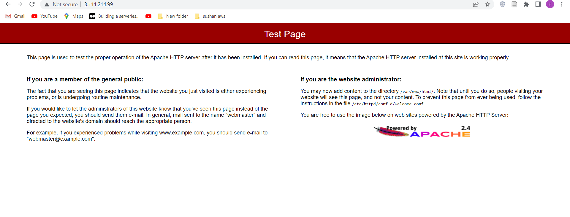

If you donot get this result check your security group

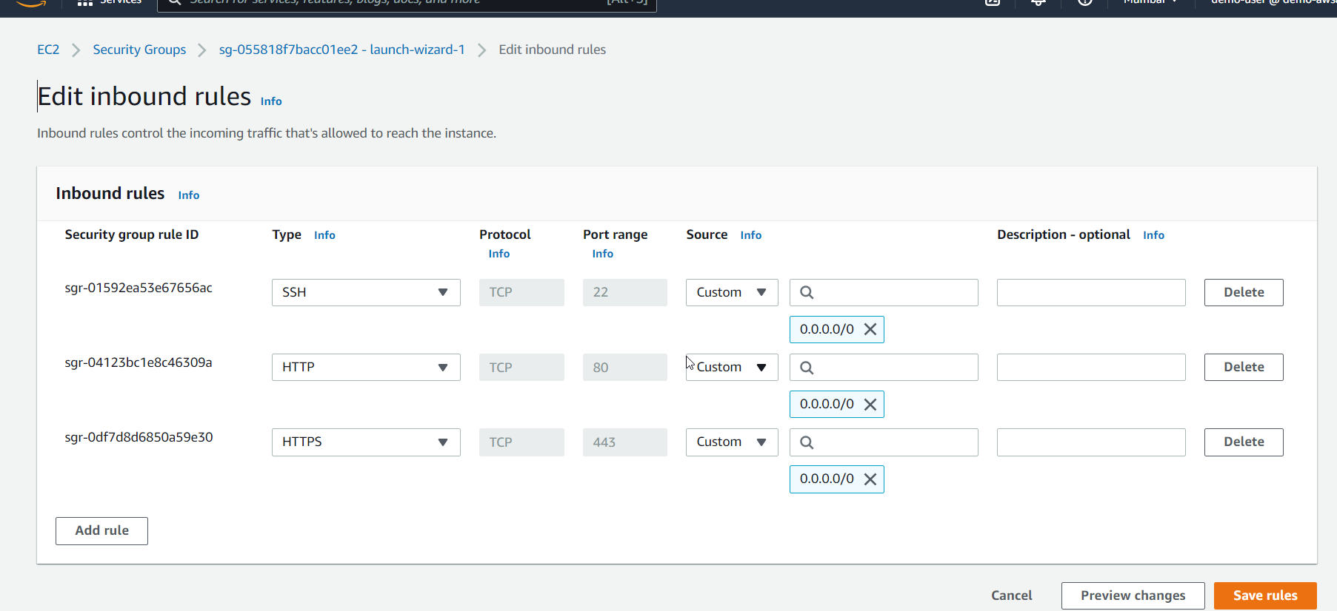

Create an AMI

SELECT YOUR INSTANCE

CLICK ACTION AND GOT TO IMAGE AND TEMPLATES

CREATE IMAGE

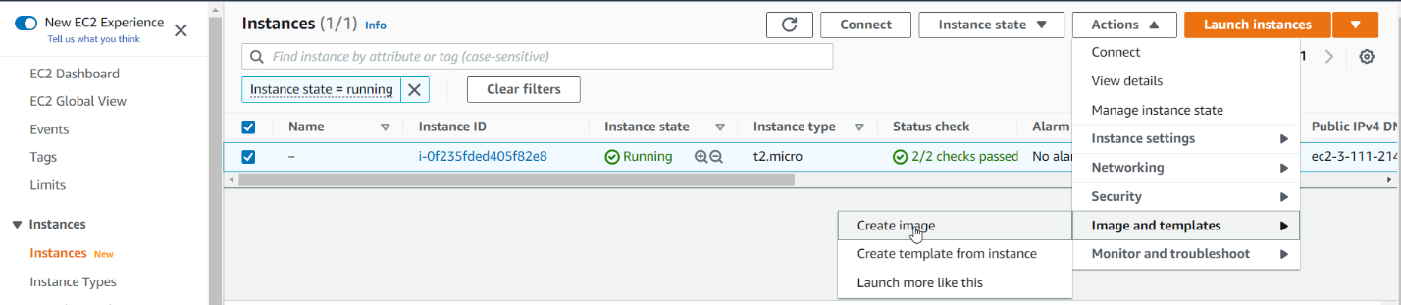

Named Image name and keep other default

Click Create Image

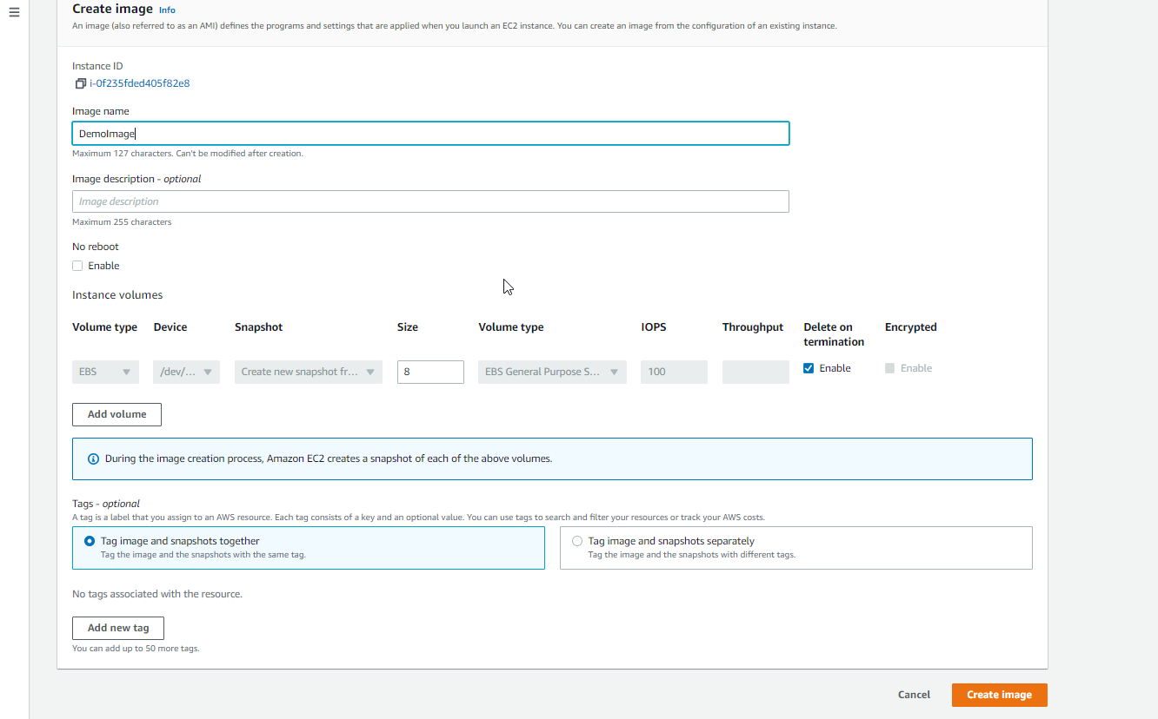

Go to AMI AND on left side of EC2 AND CLICK ON IT

YOU WILL SEE ami IS BEING CREATED.

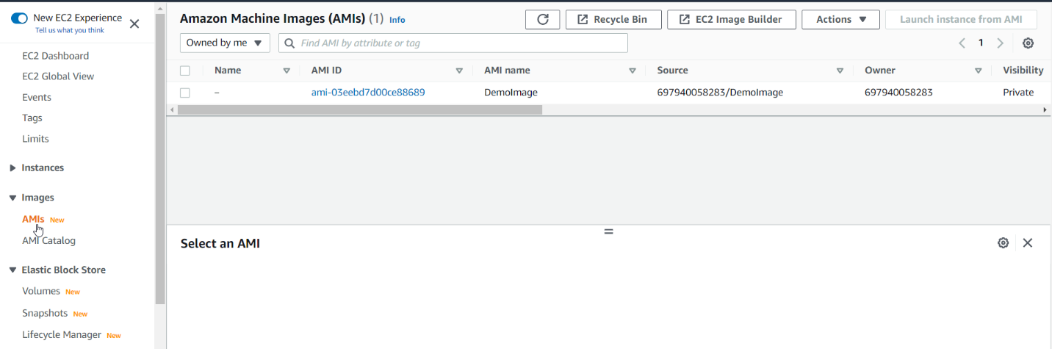

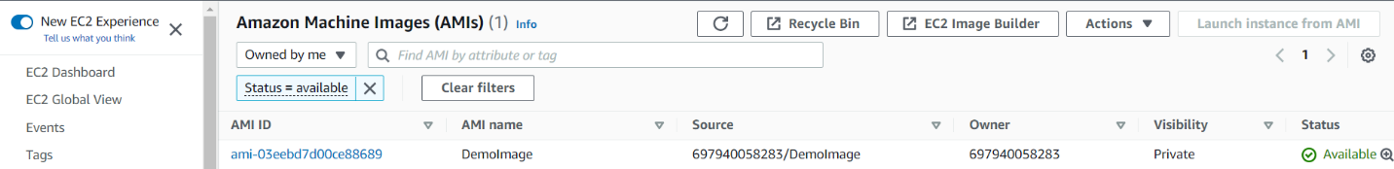

ONCE YOU OPENED

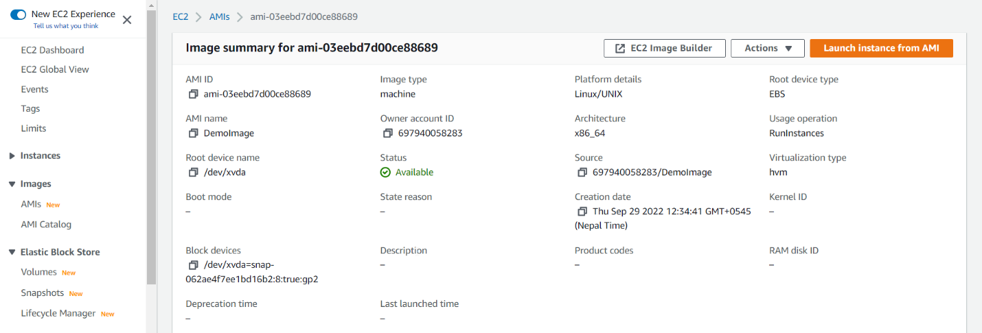

Go to ec2 instance or launch instance from AMI

Input instance name **From AMI**

Choose MY AMI’s

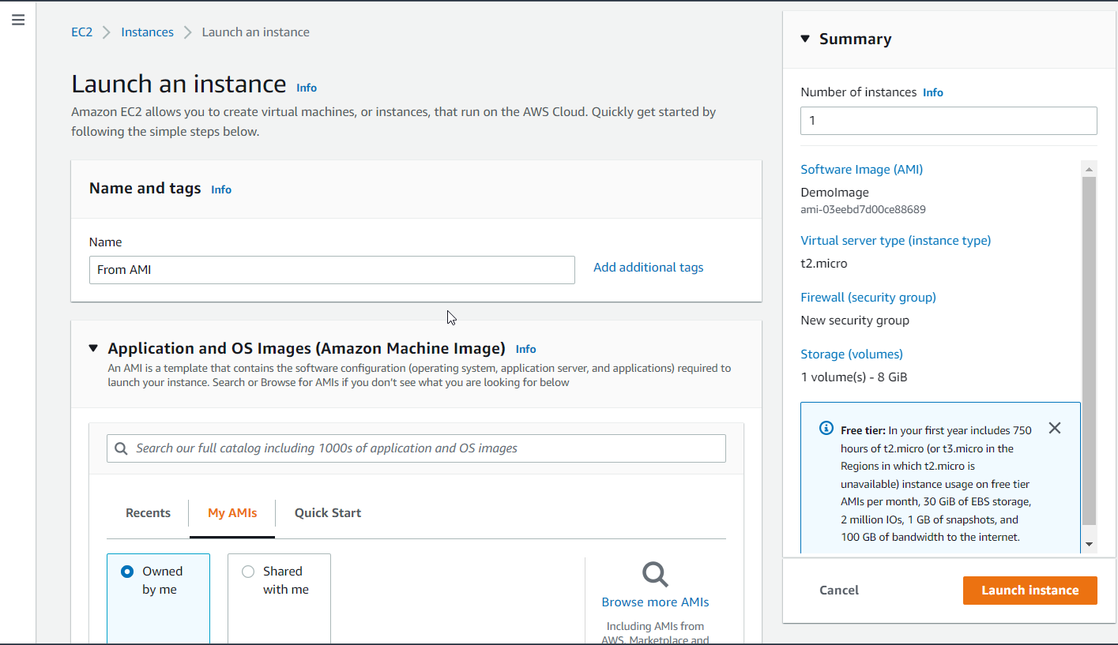

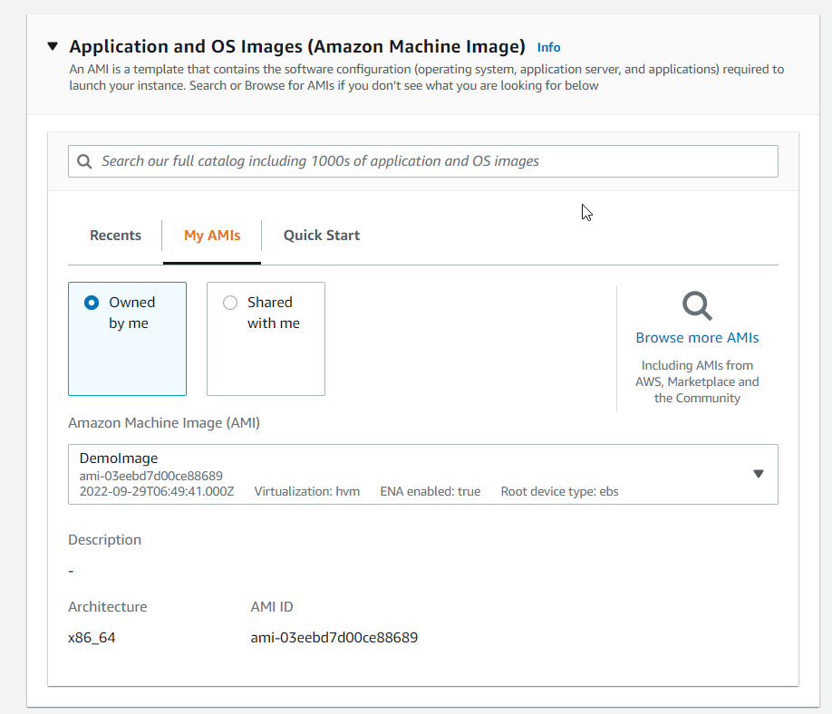

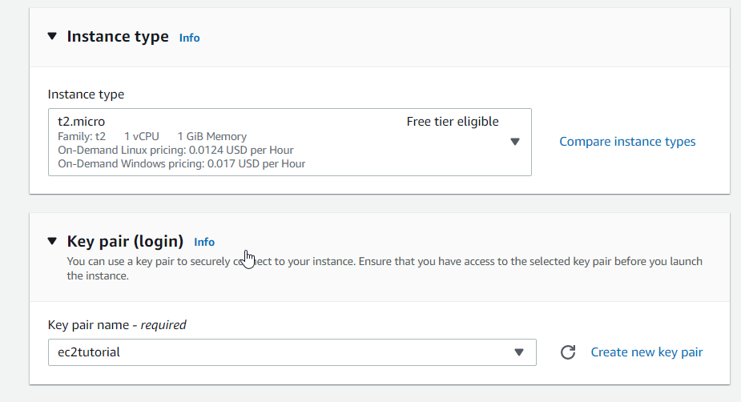

Edit network setting

Add existing security group

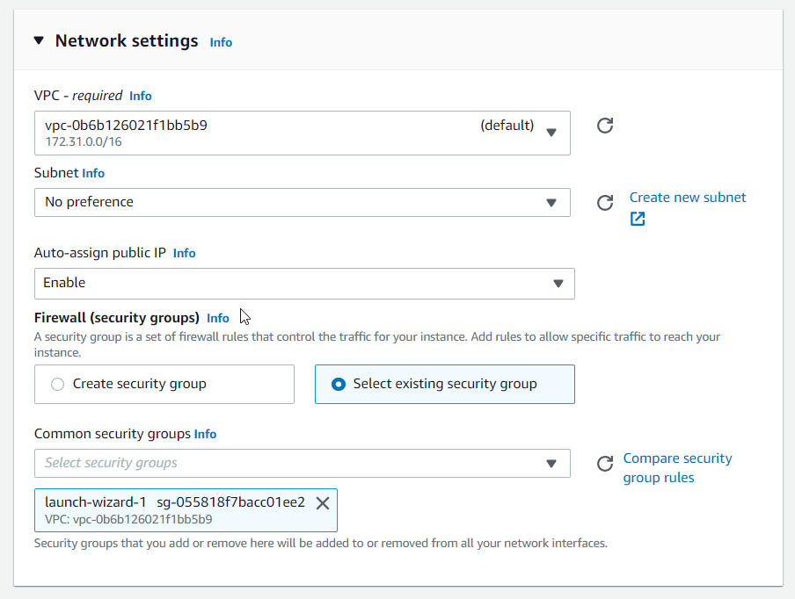

Then Go to advanced detail on user data which is blank.

Add following code

#!/bin/bash

# Use this for your user data (script from top to bottom)

# install httpd (Linux 2 version)

echo "<h1>Hello World from $(hostname -f)</h1>" > /var/www/html/index.html

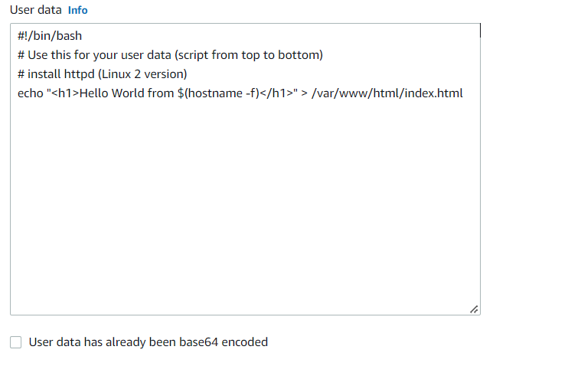

Once completed click launch instance

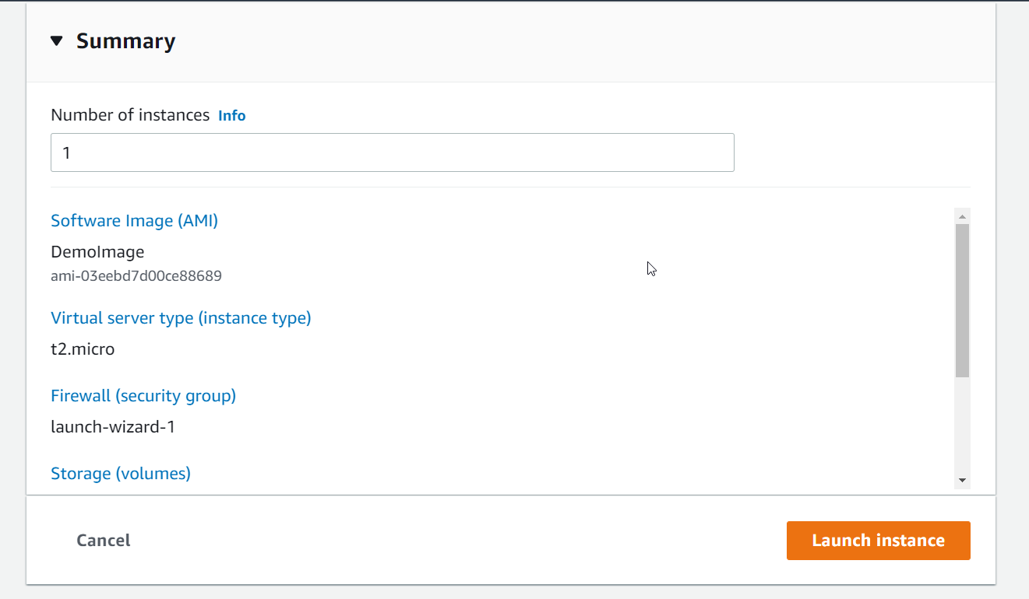

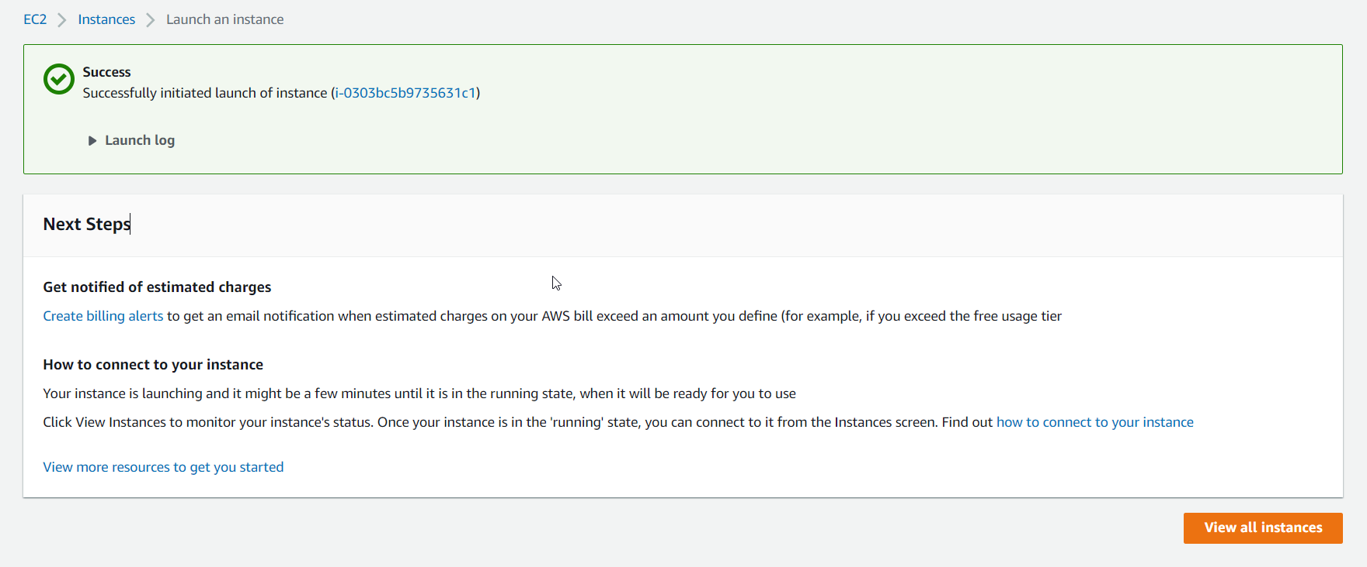

Instance is launched.

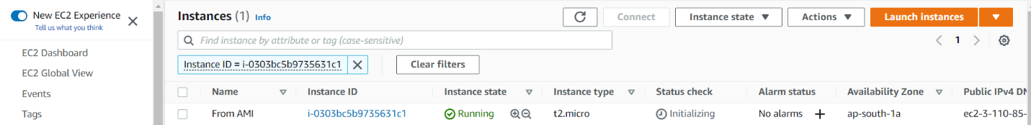

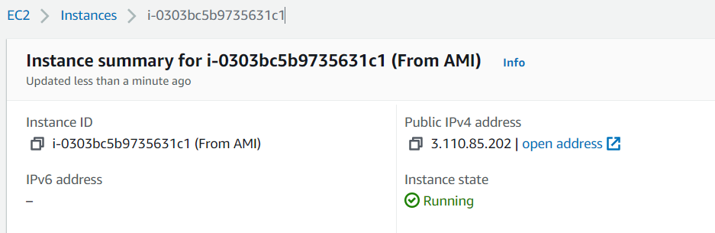

Copy and paste public ip(without http)

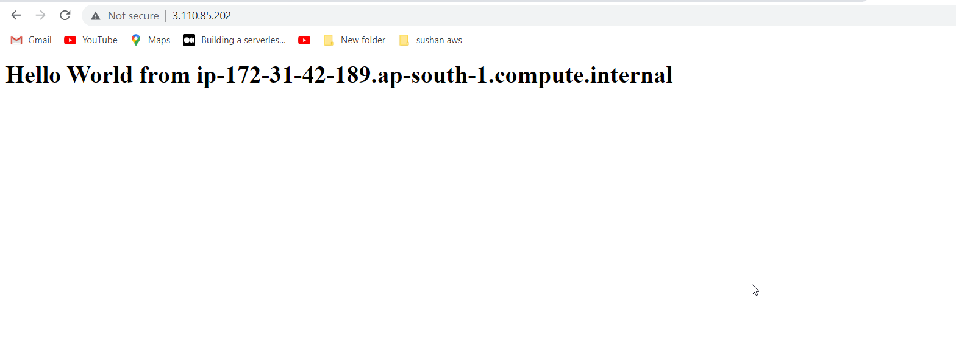

Terminate two instances

