* Go to storage on your ec2 instance

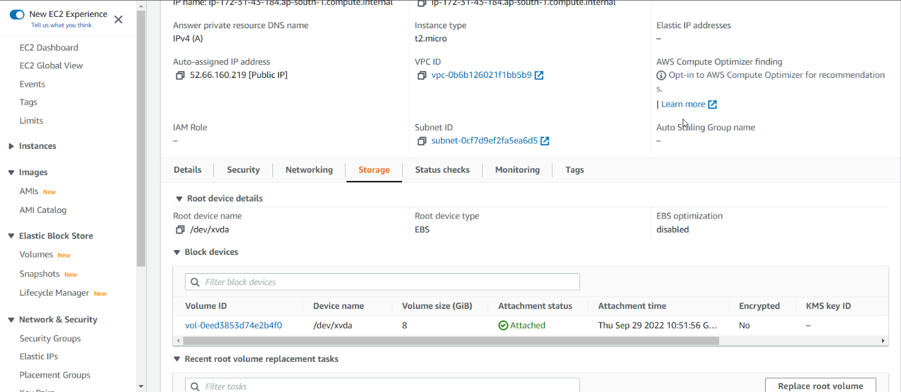

Click on volume ID

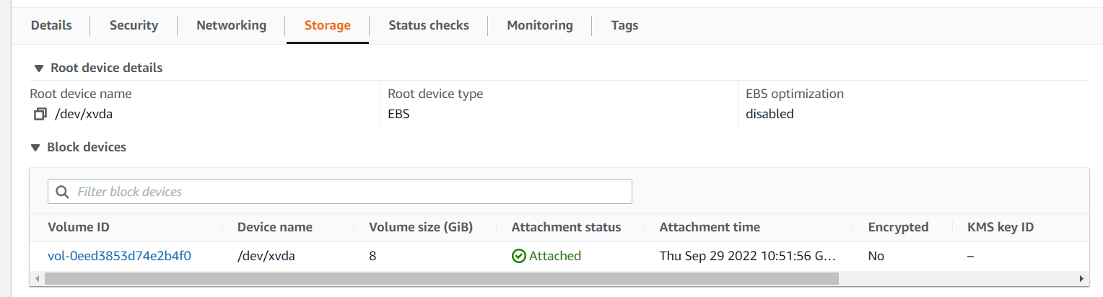

CLICK ON CREATE VOLUME

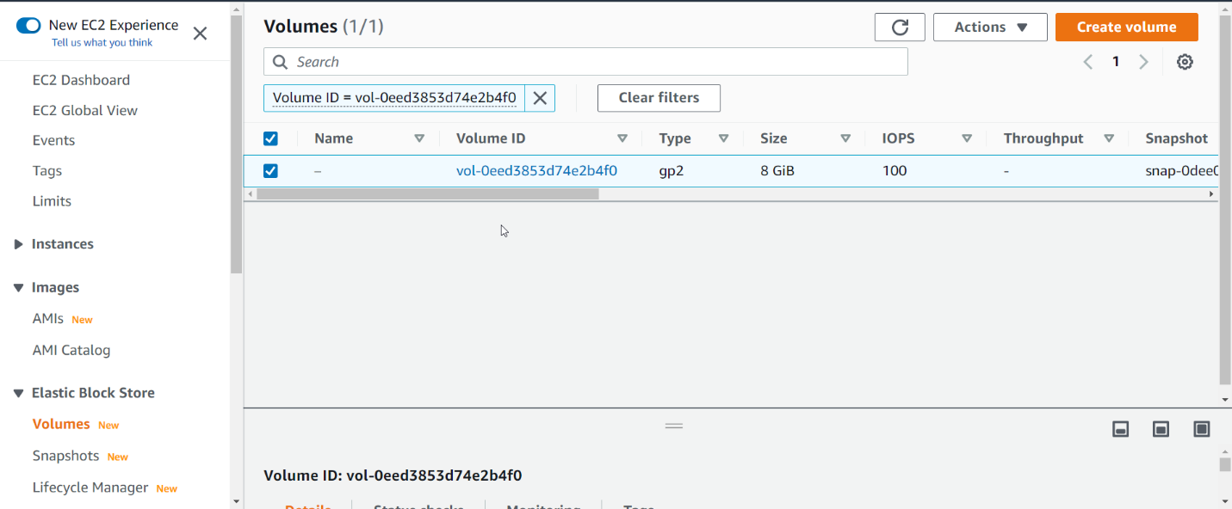

MAKE SURE YOUR EBS AVAILABILITY ZONE SHOULD BE SAME AS EC2.

GO TO EC2 NETWORKING SESSION TO CHECK EC2 AVAILABILITY ZONE

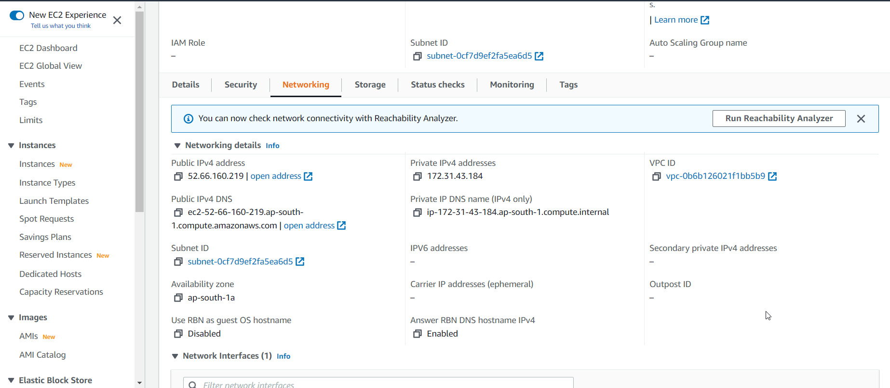

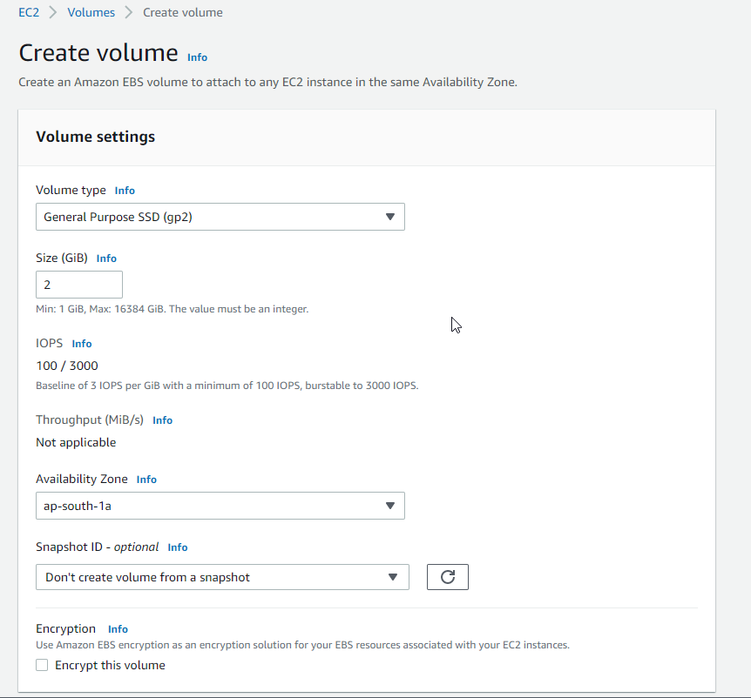

CREATE VOLUME

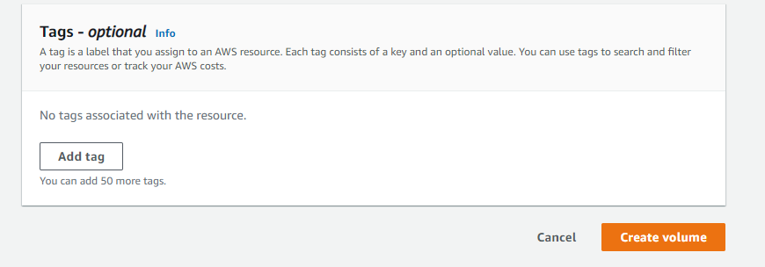

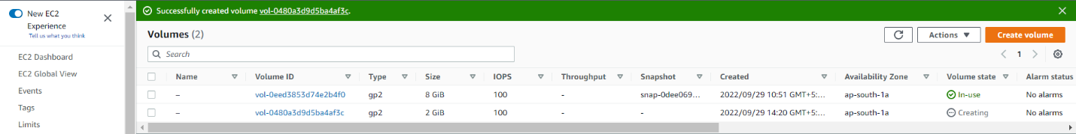

Volume state is available

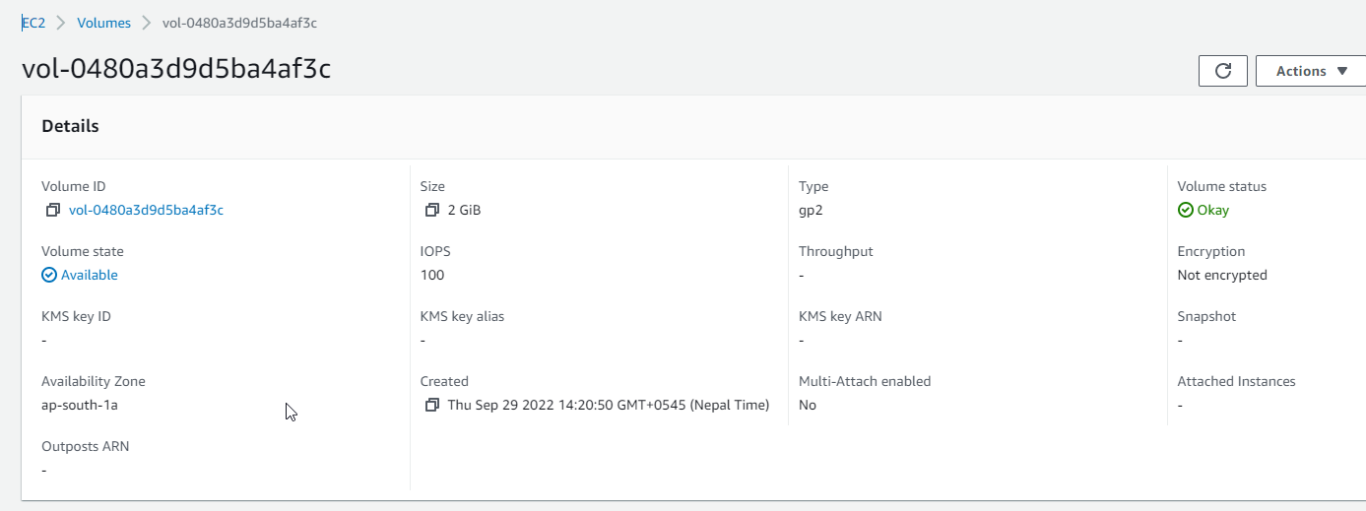

Attach a volume

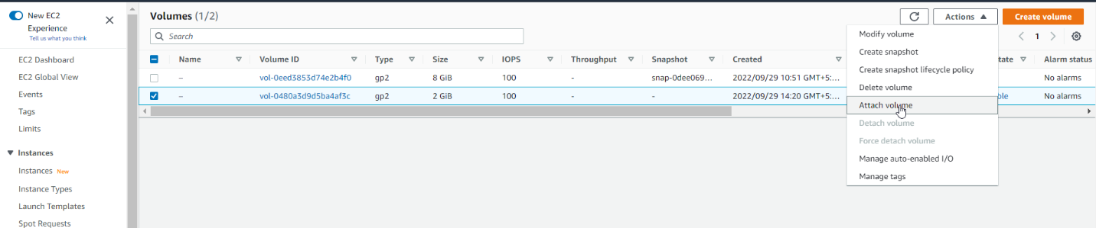

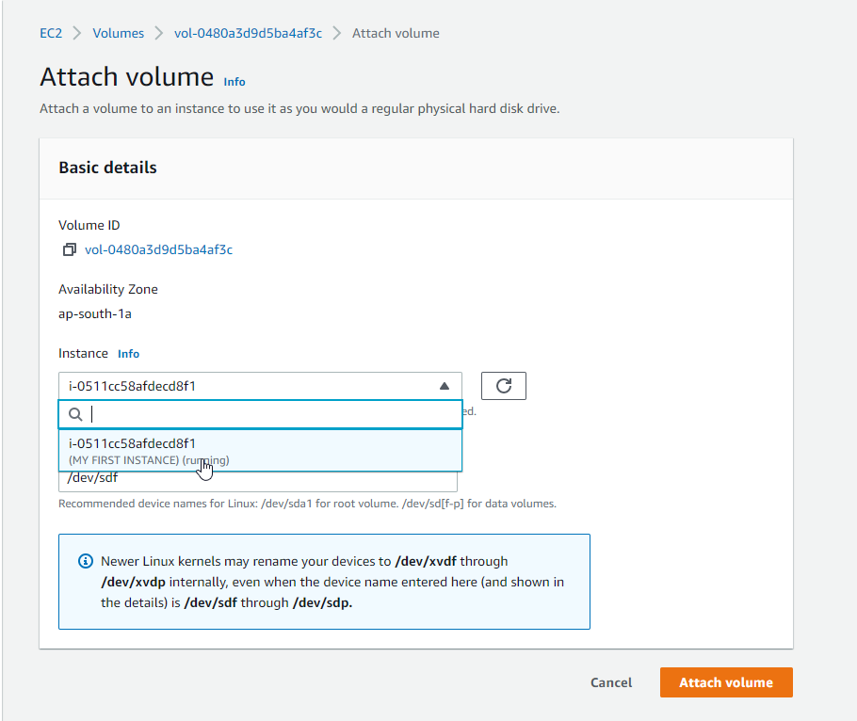

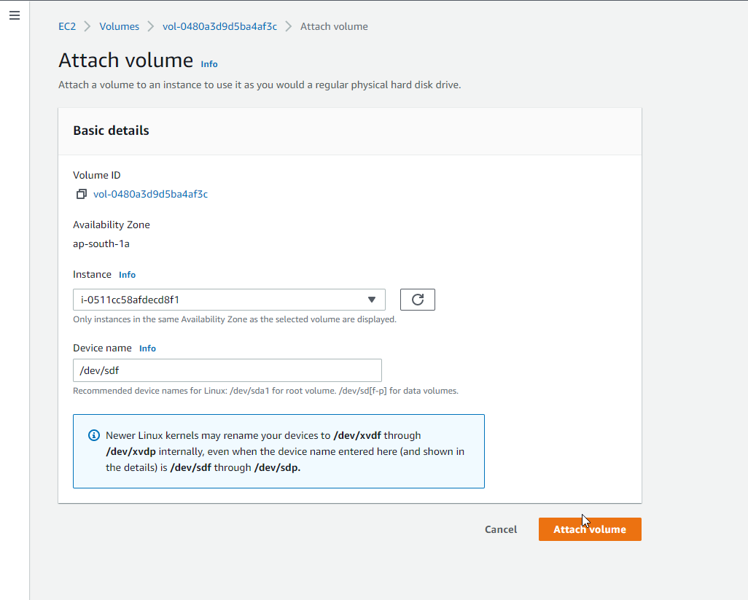

Go to storage on ec2 on storage. You will see two volume attaches.

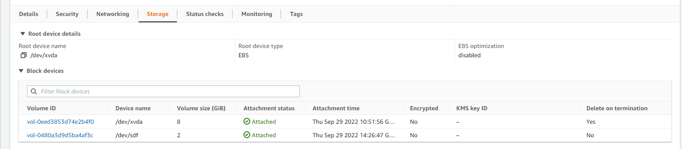

Now create a volume in different availability zone

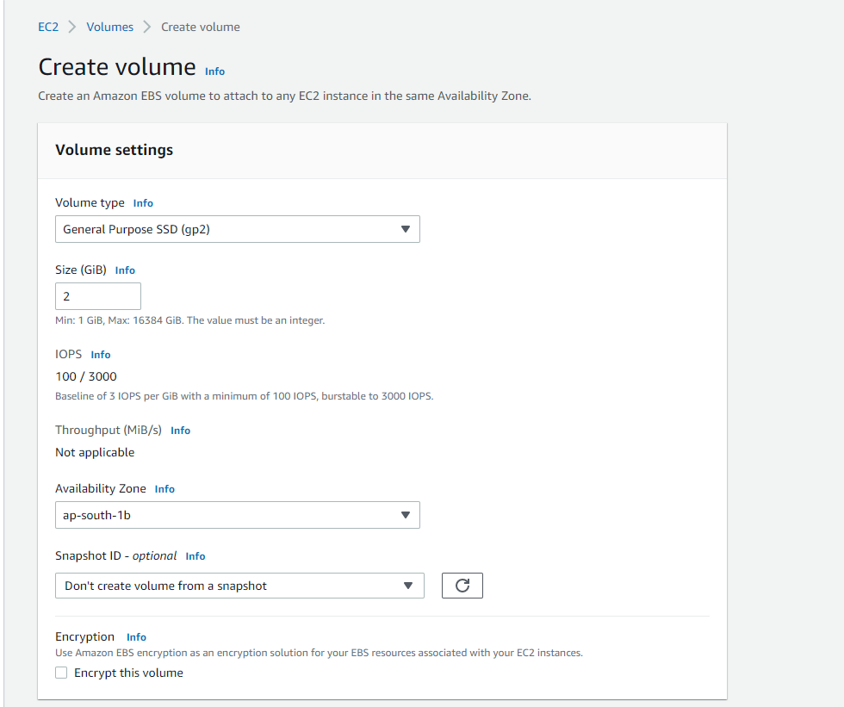

Attach volume

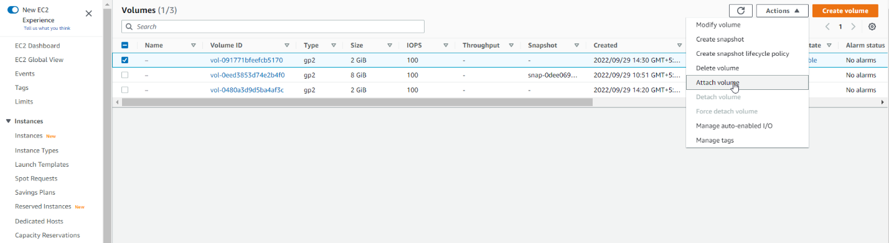

We will not found any instance

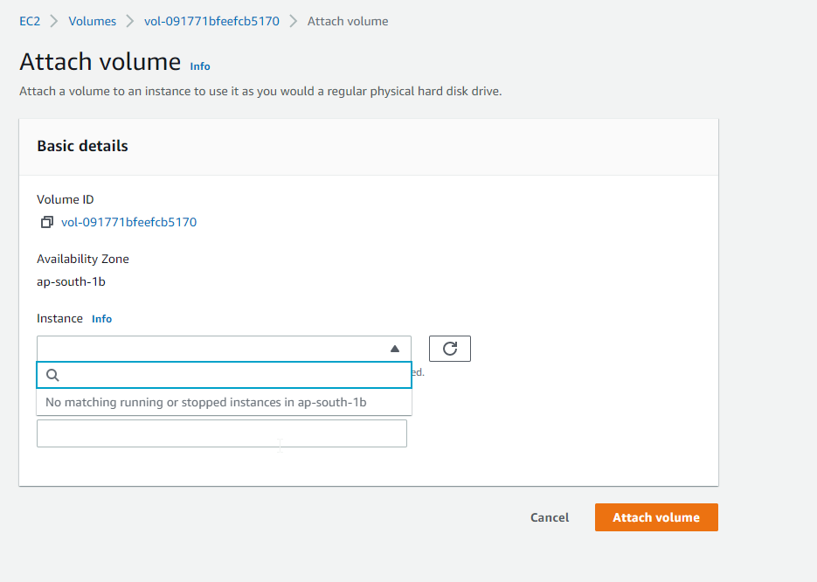

Delete that volume

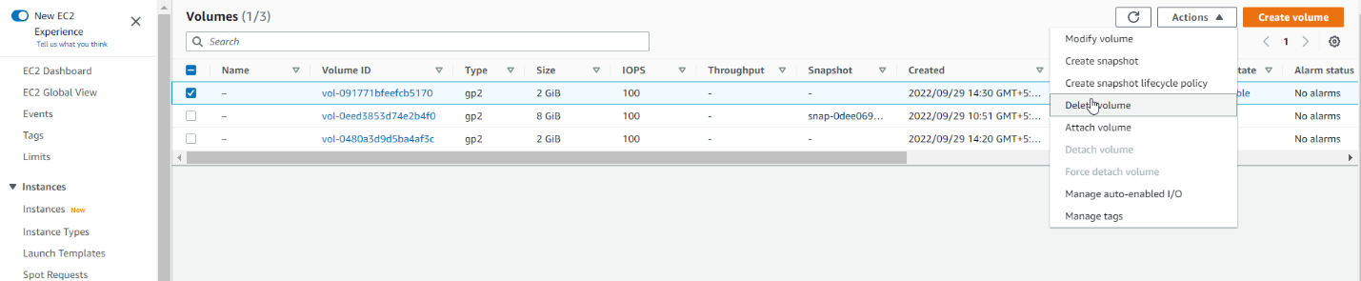

Two volumes are Delete on termination in ec2

8 GiB is default.

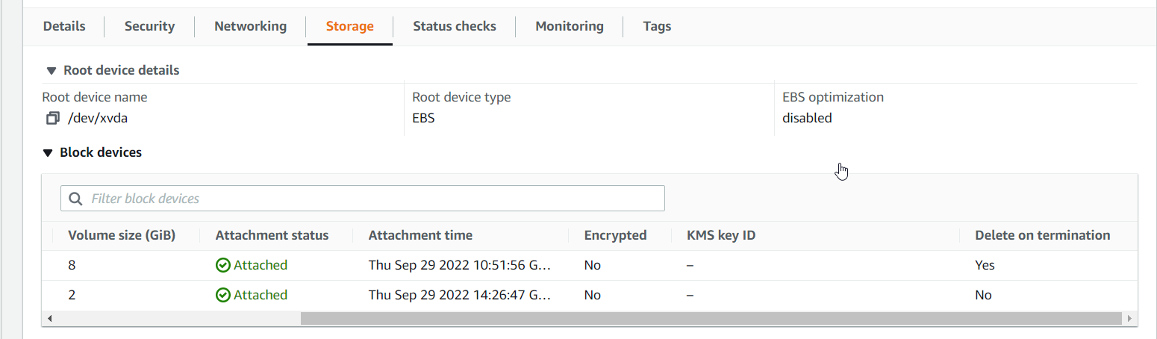

While creating ec2, our EBS volume is yes in delete on termination.

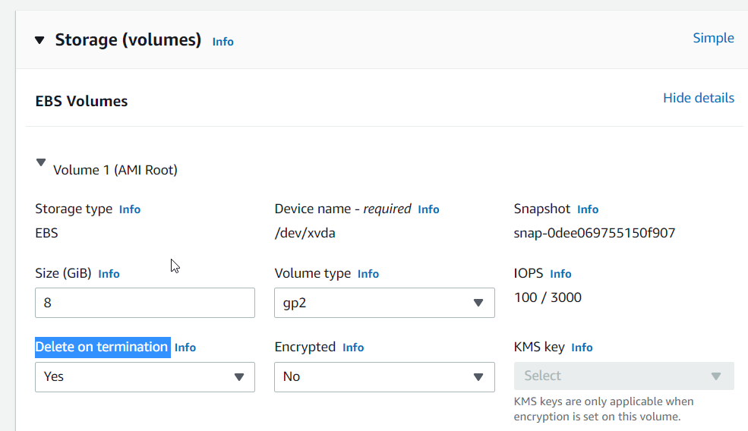

If we delete our ec2

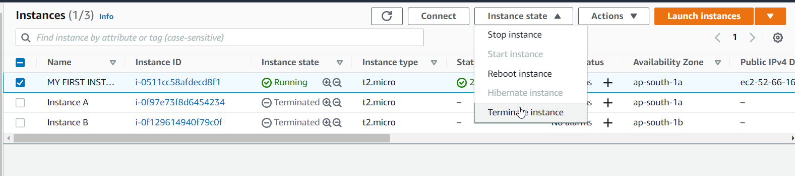

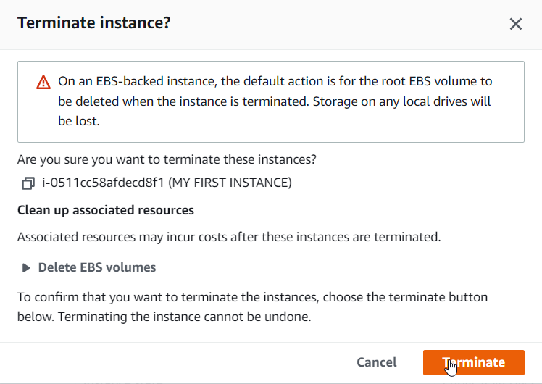

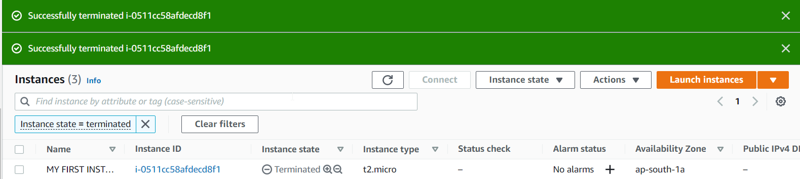

You will see On volume sedction in ec2

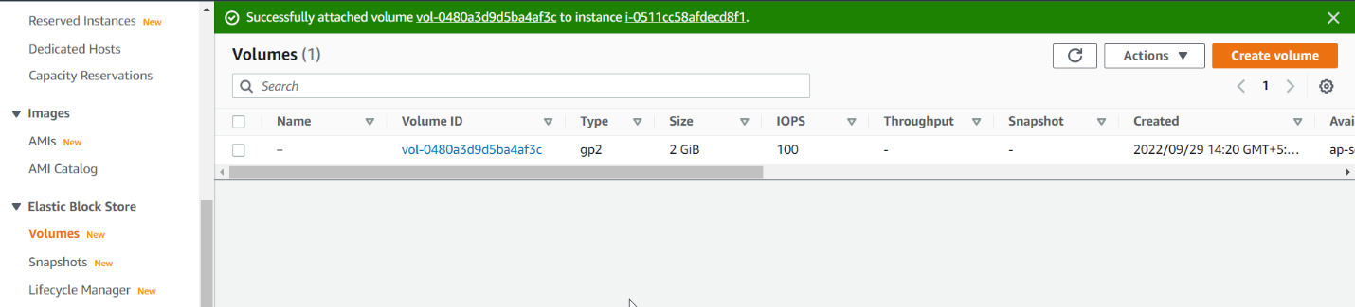

EBS SNAPSHOT

Select your EBS VOLUME

GO TO ACTION

CLICK CREATE SNAPSHOT

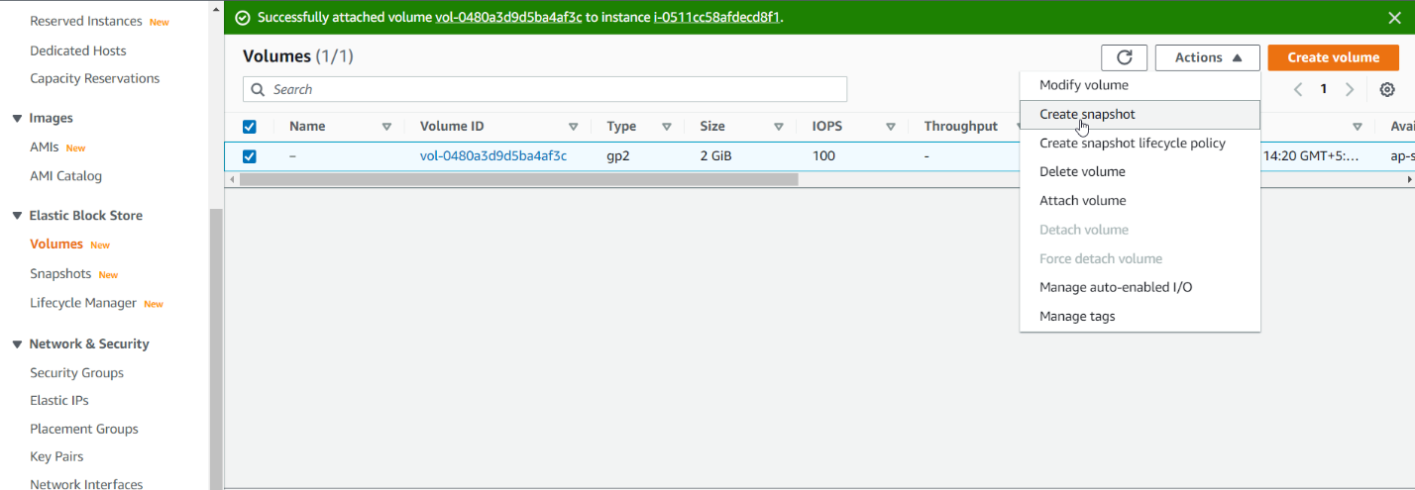

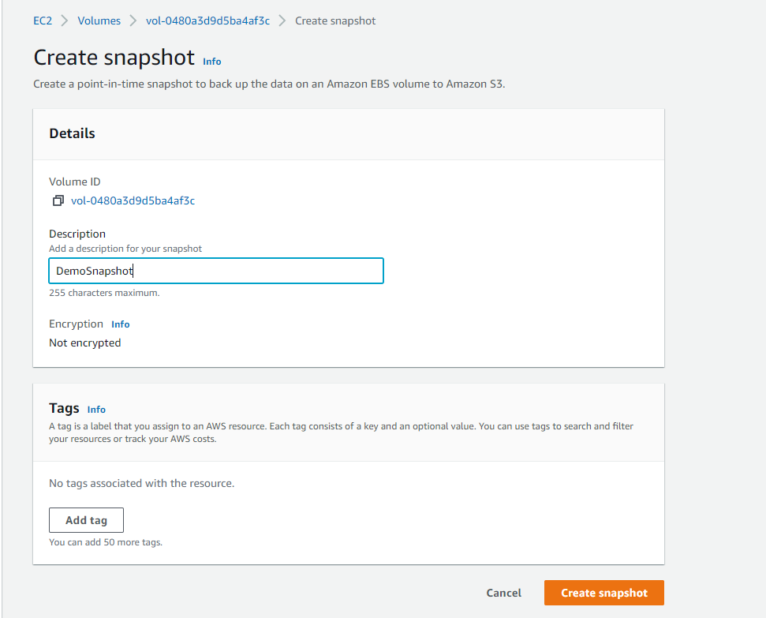

Click snapshot on EBS ON left on ec2

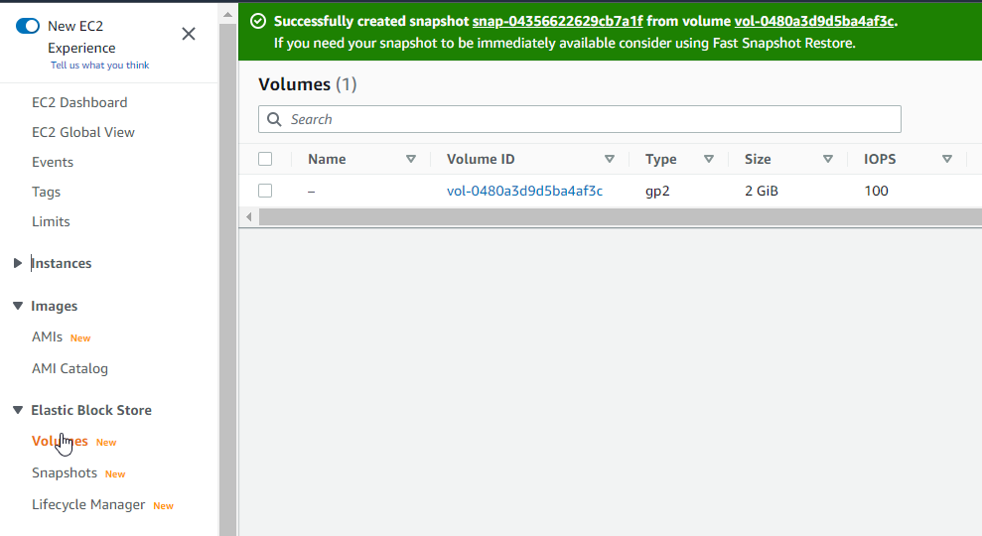

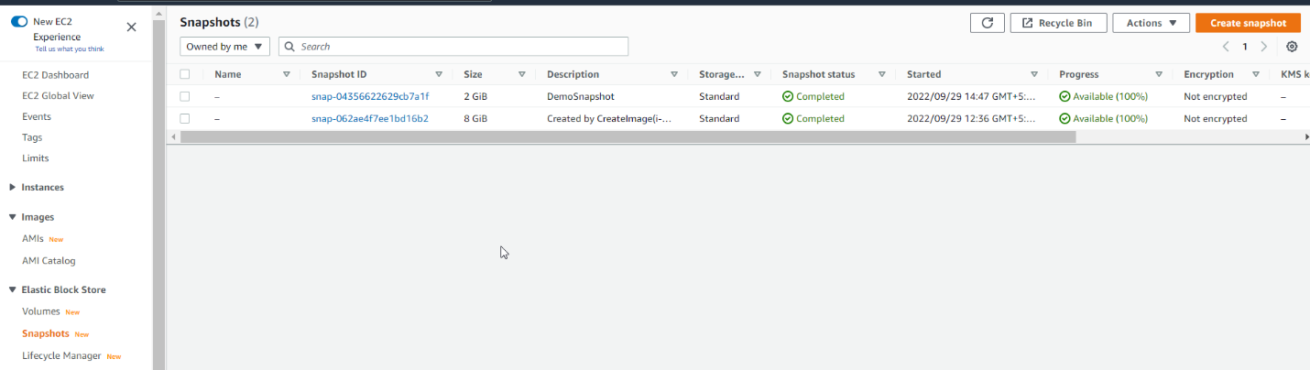

Right click on snapshot and click on Copy snapshot

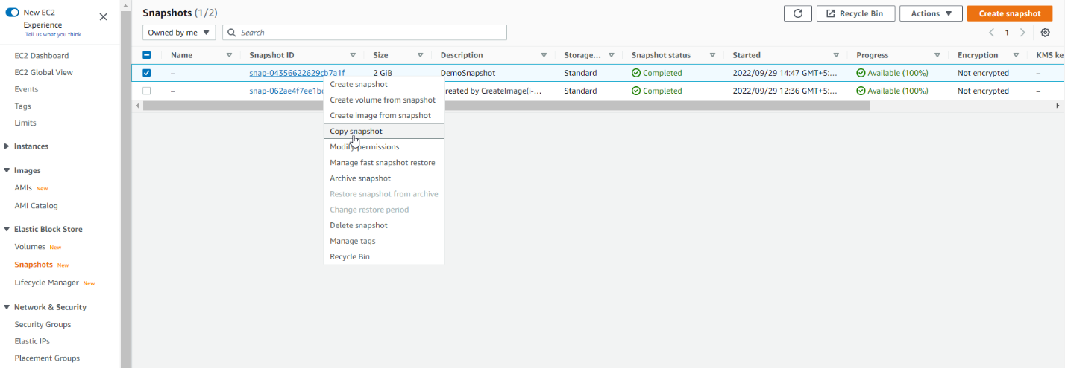

You can copy to any region

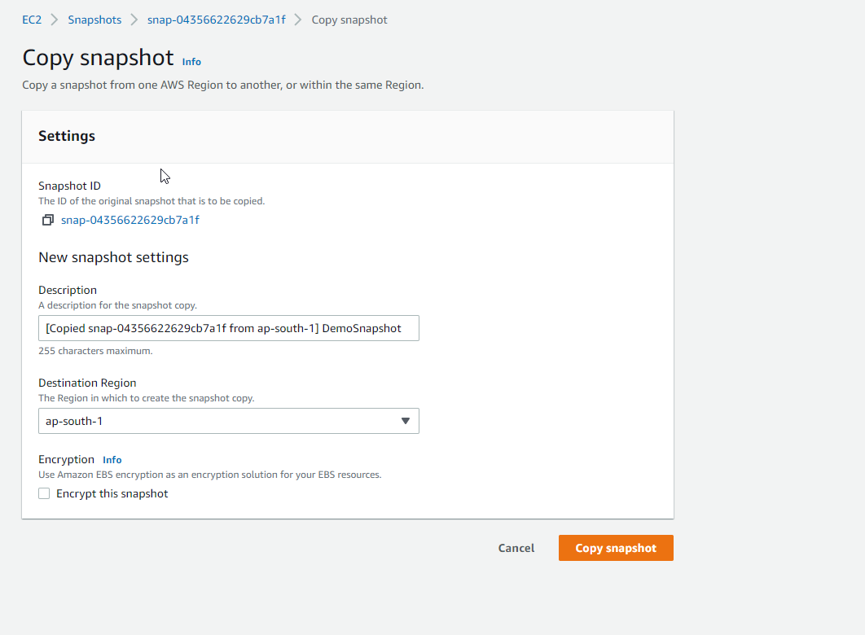

Copy volume from snaposhot

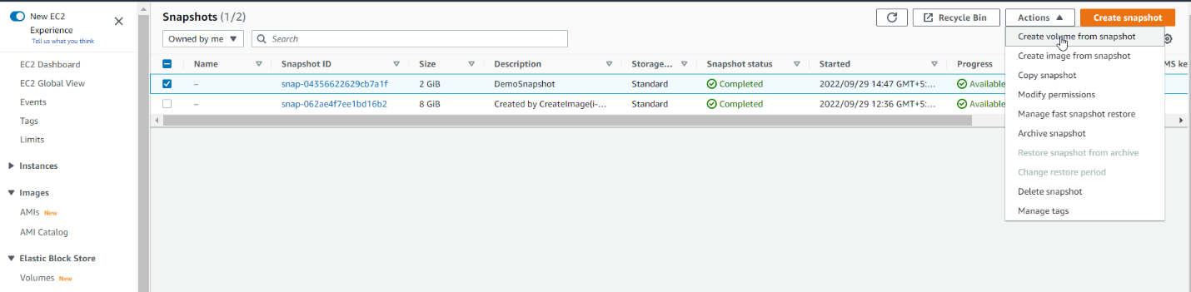

You can chose any availability zone

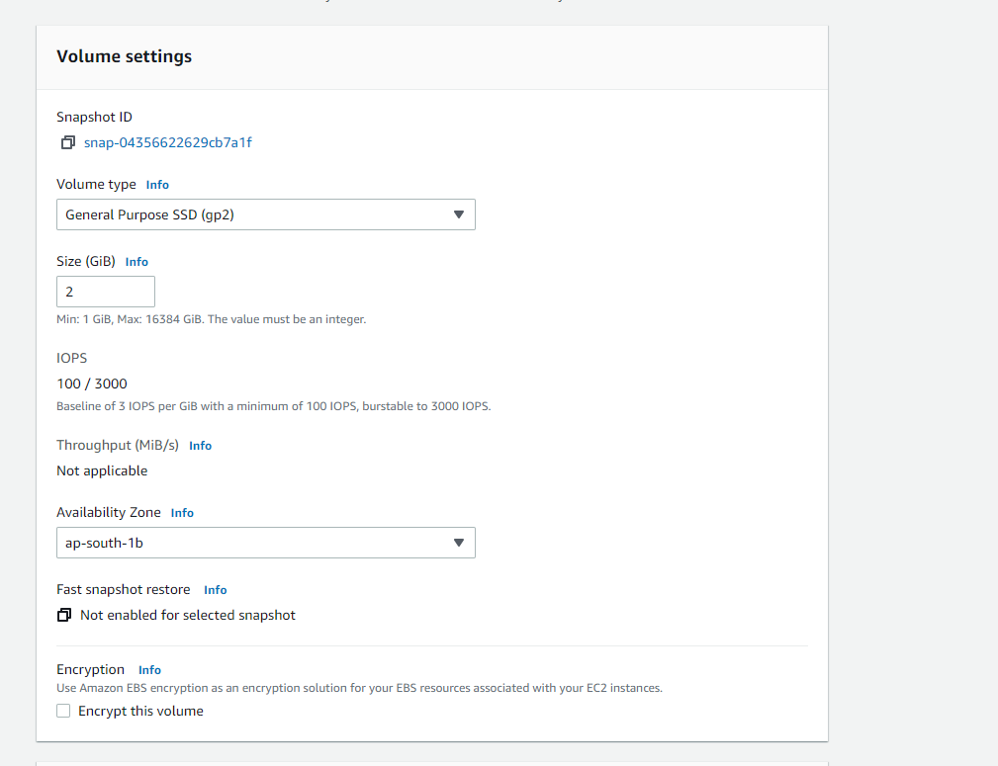

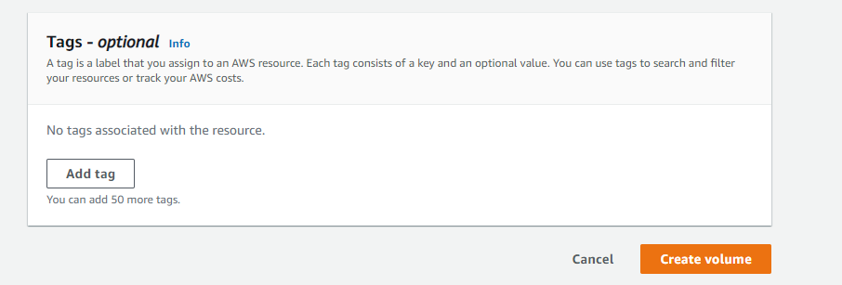

Go to EBS VOLUME section in ec2

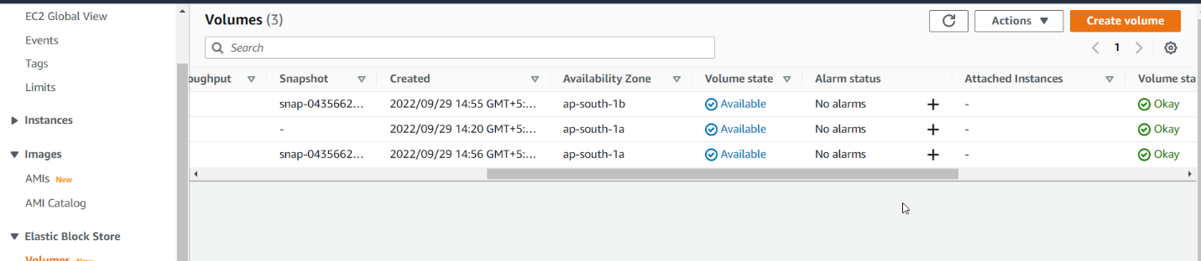

Go to snapshot and click Recycle Bin

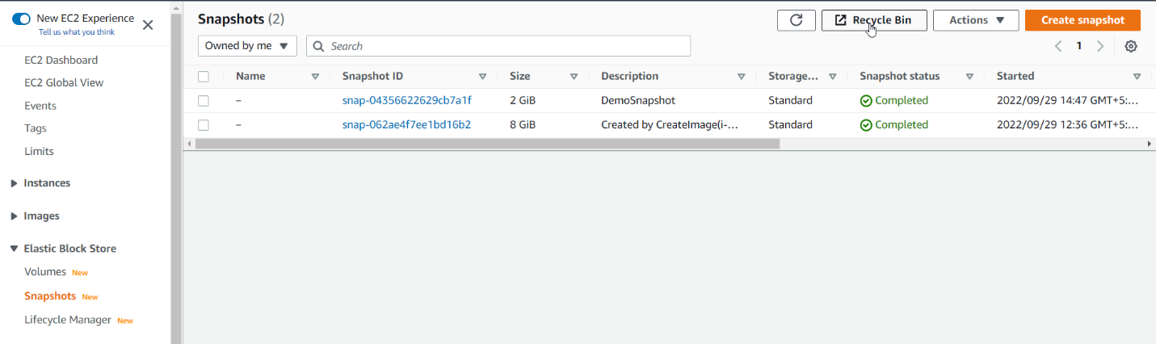

Click on Create retention rule

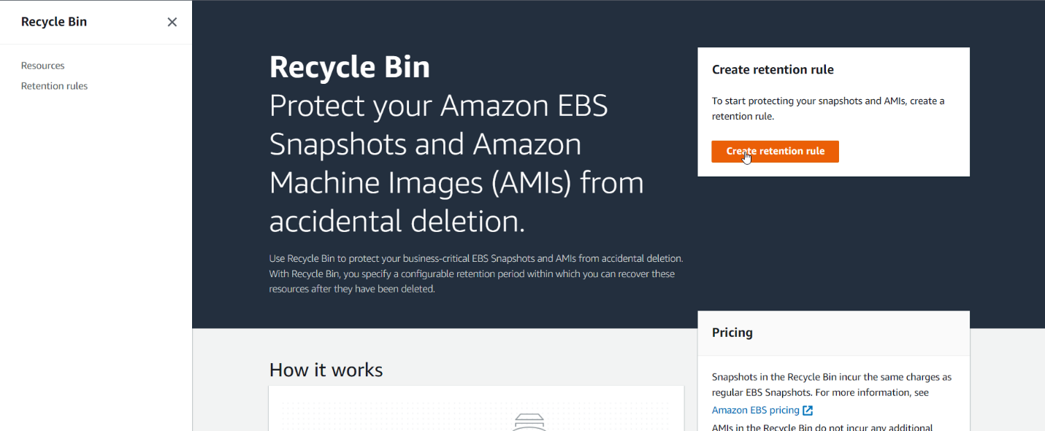

Name retention rule

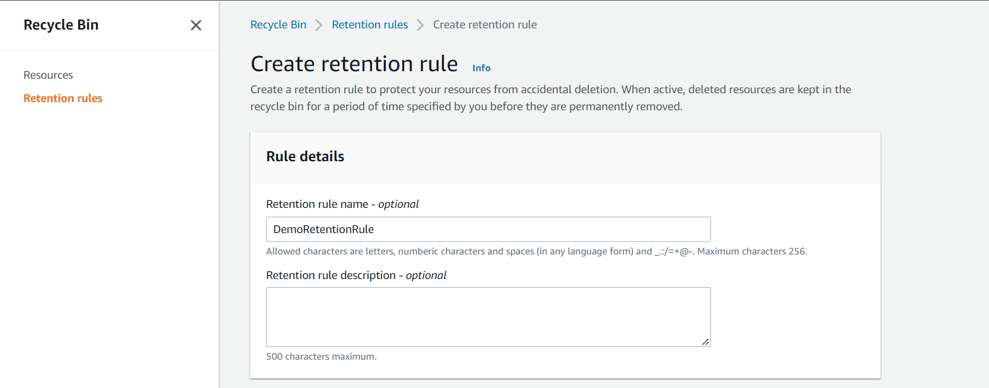

* Choose retention types
* Click Apply to all resources
* Click on retention

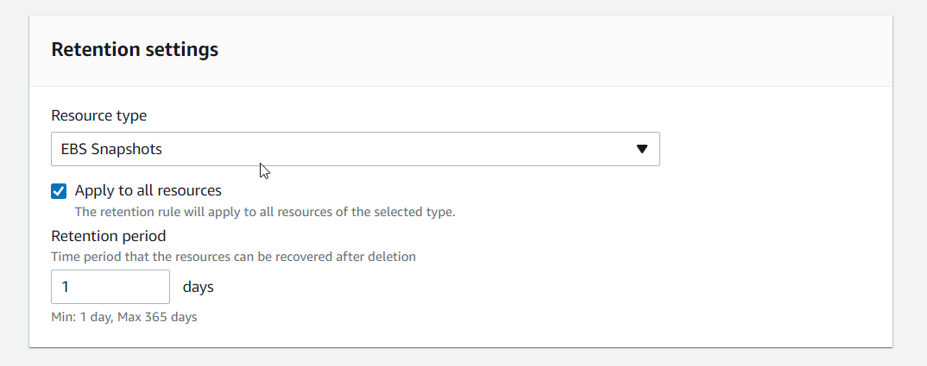

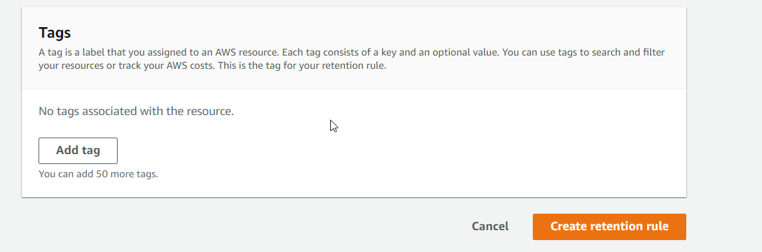

Retention created.

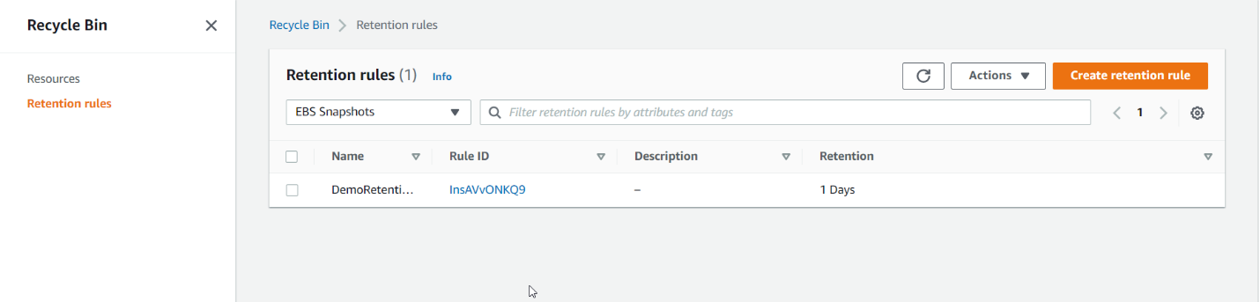

Go to snap shot ec2

Click on Archive snapshot

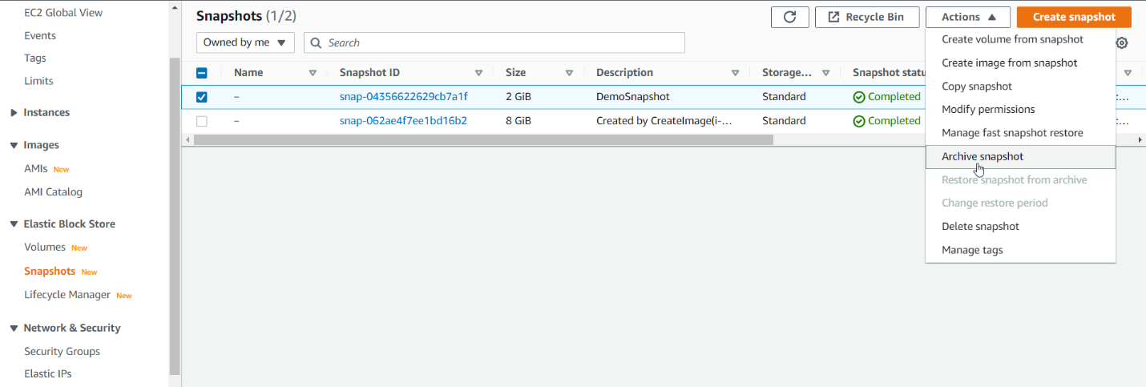

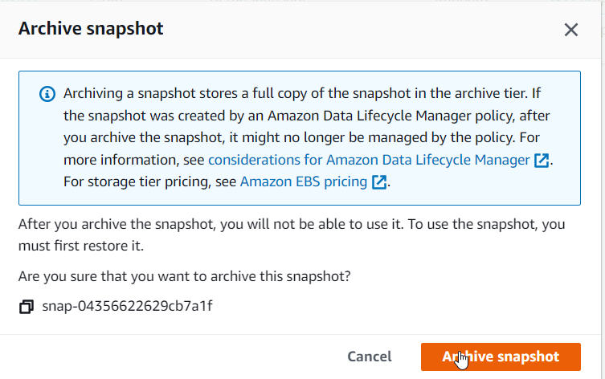

Delete snapshot

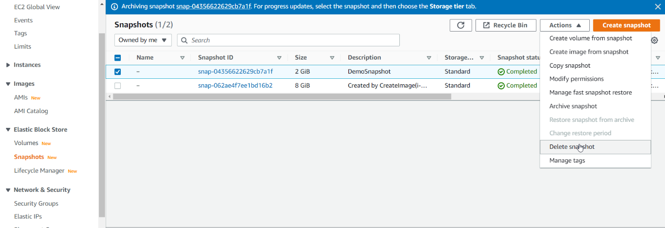

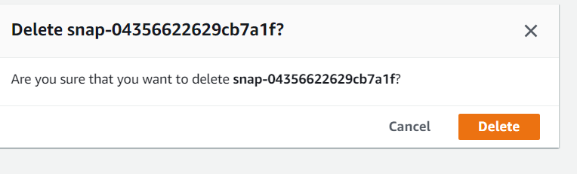

Delete snapshot

Deleted Snapshot will store on Recycle resource

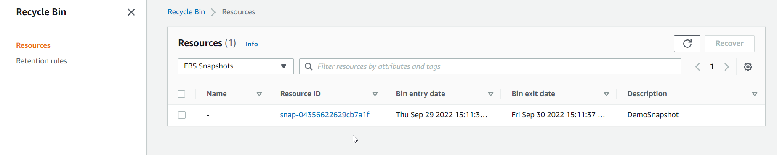

Click Recover

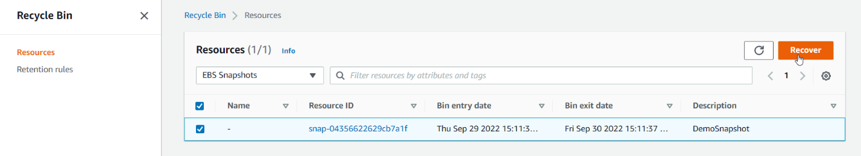

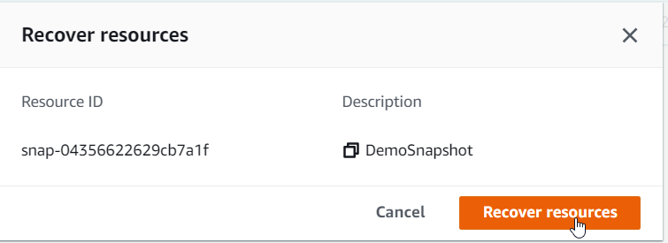

It has been recovered in snashots in ec2 section.

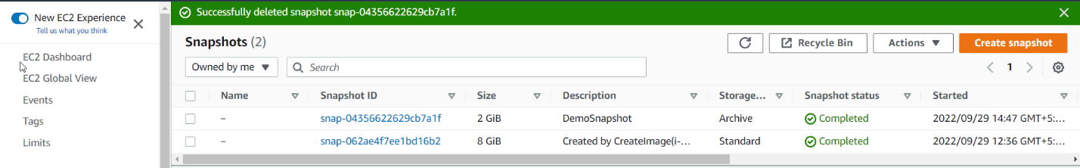

EFS V EBS deletion

Delete EBS Volume

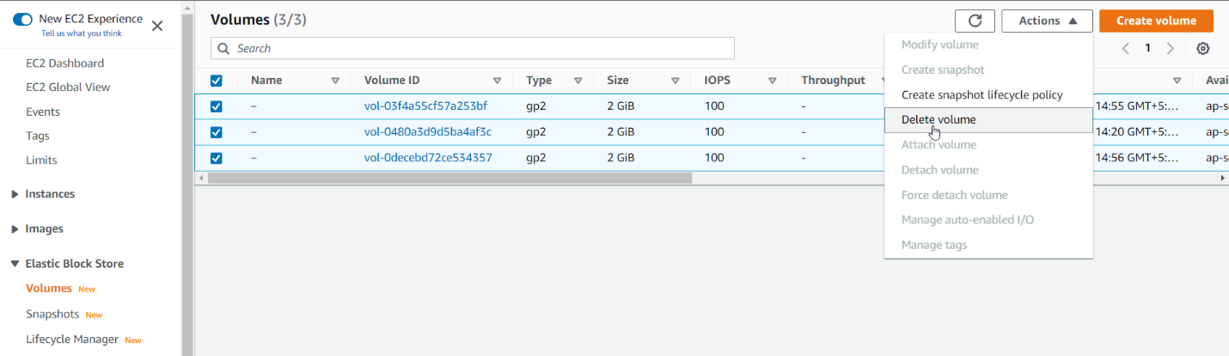

Delete snapShot

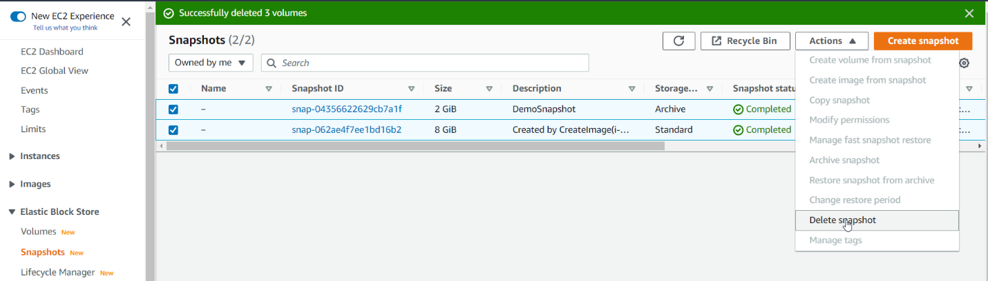

Delete security group except default one.

