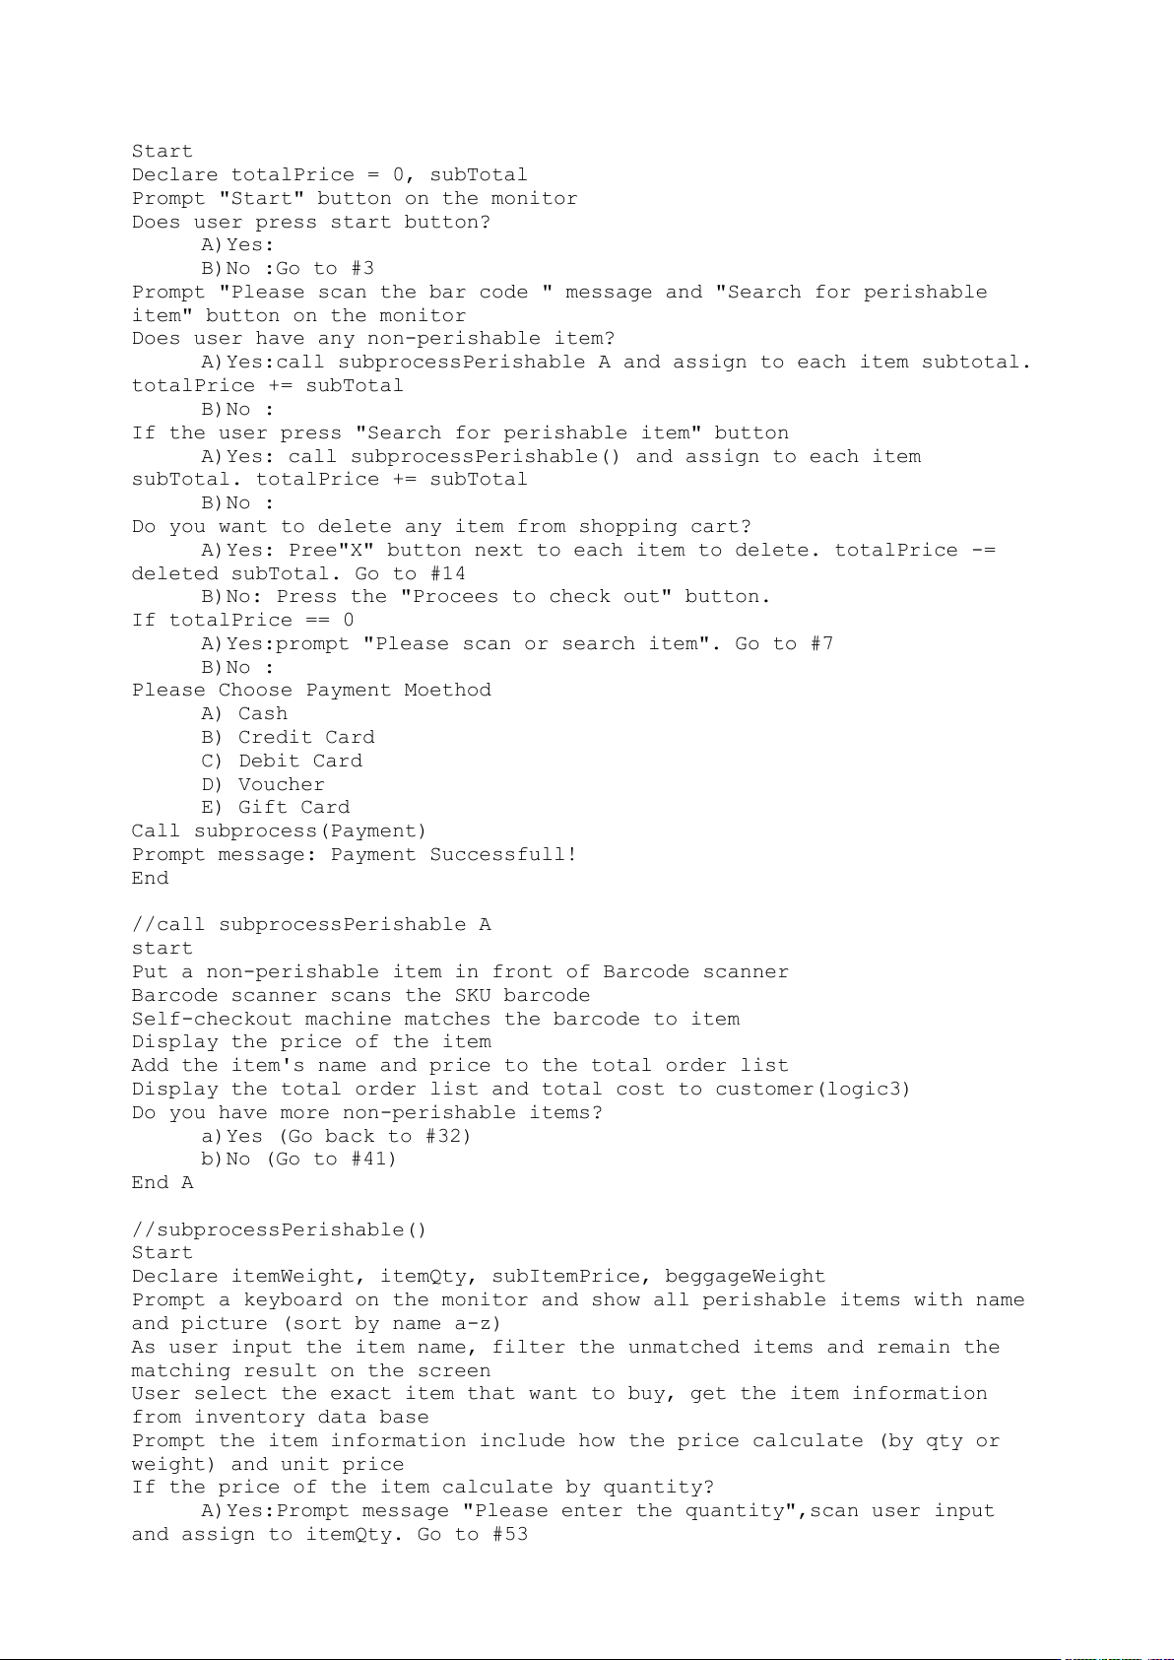

Start

Declare totalPrice = 0, subTotal

Prompt "Start" button on the monitor

Does user press start button?

A)Yes:

B)No :Go to #3

Prompt "Please scan the bar code " message and "Search for perishable

item" button on the monitor

Does user have any non-perishable item?

A)Yes:call subprocessPerishable A and assign to each item subtotal.

totalPrice += subTotal

B)No :

If the user press "Search for perishable item" button

A)Yes: call subprocessPerishable() and assign to each item

subTotal. totalPrice += subTotal

B)No :

Do you want to delete any item from shopping cart?

A)Yes: Pree"X" button next to each item to delete. totalPrice -=

deleted subTotal. Go to #14

B)No: Press the "Procees to check out" button.

If totalPrice == 0

A)Yes:prompt "Please scan or search item". Go to #7

B)No :

Please Choose Payment Moethod

A) Cash

B) Credit Card

C) Debit Card

D) Voucher

E) Gift Card

Call subprocess(Payment)

Prompt message: Payment Successfull!

End

//call subprocessPerishable A

start

Put a non-perishable item in front of Barcode scanner

Barcode scanner scans the SKU barcode

Self-checkout machine matches the barcode to item

Display the price of the item

Add the item's name and price to the total order list

Display the total order list and total cost to customer(logic3)

Do you have more non-perishable items?

a)Yes (Go back to #32)

b)No (Go to #41)

End A

//subprocessPerishable()

Start

Declare itemWeight, itemQty, subItemPrice, beggageWeight

Prompt a keyboard on the monitor and show all perishable items with name

and picture (sort by name a-z)

As user input the item name, filter the unmatched items and remain the

matching result on the screen

User select the exact item that want to buy, get the item information

from inventory data base

Prompt the item information include how the price calculate (by qty or

weight) and unit price

If the price of the item calculate by quantity?

A)Yes:Prompt message "Please enter the quantity",scan user input

and assign to itemQty. Go to #53

B)No :prompt message "Please put the item on the scan scale", scan

the weight of item and assign to itemWeight. Go to #54

subItemPrice = itemQuantity * item unit price. Go to #55

subItemPrice = itemWeight * item unit price. Go to #55

List the items information that have been added on the shopping cart list

Prompt message to ask the user put the item on the baggage area

Scan the baggage area to check if the item is placed?

A)Yes:

B)No : Go to #56

Does the user want to search for more parichable items?

A)Yes: Press "Search more" button. Go to #46

B)No : Press "Finish" button.

Return the intem information and return each subItemPrice

End

//subprocess(Payment)

Start

If payment done by

A) Cash

A.1) Please Put Cash in Box

A.2) if tcash = payment

A.2.1) Yes: Go to # A.3

A.2.2) No: Please Put More Cash

A.3) if tcash > payment

A.3.1) Yes: Please take your change back

A.3.2) No: Go to # A.4

A.4) Exit the counter

B) Credit Card

B.1) How you want to use the card?

B.1.1) Swipe

B.1.2) Insert

B.1.3) Tap: If payment< $200

B.2) if payment_method == swipe & payment_method == Insert

Enter Your Pin

B.3) Pin Details?

B.3.1) Pin Correct: Go to # B.4

B.3.2) Incorrect Pin: Please Re-enter your Pin

B.4) Exit the Counter

C) Debit Card

C.1) How you want to use the card?

C.1.1) Swipe

C.1.2) Insert

C.1.3) Tap: If payment< $200

C.2) if payment_method == swipe & payment_method == Insert

Enter Your Pin

C.3) Pin Details?

C.3.1) Pin Correct: Go to # C.4

C.3.2) Incorrect Pin: Please Re-enter your Pin

C.4) Exit the Counter

D) Voucher

D.1) Scratch The Voucher Card( Obtain the Code)

D.2) Click on Checkout with Voucher

D.3) Enter The Voucher Code

D.3.1) Correct Code: Go to #D.4

B)No :prompt message "Please put the item on the scan scale", scan

the weight of item and assign to itemWeight. Go to #54

subItemPrice = itemQuantity * item unit price. Go to #55

subItemPrice = itemWeight * item unit price. Go to #55

List the items information that have been added on the shopping cart list

Prompt message to ask the user put the item on the baggage area

Scan the baggage area to check if the item is placed?

A)Yes:

B)No : Go to #56

Does the user want to search for more parichable items?

A)Yes: Press "Search more" button. Go to #46

B)No : Press "Finish" button.

Return the intem information and return each subItemPrice

End

//subprocess(Payment)

Start

If payment done by

A) Cash

A.1) Please Put Cash in Box

A.2) if tcash = payment

A.2.1) Yes: Go to # A.3

A.2.2) No: Please Put More Cash

A.3) if tcash > payment

A.3.1) Yes: Please take your change back

A.3.2) No: Go to # A.4

A.4) Exit the counter

B) Credit Card

B.1) How you want to use the card?

B.1.1) Swipe

B.1.2) Insert

B.1.3) Tap: If payment< $200

B.2) if payment_method == swipe & payment_method == Insert

Enter Your Pin

B.3) Pin Details?

B.3.1) Pin Correct: Go to # B.4

B.3.2) Incorrect Pin: Please Re-enter your Pin

B.4) Exit the Counter

C) Debit Card

C.1) How you want to use the card?

C.1.1) Swipe

C.1.2) Insert

C.1.3) Tap: If payment< $200

C.2) if payment_method == swipe & payment_method == Insert

Enter Your Pin

C.3) Pin Details?

C.3.1) Pin Correct: Go to # C.4

C.3.2) Incorrect Pin: Please Re-enter your Pin

C.4) Exit the Counter

D) Voucher

D.1) Scratch The Voucher Card( Obtain the Code)

D.2) Click on Checkout with Voucher

D.3) Enter The Voucher Code

D.3.1) Correct Code: Go to #D.4

B)No :prompt message "Please put the item on the scan scale", scan

the weight of item and assign to itemWeight. Go to #54

subItemPrice = itemQuantity * item unit price. Go to #55

subItemPrice = itemWeight * item unit price. Go to #55

List the items information that have been added on the shopping cart list

Prompt message to ask the user put the item on the baggage area

Scan the baggage area to check if the item is placed?

A)Yes:

B)No : Go to #56

Does the user want to search for more parichable items?

A)Yes: Press "Search more" button. Go to #46

B)No : Press "Finish" button.

Return the intem information and return each subItemPrice

End

//subprocess(Payment)

Start

If payment done by

A) Cash

A.1) Please Put Cash in Box

A.2) if tcash = payment

A.2.1) Yes: Go to # A.3

A.2.2) No: Please Put More Cash

A.3) if tcash > payment

A.3.1) Yes: Please take your change back

A.3.2) No: Go to # A.4

A.4) Exit the counter

B) Credit Card

B.1) How you want to use the card?

B.1.1) Swipe

B.1.2) Insert

B.1.3) Tap: If payment< $200

B.2) if payment_method == swipe & payment_method == Insert

Enter Your Pin

B.3) Pin Details?

B.3.1) Pin Correct: Go to # B.4

B.3.2) Incorrect Pin: Please Re-enter your Pin

B.4) Exit the Counter

C) Debit Card

C.1) How you want to use the card?

C.1.1) Swipe

C.1.2) Insert

C.1.3) Tap: If payment< $200

C.2) if payment_method == swipe & payment_method == Insert

Enter Your Pin

C.3) Pin Details?

C.3.1) Pin Correct: Go to # C.4

C.3.2) Incorrect Pin: Please Re-enter your Pin

C.4) Exit the Counter

D) Voucher

D.1) Scratch The Voucher Card( Obtain the Code)

D.2) Click on Checkout with Voucher

D.3) Enter The Voucher Code

D.3.1) Correct Code: Go to #D.4

