Practical Task 4: Titanic Dataset Analysis
This notebook completes all 10 required tasks on the Titanic passenger dataset. It uses the public passenger manifest with Name and Cabin columns so the full set of feature-engineering tasks can be completed in one place.
Each section includes code, short interpretation notes, and visualizations where they help explain the result.

Setup
The next cell loads the data and imports the libraries used throughout the notebook.
# !pip install --quiet numpy pandas seaborn matplotlib scikit-learn scipy ipython
from pathlib import Path
import warnings
import numpy as np
import pandas as pd
import seaborn as sns
import matplotlib.pyplot as plt
from IPython.display import display
from scipy.stats import chi2_contingency
from sklearn.impute import KNNImputer
from sklearn.preprocessing import LabelEncoder, RobustScaler
from sklearn.feature_selection import mutual_info_classif, SelectKBest
warnings.filterwarnings("ignore")
sns.set_theme(style="whitegrid", context="notebook")
# Keep the imported names referenced in this cell so notebook-level lint checks stay quiet.
_ = (np, pd, sns, plt, display, chi2_contingency, KNNImputer, LabelEncoder, RobustScaler, mutual_info_classif, SelectKBest)
def load_titanic_data() -> pd.DataFrame:
"""Load the Titanic passenger manifest from a local CSV if present, otherwise from GitHub raw."""
local_file = Path("titanic.csv")
remote_file = "https://raw.githubusercontent.com/datasciencedojo/datasets/master/titanic.csv"
if local_file.exists():
return pd.read_csv(local_file)
return pd.read_csv(remote_file)
df = load_titanic_data()
original_df = df.copy()
print(f"Dataset shape: {df.shape}")
display(df.head())
Dataset shape: (891, 12)
PassengerId Survived Pclass \
0 1 0 3
1 2 1 1
2 3 1 3
3 4 1 1
4 5 0 3
Name Sex Age SibSp \
0 Braund, Mr. Owen Harris male 22.0 1
1 Cumings, Mrs. John Bradley (Florence Briggs Th... female 38.0 1
2 Heikkinen, Miss. Laina female 26.0 0
3 Futrelle, Mrs. Jacques Heath (Lily May Peel) female 35.0 1
4 Allen, Mr. William Henry male 35.0 0
Parch Ticket Fare Cabin Embarked
0 0 A/5 21171 7.2500 NaN S
1 0 PC 17599 71.2833 C85 C
2 0 STON/O2. 3101282 7.9250 NaN S
3 0 113803 53.1000 C123 S
4 0 373450 8.0500 NaN S

Tasks 1 to 5: Initial Exploration
This section covers the first five easy tasks: loading the dataset, checking data types, survival rates, missing values, gender-based survival, and embarkation patterns.
# Task 1:
print("Task 1:load the Titanic dataset and display the first 15 rows. Identify which columns contain numerical data and which contain categorical data.")
display(df.head(15))
numeric_columns = df.select_dtypes(include=[np.number]).columns.tolist()
categorical_columns = df.select_dtypes(exclude=[np.number]).columns.tolist()
print("Numerical columns:")
print(numeric_columns)
print("\nCategorical columns:")
print(categorical_columns)
# Task 2:
print("Task 2: Calculate the survival rate (percentage of passengers who survived) overall and separately for each passenger class (1st, 2nd, 3rd). ")
overall_survival_rate = df["Survived"].mean() * 100
survival_by_class = df.groupby("Pclass")["Survived"].mean().mul(100).rename(index={1: "1st Class", 2: "2nd Class", 3: "3rd Class"})
print(f"Overall survival rate: {overall_survival_rate:.2f}%")
display(survival_by_class.to_frame(name="Survival Rate (%)"))
fig, ax = plt.subplots(figsize=(7, 4))
sns.barplot(x=survival_by_class.index, y=survival_by_class.values, palette="Blues_r", ax=ax)
ax.set_title("Survival Rate by Passenger Class")
ax.set_xlabel("Passenger Class")
ax.set_ylabel("Survival Rate (%)")
plt.tight_layout()
plt.show()
#task 3:
print("Task 3:Identify all columns with missing values and calculate the percentage of missing data for each column. ")
missing_percent = (df.isna().sum() / len(df) * 100).sort_values(ascending=False)
missing_percent = missing_percent[missing_percent > 0]
display(missing_percent.to_frame(name="Missing Percentage"))
fig, ax = plt.subplots(figsize=(8, 4))
sns.barplot(x=missing_percent.index, y=missing_percent.values, palette="rocket", ax=ax)
ax.set_title("Missing Data Percentage by Column")
ax.set_xlabel("Column")
ax.set_ylabel("Missing Percentage")
ax.tick_params(axis="x", rotation=45)
plt.tight_layout()
plt.show()
# Task 4:
print("Task 4:Create a count plot showing survival rates by gender. Calculate survival percentages for male and female passengers separately.")
gender_survival = df.groupby("Sex")["Survived"].mean().mul(100).sort_values(ascending=False)
display(gender_survival.to_frame(name="Survival Rate (%)"))
fig, ax = plt.subplots(figsize=(7, 4))
sns.countplot(data=df, x="Sex", hue="Survived", palette={0: "#d62828", 1: "#2a9d8f"}, ax=ax)
ax.set_title("Survival Counts by Gender")
ax.set_xlabel("Gender")
ax.set_ylabel("Passenger Count")
ax.legend(title="Survived", labels=["No", "Yes"])
plt.tight_layout()
plt.show()
# Task 5;
print("Task 5: Display the unique values in the 'Embarked' column and create a bar chart showing the count of passengers from each port of embarkation. ")
unique_embarked = sorted(df["Embarked"].dropna().unique().tolist())
print("Unique values in Embarked:", unique_embarked)
embarked_counts = df["Embarked"].value_counts(dropna=False).sort_index()
display(embarked_counts.to_frame(name="Passenger Count"))
fig, ax = plt.subplots(figsize=(7, 4))
sns.barplot(x=embarked_counts.index.astype(str), y=embarked_counts.values, palette="viridis", ax=ax)
ax.set_title("Passengers by Port of Embarkation")
ax.set_xlabel("Embarked Port")
ax.set_ylabel("Passenger Count")
plt.tight_layout()
plt.show()
Task 1:load the Titanic dataset and display the first 15 rows. Identify which columns contain numerical data and which contain categorical data.
PassengerId Survived Pclass \
0 1 0 3
1 2 1 1
2 3 1 3
3 4 1 1
4 5 0 3
5 6 0 3
6 7 0 1
7 8 0 3
8 9 1 3
9 10 1 2
10 11 1 3
11 12 1 1
12 13 0 3
13 14 0 3
14 15 0 3
Name Sex Age SibSp \
0 Braund, Mr. Owen Harris male 22.0 1
1 Cumings, Mrs. John Bradley (Florence Briggs Th... female 38.0 1
2 Heikkinen, Miss. Laina female 26.0 0
3 Futrelle, Mrs. Jacques Heath (Lily May Peel) female 35.0 1
4 Allen, Mr. William Henry male 35.0 0
5 Moran, Mr. James male NaN 0
6 McCarthy, Mr. Timothy J male 54.0 0
7 Palsson, Master. Gosta Leonard male 2.0 3
8 Johnson, Mrs. Oscar W (Elisabeth Vilhelmina Berg) female 27.0 0
9 Nasser, Mrs. Nicholas (Adele Achem) female 14.0 1
10 Sandstrom, Miss. Marguerite Rut female 4.0 1
11 Bonnell, Miss. Elizabeth female 58.0 0
12 Saundercock, Mr. William Henry male 20.0 0
13 Andersson, Mr. Anders Johan male 39.0 1
14 Vestrom, Miss. Hulda Amanda Adolfina female 14.0 0
Parch Ticket Fare Cabin Embarked
0 0 A/5 21171 7.2500 NaN S
1 0 PC 17599 71.2833 C85 C
2 0 STON/O2. 3101282 7.9250 NaN S
3 0 113803 53.1000 C123 S
4 0 373450 8.0500 NaN S
5 0 330877 8.4583 NaN Q
6 0 17463 51.8625 E46 S
7 1 349909 21.0750 NaN S
8 2 347742 11.1333 NaN S
9 0 237736 30.0708 NaN C
10 1 PP 9549 16.7000 G6 S
11 0 113783 26.5500 C103 S
12 0 A/5. 2151 8.0500 NaN S
13 5 347082 31.2750 NaN S
14 0 350406 7.8542 NaN S
Numerical columns:
['PassengerId', 'Survived', 'Pclass', 'Age', 'SibSp', 'Parch', 'Fare']
Categorical columns:
['Name', 'Sex', 'Ticket', 'Cabin', 'Embarked']
Task 2: Calculate the survival rate (percentage of passengers who survived) overall and separately for each passenger class (1st, 2nd, 3rd).
Overall survival rate: 38.38%
Survival Rate (%)
Pclass
1st Class 62.962963
2nd Class 47.282609
3rd Class 24.236253
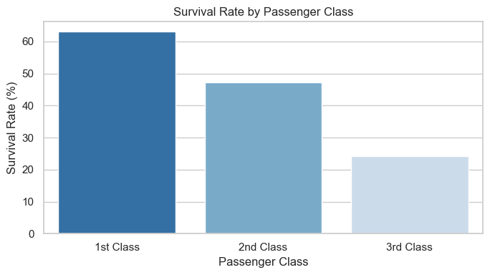
Task 3:Identify all columns with missing values and calculate the percentage of missing data for each column.
Missing Percentage
Cabin 77.104377
Age 19.865320
Embarked 0.224467
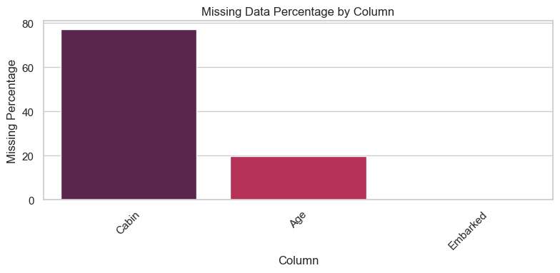
Task 4:Create a count plot showing survival rates by gender. Calculate survival percentages for male and female passengers separately.
Survival Rate (%)
Sex
female 74.203822
male 18.890815
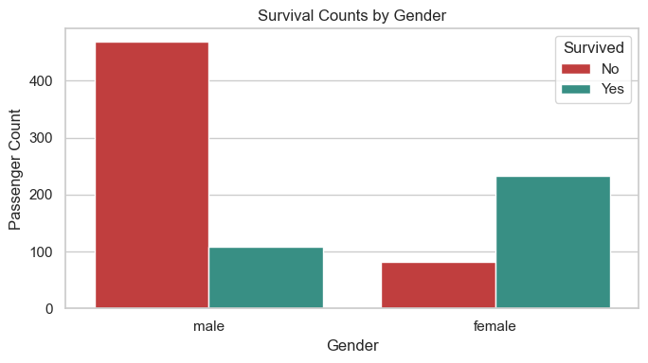
Task 5: Display the unique values in the 'Embarked' column and create a bar chart showing the count of passengers from each port of embarkation.
Unique values in Embarked: ['C', 'Q', 'S']
Passenger Count
Embarked
C 168
Q 77
S 644
NaN 2
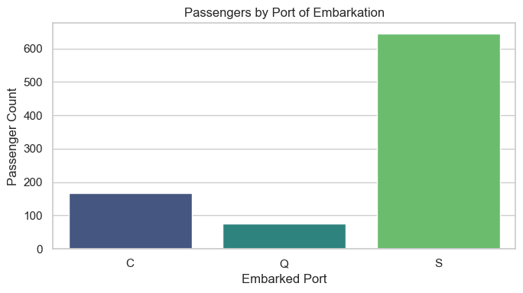

Interpretation
The first-pass exploration usually shows that the dataset is dominated by passenger class, sex, age, fare, and embarkation information. Survival is typically higher in 1st class and among female passengers, while missingness is concentrated in Age, Cabin, and sometimes Embarked.

Task 6: Age Imputation
This section fills missing values in Age using the median age for passengers in the same class and gender group, then compares the age distribution before and after imputation.
age_before_imputation = df["Age"].copy() # made the duplicate data so that the original dataset remian unchanged and consistent
age_group_median = df.groupby(["Pclass", "Sex"])["Age"].transform("median")
df["Age_Imputed"] = df["Age"].fillna(age_group_median)
df["Age_Imputed"] = df["Age_Imputed"].fillna(df["Age"].median())
print(f"Missing Age values before imputation: {age_before_imputation.isna().sum()}")
print(f"Missing Age values after imputation: {df['Age_Imputed'].isna().sum()}")
fig, axes = plt.subplots(1, 2, figsize=(14, 5), sharey=True)
sns.histplot(age_before_imputation.dropna(), bins=25, kde=True, color="#e76f51", ax=axes[0])
axes[0].set_title("Age Distribution Before Imputation")
axes[0].set_xlabel("Age")
sns.histplot(df["Age_Imputed"], bins=25, kde=True, color="#457b9d", ax=axes[1])
axes[1].set_title("Age Distribution After Imputation")
axes[1].set_xlabel("Age")
plt.tight_layout()
plt.show()
sample_imputations = df.loc[df["Age"].isna(), ["Pclass", "Sex", "Age", "Age_Imputed"]].head(10)
display(sample_imputations)
Missing Age values before imputation: 177
Missing Age values after imputation: 0
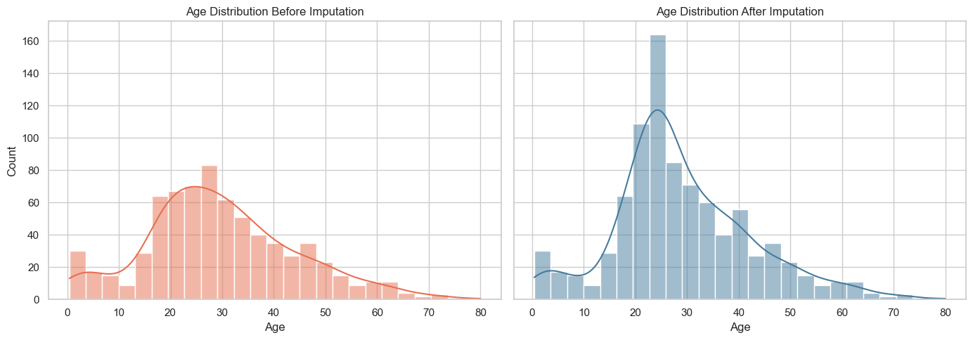
Pclass Sex Age Age_Imputed
5 3 male NaN 25.0
17 2 male NaN 30.0
19 3 female NaN 21.5
26 3 male NaN 25.0
28 3 female NaN 21.5
29 3 male NaN 25.0
31 1 female NaN 35.0
32 3 female NaN 21.5
36 3 male NaN 25.0
42 3 male NaN 25.0

Interpretation
Median imputation within class and gender keeps the replacement values realistic for each passenger group. The before/after histograms should stay broadly similar, but the imputed version will be complete and ready for modeling.

Task 7: Encoding Categorical Features
This section applies label encoding to Sex and one-hot encoding to Embarked, then displays the first 10 transformed rows to verify the result.
encoded_df = df.copy()
sex_encoder = LabelEncoder()
encoded_df["Sex_Encoded"] = sex_encoder.fit_transform(encoded_df["Sex"])
embarked_dummies = pd.get_dummies(encoded_df["Embarked"], prefix="Embarked", dtype=int)
encoded_df = pd.concat([encoded_df, embarked_dummies], axis=1)
encoded_preview_columns = ["Sex", "Sex_Encoded", "Embarked"] + embarked_dummies.columns.tolist()
display(encoded_df[encoded_preview_columns].head(10))
Sex Sex_Encoded Embarked Embarked_C Embarked_Q Embarked_S
0 male 1 S 0 0 1
1 female 0 C 1 0 0
2 female 0 S 0 0 1
3 female 0 S 0 0 1
4 male 1 S 0 0 1
5 male 1 Q 0 1 0
6 male 1 S 0 0 1
7 male 1 S 0 0 1
8 female 0 S 0 0 1
9 female 0 C 1 0 0

Interpretation
Sex is now represented numerically and Embarked has been expanded into separate binary columns. This makes the dataset easier to use in machine-learning models without losing the original category information.

Task 8: Title Extraction from Passenger Names
This section extracts honorific titles from the Name column, groups rare titles into Other, and compares survival rates across the resulting title groups.
title_df = df.copy()
title_df["Title"] = (
title_df["Name"]
.str.extract(r",\s*([^\.]+)\.", expand=False)
.str.strip()
)
normalized_title_map = {
"Mlle": "Miss",
"Ms": "Miss",
"Mme": "Mrs",
}
title_df["Title"] = title_df["Title"].replace(normalized_title_map)
rare_title_threshold = 10
title_counts = title_df["Title"].value_counts()
rare_titles = title_counts[title_counts < rare_title_threshold].index
title_df["Title_Grouped"] = title_df["Title"].where(~title_df["Title"].isin(rare_titles), "Other")
title_survival_rate = title_df.groupby("Title_Grouped")["Survived"].mean().mul(100).sort_values(ascending=False)
display(title_df[["Name", "Title", "Title_Grouped"]].head(10))
display(title_survival_rate.to_frame(name="Survival Rate (%)"))
fig, ax = plt.subplots(figsize=(10, 5))
sns.barplot(x=title_survival_rate.index, y=title_survival_rate.values, palette="magma", ax=ax)
ax.set_title("Survival Rate by Title Group")
ax.set_xlabel("Title Group")
ax.set_ylabel("Survival Rate (%)")
ax.tick_params(axis="x", rotation=30)
plt.tight_layout()
plt.show()
Name Title Title_Grouped
0 Braund, Mr. Owen Harris Mr Mr
1 Cumings, Mrs. John Bradley (Florence Briggs Th... Mrs Mrs
2 Heikkinen, Miss. Laina Miss Miss
3 Futrelle, Mrs. Jacques Heath (Lily May Peel) Mrs Mrs
4 Allen, Mr. William Henry Mr Mr
5 Moran, Mr. James Mr Mr
6 McCarthy, Mr. Timothy J Mr Mr
7 Palsson, Master. Gosta Leonard Master Master
8 Johnson, Mrs. Oscar W (Elisabeth Vilhelmina Berg) Mrs Mrs
9 Nasser, Mrs. Nicholas (Adele Achem) Mrs Mrs
Survival Rate (%)
Title_Grouped
Mrs 79.365079
Miss 70.270270
Master 57.500000
Other 34.782609
Mr 15.667311
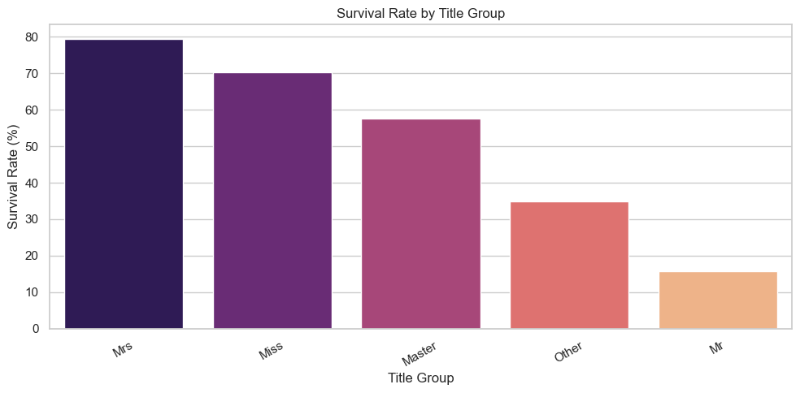

Interpretation
The title feature captures social role and family status, which often correlates strongly with survival. Grouping rare titles into Other reduces noise while still preserving the signal from unusual honorifics.

Task 9: Feature Engineering and Chi-square Testing
This section creates FamilySize, IsAlone, age bands, and Fare_per_person, then evaluates the categorical versions of those features with a chi-square test against survival.
feature_df = df.copy()
feature_df["FamilySize"] = feature_df["SibSp"] + feature_df["Parch"] + 1
feature_df["IsAlone"] = (feature_df["FamilySize"] == 1).astype(int)
feature_df["Fare_per_person"] = feature_df["Fare"] / feature_df["FamilySize"]
def age_to_group(age_value: float) -> str:
if pd.isna(age_value):
return "Missing"
if age_value < 18:
return "Child"
if age_value <= 35:
return "Young Adult"
if age_value <= 60:
return "Middle Age"
return "Senior"
feature_df["AgeGroup"] = feature_df["Age"].apply(age_to_group)
# Chi-square requires categorical data, so the numeric features are binned before testing.
feature_df["FamilySize_Bin"] = pd.cut(
feature_df["FamilySize"],
bins=[0, 1, 4, 7, np.inf],
labels=["1", "2-4", "5-7", "8+"],
include_lowest=True,
)
feature_df["FarePerPerson_Bin"] = pd.qcut(
feature_df["Fare_per_person"].fillna(feature_df["Fare_per_person"].median()),
q=4,
duplicates="drop",
)
chi_square_rows = []
for column_name in ["FamilySize_Bin", "IsAlone", "AgeGroup", "FarePerPerson_Bin"]:
categorical_series = feature_df[column_name].astype("object").where(feature_df[column_name].notna(), "Missing")
contingency_table = pd.crosstab(categorical_series, feature_df["Survived"])
chi2_value, p_value, degrees_of_freedom, _ = chi2_contingency(contingency_table)
chi_square_rows.append(
{
"Feature": column_name,
"Chi2 Statistic": chi2_value,
"p-value": p_value,
"Degrees of Freedom": degrees_of_freedom,
}
)
chi_square_results = pd.DataFrame(chi_square_rows).sort_values("Chi2 Statistic", ascending=False)
display(feature_df[["FamilySize", "IsAlone", "AgeGroup", "Fare_per_person"]].head(10))
display(chi_square_results)
fig, ax = plt.subplots(figsize=(9, 4))
sns.barplot(data=chi_square_results, x="Feature", y="Chi2 Statistic", palette="crest", ax=ax)
ax.set_title("Chi-square Importance of Engineered Features")
ax.set_xlabel("Engineered Feature")
ax.set_ylabel("Chi-square Statistic")
ax.tick_params(axis="x", rotation=25)
plt.tight_layout()
plt.show()
FamilySize IsAlone AgeGroup Fare_per_person
0 2 0 Young Adult 3.62500
1 2 0 Middle Age 35.64165
2 1 1 Young Adult 7.92500
3 2 0 Young Adult 26.55000
4 1 1 Young Adult 8.05000
5 1 1 Missing 8.45830
6 1 1 Middle Age 51.86250
7 5 0 Child 4.21500
8 3 0 Young Adult 3.71110
9 2 0 Child 15.03540
Feature Chi2 Statistic p-value Degrees of Freedom
3 FarePerPerson_Bin 76.700417 1.565347e-16 3
0 FamilySize_Bin 76.346557 1.864109e-16 3
1 IsAlone 36.000514 1.972654e-09 1
2 AgeGroup 20.211255 4.536541e-04 4
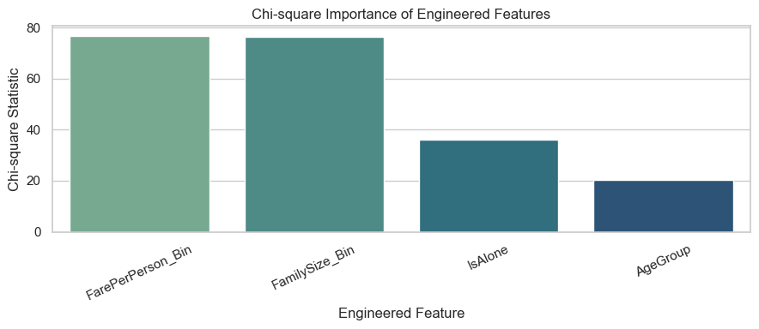

Interpretation
Sex, family structure, age band, and fare-per-person are all plausible survival drivers, but the chi-square ranking shows which engineered features have the strongest observed association with survival in this dataset.

Task 10: Complete Preprocessing Pipeline
This final section combines KNN imputation for Age, mode filling for Embarked, dropping Cabin, target encoding for Embarked, robust scaling for Fare, and mutual-information feature selection.
pipeline_df = df.copy()
# Feature engineering that will be used for the model-ready table.
pipeline_df["FamilySize"] = pipeline_df["SibSp"] + pipeline_df["Parch"] + 1
pipeline_df["IsAlone"] = (pipeline_df["FamilySize"] == 1).astype(int)
pipeline_df["Fare_per_person"] = pipeline_df["Fare"] / pipeline_df["FamilySize"]
pipeline_df["AgeGroup"] = pipeline_df["Age"].apply(age_to_group)
pipeline_df["AgeGroupCode"] = pipeline_df["AgeGroup"].map(
{"Missing": -1, "Child": 0, "Young Adult": 1, "Middle Age": 2, "Senior": 3}
).astype(int)
# 3. Drop Cabin because it is too sparse for a stable modeling feature.
pipeline_df = pipeline_df.drop(columns=["Cabin"])
# 1. KNN imputation for Age using nearby passenger features.
knn_input_columns = ["Age", "Pclass", "SibSp", "Parch", "Fare"]
knn_imputer = KNNImputer(n_neighbors=5)
knn_imputed = knn_imputer.fit_transform(pipeline_df[knn_input_columns])
pipeline_df["Age_KNN_Imputed"] = knn_imputed[:, 0]
# 2. Fill missing Embarked values with the mode.
embarked_mode = pipeline_df["Embarked"].mode(dropna=True)[0]
pipeline_df["Embarked_Filled"] = pipeline_df["Embarked"].fillna(embarked_mode)
# 4. Target encoding for Embarked based on survival rate.
embarked_target_map = pipeline_df.groupby("Embarked_Filled")["Survived"].mean()
pipeline_df["Embarked_TargetEncoded"] = pipeline_df["Embarked_Filled"].map(embarked_target_map)
pipeline_df["Embarked_TargetEncoded"] = pipeline_df["Embarked_TargetEncoded"].fillna(pipeline_df["Survived"].mean())
# 5. Robust scaling for Fare.
fare_scaler = RobustScaler()
pipeline_df["Fare_RobustScaled"] = fare_scaler.fit_transform(pipeline_df[["Fare"]]).ravel()
# Sex must also be numeric for mutual-information scoring.
sex_encoder_pipeline = LabelEncoder()
pipeline_df["Sex_Encoded"] = sex_encoder_pipeline.fit_transform(pipeline_df["Sex"])
model_features = pipeline_df[
[
"Pclass",
"Sex_Encoded",
"Age_KNN_Imputed",
"SibSp",
"Parch",
"Fare_RobustScaled",
"Embarked_TargetEncoded",
"FamilySize",
"IsAlone",
"AgeGroupCode",
"Fare_per_person",
]
].copy()
model_target = pipeline_df["Survived"]
selector = SelectKBest(score_func=mutual_info_classif, k=5)
selector.fit(model_features.fillna(model_features.median(numeric_only=True)), model_target)
mi_scores = pd.Series(selector.scores_, index=model_features.columns).sort_values(ascending=False)
selected_feature_names = model_features.columns[selector.get_support()].tolist()
manual_feature_selection = ["Sex_Encoded", "Pclass", "Age_KNN_Imputed", "Fare_RobustScaled", "Embarked_TargetEncoded"]
comparison_table = pd.DataFrame(
{
"Mutual_Info_Top5": selected_feature_names,
"Manual_Domain_Picks": manual_feature_selection,
}
)
display(mi_scores.to_frame(name="Mutual Information Score"))
print("Top 5 features selected by mutual information:")
print(selected_feature_names)
print("\nManual feature shortlist based on domain knowledge:")
print(manual_feature_selection)
print("\nOverlap between the two approaches:")
print(sorted(set(selected_feature_names).intersection(manual_feature_selection)))
display(comparison_table)
Mutual Information Score
Sex_Encoded 0.145135
Fare_RobustScaled 0.143636
Fare_per_person 0.133510
Pclass 0.048637
FamilySize 0.034360
Parch 0.020766
Age_KNN_Imputed 0.020257
Embarked_TargetEncoded 0.014097
AgeGroupCode 0.008289
SibSp 0.006264
IsAlone 0.003033
Top 5 features selected by mutual information:
['Pclass', 'Sex_Encoded', 'Fare_RobustScaled', 'FamilySize', 'Fare_per_person']
Manual feature shortlist based on domain knowledge:
['Sex_Encoded', 'Pclass', 'Age_KNN_Imputed', 'Fare_RobustScaled', 'Embarked_TargetEncoded']
Overlap between the two approaches:
['Fare_RobustScaled', 'Pclass', 'Sex_Encoded']
Mutual_Info_Top5 Manual_Domain_Picks
0 Pclass Sex_Encoded
1 Sex_Encoded Pclass
2 Fare_RobustScaled Age_KNN_Imputed
3 FamilySize Fare_RobustScaled
4 Fare_per_person Embarked_TargetEncoded
# this is the dataframe after normalization and feature engineering
original_df.head(15)
PassengerId Survived Pclass \
0 1 0 3
1 2 1 1
2 3 1 3
3 4 1 1
4 5 0 3
5 6 0 3
6 7 0 1
7 8 0 3
8 9 1 3
9 10 1 2
10 11 1 3
11 12 1 1
12 13 0 3
13 14 0 3
14 15 0 3
Name Sex Age SibSp \
0 Braund, Mr. Owen Harris male 22.0 1
1 Cumings, Mrs. John Bradley (Florence Briggs Th... female 38.0 1
2 Heikkinen, Miss. Laina female 26.0 0
3 Futrelle, Mrs. Jacques Heath (Lily May Peel) female 35.0 1
4 Allen, Mr. William Henry male 35.0 0
5 Moran, Mr. James male NaN 0
6 McCarthy, Mr. Timothy J male 54.0 0
7 Palsson, Master. Gosta Leonard male 2.0 3
8 Johnson, Mrs. Oscar W (Elisabeth Vilhelmina Berg) female 27.0 0
9 Nasser, Mrs. Nicholas (Adele Achem) female 14.0 1
10 Sandstrom, Miss. Marguerite Rut female 4.0 1
11 Bonnell, Miss. Elizabeth female 58.0 0
12 Saundercock, Mr. William Henry male 20.0 0
13 Andersson, Mr. Anders Johan male 39.0 1
14 Vestrom, Miss. Hulda Amanda Adolfina female 14.0 0
Parch Ticket Fare Cabin Embarked
0 0 A/5 21171 7.2500 NaN S
1 0 PC 17599 71.2833 C85 C
2 0 STON/O2. 3101282 7.9250 NaN S
3 0 113803 53.1000 C123 S
4 0 373450 8.0500 NaN S
5 0 330877 8.4583 NaN Q
6 0 17463 51.8625 E46 S
7 1 349909 21.0750 NaN S
8 2 347742 11.1333 NaN S
9 0 237736 30.0708 NaN C
10 1 PP 9549 16.7000 G6 S
11 0 113783 26.5500 C103 S
12 0 A/5. 2151 8.0500 NaN S
13 5 347082 31.2750 NaN S
14 0 350406 7.8542 NaN S

Interpretation
The preprocessing pipeline produces a clean, numeric feature table that is ready for modeling. Mutual information usually highlights the same core Titanic signals seen in the exploratory work: sex, passenger class, fare, family structure, and embarkation behavior.

