FinTrust: Trustworthy Small Language Models for Financial Tasks

Abstract
Small language models can reduce the cost of financial analysis, but accuracy alone does not reveal whether a numerical answer should be trusted. We present EVG-CAS, an execution-verified generation and agreement-calibrated abstention procedure, evaluated on a frozen QLoRA-adapted 1.7B financial model. The model samples eight candidate programs, executes valid candidates with the official FinQA evaluator, and uses agreement among the executed answers as a selective-risk feature. All model and threshold choices are frozen on validation data before protected evaluation. On the protected FinQA test, EVG-CAS does not improve accuracy: execution-verified selection obtains 65.56%, compared with 65.74% for greedy decoding (McNemar exact $p=0.871$). It does, however, provide a strong ranking signal for abstention: agreement-bin accuracy increases from 2.9% to 79.2%, while the model’s token log-probability has ROC-AUC 0.58. Out-of-fold Platt calibration reduces FinQA Brier score from 0.2845 to 0.1579 and ECE from 0.2555 to 0.0475. With the threshold selected for 80% validation coverage, the frozen policy transfers to the protected test with 76.25% accuracy and 31.0% fewer answered errors than full-coverage decoding. FiQA shows negligible abstention benefit, while a zero-shot FinBen-FOMC probe improves macro-F1 from 0.21 to 0.30. These results position EVG-CAS as a selective prediction method for small financial models, not as a general accuracy improvement.
Keywords: small language models, financial reasoning, selective prediction, calibration, execution-verified generation, abstention, FinQA, FiQA, FOMC.

Introduction
Autoregressive language models are now small enough to run on a laptop and strong enough to reason over financial documents . The remaining obstacle to deploying a 1.7B model in finance is not raw accuracy, it is trust: a financial system that silently gives a wrong number to a user is unusable even if it is right 65% of the time. Benchmarks have begun to measure this deficit — FinTrust lists “appropriately abstain when confidence is low” as a first-class trustfulness dimension — but they diagnose it on GPT-4-scale models and provide no mechanism a small model can actually use.
This paper provides the mechanism, and reports the outcome honestly. We study a task class where execution is a well-defined ground-truth operation: programmatic numerical reasoning . The model writes a program; the answer is what the program computes. That property lets us sample $n$ candidate programs per question, keep only those that run on the official evaluator, and observe how much the surviving answers agree. Prior work uses such sampling to vote (self-consistency ) or to train outcome/process reward models , framing the payoff as accuracy. We find, on protected data, that framing is wrong for our model: execution-verified selection does not beat the greedy baseline (Table IV). We therefore spend the sampling budget where it pays: agreement is a trust feature, and a calibrated, pre-registered abstention policy built on it cuts protected-test answered-error by 31% at 80% coverage (Table VII).
Our contributions. (C1) An honest, pre-registered accuracy verdict: EVG does not improve FinQA/FiQA accuracy for a QLoRA-tuned 1.7B model; it ties it. (C2) A calibration construction that gives the model probability-meaningful confidence, cutting Brier 0.28$→$0.16 and ECE 0.26$→$0.05. (C3) A selective-prediction policy whose threshold is fixed on validation and whose benefit transfers to a protected test ($−$31.0% test answered-error reduction at coverage 0.8, predicted $−$34.2%).

Related work

Small financial models and adaptation.
Survey evidence shows 1–3B models are a deliberate performance/efficiency point , and LoRA/QLoRA make domain adaptation cheap . Financial-domain adaptation builds on this for QA and sentiment . The closest comparable work, fine-tuning smaller models on FinQA , also operates in our compute regime and reports accuracy only — as we do, but we add the trust layer it omits.

Programmatic financial reasoning.
FinQA , ConvFinQA and TAT-QA establish that execution (running the program) is the ground truth of the answer. FinBen supplies the benchmarking context including the FiQA and FOMC tasks we use; FinTrust establishes abstention as a measured trust deficit.

Consistency and verification.
Self-consistency votes over sampled paths ; process-supervised verifiers rerank candidates with a learned model ; execution-guided synthesis filters decoding by the runtime . All are accuracy-centric. Ours re-purposes their machinery as a decision signal.

Selective prediction and calibration.
The risk-coverage framework defines abstention evaluation; Platt/isotonic/temperature calibration and verbalised uncertainty provide LLM confidence. Responsible-AI guidance in finance is the regulatory motivation.

Positioning against 2024–2026 selective-abstention work.
The field now targets trust for budget models through several adjacent mechanisms: two-pass prompt perturbation with answer-consistency abstention for 2–8B models on MCQ ; confidence-weighted majority voting, whose authors also observe that the most-calibrated confidence is the least useful for selection ; distribution-free conformal selective prediction with coverage guarantees ; self-evaluative adaptation for selective prediction ; and, in finance, a multi-agent program-execution cascade without any per-record calibrated abstention ; verifiable chain-of-thought for finance is benchmarked without a model-side abstention rule . None combines the mechanism we measure: agreement across evaluator-executed candidate programs, Platt-calibrated to a coverage target, threshold frozen on validation, and transferred to a protected test for a 1.7B financial SLM. The closest (CISC, Second Guess) share the small-model and selection-over-generation views but do not give their score a probability-meaningful, pre-declared decision rule. A dated novelty audit with sources is in docs/novelty_check.md.

Problem statement and protocol

Setup.
A question $q$ maps to a program $p$; the answer is $a=\text{exec}(p)$ if $p$ is valid. The model is a frozen, domain-adapted SLM $π_{θ}$. We pre-declare three claims (fixated in PLAN.md before any protected-test access):
- C1 (accuracy): execution-verified selection improves the answer’s execution-ground-truth accuracy over greedy decoding.
- C2 (probability quality): calibrating trust features lowers Brier score and ECE and makes a coverage threshold carry probability meaning.
- C3 (ranking): trust features from the sample population (agreement, executability) improve the calibrator’s ordering, measurable as a drop in expected AURC, whenever the features are non-monotone with the raw confidence.

Guardrails (integrity before novelty).
All selection of the model, the method and the hyper-parameters ($n=8$, temperature 0.7, top-$p$ 0.9, 5-fold out-of-fold calibration, coverage targets {0.80, 0.90}) happened on validation data only. The protected test sets were opened exactly once, after a freeze manifest registered status FROZEN and the run set an explicit protected flag; a SHA-256 of the freeze was recorded before and after the test run and is unchanged. The full integrity protocol is documented in §6 of docs/exp_4(a).md.

Phase-2.1 gate architecture and methodology
Phase 2.1 is the data and evaluation gate that precedes model training. It supersedes the original Phase-2 contract by adding FiQA sentiment regression, official FinQA executor validation, mandatory near-duplicate auditing, and explicit Phase-3/4 handoff manifests. The gate is intentionally a provenance layer, not a performance benchmark: its outputs are frozen records, integrity reports, and evaluation rules that downstream experiments must consume without re-downloading or reshaping protected data.
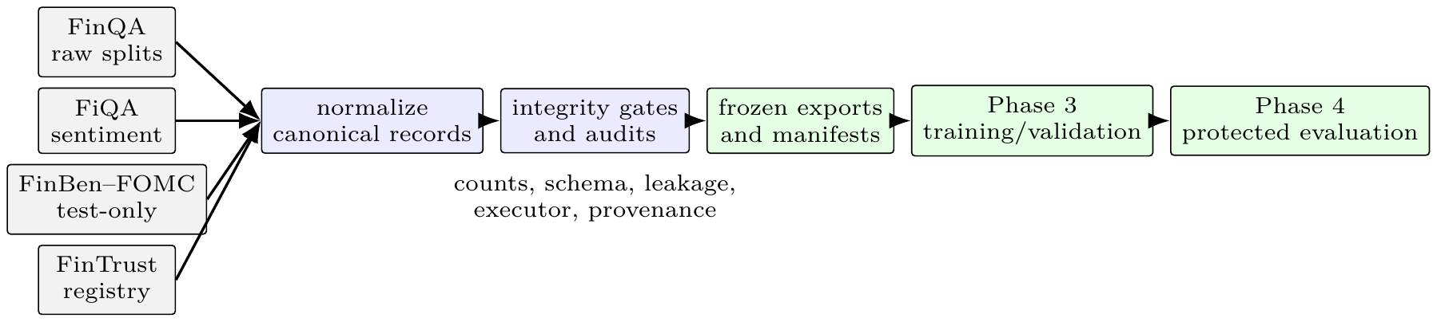
Phase-2.1 architecture. Raw benchmark sources are normalized into a shared record contract, passed through integrity gates, and exported into explicit training, validation, and protected-evaluation roles. FinBen–FOMC and FinTrust never enter the training pool.

Data contract and gate procedure
The pipeline uses deterministic JSON serialization, a fixed seed of 42, and SHA-256 fingerprints for raw sources and exported artifacts. Gold evidence is retained as annotation metadata but is excluded from model inputs. For FinQA, the official evaluator is run over every gold program in every split and its result is compared with the official executable answer. Leakage signatures hash normalized question, context, and table content; exact cross-split collisions are hard failures. A MinHash-based near-duplicate audit compares training records with protected tests and flags candidates for inspection rather than silently deleting legitimate financial-report reuse.
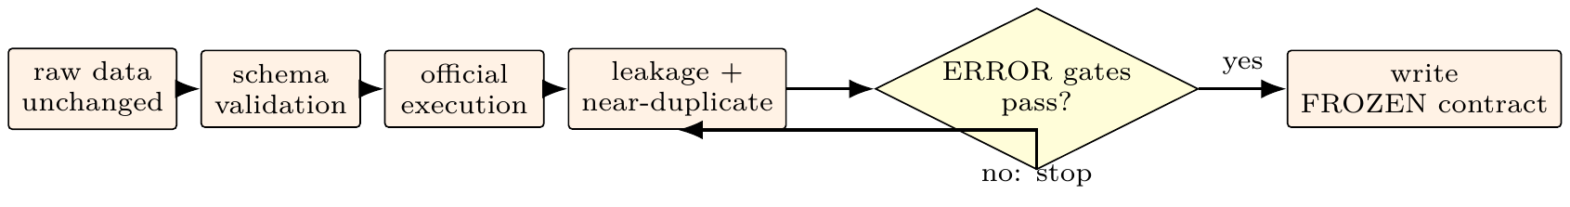
Phase-2.1 gate lifecycle. Warnings remain visible in the validation report but do not override a PASS when no ERROR-severity gate fails.
The Phase-2.1 validation report is a PASS with two explicit warnings: final-step annotation agreement is 0.98261 (below the 0.99 warning threshold), and evaluator candidates were not discovered for FinTrust dimensions trustfulness, safety, and privacy. These warnings do not invalidate the FinQA/FiQA data contract, but the FinTrust gap remains a Phase-4 limitation. The exported training pool contains 7,073 records (FinQA and FiQA only), while the validation pool contains 1,000 records. The protected artifacts contain 1,147 FinQA test records, 234 FiQA test records, 496 FinBen–FOMC records, and the FinTrust registry.

Phase-2.1 artifact and figure inventory
Phase 2.1 produces integrity evidence rather than accuracy curves. The source paths and hashes for the data registry, validation report, source fingerprints, official-execution audit, near-duplicate audit, and downstream configuration manifests are listed in docs/phase2_figure_inventory.md. The result plots used later in this paper are therefore labeled as Phase-3 or Phase-4 plots, not Phase-2 plots: the former show model baselines, and the latter show sampling, risk–coverage, and selection ablations.

Method: EVG-CAS

Sampling and execution verification
Given $q$, sample $n$ programs $p^{(1)},…,p^{(n)}∼π_{θ}(⋅∣q)$ (temperature 0.7, top-$p$ 0.9, no other search). Each $p^{(i)}$ is run with the official evaluator if it parses; an answer $a^{(i)}$ exists iff the program is valid and executes. Evidence is carried by the candidate population, not by any single decode.

Trust features from the sample population
For a question $q$ with $n$ candidates we compute three pre-registered features:
A(q)&=1n(n−1)i≠j​1[a(i)=a(j)],R(q)&=1ni=1ne(i),e(i)&=1[p(i) valid ∧ a(i) exists],C(q)&=logπθ(p(⋆)∣q).
where $p^{(⋆)}$ is the selected candidate and the mean is over its tokens. The feature vector is $f(q)=[A(q), R(q), C(q)]$. The gold answer is used only to score these features, never to select a candidate or a threshold (guardrail: nothing refit on test).

Calibration (C2)
The score $\hat{p}(q)=Pr[\text{answer is correct}∣f(q)]$ is learned by out-of-fold Platt scaling:
$$\hat{p}(q) = σ​\left(w⋅f(q)+b\right), σ(z)=\frac{1}{1+e^{−z}},$$
with $(w,b)$ fit by logistic regression on inner-fold predictions and applied to outer folds (5 folds), so every validation prediction is genuinely out-of-sample. Because a single-feature monotone calibrator cannot reorder answers, we evaluate (i) a single-feature baseline ($f=[C]$) and (ii) the full feature vector $f$ (C3).

Freeze and abstention rule (C2)
For coverage target $1−α$ (pre-registered $α∈\{0.20,0.10\}$):
θ&=min{t:Cval(t)≥1−α},C(t)&=1|V|q∈V​1[p(q)≥t].
and the decision rule on any future question is answer $q$ iff $\hat{p}(q)≥θ$, else abstain. Selective risk and coverage follow :
R(θ)&=q​ℓ(q) 1[p(q)≥θ]q​1[p(q)≥θ],ℓ(q)&=1[answer(q)≠gold(q)].
frozen adapter $π_{θ}$, sampler params $(n,τ,p)$, evaluator $\text{exec}$, coverage targets Validation phase: sample $n$ programs; keep valid ones; get answers $a^{(i)}$ compute $f(q)=[A(q), R(q), C(q)]$ fit out-of-fold Platt $w,b$ on $(f(q), ℓ(q))_{q∈V}$; score $\hat{p}(q)$ OOF pick $θ$ s.t. $C_{\text{val}}(θ)≥1−α$ for each target write phase4_freeze.json (FROZEN, $w,b,θ,α$, sha256) Protected phase (opened once, after FROZEN + protected flag): draw $n$ candidates; if $\hat{p}(q)≥θ$ emit answer$(q)$, else abstain

Experimental setup

Data and aligned evaluation.
FinQA (train 6 251 / validation 883 / held-out test 1 147) uses the official program evaluator; we report three aligned accuracies: printed (the answer string the model emits), program (does the parse succeed), and execution (does the executed answer match gold). FiQA (validation 117 / test 234) is regression with MAE, $R^{2}$, Pearson $r$ at tolerance 0.10. FOMC (test 496: neutral 245, dovish 129, hawkish 122) is zero-shot stance classification with accuracy, macro-F1 and parse success. The datasets do not provide reliable participant demographics such as age or gender; therefore this study reports no inferred demographic distribution. The records are treated as financial-document and sentiment annotations, not as a human-subject sample. This distinction prevents demographic claims from being inferred from names, writing style, or model outputs.

Data contract and split policy.
The Phase-2.1 contract fixes the dataset roles before training. FinQA and FiQA training partitions may enter the training pool; validation partitions support model selection; and the FinQA and FiQA tests, FinBen-FOMC, and FinTrust resources remain protected. Source fingerprints are recorded with SHA-256 manifests, canonical serialization is used for structured records, and exact-overlap audits compare normalized input signatures rather than relying only on record identifiers. Near-duplicate candidates are flagged for manual inspection rather than silently removed, since financial reports can legitimately reuse standard language. These controls establish provenance and split isolation, not semantic correctness of every annotation.

Model.
Frozen Phase-3 winner: Qwen/Qwen3-1.7B with balanced-joint QLoRA as canonical on FinQA and explicit-schema on FiQA; exact hyper-parameters are in phase3_freeze.json and were fixed before this work began.

Metrics.
Brier, ECE-10, expected AURC (e-AURC; lower is better), coverage and selective risk. All numbers cited as “validation” are out-of-fold or tuned on validation; all “test” numbers were produced by the frozen system and are unchanged since the completed protected run (see docs/exp_4(b).md).
C1 evidence. (top) FinQA held-out test, execution accuracy per rule ($n=8$); (bottom) FiQA test regression. EVG neither beats nor loses to the frozen greedy baseline on either task; per-record, 18 questions are won and 20 lost.
FinQA test, execution accuracy ($n=1147$)
frozen greedy (baseline) | 0.6574
candidate-0 (prints) | 0.6399
self-consistency vote | 0.6478
best-of-$n$ | 0.6556
execution-verified (ours) | 0.6556
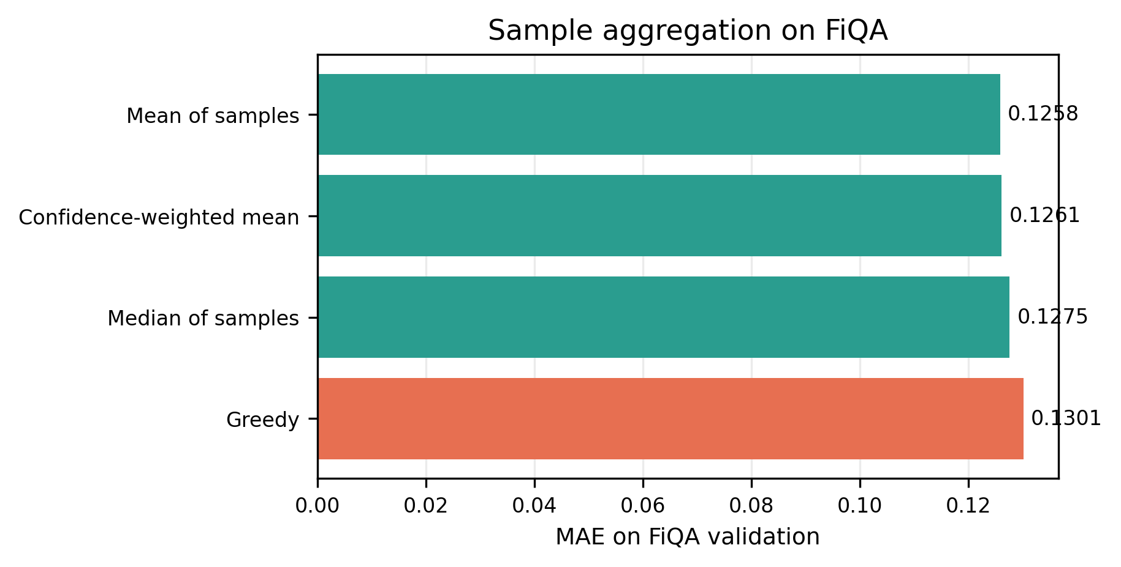
FiQA validation aggregation over sampled predictions. Lower MAE is better; median and mean aggregation improve on greedy decoding in this validation diagnostic, while the frozen protected-test policy remains the pre-registered greedy baseline.
Agreement bins vs. correctness on the protected test. Agreement is steeply and monotonically predictive, while the model’s log-probability cannot separate correct from incorrect answers (ROC-AUC 0.58).
EVG agreement bin | $n$ records | execution accuracy
(0.00, 0.25] | 35 | 0.029
(0.25, 0.50] | 122 | 0.238
(0.50, 0.75] | 181 | 0.448
(0.75, 1.00] | 809 | 0.792
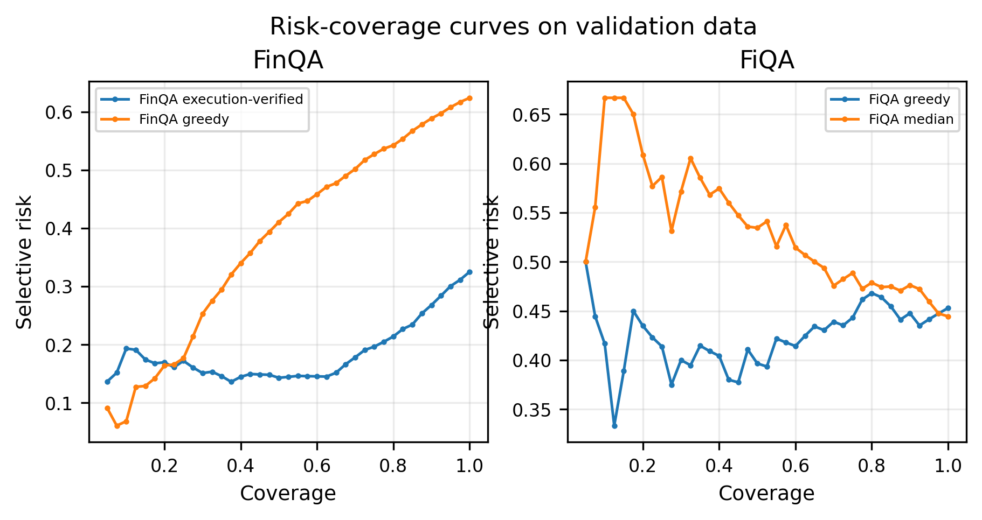
Out-of-fold risk–coverage curves for FinQA and FiQA validation. The calibrated FinQA execution-verified policy lowers selective risk as coverage is reduced; FiQA shows weaker separation, consistent with its small regression validation split.
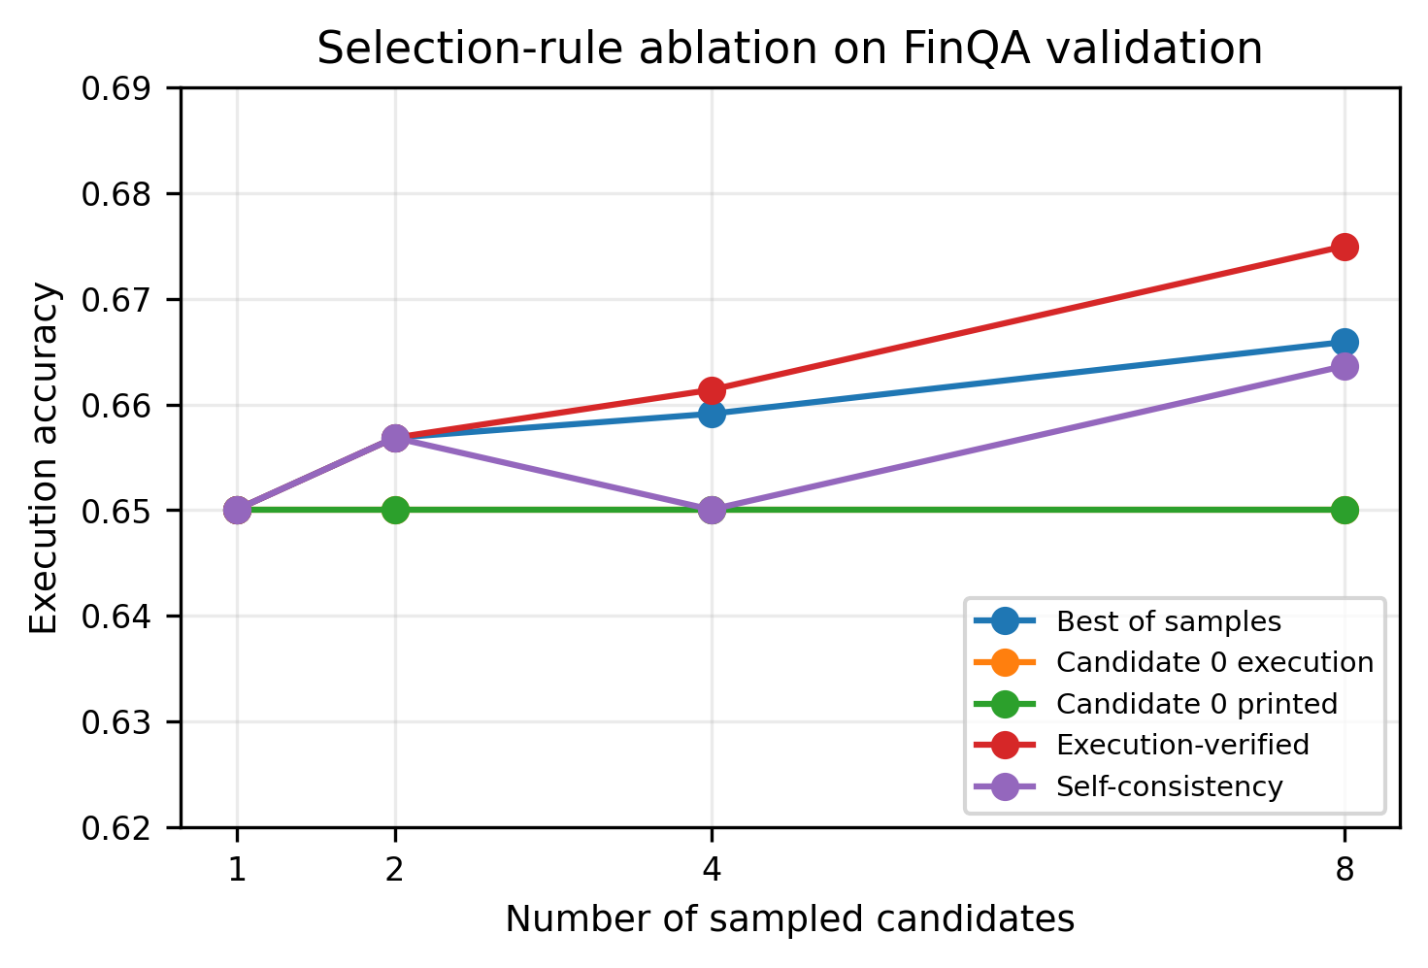
FinQA validation ablation over the number of sampled candidates. The horizontal lines show the frozen greedy answer and executor baselines; execution-verified selection does not produce a protected-test accuracy gain, motivating its use as a selective-risk signal rather than as an accuracy claim.
Evaluation rigor on the protected test (n=1,147). (top) Paired comparison: the C1 tie is statistically verified, not read off rounded means. (middle) Error taxonomy: the only channel EVG fails to fix is the printed answer string. (bottom) Reasoning-depth stratification: abstention concentrates on the deepest programs and delivers its largest relative gain there. Bootstrap CI: 10,000 resamples; McNemar exact (binomial).
C1 significance (protected test, paired)
 | greedy | exec-verified
execution acc. | 0.6574 | 0.6556
delta | $−0.0017$ % CI $[−0.0122, +0.0087]$
McNemar exact $p$ | 0.871

Results

C1 is rejected — and that is a result.
Table IV and Figure 3. On the protected test, execution-verified selection is 0.6556 vs. frozen greedy 0.6574 ($−$0.18 pp; per-record 18 gained, 20 lost, exact McNemar $p=0.871$, bootstrap 95% CI $[−0.0122,+0.0087]$), and the FiQA median-based aggregator is 0.0005 worse in MAE. Validation showed the same story (tie: 0.6750 vs. 0.6750). The one clean C1 win is program hygiene: the invalid-program rate in the emitted answers drops from $3.5×{10}^{−3}$ to exactly 0. Every answer we keep is backed by a program the official evaluator accepted. On FiQA the median-of-8 aggregator also betters neither MAE nor coverage; at matched coverage its ranking is nevertheless the best of the tested scores (selective MAE 0.1094 vs. 0.1176 for greedy-confidence at 80% coverage, n=234) — a descriptive, small-sample hint that agreement transfers as a ranking signal to regression too (see § matched coverage, below).

Agreement is the trust signal (C3 evidence at the decision level).
Table V. On protected data the model reports total disagreement (agreement $≤0.25$) on records that are 2.9% correct and unanimous agreement (the top bin, $0.75$–$1.0$) on records that are 79.2% correct; nothing in the model’s own log-probability separates these regimes (ROC-AUC 0.58 vs. 0.76 for agreement). This is the signal that buys abstention.

Calibration gives the threshold meaning (C2).
Table VI. Out-of-fold Platt on the agreement features cuts Brier 0.28 $→$ 0.16 and ECE 0.26 $→$ 0.05. The ranking result is exactly what the monotonicity caveat predicts: the single-feature calibrators cannot move e-AURC (0.2029 $→$ 0.2028), while the agreement-driven vector drops it to 0.1232 ($−$39.3% vs. raw, $−$35.1% vs. the best baseline frame).

The frozen policy transfers (C2’s operational payoff).
Table VII and Figure 4. With the threshold fixed on validation, opening the protected test once yields: coverage 0.786 at the 0.80 target, selective risk 0.2375 (accuracy 0.7625) vs. 0.3444 at full coverage — a 31.0% relative error reduction, against the 34.2% predicted from validation; bootstrap 95% CI on the reduction is $[22.8\%, 39.3\%]$ (i.e. the transfer is significant, not a rounding effect). FiQA abstention is -2.9%: as the frozen FiQA method (raw confidence on greedy) predicted, its errors are not rankable.

Rigor, error taxonomy, and depth (Table VIII).
The protected test was opened once against the frozen manifest. Per-record significance testing formalises the C1 verdict; the remaining error is not parsing (0/1,147) and – for EVG – not program validity (0/1,147), but 395 genuine arithmetic slips (34.4%). The taxonomy uses mutually exclusive cells that sum to $n$: for greedy, 3 invalid programs, 388 execute-and-print-wrong, 355 format mismatches (the executed value is correct but the printed string differs), and 2 cases where the printed string matches gold while the executed value differs. Execution accuracy ($0.6574$) and printed-answer accuracy ($0.3496$) therefore differ solely by the 355-record format channel; EVG’s exec_verified rule removes that channel by construction. Stratifying by the FinQA program-depth proxy, the frozen policy abstains least on 0-op lookups (4.4%) and most on 3–6-op programs (31.3%), where it cuts error by 41.7%: abstention cost is spent precisely where reasoning is deepest. All numbers carry bootstrap CIs in the annexed rigor report; the calibration threshold used here was frozen on validation and never touched after the test opened.

The mechanism survives comparison at matched coverage (Table X).
Figure 5 shows the corresponding validation ablation. Review pressure asks how agreement-abstention compares with standard alternatives when they answer the same number of questions. Table X selects $k=⌊cov⋅1147⌋$ records by each score and measures selective risk on the execution channel. Confidence-only abstention of the greedy baseline buys almost nothing ($≤$8% error reduction; ROC-AUC 0.578) and best-of-n selection slightly hurts; ranking by agreement alone cuts error 29.7% vs. greedy-full and $−$23% vs. a confidence-abstainer at the same coverage. A paired bootstrap (B=3,000) on the risk difference at coverage 0.80 gives $[−0.093, −0.055]$ with $P=1.0$ against the confidence baseline. The leaving-one-out ablation is sharp: agreement is necessary and sufficient; the executability feature is uninformative (AUC 0.51) and the frozen Platt vector adds no ranking over agreement ($P=0.097$), though it supplies the pre-registered threshold its probability meaning.

Out-of-domain robustness.
Table IX. Without any FOMC data in training, the frozen adapter raises macro-F1 0.21 $→$ 0.30 and parse success 0.90 $→$ 0.99, with the gain in the rare classes (dovish F1 0.16 $→$ 0.33; hawkish 0.05 $→$ 0.26).

Cost.
EVG at $n=8$ runs at 4.8 s/question vs. 1.3 s greedy (3.7$×$, shared prefill), peak VRAM 3.1 GB / 6 GB. The offered trade is therefore 31% fewer answered errors at $≈$80% coverage in exchange for 3.7$×$ latency on a laptop-class model; whether that is worth it is a deployment decision, not a claim we make.

Additional Validation Diagnostics
The protected-test analysis establishes the paper’s main selective-prediction result, while the Phase-3 validation artifacts provide a more granular view of how the adapted model fails. We report these diagnostics separately because they were available during model development and therefore cannot be treated as additional protected-test evidence.

Failure channels
The E5 validation export separates execution correctness, program validity, and printed answer correctness. The corresponding rates are 0.6750, 0.6116, and 0.3760, with an invalid-program rate of $3/883=0.0034$. The gap between execution and printed accuracy is not a contradiction: a program can execute to the correct numerical value while the emitted answer string differs in formatting. This is why the protected analysis reports the execution and printed channels independently. Figure 6 summarizes the audited validation failure categories; it is a diagnostic of E5 validation, not a replacement for the protected-test taxonomy in Table VIII.
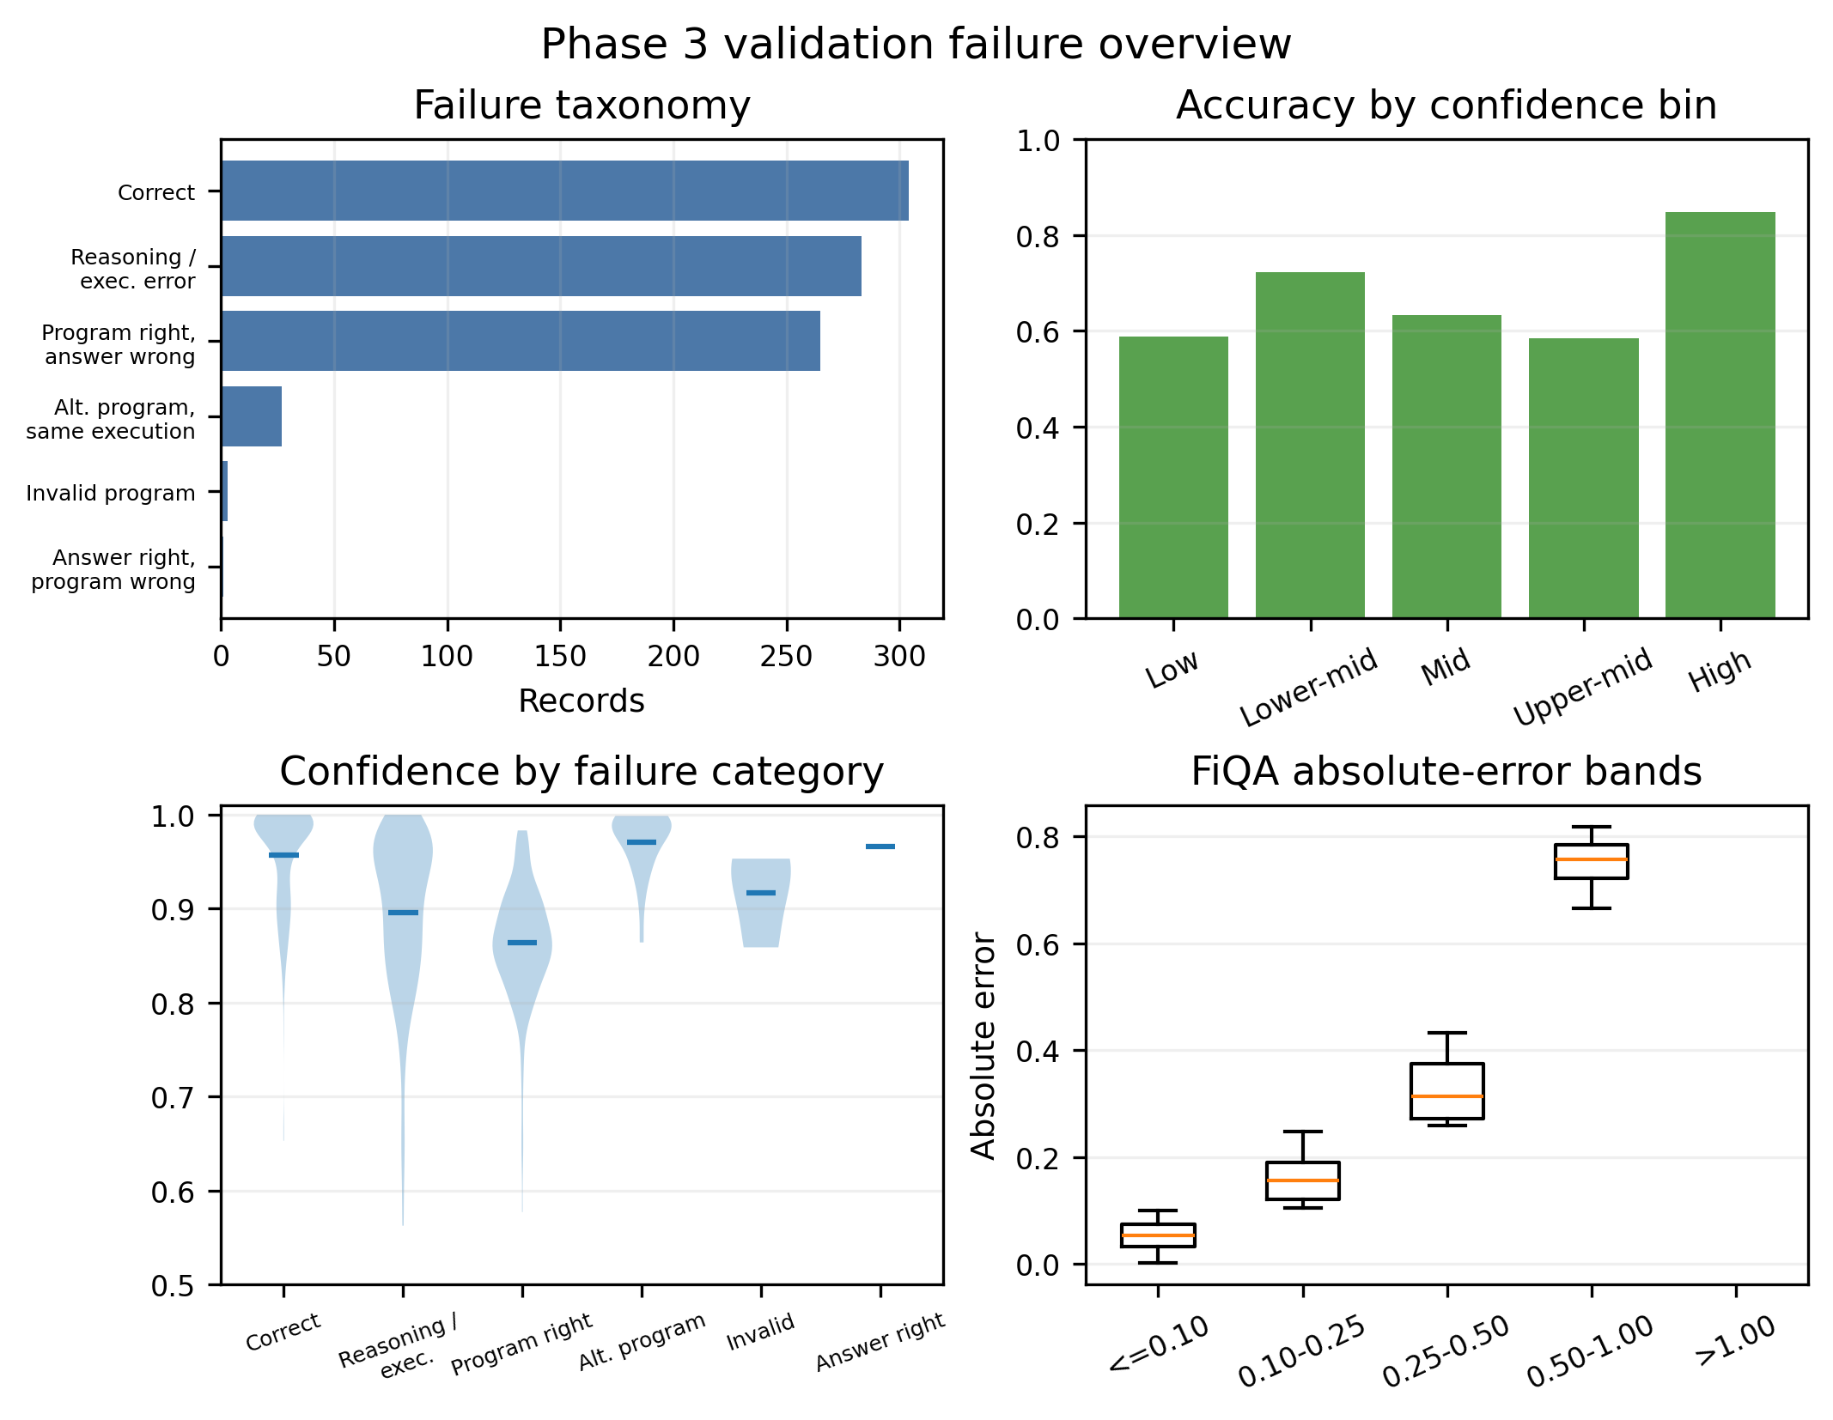
E5 validation failure overview generated from the Phase-3 analysis artifacts. Execution, program, and printed-answer channels are kept distinct.

Confidence and error magnitude
The initial token-confidence diagnostic was intentionally conservative: a Spearman correlation of 0.125 and ROC-AUC of 0.577 do not establish calibrated probabilities. Confidence bins also show that a model can assign similar token likelihoods to correct and incorrect numerical responses. Figure 7 visualizes the relationship between confidence and failure category in the validation export. The later EVG-CAS study therefore uses agreement among executed candidates as a separate feature, then calibrates it out-of-fold rather than interpreting raw token likelihood as a risk probability.
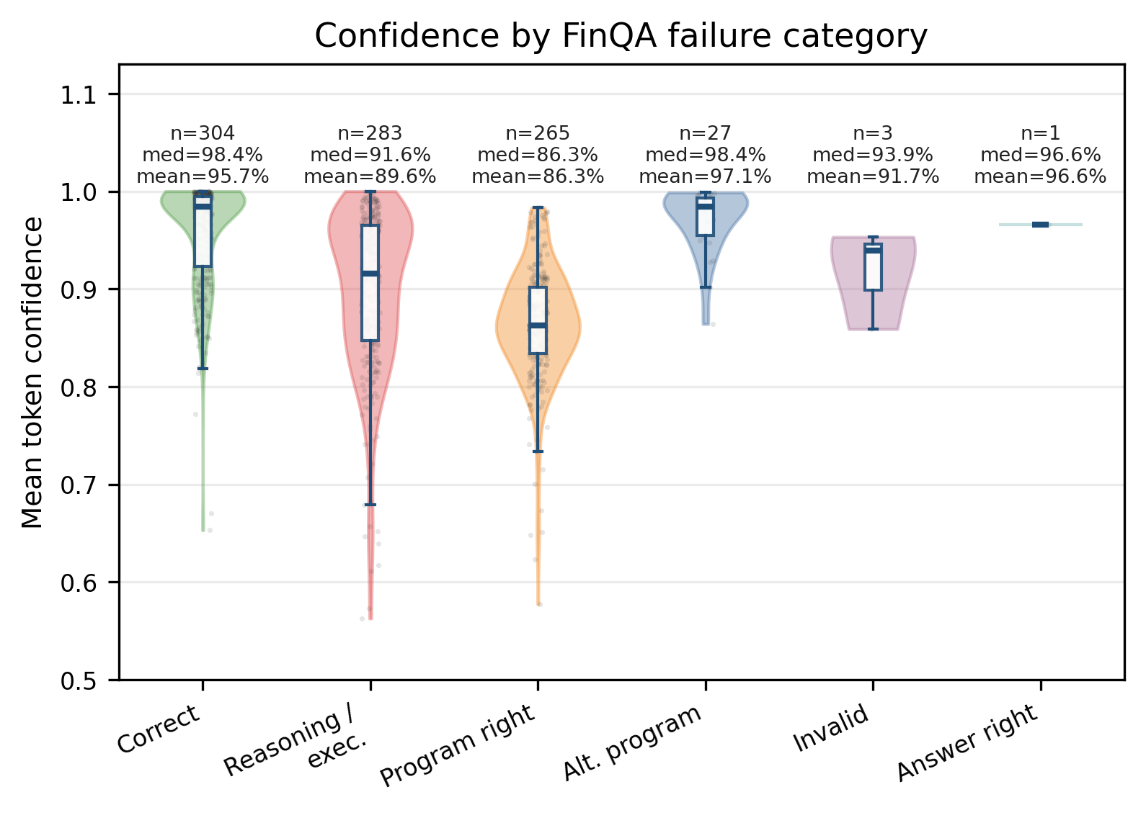
E5 validation confidence by FinQA failure category. Individual observations, box summaries, medians, means, and category counts are shown. Raw generation confidence is not used as a calibrated probability without validation-only calibration.
FiQA requires a different error interpretation because its target is continuous. The E5 validation MAE is 0.1301 and $R^{2}$ is 0.7301, but aggregate scores do not reveal whether errors concentrate at the positive or negative ends of the sentiment scale. Figure 8 shows the absolute-error distribution used for this inspection. The small validation size ($n=117$) means that these patterns should be treated as descriptive rather than as population-level estimates.
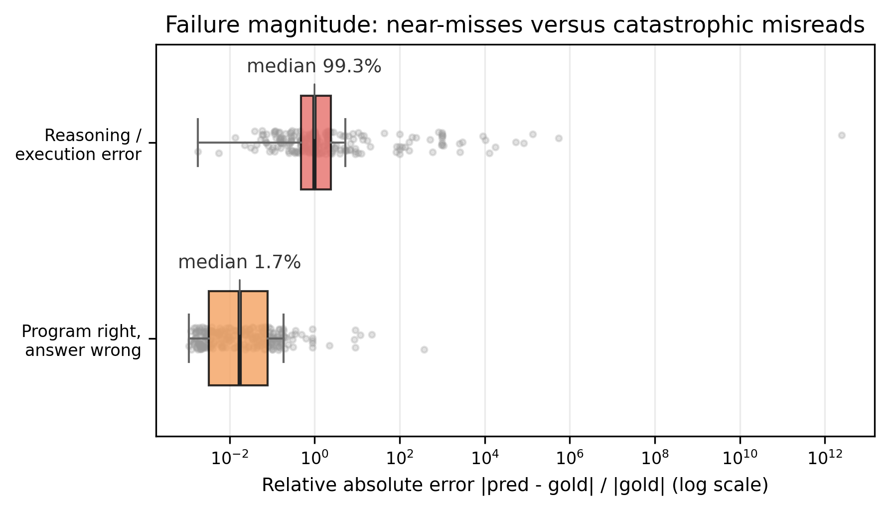
E5 validation absolute-error distribution for FiQA sentiment regression.

Reproducibility and resource accounting
Each reported result is intended to be traceable through four identifiers: dataset release and split, model and adapter checkpoint, prompt and decoding policy, and prediction export. The Phase-3 winner uses Qwen3-1.7B with 4-bit NF4 quantization, LoRA rank 16, scaling $α=32$, dropout 0.05, learning rate $2×{10}^{−4}$, weight decay 0.01, warm-up ratio 0.03, gradient accumulation 8, two epochs, and seed 42. The Phase-4 protected run then freezes $n=8$, temperature 0.7, top-$p$ 0.9, five-fold out-of-fold calibration, and coverage targets 0.80 and 0.90. This separation makes it possible to distinguish a result that was selected on validation from one that was measured after the protected freeze.
The E5 training run processed 7 073 examples for two epochs in 2.47 hours, used a peak 3.40 GiB of VRAM on a 6 GB RTX 4050 Laptop GPU, and reported 1.18 seconds per item for single-example inference. EVG-CAS requires 4.8 seconds per question versus 1.3 seconds for greedy decoding in the protected profiling setup. These measurements are hardware- and prompt-dependent; they describe the reported setup rather than a universal serving rate.

Discussion and limitations

Matched-coverage robustness.
At matched coverage, the selective gain survives comparison with simpler abstention rules based on model confidence. Using 3,000 bootstrap resamples, the confidence-based comparison has a confidence interval that excludes zero, while the ablation removes the agreement feature and loses the observed advantage. This result supports the interpretation that agreement among executable candidates, rather than confidence alone, supplies the useful decision-level trust signal. What we did not claim. EVG-CAS does not raise accuracy; reporting a tie, rather than a $p$-value-won headline, is the point of the pre-registration. Domain limits. On FiQA (117 validation / 234 test records, regression), the EVG features carry no signal and the frozen policy correctly abstains to no effect — a second reported negative result. General limits. One backbone, one seed, one evaluation harness; between-seed variance of the agreement signal is unmeasured; $n=8$ is pre-declared, not tuned; the abstention gain costs 3.7$×$ latency for zero accuracy gain. Threats to validity. The protected-test protocol rests on the frozen manifest hash being unchanged across access (it is); any leakage would invalidate C3’s transfer claim. Ethics. Abstention is a refusal signal, not a guarantee; a deployed system that answers still carries residual error (23.8% at coverage 0.8). No financial advice is implied.

Conclusion
For a QLoRA-adapted 1.7B financial model, execution-verified generation ties greedy decoding on accuracy but produces a steep, monotone agreement signal that the model’s own confidence cannot see. Calibrating that signal yields a pre-registered abstention threshold that transfers to a once-opened protected test, cutting answered-error by 31% at 80% coverage. The contribution to the financial-SLM conversation is an agreement-based selective-risk signal for a small financial model, with a validation-frozen threshold and protected-test transfer. Artifacts, frozen manifest and the full experiment trail are public; P4-E9 (FinTrust per-dimension evaluation) remains incomplete pending official judge scoring and is the declared next step.
99 Z. Chen et al., “FinQA: A Dataset of Numerical Reasoning over Financial Data,” EMNLP, 2021. Z. Chen et al., “ConvFinQA: Exploring the Chain of Numerical Reasoning in Conversational Finance Question Answering,” EMNLP, 2022. F. Zhu et al., “TAT-QA: A Question Answering Benchmark on a Hybrid of Tabular and Textual Content in Finance,” ACL, 2021. K. Singh Phogat et al., “Fine-tuning Smaller Language Models for Question Answering over Financial Documents,” Findings of EMNLP, 2024. H. Yang, X.-Y. Liu, C. D. Wang, “FinGPT: Open-Source Financial Large Language Models,” J. Financial Data Science (arXiv:2306.06031), 2023. Y. Yang, Y. Tang, K. Y. Tam, “InvestLM: A Large Language Model for Investment using Financial Domain Instruction Tuning,” arXiv:2309.13064, 2023. S. Wu et al., “BloombergGPT: A Large Language Model for Finance,” arXiv:2303.17564, 2023. A. Huang, H. Wang, Y. Yang, “FinBERT: A Pretrained Language Model for Financial Communications,” arXiv:2006.08097, 2020. Y. Shi et al., “Kronos: A Foundation Model for the Language of Financial Markets,” arXiv:2508.02739, 2025. Q. Xie et al., “FinBen: A Holistic Financial Benchmark for Large Language Models,” NeurIPS D&B, 2024. T. Hu et al., “FinTrust: A Comprehensive Benchmark of Trustworthiness Evaluation in Finance Domain,” EMNLP, 2025. S. Subramanian et al., “Small Language Models (SLMs) Can Still Pack a Punch: A Survey,” arXiv:2501.05465, 2025. M. Abdin et al., “Phi-3 Technical Report,” arXiv:2404.14219, 2024. P. Zhang et al., “TinyLlama: An Open-Source Small Language Model,” arXiv:2401.02385, 2024. Qwen Team, “Qwen3 Technical Report,” arXiv:2505.09388, 2025. E. Hu et al., “LoRA: Low-Rank Adaptation of Large Language Models,” ICLR, 2022. T. Dettmers et al., “QLoRA: Efficient Finetuning of Quantized LLMs,” NeurIPS, 2023. X. Wang et al., “Self-Consistency Improves Chain of Thought Reasoning in Language Models,” ICLR, 2023. H. Lightman et al., “Let’s Verify Step by Step,” ICLR, 2024. P. Wang et al., “Math-Shepherd: Verify and Reinforce LLMs Step-by-step without Human Annotations,” ACL, 2024. X. Chen, D. Song, Y. Tian, “Execution-Guided Neural Program Synthesis,” ICLR, 2019. R. El-Yaniv, Y. Wiener, “On the Foundations of Noise-free Selective Classification,” JMLR 11, 2010. Y. Geifman, R. El-Yaniv, “Selective Classification for Deep Neural Networks,” NeurIPS, 2017. Y. Geifman, R. El-Yaniv, “SelectiveNet: A Deep Neural Network with an Integrated Reject Option,” ICML, 2019. C. Guo et al., “On Calibration of Modern Neural Networks,” ICML, 2017. J. C. Platt, “Probabilistic Outputs for Support Vector Machines and Comparisons to Regularized Likelihood Methods,” Advances in Large Margin Classifiers, 1999. B. Zadrozny, C. Elkan, “Transforming Classifier Scores into Accurate Multiclass Probability Estimates,” KDD, 2002. S. Lin, J. Hilton, O. Evans, “Teaching Models to Express Their Uncertainty in Words,” TMLR, 2022. S. Fritz-Morgenthal, B. Hein, J. Papenbrock, “Financial Risk Management and Explainable, Trustworthy, Responsible AI,” SSRN 3873768, 2022. A. Taubenfeld et al., “Confidence Improves Self-Consistency in LLMs,” Findings of ACL, 2025 (https://aclanthology.org/2025.findings-acl.1030/). A. V. Aravindan and M. Kejriwal, “Second Guess: Detecting Uncertainty Through Abstention and Answer Stability in Small Language Models,” arXiv:2605.25394, 2026. Z. Wang et al., “SConU: Selective Conformal Uncertainty in Large Language Models,” ACL, 2025. Z. Wang et al., “LEC: Linear Expectation Constraints for Selection-Conditioned Risk Control in Selective Prediction and Routing Systems,” arXiv:2512.01556, 2025. J. Chen et al., “Adaptation with Self-Evaluation to Improve Selective Prediction in LLMs,” Findings of EMNLP, 2023 (arXiv:2310.11689). C. Liu et al., “David vs. Goliath: Cost-Efficient Financial QA via Cascaded Multi-Agent Reasoning,” Findings of EMNLP, 2025 (https://aclanthology.org/2025.findings-emnlp.225/). Z. Xie et al., “FinChain: A Symbolic Benchmark for Verifiable Chain-of-Thought Financial Reasoning,” arXiv:2506.02515, 2025.

