TRUSTFIN-SLM / RESEARCH METHODS

Phase-3 Results Analysis
and Why Phase-3.1 Is Required
Student-oriented technical report and execution roadmap
Project: Trustworthy Small Language Models for Financial Tasks
Evidence: Phase3_TrustFin_Deliverable.zip | Compiled: 20 October 2026
Evaluation status: Phase-3 E1–E16 completed on validation data; Phase-3.1 audit recommended before Phase-4.
Main takeaway The model often generates a correct executable financial program but an incorrect written answer. Phase-3.1 must verify the reporting, preserve model artifacts, and translate this failure pattern into a defensible Phase-4 methodology.

This report explains what the students implemented, what the numbers mean, which results are publishable, what needs correction, and the precise checklist for the next phase.

Who should read this report?
Students responsible for model training, metrics, data engineering, financial-program verification, trust scoring, ablation studies, and paper writing. No prior knowledge of the complete notebook is assumed.

How the report is organized
Part | Purpose
A. Context | Research goal, datasets, and what Phase-3 tested
B. Findings | E1–E16 performance, failures, confidence, efficiency
C. Research audit | Bugs, limitations, and frozen model interpretation
D. Next work | Phase-3.1 work packages, exit gates, Phase-4 plan

A. Research context and Phase-3 objectives

1. What problem are we trying to solve?
A financial Small Language Model (SLM) is expected to read financial evidence, reason over quantities, and return dependable outputs. Accuracy alone is not sufficient: if the model cannot identify when its answer is unreliable, it may produce confident but incorrect financial information.
The proposed paper investigates whether a modest-sized model can perform financial numerical reasoning and financial sentiment prediction, and whether additional verification and risk estimation can make its output more trustworthy.

2. How Phase-2.1, Phase-3, Phase-3.1 and Phase-4 fit together
Stage | Question answered | Output
Phase-2.1: Data | Are the data and train/validation/test boundaries reliable? | Frozen data contract and integrity audits
Phase-3: Baselines | How well do small models work before trust interventions? | E1–E16 results; E5 frozen baseline
Phase-3.1: Audit | Are metrics, verification claims, and model assets reproducible? | Corrected reporting and Phase-4 specification
Phase-4: Proposed system | Can verification and calibrated abstention improve trust? | TrustFin-SLM ablations and protected-test evaluation

3. Datasets used in Phase-3
Dataset | Training | Validation | Role
FinQA | 6,251 | 883 | Financial numerical questions, gold programs, executed answers
FiQA Sentiment | 822 | 117 | Continuous financial sentiment prediction (score from −1 to +1)
Total | 7,073 | 1,000 | Combined Phase-3 training and validation only

FinBen-FOMC and FinTrust were protected evaluation resources and were not part of Phase-3 model selection. Likewise, the protected FinQA and FiQA test splits were not used in these validation comparisons.
Study principle Every comparison in this report is a validation result unless specifically marked otherwise. Do not write “test accuracy” in the manuscript for these values.

B. Experiments completed in Phase-3

4. What E1–E16 mean in simple language
ID | Experiment | Student interpretation
E1 | Qwen zero-shot | What the primary model can do without examples or fine-tuning
E2 | Qwen few-shot | Whether demonstrations inside the prompt help
E3 | FinQA-only QLoRA | Specialized training for financial program reasoning
E4 | FiQA-only QLoRA | Specialized training for sentiment-score output
E5 | Qwen joint balanced QLoRA | One model trained on both tasks with equal task exposure
E6 | Phi zero-shot | Raw ability of an independent model family
E7 | Phi few-shot | Prompt-example effect in the second model
E8 | Phi joint QLoRA | Whether multi-task gains generalize across model families

ID | Experiment | Student interpretation
E9 | FinQA prompt ablation | Impact of task tags and explicit output instructions
E10 | FiQA prompt ablation | Impact of sentiment-output prompt instructions
E11 | Joint sampling ablation | Does 50/50 training beat naturally unequal task sizes?
E12 | FinQA failure analysis | Why programs, execution, and written answers disagree
E13 | FiQA failure analysis | Which sentiment examples have larger errors?
E14 | Confidence/error study | Does model confidence predict correctness?
E15 | Efficiency profiling | Training resources, runtime and inference cost
E16 | Validation comparison / freeze | Select the pre-declared Qwen backbone for Phase-4

5. Understand the evaluation metrics before reading results
Metric | Meaning | Better
Answer accuracy (FinQA) | Fraction whose generated ANSWER text matches the gold result | Higher
Program accuracy (FinQA) | Fraction whose program exactly matches the gold program | Higher
Execution accuracy (FinQA) | Fraction whose generated program executes to the correct result | Higher
Invalid-program rate | Fraction of generated programs that cannot be executed | Lower
MAE / MSE (FiQA) | Average absolute / squared error of sentiment score | Lower
R² / Pearson r (FiQA) | Quality of regression fit / score association | Higher
ROC-AUC for confidence | How well confidence ranks correct vs incorrect predictions | Higher (0.5≈random)
Coverage | Fraction of cases on which an abstaining system returns an answer | Higher, subject to risk

Important distinction The presence of an executable program is not proof that it uses the correct financial facts or the correct operations. Executability, accuracy and evidence grounding are different properties.

C. Core performance results

6. Main baseline comparison
Experiment | FinQA exec. ↑ | FiQA MAE ↓ | FiQA R² ↑
E1 — Qwen zero-shot | 0.0% | 0.501 | -1.787
E2 — Qwen few-shot | 0.0% | 0.185 | 0.472
E3 — FinQA-only QLoRA | 68.1% | 0.505 | -1.840
E4 — FiQA-only QLoRA | 0.0% | 0.129 | 0.725
E5 — Qwen balanced joint | 67.5% | 0.130 | 0.730
E6 — Phi zero-shot | 0.0% | 0.381 | -0.444
E7 — Phi few-shot | 4.0% | 0.325 | -0.181
E8 — Phi balanced joint | 70.1% | 0.130 | 0.809
E11 — Qwen natural joint | 61.5% | 0.128 | 0.736

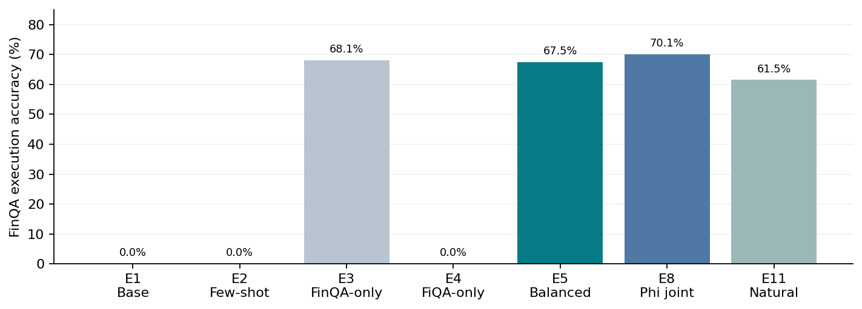
Figure 1. FinQA execution accuracy on 883 validation cases. E5 is frozen within the pre-declared Qwen comparisons; E8 is the stronger cross-family comparison.

7. What do the model comparisons tell us?
Finding A — Training matters. Unadapted models rarely produce a FinQA answer in the required executable format. FinQA-only and joint QLoRA models achieve approximately 61–70% execution accuracy. Zero-shot values partly reflect strict output-format requirements, not only reasoning ability.
Finding B — Balanced sampling matters. E5 reaches 67.5% FinQA execution accuracy against 61.5% for E11. Balanced training improves FinQA by about 6.0 percentage points. FiQA MAE is slightly lower for E11 (0.128 versus 0.130), so report the trade-off rather than a blanket “balanced is best” claim.
Finding C — E8 is competitive. Phi E8 reaches 70.1% FinQA execution accuracy and FiQA R² = 0.809. It remains an important comparison even though E5 is frozen as the pre-declared primary-model backbone.
Finding D — Why E5 was frozen. E5 outperforms E11 on the pre-declared Qwen validation selection score (0.744560 versus 0.720464). The rule did not allow switching the proposed backbone to E8 after inspecting all results.
The paired prediction comparison previously reported gave p≈0.062 for E8 vs E5 on FinQA execution and p≈0.0000069 for E5 vs E11. Treat these as paired-validation analyses, not multi-seed model-training uncertainty estimates.

D. Main scientific discovery: programs versus answers

8. E12 — Why 67.5% execution accuracy is not 67.5% written-answer accuracy
The E5 model emits both a structured financial program and an ANSWER line. We can evaluate (i) the human-readable answer and (ii) the result obtained by running the generated program. The two frequently disagree.
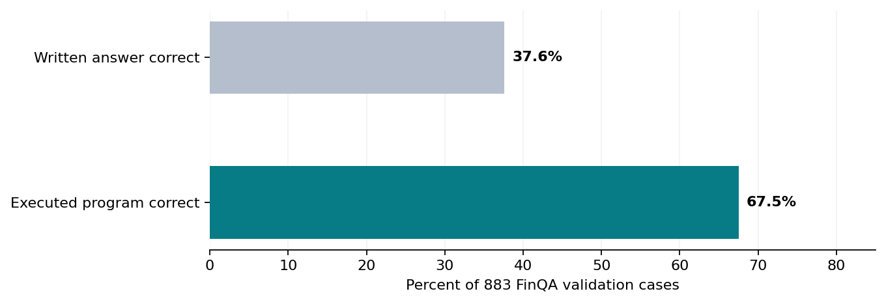
Figure 2. The same E5 predictions yield 332/883 correct written answers, versus 596/883 correct executed results.
Case category | Count | Interpretation
Program correct; written answer correct | 331 | Both outputs correct
Program correct; written answer wrong | 265 | Execution can repair incorrect written arithmetic
Program wrong; written answer correct | 1 | Blind execution may override a correct written answer
Program wrong; written answer wrong | 286 | Execution alone cannot solve the reasoning problem
TOTAL | 883 | Validation examples

Numerical lesson. Executing the model-generated program raises the observed result accuracy from 332/883 (37.6%) to 596/883 (67.5%), a net gain of 264 correct predictions. This is a strong motivation for deterministic answer reconciliation without retraining.
Trustworthiness lesson. Even when a program can run successfully, its mathematical operations or numerical inputs may be incorrect. Phase-4 therefore needs a program verifier AND an evidence-grounding/risk check; a calculator alone is insufficient.
Do not overclaim The “program correct” cases here mean the executed result agrees with the gold outcome. This is not the same as proving that every intermediate reasoning step is causally valid, or that the program contains only input-grounded values.

9. Failure categories from E12
Failure type (exported taxonomy) | Count | How students should interpret it
correct | 304 | Both outputs correct under this branch of the taxonomy
reasoning_execution_error | 283 | Executed reasoning produces the wrong result
program_right_answer_wrong | 265 | Correct execution, wrong written answer
alternate_program_same_execution | 27 | Different syntax, same final executed result
invalid_program | 3 | Program cannot execute
answer_right_program_wrong | 1 | Written answer correct, program execution wrong

This exported taxonomy partitions records by a priority-based decision rule; it is not identical to the independent 2×2 program-versus-answer table above. Both views are informative but answer different questions.

E. Sentiment, confidence and compute findings

10. E13 — FiQA sentiment regression
FinQA and FiQA measure different capabilities. FiQA does not ask the model to construct arithmetic programs; the model outputs a continuous sentiment value between −1 and +1. For the E5 joint model, MAE is 0.130, R² is 0.730, and Pearson r is approximately 0.873.
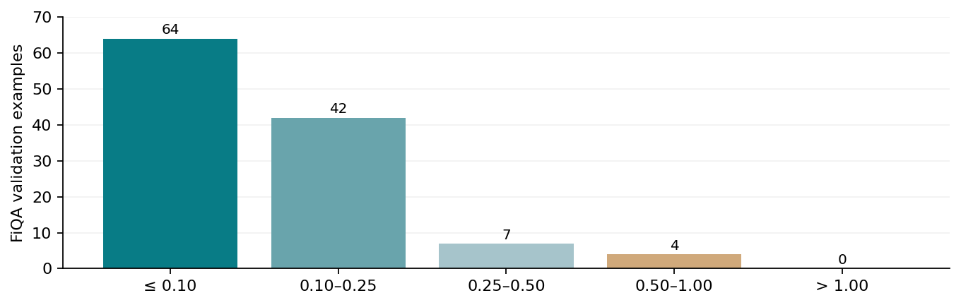
Figure 3. E5 sentiment absolute-error distribution on the 117 FiQA validation examples.
Of the 117 cases, 106 (90.6%) have absolute error at most 0.25. This supports the claim that joint training can retain sentiment-regression ability, although 11 cases still exceed 0.25 and need case-level review.
E10 finds a modest prompt advantage: “explicit_schema” gives FiQA MAE = 0.1273, compared with 0.1301 for the canonical prompt. FinQA selects the canonical prompt from E9; the best prompt need not be identical across tasks.

11. E14 — Why confidence is not yet trustworthy
Dataset | Observed relationship | Meaning
FinQA | ROC-AUC 0.577; Spearman 0.125 | Likelihood confidence weakly ranks execution correctness
FiQA | Spearman 0.237; Pearson 0.219 | Confidence only weakly tracks lower regression error

A confidence score of 0.9 should not automatically be interpreted as a 90% probability of correctness. Model token-likelihood scores need validation-based calibration; even a calibrated score must be checked for useful selective risk across task types.
Phase-4 should compare (a) likelihood-only confidence, (b) typed program validity and evidence-grounding signals, and (c) a verifier-aware calibrated risk model. Thresholds must be selected on validation data only.

12. E15 — Efficiency of the chosen SLM
Measurement | E5 Qwen | E8 Phi
Training rows | 7,073 | 7,073
Epochs | 2 | 2
Training time | 2.47 hours | 3.54 hours
Peak recorded training VRAM | 3.40 GiB | 4.90 GiB
Max. train sequence length | 1,024 | 768
LoRA trainable parameters | 17.43 million | 23.07 million
Mean inference latency | 1.18 s/sample | 1.08 s/sample

These are measurements from the supplied environment (NVIDIA GeForce RTX 4050 Laptop GPU). The exported quantized parameter counts should not be called the original model parameter counts. The models were also trained with different maximum input lengths, which limits a pure architecture comparison.

13. The context-truncation limitation
The Phase-3 run used MAX_SEQ_LENGTH = 1,024 for E5. The recorded token audit found a 53.3% truncation estimate. Among 883 FinQA validation predictions, 460 reached the 1,024-token prompt cap. Program execution accuracy is approximately 71.6% below that cap and 63.7% at the cap.
This is a correlation, not proof of causation: long contexts may also be harder. Still, evidence-preserving input construction is an attractive low-cost Phase-3.1 validation study. It must be done without changing protected test data.

F. Folder audit and what is genuinely frozen

14. What each delivered folder contributes
Location in ZIP | Contents and research use
docs/ | Narrative experiment reports; useful for discussion, but numbers must match machine exports
notebooks/ | Master notebook, executed full-run partitions, smoke runs
logs/ | Run sequence and interruptions/restarts; supports execution provenance
manifests/ | Experiment plan, environment, few-shot IDs, completion report, phase3_freeze.json
metrics/ | Task scores, E16 candidate comparisons, training metadata
predictions/ | Sample-level raw outputs; required for independent recomputation
analysis/ | Ablations E9–E11, errors E12–E13, confidence E14, efficiency E15
plots/ | Visualization exports

15. What the Phase-3 freeze currently fixes
Item | Frozen value
Primary backbone | Qwen/Qwen3-1.7B
Adaptation | E5 — balanced FinQA+FiQA QLoRA
FinQA prompt | canonical
FiQA prompt | explicit_schema
Selection score | 0.744560
Model-selection boundary | Train + validation only; no protected tests
Random seed | 42

The ZIP has an E5 adapter path in phase3_freeze.json, but does not include checkpoint weights. The path alone does not verify that the exact weights still exist. Phase-3.1 must save reproducible model revision identifiers and hashes for adapter/tokenizer/configuration files.

16. Confirmed reporting bug: negative invalid-program rate
Several metrics JSON files store negative invalid-program rates, which are logically impossible. The likely cause is applying the bitwise operator “~” to object-typed booleans rather than proper Boolean arrays.
Experiment | Exported (invalid) | Correct from record predictions
E3 | −1.9887 | 1.13%
E5 | −1.9966 | 0.34%
E7 | −1.1099 | 89.01%
E8 | −1.9966 | 0.34%
E11 | −1.9943 | 0.57%

Correct formula: invalid_rate = 1.0 − mean(program_executable.fillna(False).astype(bool)).
This does not alter the independently validated FinQA execution/answer accuracies, but the metrics must be regenerated before figures, tables, and manuscript claims are finalized.

17. Additional reproducibility cautions
- Reconcile environment details in docs/exp_3(b).md against the actual exported environment.json. The package versions do not fully agree.
- Do not use only the E16 selection score to claim one model dominates every task; inspect per-task trade-offs.
- The training experiments use one seed. A two- or three-seed repeat of the decisive E5 vs E11 comparison would strengthen the claim, subject to compute budget.
- Zero-shot execution accuracy is sensitive to strict output-format prompts and parsers. Report this limitation and consider a format-controlled baseline check.

G. Why Phase-3.1 is needed before Phase-4

18. Why not start Phase-4 immediately?
Phase-3 has identified which technical weakness Phase-4 should target, but the research measurement and implementation interfaces need to be made defensible. Starting a new proposed method while an invalid metric, unverifiable adapter path, and incomplete trust evaluator mappings remain would make subsequent claims difficult to audit.
Observed Phase-3 issue | Why it matters | Phase-3.1 response
Negative invalid-program rates | Tables would contain mathematically impossible findings | Repair and re-export all derived metrics
Correct program / wrong text answer | Large recoverable final-answer loss | Independent execution/reconciliation audit
Valid programs can still be wrong | A calculator is not a grounded verifier | Operand + evidence-grounding labels and error cases
Weak confidence AUC 0.577 | Raw likelihood does not reliably detect failures | Verifier-aware risk features and baseline assessment
Heavy truncation | Financial evidence may be missing from model context | Quantify, stratify, test evidence-preserving prompts
Checkpoint absent from ZIP | Freeze cannot be reproduced from metadata alone | Fingerprint adapter and tokenizer files
FinTrust evaluator gaps | Incomplete seven-dimension scoring may bias the paper | Explicit evaluator/metric mapping for each dimension

Definition of success Phase-3.1 does not need to beat E5 in model training. Its purpose is to ensure the results are correct, the baseline is reproducible, and the Phase-4 method can be evaluated fairly.

19. Phase-3.1 work packages and student allocation
Package | Task / deliverable | Suggested owner | Priority
WP1 | Repair metrics & regenerate E1–E16 tables + asserts | Metrics/QA student | P0
WP2 | Independent execution, answer-reconciliation contingency | FinQA evaluation student | P0
WP3 | Gold-free operand grounding and verifier design | Reasoning-method student | P0
WP4 | Risk-feature audit & task-aware confidence study | Trust/uncertainty student | P0
WP5 | Checkpoint fingerprint + environment consistency | Reproducibility student | P0
WP6 | Truncation + evidence-preserving validation pilot | Data/prompt student | P1
WP7 | FinTrust scoring contracts, seven dimensions | Benchmark student | P0
WP8 | Prepare protocol freeze and research notes | Research lead | P0

20. Sequence for students: what to run and check
- Make a read-only backup of Phase-2.1 and Phase-3 outputs. Never overwrite the original prediction CSVs or the frozen E5 weights.
- Rerun metric computation from raw prediction CSVs and assert every rate is between 0 and 1. Produce a before/after correction table.
- For each FinQA prediction, compare raw ANSWER text, executable program result, and gold execution result. Export four-way contingency and representative errors.
- Validate operand typing, allowed functions and whether numerical operands can be mapped to provided financial evidence. Mark grounding as “verified”, “unsupported”, or “indeterminate” rather than assuming numbers are grounded.
- Recompute confidence diagnostics for the frozen task-specific prompts. Do not select abstention thresholds using protected tests.
- Analyze capped versus uncapped contexts and run an evidence-preservation pilot on validation data only; maintain a separate result ID for any added experiment.
- Record hashes and exact revisions for the E5 adapter, tokenizer files and model. Correct provenance mismatches between docs and manifests.
- Map official metrics and evaluation scripts for each FinTrust dimension and document any dimension whose protocol cannot yet be reproduced.
- Generate a final Phase-3.1 readiness report with PASS/WARN/FAIL gates and a frozen Phase-4 input contract.

H. Phase-4 plan after Phase-3.1

21. Proposed TrustFin-SLM components
The recommended methodology keeps the E5 model fixed. It adds interpretable post-generation components rather than a second large model: (1) program syntax/type validation; (2) deterministic execution; (3) evidence grounding for numerical operands; (4) risk/confidence estimation; and (5) task-aware answer or abstain decisions.
Experiment | Configuration | Question
P4-B0 | Frozen E5 raw ANSWER | How accurate is the original generated text?
P4-B1 | E5 + deterministic program execution | How much arithmetic correction is recoverable?
P4-B2 | E5 + typed, grounded program verification | Do grounding checks reduce faulty reasoning?
P4-B3 | E5 + likelihood-only abstention | What does basic uncertainty achieve?
P4-B4 | E5 + calibrated verifier-aware risk | Does risk modeling improve error detection?
P4-F | Full proposed TrustFin-SLM | Best accuracy–risk–coverage trade-off?
P4-X | E8 cross-family reference | Are findings tied to Qwen alone?

22. Metrics to report in Phase-4
- FinQA: raw-answer accuracy, executed-answer accuracy, program validity, input-operand grounding, selective error rate, coverage and area under risk–coverage curve.
- FiQA: MAE, MSE, R², selective MAE, coverage and regression-appropriate uncertainty measures.
- FinTrust: official task-specific metrics across all seven dimensions; do not combine incompatible scores into one invented accuracy.
- Efficiency: model weights, adapter parameters, VRAM, inference latency and added verifier overhead.
Calibration and abstention thresholds must be chosen only on the validation split; final protected-test evaluation must happen after the methodology, prompts, thresholds and model checkpoint are frozen.

I. Acceptance criteria and files students must share

23. Phase-3.1 GO / NO-GO checklist
Gate | PASS condition
A. Metrics valid | No impossible rates; recomputed exports match prediction-level results
B. E5 weights preserved | Adapter, tokenizer and revisions exist with cryptographic hashes
C. Program evaluation trace | Every FinQA validation prediction has parse/execute/error provenance
D. Grounding protocol | Explicit numeric-evidence matching rules, ambiguous cases identified
E. Confidence protocol | No test-set tuning; diagnostics regenerated for frozen prompts
F. Context audit | Truncation statistics reproduced; validation pilot independently labeled
G. FinTrust contract | Each of seven dimensions has a documented loader, metric and evaluator
H. Publication audit | Environment and notebook claims reconcile with the raw artifact records

24. Suggested Phase-3.1 deliverables
File | Purpose
phase3_1_readiness_report.json | Overall PASS/WARN/FAIL gate report
phase3_corrected_validation_metrics.csv | Recomputed E1–E11 scores with valid program-rate fields
finqa_answer_execution_audit.csv | Per-case raw/execute/gold agreement
finqa_grounding_audit.csv | Operand provenance and unverifiable-operand cases
confidence_risk_diagnostics.csv | Uncertainty and error relationship
truncation_impact_report.csv | Prompt-length strata and evidence-retention diagnostics
fintrust_evaluator_map.json | Seven benchmark dimensions and official metrics
phase3_checkpoint_fingerprints.json | Exact model/adapter/tokenizer provenance
phase4_protocol_freeze.json | Frozen inputs, method, thresholds policy, evaluation plan
executed Phase-3.1 notebook | Full audit log, reproducible without tests

25. What the students should write in the paper at this point
Safe claim. Joint QLoRA produced competent performance on two different financial validation tasks; the frozen E5 model achieved 67.5% executable-result accuracy on FinQA and FiQA MAE 0.130.
Strongest motivating observation. The same E5 model produced correct written numerical answers in only 37.6% of FinQA cases, indicating a substantial answer–execution discrepancy that can motivate a verifier.
Not yet supported. The proposed verifier reduces financial hallucinations, improves fairness/privacy, or produces calibrated confidence. These remain hypotheses until Phase-4 experiments are completed.

26. Final recommendation
NEXT: Phase-3.1 Keep Phase-3 “implemented and frozen at validation selection level.” Do not rerun all E1–E16. Repair the documented metric bug, validate the executable-answer premise, fingerprint E5 and freeze the full Phase-4 evaluation contract. Then execute Phase-4 validation ablations before accessing protected test sets.

Appendix — Source traceability
Primary source: Phase3_TrustFin_Deliverable.zip supplied by the research team. The numerical results in this report were checked against its metrics/, predictions/, analysis/, manifests/ and notebooks/ directories.
Specific audit files: metrics/E5.json, metrics/E8.json, metrics/E11.json, metrics/E16_joint_candidate_comparison.csv; predictions/E5.csv; analysis/E9_finqa_prompt_ablation.csv, E10_fiqa_prompt_ablation.csv, E11_sampling_ablation.csv, E12_finqa_failure_summary.csv, E13_fiqa_failure_summary.csv, E14_confidence_error_correlation.csv, E15_efficiency_profile.csv; manifests/phase3_freeze.json, environment.json and phase3_completion_report.json.
All values here are Phase-3 validation results or calculations based on supplied predictions; no protected test results or Phase-4 improvement are asserted.

Student team progress tracker (complete during Phase-3.1)
Work package | Assigned student | Status | Evidence / review note
WP1 Metrics repair | _______________ | Not started | __________________
WP2 FinQA reconciliation | _______________ | Not started | __________________
WP3 Operand grounding | _______________ | Not started | __________________
WP4 Confidence diagnostics | _______________ | Not started | __________________
WP5 Checkpoint reproducibility | _______________ | Not started | __________________
WP6 Truncation pilot | _______________ | Not started | __________________
WP7 FinTrust evaluators | _______________ | Not started | __________________
WP8 Phase-4 protocol freeze | _______________ | Not started | __________________

Questions for the next student review meeting
- Which FinQA errors can be fixed by execution alone, and which need grounded program checking?
- Are weak confidence estimates sufficiently predictive to support abstention without additional verifier features?
- Can every reported table be reproduced from predictions and frozen configs without opening protected tests?

