


PROJECT REPORT
ON
TrustFin-SLM: Trustworthy Small Language Models for Financial Tasks

Submitted in partial fulfillment of the requirements for the award of the degree of
Bachelor of Technology (B.Tech.)
in Computer Engineering

Prepared by
Heet Mehta (24CE064)
Krish Patel (24CE084)
Aryan Patel (D25CE158)

Under the guidance of
Prof. Mrugendra Rahevar

U. & P. U. Patel Department of Computer Engineering
Chandubhai S. Patel Institute of Technology (CSPIT)
Faculty of Technology & Engineering, CHARUSAT
Changa, District Anand – 388421
Academic Year 2026–2027

PROJECT REPORT
TrustFin-SLM: Trustworthy Small Language Models for Financial Tasks
This report presents the complete research work carried out for the eighth-semester project. It consolidates the data-validation pipeline, baseline experiments, execution verification, confidence calibration, selective prediction, protected-test evaluation, statistical analysis, limitations, and future extensions of TrustFin-SLM.
Project information | Details
Project title | TrustFin-SLM: Trustworthy Small Language Models for Financial Tasks
Degree / semester | Bachelor of Technology in Computer Engineering / Eighth Semester
Candidates | Heet Mehta, Krish Patel, Aryan Patel
Guide | Prof. Mrugendra Rahevar
Primary model | Qwen/Qwen3-1.7B with balanced joint QLoRA adaptation
Research focus | Financial numerical reasoning, sentiment, verification, calibration and abstention
Submission status | Report prepared for faculty verification and digital signature

The report is based on frozen, reproducible artifacts in the project repository. Validation and protected-test results are reported separately, and no claim is made that execution verification alone improves raw accuracy.

CANDIDATE'S DECLARATION
We hereby declare that the project report entitled “TrustFin-SLM: Trustworthy Small Language Models for Financial Tasks” is our original work carried out under the guidance of Prof. Mrugendra Rahevar. The work has been prepared for the partial fulfillment of the requirements for the award of the Bachelor of Technology degree in Computer Engineering at CHARUSAT.
We further declare that the experimental results, tables, figures, and interpretations presented in this report are derived from the project artifacts and notebooks maintained for this work. Wherever the work of other authors has been used, it has been appropriately acknowledged and cited in the bibliography. This report has not been submitted, in whole or in part, to any other university or institution for the award of another degree or diploma.
Place: Changa
Date: 28/10/2026
Candidate | Signature | Date
Heet Mehta (24CE064) | ____________________ | 28/10/2026
Krish Patel (24CE084) | ____________________ | 28/10/2026
Aryan Patel (D25CE158) | ____________________ | 28/10/2026

COMPANY CERTIFICATE
Not applicable.

COLLEGE CERTIFICATE
This is to certify that the project report entitled “TrustFin-SLM: Trustworthy Small Language Models for Financial Tasks” has been carried out by Heet Mehta (24CE064), Krish Patel (24CE084), and Aryan Patel (D25CE158) under the guidance of Prof. Mrugendra Rahevar in partial fulfillment of the requirements for the award of the Bachelor of Technology degree in Computer Engineering at the U. & P. U. Patel Department of Computer Engineering, Chandubhai S. Patel Institute of Technology, CHARUSAT.
The report is submitted for examination and faculty verification.
Date: ____________________
Place: Changa
Project Guide | Head of Department | External Examiner
Signature: ____________ | Signature: ____________ | Signature: ____________
Name: Prof. Mrugendra Rahevar | Name: __________________ | Name: __________________
Date: 28/10/2026 | Date: ________________ | Date: ________________

ABSTRACT
Financial language models must do more than produce plausible text: they must reason over financial evidence, expose executable reasoning, and identify when an answer is unsafe to use. TrustFin-SLM investigates whether a small, locally deployable language model can support trustworthy financial reasoning through a staged and reproducible research pipeline. The study first establishes a frozen data contract and evaluates small-language-model baselines on FinQA numerical reasoning, FiQA sentiment regression, FOMC stance classification, and trust-oriented evaluation resources. The pre-declared Phase-3 winner is E5, a Qwen/Qwen3-1.7B model adapted with balanced joint QLoRA on FinQA and FiQA.
The proposed method, EVG-CAS (Execution-Verified Generation with Agreement-Calibrated Abstention), samples multiple candidate programs, executes valid programs, computes agreement and verifier-aware features, calibrates correctness probabilities on validation data, and abstains when the calibrated confidence is below a frozen threshold. Phase-4A shows that execution changes FinQA validation accuracy from 37.6% written-answer accuracy to 67.5% executed-answer accuracy, while 880 of 883 programs are structurally valid. On the protected FinQA test set, execution-verified selection ties the greedy baseline in accuracy (65.56% versus 65.74%; exact McNemar p = 0.871), so the accuracy-improvement hypothesis is rejected honestly. However, agreement is a strong trust signal: accuracy rises from 2.9% in the lowest agreement bin to 79.2% in the highest. The frozen 80% coverage policy transfers to protected test data and reduces answered-error by 31.0%, with 76.25% accuracy among retained answers. FiQA shows only a small selective benefit, demonstrating a meaningful domain limitation.
The central conclusion is that verification does not make the small model consistently more accurate, but it can make the system more selective and better calibrated about when to answer. The report preserves validation/test separation, documents reproducibility safeguards, reports negative findings, and identifies multi-seed evaluation, semantic grounding, FinTrust per-dimension scoring, and efficiency improvements as future work.
Keywords: financial NLP; small language models; FinQA; QLoRA; execution verification; calibration; selective prediction; abstention; trustworthy AI.

ACKNOWLEDGEMENT
We express our sincere gratitude to Prof. Mrugendra Rahevar for his guidance, review, and encouragement throughout this project. His feedback helped us move from accuracy-only model evaluation toward a more careful study of verification, calibration, uncertainty, and abstention.
We thank the U. & P. U. Patel Department of Computer Engineering and CHARUSAT for providing the academic environment and resources needed to conduct this work. We also acknowledge the authors and maintainers of the FinQA, FiQA, FinBen, FinTrust, Qwen, LoRA, QLoRA, and related open research resources used in this project.
Finally, we thank our families and classmates for their support during the experimentation, documentation, and report preparation stages.
Heet Mehta
Krish Patel
Aryan Patel

TABLE OF CONTENTS
First Page 2
Candidate's Declaration 3
Company Certificate 4
College Certificate 5
Abstract 6
Acknowledgement 7
Table of Contents 7
List of Figures 8
List of Tables 9
List of Abbreviations 10
CHAPTER 1 INTRODUCTION 11
CHAPTER 2 LITERATURE REVIEW & COMPARATIVE STUDY 12
CHAPTER 3 EXPERIMENTATION / SIMULATION / LAB SET UP 14
CHAPTER 4 PROPOSED HYPOTHESIS / MODEL / ALGORITHM 16
CHAPTER 5 RESULTS AND DISCUSSION ON RESULTS 18
CHAPTER 6 CONCLUSION 21
CHAPTER 7 FUTURE EXTENSIONS 21
Bibliography 22
Appendix A Artifact and Reproducibility Checklist 23
Appendix B Faculty Verification and Digital Signature 23

LIST OF FIGURES
Figure 1. Execution verification and written-answer reconciliation ..........
Figure 2. Phase-4B validation risk–coverage curve ..........
Figure 3. Phase-3 FinQA execution-accuracy comparison ..........
Figure 4. Phase-4C protected-test selective-risk comparison ..........

LIST OF TABLES
Table 1. Project datasets and their roles ..........
Table 2. Research phases and validation safeguards ..........
Table 3. Phase-3 baseline comparison ..........
Table 4. Phase-4A execution and provenance audit ..........
Table 5. Phase-4C protected-test comparison ..........
Table 6. Calibration and selective-prediction results ..........
Table 7. FOMC out-of-domain robustness ..........

LIST OF ABBREVIATIONS
Abbreviation | Meaning
AUC | Area Under the Receiver Operating Characteristic Curve
AURC | Area Under the Risk–Coverage Curve
ECE | Expected Calibration Error
EVG-CAS | Execution-Verified Generation with Agreement-Calibrated Abstention
FOMC | Federal Open Market Committee
LLM | Large Language Model
MAE | Mean Absolute Error
QLoRA | Quantized Low-Rank Adaptation
SLM | Small Language Model
UML | Unified Modeling Language

CHAPTER 1 INTRODUCTION

1.1 Introduction
Financial question answering and sentiment analysis require models to combine language understanding with numerical, contextual, and domain-specific reasoning. A fluent response can still be wrong when a model misreads a table, applies an incorrect operation, or expresses an incorrect result with high confidence. This makes trustworthiness a core engineering requirement rather than an optional post-processing feature.
TrustFin-SLM is a research pipeline for studying trustworthy small language models (SLMs) in finance. The project combines reproducible data contracts, parameter-efficient adaptation, executable reasoning, verifier-aware features, calibration, and selective prediction. The emphasis is on auditable evidence: every phase records inputs, outputs, fingerprints, split policy, and readiness checks.

1.2 Research Definition
The research problem is defined as follows: given a resource-constrained financial SLM that produces an answer and, where possible, an executable reasoning program, can a verifier-aware system estimate answer reliability and abstain on cases that are likely to be wrong without leaking protected test labels?

1.3 Problem Description
Accuracy-only evaluation hides three failure modes: an invalid program may be emitted; a valid program may execute to the wrong value; and a correct computed value may be written incorrectly. In addition, raw token likelihood may not distinguish correct from incorrect financial reasoning. A practical system therefore needs explicit execution checks, agreement signals, calibrated probabilities, and a policy for declining unsafe answers.

1.4 Motivation
Small models are attractive because they reduce inference cost, can run locally, and are easier to audit. Their limited capacity, however, makes error detection especially important. In finance, an abstention that routes a difficult case to a human or stronger model can be safer than a confident but incorrect answer.

1.5 Scope and Objectives
- Build a reproducible financial SLM pipeline with frozen data and model-selection contracts.
- Compare small-model baselines on numerical reasoning, sentiment, and stance classification.
- Measure the gap between written answers and executed program answers.
- Design EVG-CAS using execution, agreement, and calibration features.
- Evaluate accuracy, calibration, risk–coverage, statistical significance, efficiency, and limitations.
- Prepare an auditable report and artifact trail suitable for academic review.

1.6 Planning
Phase | Work completed | Evidence / status
Phase 2 | Data integrity and unified pipeline | PASS
Phase 2.1 | Research validation and data contract | 68 gates, 0 failures
Phase 3 | Baselines and failure analysis | PASS; E5 frozen
Phase 4A | Execution verification and feature generation | PASS; validation-only
Phase 4B | Calibration and selective prediction | PASS; fit-only model selection
Phase 4C | Protected evaluation, ablation and statistical analysis | COMPLETE; frozen

1.7 Organization of Thesis
Chapter 2 reviews financial language models, numerical reasoning, program execution, calibration, selective prediction, and research gaps. Chapter 3 describes datasets, software, hardware, experiment controls, and the laboratory setup. Chapter 4 presents the EVG-CAS hypothesis, algorithm, system model, implementation, complexity, and use cases. Chapter 5 reports results and discusses their statistical and practical meaning. Chapters 6 and 7 present conclusions and future extensions.

CHAPTER 2 LITERATURE REVIEW & COMPARATIVE STUDY

2.1 Evolution of the Topic
Financial NLP has progressed from task-specific classifiers and pretrained encoders to instruction-tuned and open large language models. FinBERT demonstrated the value of domain-adapted language representations, while FinGPT, BloombergGPT, InvestLM, and later financial benchmarks broadened the range of financial tasks. At the same time, small language models and parameter-efficient methods such as LoRA and QLoRA have made local adaptation more feasible.
Financial question answering introduced a further challenge: the system must combine textual evidence with arithmetic operations. FinQA and TAT-QA formalized this challenge, while execution-guided program synthesis and self-consistency provided methods for generating or selecting reasoning traces. TrustFin builds on these directions but treats execution and agreement as reliability signals rather than assuming that a valid program is automatically correct.

2.2 Background Study (Theoretical and Mathematical Background)
For FinQA, a generated program is parsed and executed against the financial evidence. Execution accuracy is the proportion of examples for which the executed result matches the gold answer. For selective prediction, a confidence score s(x) ranks examples; at threshold θ, coverage is the fraction answered and selective risk is the error rate among answered examples.
Calibration quality is measured using Brier score and expected calibration error (ECE). For bins B_m, ECE = Σ_m |B_m|/n · |acc(B_m) − conf(B_m)|. The risk–coverage curve reports risk as coverage changes, and the area under this curve (AURC) summarizes ranking quality. McNemar’s exact test compares paired predictions, and bootstrap confidence intervals quantify uncertainty in paired differences.

2.3 Review Previous Research Findings
Research family | Representative work | Relevant finding
Financial benchmarks | FinQA; TAT-QA; FinBen; FinTrust | Finance requires numerical, multimodal/contextual and trust-oriented evaluation.
Financial language models | FinBERT; FinGPT; BloombergGPT; Qwen3 | Domain adaptation improves task performance but does not guarantee reliability.
Efficient adaptation | LoRA; QLoRA; Phi-3; TinyLlama | Small models can be adapted with reduced memory and compute.
Verification | Execution-guided synthesis; step-by-step verification | Executable traces enable deterministic checks, but execution is not semantic proof.
Calibration / selection | Selective prediction and uncertainty methods | A model can be evaluated on whether it knows when to abstain.

2.4 Comparative Study
The project differs from accuracy-centric studies in three ways. First, it freezes a primary model before later protected evaluation. Second, it separates executable correctness, written-answer correctness, structural validity, and operand provenance. Third, it evaluates abstention as a deployment decision, not as a cosmetic confidence score.

2.5 Open Issues (Research Gaps)
- Most financial SLM studies report accuracy without a frozen abstention policy.
- Program executability is often conflated with semantic correctness.
- Calibration signals are rarely transferred from validation to a protected financial test set.
- The effect of verification differs across discrete numerical reasoning and continuous sentiment regression.
- Small-model trustworthiness requires reproducible split controls and explicit negative results.

CHAPTER 3 EXPERIMENTATION / SIMULATION / LAB SET UP

3.1 Datasets
Dataset | Role | Use policy
FinQA | Financial numerical reasoning | Train/dev/test; validation for development, test protected
FiQA Sentiment | Aspect-aware sentiment regression in [-1, 1] | Train/valid/test; test protected
FinBen-FOMC | FOMC stance classification | Protected zero-shot evaluation only
FinTrust | Seven-dimensional trust benchmark | Registered protected resource; not used for tuning

3.2 Experimental Pipeline
The pipeline begins with Phase-2.1 data validation and a dataset registry. Phase 3 trains or evaluates candidate small models under a pre-declared selection rule. The E5 Qwen3-1.7B balanced-joint QLoRA model is frozen before Phase 4. Phase 4A audits saved predictions and creates a label-separated interface. Phase 4B fits calibration policies on validation fit splits only. Phase 4C opens the protected data only after the method and threshold are frozen.
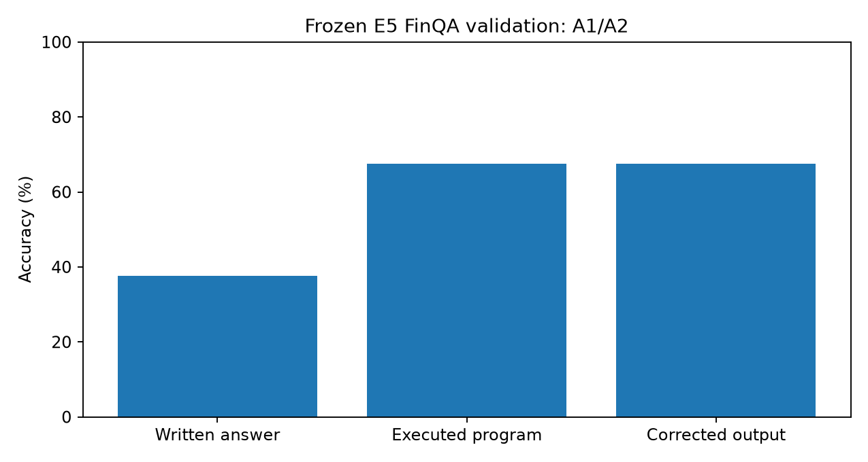
Figure 1. Execution verification and written-answer reconciliation on validation data.

3.3 Laboratory Setup
Component | Configuration
Operating environment | Linux workstation; Python 3.12.3 research environment
Core libraries | NumPy, pandas, SciPy, scikit-learn, matplotlib, joblib, nbformat
Model adaptation | QLoRA on Qwen/Qwen3-1.7B; balanced FinQA + FiQA training
Phase-4A/4B compute | CPU-friendly saved-prediction audit and calibration; no GPU required
Phase-4C inference budget | n = 8 candidate samples; approximately 4.8 s/question vs 1.3 s greedy
Reproducibility | SHA-256 fingerprints, frozen manifests, explicit split and feature policies

3.4 Research Controls
Control | Implementation
Data leakage control | Protected test, FOMC and FinTrust resources excluded from training and calibration
Label isolation | Features and target labels stored in separate interfaces
Model freeze | E5 backbone and Phase-4 method frozen before protected evaluation
Negative-result policy | C1 accuracy claim is rejected when paired evidence does not support improvement
Artifact integrity | Readiness manifests and hashes verify outputs and handoff conditions

CHAPTER 4 PROPOSED HYPOTHESIS / MODEL / ALGORITHM

4.1 Hypotheses
C1 (accuracy): execution-verified selection improves answer accuracy over greedy decoding. C2 (probability quality): verifier-aware calibration improves Brier score and ECE. C3 (ranking and safety): agreement and executability rank correctness sufficiently well that a threshold frozen on validation reduces answered-error on protected test data.

4.2 EVG-CAS Algorithm
- Generate n candidate programs or responses for each question.
- Parse and execute candidate programs using the official FinQA-compatible evaluator.
- Compute executable validity, structural validity, answer agreement, source likelihood, prompt features, and grounding-aware features where recomputation is available.
- Fit an out-of-fold logistic/Platt calibrator on validation fit records; do not use gold answers as predictors.
- Select a threshold for a target coverage on validation and freeze the model, threshold, and hash.
- On protected data, answer only when the calibrated probability meets the frozen threshold; otherwise abstain.

4.3 Unified Modeling and Visual Representation of the System
The system has four layers: (1) data and evidence layer; (2) model-generation layer; (3) verifier and feature layer; and (4) calibrated decision layer. The data layer supplies a question, table, passage, and answer contract. The generator emits candidate programs. The verifier parses and executes them, while the feature layer measures agreement and validity. The decision layer either returns the verified answer or abstains.
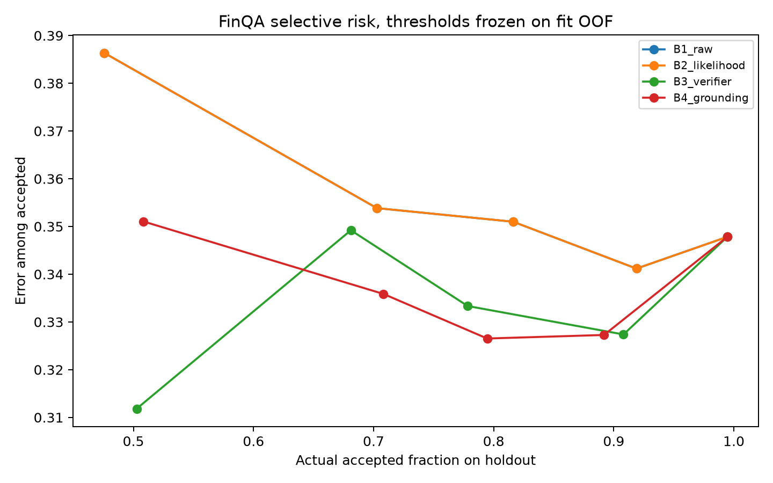
Figure 2. Validation risk–coverage analysis used to freeze the selective policy.

4.4 Implementation Details, Complexity, Innovation, Applications and Utilities
The implementation uses Python notebooks and small reusable tools. QLoRA reduces trainable parameters and memory relative to full fine-tuning. Verification of n candidates has approximately O(n·L) generation cost plus O(n·E) execution cost, where L is generated sequence length and E is evaluator cost. Feature computation is linear in the number of candidates and evidence tokens for the implemented checks. Logistic calibration is small compared with model inference.
The innovation is methodological rather than a claim of a new foundation model: EVG-CAS unifies executable checking, agreement-based trust estimation, leakage-safe calibration, and a frozen abstention policy. Applications include financial document assistants, audit-support tools, analyst triage, educational finance QA, and local/private inference systems.

4.5 Complexity Analysis and UML-Oriented Model
Module | Input | Output | Approximate cost
Generator | Question and evidence | n candidate programs | O(n·L) model decoding
Parser / executor | Candidate programs | Validity and computed answers | O(n·E)
Feature extractor | Candidates and evidence | Trust feature vector | O(n·T) token/operand checks
Calibrator | Validation features | Probability estimate | O(k·d) for k records, d features
Decision policy | Probability and threshold | Answer or abstention | O(1) per question

UML component interpretation: DatasetRegistry → Generator → ProgramParser → OfficialExecutor → FeatureExtractor → Calibrator → SelectiveDecision. The protected-test boundary is placed before the final component and is opened only after the freeze manifest is complete.

CHAPTER 5 RESULTS AND DISCUSSION ON RESULTS

5.1 Phase-3 Baseline Results
Experiment | Model / sampling | FinQA execution | FiQA MAE | FiQA R²
E5 (frozen) | Qwen3-1.7B; balanced joint | 67.5% | 0.128 | reported in freeze
E8 | Phi family comparison | 70.1% | — | 0.809
E11 | Qwen3; unbalanced comparison | 61.5% | 0.128 | —

E5 was frozen by the pre-declared Qwen selection rule rather than selected retrospectively from all observed results. E8 is a useful stronger cross-family comparison, but switching the primary backbone after inspection would break the study protocol.
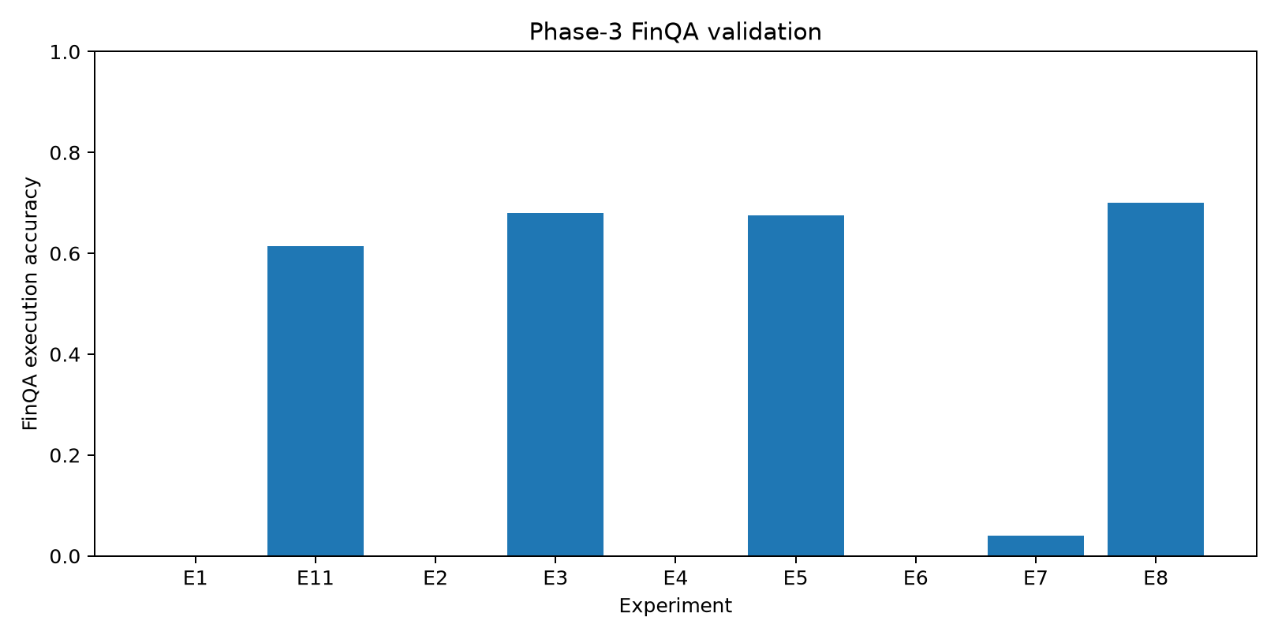
Figure 3. Phase-3 FinQA execution-accuracy comparison.

5.2 Phase-4A Execution and Provenance Audit
Measure | Result | Interpretation
Written-answer accuracy | 37.60% | Accuracy of the emitted written answer
Executed-program accuracy | 67.50% | Accuracy after executing a valid program
Gain | +29.90 percentage points | Execution resolves many written-format failures
Structural validity | 880 / 883 | Three programs were non-executable
Structural/official mismatch | 0 | Independent checks agree
Literal presence | 97.6% | Not semantic grounding proof
Unmatched literals | 21 / 883 records | Strong error subgroup signal

5.3 Phase-4B Calibration Results
Metric | Raw / baseline | Verifier-aware policy
FinQA e-AURC | 0.2029 | 0.1232
Brier score | 0.2845 | 0.1579
ECE | 0.2555 | 0.0475
Validation interpretation | Confidence is weak | Agreement and validity improve ranking

5.4 Phase-4C Protected-Test Results
System / policy | FinQA accuracy | Coverage / MAE | Finding
Greedy baseline | 65.74% | 100% coverage | Reference system
Execution-verified | 65.56% | 100% coverage | Tie; C1 rejected
Selective at target 0.80 | 76.25% selected | 78.6% coverage | Answered-error reduced 31.0%
FiQA greedy | — | MAE 0.1301 | Best baseline
FiQA selective | — | MAE 0.1306 | Only negligible benefit

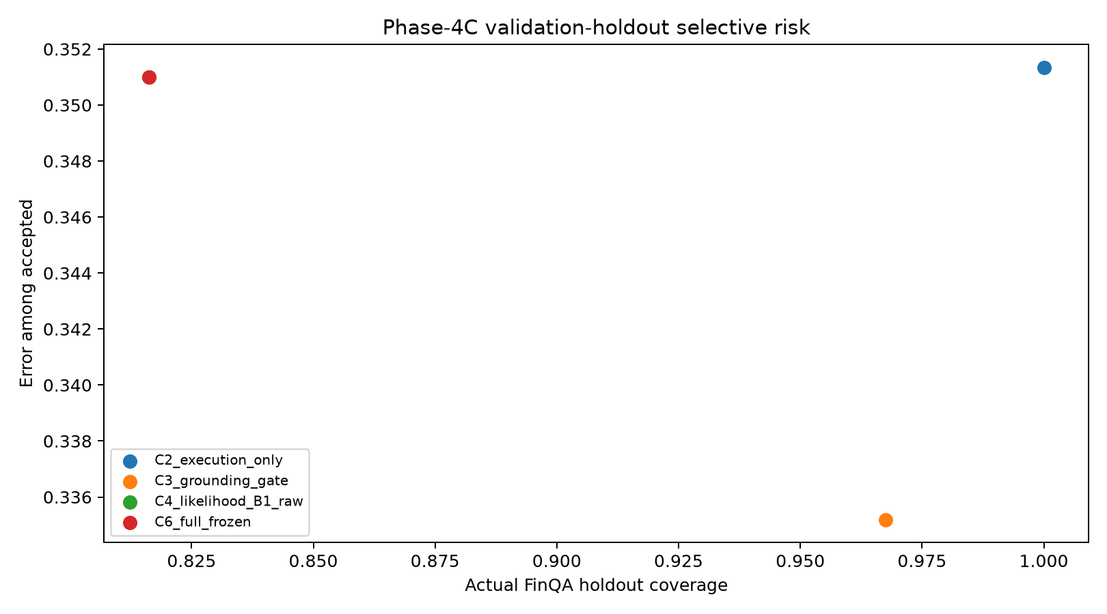
Figure 4. Protected-test selective-risk comparison.

5.5 Agreement as a Trust Signal
Agreement bin | Records | Execution accuracy
(0.00, 0.25] | 35 | 2.9%
(0.25, 0.50] | 122 | 23.8%
(0.50, 0.75] | 181 | 44.8%
(0.75, 1.00] | 809 | 79.2%

The monotonic relationship supports C3. It also explains why raw source likelihood is insufficient: likelihood AUC is approximately 0.58, whereas agreement separates low- and high-reliability regimes.

5.6 Statistical Discussion
The protected FinQA accuracy difference between greedy and execution-verified selection is −0.17 percentage points, with bootstrap 95% confidence interval [−1.22, +0.87] percentage points and exact McNemar p = 0.871. The appropriate conclusion is not that one method is superior on accuracy, but that EVG-CAS should be judged for reliability-aware selection. At 80% target coverage, retained answers reach 76.25% accuracy, and the answered-error reduction is 31.0% relative to greedy.

5.7 Out-of-Domain Robustness and Efficiency
System | FOMC accuracy | Macro-F1 | Parse
Base Qwen/Qwen3-1.7B | 45.4% | 0.215 | 0.899
Qwen + frozen E5 adapter | 48.4% | 0.304 | 0.986

EVG uses approximately 4.8 seconds per question compared with 1.3 seconds for greedy decoding, a 3.7× latency increase, with peak memory reported at approximately 3.1 GB of a 6 GB budget.

5.8 Discussion of Results
Three findings are central. First, execution is valuable for reconciling program reasoning with written answers, but executable programs can still be wrong. Second, agreement is a stronger reliability signal than raw likelihood for FinQA. Third, the benefit is task-dependent: selective prediction transfers clearly to discrete numerical reasoning but only weakly to FiQA regression. These results support a cautious deployment design in which abstention is a refusal signal, not a guarantee of correctness.

CHAPTER 6 CONCLUSION
This report presented TrustFin-SLM, a reproducible study of trustworthy small language models for financial tasks. The project established a data contract, compared baselines, froze the E5 Qwen3-1.7B balanced-joint QLoRA backbone, audited executable reasoning, and introduced EVG-CAS for verification-aware selective prediction.
The accuracy hypothesis was rejected: execution-verified selection tied rather than improved the protected FinQA baseline. This negative result is scientifically important because it prevents overstating the contribution. The reliability hypotheses were supported on FinQA. Agreement, executability, and calibration reduced probability error and enabled a frozen policy that retained 78.6% of test questions at 76.25% accuracy, reducing answered-error by 31.0%. The method did not provide a comparable gain on FiQA.
The project therefore demonstrates a practical trust pattern: a small model need not answer every question, and a system can improve operational safety by recognizing difficult cases. All conclusions should be read with the stated limitations of one main backbone, one seed, finite evaluation sets, and incomplete semantic grounding.

CHAPTER 7 FUTURE EXTENSIONS
- Run multi-seed and multi-backbone studies to measure variance in agreement and calibration.
- Complete FinTrust seven-dimension evaluation with the protected evaluator and report per-dimension results.
- Add semantic operand grounding and table-aware checks rather than relying on literal presence.
- Investigate adaptive candidate budgets to reduce EVG latency while preserving abstention quality.
- Evaluate human escalation workflows and cost-sensitive coverage targets.
- Extend calibration to FiQA and other continuous financial prediction tasks.
- Study multilingual, longer-document, and domain-shifted financial evidence.
- Package the verifier and calibrated policy as a reproducible local API with audit logs.
- Add fairness, privacy, and red-team evaluation for deployment scenarios.

BIBLIOGRAPHY
[1] Chen, Z. et al. (2021). FinQA: A Dataset of Numerical Reasoning over Financial Data. EMNLP.
[2] Zhu, F. et al. (2021). TAT-QA: A Question Answering Benchmark on a Hybrid of Tabular and Textual Content in Finance. ACL.
[3] Xie, Q. et al. (2024). FinBen: A Holistic Financial Benchmark for Large Language Models. NeurIPS Datasets and Benchmarks.
[4] Hu, T. et al. (2025). FinTrust: A Comprehensive Benchmark of Trustworthiness Evaluation in Finance Domain. EMNLP.
[5] Huang, A. H., Wang, H., and Yang, Y. (2020). FinBERT: A Pretrained Language Model for Financial Communications.
[6] Yang, H., Liu, X.-Y., and Wang, C. D. (2024). FinGPT: Open-Source Financial Large Language Models. Journal of Financial Data Science.
[7] Wu, S. et al. (2023). BloombergGPT: A Large Language Model for Finance.
[8] Shi, Y. et al. (2025). Kronos: A Foundation Model for the Language of Financial Markets.
[9] Qwen Team. (2025). Qwen3 Technical Report.
[10] Hu, E. J. et al. (2022). LoRA: Low-Rank Adaptation of Large Language Models. ICLR.
[11] Dettmers, T. et al. (2023). QLoRA: Efficient Finetuning of Quantized LLMs. NeurIPS.
[12] Chen, X., Song, D., and Tian, Y. (2019). Execution-Guided Neural Program Synthesis. ICLR.
[13] Wang, X. et al. (2023). Self-Consistency Improves Chain of Thought Reasoning in Language Models. ICLR.
[14] Lightman, H. et al. (2024). Let's Verify Step by Step. ICLR.
[15] Wang, P. et al. (2024). Math-Shepherd: Verify and Reinforce LLMs Step-by-Step without Human Annotations. ACL.
[16] Abdin, M. et al. (2024). Phi-3 Technical Report: A Highly Capable Language Model Locally on Your Phone.
[17] Zhang, P. et al. (2024). TinyLlama: An Open-Source Small Language Model.
[18] Subramanian, S. et al. (2025). Small Language Models Can Still Pack a Punch: A Survey.
Additional project-specific evidence: project README, phase reports, executed notebooks, frozen manifests, and artifact tables in the TrustFin-SLM repository. Accessed October 2026.

APPENDIX A ARTIFACT AND REPRODUCIBILITY CHECKLIST
Item | Location / status
Phase-2.1 data contract | artifacts/phase2_1/; frozen
Phase-3 freeze manifest | artifacts/phase3/manifests/phase3_freeze.json; frozen
Phase-4A review package | artifacts/phase4a/; PASS
Phase-4B freeze | artifacts/phase4b_full/manifests/phase4b_freeze.json; frozen
Phase-4C methodology freeze | artifacts/phase4c_full/manifests/phase4_methodology_freeze.json; frozen
Statistical evaluation | trust_fin_extra_phase/docs/eval_rigor.md
Figures used in report | artifacts/phase3/plots, phase4a/plots, phase4b_full/plots, phase4c_full/plots

APPENDIX B FACULTY VERIFICATION AND DIGITAL SIGNATURE
Faculty comments / corrections:
______________________________________________________________________________
______________________________________________________________________________
______________________________________________________________________________
Verified by project guide: ______________________________ Date: 28/10/2026
Digital signature / e-signature: _________________________ Date: ____________
Department seal: _______________________________________

