TrustFin-SLM
Phase-4B and Phase-4C
Results Verification & Student Research Guide
  - Financial risk calibration, selective prediction, ablation studies, statistical evidence, and manuscript-readiness decisions

Document purpose | Scope
Audience | Students implementing and writing the Tier-3 TrustFin-SLM research paper
Evidence | Executed Phase-4B/4C notebooks + their two review-package ZIPs + cross-checks with Phase-4A labels
Data status | FinQA: 698 calibration-fit + 185 validation holdout; FiQA: 92 + 25
Core decision | Engineering PASS; verifier-aware scientific superiority NOT established
Protected testing | FinQA/FiQA protected tests, FinBen-FOMC and FinTrust were not evaluated here

Prepared on 29 October 2026. Figures and tables reflect uploaded outputs, not invented results.
READ THIS FIRST: A notebook successfully finishing is not proof that the proposed algorithm performs better. This report explains both what passed and what remains scientifically unproven.

Executive summary
Phase-4B: PASS_FROZEN. The model-selection rule was applied using 698 FinQA calibration-fit examples; B1 raw likelihood was frozen before examining the 185-example holdout.
Phase-4C: PASS_METHODOLOGY_FROZEN. All C1–C10 result artifacts and declared process gates were produced; this is an implementation/protocol freeze, not a positive efficacy finding.
Research conclusion: CONDITIONAL. Execution correction helps markedly, but the frozen complete selective system (C6) is identical to the B1 likelihood baseline on the holdout. The model-selection evidence did not favor verifier-aware scoring.
Key measurement | Observed value | How to interpret it
FinQA model-written answer accuracy (883) | 37.60% | Raw model output is frequently numerically wrong
FinQA executed-program accuracy (883) | 67.50% | Deterministic reconciliation improves answer accuracy by +29.90 pp
Fit-OOF winner | B1_raw | Selection objective was lowest AURC, not lowest Brier
Frozen C6 risk at 80%-target policy | 35.10% at 81.62% coverage | No gain over likelihood-only B1
Exploratory B4 risk | 32.65% at 79.46% coverage | Promising, but B4 lost fit-side model selection
FiQA likelihood-only selective MAE | 0.101 (19/25 cases) | Descriptive; sample is too small for broad claims
FinTrust final evaluator | NOT_VERIFIED | Seven-dimensional trust claim not yet supported

What students should understand
- The paper has a supported result about program-based numerical correction, but execution verification is not automatically original or semantically reliable.
- Better calibration (probabilities reflecting frequency of correctness) is not the same as better ranking or selecting low-risk cases.
- Phase-4C reused the Phase-4B holdout; the phases did not generate two independent experimental test sets.
- The final manuscript must distinguish confirmed observations, exploratory findings, and proposed improvements.

1. Research purpose and pipeline
Phase-3 trained a frozen Qwen3-1.7B model (E5) using balanced FinQA + FiQA QLoRA. Phase-4A generated verification features and separate validation labels. Phase-4B fitted lightweight predictors of whether a FinQA program will execute to the correct answer, and explored FiQA absolute-error prediction. Phase-4C used those frozen scores for controlled comparisons and readiness checks.
Stage | Input | Output / responsibility
Phase-3 | FinQA/FiQA train and validation | Frozen E5 model and validation predictions
Phase-4A | E5 predictions + original validation evidence | Verifier/grounding features; labels exported separately
Phase-4B | Phase-4A features; 698/185 and 92/25 splits | OOF model selection, fitted calibrators, holdout predictions, frozen threshold
Phase-4C | Phase-4B scores + Phase-4A data | Ablations, significance tests, comparative tables, final protocol manifest
Future protected evaluation | Frozen models + predefined test protocols | Independent estimates on untouched tests; not completed

Leakage safeguard: gold execution correctness and true FiQA errors are valid learning targets during fitting. They must never appear in the inference-time feature columns. The notebooks include whitelist checks; future code must preserve them.

2. Uploaded-file inventory and independent verification
Review package | Machine-readable contents | Verification status
Phase4B_Review_Package.zip | 12 files: manifests 5; tables 4; predictions 2; plot 1 | Parsed all JSON/CSV files and independently recalculated holdout metrics
Phase4C_Review_Package.zip | 13 files: manifests 3; tables 8; predictions 1; plot 1 | Compared C1–C10 results with Phase-4B frozen policy and outputs
Executed Phase-4B notebook | 20 cells; 9 executed code cells; no recorded exception | Run evidence consistent with PASS_FROZEN
Executed Phase-4C notebook | 23 cells; 11 executed code cells; no recorded exception | Run evidence consistent with PASS_METHODOLOGY_FROZEN

Independent recomputation: FinQA holdout = 185 IDs with four scores per ID (740 score rows). Baseline execution correctness = 120/185 (64.86%). Every reported FinQA Brier score and ROC-AUC in the holdout table was reproduced from individual scores and Phase-4A labels. FiQA holdout = 25 records.

3. Phase-4B: Why did we run it?
A financial model should know when it is likely to be wrong. Phase-4B asks: Can likelihood, program validity, prompt length, truncation and financial grounding indicators estimate the probability that the executed numerical result is correct? If yes, can the system abstain on risky cases?

3.1 B1–B8 experiment map
ID | Experiment | Student interpretation
B1 | Raw likelihood | Baseline: token-likelihood score treated as a raw correctness score; it is not calibrated automatically
B2 | Likelihood calibration | Logistic mapping of token-likelihood into an estimated probability of correctness
B3 | Verifier-aware calibration | B2 plus length, truncation and program-executability/structure signals
B4 | Grounding-aware calibration | B3 plus numerical-literal and question-local evidence overlap features
B5 | Selective prediction | Freeze thresholds on calibration-fit and measure error among accepted holdout cases
B6 | FiQA uncertainty | Predict sentiment absolute error using continuous regression; study selective MAE
B7 | Reliability diagnostics | ROC-AUC, Brier, ECE, NLL and AURC; each evaluates a different property
B8 | Freeze | Choose the method using fit-only out-of-fold AURC; preserve thresholds/model records

3.2 Model selection: why B1 won
Five-fold out-of-fold (OOF) predictions were generated on 698 FinQA calibration-fit samples. The pre-declared primary ranking criterion was AURC (lower is better), with Brier score only as a tie-breaker. Raw likelihood won: B1 AURC 0.24034, B2 0.24364, B3 0.26526, B4 0.26726.
Fit-only method | ROC-AUC ↑ | Brier ↓ | ECE ↓ | AURC ↓
B1 raw | 0.5845 | 0.2646 | 0.2270 | 0.2403
B2 calibrated likelihood | 0.5833 | 0.2129 | 0.0461 | 0.2436
B3 verifier | 0.5743 | 0.2109 | 0.0276 | 0.2653
B4 grounding | 0.5881 | 0.2071 | 0.0087 | 0.2673

Interpretation: B4 had the best numerical calibration (lowest Brier and ECE) but the weakest overall fit-side risk–coverage ranking. Therefore B4 could not legitimately be declared the winner after viewing the holdout. A model can be well calibrated in the aggregate yet fail to order individual cases from safest to riskiest.

3.3 Independent 185-case holdout results
Holdout method | ROC-AUC ↑ | Brier ↓ | ECE ↓ | AURC ↓
B1 raw | 0.5456 | 0.2996 | 0.2676 | 0.2879
B2 calibrated likelihood | 0.5456 | 0.2305 | 0.0422 | 0.2879
B3 verifier | 0.5700 | 0.2251 | 0.0404 | 0.2849
B4 grounding | 0.5510 | 0.2228 | 0.0699 | 0.3245

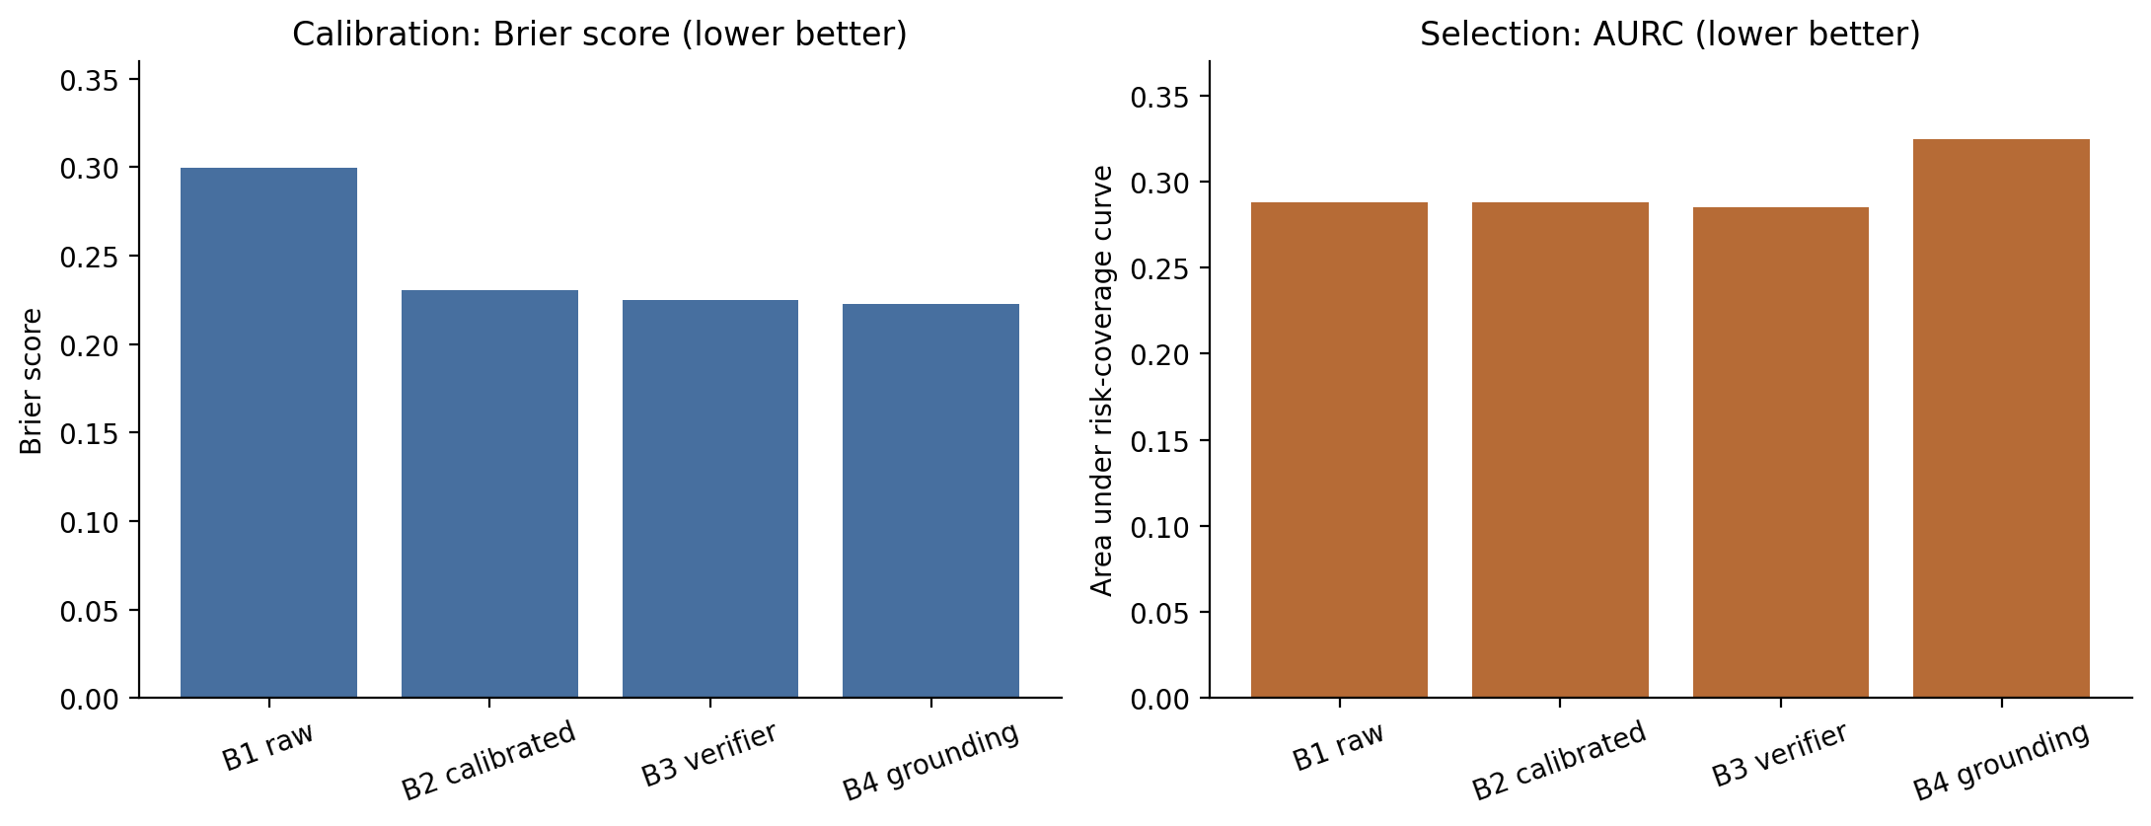
Figure 1. Calibration loss and global selective-risk ranking measure different model properties.
B3 has the best holdout ROC-AUC and AURC, albeit by small margins over B1 for AURC. B4 has the best Brier but the worst AURC. This is a concrete reason not to select the policy based on just one convenient holdout metric.

4. Selective prediction: how to read coverage and risk
Coverage = accepted questions / total questions. Selective risk = incorrect accepted answers / accepted answers. At 80% target coverage, the algorithm tries to answer about 80 of every 100 cases. Lower risk means the answered subset is more reliable, but rejecting more cases usually changes the comparison.
Method | Accepted / 185 | Actual coverage | Wrong among accepted | Selective risk
B1 raw (frozen) | 151 | 81.62% | 53 | 35.10%
B2 calibrated likelihood | 151 | 81.62% | 53 | 35.10%
B3 verifier | 144 | 77.84% | 48 | 33.33%
B4 grounding | 147 | 79.46% | 48 | 32.65%

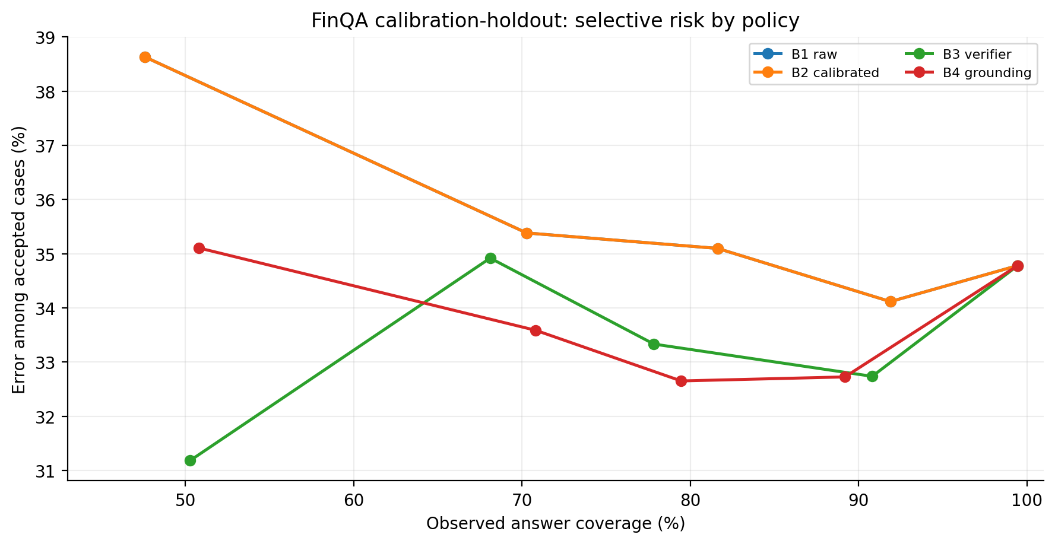
Figure 2. FinQA validation-holdout risk–coverage results using fit-side thresholds. Points represent distinct target settings, not a continuous deployment guarantee.
Why C6 does not demonstrate novel benefit: the frozen Phase-4B winner is B1, and C6 applies that same likelihood score and gate. It answers the same 151 holdout cases as B1, so both necessarily have the same 35.10% error rate. C6 is not evidence that verifier-aware confidence improved selection.
Exploratory matched-coverage comparison: when each model ranks exactly 148/185 cases (80%), B4 has 32.43% risk versus B1 35.81%. In an additional paired bootstrap performed during this independent review (5,000 resamples), the B4–B1 risk difference had a 95% interval of approximately −6.08 to +1.35 percentage points, including zero. This analysis is post hoc and must not replace the fit-only freeze or be presented as decisive proof.

5. B6: Financial sentiment uncertainty (FiQA)
FiQA is a continuous target in approximately [−1,+1]; here the response is a sentiment score, not a binary correctness label. Phase-4B trains a Ridge regression model to estimate absolute prediction error and compares it with raw likelihood and a constant baseline. The fit dataset has 92 examples; the holdout has only 25. The small sample gives uncertain estimates.
FiQA policy | Answered / 25 | Coverage | Selective MAE | Meaning
B6 constant | 25 | 100% | 0.1245 | Unable to prioritize risk; returns essentially all examples
B6 likelihood | 19 | 76% | 0.1010 | Lower error among selected cases, but very small subgroup
B6 Ridge error | 18 | 72% | 0.1328 | Error-risk regression did not improve selection

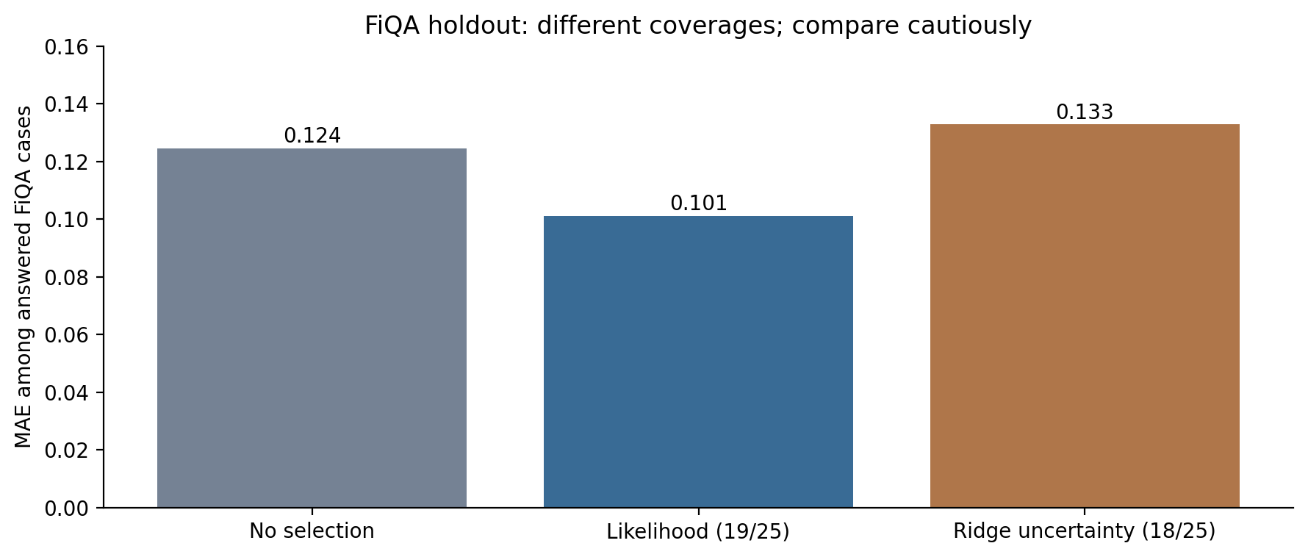
Figure 3. FiQA selective MAE; coverages are not matched, so comparisons are descriptive.
The reported descriptive interval uses a fixed 90th-percentile fit-side absolute error radius of 0.2571 and obtained 96% empirical coverage on 25 holdout cases. This is NOT a proven conformal prediction guarantee. The feature named expected_absolute_error in the B6 prediction file is the model estimate q_hat, not the true error; its role should be made explicit in student analysis.

6. Phase-4C: Why did we run it?
Phase-4C asks whether the completed system is genuinely more reliable than simpler controls. It applies already-frozen B scores and thresholds to the same holdout, generates ablations, computes paired comparisons and records methodology status. It does not retrain the SLM or create a second independent test.

6.1 C1–C10 experiment map
ID | Purpose | What is verified
C1 | Model-written answer | Original generated-answer baseline
C2 | Deterministic program result | Arithmetic reconciliation without new model training
C3 | Structural and literal grounding gates | Reject invalid or suspicious programs; risk/coverage changes
C4 | Likelihood-only abstention | Frozen B1/B2 control at fit-side thresholds
C5 | Verifier/grounding-aware abstention | B3/B4 alternatives, not selected as primary
C6 | Full frozen system | Frozen E5 + deterministic execution + B1 risk + validity gate
C7 | Ablation | Compare components; warns of coverage confounding
C8 | Statistical testing | Paired accuracy bootstrap, McNemar, matched-coverage risk inspection
C9 | Efficiency | Original E5 inference time; verifier/calibrator overhead remains unmeasured
C10 | Methodology freeze | Export final threshold/policy; preserve untouched tests

6.2 C1/C2: corrected numerical answers
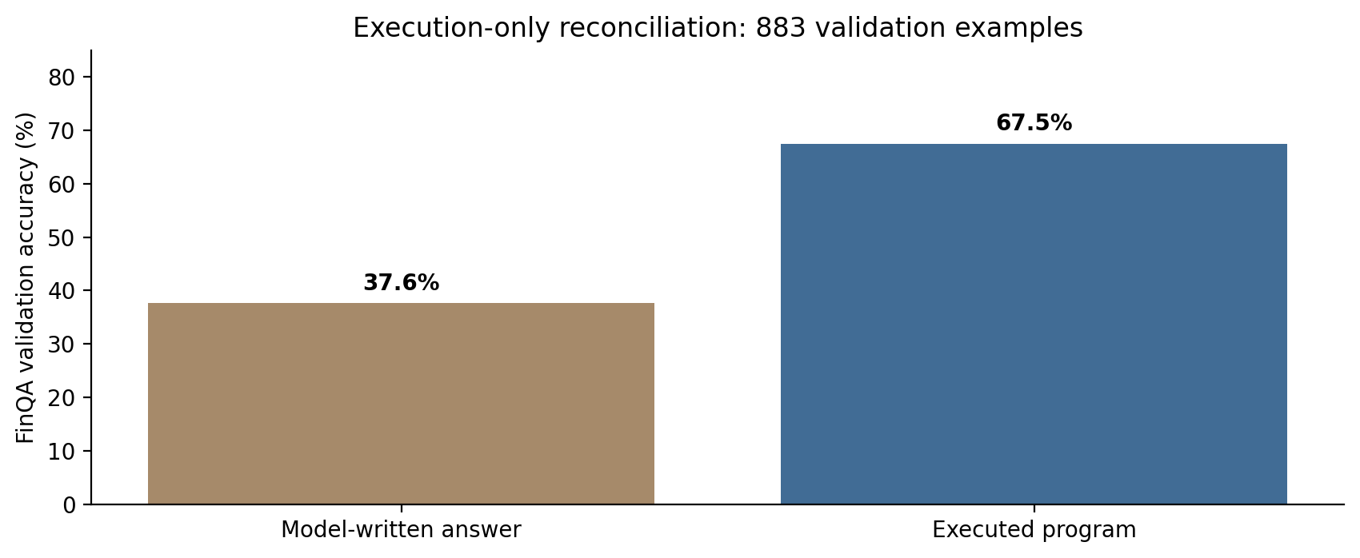
Figure 4. E5 validation written-answer accuracy versus the deterministic execution result.
FinQA evaluation | Written answer | Executed result | Difference
Full validation: 883 records | 332/883 = 37.60% | 596/883 = 67.50% | +29.90 pp
Calibration holdout: 185 | 64/185 = 34.59% | 120/185 = 64.86% | +30.27 pp

The reported full-validation paired analysis found 265 cases where execution is correct but the written answer is wrong, versus only 1 case with the reverse pattern. Exact McNemar p ≈ 4.5×10^-78; the 95% paired bootstrap interval for the full-validation accuracy improvement is about +26.95 to +32.96 pp. This supports execution reconciliation; it does NOT establish novel mathematical reasoning or independent protected-test performance.

6.3 C3–C6: holdout ablations
Method | Coverage | Selective accuracy | Risk
C2 execution-only | 100.00% | 64.86% | 35.14%
C3 structure gate | 99.46% | 65.22% | 34.78%
C3 grounding gate | 96.76% | 66.48% | 33.52%
C4 likelihood B1 | 81.62% | 64.90% | 35.10%
C5 verifier B3 | 77.84% | 66.67% | 33.33%
C5 grounding B4 | 79.46% | 67.35% | 32.65%
C6 full frozen | 81.62% | 64.90% | 35.10%

C7 reports differences relative to execution-only risk, but coverages are unequal. Therefore these differences cannot be interpreted causally as a model-component gain. C8 provides a more useful equal-count comparison, but it is exploratory and does not replace the pre-registered fit-side policy choice. The C8 paired-bootstrap file comparing C6/B1 against B1 gives exactly 0 with interval [0,0] because it compares the identical frozen scoring policy to itself; this is a tautology, not an effect estimate supporting novelty.

7. Independent numerical cross-checks and research integrity
Check | How independently verified | Result
Phase-4B prediction cardinality | Read B1_B4_finqa_holdout_scores.csv | 740 = 185 × 4; IDs align one-to-one
FinQA holdout baseline accuracy | Join Phase-4A execution labels by record_id | 120/185 = 64.86%
B1–B4 ROC-AUC / Brier | Recalculate with sklearn from per-record probabilities | All values match B7 diagnostics
B5 fit-threshold acceptance | Reapply frozen threshold plus structural gate | 151, 151, 144 and 147 accepted
FiQA selective MAE | Join B6 selection masks to 25 true absolute errors | 0.1245, 0.1010 and 0.1328 confirmed
Phase-4C final policy | Inspect frozen Phase-4C JSON | Winner B1_raw, threshold 0.8472787383
Protected test access | Review notebook data loading/readiness declarations | No protected test data indicated in reviewed code/outputs
New independent test from C | Check record IDs / source partitions | None; C reuses B holdout

Verification boundary: source code and outputs demonstrate consistency and reported protocol enforcement. The ZIPs do not include the fitted joblib model files; without them, independent reproduction of all calibrated probabilities from scratch was not possible from these two packages alone. The imported scores themselves can be rechecked against the labels.

8. What does PASS really mean?
Claim | Supported? | Reason
Both notebooks ran successfully | YES | Outputs and structural readiness gates exist
Fit-only winner and thresholds frozen | YES | B8 manifest generated before holdout cell
B1 is the selected risk policy | YES | OOF AURC smallest for B1
B4 improves probability-calibration loss | DESCRIPTIVELY | Best Brier; AURC is worse overall
Frozen full system beats B1 likelihood | NO | Same policy, selected cases, and error rate
Verifier improves semantic program correctness | NOT ESTABLISHED | Grounding is largely numeric-literal presence; no semantic ground-truth verifier
FiQA risk estimator reliable | NOT ESTABLISHED | 25 holdout examples; Ridge selection not superior
FinTrust seven dimensions evaluated | NO | Final FinTrust protocol NOT_VERIFIED
Ready for conference submission | NO | Protected tests, FinTrust protocol, final novelty evidence pending

9. Major limitations the paper must disclose
- AURC-based policy selection chose B1 likelihood; B3/B4 were not validated as the pre-selected final mechanism. Post-hoc holdout observations must not override this choice.
- Raw model likelihood is not a calibrated correctness probability; B1 ECE/Brier are poor despite favorable fit-side ranking.
- B4 improves Brier but does not globally improve AURC; a better average probability does not imply better abstention ranking.
- The 185 FinQA and 25 FiQA cases are validation holdouts, not untouched official test sets; C reuses them.
- FiQA regression uncertainty is evaluated on a small holdout. The 96% empirical interval coverage is descriptive, without a formal coverage guarantee.
- Numerical-literal matching cannot establish that the numbers belong to the correct year, row, accounting item or question.
- The structural program gate rejects very few cases; large errors remain among executable programs.
- Overhead of the verifier and risk estimator is marked NOT_MEASURED in C9. Do not claim deployment-time efficiency of the full system.
- FinTrust official protocol evaluation is NOT_VERIFIED; do not claim seven-dimensional trust improvements.
- Model artifacts are recorded in freeze manifests but not packaged as joblib weights; reproducibility requires preserving the actual fitted calibrators and frozen E5 adapter.

10. Next technical plan for students
Priority | Student task | Acceptance evidence
P0 | Archive frozen model artifacts and package checksums | E5 adapter and B2/B3/B4/B6 joblib hashes; model/tokenizer revisions
P0 | Do not retune the frozen B1 threshold using the holdout | Immutable freeze file and methodology note
P0 | Create a fully locked protected-test inference/evaluation script | Same model + prompts + thresholds; no training or target-label access
P0 | Finalize FinTrust evaluation protocols or narrow trust scope | Official/reproduced metric per dimension; passing fixtures
P0 | Report separate calibration and selection behavior | Brier/ECE vs AURC/risk–coverage results
P1 | Study verifier features on NEW development evidence only | Source-specific, semantic evidence tests; independent rationale examples
P1 | Measure post-processing time and RAM | Real measured additional latency for execution, grounding, calibration
P1 | For stronger claim, replicate key SLM adaptation with more seeds | Seed-wise macro metrics, uncertainty and runtime

Protocol warning: Since the shared validation holdout has now been inspected repeatedly, any change to the risk model or threshold using these observations needs a new clean evaluation design. For this frozen pipeline, the next unbiased performance assessment should be on protected tests, with all policy decisions fixed in advance.

11. Manuscript guidance: what can be written now?
Manuscript part | Ready? | Evidence to use
Introduction & motivation | YES | Financial arithmetic reliability and failure risk
Datasets / split protocol | YES | Phase-2.1 and current 698/185, 92/25 internal validation
Frozen E5 SLM architecture | YES | Phase-3 training metadata and freeze
Program execution reconciliation | YES | C1/C2 and paired tests, labeled validation
Calibration vs ranking analysis | YES | B1–B4 OOF and holdout; separate claims
Verifier-aware superiority claim | NO | Not selected by the primary model-selection criterion
Comprehensive FinTrust claim | NO | Evaluator integration not verified
Protected-test Results section | NO | Cannot write without frozen test evaluations

Scientifically defensible alternative research story: “Efficient multi-task financial SLMs with executable-answer reconciliation and a negative finding about the limits of token likelihood and simple verifier-aware risk features.” A stronger positive trust-aware title or claim requires independent evidence. Preserve the current working title only as provisional.

12. Suggested student work allocation and review questions
Role | Assignment | Verification question
Student 1 — calibration | Explain B1–B4, ECE/Brier/NLL, AURC and threshold policy | Why is B4 better calibrated but not the frozen winner?
Student 2 — FinQA | Explain C1/C2, structural/grounding gates, 284 wrong executions | Why can a program run correctly but answer the wrong question?
Student 3 — FiQA | Explain score regression, selective MAE and sample uncertainty | What does 19/25 coverage imply for the strength of the claim?
Student 4 — statistics | Reproduce paired tests and matched-coverage comparisons | Why is p<0.05 on execution correction not proof of novelty?
Student 5 — reproducibility | Hash all model/calibrator artifacts and finalize evaluation entrypoints | Could a different lab reproduce this exact frozen policy?

Questions for the research meeting
- If B4 has a lower Brier score, why did the selection algorithm choose B1?
- At 80% target coverage, why can measured coverage be 81.62% or 77.84%?
- What is the difference between answer accuracy, execution accuracy and semantic grounding?
- Why does Phase-4C PASS not mean the proposed trust mechanism wins?
- Which claims may safely be used in an abstract before protected tests are opened?

13. Student glossary
Calibration — How closely a predicted 0.7 confidence corresponds to approximately 70% empirical correctness.
ROC-AUC — How well the score orders correct cases ahead of incorrect ones over decision thresholds.
Brier score — Mean squared error between predicted correctness probability and the 0/1 correctness label; lower is better.
ECE — Binned average difference between confidence and observed accuracy; depends on binning and sample size.
AURC — Average risk across ranked coverage levels; lower is better for selective prediction.
Coverage — Fraction of cases for which the model answers rather than abstains.
Selective risk — Error fraction among cases that were answered.
Out-of-fold (OOF) — A prediction for a development case from a model trained without that case.
Freeze — A recorded, immutable model/prompt/threshold policy chosen without using protected tests.
Program execution — Running a generated arithmetic program against financial inputs; not a proof the program matches the intended question.

14. Source artifacts used in this verification
All substantive numerical results in this guide come from the user-supplied executed notebooks and review ZIPs, cross-checked against Phase-4A label files already available in the conversation. No unreported experiments have been silently imputed.
- Phase4B_TrustFin_Calibration_and_Selective_Prediction_executed.ipynb
- Phase4B_Review_Package.zip: tables/B1_B4_fit_oof_comparison.csv, B5_risk_coverage.csv, B6_fiqa_uncertainty.csv, B7_model_diagnostics.csv
- Phase4B_Review_Package.zip: predictions/B1_B4_finqa_holdout_scores.csv, B6_fiqa_holdout_scores.csv
- Phase4B_Review_Package.zip: manifests/B8_fit_only_selection.json, phase4b_freeze.json, phase4b_readiness.json
- Phase4C_TrustFin_Ablation_Statistical_Evaluation_executed.ipynb
- Phase4C_Review_Package.zip: tables/C1_C2_answer_reconciliation.csv, C3_C6_ablation_holdout.csv, C7_component_ablation.csv
- Phase4C_Review_Package.zip: tables/C8_paired_significance.csv, C8_coverage_matched_comparison.csv, C8_fiqa_selective_mae.csv, C9_efficiency.csv
- Phase4C_Review_Package.zip: manifests/phase4_methodology_freeze.json, phase4c_readiness.json
- Phase4A_Review_Package(1).zip: labels/phase4b_finqa_labels.jsonl, labels/phase4b_fiqa_labels.jsonl
Research decision: begin responsible manuscript drafting; do not claim full TrustFin-SLM superiority or submit before the missing evaluation evidence is resolved.

