Purchase – Workflow

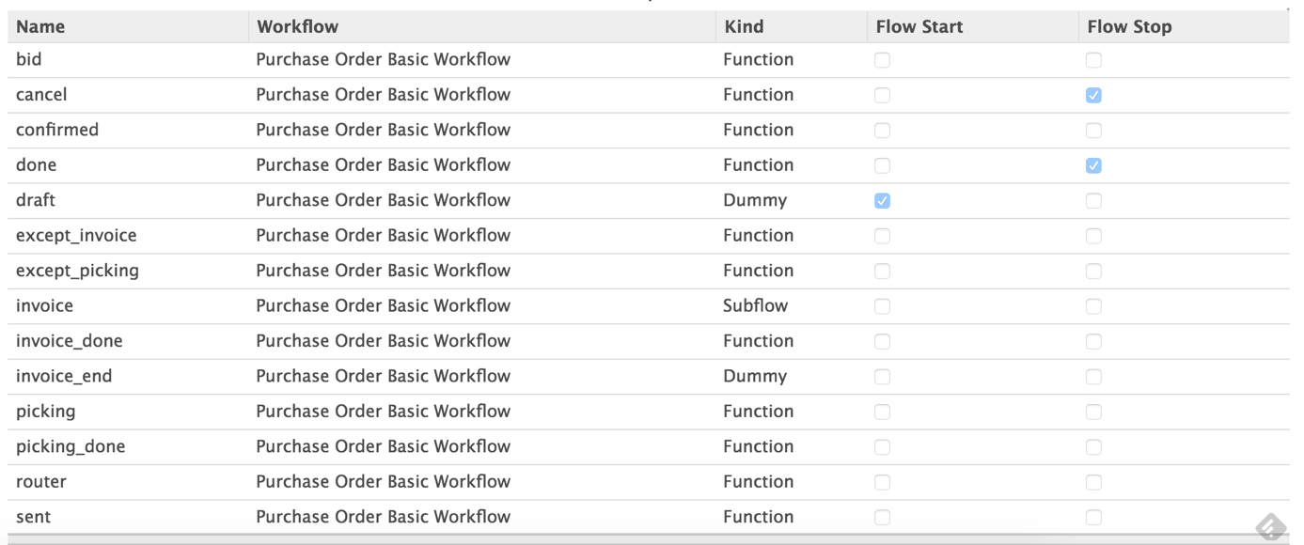

draft -> sent -> to_approve -> purchase -> done

1. purchase_confirm
2. send_rfq
3. purchase_cancel

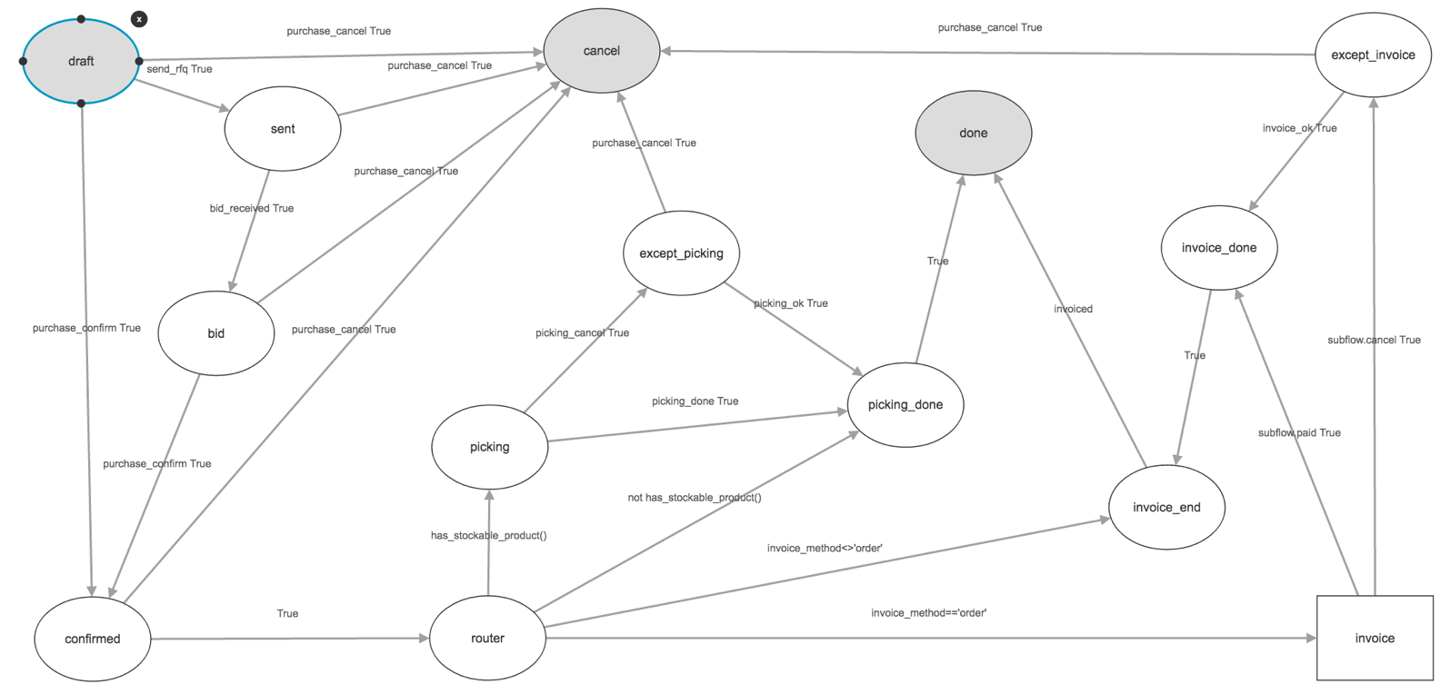

Manufacturing – Workflow

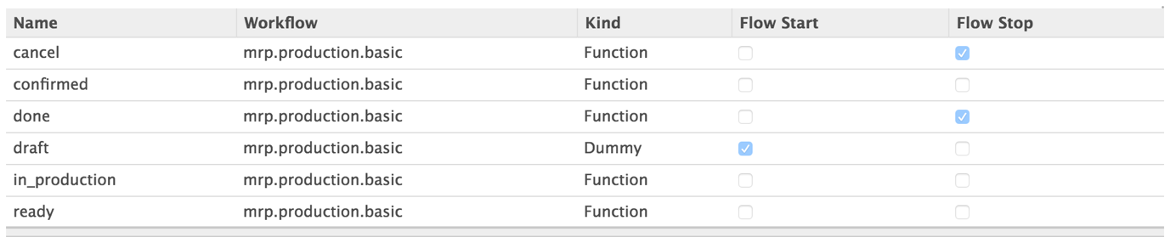

action_confirm()

action_production_end()  
action_in_production()

action_ready()

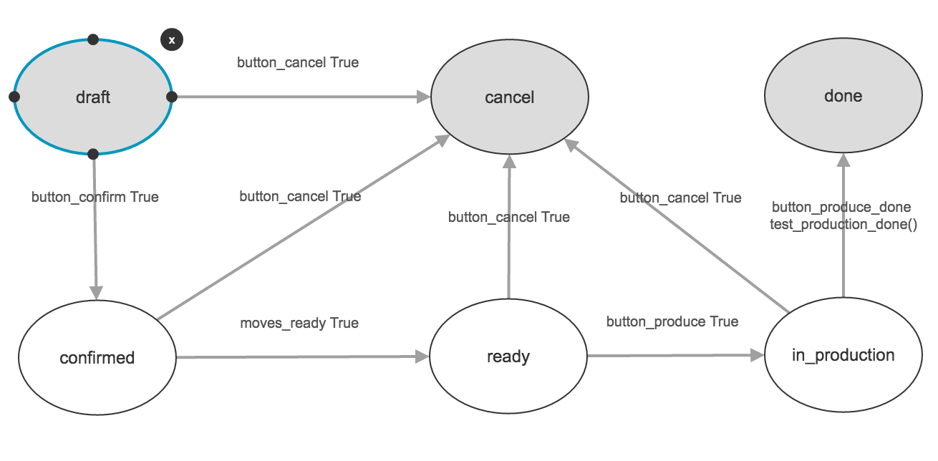

Sale – Workflow

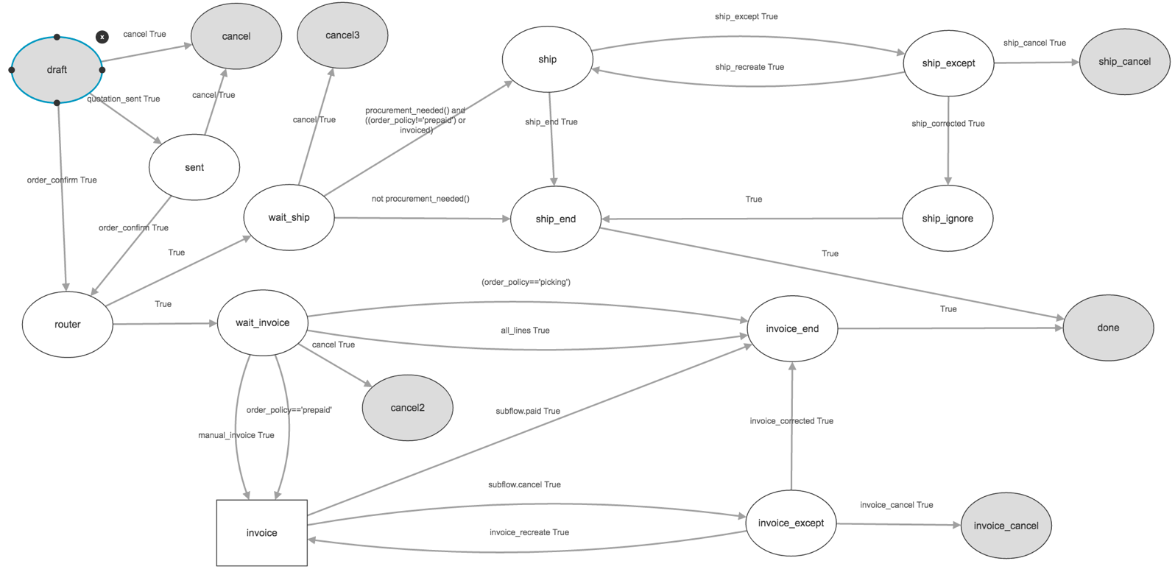

Invoicing

