Slyum – Patch note 1.2

Interface
- New options added to the contextual menu of diagram.
- Rebuild of the properties dialog.
  - Adding “Background gradient” option. By checking this case, you can disable or enable the gradient effect on the background diagram.
  - Adding “Font” panel. You can change the typeface and the size of fonts int Slyum.
  - Adding Graphics tab. You can change the quality of drawing in Slyum for improve performances. Parameter can be “Low”, “Medium” or “Max”.
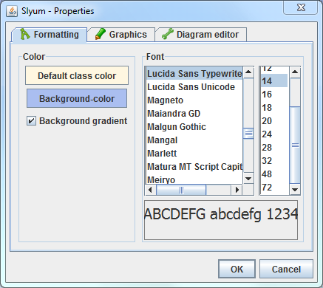
  - Adding “Diagram editor” tab. You can reverse the Ctrl+click function on a relation.
- The properties are now saved in a PROPERTIES file. This file is placed to the same location than Slyum. The first time you launch Slyum, the file will be created.
- The properties view has been rebuilt for look better. See below for details.
- Two buttons remove has been added in attributes and methods panels in entities properties view.
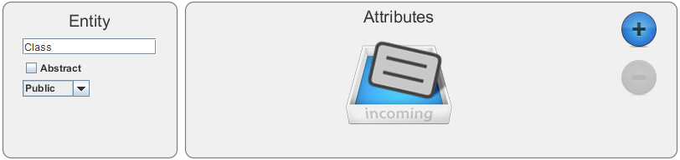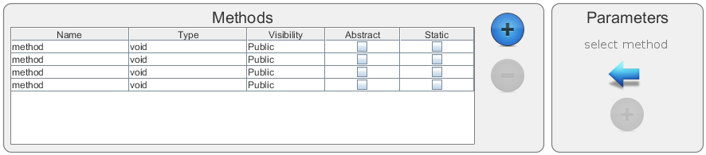
- You can now select an attribute or a method by clicking on it on the diagram.

Bugs

