# Report: group 15

## Framerate issues

There are some framerate issues with your graphical application. Robots seem to stutter when moving, the direction circle within the robot isn’t synchronized with the robots’ movements.

## Crash to desktop when opening a timeline

When we try to open a timeline while having one playing the graphical application crashes. This behavior is undefined as sometimes instead of crashing the application remains opened, but the controls are unresponsive.

## Resizing issues when opening a timeline

When we open a timeline, the size of the entire window is changed to fit the maximum height possible which is inconvenient as we always need to reduce the window’s height to not have a part of the region clipped. Besides that, the resizing is working perfectly which is great.

## Generation with custom constraints and state doesn’t work

When we try to generate a timeline using our own files, the file is not created. We get the following error:

## Setup usage is not provided

No usage nor help is given in the CLI application when we execute it. There is only the following message “*Erreur nombre d’argument invalide*” which is not informative. It might be better if you give a message such as “Missing arguments, usage: setup.exe [state file] [constraints file]”.

## No way to know where the timeline has been generated

There is no way to know where the timeline has been generated after launching the CLI application. Giving the ability to choose the output path and printing in the standard output that the file has been saved to some location would be great and more user-friendly.

## Saving crashes to desktop

When we save a state while having a state loaded, the graphical application crashes. This doesn’t happen if it is a timeline that is loaded.

## Controls

Controls are working fine; we can reset the timeline and the correct state is displayed. You may improve the user experience by disabling controls when no state nor timeline is loaded. This would prevent also undefined behaviors.

Time controls might cause undefined behaviors as we can go further in time than the timeline itself, you should set the maximum value of the time’s spin box to the duration of the timeline.

## Robots’ movement

Straight, curved or stationary movements all work very well. Aside that framerate issue, the calculations are correct!

## Display is cropped

The display is cropped with some of the examples given on Teams.

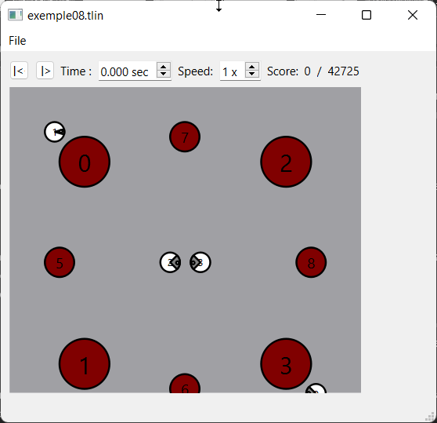

Should you have any questions, please ask us directly on Teams.