**PRACTICAL 1**

**AIM : WWW : Protocols and programs, secure connections, application and development tools, the web browser.**

**WWW:**

* WWW stands for World Wide Web.
* It is a global information medium in which user can read and write via a computer connected to the internet.
* It is a system of internet servers that supports specially formatted documents. The documents are formatted in a markup language called Hyper Text Markup Language (HTML) that supports other documents as well as audio, video and graphics.
* In short WWW is collection of text, pictures, videos, audio and animations that you can access over the internet.
* WWW uses **Hyper Text Transfer Protocol (HTTP)**.

# HTTP Protocol: Request and Response

* Http stands for Hyper Text Transfer Protocol.
* Http is based on the client-server architecture model and a stateless request/response protocol that operates by exchanging messages across a reliable TCP/IP connection.
* HTTP is a stateless protocol means the HTTP Server doesn’t maintain the contextual information about the clients communicating with it and hence we need to maintain sessions in case we need that feature for our Web-applications.

HTTP Request Structure

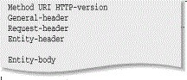

HTTP Response Structure

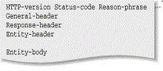

# Web Browser

* Web browser is a client program, software or tool through which we sent HTTP request to web server. The main purpose of web browser is to locate the content on the World Wide Web and display in the shape of web page, image, audio or video form.
* We can also call it a client server because it contacts the web server for desired information. If the requested data is available in the web server data then it will send back the requested information again via web browser.
* Microsoft Internet Explorer, Google Chrome, Mozilla Firefox are examples of web browser and they are more advanced than earlier web browser because they are capable to understand the HTML, JavaScript, AJAX, etc.

# Web Server

* Web server is computer system, which provides the web pages via HTTP. IP address and a domain name is essential for every web server.
* Whenever, you insert a URL or web address into your web browser, this sends request to the web address where domain name of your URL is already saved. Then this server collects all the information of your web page and sends to browser, which you see in form of web page on your browser.
* Lots of web server software is available in the market in shape of NCSA, Apache, Microsoft Netscape. Storing, processing and delivering web pages to clients are its main function. All the communication between client and server takes place via HTTP.

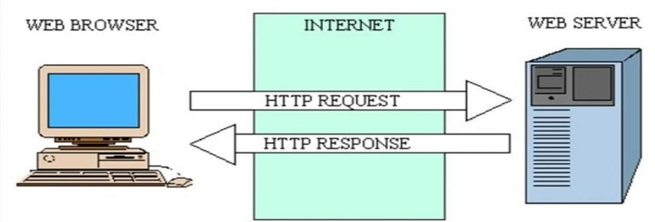

# Secure connections

* Hypertext Transfer Protocol Secure (HTTPS) is an extension of the Hypertext Transfer Protocol (HTTP) for secure communication over a computer network, and is widely used on the Internet.
* A secure connection is a connection that is encrypted by one or more security protocols to ensure the security of data flowing between two or more nodes.
* When a connection is not encrypted, it can be easily listened to by anyone with the knowledge on how to do it, or even prone to threats by malicious software and rogue and unexpected events.
* This method usually needs an appropriate program installed on both computers involved in the connection that will encrypt and decrypt the information.
* Among these are our basic security protocols embedded in main communication protocols like TCP/IP, HTTPS, POP3 or IMAP.

# Web Applications

* A web application is any computer program that performs a specific function by using a web browser as its client.
* The application can be as simple as a message board or a contact form on a website or as complex as a word processor or a multi-player mobile gaming app that you download to your phone.
* Web applications commonly use a combination of server-side script (ASP, PHP, etc.) and client-side script (HTML, JavaScript, etc.) to develop the application.

# Web Developer Tools

* Web development tools (often called Dev-tools) allow web developers to test and debug their code.
* They are different from website builders and integrated development environments (IDEs) in that they do not assist in the direct creation of a webpage, rather they are tools used for testing the user interface of a website or web application.
* Web development tools come as browser add-ons or built-in features in web browsers.
* Web development tools allow developers to work with a variety of web technologies, including HTML, CSS, the DOM, JavaScript, and other components that are handled by the web browser.

**PRACTICAL 2**

**AIM : HTML part1: Basic HTML, formatting and font, commenting code, color, hyperlink list, tables, images.**

<html>

<head>

<title>basic html</title>

</head>

<body background='sky.jpg'>

<center>

<h1>Basics of html</h1>

</center>

<p><b>This is a paragraph with bold text.<b></p>

<p title="hello!">Hover over me.</p>

<img src="flower.jpg" alt="flower" width="50px" height="50px"><br>

<a href="https//www.google.com">www.google.com</a>

<p style="color:pink; background-color:rgb(153, 153, 214); font-size:20px; font-family:verdana">This is a

formatted text.</p>

<!--this comment will not be displayed-->

<p style="border:3px solid rgb(116, 116, 153)">Have a great day</p>

<pre>

This is pre formatted text.

The spaces are not avoided.

<i>This text is italic</i>

</pre>

<p> Following is the list of items:</p>

<ul>

<li>NAMES</li>

<ol><li>heli</li>

<li>priyal</li>

</ol>

<li>NAMES</li>

<ol><li>heli</li>

<li>priyal</li>

</ol>

</ul>

<table border="1px solid black">

<tr><th>Name</th>

<th>Age</th></tr>

<tr><td>heli</td>

<td>2</td></tr>

<tr><td>priyal</td>

<td>3</td></tr>

</table>

</body>

</html>

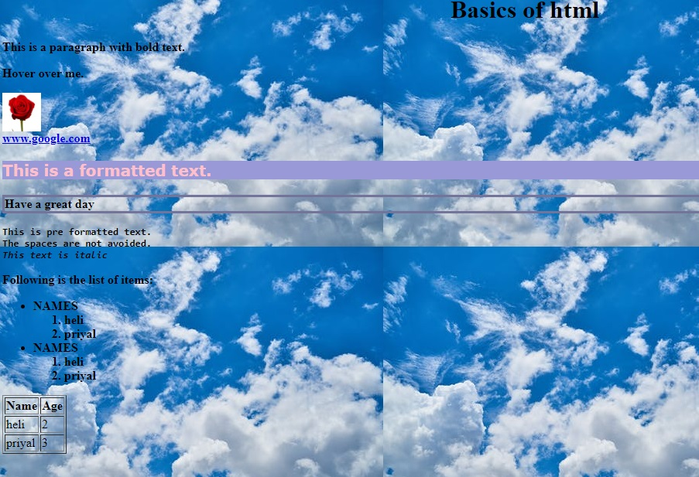

**PRACTICAL 3**

**AIM : HTML part2: HTML forms, containing text, password, textarea, radio button, checkbox, file access, dropdown list, submit button, fieldset and website structure.**

<html>

<head>

<style>

table

{ border-collapse:collapse;

cellspacing:20px;

background-color:black;

color:white

}

</style>

</head>

<body>

<table BORDER="1px solid black" align="center">

<form>

<caption style="color:rgb(17, 3, 48)">

<b>FORM EXAMPLE</b>

</caption>

<tr>

<td>FIRSTNAME:</td>

<td><input type="text" name="firstname"></td>

</tr>

<tr>

<td>LASTNAME:</td>

<td><input type="text" name="lastname"></td>

</tr>

<tr>

<td>PASSWORD:</td>

<td><input type="password" name="password"></td>

</tr>

<tr>

<td>ADDRESS:</td>

<td><TEXTAREA ROWS="5" cols="10"></textarea></td>

</tr>

<tr>

<td>GENDER:</td>

<td><input type="radio" name="male">MALE

<input type="radio" name="female">FEMALE</td>

</tr>

<tr>

<td>COURSES:</td>

<td><select name="courses">

<option value="ENGLISH">ENGLISH</option>

<option value="WEB TECH">WEB TECH</option>

<option value="ECONOMICS">ECONOMICS</option></td>

</tr>

<tr>

<td>YEAR:</td>

<td><input type="CHECKBOX" name="FIRST">1st

<input type="checkbox" name="second">2nd

<input type="checkbox" name="third">3rd</td>

</tr>

<tr>

<td><button type="submit" name="submit">SUBMITT</button></td>

<td><button type="reset" name="reset">RESET</button></td>

</tr>

</form>

</table>

</body>

</html>

