# RATAN TATA: *the 'modest' Indian tycoon*

# A compassionate industrialist who cared about employees and citizens as well as profit.

# The tycoon led the Tata Group - known as a "salt-to-software" conglomerate of more than 100 companies, employing some 660,000 people - for more than two decades. Its annual revenues are in excess of $100bn (£76.5bn).

**Ratan Tata, the former chairman of Tata Sons, is one of India’s most respected business leaders. Under his leadership, the Tata Group transformed into a global conglomerate, expanding its operations across industries such as steel, automobiles, IT services, and more. This case study provides an in-depth analysis of Ratan Tata’s leadership, strategies, challenges, and the** **significance** role he played in shaping the Tata Group, offering insights for Home School of Business students on leadership, innovation, and corporate growth.

Ratan Tata was born in 1937 in a traditional family of Parsis - a highly educated and prosperous community that traces its ancestry to Zoroastrian refugees in India. His parents separated in the 1940s.

During his 21 years as chairman and chief executive, from 1991 to 2012, the Tata Group’s profits multiplied 50 times, with most revenues coming from sales abroad of such recognizable Tata products as Jaguar and Land Rover vehicles and Tetley teas.

Despite the conglomerate’s international outreach, its impact at home remained greater than ever under Mr. Tata’s leadership. For middle-class Indians, it was almost impossible to get through the day without buying Tata goods and services. They awoke to Tata tea, surfed the internet with Tata Photon, watched Tata Sky programs on television, rode in Tata taxis or drove their own Tata cars, and used uncounted products made with Tata steel.

**Beginning in the 2010s, other family-led business groups rivaled or overtook the Tata Group in revenues and valuation. But none of the new magnates enjoyed the public esteem of Mr. Tata, who was renowned for disbursing a majority** of his wealth to philanthropy and for his investments in startup businesses by young, underfinanced entrepreneurs.

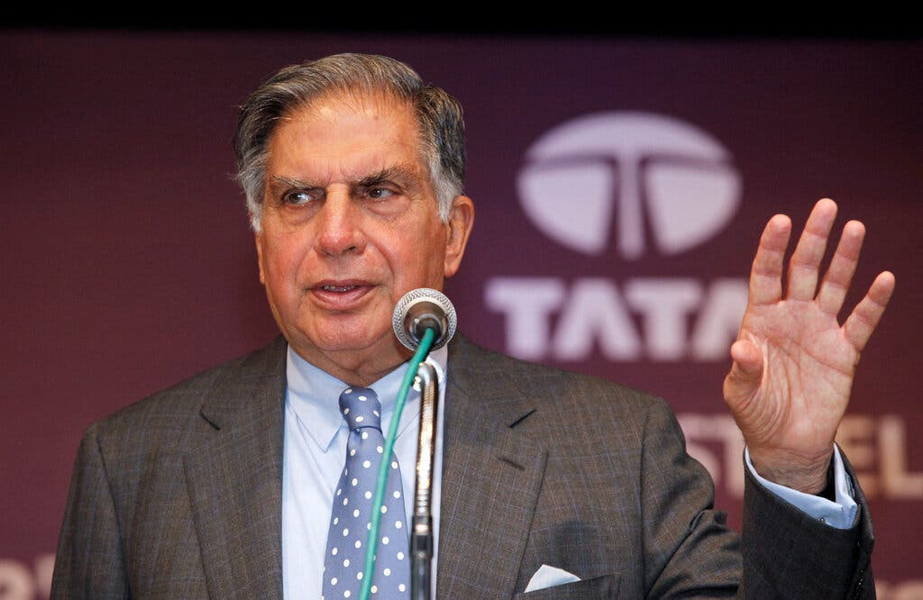

The unusual ownership structure of the Tata Group added to Mr. Tata’s allure. The parent company, Tata Sons Pvt. Ltd., held the majority shares and was itself two-thirds-owned by philanthropic trusts endowed by Tata family members.

Beginning in the 2010s, other family-led business groups rivaled or overtook the Tata Group in revenues and valuation. But none of the new magnates enjoyed the public esteem of Mr. Tata, who was renowned for disbursing a majority of his wealth to philanthropy and for his investments in startup businesses by young, underfinanced entrepreneurs.

The unusual ownership structure of the Tata Group added to Mr. Tata’s allure. The parent company, Tata Sons Pvt. Ltd., held the majority shares and was itself two-thirds-owned by philanthropic trusts endowed by Tata family members.

India’s prime minister, Narendra Modi, called Mr. Tata “a compassionate soul and an extraordinary human being” on Wednesday night, saying he had “an unwavering commitment to making our society better.”

Mr. Tata preferred to stay out of the limelight and projected a public image of a shy loner, a man who never married or had children. But he became ensnared in a major controversy late in his career when he persuaded Tata’s board to oust his handpicked successor. The ensuing legal controversy took years to resolve and was a subject of constant media attention.

Tata took over the group’s reins in 1991, just as India began shedding its socialist-era protectionist policies. He set about transforming the more than century-old industrial group into an innovative, cost and labour-efficient, global conglomerate.

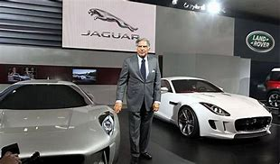

“I would hope that people would say that I was able to lead the group with dignity and that I tried to do the right thing,” Tata said in 2012 of his legacy. “You never succeed, having that said, because you always have upset somebody or another, but I think that’s what I would like to be remembered for.”