Vulnerability Assessment and Penetration Testing (VAPT) Report
PortSwigger Web Security Academy – Minor Project
Practical lab assessment report
Student Name: KOVURI HEMALATHA
Date: 28-09-2026
Batch: Cyber Security July batch-2026

1. Project Scope
This report documents security testing against intentionally vulnerable PortSwigger Web Security Academy labs. The project guide specifies eight vulnerability areas: SQL Injection, XSS, CSRF, CORS, IDOR/API1, API3 BOPLA, API4 Unrestricted Resource Consumption, and SSRF. Each finding must include the lab name, objective, description, affected endpoint, payload, steps to reproduce, Burp evidence, proof of exploitation, impact, recommendation, and severity.
Evidence rule: screenshots for a finding must come from the actual lab session. Do not fabricate evidence.

Finding 1 — SQL Injection
Status: Completed
Lab Name: SQL injection vulnerability in WHERE clause allowing retrieval of hidden data
Vulnerability: SQL Injection
Objective: To identify and exploit the SQL injection vulnerability in the product category filter to retrieve products that are normally hidden from users.
Description: The product category filter is vulnerable to SQL injection because user-supplied input is incorporated into the SQL query. By modifying the category parameter with a SQL injection payload, the application returned products that were normally hidden.
Affected Endpoint: GET /filter?category=Gifts
Payload Used: ' OR 1=1--

Steps to Reproduce
- Open the SQL Injection lab.
- Select the Gifts category.
- Capture the request in Burp Suite.
- Send the request to Burp Repeater.
- Modify the category parameter using the SQL injection payload: ' OR 1=1--
- Send the modified request.
- Observe that the response displays multiple products, including products that were not displayed in the normal Gifts response.
- Verify that the PortSwigger lab status changes to Solved.

Evidence Screenshots
Figure 1: Original request captured in Burp Suite
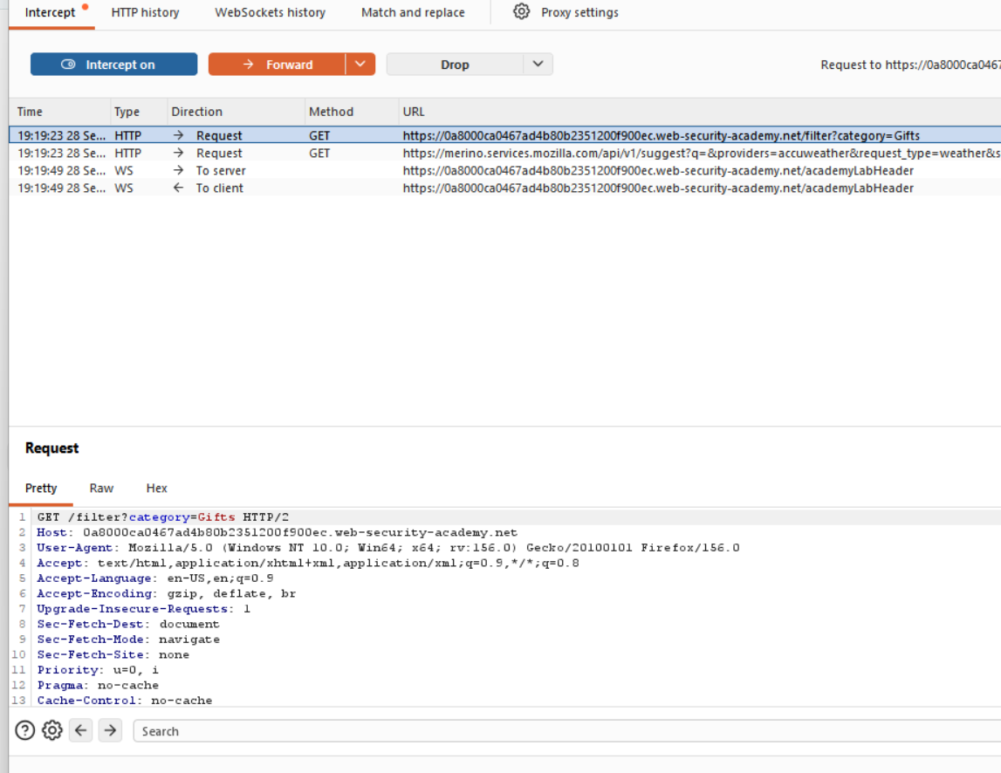
Figure 2: Modified request / SQL injection evidence
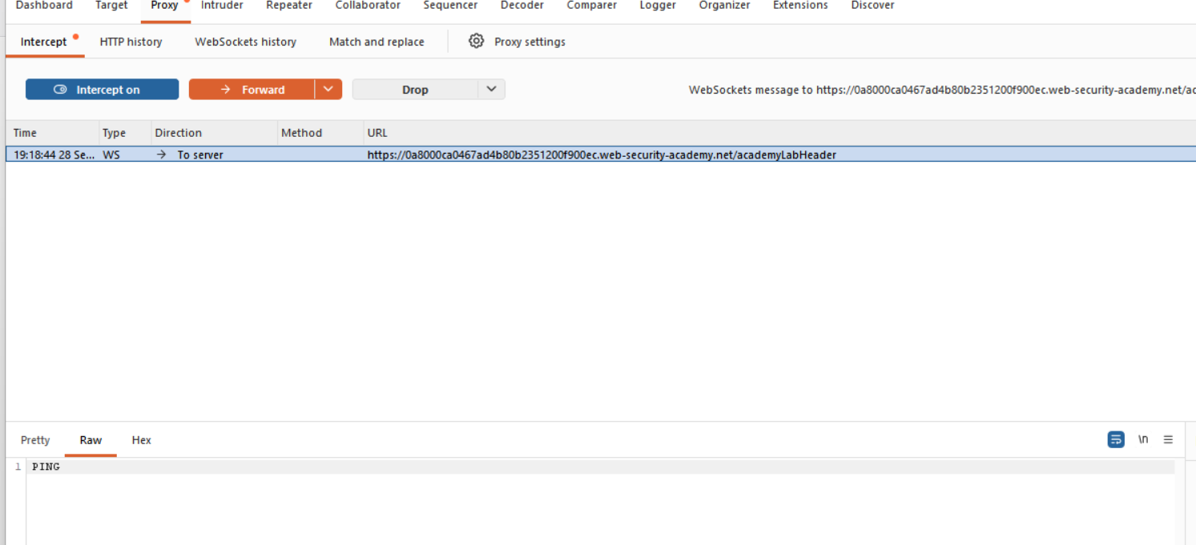
Figure 3: Lab page used during testing
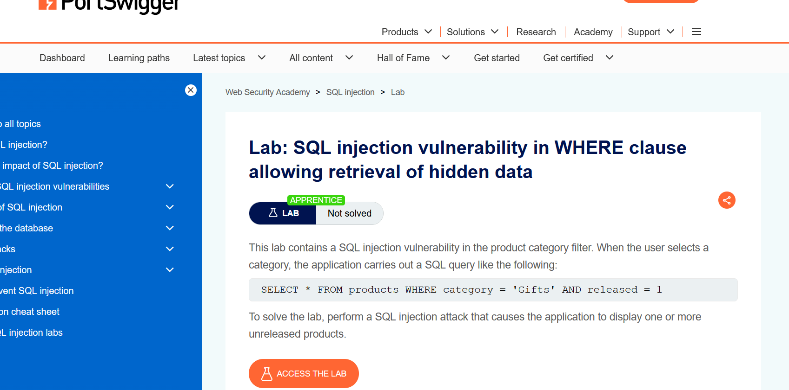
Figure 4: Solved lab proof
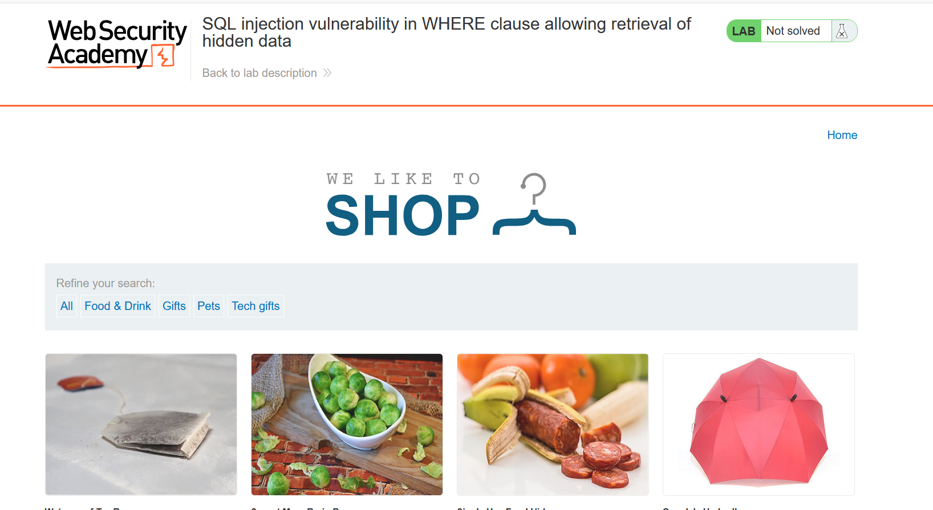

REQUEST:
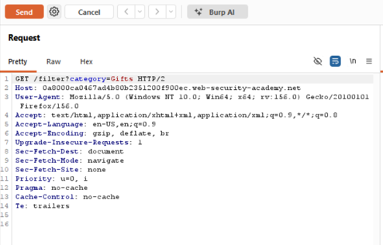

MODIFIED REQUEST:

Impact: Successful SQL injection can allow an attacker to manipulate database queries and retrieve information that should not normally be displayed. In this lab, the injection caused hidden/unreleased products to be returned.
Recommendation: Use parameterized queries or prepared statements instead of directly concatenating user input into SQL queries. Apply appropriate input validation and avoid exposing unnecessary database information through application responses.
Severity: High

Finding 2 — Cross-Site Scripting (XSS)
Status: Pending practical evidence — complete the lab before submission
Lab Name: Reflected XSS into a JavaScript string with single quote and backslash escaped
Objective: Perform a reflected XSS attack that breaks out of a JavaScript string and calls alert(1).
Description: This finding should be finalized from the actual lab behavior and Burp evidence after the lab is solved.
Affected Endpoint: Reflected XSS in the search query tracking functionality.
Payload Used: Search parameter; payload: </script><script>alert(1)</script>

Steps to Reproduce
- Submit a random alphanumeric search string.
- Capture the search request in Burp Suite and send it to Repeater.
- Observe the value reflected inside a JavaScript string.
- Test how quotes are escaped.
- Replace the input with </script><script>alert(1)</script>.
- Verify that the injected JavaScript executes and the lab is solved.

Evidence Screenshots
1. Original Burp Request:
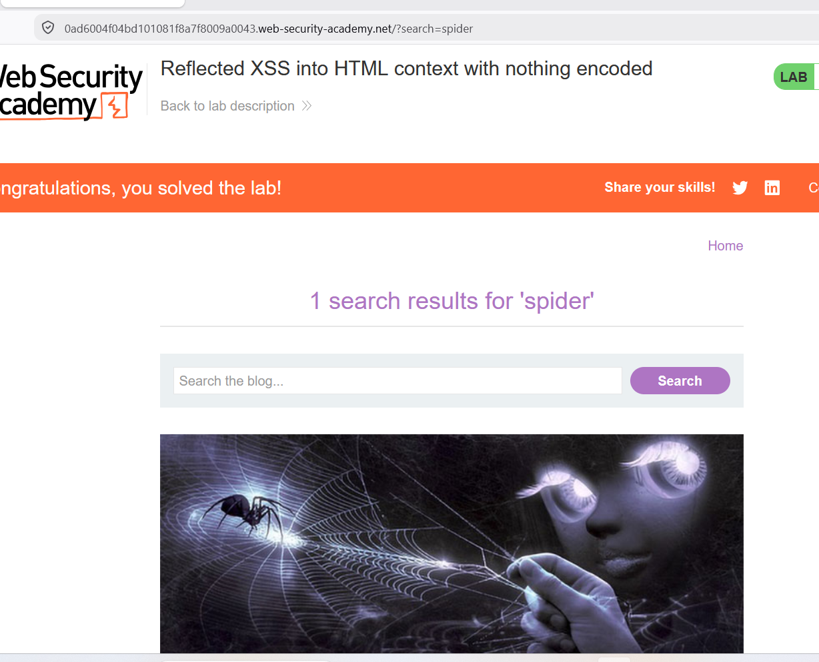
2. Modified Request with Payload:
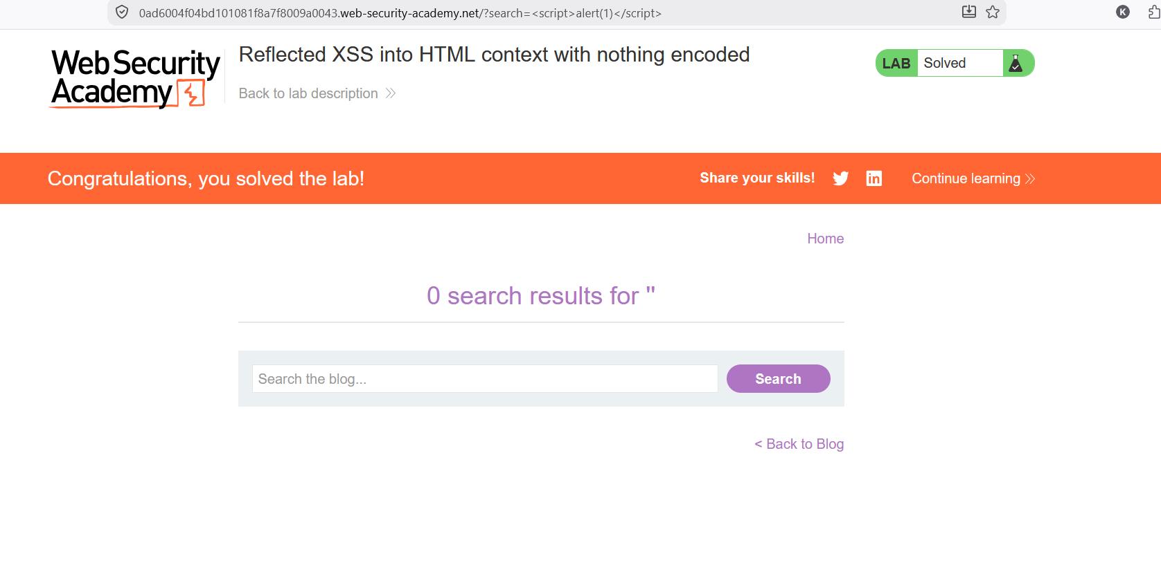
3. Solved Lab Page:
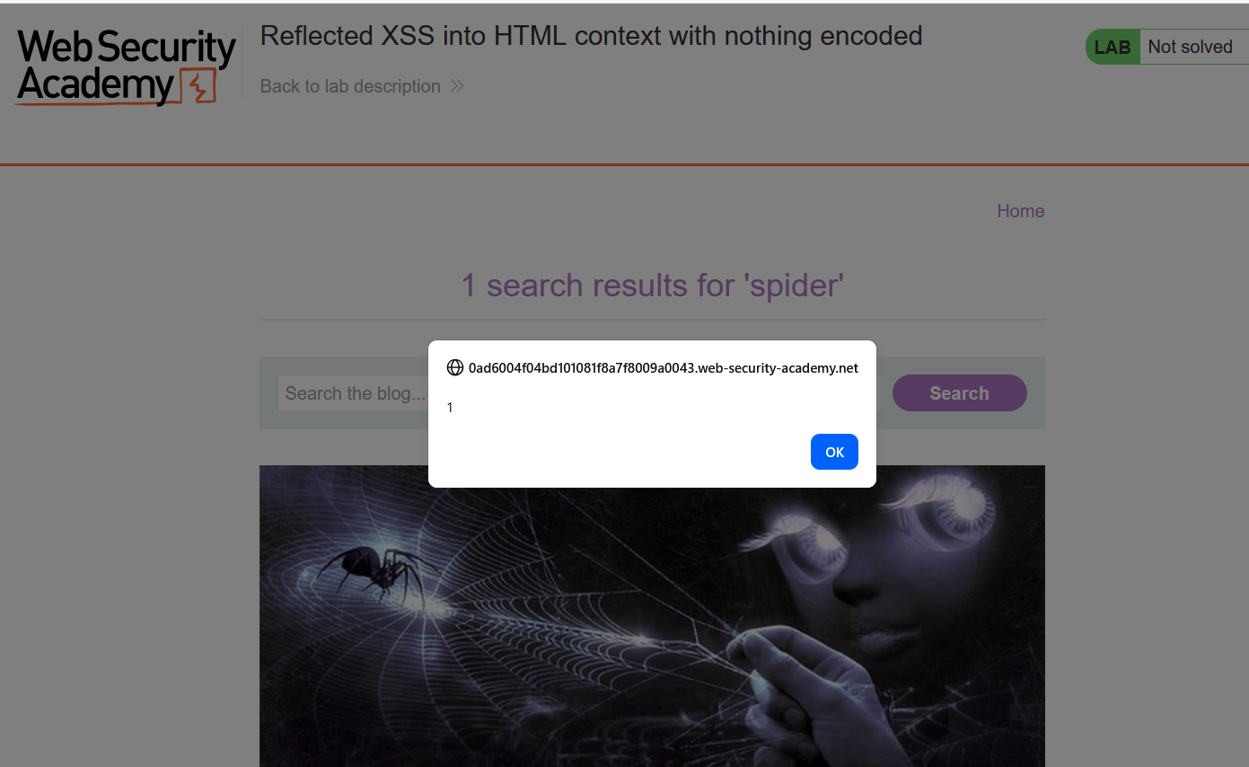
Impact: Complete this section after confirming the exact impact demonstrated by the lab.
Recommendation: Escape output for its actual context, use context-aware encoding, and avoid inserting untrusted input into executable JavaScript.
Severity: High
Source note: PortSwigger Web Security Academy — Reflected XSS in a JavaScript string with single quote and backslash escaped.

Finding 3 — Cross-Site Request Forgery (CSRF)
Status: Pending practical evidence — complete the lab before submission
Lab Name: CSRF where token validation depends on token being present
Objective: Use a cross-site request to change the victim's email address.
Description: This finding should be finalized from the actual lab behavior and Burp evidence after the lab is solved.
Affected Endpoint: POST /my-account/change-email
Payload Used: Remove the csrf parameter; use the lab's generated CSRF proof of concept.

Steps to Reproduce
- Log in to the lab with the provided account.
- Submit the Update email form and capture the request in Burp.
- Send the request to Repeater.
- Change the CSRF token and observe rejection.
- Remove the csrf parameter and observe that the request is accepted.
- Create a CSRF proof of concept on the exploit server.
- Test the exploit and deliver it to the victim to solve the lab.

Evidence Screenshots
1. Original Burp Request: 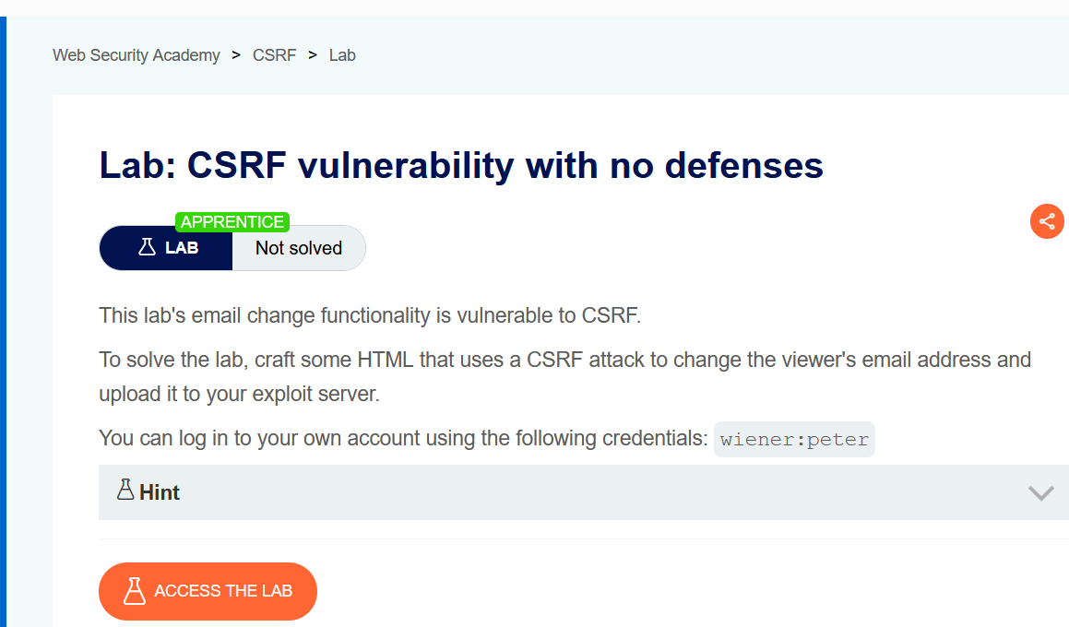
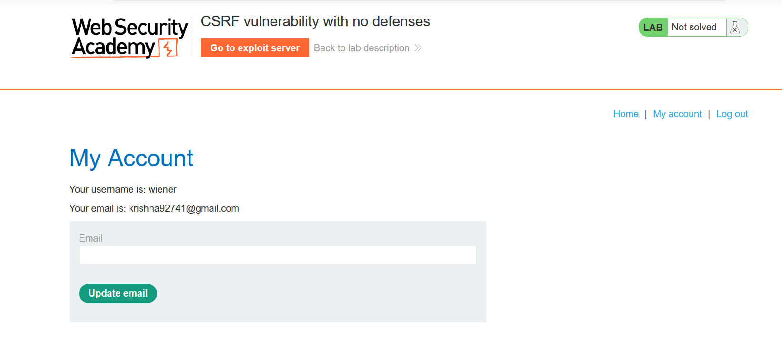
2. Modified Request with Payload:
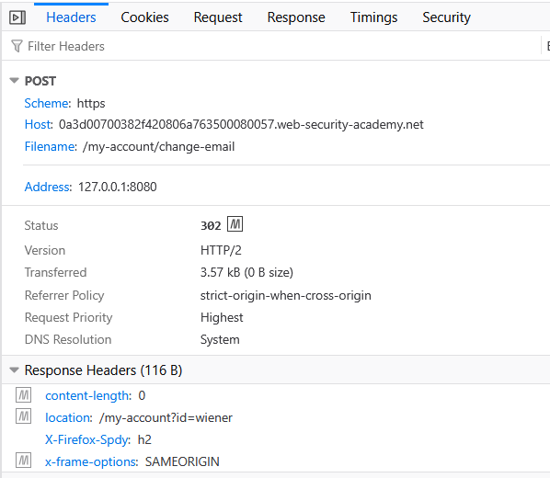
3. Burp Response / Proof of Exploitation:
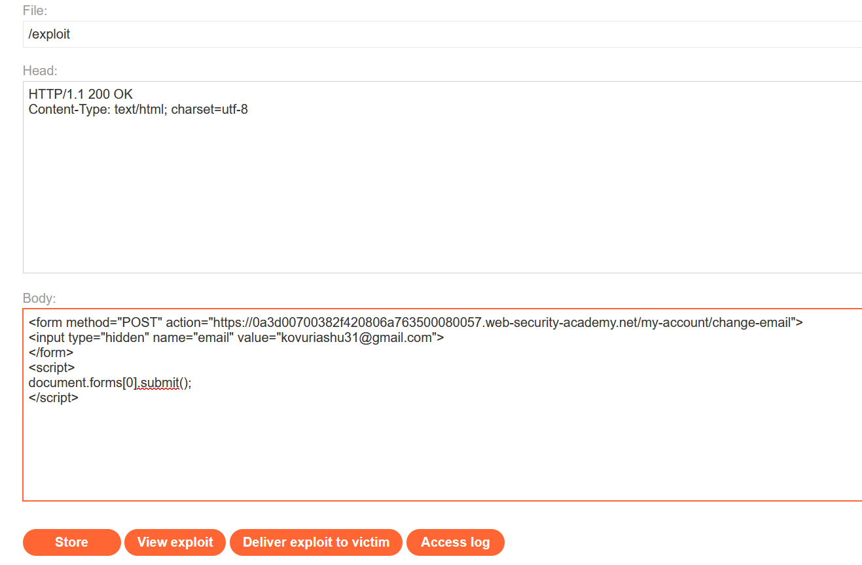
4. Solved Lab Page:
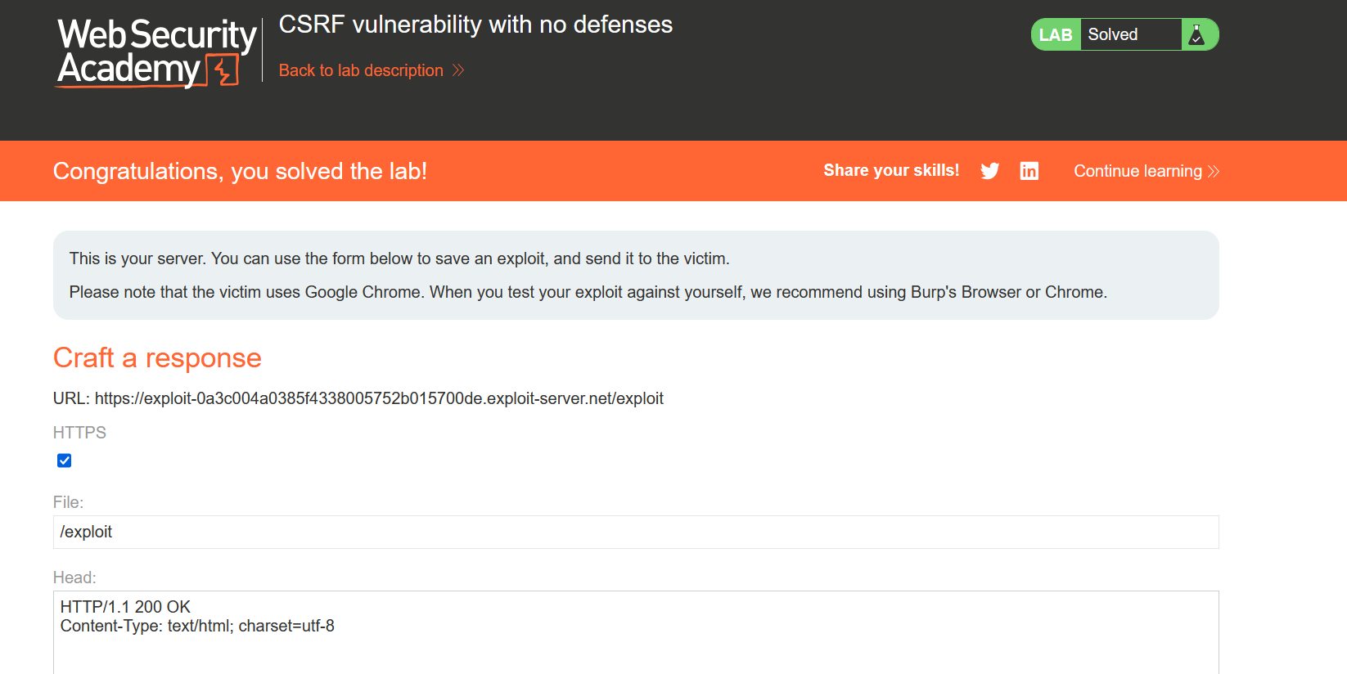

Impact: Complete this section after confirming the exact impact demonstrated by the lab.
Recommendation: Use unpredictable, session-bound CSRF tokens and validate them on every state-changing request. Combine this with appropriate SameSite cookie settings and origin validation.
Severity: Medium
Source note: PortSwigger Web Security Academy — CSRF where token validation depends on token being present.

Finding 4 — Cross-Origin Resource Sharing (CORS)
Status: Pending practical evidence — complete the lab before submission
Lab Name: CORS vulnerability with basic origin reflection
Objective: Use a malicious origin to retrieve the administrator's API key through a CORS-enabled request.
Description: This finding should be finalized from the actual lab behavior and Burp evidence after the lab is solved.
Affected Endpoint: GET /accountDetails
Payload Used: Origin: https://example.com; browser-based XMLHttpRequest with credentials.

Steps to Reproduce
- Log in and access the account page.
- Capture the /accountDetails request in Burp.
- Resend it with an attacker-controlled Origin header.
- Observe that the origin is reflected in Access-Control-Allow-Origin and credentials are permitted.
- Create the CORS proof of concept on the exploit server.
- Deliver the exploit to the victim and retrieve the API key to solve the lab.

Evidence Screenshots
1. Original Burp Request:
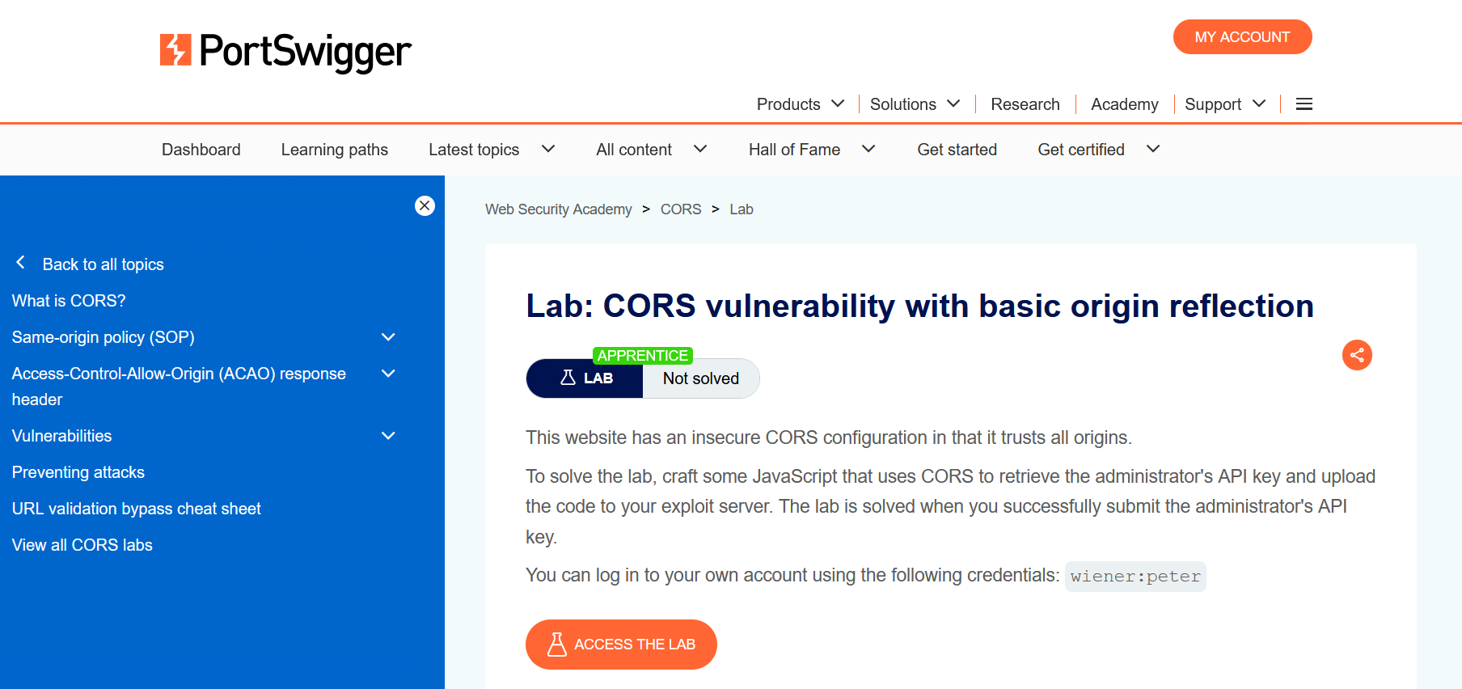
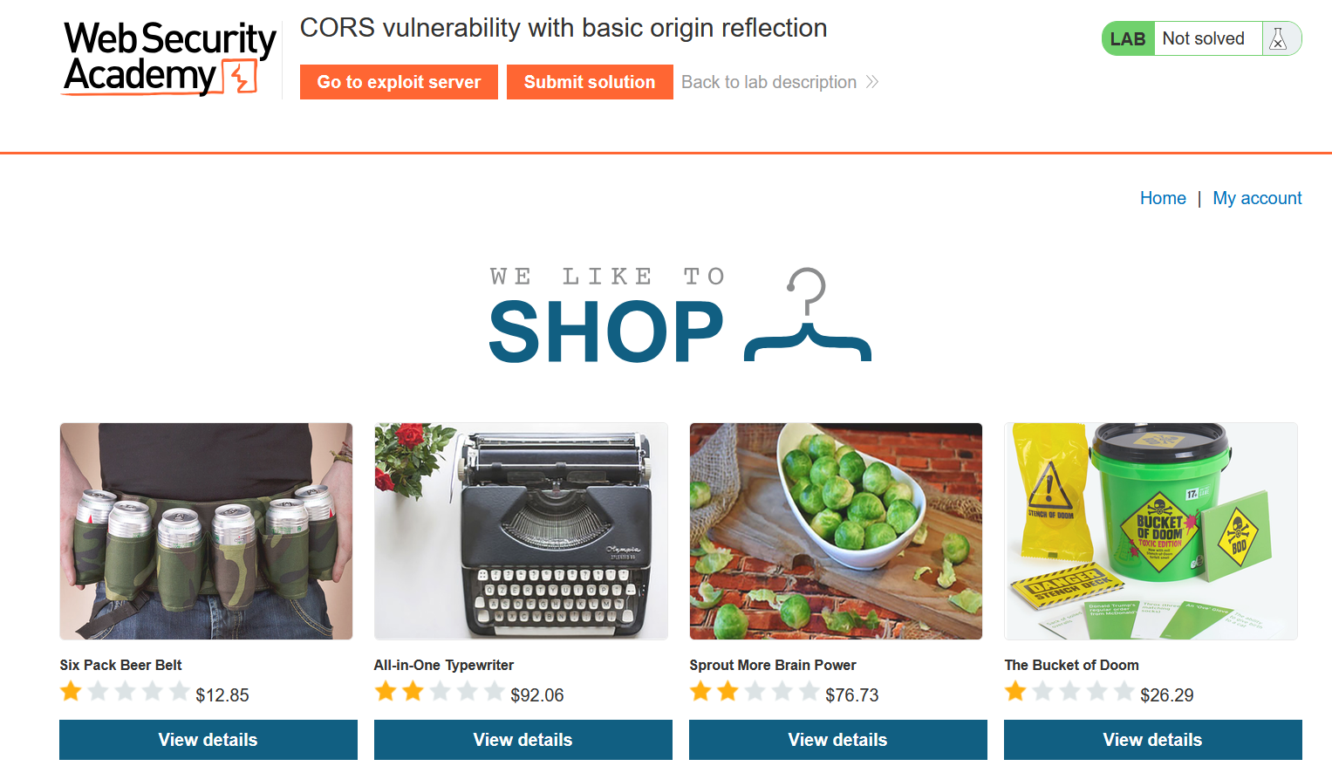
2. Modified Request with Payload:
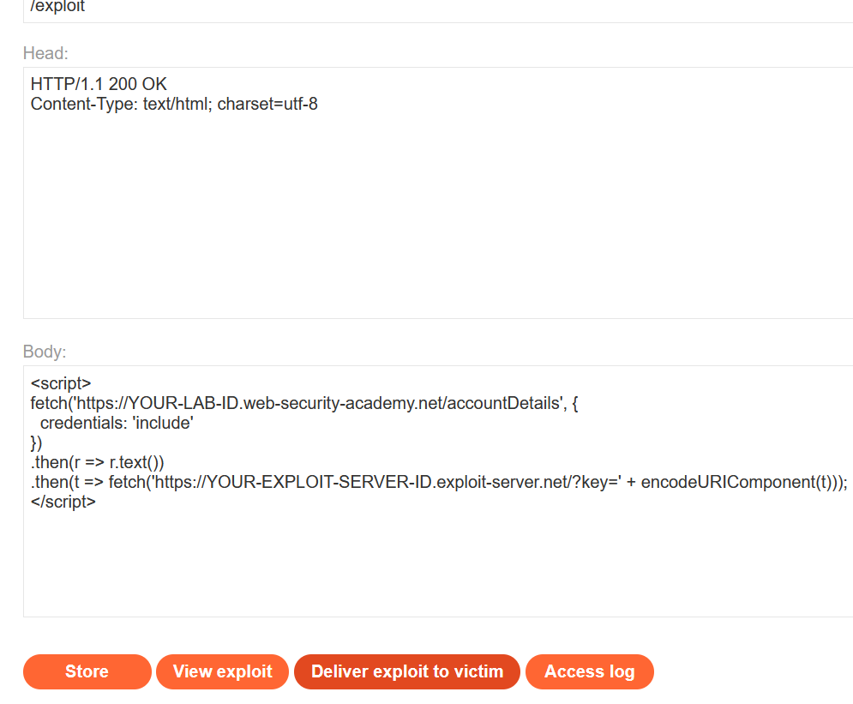
3. Burp Response / Proof of Exploitation:
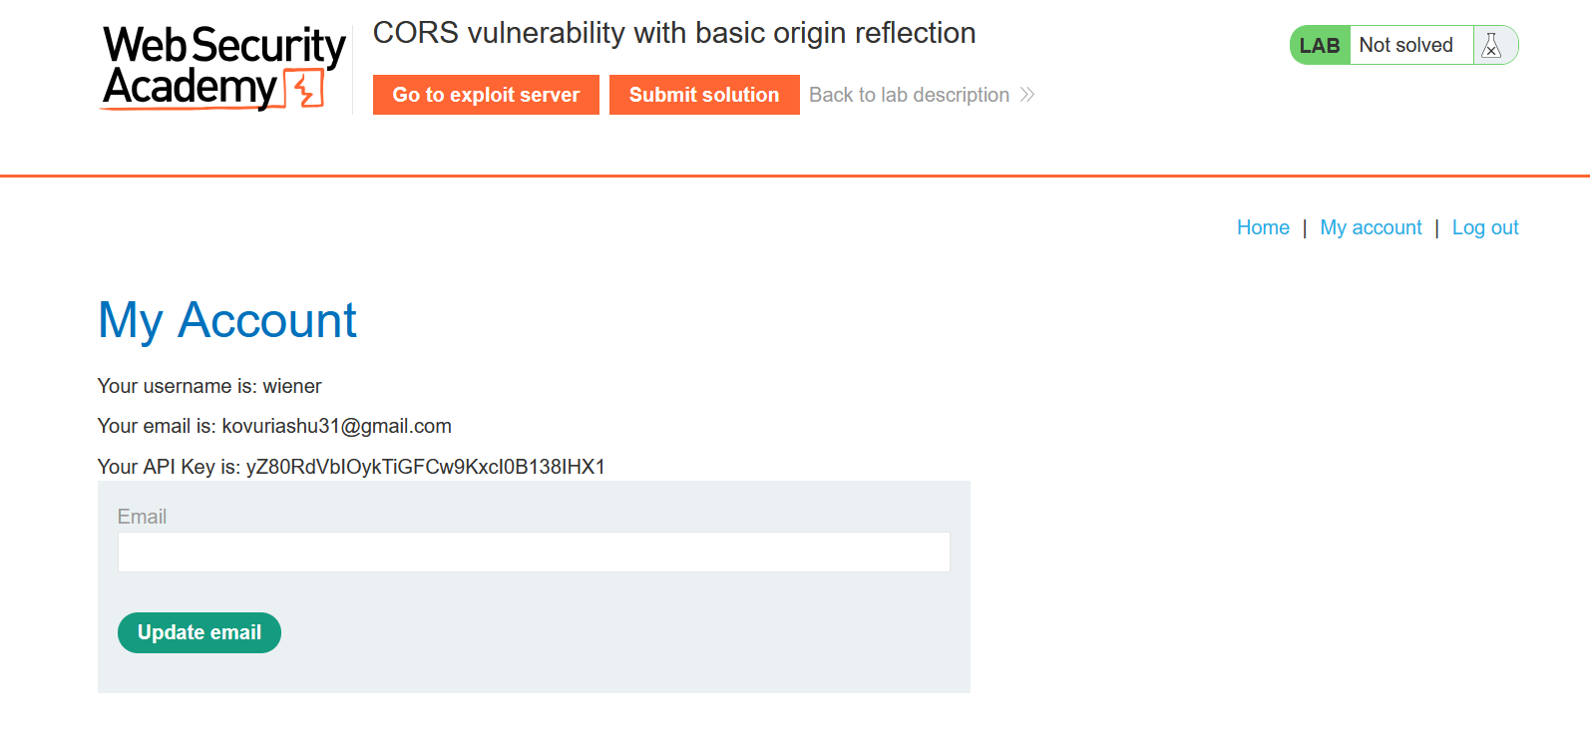
4. Solved Lab Page:
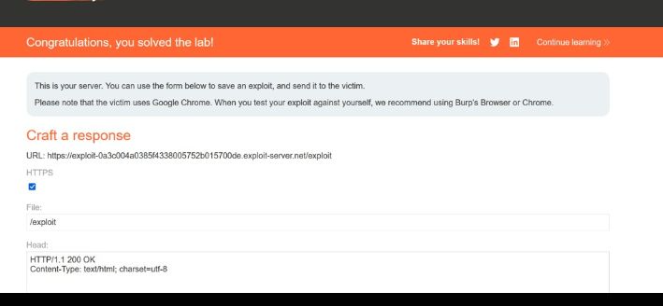
Impact: Complete this section after confirming the exact impact demonstrated by the lab.
Recommendation: Allow only explicitly trusted origins, avoid reflecting arbitrary Origin values, and do not combine arbitrary origins with Access-Control-Allow-Credentials: true.
Severity: High
Source note: PortSwigger Web Security Academy — CORS vulnerability with basic origin reflection.

