ANN Modelling Results

1. Research Design Overview
Problem: Predict school performance in England from socio-economic and institutional factors, with interpretability as the primary research contribution.
Three-target design:
Target | Type | Rationale
Ofsted grade | Classification (4 classes: Inadequate / RI / Good / Outstanding) | Historical study of the pre-September-2024 inspection framework
Progress 8 (P8) | Regression (continuous) | School-effect measure — currently paused due to COVID-cancelled KS2 baseline
Attainment 8 (A8) | Regression (continuous) | Forward-looking predictive target — always published annually

Models trained so far: Ofsted (classification, complete), A8 (regression, complete). P8 next.

2. Input Variables — 16 Features
All three models use the same 16 numeric features:
# | Feature | Source
1 | fsm_pct_2024 | KS4 2023/24
2 | imd_score | IMD 2025
3 | income_score | IMD 2025
4 | employment_score | IMD 2025
5 | health_score | IMD 2025
6 | crime_score | IMD 2025
7 | barriers_score | IMD 2025
8 | living_env_score | IMD 2025
9 | idaci_score | IMD 2025
10 | adult_skills_score | IMD 2025 (leakage-free substitute for edu_skills)
11 | geo_barriers_score | IMD 2025
12 | wider_barriers_score | IMD 2025
13 | indoors_score | IMD 2025
14 | outdoors_score | IMD 2025
15 | p8_2023 | DfE KS4 2022/23 (prior-year performance)
16 | a8_2024 | DfE KS4 2023/24 (prior-year performance)

- Can include up to 52 input features. But for the preliminary study only considered above set of data.
- edu_skills_score was excluded (contains KS2/KS4 attainment — leakage); adult_skills_score was substituted .
- Prior Ofsted grade is also excluded, as it would make the Ofsted classification obvious from previous results.

3. Data Split Sizes (70/15/15)
Target | Train | Validation | Test
Ofsted (classification, stratified) | 1,269 | 272 | 273
A8 (regression, random) | 2,250 | 482 | 483

Stratification (Every split gets its fair share of every class.) used for Ofsted to preserve class proportions; random split for A8 (continuous target). SEED = 42 for reproducibility.

4. Ofsted Classification Results (Test Set — 273 Schools)
Metric: Macro-F1 — averages per-class F1 equally so minority classes matter. Accuracy alone would reward majority-class prediction (68% of schools are Good).
Model | Macro-F1 | Accuracy
Logistic Regression | 0.35 | 0.41
Random Forest | 0.43 | 0.60
ANN (16→64→32→4) | 0.40 | 0.55
ANN unweighted (ablation) | 0.32 | 0.69

ANN architecture: feed-forward 16→64→32→4, ReLU activations, dropout 0.3, approximately 3,300 trainable parameters, early stopping with patience 40 on validation macro-F1.
Class weighting: full inverse-frequency weights (Inadequate 8.35×) proved too aggressive; moderated with power-0.7 transform to (4.42, 1.51, 0.50, 1.43). Ablation without weights confirmed accuracy rose but macro-F1 collapsed. The model reverted to majority prediction, validating both the metric choice and the weighting decision.
Finding: Random Forest slightly outperforms the ANN on this 16-feature set. Consistent with the ML literature for tabular data at this scale.

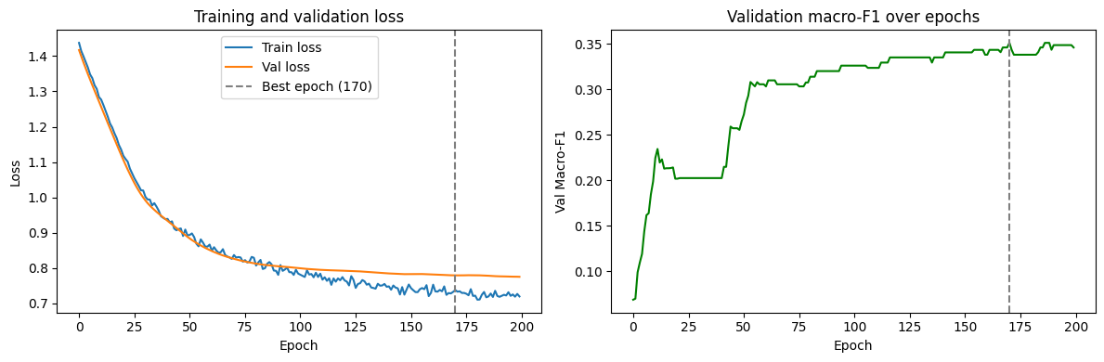

5. A8 Regression Results (Test Set — 483 Schools)
Metrics: R² (coefficient of determination), RMSE (average error), MAE (median error).
Model | R² | RMSE | MAE
Random Forest | 0.890 | 3.02 | —
ANN (16→64→32→1) | 0.901 | 3.03 | 2.33

R² formula (coefficient of determination):
Where:
- SS_res = Sum of Squared Residuals = Σ(actual − predicted)² — how much the model gets wrong
- SS_tot = Total Sum of Squares = Σ(actual − mean)² — how much variance there is in the data overall

ANN architecture: 16→64→32→1 (single continuous output), MSE loss, Adam optimiser (lr=0.001), target standardised during training.
ANN matches Random Forest performance. Unlike Ofsted, where RF beat the ANN, A8 shows parity , both methods find the same ceiling.

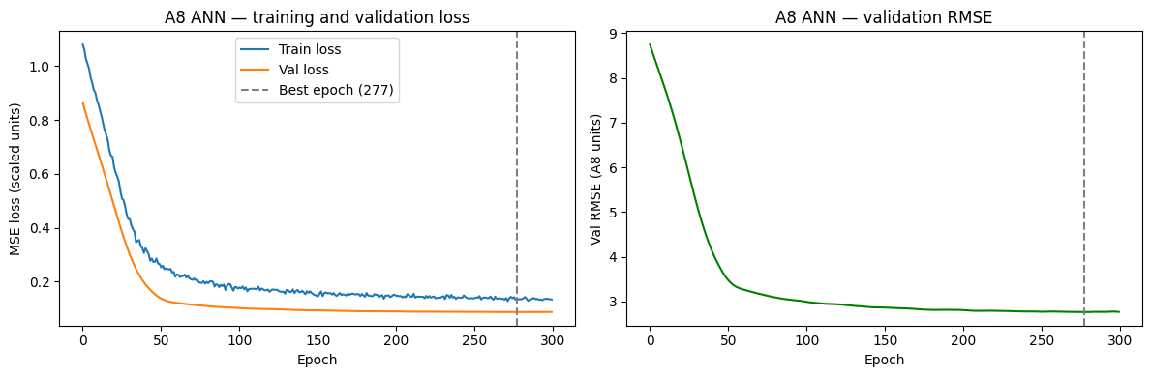

6. Permutation Importance (A8 Model)
Permutation importance measures how much the model's error (RMSE) increases when each feature's values are randomly shuffled. Higher increase = more important feature.
Feature | RMSE increase when shuffled
a8_2024 | 7.77
p8_2023 | 0.64
idaci_score | 0.19
adult_skills_score | 0.14
fsm_pct_2024 | 0.13
income_score | 0.12
wider_barriers_score | 0.10
living_env_score | 0.10
geo_barriers_score | 0.10
indoors_score | 0.09
employment_score | 0.07
barriers_score | 0.06
imd_score | 0.06
outdoors_score | 0.04
health_score | 0.02
crime_score | −0.01

Key interpretation:
- a8_2024 dominates — 12× more important than the next feature. Prior-year A8 is nearly identical to current A8 year-over-year, which inflates the headline R² of 0.90.
- This is temporal auto-correlation leakage — the model is essentially learning "this year's A8 ≈ last year's A8 + small correction", not socio-economic drivers.
- Socio-economic ranking is theoretically coherent: IDACI → adult skills → FSM → income are the top four — exactly what the deprivation literature predicts should matter most for pupil attainment.
- Crime ranked last with slightly negative importance — at LSOA level, crime adds noise rather than signal for school attainment.

7. Ablation Required to Isolate Socio-Economic Signal
Planned next step: retrain the A8 ANN without p8_2023 and a8_2024. Expected R² to drop from 0.90 to approximately 0.40–0.55. The gap between the two R² values is the research-relevant quantity — it attributes the 90% explained variance into "due to prior performance" vs "due to socio-economic factors".

8. SHAP Analysis
SHAP will complement permutation importance by producing per-school, per-feature contribution scores with direction (positive/negative). This answers "why did the model predict this specific school as Inadequate?" — the policy-relevant output.

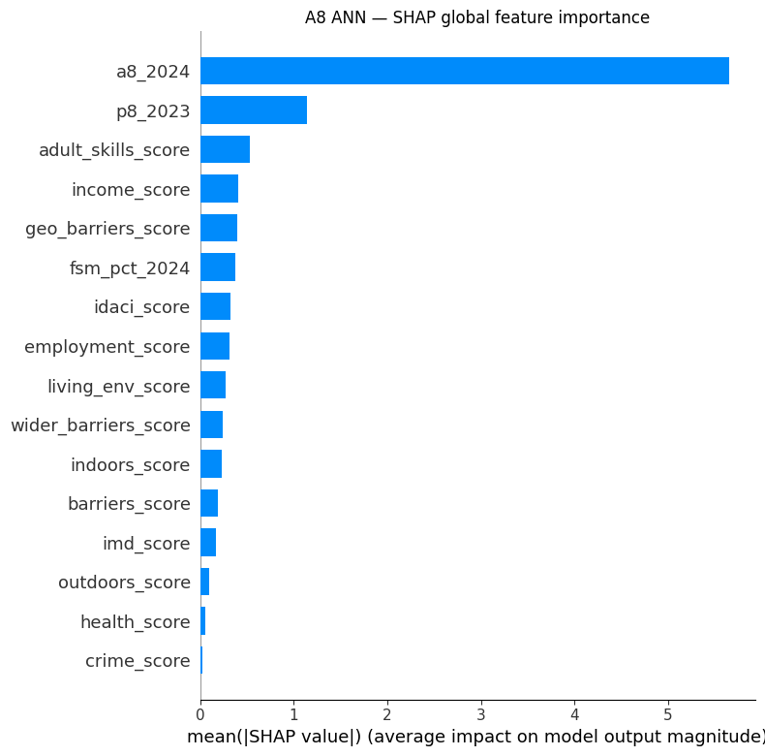

Beeswarm plot

E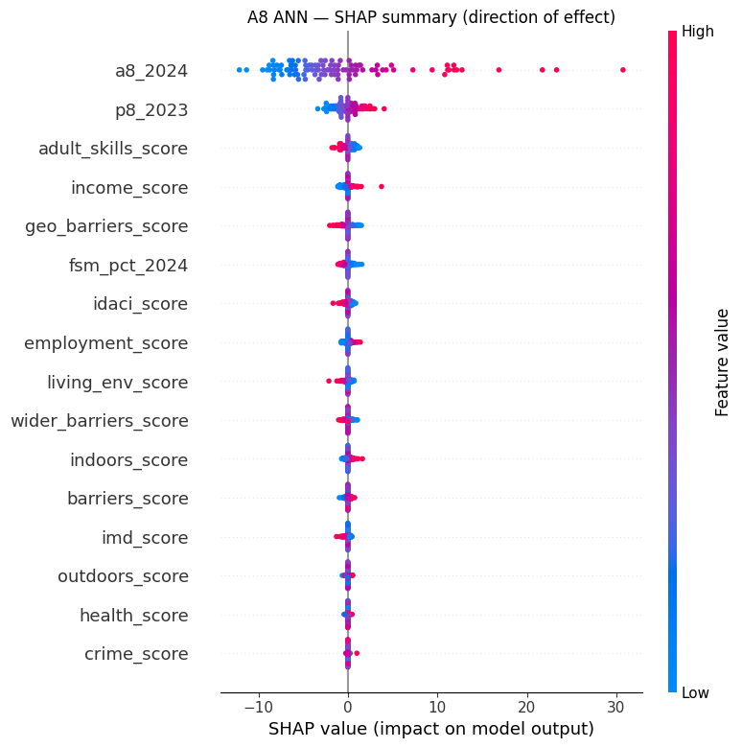

Each dot – one school

Y-axis — features ranked by overall importance (top = most important)

X-axis — SHAP value in A8 units. Negative = pushed prediction down. Positive = pushed prediction up.

Colour — red = high feature value, blue = low feature value, purple = mid-range

A8_2024 dominates and p8_2023 is the second. Red Dots on right and blue dots in the left means high prior A8 pushes current A8 up; low prior A8 pushes it down

But this is different in adult_skills_score. To understand this behaviour, a heat map has been drawn to find the correlations.

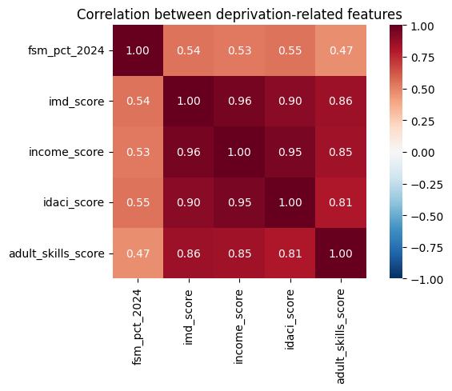

The reversed direction of income_score in the SHAP summary may be due to multicollinearity. The16 features include four closely correlated income-deprivation measures (income_score, idaci_score, fsm_pct_2024, imd_score). SHAP distributes shared variance mathematically among correlated features, which can produce residual-adjustment directions that appear to contradict the underlying causal relationship. The deprivation signal is in fact correctly attributed to fsm_pct_2024 and idaci_score ( both show the expected negative direction ) and income_score acts as a correction once those are accounted for.

Further analysis must carry on how actual data behave on A8.

9. Key Research Findings So Far
- Ofsted classification is hard — no single feature exceeds |r|=0.3 with the grade; even the best model (RF, macro-F1 0.43) misses every Inadequate test school.
- A8 regression achieves high R² but mostly from temporal auto-correlation — ablation needed to isolate the socio-economic features.
- Socio-economic feature ranking is theoretically coherent — IDACI, adult skills and FSM rank as the top socio-economic predictors, consistent with deprivation literature.
- Class weighting is necessary for imbalanced classification — ablation confirmed removing it collapses macro-F1 while raising accuracy, confirming the metric choice.

