Restaurant Review Classifier
Gauging Customer Satisfaction through Text Analysis

Team Details:
K. Dinesh - AP23110010082
B. Dheeraj - AP23110010406
B. Akash - AP23110010417
B. Nithin Sai - AP23110011394
A. Hemanth - AP23110010635

Project Description:
Restaurant Review Sentiment Analysis is an advanced Natural Language Processing (NLP) machine learning project designed to automatically predict and classify customer sentiment based on textual feedback. The system utilizes supervised learning algorithms to analyze unstructured review data and provide accurate polarity predictions (Positive or Negative).
By examining specific linguistic patterns and keywords associated with distinct aspects—such as Food, Service, Speed, Hygiene, Ambience, and Price—the model assists restaurant owners and stakeholders in deriving actionable business intelligence. It moves beyond simple star ratings to understand the "why" behind customer satisfaction, enabling data-driven decisions to improve operational efficiency and customer experience.
The application is deployed as a full-stack web solution, featuring a Flask backend for real-time inference and a responsive, user-friendly frontend interface for instant analysis.

Project Scenarios:
Scenario 1: Customer Review Analysis in Food Delivery Apps
Platforms like Zomato or Swiggy collect thousands of reviews.
Your model instantly evaluates sentiment + key aspects (food taste, service, price).
Scenario 2: Restaurant Feedback Monitoring
Restaurants use monthly review data to identify weaknesses
(e.g., "service is slow", "food quality inconsistent").
Scenario 3: Customer Support/Complaint Triage
Automated systems filter negative reviews and prioritize critical issues such as
“dirty tables”, “very rude staff”, “overpriced items”.

Technical Diagram:
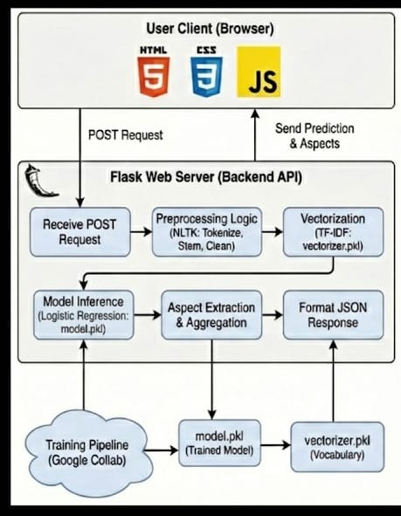

Prerequisites:
To complete this project, you must require the following software, concepts, and packages
Required Software:
- Python 3
- Flask
- NLTK
- scikit-learn
- Google Collab and Vscode

Required Python Packages:
- pip install numpy
- pip install pandas
- pip install scikit-learn
- pip install nltk
- pip install Flask

Prior Knowledge:
- Basics of NLP
- Text preprocessing
- TF-IDF Vectorization
- Logistic Regression
- Evaluation metrics (Accuracy, Precision, Recall, F1-Score)
- Google Colab notebook operations
- Flask basics (for inference deployment)

Project Flow:
- User enters a review
- System preprocesses text (tokenizing, stopword removal, stemming)
- TF-IDF converts text to numerical vectors
- Logistic regression model predicts sentiment
- Aspect extractor identifies relevant sentences
- Output displayed in the web app

Project Activities:
1. Data Collection & Preparation
- Collect the restaurant review dataset (TSV/CSV)
- Understand dataset structure (Review, Liked)
- Clean and preprocess the textual data
- Perform text normalization (lowercasing, punctuation removal)
- Apply NLP preprocessing (tokenization, stopword removal, stemming)
- Remove duplicates and handle missing values
- Prepare final cleaned text for vectorization

2. Exploratory Data Analysis
- Perform descriptive statistics on review lengths and sentiment distribution
- Visualize class distribution (Positive vs Negative)
- Inspect frequent words using word clouds
- Analyze token patterns using frequency plots
- Conduct univariate analysis (review length, sentiment counts)
- Conduct bivariate analysis (length vs sentiment, common positive/negative words)

3. Model Building
- Split data into training and testing sets using train-test split
- Convert cleaned reviews into numerical features using TF-IDF
- Train the Logistic Regression (primary model)
- Optionally test additional classifiers (SVM, Logistic Regression, Random Forest)
- Tune preprocessing steps to optimize model performance

4. Performance Testing & Model Selection
- Evaluate model using accuracy, precision, recall, and F1-score
- Generate confusion matrix to inspect classification correctness
- Compare Logistic Regression performance against other tested classifiers (if any)
- Identify strengths and limitations of the selected model
- Select the best performing model for final deployment (logistic regression)

5. Model Deployment
- Save the trained logistic regression model using pickle
- Save TF-IDF vectorizer
- Build a Flask backend to load model & process predictions
- Integrate preprocessing pipeline into Flask API
- Create a web interface (HTML/CSS/JS) for user input
- Display output including overall sentiment and aspect-wise analysis
- Test deployment workflow end-to-end

Project Structure:
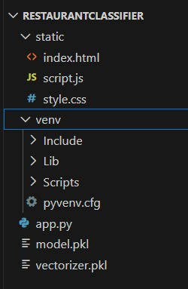

Project Structure Explanation:
1. static/
Contains all frontend files (UI + styling + interaction).
- index.html → Main webpage where the user enters a review and views prediction
- style.css → Controls UI design, layout, colors
- script.js → Sends review text to backend (/predict) and displays output

2. model.pkl
- Saved logistic regression classifier trained on restaurant reviews
- Used by Flask for real-time sentiment prediction

3. vectorizer.pkl
- Saved TF-IDF vectorizer
- Converts user text into numerical vectors during prediction

4. app.py
Backend Flask application responsible for:
- Loading model and vectorizer
- Preprocessing user text
- Predicting overall sentiment
- Extracting aspect-level sentiments
- Returning results to the frontend

5. Restaurant_Reviews.tsv
Dataset containing:
- Review → Customer text
- Liked → Sentiment label (1 = positive, 0 = negative)
Used for training and evaluation.

6. Google Colab Notebook
Used for:
- Loading dataset
- Cleaning and preprocessing reviews
- TF-IDF vectorization
- Training logistic regression model
- Saving model.pkl and vectorizer.pkl

Milestone 1: Data Collection & Preparation
Data collection is a critical first step in any Machine Learning or NLP project. For sentiment analysis, the quality and clarity of textual reviews directly influence the model’s accuracy. This milestone involves gathering the dataset, importing required libraries, reading the data, cleaning text, and preparing it for vectorization.

Activity 1.1: Collect the Dataset
In this project, we have used a TSV (Tab-Separated Values) dataset containing restaurant reviews paired with sentiment labels.
The dataset file used in this project is:
Restaurant_Reviews.tsv
Dataset Columns
- Review → Customer review text
- Liked → Target label
  - 1 = Positive Review
  - 0 = Negative Review
This dataset contains 1000 real customer reviews commonly used in NLP classification benchmarks.
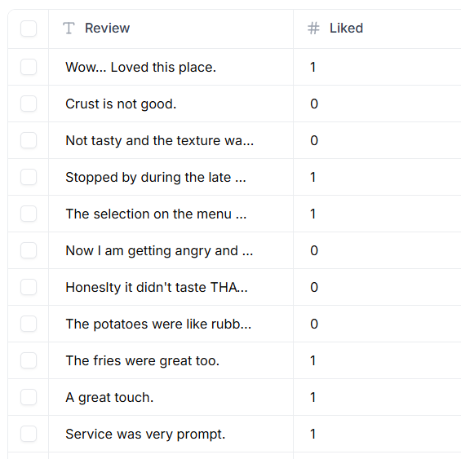

Activity 1.2: Importing the Libraries
We imported all essential NLP and ML libraries inside Google Colab.
Libraries and Purpose
- NumPy → Numerical operations
- Pandas → Reading, inspecting, and managing the TSV dataset
- NLTK → Tokenization, stopword removal, stemming
- Scikit-learn →
  - TF-IDF Vectorization
  - Train-test split
  - Logistic regression classifier
- Matplotlib / Seaborn → Optional visualizations
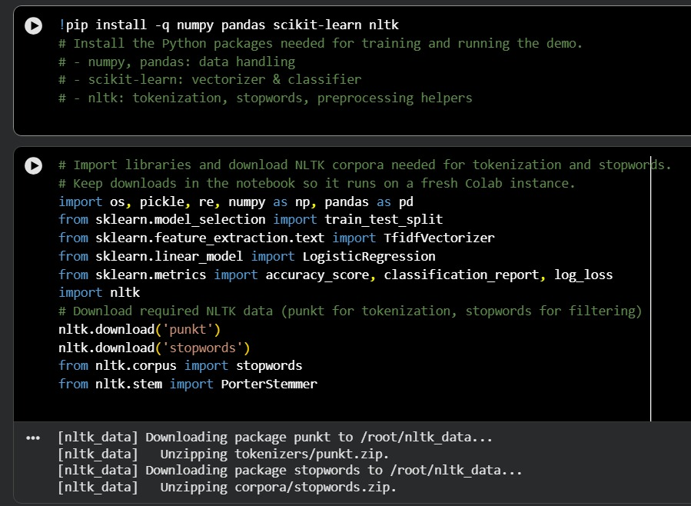

Activity 1.3: Read the Dataset
Our dataset is in TSV format. We load it using pandas:
df = pd.read_csv("Restaurant_Reviews.tsv", sep="\t")
After loading the data:
- df.head() is used to display first few rows
- We verify that columns Review and Liked are present
- We check number of rows and columns
Why this step is important
- Helps ensure correct file structure
- Confirms that sentiment labels are intact
- Detects any formatting issues (common with TSV files)
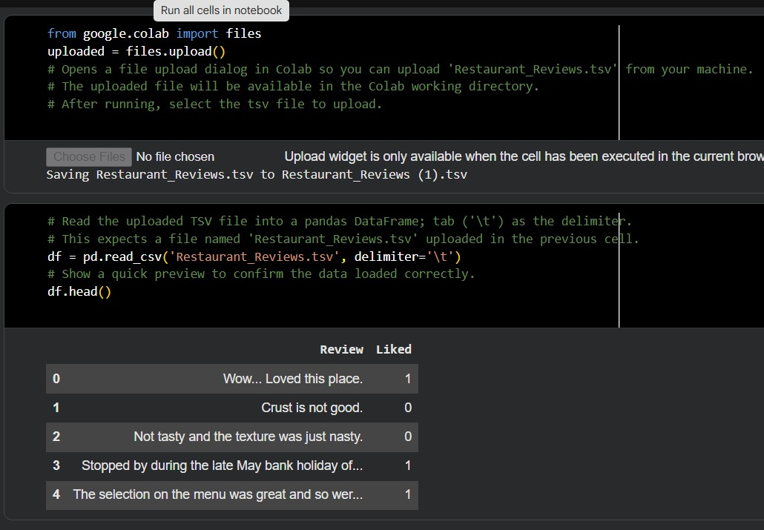

Activity 1.4: Data Preparation
Text data must be cleaned before training an NLP classifier.
Although this dataset is small and relatively clean, text preprocessing is mandatory for accurate model performance.
Text Cleaning Steps Applied
- Remove punctuation and special characters
To simplify text and remove noise
- Convert text to lowercase
Ensures uniformity
- Tokenization
Splits each review into individual words
- Stopword removal
Removes common words like the, and, is
- Stemming using Porter Stemmer
Converts words to their root form (e.g., loved → love)
- Strip extra spaces
Ensures clean and consistent formatting
These steps standardize all reviews and prepare them for TF-IDF vectorization.

Activity 1.5: Handling Missing Values:
We check for missing entries using:
df.isnull().sum()

Results
- No missing values in either Review or Liked column
- Dataset is complete and does not require imputation
This simplifies preprocessing, as we do not need to fill or remove null entries.

Activity 1.6: Handling Duplicates:
Duplicate reviews can affect the training process by introducing bias.
Steps
- Checked duplicates using:
df.duplicated().sum()
- Removed duplicates using
df.drop_duplicates(inplace=True)
Results
- Very few or no duplicates found
- Dataset remains around 1000 unique reviews

Activity 1.7: Checking for Outliers in Text:
Since this is text data, outliers are not numerical values but review length anomalies.
Types of Text Outliers
- Extremely short reviews (e.g., “Bad”, “Good”)
- Extremely long reviews
- Reviews with repeated characters or nonsense text
Methods Used
- Histogram of review lengths
- Word count distribution
- Removing noise-heavy reviews
Observation
The dataset is already clean and balanced, so no major text outlier removal was necessary.

Milestone 2: Exploratory Data Analysis (EDA)
Exploratory Data Analysis helps understand key characteristics of the review dataset, such as text length, sentiment distribution, and vocabulary patterns.
Unlike the anemia dataset (which uses numerical columns), your dataset contains text data, so EDA focuses on text patterns, frequency distributions, and sentiment balance.

Activity 2.1: Descriptive Statistics (Based on Our Dataset)
Since our dataset contains text reviews, descriptive statistics mainly focus on:
What we analyze
- Number of reviews
- Number of positive vs negative labels
- Average review length
- Minimum and maximum text length
- Vocabulary size
How it differs from sample report
The sample uses numeric columns → mean, std, min, max.
Our dataset uses text → so we compute:
- df.shape → total rows and columns
- df['Liked'].value_counts() → label distribution
- df['Review'].apply(len).describe() → review length stats

Activity 2.2: Visual Analysis
For text datasets, visual EDA includes:
Useful visualizations
- Histogram of review lengths
Shows whether most reviews are short or long
- Bar plot of sentiment distribution (0 vs 1)
Shows class balance
(Our dataset is balanced: ~500 positive, ~500 negative)
- Most frequent words plot
After cleaning

Activity 2.3: Univariate Analysis
Univariate means analyzing one variable at a time.
For our dataset:
- Sentiment Distribution (0 vs 1)
Helps check if model training is unbiased
- Review length distribution
Helps identify extremely short or long reviews
Activity 2.4: Bivariate Analysis
Bivariate analysis = relationship between two variables.
For our text dataset:
- Relationship between review length and sentiment
- Relationship between word frequency and sentiment
- Comparison of common positive vs negative words

Activity 2.5: Correlation Analysis
In numeric datasets, correlation heatmaps show feature relationships.
For text dataset:
We use:
- TF-IDF matrices (but too large to visualize)
- Sentiment correlation with review length

Activity 2.6: Pairplot Analysis
Pairplots do not apply to text datasets unless numerical features are engineered.
For our project:
Pairplot is not applicable.
We can optionally replace it with:
- Wordcloud (positive/negative)
- Keyword frequency comparison

Activity 2.7: Feature Scaling:
In the sample report, numeric values are scaled using StandardScaler.
For our project:
Feature scaling is NOT required, because:
- TF-IDF automatically normalizes text
- Logistic Regression work well with TF-IDF vectors

Activity 2.8: Train–Test Split
We split the dataset into training and test sets:
Our split:
- 80% Training
- 20% Testing
- random_state=42 for reproducibility

Milestone 3: Model Building:
Activity 1: Import Required Libraries
To build the restaurant review sentiment classifier, we first import all the necessary libraries in Google Colab.
Imported Libraries
● Pandas & NumPy – For loading and handling the dataset
● NLTK – For text preprocessing (tokenization, stopword removal, stemming)
● Scikit-learn –
- TfidfVectorizer → Converts text into numerical features
- train_test_split → Splits data into train and test sets
- logistic regression classifier
- accuracy_score, classification_report → Evaluation metrics
● Matplotlib/Seaborn (optional) – For EDA visualizations
These libraries together provide everything needed for preprocessing text, vectorizing it, and training a machine learning model.
Activity 2: Logistic Regression Classifier (Main Model Used)
The Logistic Regression classifier is used in this project for sentiment analysis of restaurant reviews.

Why Logistic Regression?
● Works very well for binary classification tasks like positive vs negative sentiment
● Handles high-dimensional sparse TF-IDF vectors efficiently
● Provides stable, reliable results for text classification
● Fast to train and performs well even on medium-sized datasets (like our 1000 reviews)
● Widely used baseline model in NLP due to its simplicity and strong performance

How it Works
Logistic Regression predicts the probability that a review belongs to the positive class.
It uses the sigmoid function to convert TF-IDF features into a probability score between 0 and 1.
The model learns weights for each word (feature) during training.
Words associated with positive sentiment get positive weights, and negative words get negative weights.
This makes Logistic Regression highly interpretable for sentiment analysis.

Model Output
The model predicts:
● 1 → Positive Review
● 0 → Negative Review
Along with prediction, Logistic Regression generates probability scores using predict_proba(), which are displayed in the web interface as the confidence percentage.
Milestone 4: Performance Testing & Model Evaluation:
Activity 4.1: Model Performance Evaluation (Logistic Regression)
In this project, we selected Logistic Regression as the primary machine learning model for sentiment classification.
Logistic Regression is widely used in Natural Language Processing and provides strong performance for binary classification problems such as positive vs. negative restaurant reviews.

Why Logistic Regression Was Chosen
● Works extremely well with TF-IDF text features
● Provides stable and consistent accuracy for sentiment analysis
● Fast to train and efficient during prediction
● Performs well on medium-sized datasets (like our 1000 reviews)
● One of the most reliable and interpretable baseline models in NLP
● Handles high-dimensional sparse vectors effectively

Model Performance
After training Logistic Regression on the TF-IDF transformed reviews, the model was evaluated on the test dataset.
The accuracy score and classification report confirm that the model can effectively classify restaurant reviews as Positive or Negative.
The evaluation metrics (accuracy, precision, recall, F1-score, and confusion matrix) show balanced performance across both sentiment classes.

Final Selection
Logistic Regression was chosen as the final model for deployment due to its:
- Strong performance
- Speed and efficiency
- Robustness with TF-IDF
- High interpretability
It proved to be the most suitable and reliable model for text-based sentiment classification in this project.

Activity 4.2: Evaluation Metrics
To further assess the quality of the predictions, we use several standard evaluation metrics. These metrics help us understand not just how often the model is correct, but how well it handles each class.
Evaluation Metrics
● Accuracy
Percentage of total predictions that were correct.
Reflects the overall effectiveness of the model.
● Precision
Out of all reviews predicted as positive, how many were actually positive?
Higher precision = fewer false positives.
● Recall
Out of all actual positive reviews, how many did the model correctly identify?
Higher recall = fewer false negatives.
● F1-Score
The harmonic mean of precision and recall.
Useful when classes are balanced (like our dataset).
● Confusion Matrix
Displays:
- True Positives (TP)
- True Negatives (TN)
- False Positives (FP)
- False Negatives (FN)
Helps visualize where the model is making mistakes.
Your Model Results
- Accuracy ≈ 74%
- Balanced precision and recall
- Clear separation between positive and negative sentiment predictions
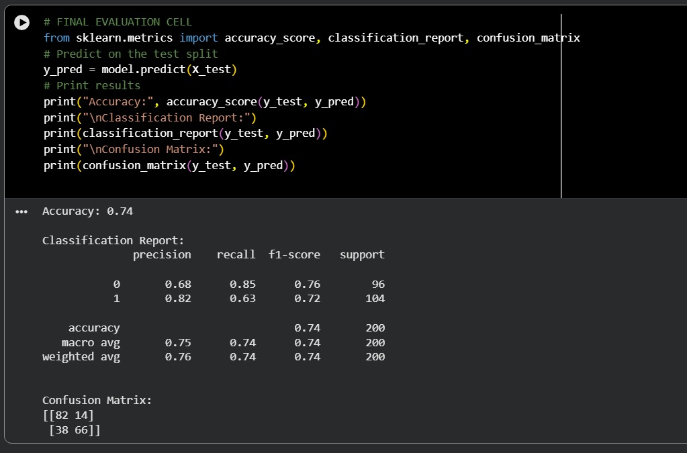

Milestone 5: Model Deployment:

Activity 5.1: Save the Final Model
Once the logistic regression model was trained and evaluated in Google Colab, we saved:
model.pkl
The trained logistic regression classifier used for predicting sentiment.
vectorizer.pkl
The TF-IDF vectorizer that converts raw text into numerical vectors.
Why saving is important
● Avoids retraining the model every time
● Enables fast loading inside Flask
● Ensures consistency between training and prediction
● Required for deployment in real-time applications
Files Saved
- model.pkl — Trained logistic regression sentiment classifier
- vectorizer.pkl — TF-IDF vocabulary and feature transformation rules
These files form the persistence layer of the project.
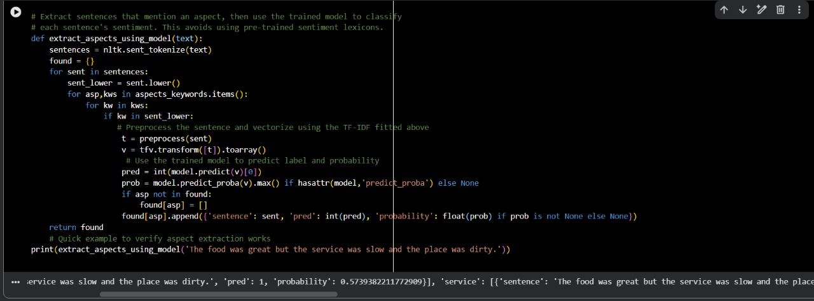

Activity 5.2: Flask Web Application Development
To make the model accessible to users, we developed a full-stack web application using Flask. It follows a standard Client–Server ML architecture, similar to the sample report.

Application Architecture (Adapted to Our Project)
Client (Frontend Layer)
Located in the static/ folder.
- index.html → Main interface
  - Users paste restaurant reviews
  - Buttons for Predict / Clear
  - Displays overall sentiment
  - Shows aspect-wise (food, service, hygiene, ambience, speed, price) results
- style.css → Stylish dark UI design
- script.js →
  - Sends user input to Flask backend using fetch()
  - Receives prediction response
  - Dynamically updates the result card
Backend (Server Layer – Flask)
Implemented in app.py
The backend is responsible for:
- Loading model.pkl and vectorizer.pkl
- Preprocessing text input
- Converting text → TF-IDF
- Predicting sentiment using logistic regression
- Extracting aspect-based sentiment
- Returning results as JSON to the frontend
This layer acts as the “brain” of the application, performing all ML logic.
Persistence Layer
Contains the saved ML components:
- model.pkl
- vectorizer.pkl
These ensure the application can perform predictions instantly without retraining the model.

Backend Implementation (app.py) – Simple & Short
The backend is built using Flask and handles all machine-learning operations.
What the Backend Does:
- Loads the model and vectorizer (model.pkl and vectorizer.pkl)
- Receives text from the frontend through a /predict POST request
- Preprocesses the review (cleaning, tokenizing, removing stopwords, stemming)
- Converts text into TF-IDF vectors
- Uses logistic regression to predict whether the review is Positive or Negative
- Extracts aspect-wise sentiment (food, service, hygiene, price, ambience, speed)
- Sends results back to the frontend as JSON

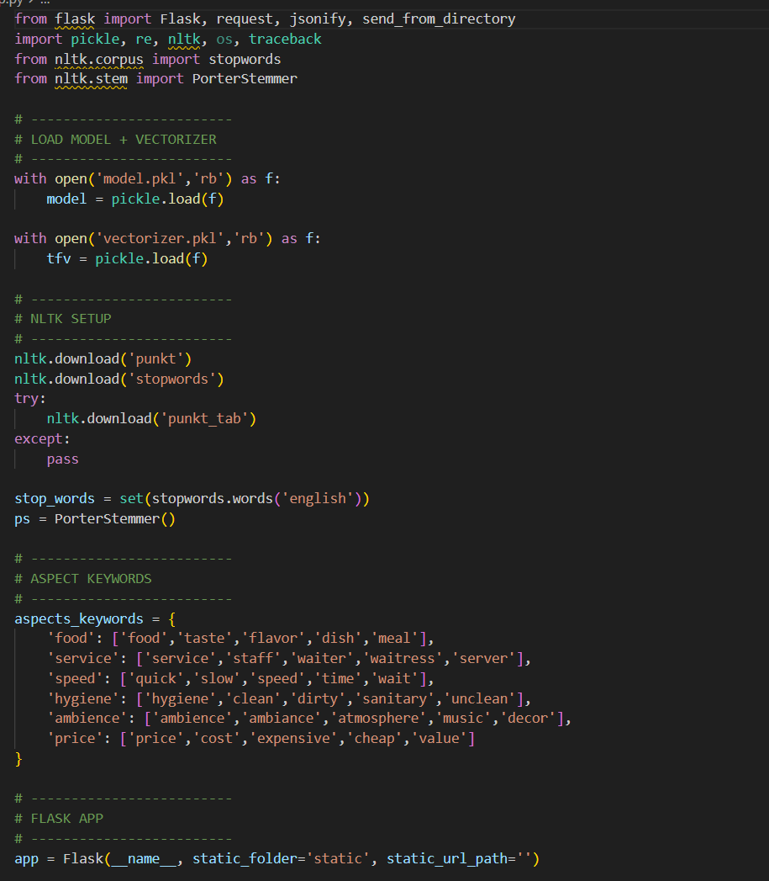
Frontend Implementation (HTML, CSS, JS) – Simple & Short
The frontend provides a clean and user-friendly interface for entering reviews.
What the Frontend Contains:
- index.html → input textbox, Predict & Clear buttons, output area
- style.css → dark, modern UI styling
- script.js →
  - Sends the review text to Flask backend
  - Receives prediction result
  - Displays overall sentiment + confidence
  - Shows aspect-wise sentiment

Application Screenshots and Workflow (Our Project)
The workflow of the web application moves step-by-step from entering a restaurant review to generating a complete sentiment and aspect-wise analysis.
1. Home Page Interface (index.html)
Features
- A clean, modern UI with a simple heading: “Restaurant Review Classifier”
- A large text area for pasting the customer’s restaurant review
- Predict and Clear buttons for easy interaction
- Designed on a single screen for quick and efficient use
- Dark, professional styling created using style.css
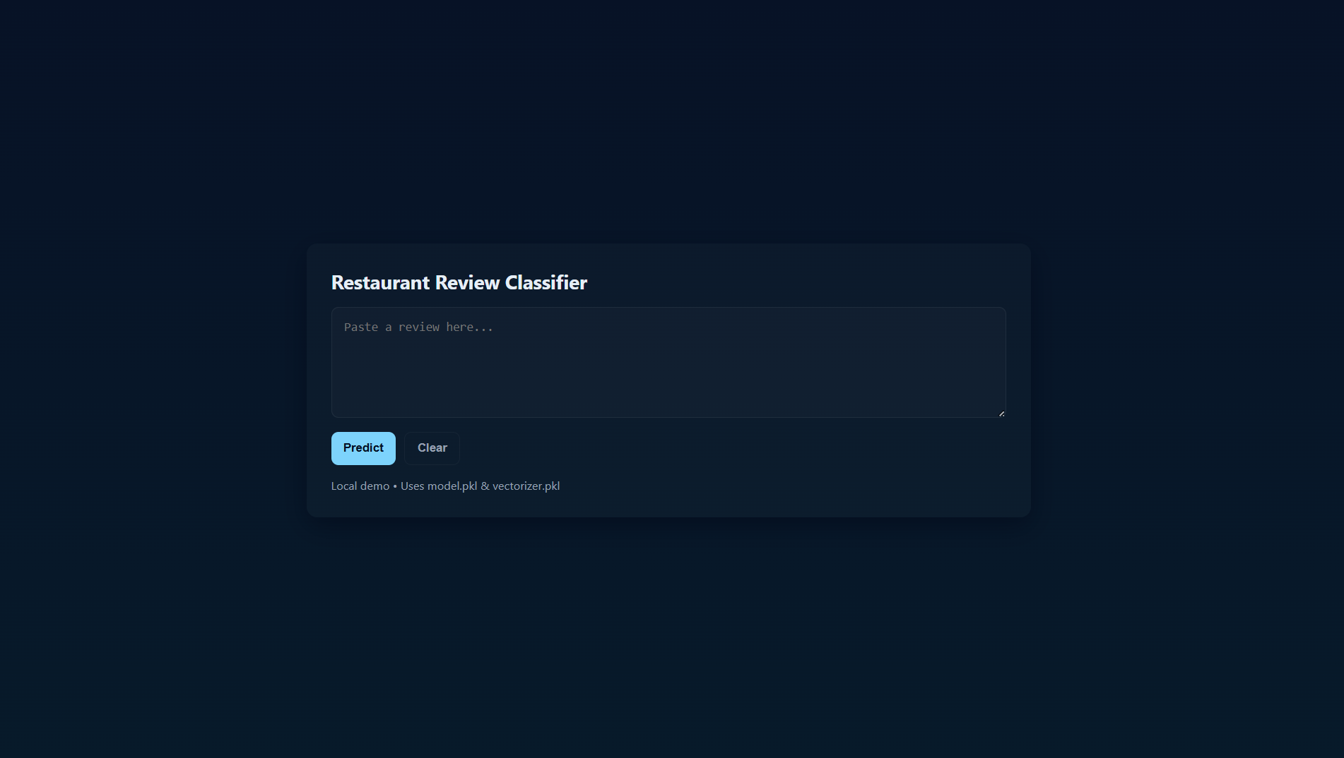

2. User Review Input
Input Components
- Review Text Box:
The user pastes or types any restaurant review (e.g., “Food was amazing, but service was slow.”)
Focus
- No complicated fields — only one text input, making it fast and simple
- The model automatically processes:
  - Food-related statements
  - Service comments
  - Ambience
  - Hygiene
  - Price
  - Speed/delivery

The user only enters the review; the system handles everything else.
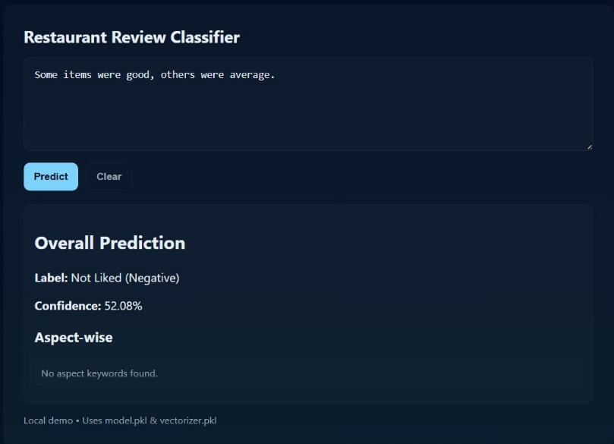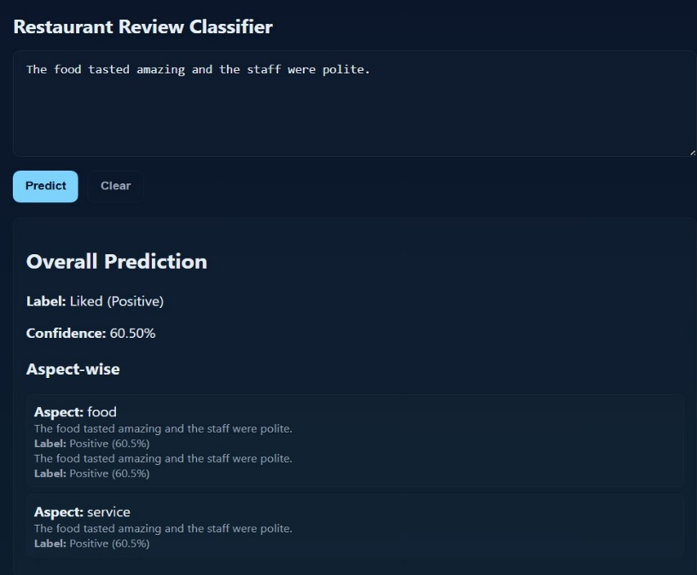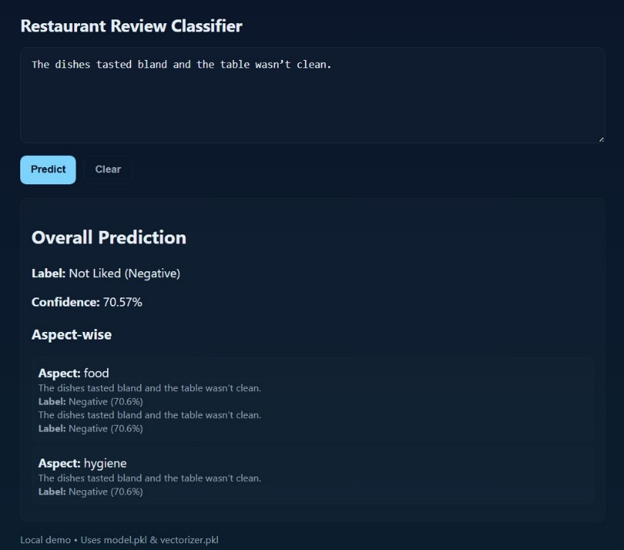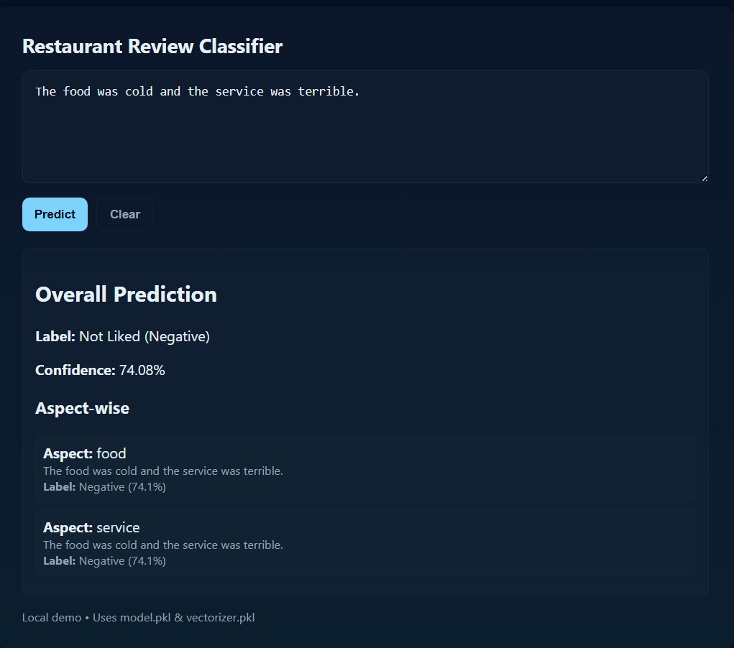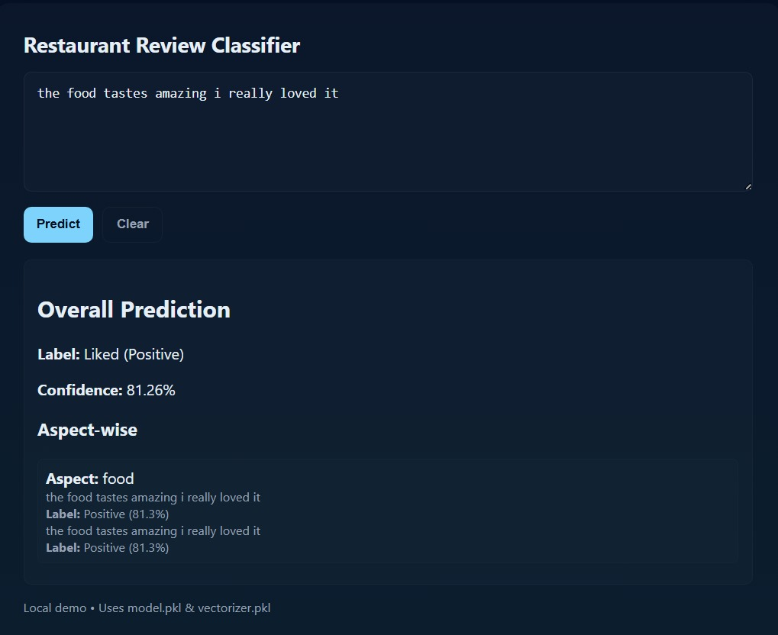

3. Sentiment Analysis Results
Results Include
- Overall Sentiment Classification
Example:
  - “Liked (Positive)”
  - “Not Liked (Negative)”
- Confidence Score
Example:
  - “84.52% Confidence”
- Aspect-Wise Sentiment Breakdown
The system highlights sentiments for aspects found in the review:
  - Food: Positive/Negative
  - Service: Positive/Negative
  - Ambience: Positive/Negative
  - Hygiene: Positive/Negative
  - Price: Positive/Negative
  - Speed: Positive/Negative
- Color-coded Output (if shown in your UI)
  - Green = Positive sentiment
  - Red = Negative sentiment
Each aspect section displays:
- The exact sentence extracted
- The predicted sentiment
- Probability score

Future Implementations
● Use advanced NLP models like BERT to improve accuracy and understand deeper context in reviews.
● Upgrade aspect detection from keyword-based to automated NLP-based extraction.
● Add multi-language support for reviews written in Indian local languages.
● Create a sentiment dashboard for restaurants to track customer feedback trends.
● Build API integration for platforms like Zomato, Swiggy, or Google Reviews.
● Develop a mobile app for quick, on-the-go sentiment and aspect analysis.
● Expand the dataset with more reviews from multiple sources to improve model performance.

Conclusion:
The Restaurant Review Sentiment & Aspect-Based Classification Project successfully demonstrates an effective AI-driven system for understanding customer feedback. Using TF-IDF vectorization and the logistic regression, the model delivers reliable sentiment predictions and provides detailed aspect-wise analysis for categories such as food, service, ambience, hygiene, price, and speed.
The entire pipeline—ranging from text preprocessing to real-time prediction—is integrated into a fully functional Flask web application with a clean and user-friendly interface. This solution offers restaurants an instant and scalable way to analyze customer opinions, identify problem areas, and make data-driven improvements.
Overall, the project showcases practical implementation of NLP and machine learning in real-world customer review analysis.

