**THE SCOPE OF FUELS LIKE OIL, GAS AND**

**OTHER IN THE FUTURE**

**Table of Content**

BUSINESS REPORT 1

1. Executive Summary 1

1.1. Questions to be addressed 1

1.2. Key Findings 2

1.3. Recommendations 3

2. Report Body 4

2.1. Introduction 4

2.2. Data Source 4

3. Power BI Requirements 5

3.1. Major Findings 5

3.1.1. Year-wise Total Open Position: 5

3.1.2. Yearly Overview of Daily Price Change and Trading Volume: 6

Figure 3.2.: Yearly Overview of Daily Price Change and Trading Volume: 7

3.1.3. Average Close Price by date: 7

3.1.4. Overall Volume by Date: 9

3.1.5. Date-Wise Percentage Positive Negative Changes Trends 10

4. Conclusions and Recommendations 23

5. Appendix: BI Design 25

5.1. Data preprocessing 25

5.2. Data Modelling 26

5.3. DAX Functions & M Query 27

5.3.1. DAX Functions 27

5.3.2. M Query 32

5.4. Dashboard Design 33

Self-Assessment Table 36

# BUSINESS REPORT

# 1. Executive Summary

This dataset offers a comprehensive view at the complex dynamics of the fuel-energy industry, showcasing various trends and patterns in a comprehensive repository of futures contracts linked to gas, oil, and other fuels. Notable findings include trade identification, market volatility, historical behaviour, correlation analysis, trading opportunities, global event impact, seasonal trends. Analysing the current data, can serve as a very important aspect not only for stakeholders, but also for researchers and market analysts, involved in trading and business in mining, trading and refining of fuels.

### 1.1. Questions to be addressed

Questions those were addressed in this report are:

1. What are the important trends in the fuel-energy industry?
2. How does the changes in price fluctuation patterns help in trend recognition?
3. How does the dataset contribute to providing information regarding market insights?
4. Can the price fluctuation be analysed and if yes then how?
5. How does the historical dataset contribute to analysing the future of fuel-energy?
6. How can these datasets help in predicting trading opportunities?
7. How the dataset and historical data are observed to set trading strategies?
8. In what ways does data help in identifying periods of risk?
9. How can data be effective in predicting global events on fuel prizes?
10. How does the dataset help in overviewing the relationship between trading volume and price fluctuation?
11. How analyzing insights according to fuel-type can help in the trading industry?
12. What are the patterns that could be observed from crude-oil, heating-oil and other fuels?

### 1.2. Key Findings

The key findings emphasize the importance of datasets and its contribution in the market. The analysis of fuel-energy data has provided us with various important insights. The dataset discloses historical price behaviour, market volatility and different trends. This also provides insights in the relationship among various types of fuels. The dataset is a very important aspect when it comes to market treasures. Through studying these data, it is possible to discover how to make money and also prevent market risk especially during tricky times. It also affects global fuel price fluctuation, which makes it possible to determine when the price can be high and when it can be low.

Year 2008 was a potential market as it marked the highest sum of high prices. The market was high and low in terms of trends but 2020 experienced a dip, mostly due to global pandemic. Crude Oil leads with highest total volume and aggregate close price. Heating Oil and Natural Gas closely followed, contributing to pricing trends.

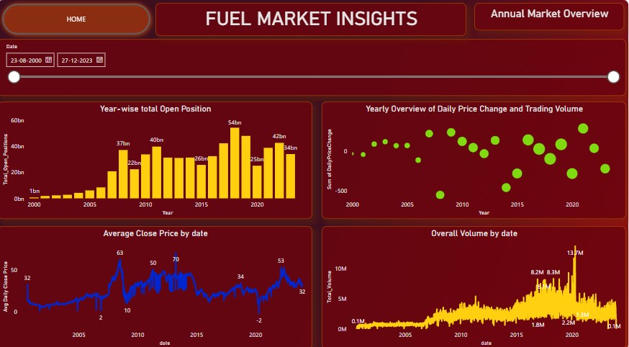

***Figure 1:*** *Market Overview*

### 1.3. Recommendations

Emphasis of investing in various fuel-type markets and implementing strategies will help in taking risk during critical-market situations. Stay alert during global fuel price fluctuations and big events. Crude Oil dominates the market trends so keep focus there but also keep an eye on heating Oil and Natural Gas as those are steady markets. Use dataset and market analysis to stay updated and be prepared to adapt to unexpected events.

This recommendation aims to enhance the resilience and efficiency in market trends, ensuring a good contribution in the fuel-energy market globally.

# 2. Report Body

### 2.1. Introduction

The report delves into a deep understanding of energy-fuel market trends, trading strategies, global events, price fluctuations, fuel-type overview. This part of the report showcases the importance of dataset. With this dataset, the main objective is to alert readers and be prepared with every changing event in the market.

### 2.2. Data Source

The report is from kaggle for datasets named ‘Oil, Gas and Other Fuels Future Data’. This dataset provides comprehensive and up-to-date information on futures related to oil, gas, and other fuels. Futures are financial contracts obligating the buyer to purchase and the seller to sell a specified amount of a particular fuel at a predetermined price and future date. This data can be used for trend analysis, academic research, trading strategies, risk management. This dataset encompasses a diverse range of variables, including Date, opening price, high peak during trading window, lowest traded price, market closed price, volume, ticker, and various types of fuels. With this rich collection of data, analysts and researchers can delve into decision-making processes, aiding businesses in targeted marketing

strategies.

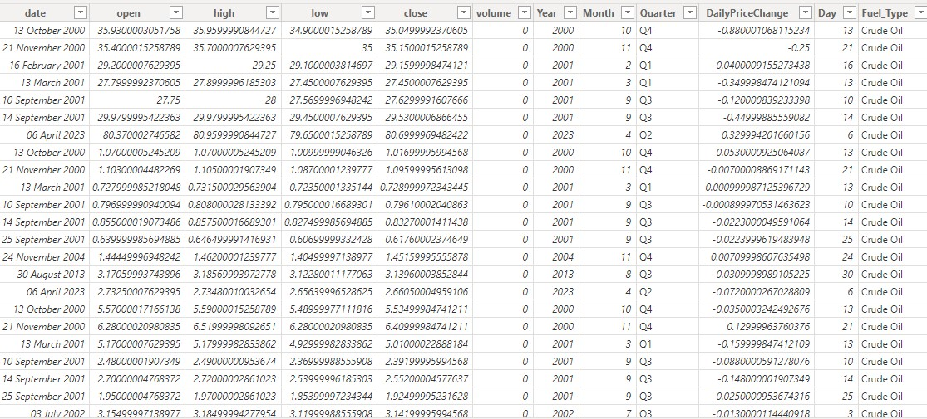

***Figure 2.1.:*** *Overview of the data*

# 3. Power BI Requirements

Knowledge of Power BI modelling functions and visualisation tools plays a vital role in making reports and dashboards and gaining insights from the dataset.

### 3.1. Major Findings

The major findings of the report are:

#### 3.1.1. Year-wise Total Open Position:

The analysis of opening market price trends over years demonstrates distinctive patterns. The chart signifies the rising opening price over the years. In 2008, the market subsequently increased. Soon after, the market dipped in 2009, mostly due to the economic downturn, after which the market kept on boosting to new heights. Later, 2020 marked off-market, possibly influenced by global pandemic.

Chart Analysis:

1. 2008 Insight: Period of Market Vibrancy.
2. 2009 Insights: Off-market due to Global economic challenges.
3. Subsequent years insights: Rise in market.
4. 2018: lead the market with 54 billion open positions.
5. 2020: Dip in the market, mostly due to global pandemic.

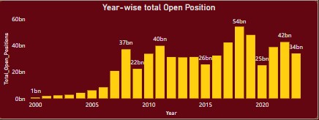

***Figure 3.1.:*** *Year-wise total Open Position*

#### 3.1.2. Yearly Overview of Daily Price Change and Trading Volume:

The analysis of daily price change and trading volume offers valuable insights. In 2008, the market had substantial negative price change and an increase in trading volume. After 2008, the subsequent years show a steady rise in price change and trading volume. Although 2020 had a different scenario with notable negative price change and subsequent increasing trading volume, mostly due to global pandemic. 2021 turned out with positive price change and robust trading volume resulting in a dynamic market.

● **2000 Insights:**

Daily price change: -30.56

Total volume: 37,282,756 ● **2008 Insights:**

Daily price change: -556.43

Total volume: 526,750,367 ● **2013 Insights:**

Daily price change: 139.98 Total volume: 579,869,252 ● **2020 Insights:**

Daily price change: -283.74

Total volume: 963,500,562 ● **2020 Insights:**

Daily price change: 291.94

Total volume: 848,232,675

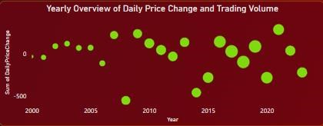

#### *Figure 3.2.: Yearly Overview of Daily Price Change and Trading Volume:*

#### 3.1.3. Average Close Price by date:

The Analysis of Average close price by date shows a roller-coaster journey regarding average closing price in the market. In August 2000, the average closing price was 32.05. After which, the subsequent years experienced constant fluctuations reaching the peak in July 2008. In January 2009, a dip occurred. However, the market bounced back in May 2019. Although the global pandemic in 2020 resulted in a dip in the market with price 11.89. In 2021, the price started increasing again and in June 2022 price reached to 45.73 showcasing the evolving market.

● **23 August 2000:**

Average Closing Price - 32.05 ● **21 July 2008:**

Average Closing Price - 56.22 ● **15 January 2009:**

Average Closing Price – 10.73 ● **17 May 2019:**

Average Closing Price – 41.93 ● **5 May 2020:**

Average Closing Price – 11.89 ● **23 June 2022:**

Average Closing Price – 45.73

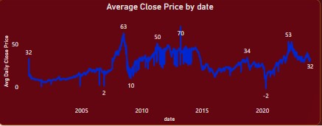

***Figure 3.3.: Average Close Price by Date***

#### 3.1.4. Overall Volume by Date:

The analysis of total volume plays a vital role in market analysis. In August 2000, the total volume was 79,385, and the following years experienced fluctuations. In January 2000, the volume turned out to be 1,458,804. In April 2011 volume increased by 1,907,340. After some fluctuations, in January 2015 market volume increased by 2,169,400, soon after which it reached the peak during the global pandemic in April 2020. In July 2022 the volume stood at

2,688,200.

● **23 August 2000:**

Total Volume – 79385 ● **17 January 2007:**

Total Volume – 1,458,804 ● **26 April 2011:**

Total Volume – 1,907,340 ● **27 January 2015:**

Total Volume – 2,169,400 ● **4 August 2017:**

Total Volume – 4,950,880 ● **28 April 2000:**

Total Volume – 5,532,020 ● **8 July 2021:**

Total Volume – 2,688,200

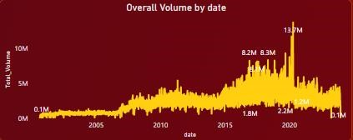

***Figure 3.4.:*** *Overall Volume by date*

#### 3.1.5. Date-Wise Percentage Positive Negative Changes Trends

The Analysis of date-wise percentage positive negative changes highlights in market shifts and volatility. In 2000, the positive and negative changes in the market started shifting. Due to the global financial crisis the market was at its worst with -5.48% in 2008. Following these few years turned out to be fluctuating in positive and negative swings. In 2011, the market decreased with -32.62% change. In 2011, it rebounded with 44.73%. Year 2022, faced extreme negative decrement with -73.60% creating market turbulence.

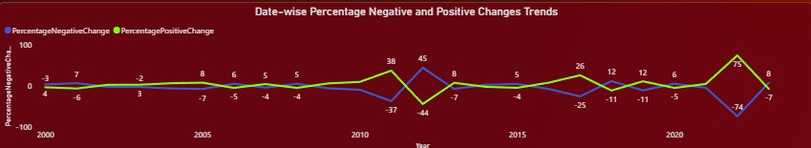

***Figure 3.5.:*** *Date-wise Percentage Negative and Positive Changes Trends*

● **Year 2000:**

Percentage Positive Change: 4.00 Percentage Negative Change: -3.00 ● **Year 2008:**

Percentage Positive Change: 5.48

Percentage Negative Change: -4.48 ● **Year 2011:**

Percentage Positive Change: 37.62 Percentage Negative Change: -36.62 ● **Year 2012:**

Percentage Positive Change: 44.73 Percentage Negative Change: -43.73 ● **Year 2022:**

Percentage Positive Change: 74.60

Percentage Negative Change: -73.60

**3.1.6. Yearly Rolling Average of Close Price:**

The overview of Year-wise 7 days rolling average of close price provides significant information about market movements.

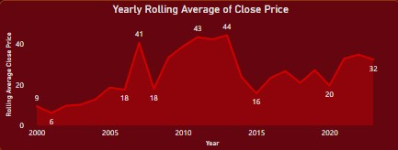

***Figure 3.6.:*** *Yearly Rolling Average of Close Price*

* **Year 2000:**

In 2000, the 7-day rolling average close price was low at 9.46 but gradually increased over years.

* **Year 2005:**

In 2005, the 7-day rolling average close price

Reached 18.60.

* **Year 2007:**

In 2007, the 7-day rolling average close price increased up to 40.53, soon after which it decayed and in 2008 it reached 17.91.

* **Year 2011:**

In 2011, the 7-day rolling average close price experienced a sudden high with 43.30 and in 2013, it touched the peak with 44.24.

* **Year 2015:**

In 2015, the 7-day rolling average close price experienced a temporary decline.

* **Year 2022:**

In 2022, the 7-day rolling average close price reached 34.74 and renewed positive momentum.

**3.1.7. Aggregated High and Low prices:**

The overview of monthly aggregated high and low prices highlights seasonal information about fuel movements.

Months:

February: The second month mostly have dip in both high and low prices.

* Sum of High - 2,68,317.39
* Sum of Low – 2,60,551.36

August: Price abruptly increased during August reaching its peak, which indicates rising behaviour during summer.

* Sum of High – 3,37,456.76
* Sum of Low – 3,28,199.90

December: This month values show that the year ends with stable market values.

* Sum of High - 2,96,942.10
* Sum of Low – 2,88,380.73

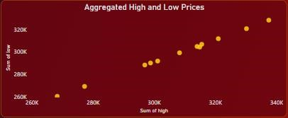

***Figure 3.7.:*** *Aggregated high and low prices*

**3.1.8. Top 10 Year-wise Analysis: Open and Close**

The overview of Yearly analysis of Open and Close prices provides an important insight which helps in further decision-making.

* **2008:**

Year 2008 experience increased volatility with open and close prices

Close – 7.03% Open – 7.05%

* **2010:**

Year 2010 experience stability with open and close prices

Close – 5.56% Open – 5.55%

* **2015:**

Year 2015 experience dip in open and close prices

Close – 3.58% Open – 3.59%

* **2020:**

Year 2020 also experienced decrease in open and close prices, mostly due to global pandemic

Close – 2.88%

Open – 2.87%

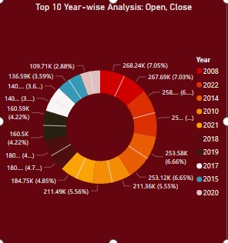

***Figure 3.8.:*** *Year-wise analysis: Open and Close*

**3.1.9. Top 10 Year-wise Analysis: High and Low**

The overview of Yearly analysis of High and Low prices provides an important insight which helps in further decision-making.

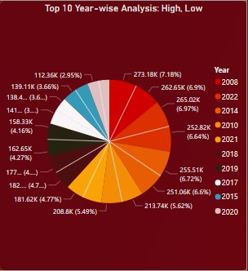

***Figure 3.9.:*** *Year-wise analysis: Open and Close*

* **2008:**

Year 2008 experienced increased volatility with highest high and lowest low value.

low – 6.90% high – 7.18%

* **2015:**

Year 2008 experienced a dip with both high and low value.

low – 3.52% high – 3.66%

* **2020:**

Year 2020 also experiences abruptly decreasing high and low values.

low – 2.95% high – 2.8%

**3.1.10. Total Open, Close and Volume:**

Through filter cards total volume, total open position, and total close position are shown:

* Total_volume indicates market participation
* Total_open indicates commitment in the market
* Total_close indicates aggregate value of closed position

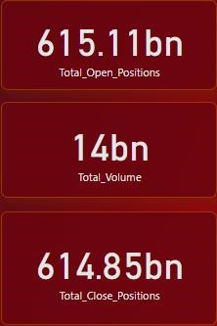

***Figure 3.10.:*** *Filter cards: volume, open, close*

**3.1.11. Close Price Summation by Volume:**

The overview of close price summation by volume helps distributing closed prices on the basis of trading volume.

* According to analysis the maximum sum of closing price 6827 corresponds with volume 2.
* The minimum sum of closing price -188.15 corresponding with volume 247947.

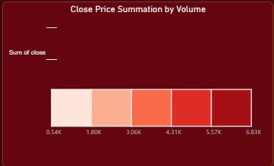

***Figure 3.11.:*** *Close Price Summation by Volume*

**3.1.12. Annual Daily Price Change:**

The overview of Annual daily price change helps in gathering information regarding price change and market movement.

* **Year 2000**

Market decreased with negative price change -31

* **Year 2008**

Market abruptly decreased with significant negative price change of -556

* **Year 2013**

Market increased with positive price change of 140

* **Year 2014 and 2015**

Both year experienced decay in market with negative price change of -462

* **Year 2020**

Market decreased with negative price change -284, mostly due to global pandemic

* **Year 2021**

After pandemic, in 2021 market started getting positive with price change 292

* **Year 2023**

Market decreased with negative price change -221

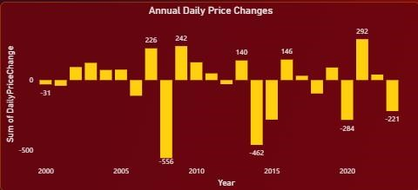

***Figure 3.12.:*** *Annual Daily Price Change*

**3.1.13. Filter cards- Max_Volume, Average Daily Close Price, Rolling**

**Average Close Price, Price Volatility**

* Max Volume: Maximum of trading volumes recorded
* Average Daily Close Price: Average closing price
* Rolling Average Close Price: rolling average closing price in 7 days
* Price Volatility: Market fluctuation



***Figure 3.13.:*** *Filter cards*

**3.1.14. Close Price Comparison among fuel type:**

This analysis will provide insights on various kinds of fuel and help in comparing them through market value.

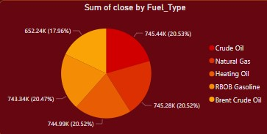

***Figure 3.14.:*** *Fuel type closing price*

* Closing Price is approximately the same for all 4 fuels with a very small difference.

Crude Oil: 20.53%

Natural Gas: 20.52%

Heating Oil: 20.52%

RBOB Gasoline: 20.47%

* Brent Crude oil has a minimum closing price of 17.96%.

**3.1.15. Volume Comparison among fuel type:**

The trading volume analysis of various fuel type helps in analysing the size of market in different fuel types.

* Crude Oil: With Volume of 2,902,657,537, crude oil has the highest volume and is very significant in the market.
* Natural Gas: Closely follow the crude oil market, it has volume of 2,902,381,986
* Heating Oil: Heating oil is behind crude oil and natural gas but with volume of

2,901,807,037 it dominates large part of market

* RBOB Gasoline: It has volume of 2,896,549,859
* Brent Crude Oil: Lower in volume of 2,563,187,406 as compared to other fuels.

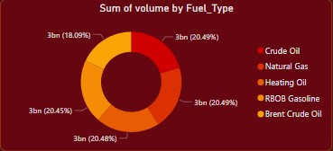

***Figure 3.15.:*** *Fuel type volatility*

**3.1.16. Open Price Comparison among fuel type:**

This analysis will provide insights on various kinds of fuel and help in comparing them through market value.

* Crude Oil: Crude Oil lead the market with opening price of 745498.7
* Natural Gas: Closely follow the crude oil market, opening price of natural gas is

745341.4

* Heating Oil: Heating oil is slightly behind crude oil and natural gas with opening price of 745053.6
* RBOB Gasoline: It has opening price of 743398.5
* Brent Crude Oil: Brent crude oil has lowest opening price with 652369.3

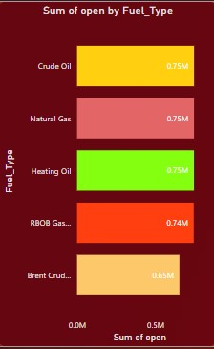

***Figure 3.16.:*** *Fuel type open prices*

**3.1.17. High Value Comparison among fuel type:**

This analysis will provide insights on various kinds of fuel and help in comparing them through market value.

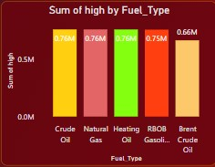

***Figure 3.16.:*** *Fuel type high values*

* Crude Oil: Crude Oil lead the market with highest high value of 756238
* Natural Gas: Closely follow the crude oil market, high value of natural gas is 756078
* Heating Oil: Heating oil is slightly behind crude oil and natural gas with high value of 755788
* RBOB Gasoline: It has high value of 754104
* Brent Crude Oil: Brent crude oil has lowest high value among various fuels with

661596

**3.1.18. Low Value Comparison among fuel type:**

This analysis will provide insights on various kinds of fuel and help in comparing them through market value.

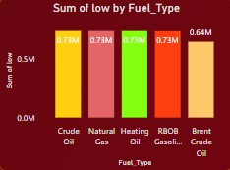

***Figure 3.16.:*** *Fuel type Low values*

* Low value is approximately the same for all 4 fuels with a very small difference.

Crude Oil: 734079

Natural Gas: 733923

Heating Oil: 733638

RBOB Gasoline: 732012

* Brent Crude oil have lowest low value with 642459

**3.1.19. Slicer:**

Date slicer make the dashboard more preferable and give easy access to any date data that have to be analysed.



***Figure 3.19.:*** *Slicer*

## 4. Conclusions and Recommendations

The analysis provided important information into the fuel-energy market. The data brief about historical price behaviour, market volatility and different trends. This also provides insights in the relationship among various types of fuels as well as global fluctuation and events for businesses and traders helping them in risk taking and critical markets.

**Risk Management Strategies:** Risk management strategies makes it possible to discover how to make money and also prevent market risk especially during tricky times. It also affects global fuel price fluctuation, which makes it possible to determine when the price can be high and when it can be low. Pre-Planned strategies should be made according to the analysis identified.

**Data Driven Decision making:** Data-centric segmentation strategy results in good and effective impact. Dataset plays a vital role in the market as planning according to the insights can give better results and prevent risk. Marketing strategies planned according to data-driven insights can provide value and loyalty.

**Diversification of Portfolios:** It is really important to find market scenarios according to various fuel types. By analysing the historical data and market, the right choice should be made and accordingly the focus should be set. Also investing in different fuel type can minimize the risk. By right analysis and insights good results can be achieved.

**Monitoring Key indicator:** It is more efficient to analyse the market dimensions in accordance to historical price behaviour such as profit, loss, trading volume, daily price change, opening positions, market trends and global events which will eventually help in discovering potential opportunities.

**Strategic Adaptation:** It is important to adapt the changing dynamics and scenario in the market and also to stay alert with a proactive response to critical situations.

# 5. Appendix: BI Design

### 5.1. Data preprocessing

The data is recorded in different tables according to fuel type, so in the first step all the table data was appended to one table.

***Figure 5.1.:***

*Preprocessing step to combine datasets*

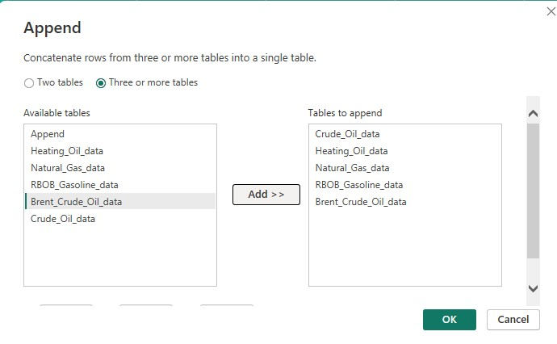

Then the fuel type column was merged with the append table from the fuel type table. This step helps in distinguishing data according to fuel type as well which further helps with the insights.

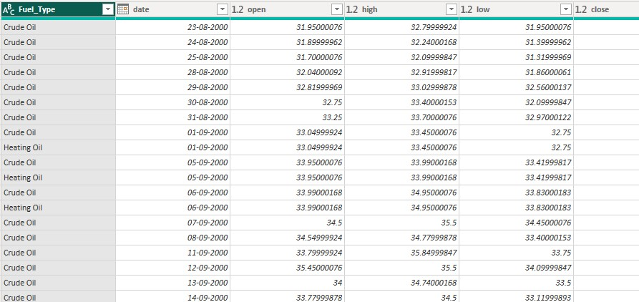

***Figure 5.2.:*** *Merging Fuel_type*

### 5.2. Data Modelling

***Figure 5.3.:***

*Dataset after combining data*

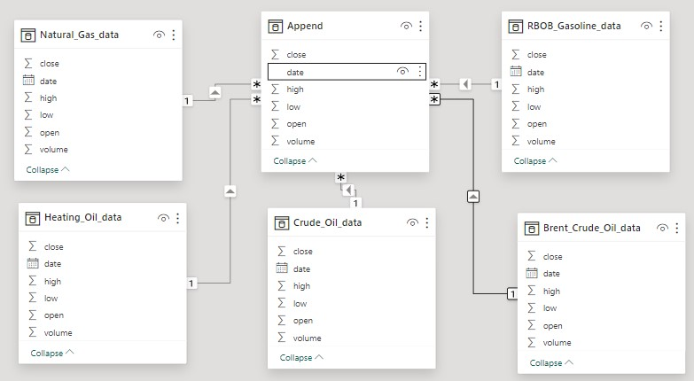

Appended dataset was created by combining all the data in one table establishing a relationship with the primary dataset to enable efficient fuel type analysis and grouping of close, high, low, open, volume by date.

### 5.3. DAX Functions & M Query

#### 5.3.1. DAX Functions

DAX stands for Data Analysis Expression, is a library of functions used to create formulae and expressions in Power BI, Analysis Services, and Power Pivot in Excel data models. It can also create calculated columns, and custom tables. These tables are columns created using values within a specified dataset.

Total_Close_Positions =

SUMX (

'Append’, ‘Append'[close] * 'Append'[volume]

)

Total_Open_Positions =

SUMX (

'Append’, ‘Append'[open] * 'Append'[volume]

)

Total Volume =

SUM('Append'[volume])

Total Open = SUM('Append'[open])

TotalPriceChanges =

SUMX (

'Append’, ‘Append'[close] - 'Append'[open]

)

The above DAX functions computes the total values for different metrics within a specified dataset (‘Fuels Future Data’). Each function calculates the total value for specific columns or measures.

* Total close position represents total closing positions.
* Total open position represents total opening positions.
* Total volume represents total trading volume.
* Total Open represents total open prices
* Total Price Change represents the sum of price change for each row.

Avg Daily Close Price =

AVERAGE('Append'[close])

Rolling Average Close Price =

VAR Numdays=7

VAR RollingAverage=

CALCULATE(AVERAGE('Append'[close]),

DATESINPERIOD('Append'[date], LASTDATE('Append'[date]), -Numdays, DAY)

)

RETURN RollingAverage

The above DAX functions computes the average values for different metrics within a specified dataset (‘Fuels Future Data’). Each function calculates the average for specific columns or measures.

Average Daily Close Price represents the average closing price across all days.

Rolling Average Close Price represents the integrated sum of 7 days closing price since the numdays value is assigned as 7.

Max_volume =

Max('Append'[volume])

The above DAX functions compute the maximum values within a specified dataset (‘Fuels Future Data’). Max function calculates the maximum of a specific column. Max_Volume represents the maximum trading volume across all days.

NegativePriceChanges =

CALCULATE (

SUMX (

'Append’,IF('Append'[Close]<'Append'[Open],'Append'[Close] - 'Append'[Open], 0))

)

PositivePriceChanges =

CALCULATE (

SUMX (

'Append',IF('Append'[Close]>'Append'[Open],'Append'[Close] - 'Append'[Open], 0))

)

PercentageNegativeChange =

DIVIDE (

[NegativePriceChanges], [TotalPriceChanges], 0

)

PercentagePositiveChange =

DIVIDE (

[PositivePriceChanges], [TotalPriceChanges], 0

)

OverallPercentageChange =

DIVIDE (

SUMX ('Append', 'Append'[close] - 'Append'[open]),

CALCULATE (SUMX ('Append', 'Append'[open]))

) * 100

The above DAX functions computes the percentage change for different metrics within a specified dataset (‘Fuels Future Data’). Each function calculates the total value for specific columns or measures.

Negative Price Change represents the price change whose closing price is less than opening price.

Position Price Change represents the price change whose opening price is less than closing price.

Percentage Negative Change represents the negative price change in respect to total price change

Percentage Positive Change represents the positive price change in respect to total price change

Overall Percentage Change represents the percentage change.

Price Volatility =

AVERAGEX ('Append', ABS('Append'[close] - 'Append'[open])

)

The above DAX functions computes the average absolute price change for different metrics within a specified dataset (‘Fuels Future Data’)

Year =

YEAR('Append'[date])

Month =

MONTH('Append'[date])

Quarter =

FORMAT('Append'[date], "\QQ")

Day =

DAY('Append'[date])

The above DAX functions computes the date values within a specified dataset (‘Fuels Future Data’). Year represents a specific year from the date column. Months represent specific months from the date column. Quarter represents a specific quarter from the date column.

Day represents a specific week day from the date column.

DailyPriceChange =

'Append'[close] - 'Append'[open]

The above DAX functions computes the price change of all dates within a specified dataset (‘Fuels Future Data’). Each function calculates the difference between closing and opening price for each day.

#### 5.3.2. M Query

M query is used for data transformation.

= Table.Combine

({#"Changed Type",

Heating_Oil_data,

Natural_Gas_data,

RBOB_Gasoline_data,

Brent_Crude_Oil_data})

The above query, Table Combine concatenates multiple tables into a single table. It takes several tables represented by crude oil data, natural gas data, heating oil data, rbob gasoline data, brent crude oil data, and combines them into one table, stacking the data from each table on top of one another.

= Table.NestedJoin

(#"Appended Query", {"date"}, fuel_type, {"date"}, "all_fuels_data"

, JoinKind.LeftOuter)

The above query, Table Nested Join merges column from one table into another table. It takes two tables represented by an all_fuel_data table from which the fuel_type column is merged in the appended table, stacking the data from each table on top of one another.

### 5.4. Dashboard Design

Overview of final dashboard

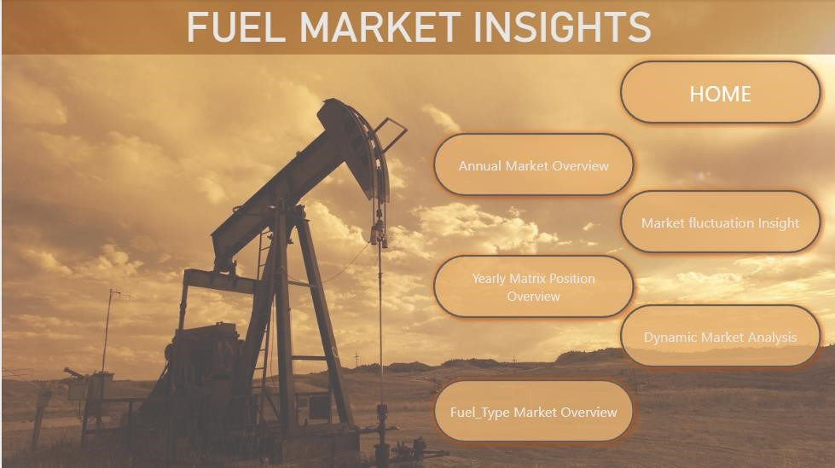

***Figure 5.4.:*** *Home Page of Interactive Dashboard*

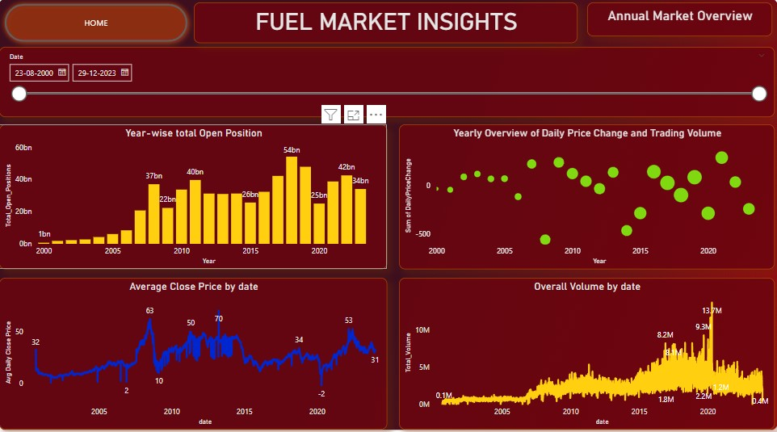

***Figure 5.5.:*** *Annual Market Insight*

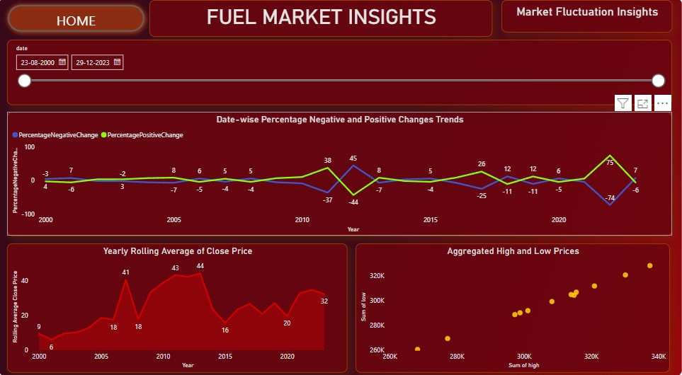

***Figure 5.6.:*** *Market Fluctuation Insights*

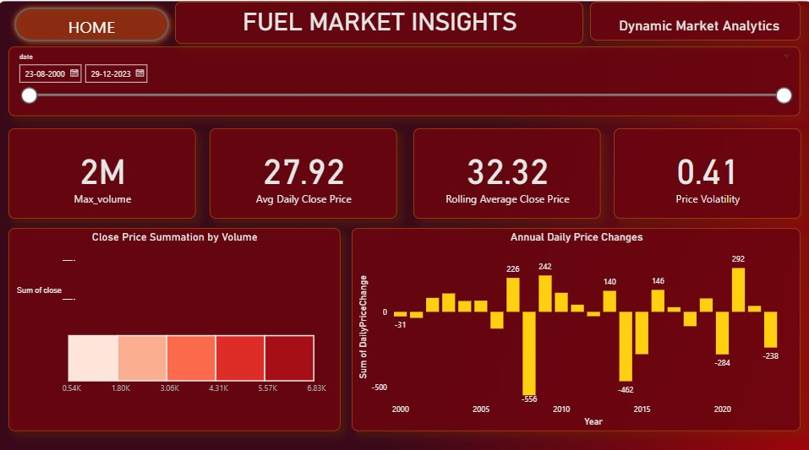

***Figure 5.7.:*** *Dynamic Market Analytics*

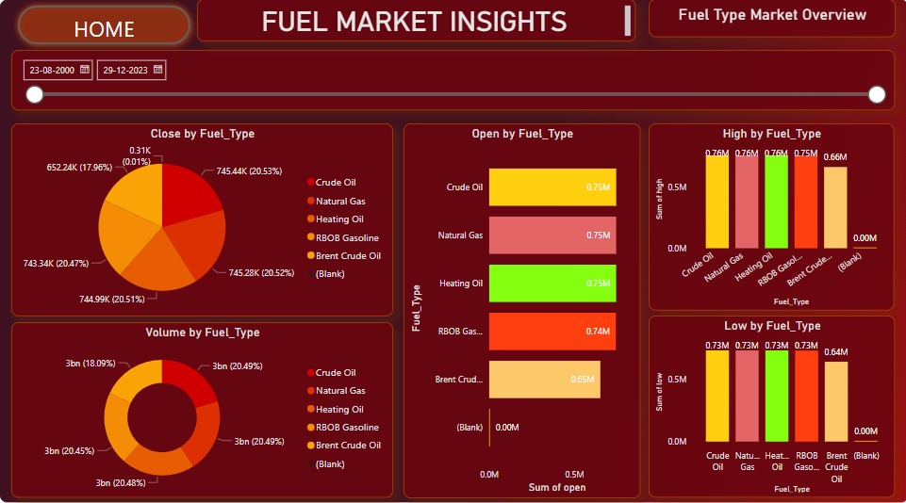

***Figure 5.8:*** *Fuel Type Market Overview*

# Self-Assessment Table

|  |  |  |
| --- | --- | --- |
| **Report Section** | **Description** | **Grade your work from 0 to**  **100** |
| Report Structure | The report is well-organised and follows an appropriate structure. It includes all necessary sections, each appropriately labelled with relevant headlines and subheadlines. | 92 |
| Data Pre-processing and  Data Modelling | Data preprocessing is undertaken to cleanse the data and eliminate any noise. The star schema is crafted, incorporating sub-tables derived from the primary dataset. | 90 |
| Dax and M language | DAX calculations are used to derive statistical estimates | 85 |

|  |  |  |  |
| --- | --- | --- | --- |
|  | from the data. The M language is utilised for transforming measures during the data processing. |  |  |
| Dashboard Design | A multi-page dashboard designed to present specific insights. | 90 |
| **Average** |  | **Add below the average of the four cells above:**  **89** |
|  | | | |