Module 3 – Communication, Data & Monitoring
Output Demonstration — Satellite Mission Control System
Overview
Module 3 delivers real-time visibility into active passes, simulated telemetry, and historical mission performance through an operator dashboard. The module provides live pass-tracking, telemetry monitoring, ground-track and polar-plot visualization, historical reporting and station utilization, together with conflict and missed-pass alerts.
Output 1: Live Pass Tracking & Simulated Telemetry
The Live Pass Tracking dashboard demonstrates an active tracking session for a satellite and ground station. The screen presents AOS/LOS timing, maximum elevation, azimuth and pass duration, alongside a ground-track view. During the pass, the telemetry panel displays simulated battery, signal-strength, temperature and packet information. The alert panel provides the current session state and operational notifications.
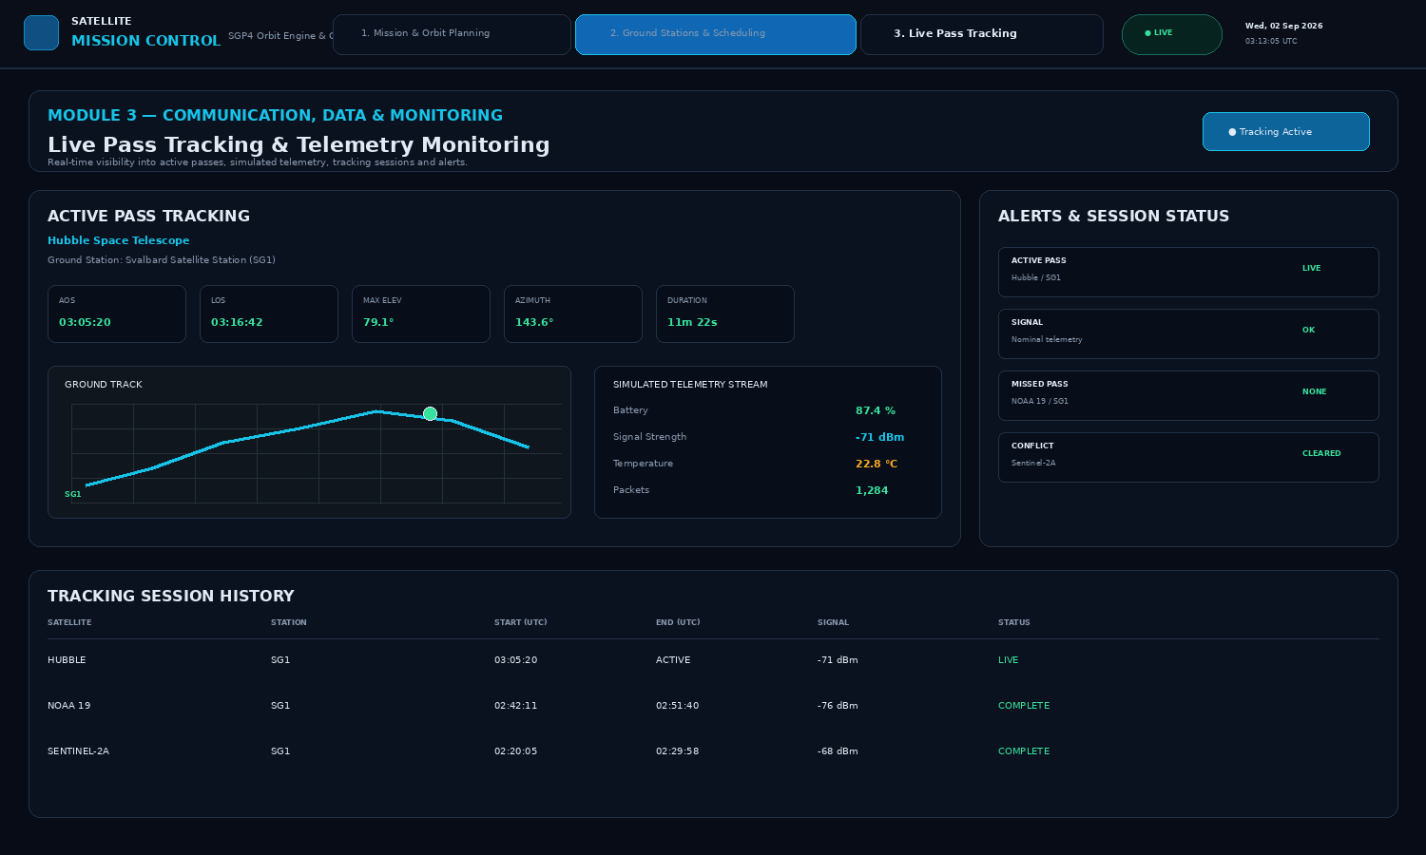
Figure 1 — Module 3 live pass-tracking dashboard showing active pass information, simulated telemetry, ground track and alerts.
Output 2: Historical Reporting & Station Utilization
The reporting view summarizes mission performance over completed tracking sessions. It provides total passes, success rate, station utilization and missed-pass indicators, together with telemetry-quality trends and station-level utilization. The historical mission report supports review of operational performance and ground-station usage.
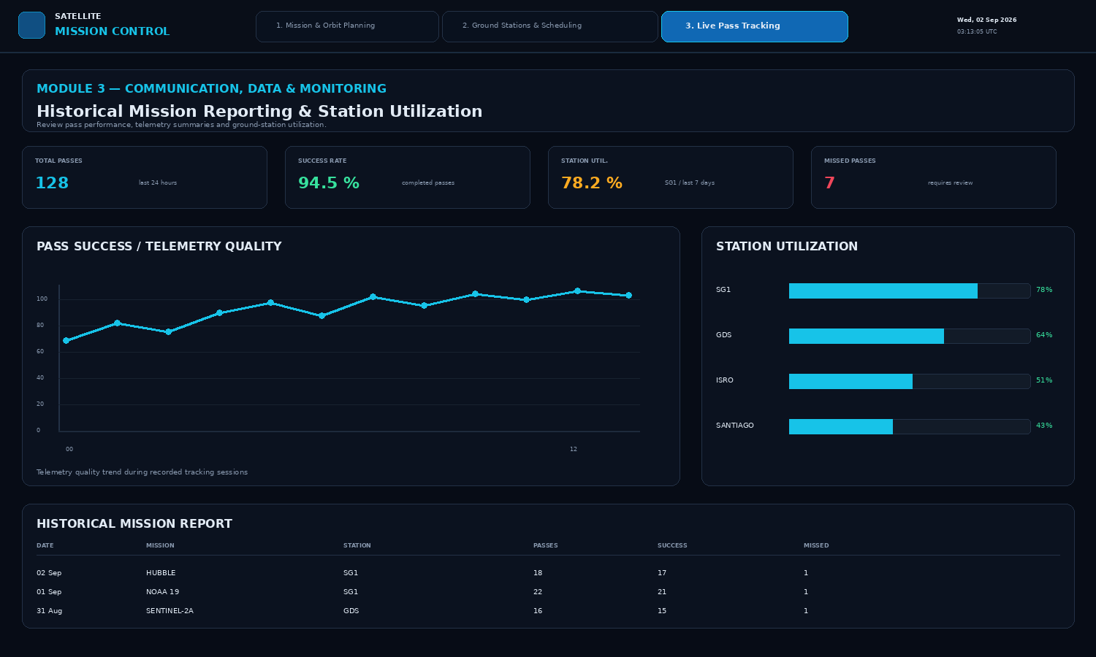
Figure 2 — Module 3 historical reporting dashboard showing mission statistics, telemetry-quality trend and station utilization.
Summary of Demonstrated Functionality
Requirement | Demonstrated?
Live pass-tracking dashboard | Yes — Figure 1
Simulated telemetry stream during passes | Yes — Figure 1
Ground-track & polar-plot visualization | Yes — Figure 1
Historical reporting & station utilization | Yes — Figure 2
Conflict / missed-pass alerts | Yes — Figure 1
Module 3 Demonstration Summary
The demonstration is based on the Module 3 definition in the supplied project presentation: Communication, Data & Monitoring. It focuses on the operator-facing monitoring layer that follows mission planning and ground-station scheduling, with live tracking, simulated telemetry, visualization, alerts and historical performance reporting.

