SIMATS ENGINEERING
ASSESSMENT TOOL 1 – CONSTRAINT-BASED PROBLEM SOLVING
Course: Computer Vision with OpenCV | Course Code: DSA02
Student Name | BATHALA HEMANTH KUMAR
Register No. | 192324238

COURSE OUTCOME CO5
Apply computer vision techniques to real-world applications such as face recognition, tracking, medical imaging, and autonomous systems.

Assessment Overview
This assessment contains five constraint-based computer vision scenarios covering face recognition, photo organization, surveillance, autonomous driving, and medical/AR segmentation.
The answers below explicitly address the stated constraints and provide practical design decisions, trade-offs, and justification.
1. Secure Access System Using Face Recognition in Low-Light Environment
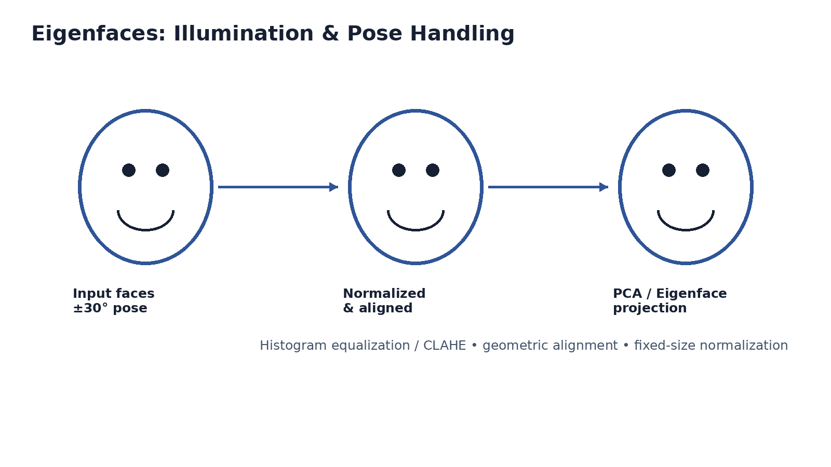
Figure 1. Eigenface preprocessing and pose/illumination normalization.
Q1. How would you adapt Eigenface-based recognition to handle varying illumination and orientation?
Eigenface recognition is based on PCA, so the quality and alignment of the training images strongly affect recognition. For a ±30° orientation range, the system should use aligned face images captured at different poses or use separate pose-specific subspaces. Before PCA projection, the detected face should be geometrically aligned using eye or landmark positions, resized to a fixed size, and normalized. For illumination variation, the face can be normalized before projection so that overall brightness differences do not dominate the principal components. The recognition stage then projects the input into the Eigenface space and compares it with stored projections using Euclidean distance. A confidence threshold should be used to reject an unknown person rather than forcing the closest database identity.
Q2. Suggest preprocessing steps to improve recognition under low-light conditions.
A suitable preprocessing pipeline is: grayscale conversion → illumination enhancement → noise reduction → face detection/alignment → intensity normalization → resizing. Histogram equalization or CLAHE can improve local contrast, while gamma correction can brighten dark regions. Mild Gaussian or median filtering can reduce sensor noise. The face should then be aligned and resized consistently before PCA. These operations improve the quality of the input without adding a large computational burden to an embedded device.
Q3. Discuss strategies to optimize computation for real-time performance on constrained hardware.
The target is recognition in less than 200 ms per face, so the system should avoid processing the full image repeatedly. A lightweight face detector can first locate the face, after which only the face region is processed. Eigenfaces and database projections should be computed offline and stored. The input can be resized to a compact fixed resolution, and only the most useful principal components should be retained. Efficient matrix operations, caching, frame skipping when appropriate, and early rejection of low-confidence detections can reduce latency. The design should be profiled on the actual embedded hardware to verify the 200 ms requirement.

2. AI-Based Photo Album Organization
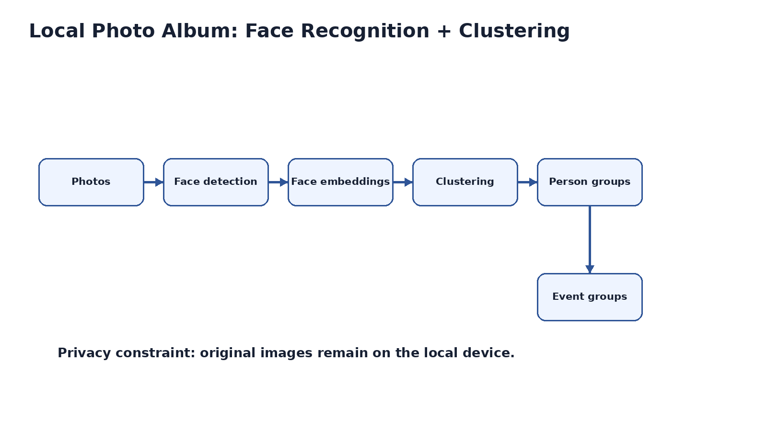
Figure 2. Local photo organization pipeline.
Q1. How would you use face recognition and clustering to group photos of the same individual?
First, detect and align all visible faces. For every reliable face, extract a compact representation and compare it with other face representations. Similar faces can be grouped with a clustering algorithm such as DBSCAN or hierarchical clustering. A cluster can be linked to a known person when its similarity to a stored identity is sufficiently high. Event grouping can then combine person information with capture time, location metadata, and overall visual similarity. Processing remains local so that the original photos do not need to leave the device.
Q2. Propose a method to detect and separate images with occlusions or partial faces.
Each detected face should receive a quality score based on detector confidence, face size, blur, pose, and landmark visibility. If important landmarks are missing or a large part of the face is covered, the image can be marked as partially visible. Reliable faces can enter the normal recognition pipeline, while low-quality or occluded faces can be placed in a separate review group or processed by a partial-face model. This prevents poor-quality observations from corrupting identity clusters.
Q3. Discuss trade-offs between accuracy and computational efficiency for local processing.
A large recognition model and high-resolution images can improve accuracy but require more CPU, memory, battery, and storage. Smaller models and lower resolution reduce computation but may lose fine facial details. Local processing provides strong privacy because images remain on the device, but the hardware becomes the main resource constraint. A practical compromise is a lightweight detector, compact face representation, caching of repeated identities, and expensive processing only for uncertain cases.

3. Smart City Multi-Camera Pedestrian Surveillance
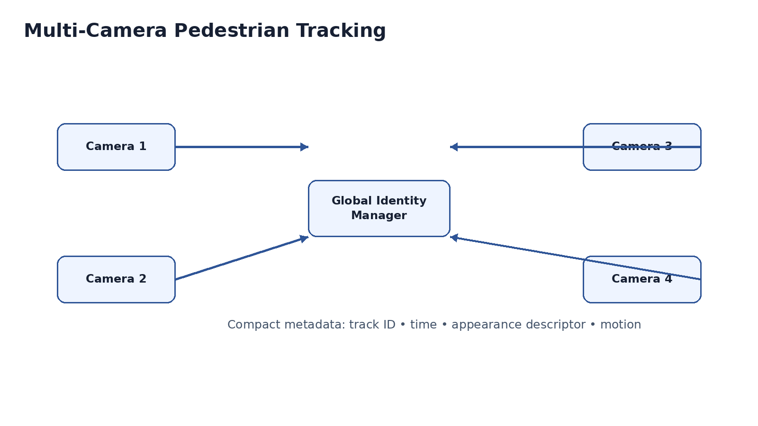
Figure 3. Multi-camera pedestrian identity strategy.
Q1. How would you design a foreground–background separation algorithm to minimize false positives in crowded scenes?
An adaptive background model such as a Gaussian Mixture Model can represent normal background appearance. Each frame is compared with this model to create a foreground mask. Shadow suppression, morphological opening and closing, connected-component filtering, and minimum object-size rules reduce noise. Because crowded scenes contain many moving people, foreground detection should be combined with a person detector and temporal consistency. The background model should update gradually so that slow environmental changes do not become permanent false foreground objects.
Q2. Explain how particle filters can be used to handle occlusion during tracking.
A particle filter represents a pedestrian's possible state using many particles. Each particle can contain position and velocity. In visible frames, the observation model gives higher weights to particles close to the detected person. During occlusion, observations become unreliable, so the motion model predicts where the pedestrian is likely to move and the particle distribution is propagated. When the pedestrian becomes visible again, the new observation updates the weights and the track can be recovered.
Q3. Propose an efficient multi-camera strategy for consistent pedestrian identification across viewpoints.
Each camera can perform detection and local tracking independently. Instead of sending full video over a limited network, cameras can transmit compact track information such as timestamps, bounding boxes, motion direction, and appearance descriptors. A global identity manager matches tracks using appearance similarity, time-of-travel constraints, camera topology, and motion consistency. Confidence scores can be used to resolve ambiguous matches. This reduces bandwidth while maintaining a consistent identity across camera views.

4. Autonomous Driving in Urban Streets
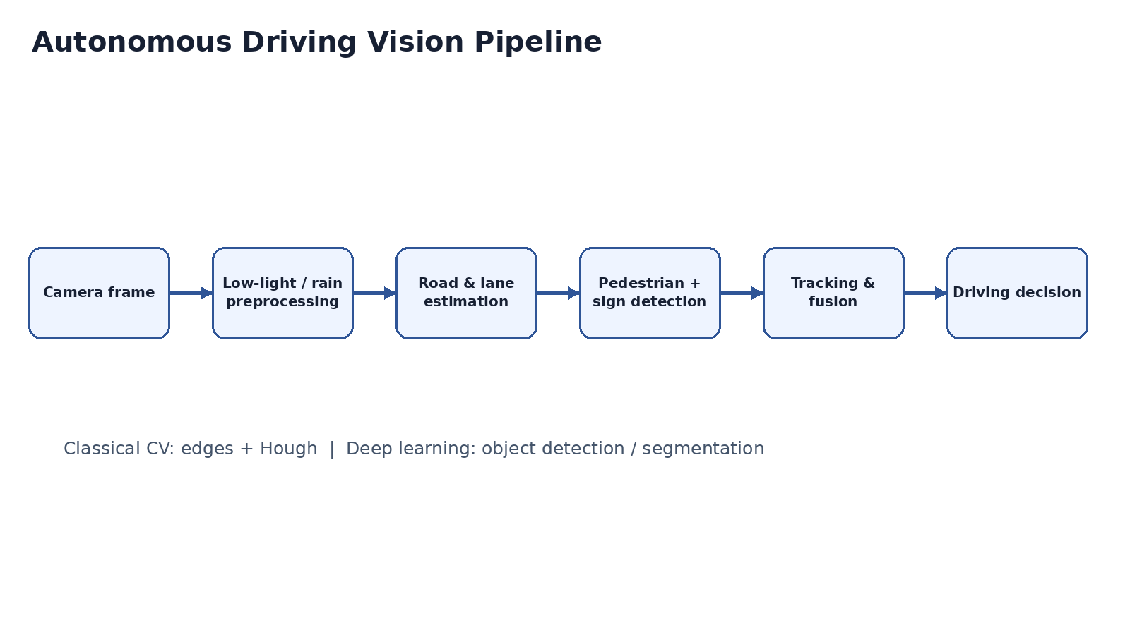
Figure 4. Autonomous driving vision pipeline.
Q1. How would you implement road detection robust to shadows, rain, and nighttime illumination?
The road-detection pipeline should use camera calibration and a region of interest focused on the drivable area. Illumination normalization can reduce the effect of changing brightness. Edge and color information can be combined with segmentation rather than relying on one fixed intensity threshold. For rain and shadows, adaptive thresholds and temporal filtering reduce unstable detections. At night, low-light enhancement can be applied before road and lane estimation. A learned segmentation model can provide greater robustness where classical thresholds fail.
Q2. Propose a pipeline to simultaneously detect road signs and pedestrians efficiently.
A practical pipeline is: camera capture → resize and illumination normalization → lightweight object detector for signs and pedestrians → lane/road estimation → non-maximum suppression → tracking → decision output. The detector can focus on the regions where objects are expected, while the lane module handles the road geometry. Tracking across frames avoids rediscovering the same object from scratch. High-cost processing can be reserved for uncertain detections so the system can remain within the real-time requirement.
Q3. Discuss the trade-offs between deep learning-based detectors and classical computer vision methods under real-time constraints.
Deep learning detectors generally handle complex backgrounds, pose changes, weather, and appearance variation better, but they require more computation and memory. Classical methods such as Canny edges, Hough Transform, color thresholding, and contours are lightweight and interpretable but are more sensitive to lighting and environmental changes. A hybrid approach is therefore useful: classical vision can perform simple geometric tasks such as lane estimation, while a compact neural detector handles pedestrians and road signs. Hardware acceleration and model compression can further reduce latency.

5. AR Surgical Assistance – Real-Time Organ Segmentation
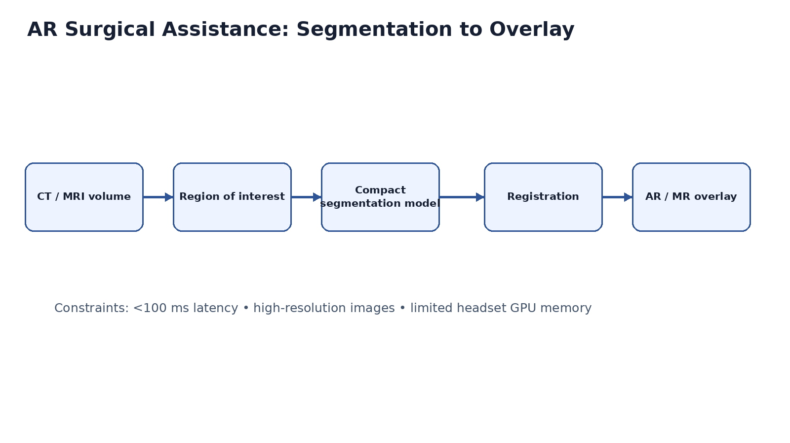
Figure 5. AR surgical segmentation and registration pipeline.
Q1. How would you implement real-time organ segmentation under these memory and latency constraints?
The system should use a compact segmentation model and process only the relevant region or volume rather than the entire high-resolution CT/MRI dataset. Downsampling, region-of-interest extraction, tiled inference, pruning, and quantization can reduce memory use. A 2D or 2.5D approach may be preferable when full 3D inference exceeds the wearable headset's memory budget. Temporal reuse can avoid recomputing stable regions. The complete segmentation-to-rendering pipeline must be profiled to keep interaction latency below 100 ms.
Q2. Discuss methods to integrate segmentation results accurately in AR/MR overlays.
The CT/MRI coordinate system must be registered with the patient's physical coordinate system. Fiducial markers, anatomical landmarks, or image-to-patient registration can establish the transformation. The headset's camera and spatial tracking then maintain the AR coordinate frame. The segmentation mask is transformed into that frame and rendered with suitable transparency and depth awareness. Continuous tracking and motion compensation are important because a small registration error can cause the virtual organ boundary to appear displaced from the real anatomy.
Q3. Suggest strategies to reduce computational load while maintaining segmentation accuracy.
Useful strategies include model pruning, quantization, knowledge distillation, a compact network architecture, lower-resolution inference, and region-of-interest processing. Temporal reuse can update only areas that change. Hardware acceleration can improve inference speed. Post-processing should be limited to operations that materially improve the boundary. A confidence-based system can use fast inference normally and trigger a more accurate high-resolution pass only when the segmentation confidence becomes low.

