SIMATS ENGINEERING
ASSESSMENT TOOL 2 – PSEUDOCODE WRITING TASK
Course: Computer Vision with OpenCV | Course Code: DSA02
Student Name | BATHALA HEMANTH KUMAR
Register No. | 192324238

COURSE OUTCOME CO5
Apply computer vision techniques to real-world applications such as face recognition, tracking, medical imaging, and autonomous systems.

Algorithm Design – Problem Understanding
The task requires complete, logically sound pseudocode with appropriate control structures and handling of the stated constraints.
Scenario 1 – Face Detection and Recognition Using Eigenfaces
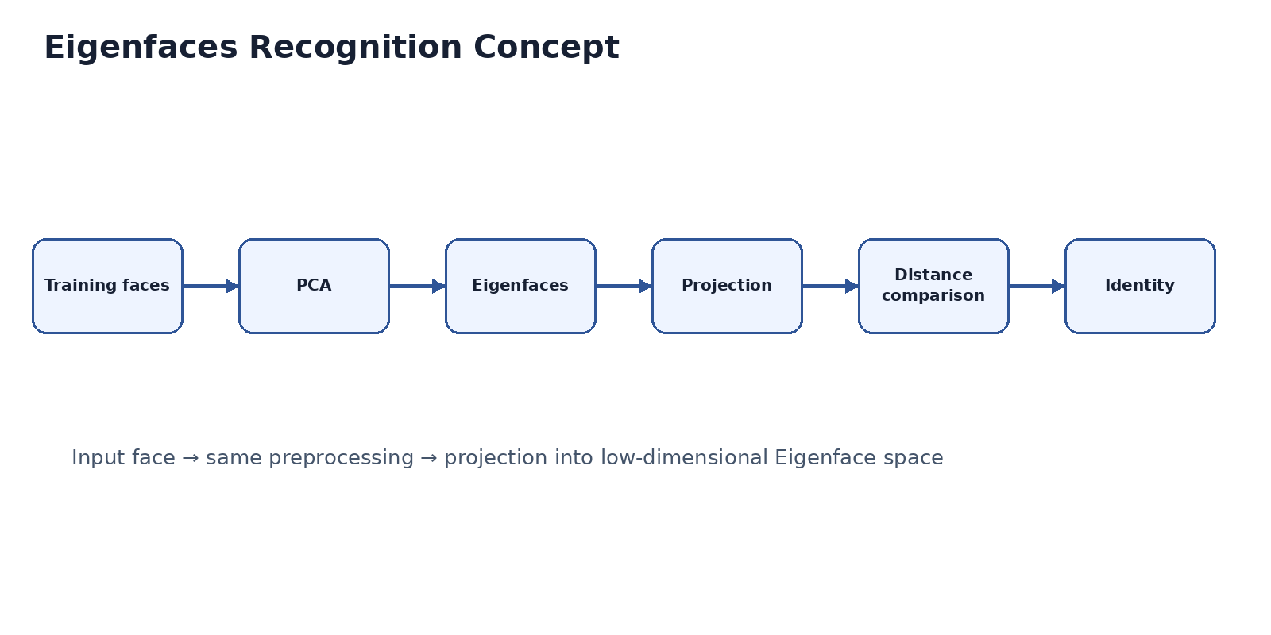
Figure. Algorithm workflow.
BEGIN
INPUT: Grayscale image I of size M × N
OUTPUT: Bounding boxes and recognized names
1. Read the input image.
2. Normalize grayscale illumination.
3. Apply histogram equalization or CLAHE.
4. Detect all faces using a Viola-Jones detector or sliding window.
5. FOR each detected face:
5.1 Crop the face region.
5.2 Align the face using facial landmarks when available.
5.3 Resize to the training dimensions.
5.4 Normalize intensity.
5.5 Project the face onto the precomputed Eigenface/PCA basis.
5.6 Compute Euclidean distance to stored face projections.
5.7 Select the identity with minimum distance.
5.8 IF distance < recognition threshold:
label = matched known name
ELSE:
label = "Unknown"
6. Draw each bounding box and label.
7. Display/return the result.
END
Special cases:
- Process every detected face independently.
- Use pose-diverse training images for ±30° orientation.
- Reject uncertain matches using the confidence threshold.

Scenario 2 – Real-Time Road Lane Detection
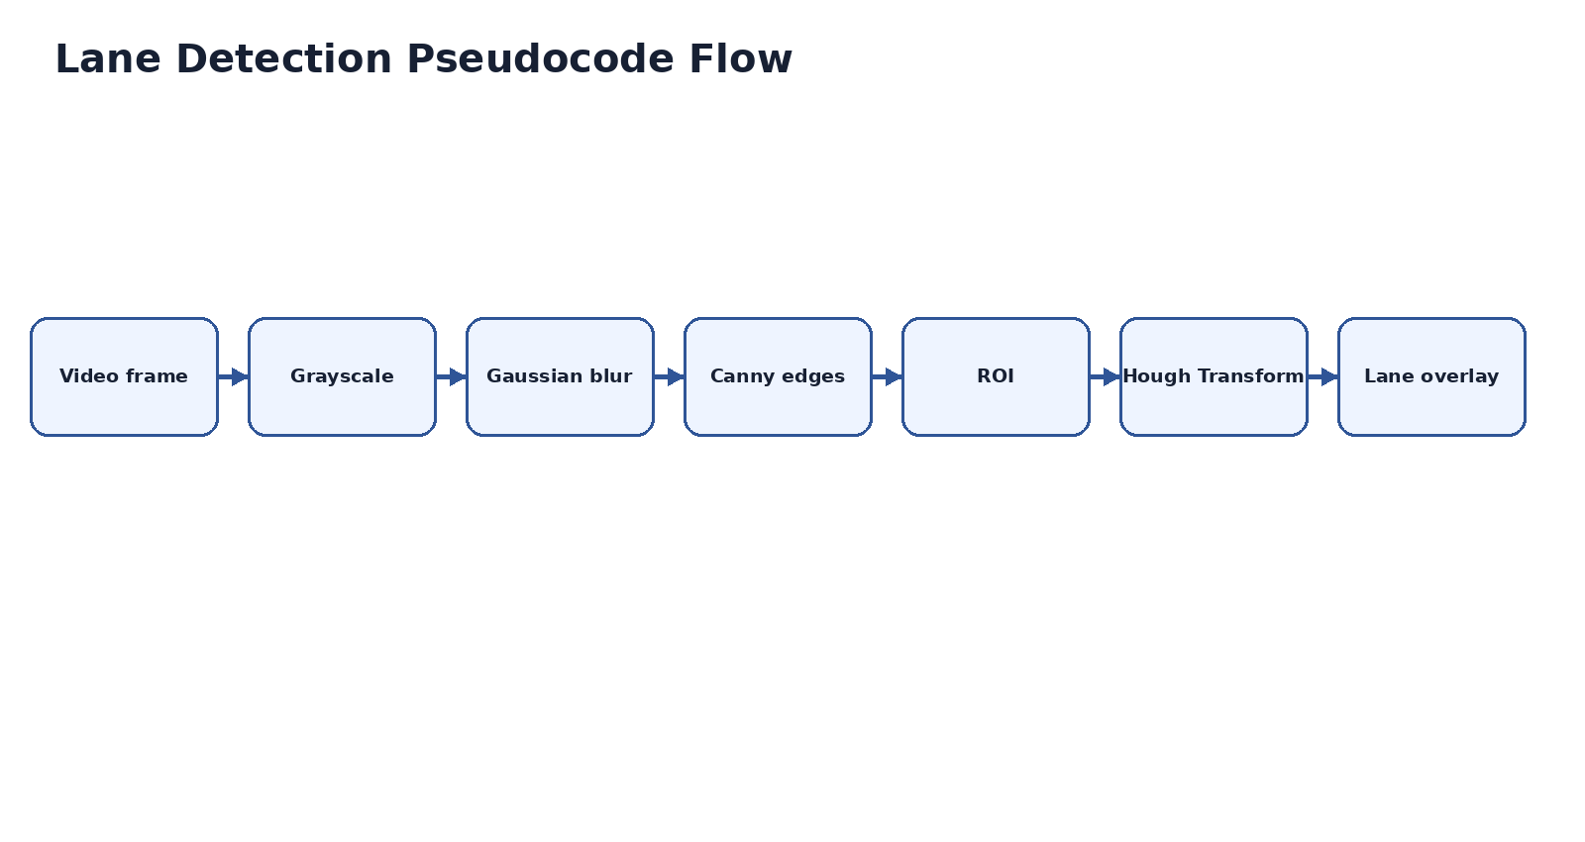Figure. Algorithm workflow.
BEGIN
INPUT: Front-facing driving video
OUTPUT: Each frame with detected lane lines highlighted
1. Open the video stream.
2. WHILE a frame is available:
2.1 Capture the current frame.
2.2 Convert the frame to grayscale.
2.3 Apply Gaussian smoothing.
2.4 Select the road region of interest.
2.5 Apply Canny edge detection.
2.6 Apply Hough Transform to detect lane candidates.
2.7 Filter candidates using slope, position, and temporal consistency.
2.8 Estimate left and right lane boundaries.
2.9 Overlay the lane lines on the original frame.
2.10 Display the processed frame.
3. Stop when the video ends or the user exits.
4. Release video resources.
END
Special cases:
- Use smoothing and temporal filtering to reduce noise.
- Use ROI filtering to reject irrelevant edges.
- Extend line fitting with polynomial curves for curved lanes.

