SIMATS ENGINEERING
ASSESSMENT TOOL 3

COURSE CODE: ITA 0611 COURSE NAME: MACHINE LEARNING

COURSE OUTCOME COVERED

CO4: K- Nearest Neighbour Learning – Locally weighted Regression – Radial Bases Functions – Case Based Learning (BL 5)

Assessment Tool Weightage: 10%

QUESTIONS: 5 Total Marks:50

Code of Conduct:

I B. HEMANTH KUMAR (192324238) (Name / Reg No) certify that this submission is my original work and that I have adhered to the guidelines specified for this assessment.
I understand that any violation of academic integrity rules will result in disciplinary action.

Signature of the student:

QUESTION 2 – LWR VS RBF
Dataset: Auto MPG dataset (archive 5)
Dataset Sample
mpg | cylinders | displacement | horsepower | weight | acceleration
18.0 | 8.0 | 307.0 | 130.0 | 3504.0 | 12.0
15.0 | 8.0 | 350.0 | 165.0 | 3693.0 | 11.5
18.0 | 8.0 | 318.0 | 150.0 | 3436.0 | 11.0
16.0 | 8.0 | 304.0 | 150.0 | 3433.0 | 12.0
17.0 | 8.0 | 302.0 | 140.0 | 3449.0 | 10.5

Python Code
import pandas as pd, numpy as np
import matplotlib.pyplot as plt
from sklearn.kernel_ridge import KernelRidge
df=pd.read_csv("auto-mpg.csv");df["horsepower"]=pd.to_numeric(df.horsepower,errors="coerce");df=df.dropna(subset=["horsepower","mpg"]);x=df.horsepower.values;y=df.mpg.values
def lwr(q,tau=25):
w=np.exp(-((x-q)**2)/(2*tau**2));A=np.c_[np.ones(len(x)),x];W=np.diag(w);th=np.linalg.pinv(A.T@W@A)@A.T@W@y;return th[0]+th[1]*q
xx=np.linspace(x.min(),x.max(),200);rbf=KernelRidge(alpha=.5,kernel="rbf",gamma=.002).fit(x[:,None],y)
plt.scatter(x,y,s=8);plt.plot(xx,[lwr(q) for q in xx],label="LWR");plt.plot(xx,rbf.predict(xx[:,None]),label="RBF");plt.legend();plt.show()

Actual Output

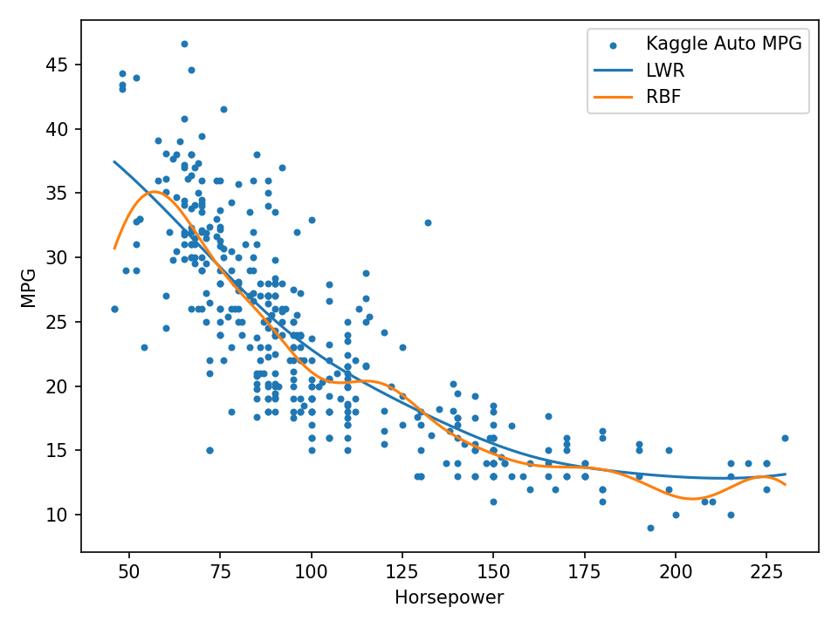

QUESTION 3 – KNN VS RBF
Dataset: Wine Classification dataset (archive 4)
Dataset Sample
class | Alcohol | Malic acid | Ash | Alcalinity of ash | Magnesium
1.0 | 14.23 | 1.71 | 2.43 | 15.6 | 127.0
1.0 | 13.2 | 1.78 | 2.14 | 11.2 | 100.0
1.0 | 13.16 | 2.36 | 2.67 | 18.6 | 101.0
1.0 | 14.37 | 1.95 | 2.5 | 16.8 | 113.0
1.0 | 13.24 | 2.59 | 2.87 | 21.0 | 118.0

Python Code
import pandas as pd
from sklearn.model_selection import train_test_split
from sklearn.preprocessing import StandardScaler
from sklearn.neighbors import KNeighborsClassifier
from sklearn.kernel_approximation import RBFSampler
from sklearn.linear_model import LogisticRegression
from sklearn.pipeline import make_pipeline
from sklearn.metrics import accuracy_score
df=pd.read_csv("Wine dataset.csv");df.columns=df.columns.str.strip();X=df.drop(columns="class");y=df["class"]
a,c,ya,yc=train_test_split(X,y,test_size=.3,random_state=42,stratify=y);s=StandardScaler();a=s.fit_transform(a);c=s.transform(c)
kn=KNeighborsClassifier(5).fit(a,ya);rb=make_pipeline(RBFSampler(gamma=.05,n_components=200,random_state=42),LogisticRegression(max_iter=2000)).fit(a,ya)
print("KNN Accuracy:",accuracy_score(yc,kn.predict(c)));print("RBF Accuracy:",accuracy_score(yc,rb.predict(c)))

Actual Output

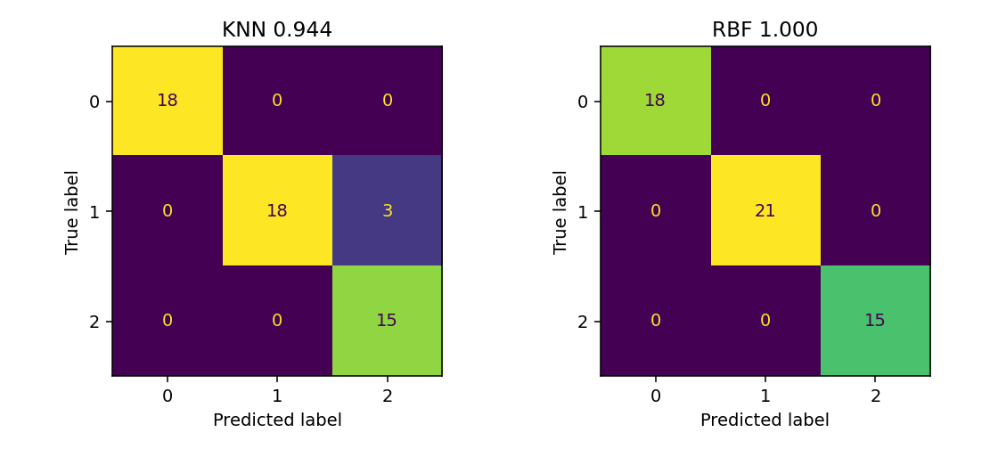

QUESTION 4 – CASE-BASED LEARNING VS LWR
Dataset: MovieLens movies/ratings (archive 3); 300,000 real ratings sampled for computation
Dataset Sample
userId | movieId | rating | timestamp
1.0 | 296.0 | 5.0 | 1147880044.0
1.0 | 306.0 | 3.5 | 1147868817.0
1.0 | 307.0 | 5.0 | 1147868828.0
1.0 | 665.0 | 5.0 | 1147878820.0
1.0 | 899.0 | 3.5 | 1147868510.0

Python Code
import pandas as pd,numpy as np
from sklearn.neighbors import NearestNeighbors
r=pd.read_csv("ratings.csv",usecols=["userId","movieId","rating"]).sample(300000,random_state=42);m=r.groupby("movieId").rating.agg(["mean","count"]).reset_index();m.columns=["movieId","avg_rating","n_ratings"]
F=m[["avg_rating","n_ratings"]].values;q=np.array([[4.,500.]]);nn=NearestNeighbors(5).fit(F);_,ix=nn.kneighbors(q);print("CBL Prediction:",m.iloc[ix[0]].avg_rating.mean())
A=np.c_[np.ones(len(F)),F];d=np.linalg.norm((F-q)/[1,500],axis=1);W=np.diag(np.exp(-d*d/2));th=np.linalg.pinv(A.T@W@A)@A.T@W@m.avg_rating.values;print("LWR Prediction:",np.array([1,4,500])@th)

Actual Output

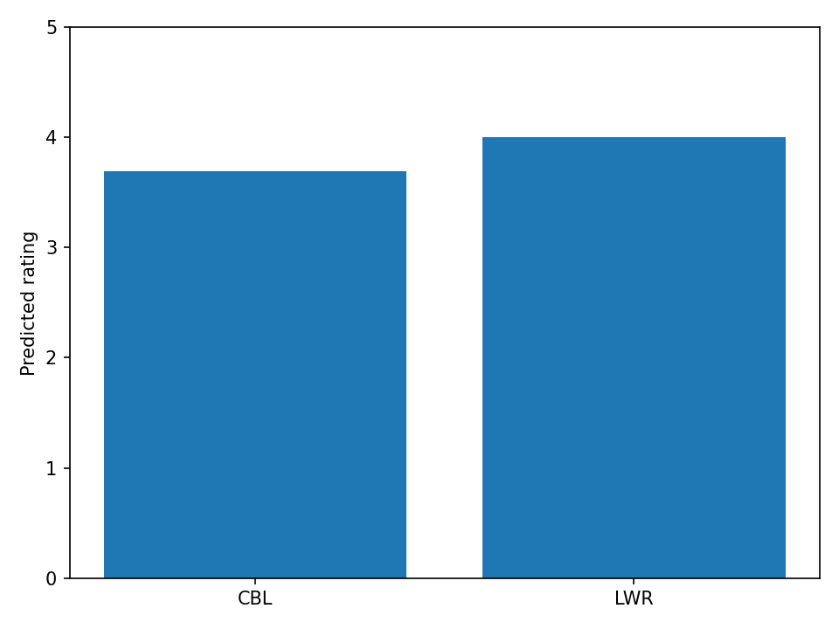

QUESTION 6 – NAÏVE BAYES VS LOGISTIC REGRESSION
Dataset: SMS Spam Collection (archive 2), 5,574 real labelled messages
Dataset Sample
ham Go until jurong point | crazy.. Available only in bugis n great world la e buffet... Cine there got amore wat...
ham Ok lar... Joking wif u oni... | None
spam Free entry in 2 a wkly comp to win FA Cup final tkts 21st May 2005. Text FA to 87121 to receive entry question(std txt rate)T&C's apply 08452810075over18's | None
ham U dun say so early hor... U c already then say... | None
ham Nah I don't think he goes to usf | he lives around here though
spam FreeMsg Hey there darling it's been 3 week's now and no word back! I'd like some fun you up for it still? Tb ok! XxX std chgs to send | Â£1.50 to rcv

Python Code
import pandas as pd
from sklearn.model_selection import train_test_split
from sklearn.feature_extraction.text import TfidfVectorizer
from sklearn.naive_bayes import MultinomialNB
from sklearn.linear_model import LogisticRegression
from sklearn.pipeline import make_pipeline
from sklearn.metrics import accuracy_score
df=pd.read_csv("SpamCollectionSMS.txt",sep="\t",header=None,names=["label","message"]);a,c,ya,yc=train_test_split(df.message,df.label,test_size=.25,random_state=42,stratify=df.label)
nb=make_pipeline(TfidfVectorizer(),MultinomialNB()).fit(a,ya);lr=make_pipeline(TfidfVectorizer(),LogisticRegression(max_iter=1000)).fit(a,ya)
print("Naive Bayes Accuracy:",accuracy_score(yc,nb.predict(c)));print("Logistic Regression Accuracy:",accuracy_score(yc,lr.predict(c)))

Actual Output

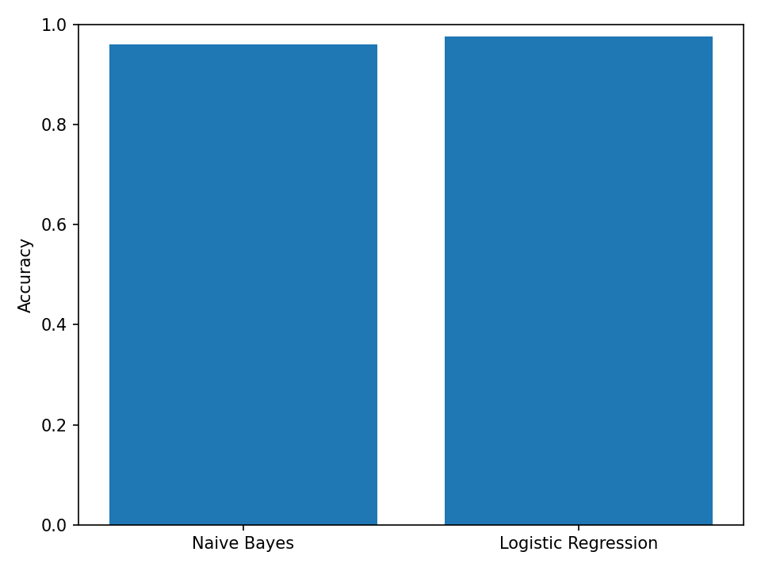

QUESTION 10 – PCA VS FEATURE SELECTION
Dataset: Wine Quality red/white (archive 1), 6,497 real records
Dataset Sample
type | fixed acidity | volatile acidity | citric acid | residual sugar | chlorides
white | 7.0 | 0.27 | 0.36 | 20.7 | 0.045
white | 6.3 | 0.3 | 0.34 | 1.6 | 0.049
white | 8.1 | 0.28 | 0.4 | 6.9 | 0.05
white | 7.2 | 0.23 | 0.32 | 8.5 | 0.058
white | 7.2 | 0.23 | 0.32 | 8.5 | 0.058

Python Code
import pandas as pd
from sklearn.model_selection import train_test_split
from sklearn.preprocessing import StandardScaler
from sklearn.decomposition import PCA
from sklearn.feature_selection import SelectKBest,f_classif
from sklearn.linear_model import LogisticRegression
from sklearn.metrics import accuracy_score
df=pd.read_csv("wine-quality-white-and-red.csv");X=df.drop(columns=["type","quality"]);y=df.quality;a,c,ya,yc=train_test_split(X,y,test_size=.3,random_state=42);s=StandardScaler();a=s.fit_transform(a);c=s.transform(c)
p=PCA(5).fit(a);pm=LogisticRegression(max_iter=2000).fit(p.transform(a),ya);sel=SelectKBest(f_classif,k=5).fit(a,ya);sm=LogisticRegression(max_iter=2000).fit(sel.transform(a),ya)
print("PCA Accuracy:",accuracy_score(yc,pm.predict(p.transform(c))));print("Feature Selection Accuracy:",accuracy_score(yc,sm.predict(sel.transform(c))))

Actual Output

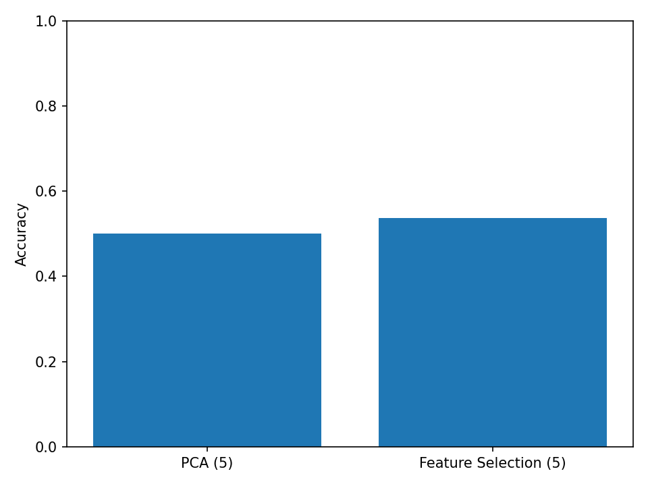
The embedded figure is the actual output generated from the supplied real dataset.

