5 a)
Write a program to demonstrate the various ways you can reference a color in CSS
<!DOCTYPE html>
<html>
<head>
<title>CSS Color Referencing Demo</title>
<style>
/* 1. Named Color */
.named-color {
color: red;
background-color: lightyellow;
}

/* 2. Hexadecimal */
.hex-color {
color: #0000FF; /* Blue */
background-color: #F0F0F0;
}

/* 3. RGB */
.rgb-color {
color: rgb(0, 128, 0); /* Green */
background-color: rgb(230, 230, 250);
}

/* 4. RGBA */
.rgba-color {
color: rgba(255, 165, 0, 0.9); /* Orange with slight transparency */
background-color: rgba(255, 255, 255, 0.5);
}

/* 5. HSL */
.hsl-color {
color: hsl(240, 100%, 50%); /* Blue */
background-color: hsl(60, 100%, 90%);
}

/* 6. HSLA */
.hsla-color {
color: hsla(300, 100%, 50%, 0.8); /* Purple with transparency */
background-color: hsla(0, 0%, 100%, 0.5);
}
</style>
</head>
<body>
<h2>Different Ways to Apply Colors in CSS</h2>

<p class="named-color">This text uses a named color: <strong>red</strong>.</p>
<p class="hex-color">This text uses a hex code: <strong>#0000FF</strong>.</p>
<p class="rgb-color">This text uses RGB format: <strong>rgb(0, 128, 0)</strong>.</p>
<p class="rgba-color">This text uses RGBA: <strong>rgba(255, 165, 0, 0.9)</strong>.</p>
<p class="hsl-color">This text uses HSL: <strong>hsl(240, 100%, 50%)</strong>.</p>
<p class="hsla-color">This text uses HSLA: <strong>hsla(300, 100%, 50%, 0.8)</strong>.</p>
</body>
</html>

Output:
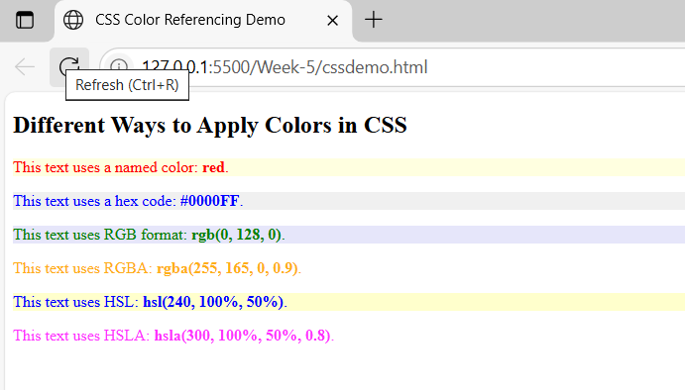

5 b)
Write a CSS rule that places a background image halfway down the page, tilting it
horizontally. The image should remain in place when the user scrolls up or down.
<!DOCTYPE html>
<html>
<head>
<title>Fixed Flipped Background Example</title>
<style>
body {
margin: 0;
height: 200vh; /* Makes the page scrollable */
}
.background {
position: fixed;
top: 20%; /* Halfway down the page */
left: 0;
width: 100%;
height: 200px; /* Adjust as needed */
background-image:url('https://picsum.photos/id/1015/600/400');
background-repeat:repeat;
background-size:cover;
background-position:center;
transform: rotate(-15deg); /* Flip horizontally */
z-index: -1; /* Place behind content */

}
.content {
padding: 50px;
font-size: 20px;
}

.vtext{
writing-mode:vertical-rl;
}
</style>
</head>
<body>
<div class="background"></div>
<div class="content">
<h1 class="vtext">Scroll Down</h1>
<p>This is an example page with a background image fixed halfway down and flipped horizontally.</p>
<p>Keep scrolling to see the background image stay in place.</p>
<p>To tilt an image horizontally you can either flip it (mirror across the vertical axis) or rotate it slightly for a tilted look. Use CSS transform — scaleX(-1) for a horizontal flip, rotate() for a 2D tilt, or rotateX() for a 3D tilt effect. Adjust transform-origin and transition for smoother results.</p>
</div>
</body>
</html>

Output:
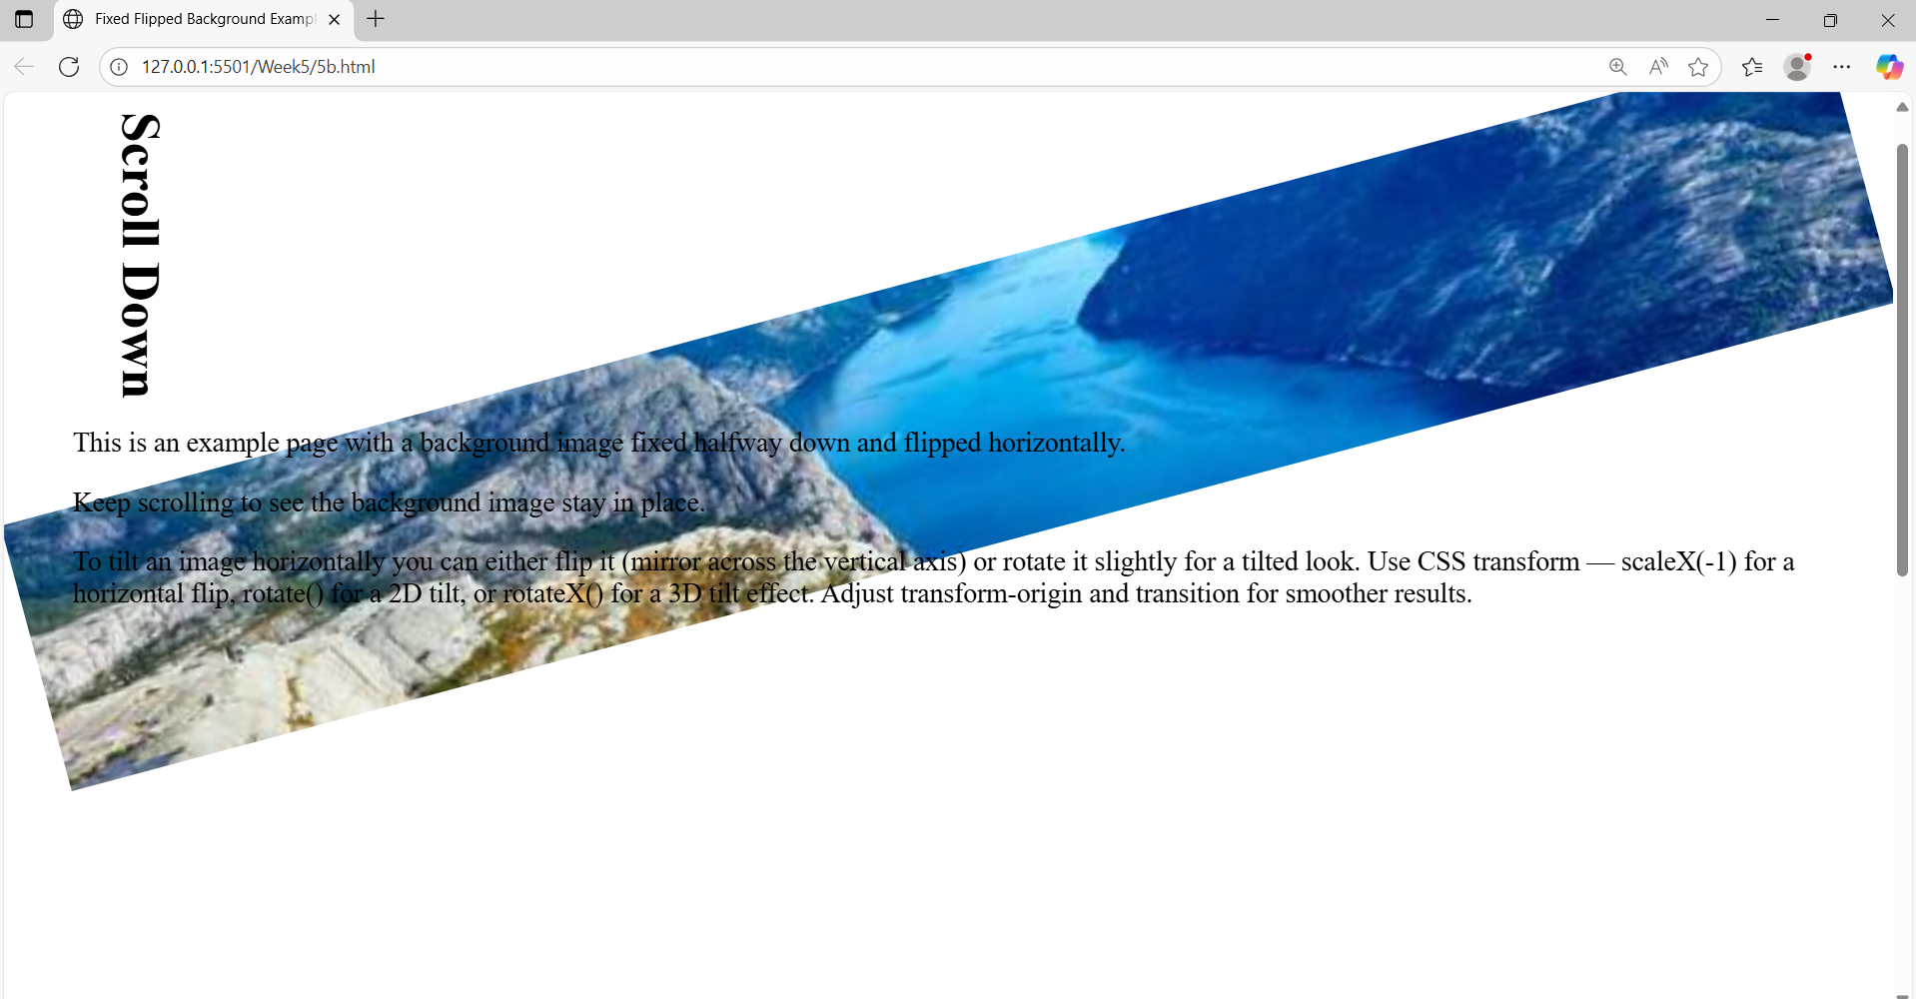

5 c)
Write a program using the following terms related to CSS font and text:
i. font-size ii. font-weight iii. font-style
iv. text-decoration v. text-transformation vi. text-alignment

<!DOCTYPE html>
<html>
<head>
<title>CSS Font and Text Properties</title>
<style>
.font-size {
font-size: 24px; /* Increases text size */
}
.font-weight {
font-weight: bold; /* Makes text bold */
}
.font-style {
font-style: italic; /* Makes text italic */
}
.text-decoration {
text-decoration: underline; /* Underlines the text */
}
.text-transform {
text-transform:uppercase; /* Converts text to uppercase */
}
.text-align {
text-align: center; /* Centers the text */
}
</style>
</head>
<body>
<h2>CSS Font and Text Formatting Examples</h2>
<p class="font-size">This text uses <strong>font-size: 24px</strong>.</p>
<p class="font-weight">This text uses <strong>font-weight: bold</strong>.</p>
<p class="font-style">This text uses <strong>font-style: italic</strong>.</p>
<p class="text-decoration">This text uses <strong>text-decoration: underline</strong>.</p>
<p class="text-transform">This text uses <strong>text-transform: uppercase</strong>.</p>
<p class="text-align">This text uses <strong>text-align: center</strong>.</p>
</body>
</html>

Output:
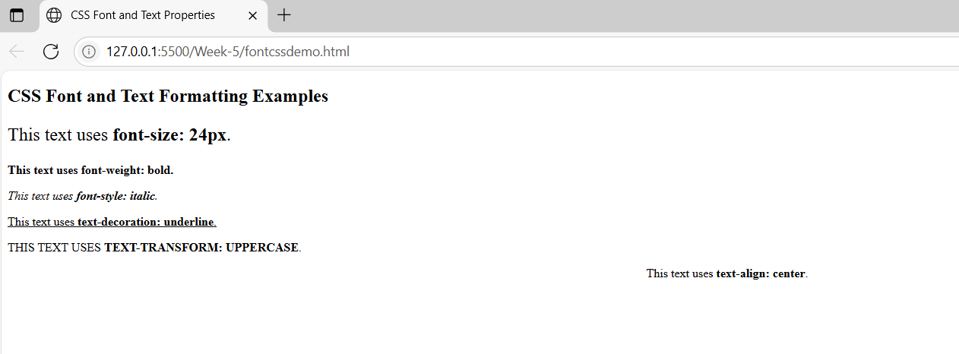

5 d)
Write a program, to explain the importance of CSS Box model using
i. Content ii. Border iii. Margin iv. Padding

<!DOCTYPE html>
<html>
<head>
<title>CSS Box Model Demo</title>
<style>
.box {
width: 300px;
height: 100px;
background-color: lightyellow; /* Content background */
padding: 20px; /* Space inside border */
border: 5px solid orange; /* Border around content and padding */
margin: 30px auto; /* Space outside the border */
text-align: center;
font-size: 18px;
box-sizing: content-box; /* Default box model behavior */
}
body {
background-color: #f2f2f2;
font-family: Arial, sans-serif;
}
</style>
</head>
<body>
<h2 style="text-align:center;">CSS Box Model Explanation</h2>

<div class="box">
<strong>Content:</strong> This is the main content.<br>
<strong>Padding:</strong> Adds space inside the box.<br>
<strong>Border:</strong> Adds a visible edge around it.<br>
<strong>Margin:</strong> Adds space outside the box.
</div>
</body>
</html>

Output:

