6 a) Write a program to embed internal and external javascript in a webpage.
script.js:
// script.js
function greetExternal() {
alert("Hello from External JavaScript!");
}
jsdemo.html:
<!DOCTYPE html>
<html>
<head>
<title>Internal and External JavaScript</title>

<!-- Link to external JavaScript file -->
<script src="script.js"></script>

<!-- Internal JavaScript -->
<script>
function greetInternal() {
alert("Hello from Internal JavaScript!");
}
</script>
</head>
<body>
<h1>Welcome to JavaScript Demo</h1>
<button onclick="greetInternal()">Click for Internal Script</button>
<button onclick="greetExternal()">Click for External Script</button>
</body>
</html>

Output:
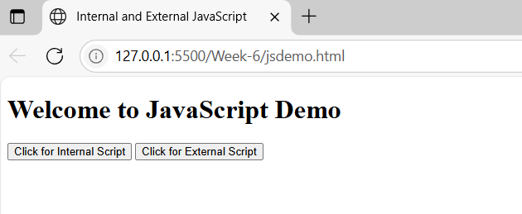

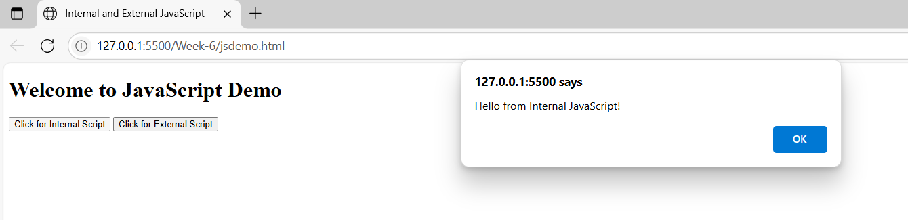

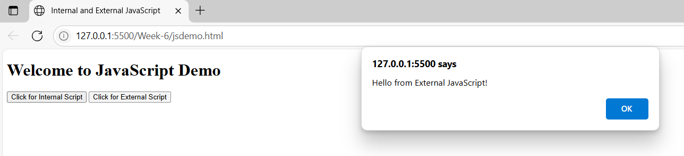

6 b) Write a program to explain the different ways for displaying output.
Method | Description
alert() | Displays a popup dialog with a message.
console.log() | Outputs to the browser console (developer tools).
document.write() | Writes content directly into the HTML document.
innerHTML | Displays output inside a specific HTML element.
<!DOCTYPE html>
<html>
<head>
<title>Output Methods in JavaScript</title>
<script>
// Method 1: alert() - Popup alert box
function showAlert() {
alert("This is an alert box!");
}
// Method 2: console.log() - Logs output to browser console
function showConsoleLog() {
console.log("This is a console log message.");
}
// Method 3: document.write() - Writes directly to the web page
function showDocumentWrite() {
document.write("<p>This is written using document.write().</p>");
}
// Method 4: innerHTML - Outputs content into an HTML element
function showInnerHTML() {
document.getElementById("outputArea").innerHTML = "This is output using innerHTML.";
}
</script>
</head>
<body>

<h2>JavaScript Output Methods</h2>
<button onclick="showAlert()">Show Alert Box</button><br><br>
<button onclick="showConsoleLog()">Show Console Log</button><br><br>
<button onclick="showDocumentWrite()">Use document.write()</button><br><br>
<button onclick="showInnerHTML()">Use innerHTML</button><br><br>
<div id="outputArea" style="color: blue; font-weight: bold;"></div>
</body>
</html>
Output:
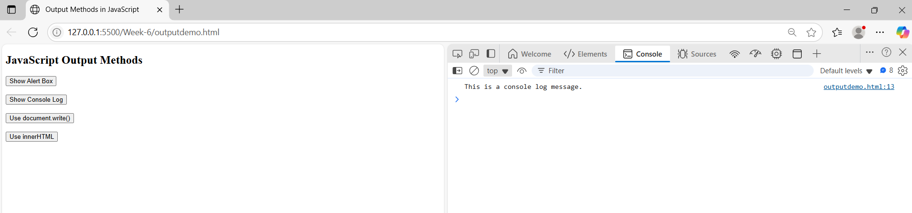

6 c)
Write a program to explain the different ways for taking input.
<!DOCTYPE html>
<html>
<head>
<title>Input Methods in JavaScript</title>
<script>
// Method 1: prompt() - Takes input using a dialog box
function takePromptInput() {
let name = prompt("Enter your name:");
alert("Hello, " + name + "! (from prompt input)");
}
// Method 2: Using HTML input element and get value using DOM
function takeFormInput() {
let userInput = document.getElementById("textInput").value;
document.getElementById("formOutput").innerHTML = "You entered: " + userInput + " (from input field)";
}

</script>
</head>
<body>

<h2>JavaScript Input Methods</h2>
<!-- Method 1: prompt() -->
<button onclick="takePromptInput()">Take Input using prompt()</button><br><br>
<!-- Method 2: Input field + DOM access -->
<label>Enter something:</label>
<input type="text" id="textInput">
<button onclick="takeFormInput()">Submit</button>
<p id="formOutput" style="color: blue;"></p>
</body>
</html>
Output:
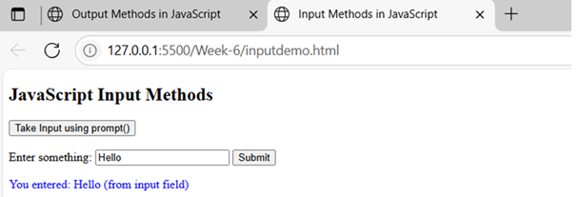

6 d)
Create a webpage which uses prompt dialogue box to ask a voter for his name and age. Display the information in table format along with either the voter can vote or not.
<!DOCTYPE html>
<html>
<head>
<title>Voter Eligibility Check</title>
<style>
table {
border-collapse: collapse;
margin-top: 20px;
width: 50%;
}
th, td {
border: 1px solid black;
padding: 10px;
text-align: center;
}
th {
background-color: #f2f2f2;
}
</style>
<script>
function checkVoter() {
let name = prompt("Enter your name:");
let age = prompt("Enter your age:");
age = parseInt(age); // Convert age to number

let status = (age >= 18) ? "Eligible to Vote" : "Not Eligible to Vote";
// Insert data into the table
document.getElementById("voterName").innerText = name;
document.getElementById("voterAge").innerText = age;
document.getElementById("voterStatus").innerText = status;
}
</script>
</head>
<body onload="checkVoter()">
<h2>Voter Information</h2>
<table>
<tr>
<th>Name</th>
<th>Age</th>
<th>Voter Status</th>
</tr>
<tr>
<td id="voterName"></td>
<td id="voterAge"></td>
<td id="voterStatus"></td>
</tr>
</table>
</body>
</html>

Output:
