Week-7: JavaScript Pre-defined and User-defined Objects
a) Write a program using document object properties and methods.
Feature | Usage
document.title | Get the title of the webpage
document.URL | Get the full URL of the current page
document.domain | Get the domain name of the page
document.lastModified | Shows when the document was last changed
document.getElementById() | Access a specific element by ID
document.write() | Writes content directly into the document (overwrites entire document if used after page load)
<!DOCTYPE html>
<html>
<head>
<title>Document Object Demo</title>
<script>
function showDocumentInfo() {
// Using document properties
document.getElementById("title").innerText = "Title: " + document.title;
document.getElementById("url").innerText = "URL: " + document.URL;
document.getElementById("domain").innerText = "Domain: " + document.domain;
document.getElementById("lastModified").innerText = "Last Modified: " + document.lastModified;

// Using document methods
document.getElementById("outputArea").style.color = "green";
// document.write("<p>This line is written using <b>document.write()</b>.</p>");
}
</script>
</head>
<body>
<h2>Using Document Object Properties and Methods</h2>
<button onclick="showDocumentInfo()">Show Document Info</button>
<div id="outputArea">
<p id="title"></p>
<p id="url"></p>
<p id="domain"></p>
<p id="lastModified"></p>
</div>
</body>
</html>

Output:
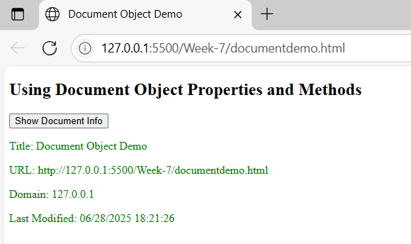

7 b)
Write a program using window object properties and methods

<!DOCTYPE html>
<html>
<head>
<title>Window Object Demo</title>
<script>
function showWindowInfo() {
// Using window properties
document.getElementById("height").innerText = "Inner Height: " + window.innerHeight + " px";
document.getElementById("width").innerText = "Inner Width: " + window.innerWidth + " px";
document.getElementById("location").innerText = "Location: " + window.location.href;

// Using window methods
window.alert("This is an alert from window.alert()");
}

function openNewWindow() {
// Open a new window or tab
window.open("https://www.example.com", "_blank");
}

function confirmAction() {
// Using window.confirm()
let result = window.confirm("Do you want to continue?");
document.getElementById("confirmResult").innerText = result
? "You clicked OK"
: "You clicked Cancel";
}

function promptInput() {
// Using window.prompt()
let name = window.prompt("Enter your name:");
if (name)
document.getElementById("promptResult").innerText = "Hello, " + name + "!";
}
</script>
</head>
<body>

<h2>Using Window Object Properties and Methods</h2>

<button onclick="showWindowInfo()">Show Window Info</button><br><br>
<button onclick="openNewWindow()">Open New Window</button><br><br>
<button onclick="confirmAction()">Confirm Action</button><br><br>
<button onclick="promptInput()">Prompt for Name</button><br><br>

<p id="height"></p>
<p id="width"></p>
<p id="location"></p>
<p id="confirmResult" style="color: blue;"></p>
<p id="promptResult" style="color: green;"></p>

</body>
</html>
Output:
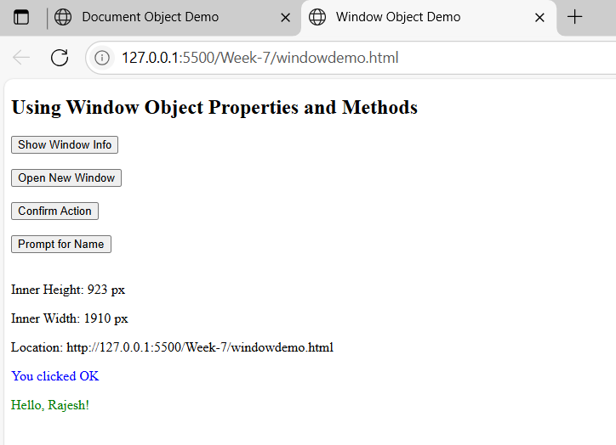

Feature | Description
window.innerHeight / innerWidth | Gets the visible area of the browser window.
window.location.href | Returns the current page URL.
window.alert() | Displays an alert dialog box.
window.open() | Opens a new browser window/tab.
window.confirm() | Asks user for OK/Cancel confirmation.
window.prompt() | Gets user input via dialog box.

7 c)
Write a program using array object properties and methods.
Feature | Description
.length | Returns the number of elements in the array
.push() | Adds an element to the end of the array
.pop() | Removes the last element from the array
.unshift() | Adds an element to the start of the array
.shift() | Removes the first element from the array
.indexOf() | Returns the index of a specified element
.join() | Joins array elements into a single string

<!DOCTYPE html>
<html>
<head>
<title>Array Object Demo</title>
<script>
function showArrayOperations() {
// Create an array
let fruits = ["Apple", "Banana", "Mango"];

// Display original array
document.getElementById("original").innerText = "Original Array: " + fruits;

// Property: length
document.getElementById("length").innerText = "Length: " + fruits.length;

// Method: push() - add to end
fruits.push("Orange");

// Method: pop() - remove from end
let popped = fruits.pop();

// Method: unshift() - add to start
fruits.unshift("Strawberry");

// Method: shift() - remove from start
let shifted = fruits.shift();

// Method: indexOf() - find index
let index = fruits.indexOf("Banana");

// Method: join() - convert to string
let joined = fruits.join(" | ");

// Display results
document.getElementById("finalArray").innerText = "Final Array: " + fruits;
document.getElementById("popped").innerText = "Popped Element: " + popped;
document.getElementById("shifted").innerText = "Shifted Element: " + shifted;
document.getElementById("index").innerText = "Index of Banana: " + index;
document.getElementById("joined").innerText = "Joined Array: " + joined;
}
</script>
</head>
<body>
<h2>Array Object Properties and Methods</h2>
<button onclick="showArrayOperations()">Run Array Operations</button>

<p id="original"></p>
<p id="length"></p>
<p id="popped"></p>
<p id="shifted"></p>
<p id="index"></p>
<p id="joined"></p>
<p id="finalArray" style="font-weight: bold; color: green;"></p>

</body>
</html>

Output:
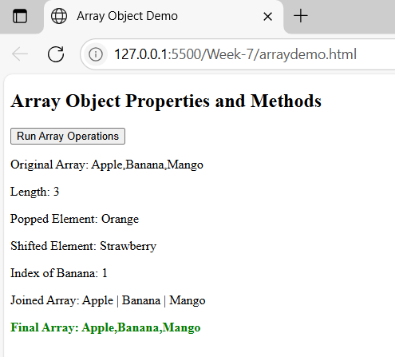

<!DOCTYPE html>
<html>
<head>
<title>Advanced Array Methods</title>
<script>
function runAdvancedArrayOperations() {
let numbers = [5, 10, 15, 20, 25];

// map() - multiply each number by 2
let mapped = numbers.map(num => num * 2);

// filter() - get numbers greater than 10
let filtered = numbers.filter(num => num > 10);

// reduce() - sum of all numbers
let total = numbers.reduce((acc, val) => acc + val, 0);

// sort() - ascending
let sorted = [...numbers].sort((a, b) => a - b); // copy first to preserve original

// Multidimensional array
let matrix = [
[1, 2, 3],
[4, 5, 6],
[7, 8, 9]
];

// Convert matrix to string for display
let matrixString = matrix.map(row => row.join(" ")).join("<br>");

// Output
document.getElementById("original").innerText = "Original Array: " + numbers;
document.getElementById("map").innerText = "Mapped (×2): " + mapped;
document.getElementById("filter").innerText = "Filtered (>10): " + filtered;
document.getElementById("reduce").innerText = "Reduced (sum): " + total;
document.getElementById("sort").innerText = "Sorted (ascending): " + sorted;
document.getElementById("matrix").innerHTML = "<strong>3×3 Matrix:</strong><br>" + matrixString;
}
</script>
</head>
<body>

<h2>Advanced Array Methods & Multidimensional Arrays</h2>

<button onclick="runAdvancedArrayOperations()">Run Advanced Operations</button>

<p id="original"></p>
<p id="map"></p>
<p id="filter"></p>
<p id="reduce"></p>
<p id="sort"></p>
<p id="matrix" style="color: darkblue;"></p>

</body>
</html>

Output:
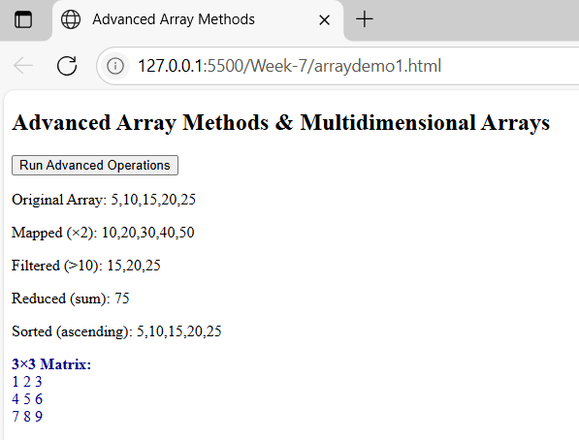

Method | Purpose
.map() | Transforms each element in the array
.filter() | Filters elements based on a condition
.reduce() | Reduces the array to a single value (e.g., sum)
.sort() | Sorts elements (ascending/descending)
Matrix | Demonstrates a 2D array (array of arrays)

7 d)
Write a program using math object properties and methods

<!DOCTYPE html>
<html>
<head>
<title>Math Object Demo</title>
<script>
function showMathOperations() {
let number = 9.56;

// Math properties
let pi = Math.PI;
let e = Math.E;
// Math methods
let round = Math.round(number);
let floor = Math.floor(number);
let ceil = Math.ceil(number);
let sqrt = Math.sqrt(64);
let pow = Math.pow(2, 5);
let abs = Math.abs(-7);
let max = Math.max(10, 30, 20, 5);
let min = Math.min(10, 30, 20, 5);
let random = Math.random(); // Between 0 and 1
// Output to HTML
document.getElementById("pi").innerText = "Math.PI: " + pi;
document.getElementById("e").innerText = "Math.E: " + e;
document.getElementById("round").innerText = "Math.round(9.56): " + round;
document.getElementById("floor").innerText = "Math.floor(9.56): " + floor;
document.getElementById("ceil").innerText = "Math.ceil(9.56): " + ceil;
document.getElementById("sqrt").innerText = "Math.sqrt(64): " + sqrt;
document.getElementById("pow").innerText = "Math.pow(2, 5): " + pow;
document.getElementById("abs").innerText = "Math.abs(-7): " + abs;
document.getElementById("max").innerText = "Math.max(10, 30, 20, 5): " + max;
document.getElementById("min").innerText = "Math.min(10, 30, 20, 5): " + min;
document.getElementById("random").innerText = "Math.random(): " + random.toFixed(4);
}
</script>
</head>
<body>
<h2>JavaScript Math Object Demo</h2>
<button onclick="showMathOperations()">Show Math Results</button>
<p id="pi"></p>
<p id="e"></p>
<p id="round"></p>
<p id="floor"></p>
<p id="ceil"></p>
<p id="sqrt"></p>
<p id="pow"></p>
<p id="abs"></p>
<p id="max"></p>
<p id="min"></p>
<p id="random"></p>

</body>
</html>

Output:
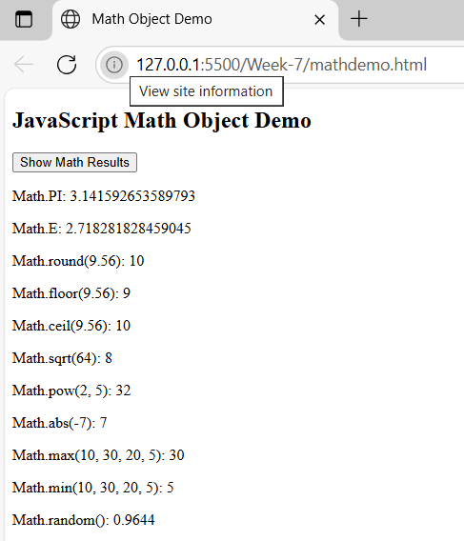

7 e)
Write a program using string object properties and methods

<!DOCTYPE html>
<html>
<head>
<title>String Object Demo</title>
<script>
function showStringOperations() {
let text = " JavaScript is Powerful! ";

// String Properties & Methods
let length = text.length;
let trimmed = text.trim();
let upper = text.toUpperCase();
let lower = text.toLowerCase();
let char = text.charAt(5);
let index = text.indexOf("Powerful");
let includes = text.includes("Script");
let replaced = text.replace("Powerful", "Amazing");
let sliced = text.slice(2, 12);
let sub = text.substring(2, 12);
let split = text.trim().split(" "); // split into words

// Output results
document.getElementById("original").innerText = "Original Text: '" + text + "'";
document.getElementById("length").innerText = "Length: " + length;
document.getElementById("trimmed").innerText = "Trimmed: '" + trimmed + "'";
document.getElementById("upper").innerText = "Uppercase: " + upper;
document.getElementById("lower").innerText = "Lowercase: " + lower;
document.getElementById("char").innerText = "Character at index 5: '" + char + "'";
document.getElementById("index").innerText = "Index of 'Powerful': " + index;
document.getElementById("includes").innerText = "Includes 'Script': " + includes;
document.getElementById("replace").innerText = "Replace 'Powerful' with 'Amazing': " + replaced;
document.getElementById("slice").innerText = "Slice (2,12): " + sliced;
document.getElementById("substring").innerText = "Substring (2,12): " + sub;
document.getElementById("split").innerText = "Split into words: " + split.join(" | ");
}
</script>
</head>
<body>
<h2>JavaScript String Object Demo</h2>
<button onclick="showStringOperations()">Run String Operations</button>
<p id="original"></p>
<p id="length"></p>
<p id="trimmed"></p>
<p id="upper"></p>
<p id="lower"></p>
<p id="char"></p>
<p id="index"></p>
<p id="includes"></p>
<p id="replace"></p>
<p id="slice"></p>
<p id="substring"></p>
<p id="split"></p>
</body>
</html>
Output:
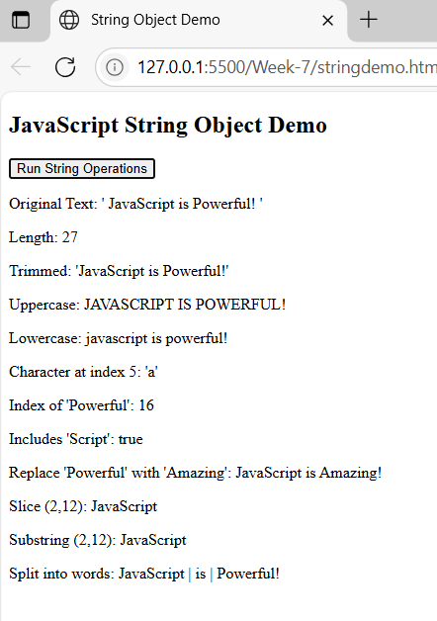

7 f)
Write a program using regex object properties and methods.
<!DOCTYPE html>
<html>
<head>
<title>RegExp Object Demo</title>
</head>
<body>
<h2>Email Validation using RegExp Object</h2>
<input type="text" id="email" placeholder="Enter email">
<button onclick="validateEmail()">Validate</button>
<p id="result"></p>
<script>
function validateEmail() {
let input = document.getElementById("email").value;
// Regular Expression for email
let pattern = /^[a-zA-Z0-9._%+-]+@[a-zA-Z0-9.-]+\.[a-z]{2,}$/;
// Create a RegExp object
let regex = new RegExp(pattern);
// Use RegExp methods
let result = regex.test(input); // returns true/false
let match = input.match(regex); // returns match array or null
let execResult = regex.exec(input); // returns match result or null
// Using RegExp properties (after a match attempt)
document.getElementById("result").innerHTML = `
<strong>Validation Result:</strong> ${result ? "Valid Email ✅" : "Invalid Email ❌"}<br>
<strong>Match:</strong> ${match ? match[0] : "No match"}<br>
<strong>Exec Output:</strong> ${execResult ? execResult[0] : "No match"}<br>
<strong>RegExp Source:</strong> ${regex.source}<br>
<strong>Global Flag:</strong> ${regex.global}<br>
<strong>Ignore Case:</strong> ${regex.ignoreCase}<br>
<strong>Multiline:</strong> ${regex.multiline}
`;
}
</script>
</body>
</html>
Output:
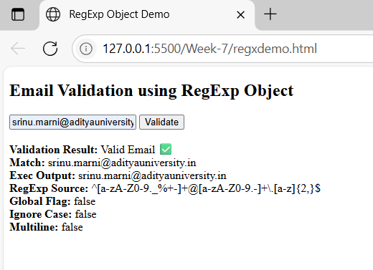

7 g)
Write a program using date object properties and methods.

<!DOCTYPE html>
<html>
<head>
<title>Date Object Demo</title>
</head>
<body>
<h2>JavaScript Date Object Example</h2>
<button onclick="showDateInfo()">Show Current Date Info</button>
<p id="output"></p>
<script>
function showDateInfo() {
// Create a Date object representing the current date and time
let currentDate = new Date();
// Using Date object methods
let fullDate = currentDate.toDateString(); // Returns date string
let time = currentDate.toTimeString(); // Returns time string
let year = currentDate.getFullYear(); // Returns full year (e.g., 2025)
let month = currentDate.getMonth(); // Returns month (0-11)
let date = currentDate.getDate(); // Returns day of the month (1-31)
let day = currentDate.getDay(); // Returns day of the week (0-6)
let hours = currentDate.getHours(); // Returns current hour (0-23)
let minutes = currentDate.getMinutes(); // Returns current minutes (0-59)
let seconds = currentDate.getSeconds(); // Returns current seconds (0-59)
let milliseconds = currentDate.getMilliseconds();// Returns milliseconds (0-999)
let timezoneOffset = currentDate.getTimezoneOffset(); // Minutes difference from UTC
document.getElementById("output").innerHTML = `
<strong>Full Date:</strong> ${fullDate} <br>
<strong>Time:</strong> ${time} <br>
<strong>Year:</strong> ${year} <br>
<strong>Month (0-based):</strong> ${month} <br>
<strong>Date:</strong> ${date} <br>
<strong>Day of Week (0=Sun):</strong> ${day} <br>
<strong>Hours:</strong> ${hours} <br>
<strong>Minutes:</strong> ${minutes} <br>
<strong>Seconds:</strong> ${seconds} <br>
<strong>Milliseconds:</strong> ${milliseconds} <br>
<strong>Timezone Offset (in mins):</strong> ${timezoneOffset}
`;
}
</script>
</body>
</html>

Output:
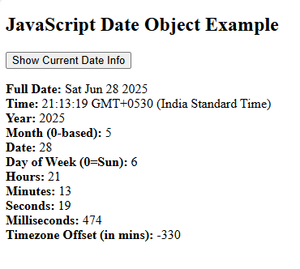
7 h)
Write a program to explain user-defined object by using properties, methods, accessors, constructors and display.
<!DOCTYPE html>
<html>
<head>
<title>User-Defined Object Example</title>
</head>
<body>
<h2>Student Object Demo</h2>
<button onclick="createStudent()">Create and Display Student</button>
<p id="output"></p>
<script>
// Constructor function for a Student object
function Student(name, age, course) {
// Properties
this.name = name;
this.age = age;
this.course = course;

// Accessor: Getter for course
this.getCourse = function() {
return this.course;
};

// Accessor: Setter for course
this.setCourse = function(newCourse) {
this.course = newCourse;
};
// Method to display student details
this.display = function() {
return `Name: ${this.name} <br> Age: ${this.age} <br> Course: ${this.course}`;
};
}

// Function to create object and interact with it
function createStudent() {
// Creating object using constructor
let student1 = new Student("John Doe", 20, "Computer Science");

// Update course using setter
student1.setCourse("Data Science");

// Display using method
document.getElementById("output").innerHTML = `
<strong>Student Details:</strong><br> ${student1.display()}<br><br>
<strong>Access Course using Getter:</strong> ${student1.getCourse()} `;
}
</script>
</body>
</html>

Output:
