Week-8: JavaScript Conditional Statements Loops
a) Write a program which asks the user to enter three integers, obtains the numbers from the user and outputs HTML text that displays the larger number followed by the words “LARGER NUMBER” in an information message dialog. If the numbers are equal, output HTML text as “EQUAL NUMBERS”.
<!DOCTYPE html>
<html>
<head>
<title>Compare Three Numbers</title>
</head>
<body>
<h2>Compare Three Integers</h2>
<button onclick="compareNumbers()">Enter and Compare</button>
<script>
function compareNumbers() {
// Get user input
let num1 = parseInt(prompt("Enter first integer:"));
let num2 = parseInt(prompt("Enter second integer:"));
let num3 = parseInt(prompt("Enter third integer:"));

// Validate input
if (isNaN(num1) || isNaN(num2) || isNaN(num3)) {
alert("Please enter valid integers.");
return;
}
// Check if all numbers are equal
if (num1 === num2 && num2 === num3) {
alert("EQUAL NUMBERS");
} else {
// Find the largest number
let largest = Math.max(num1, num2, num3);
alert(largest + " LARGER NUMBER");
}
}
</script>
</body>
</html>

Output:
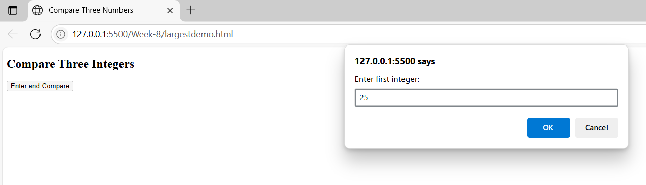

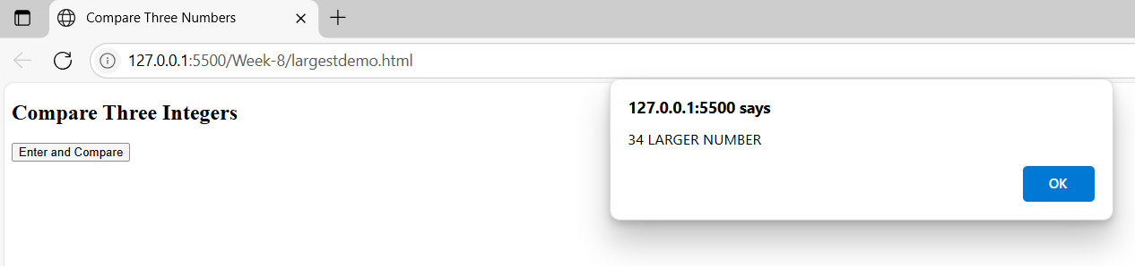

8 b) Write a program to display week days using switch case.
<!DOCTYPE html>
<html>
<head>
<title>Weekday Switch Case</title>
</head>
<body>
<h2>Display Weekday</h2>
<label>Enter a number (1-7): </label>
<input type="number" id="dayNumber" min="1" max="7">
<button onclick="showWeekday()">Show Day</button>
<p id="result"></p>
<script>
function showWeekday() {
let num = parseInt(document.getElementById("dayNumber").value);
let dayName = "";
switch (num) {
case 1:
dayName = "Sunday";
break;
case 2:
dayName = "Monday";
break;
case 3:
dayName = "Tuesday";
break;
case 4:
dayName = "Wednesday";
break;
case 5:
dayName = "Thursday";
break;
case 6:
dayName = "Friday";
break;
case 7:
dayName = "Saturday";
break;
default:
dayName = "Invalid input! Please enter a number between 1 and 7.";
}
document.getElementById("result").innerHTML = `<strong>Result:</strong> ${dayName}`;
}
</script>
</body>
</html>
Output:
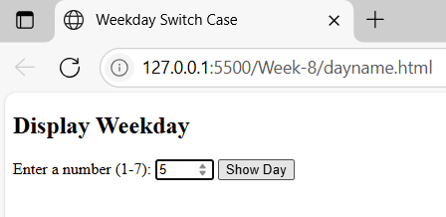

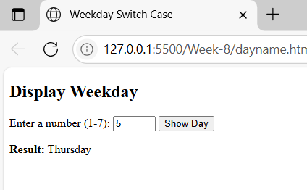

8 c) Write a program to print 1 to 10 numbers using for, while and do-while loops.
<!DOCTYPE html>
<html>
<head>
<title>Loop Demo</title>
</head>
<body>
<h2>Print 1 to 10 Using Loops</h2>
<button onclick="printUsingFor()">Print Using For Loop</button>
<button onclick="printUsingWhile()">Print Using While Loop</button>
<button onclick="printUsingDoWhile()">Print Using Do-While Loop</button>
<h3>Output:</h3>
<p id="output"></p>
<script>
function printUsingFor() {
let result = "For Loop: ";
for (let i = 1; i <= 10; i++) {
result += i + " ";
}
document.getElementById("output").innerHTML = result;
}
function printUsingWhile() {
let i = 1;
let result = "While Loop: ";
while (i <= 10) {
result += i + " ";
i++;
}
document.getElementById("output").innerHTML = result;
}
function printUsingDoWhile() {
let i = 1;
let result = "Do-While Loop: ";
do {
result += i + " ";
i++;
} while (i <= 10);
document.getElementById("output").innerHTML = result;
}
</script>
</body>
</html>

Output:
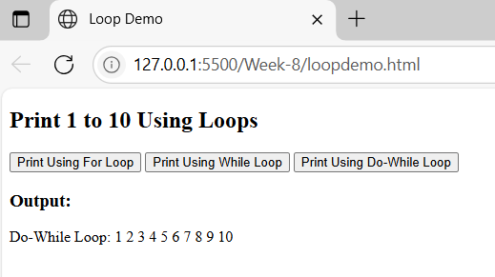

8 d) Write a program to print data in object using for-in, for-each and for-of loops.
for…in (iterating over object keys),
forEach (iterating over an array of keys or entries), and
for…of (iterating over iterable objects like arrays).

test.js:
// Student object with some realistic data
const student = {
name: "Alice Johnson",
age: 21,
course: "Computer Science",
gpa: 3.8
};

console.log("=== Using for...in (iterate over keys directly) ===");
for (let key in student)
{
console.log(key+" -> "+student[key]);
}

// Convert object to an array of [key, value] pairs for forEach
console.log("\n=== Using forEach on Object.entries() ===");
Object.entries(student).forEach(([key, value]) => {
console.log(key+" -> "+value);
});

// Use for...of with Object.entries to iterate key-value pairs
console.log("\n=== Using for...of on Object.entries() ===");
for (let [key, value] of Object.entries(student)) {
console.log(key+" -> "+value);
}
Demo.html:
<html>
<head>
<script src=”test.js”>
</script>
</head>
<body>
<h1>Working with for-of, for-in and for-each</h1>
</body>
</html>
Output:
"=== Using for...in (iterate over keys directly) ==="
"name -> Alice Johnson"
"age -> 21"
"course -> Computer Science"
"gpa -> 3.8"
=== Using forEach on Object.entries() ===
"name -> Alice Johnson"
"age -> 21"
"course -> Computer Science"
"gpa -> 3.8"

=== Using for...of on Object.entries() ===
"name -> Alice Johnson"
"age -> 21"
"course -> Computer Science"
"gpa -> 3.8"

