Week-9: JavaScript functions and Events
- Design a appropriate function should be called to display.
- Design a HTML having a text box and two buttons named factorial and Fibonacci, when a button is pressed an appropriate function should be called to display.
<!DOCTYPE html>
<html lang="en">
<head>
<meta charset="UTF-8">
<title>Factorial and Fibonacci Calculator</title>
<style>
body { font-family: Arial, sans-serif; margin: 20px; }
input, button { margin: 5px; padding: 8px; }
#result { margin-top: 15px; font-weight: bold; color: darkblue; }
</style>
</head>
<body>
<h2>Factorial & Fibonacci Calculator</h2>
<label>Enter a number:</label>
<input type="number" id="numInput" placeholder="Enter a number" />
<br>
<!-- Buttons -->
<button onclick="displayFactorial()">Factorial</button>
<button onclick="displayFibonacci()">Fibonacci</button>
<div id="result"></div>
<script>
// (a) Function to display factorial
function displayFactorial() {
const n = parseInt(document.getElementById('numInput').value);
if (isNaN(n) || n < 0) {
document.getElementById('result').innerText = "Please enter a non-negative integer.";
return;
}
let fact = 1;
for (let i = 1; i <= n; i++) {
fact *= i;
}
document.getElementById('result').innerText = `Factorial of ${n} is ${fact}`;
}

// (b) Function to display Fibonacci sequence
function displayFibonacci() {
const n = parseInt(document.getElementById('numInput').value);
if (isNaN(n) || n <= 0) {
document.getElementById('result').innerText = "Please enter a positive integer.";
return;
}
let fib="";
let a = 0, b = 1;
let c=a+b;
fib=a+" "+b+" ";
while(c<=n)
{
fib=fib+c+" ";
a=b;
b=c;
c=a+b;
}
document.getElementById('result').innerText = "Fibonacci upto "+n+" is: "+fib;
}
</script>
</body>
</html>
Output:
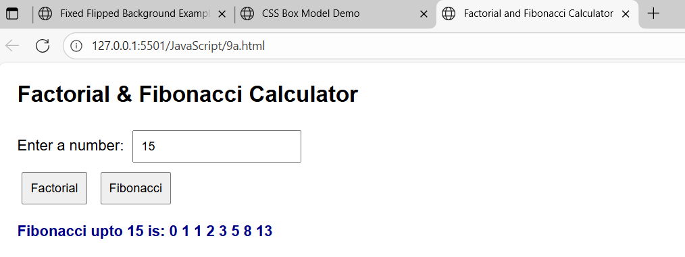
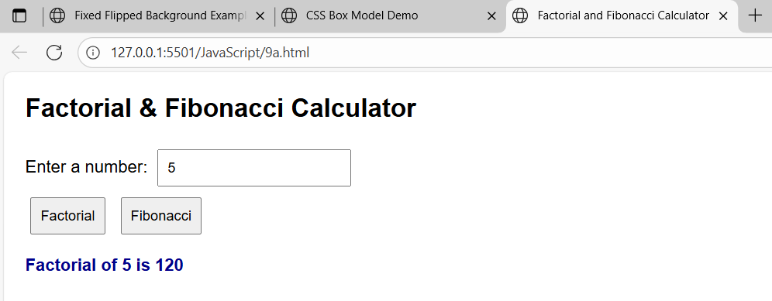

- Write a program to validate the following fields in a registration page
- Name (start with alphabet and followed by alphanumeric and the length should not be less than 6 characters)
- Mobile (only numbers and length 10 digits)
- Email (Should contain format like xxxxxx@xxxxx.xxx)

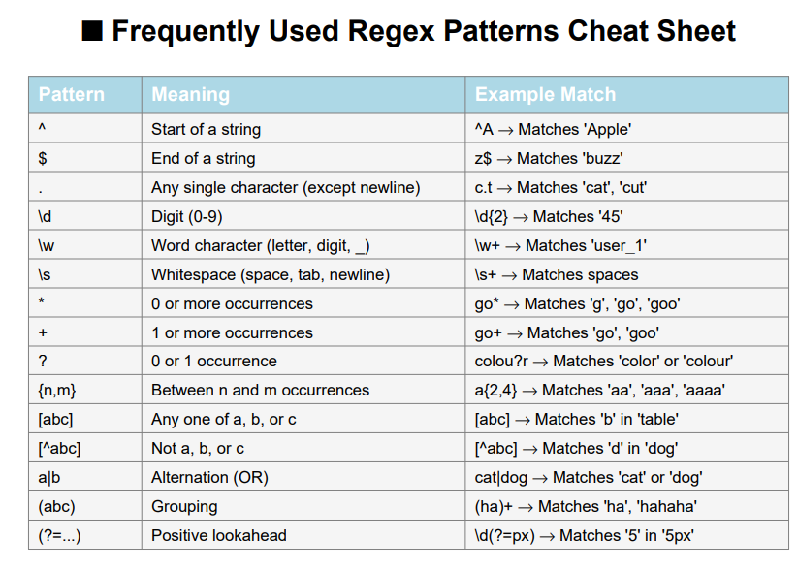
<!DOCTYPE html>
<html lang="en">
<head>
<meta charset="UTF-8">
<title>Registration Form Validation</title>
<style>
body { font-family: Arial, sans-serif; margin: 20px; }
label { display: block; margin-top: 10px; }
input { padding: 6px; width: 250px; }
button { margin-top: 15px; padding: 8px 12px; }
.error { color: red; font-size: 0.9em; }
.success { color: green; font-weight: bold; }
</style>
</head>
<body>
<h2>Registration Page</h2>
<form id="regForm" onsubmit="return validateForm()">
<label>Name:</label>
<input type="text" id="name" placeholder="Enter your name">
<div id="nameError" class="error"></div>

<label>Mobile:</label>
<input type="text" id="mobile" placeholder="Enter 10-digit mobile number">
<div id="mobileError" class="error"></div>

<label>Email:</label>
<input type="text" id="email" placeholder="Enter your email">
<div id="emailError" class="error"></div>
<button type="submit">Register</button>
</form>
<div id="result" class="success"></div>
<script>
function validateForm() {
// Get input values
const name = document.getElementById("name").value.trim();
const mobile = document.getElementById("mobile").value.trim();
const email = document.getElementById("email").value.trim();

// Clear previous errors
document.getElementById("nameError").innerText = "";
document.getElementById("mobileError").innerText = "";
document.getElementById("emailError").innerText = "";
document.getElementById("result").innerText = "";

let isValid = true;
// i) Name validation: Start with alphabet, followed by alphanumeric, length >= 6
const namePattern = /^[A-Za-z][A-Za-z0-9]{5,}$/;
if (!namePattern.test(name)) {
document.getElementById("nameError").innerText =
"Name must start with a letter, be alphanumeric, and at least 6 characters long.";
isValid = false;
}

// ii) Mobile validation: Exactly 10 digits
const mobilePattern = /^[0-9]{10}$/;
if (!mobilePattern.test(mobile)) {
document.getElementById("mobileError").innerText =
"Mobile number must be exactly 10 digits.";
isValid = false;
}
// iii) Email validation: Format xxxxxx@xxxxx.xxx
const emailPattern = /^[A-Za-z0-9._%+-]+@[A-Za-z0-9.-]+\.[A-Za-z]{2,3}$/;
if (!emailPattern.test(email)) {
document.getElementById("emailError").innerText =
"Email must be in the format: example@domain.com";
isValid = false;
}
// Display success message if all fields are valid
if (isValid) {
document.getElementById("result").innerText =
"Registration successful!";
}
return false; // Prevent actual form submission for demo
}
</script>
</body>
</html>
Output:
