Stack and Queue Implementation Report

1. Array Stack — Balanced Brackets Linter
Objective: Implement a Balanced Brackets Linter that validates if brackets (), {}, [] are properly matched and nested.

Design Explanation:
The program reads a string of characters and pushes each bracket into an array-based stack. It checks for valid pairs and order using ASCII comparisons. Non-bracket characters are ignored. The solution ensures that every opening bracket has a corresponding closing bracket of the correct type.

Edge Cases:
- Empty input → Valid
- Unmatched closing bracket → Invalid at position
- Unmatched opening bracket → Invalid
- Nested structures like [({})] → Valid; [(]) → Invalid

Code Snippet:
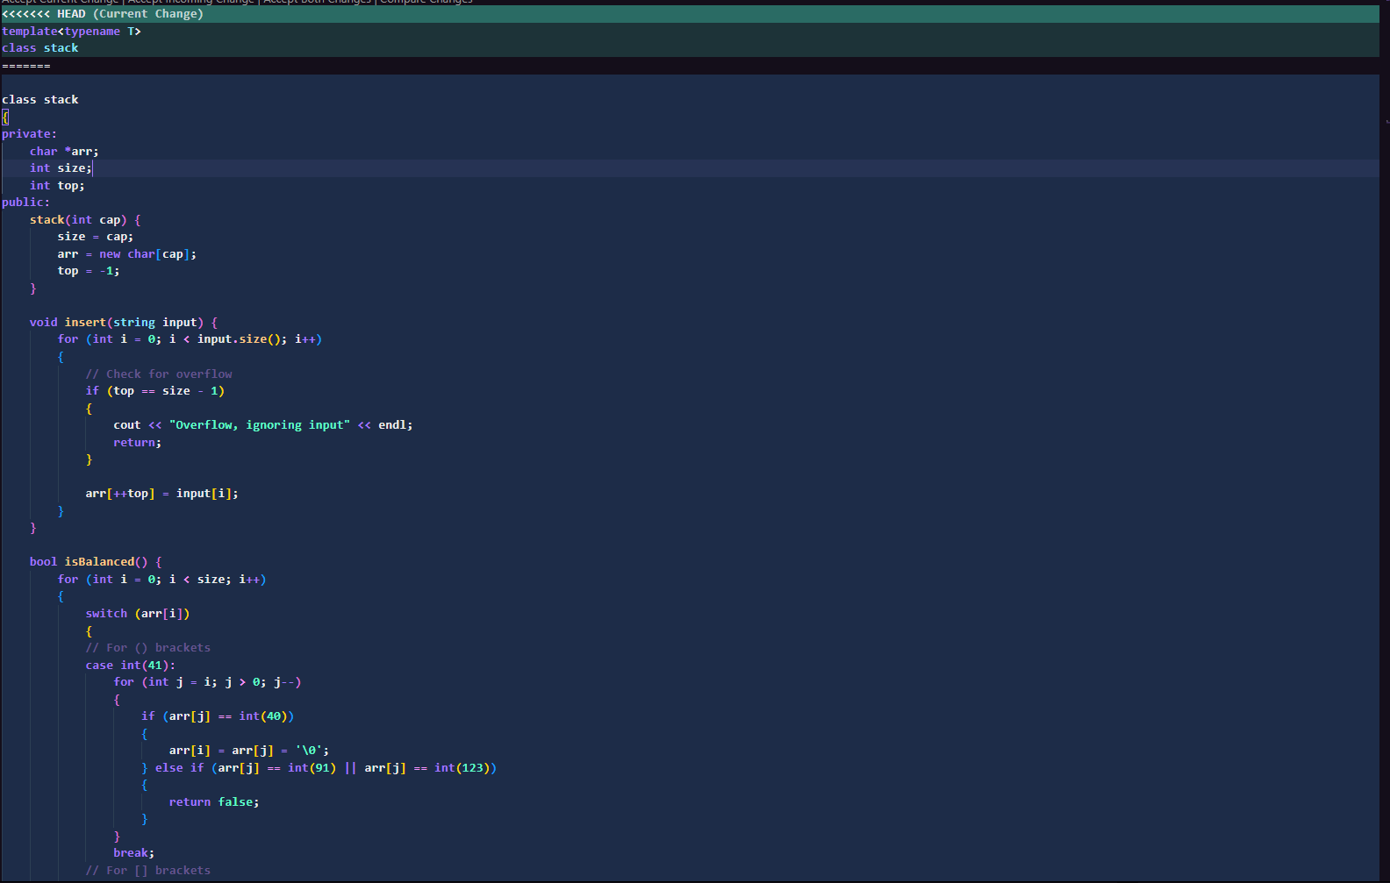
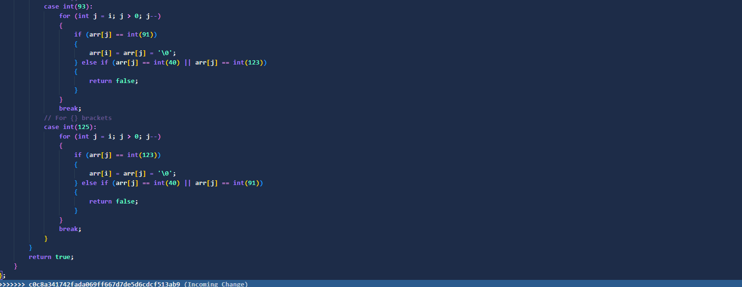

2. Helpdesk Ticket Queue — Linked List Implementation
Objective: Implement a queue system for handling helpdesk tickets using a singly linked list to preserve FIFO order.

Design Explanation:
The queue stores pairs of ticket IDs and names. Each new ticket is added at the rear (tail) and processed from the front (head). The linked list allows dynamic memory usage without size limits. This structure ensures fairness and order of service.

Edge Cases:
- Dequeue on empty queue → Print message.
- Peek on empty queue → Handle safely.
- After last element is removed → Reset head and tail to null.

Code Snippet:
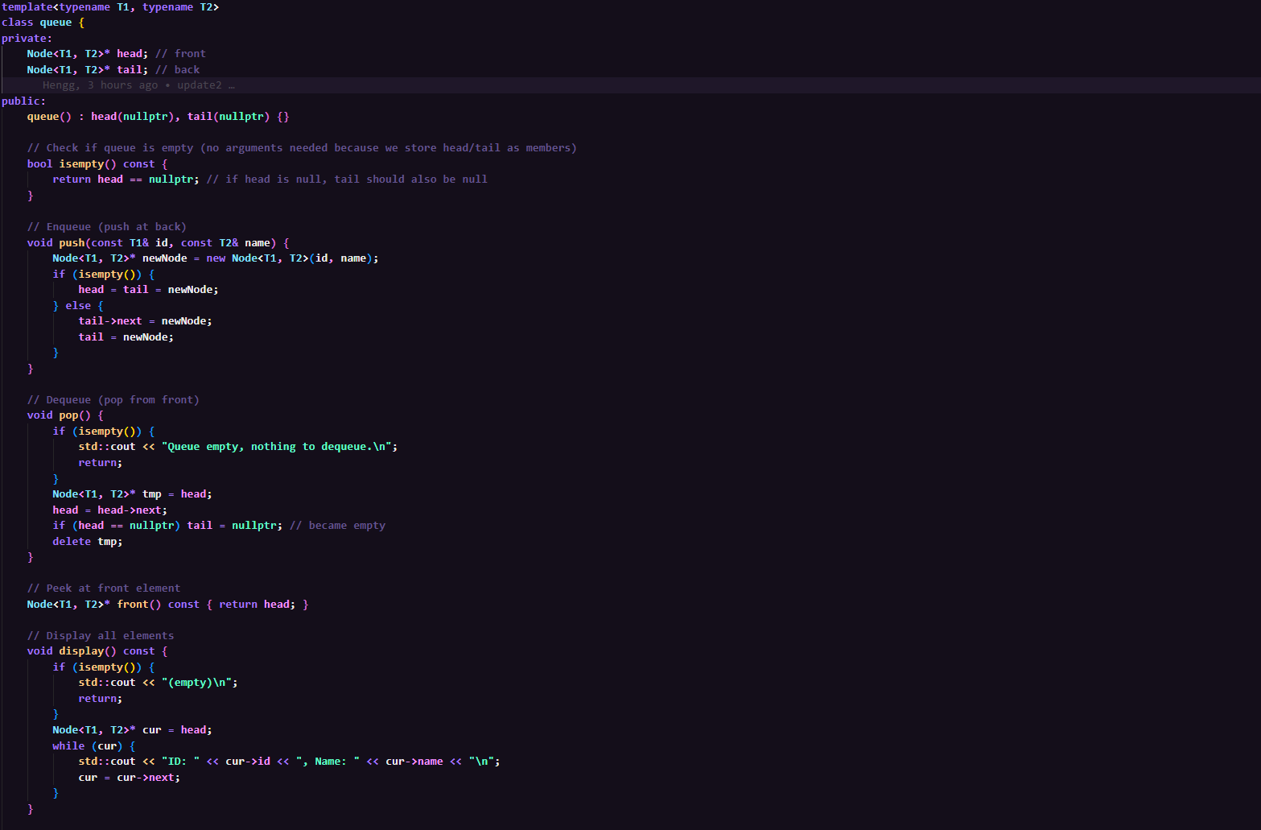

3. Comparison between Stack and Queue
Feature | Stack | Queue
Principle | LIFO (Last In, First Out) | FIFO (First In, First Out)
Main Use | Syntax checking, function calls | Task scheduling, ticketing
Core Ops | push(), pop() | enqueue(), dequeue()
Memory Model | Array-based or Linked list | Linked list or Array

Conclusion
Both implementations showcase mastery of core data structures. The Stack ensures proper syntax checking, while the Queue ensures fairness in processing. Each model can be extended to handle real-world programming tasks efficiently.

