**1.) Create a flask application to create multiple routes.**

from flask import Flask

App = Flask(__name__)

@App.route("/")

def home():

return "<h1>That is home</h1>"

@App.route("/Product")

def Product():

return "<h1>That is Product</h1>"

@App.route("/User/<name>")

def User(name):

return "<h1> Welcome back " + name + " ."

App.run(debug=True)

**----------------------OUTPUT---------------------**

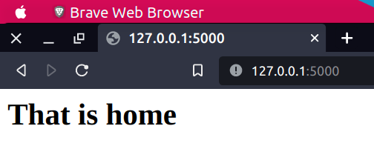

**1.)**

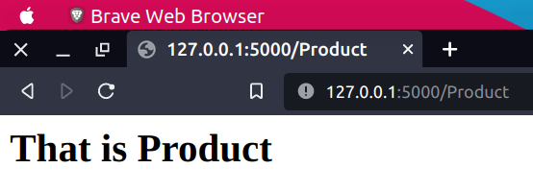

**2.)**

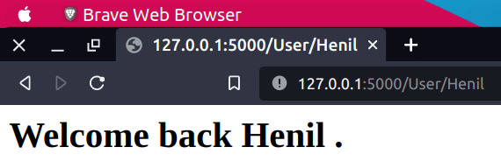**3.)**

**2.) Create a flask application to render any HTML page using the static route**

<html>

<head>

<title>Henil Code</title>

</head>

<body>

<div>

<h3>My Name is Henil. i am Devloper.</h3>

<h4>i am study in BCA</h4>

</div>

</body>

</html>

from flask import Flask , render_template

App = Flask(__name__)

@App.route("/")

def home():

return "<h1>That is Home Page</h1>"

@App.route("/About")

def about():

return render_template("About.html")

App.run(debug=True)

**-----------------------------OUTPUT--------------------------------**

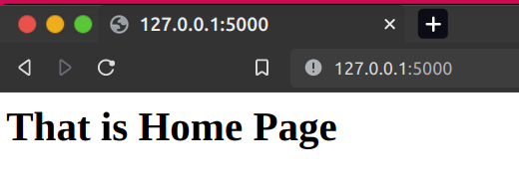

**1.)**

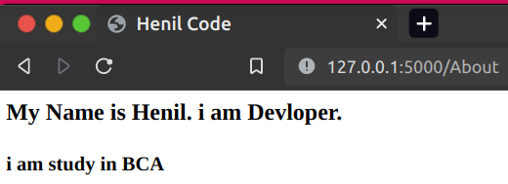

**2.)**

**3.) Create a flask application to implement inheritance.**

from flask import *

app = Flask(__name__)

@app.route("/")

def home():

return render_template("index.html")

app.run(debug=True)

<h3>My name is <u>Henil Code</u> </h3>

{% extends "file1.html" %}

{% block body %}

<h1>That is body part</h1>

{%endblock%}

<h1>That content in extended file</h1>

{% block body %}

{%endblock%}

**-----------------OUTPUT---------------------**

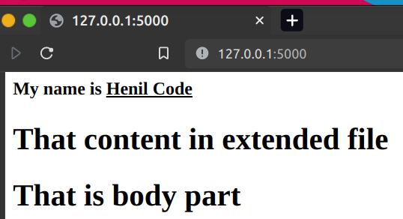

**4.) Create a flask application to add and delete session variable.**

**5.) Create a flask application which include all the jinja2 delimiters in a single app.**

from flask import *

app = Flask(__name__)

@app.route("/")

def home():

name = ["Henil","Kevin","Harshil"]

return render_template("index.html",arr = name)

app.run(debug=True)

<body>

Name :

{% for x in arr %}

{{x}} &nbsp;

{% endfor %}

</body>

**----------------------OUTPUT---------------------**

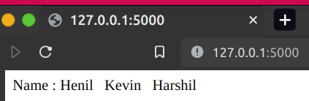

**6.) write a PHP script and call it in the python script. Use the variables like pass the value from the python to the php script.**