1.)Print Hello user on default url ‘/’

from flask import Flask

App = Flask(__name__)

@App.route("/")

def home():

return "Hello User"

App.run(debug=True)

-------------------------------OUTPUT--------------------

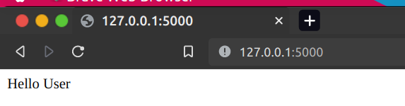

2.)Print Hello Henil on url ‘/henil’

from flask import Flask

App = Flask(__name__)

@App.route("/henil")

def henil():

return "Welcome Henil"

App.run(debug=True)

----------------OUTPUT---------------------

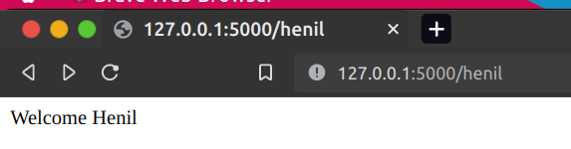

3.)Print Hello Guest on the ‘/1’ url.

from flask import Flask

App = Flask(__name__)

@App.route("/1")

def guest():

return "Welcome Guest !"

App.run(debug=True)

----------------OUTPUT--------------------

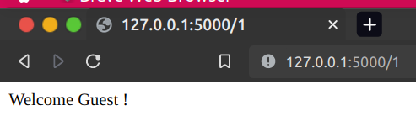

4.) Print Hello <name> on the url given dinamicaly

from flask import Flask , render_template

App = Flask(__name__)

@App.route("/User/<name>")

def getName(name):

return "Hello " + name

App.run(debug=True)

---------------------OUTPUT-------------------------

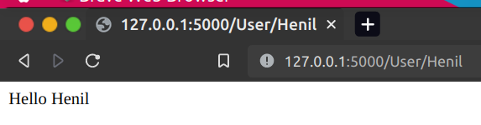

5.)Print message when the url given as integer float type dinamicalu

from flask import Flask , render_template

App = Flask(__name__)

@App.route("/Num/<float:num>")

def getNum(num):

return "Number %f"%num

------------OUTPUT------------------

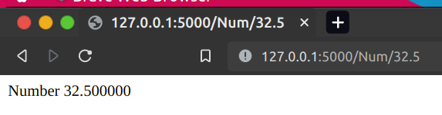

6.)Print Hello World use HTML tag in the .py file

from flask import Flask , render_template

App = Flask(__name__)

@App.route("/")

def home():

return “<h1> Hello World </h1>”

----------OUTPUT------------

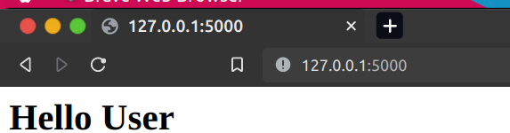

7.)Render Html file in the .py file.

from flask import Flask , render_template

App = Flask(__name__)

@App.route("/login")

def userLogin():

return render_template("login.html")

<!DOCTYPE html>

<html lang="en">

<body>

<form action="/log" method="post">

<label>Name</label>

<input type="text" name="uname" /><br>

<label>Password</label>

<input type="password" name="pass" /><br>

<input type="submit" name="done" />

</form>

</body>

</html>

---------------OUTPUT--------------

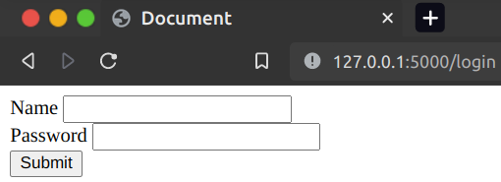

8.)jinja template in use delimeter {{ }}

from flask import Flask , render_template

App = Flask(__name__)

@App.route("/name")

def name():

return render_template("deli.html",age=19)

App.run(debug=True)

<!DOCTYPE html>

<html>

<head>

<title>Document</title>

</head>

<body>

<h1>Age is :{{ age }}</h1>

</body>

</html>

-------------OUTPUT------------

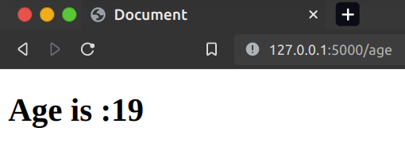

9) jinja template in use delimeter {% %}

from flask import Flask , render_template

App = Flask(__name__)

@App.route("/name")

def name():

return render_template("deli.html",age=19)

App.run(debug=True)

<!DOCTYPE html>

<html >

<head>

<title>Document</title>

</head>

<body>

<h1>Age is :{{ age }}</h1>

{% if age > 18 %}

<h4> You are Eligible for Voter</h4>

{% else %}

<h4>You are not Eligible for voter</h4>

{% endif%}

</body>

</html>

---------------OUTPUT----------------.

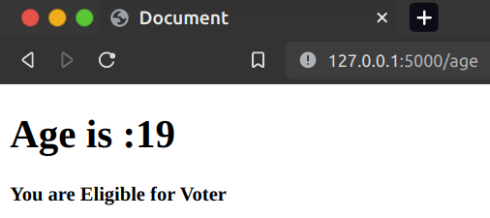

10.) flask in create log in page.

from flask import *

App = Flask(__name__)

@App.route("/login")

def login():

return render_template("login.html")

@App.route("/log",methods=['post'])

def log():

name = request.form['uname']

passs = request.form['pass']

return name + " " + passs

App.run(debug=True)

<!DOCTYPE html>

<html lang="en">

<body>

<form action="/log" method="post">

<label>Name</label>

<input type="text" name="uname" /> <br>

<label>Password</label>

<input type="password" name="pass" /><br>

<input type="submit" name="done" />

</form>

</body>

</html>

--------------------------------OUTPUT------------------------------

